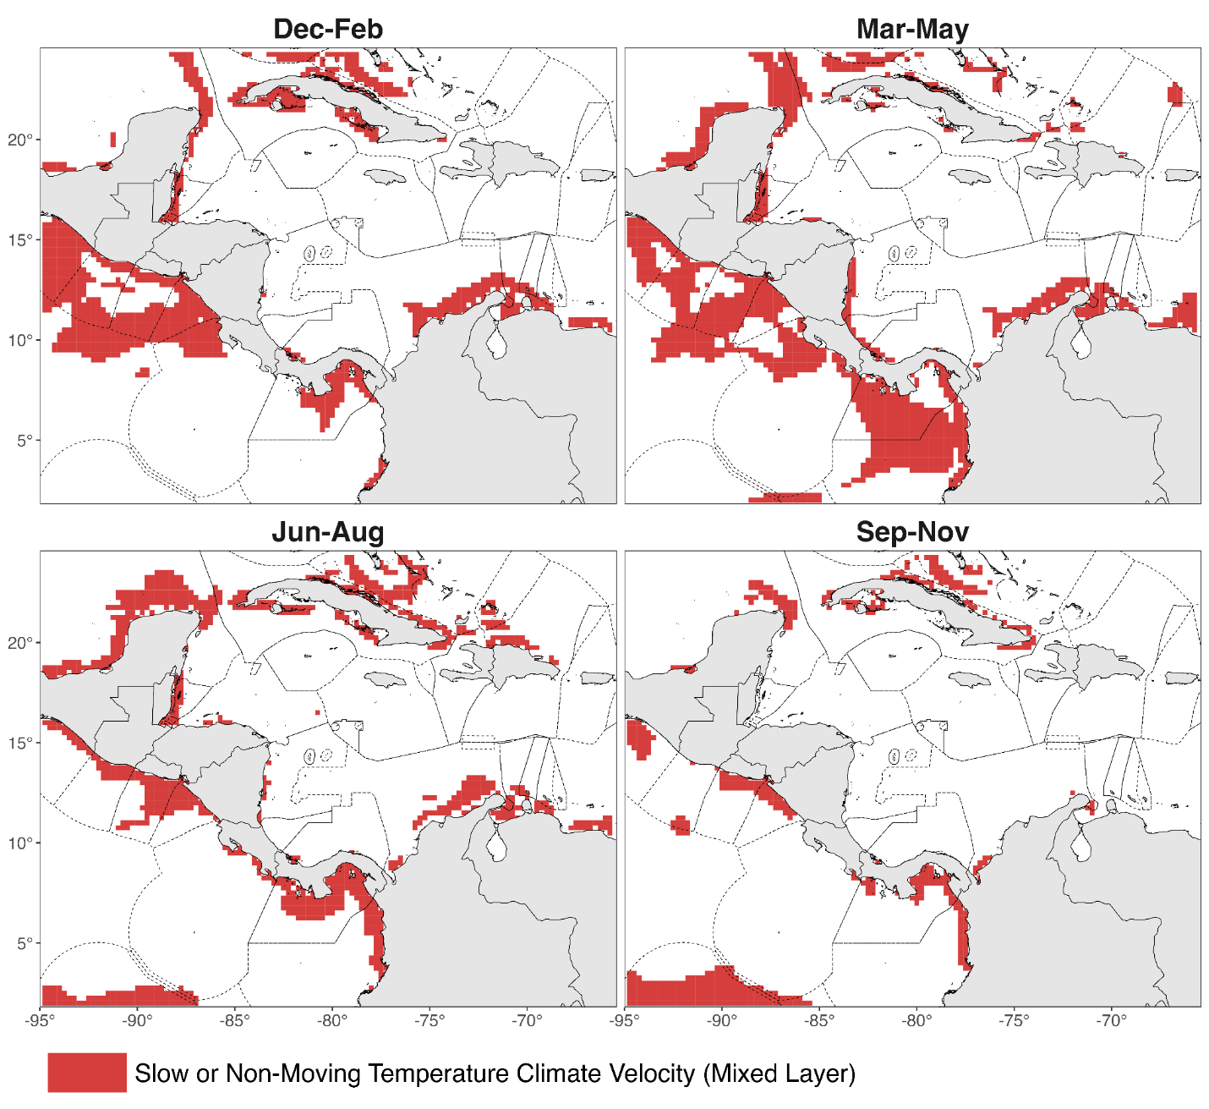
Fig S1 Spatial distribution of historical temperature climate velocity refugia within OSPESCA member-country EEZs identified for the mixed layer

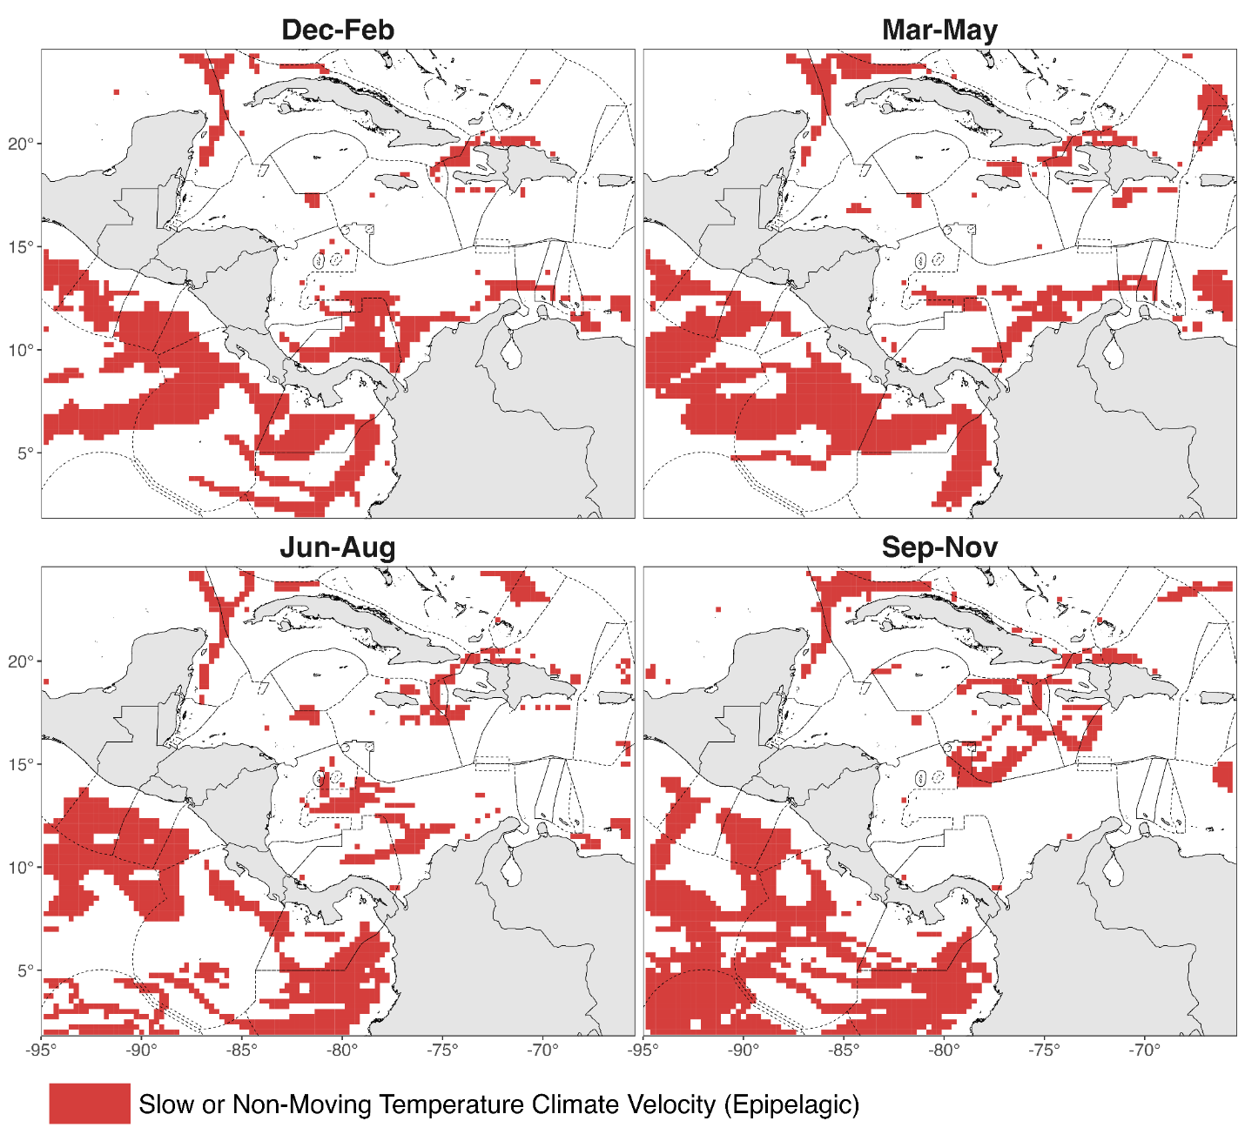
Fig S2 Spatial distribution of historical temperature climate velocity refugia within OSPESCA member-country EEZs identified for the epipelagic layer (mixed layer – 200 m)

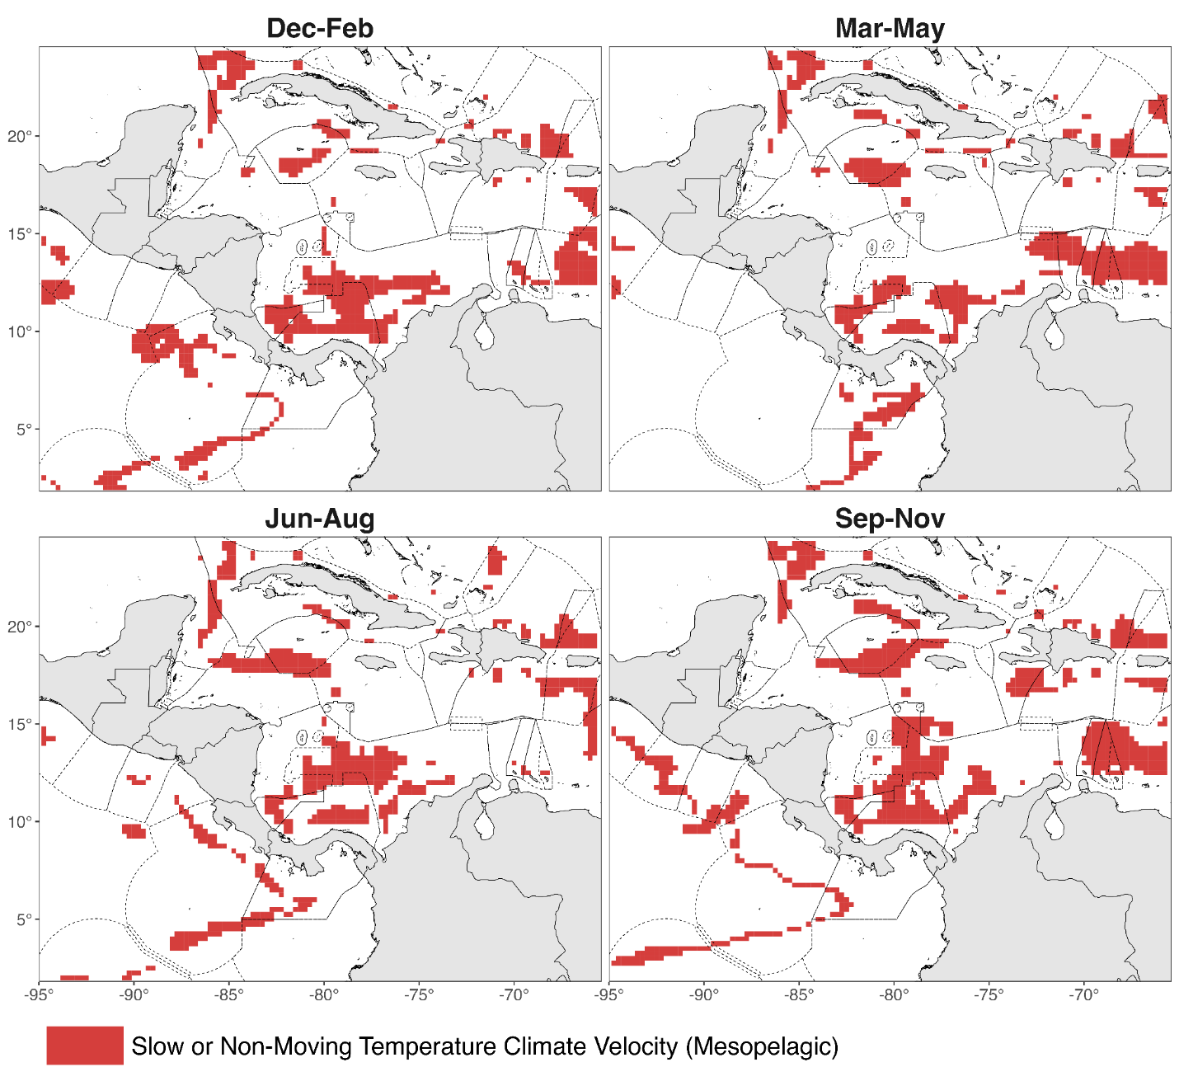
Fig S3 Spatial distribution of historical temperature climate velocity refugia within OSPESCA member-country EEZs identified for the mesopelagic layer (200 – 1000 m)

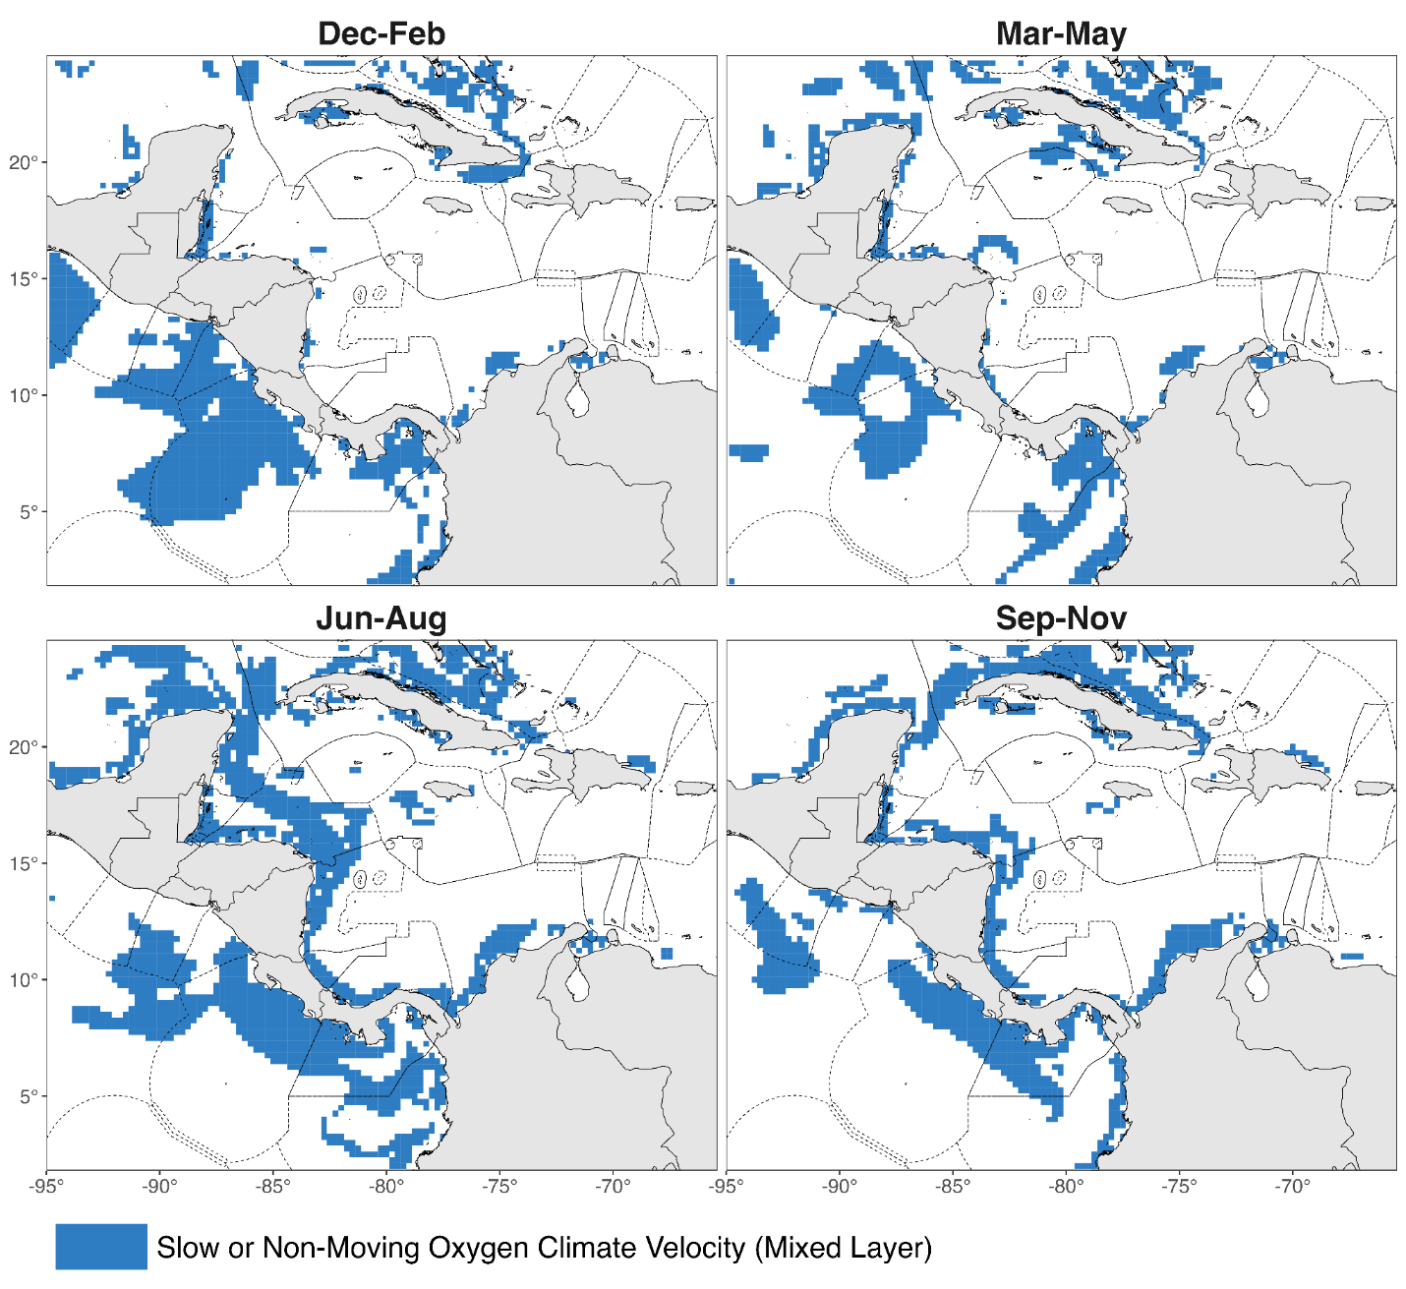
Fig S4 Spatial distribution of historical oxygen climate velocity refugia within OSPESCA member-country EEZs identified for the mixed layer

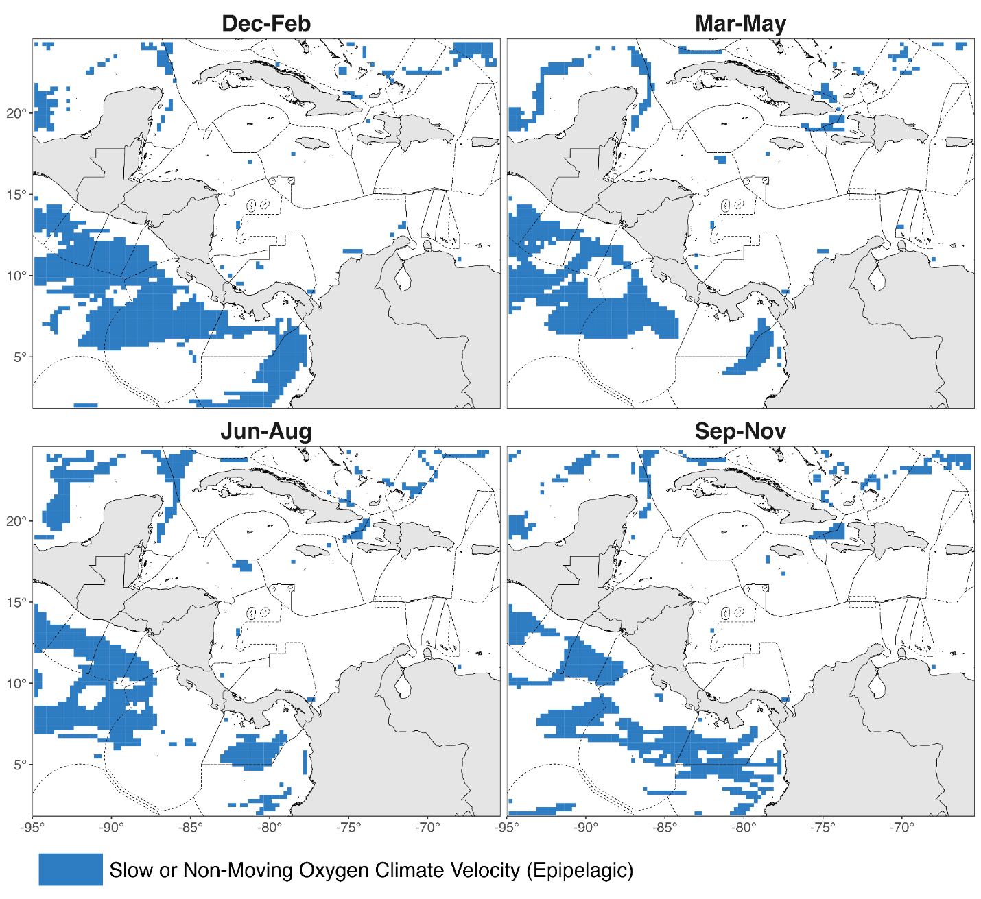
Fig S5 Spatial distribution of historical oxygen climate velocity refugia within OSPESCA member-country EEZs identified for the epipelagic layer (mixed layer – 200 m)

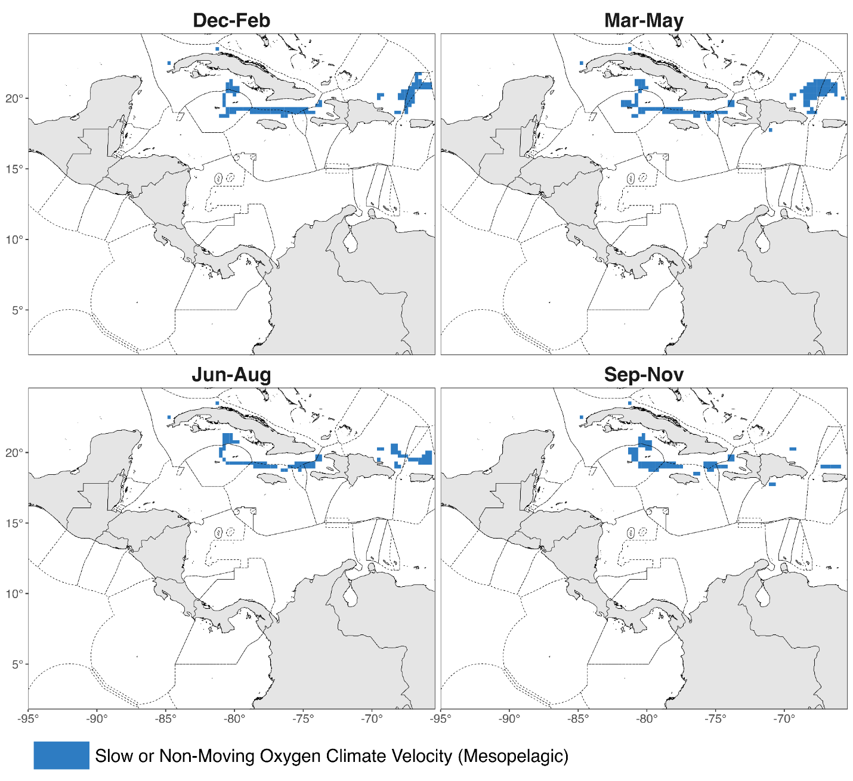
Fig S6 Spatial distribution of historical oxygen climate velocity refugia within OSPESCA member-country EEZs identified for for the mesopelagic layer (200 – 1000 m)

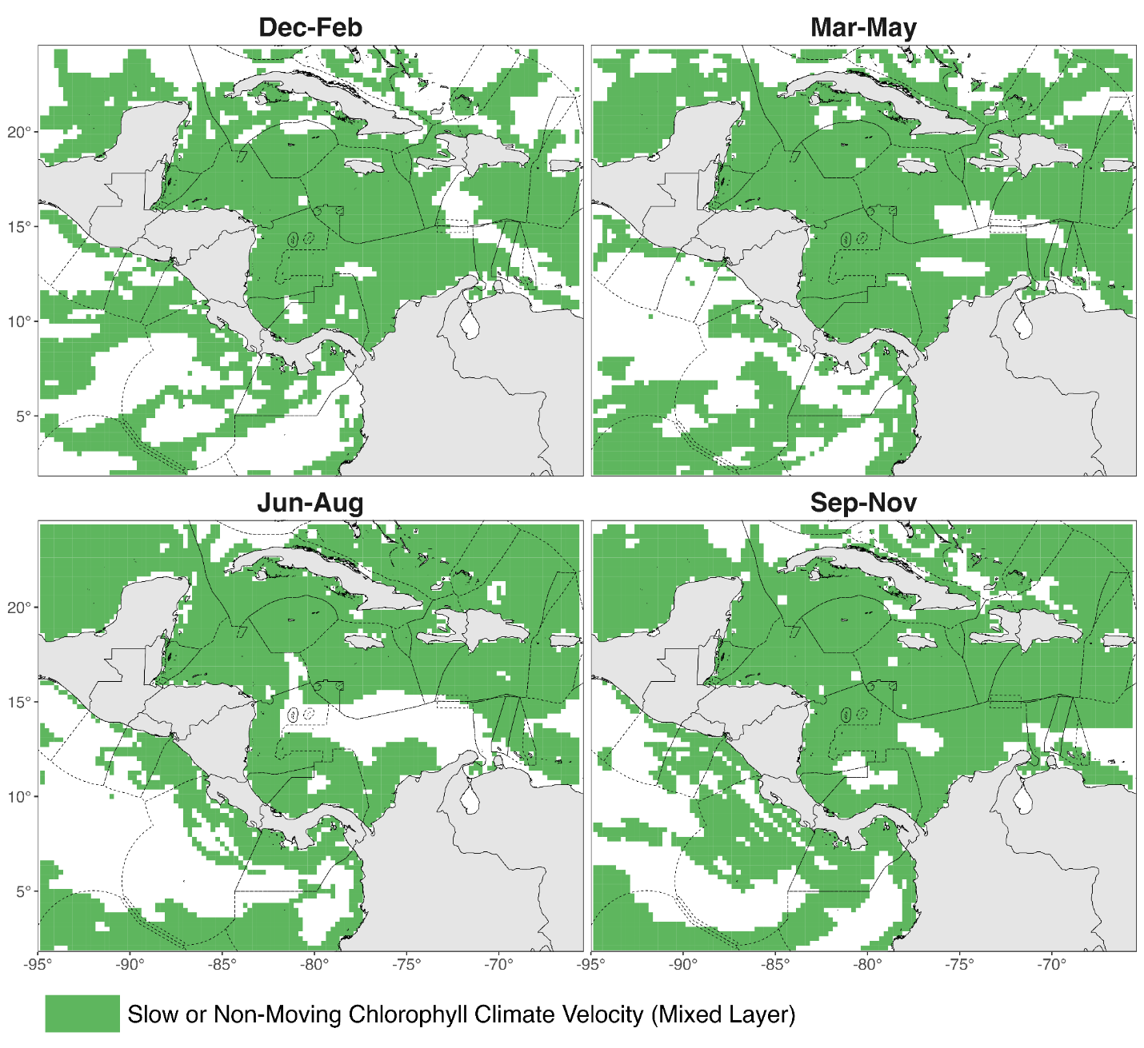
Fig S7 Spatial distribution of historical chlorophyll climate velocity refugia within OSPESCA member-country EEZs identified for the mixed layer

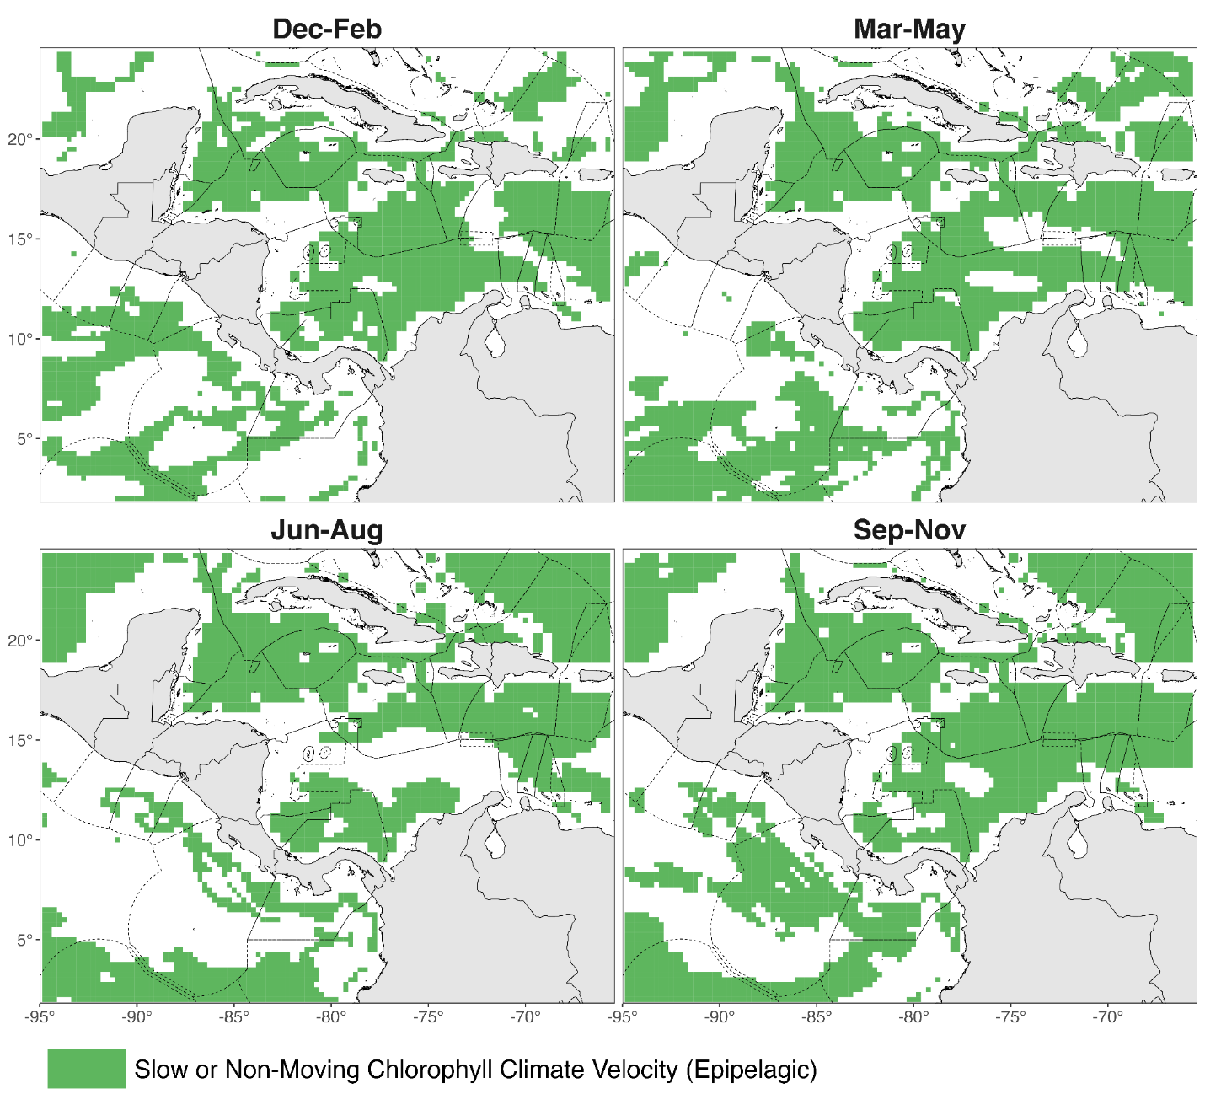
Fig S8 Spatial distribution of historical chlorophyll climate velocity refugia within OSPESCA member-country EEZs identified for the epipelagic layer (mixed layer – 200 m)

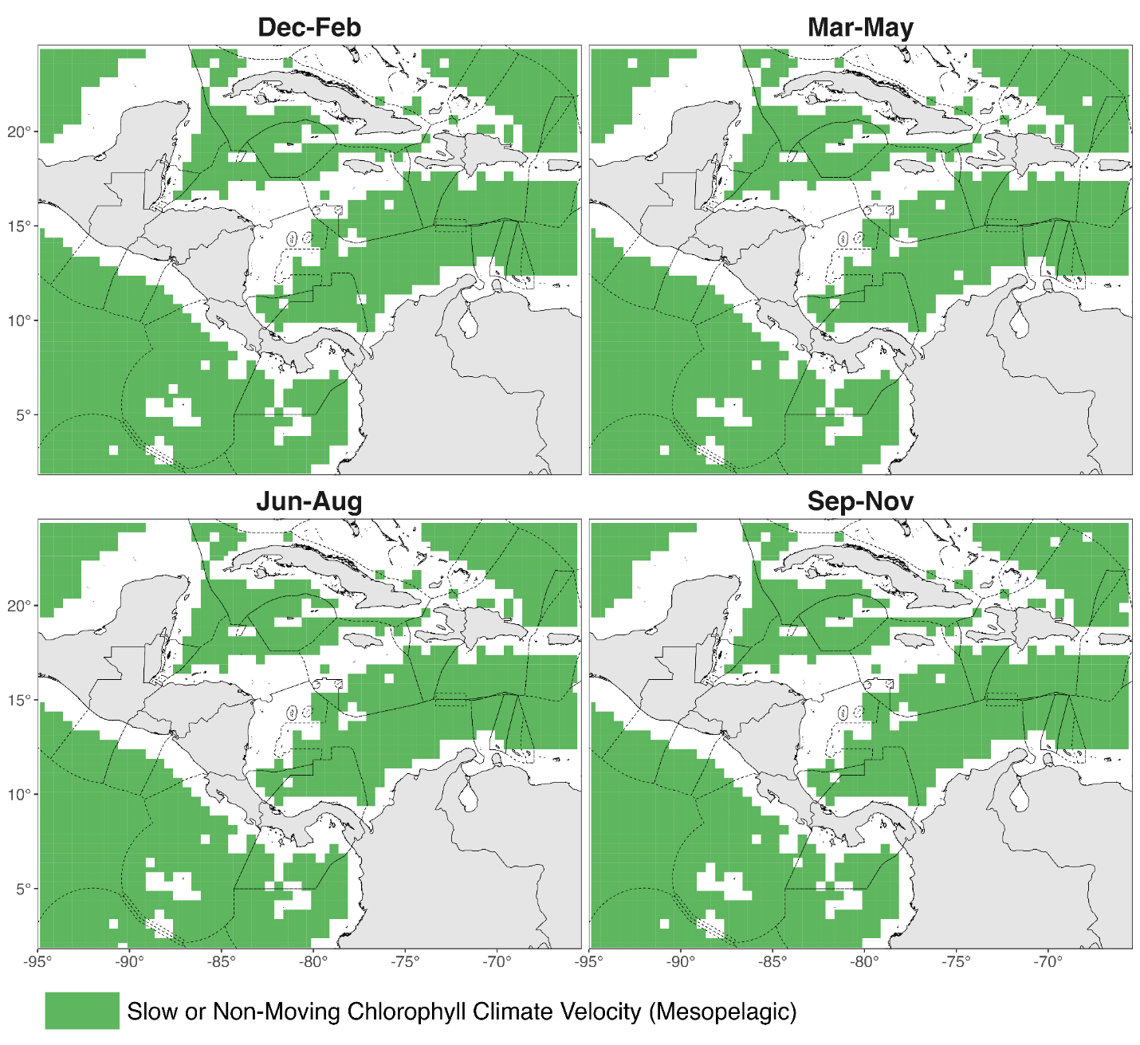
Fig S9 Spatial distribution of historical chlorophyll climate velocity refugia within OSPESCA member-country EEZs identified for the mesopelagic layer (200 – 1000 m)

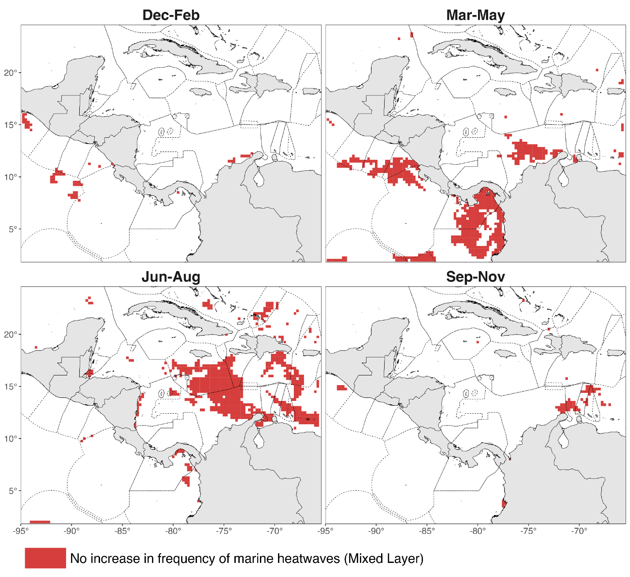
Fig S10 Spatial distribution of historical temperature extreme events refugia within OSPESCA member-country EEZs identified for the mixed layer

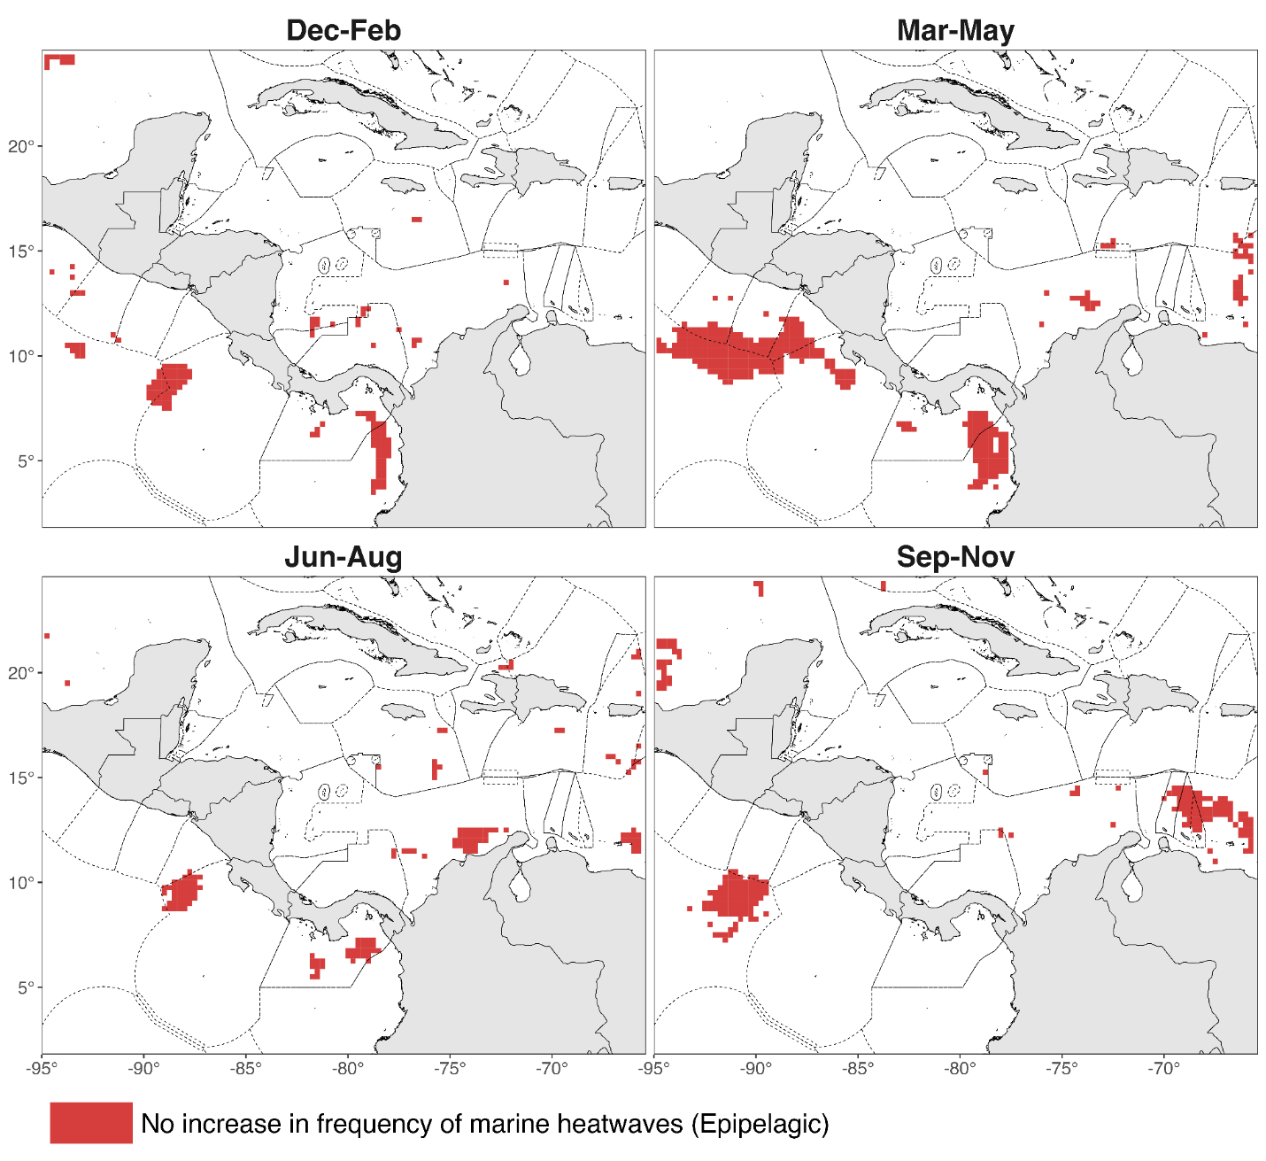
Fig S11 Spatial distribution of historical temperature extreme events refugia within OSPESCA member-country EEZs identified for the epipelagic layer (mixed layer – 200 m)

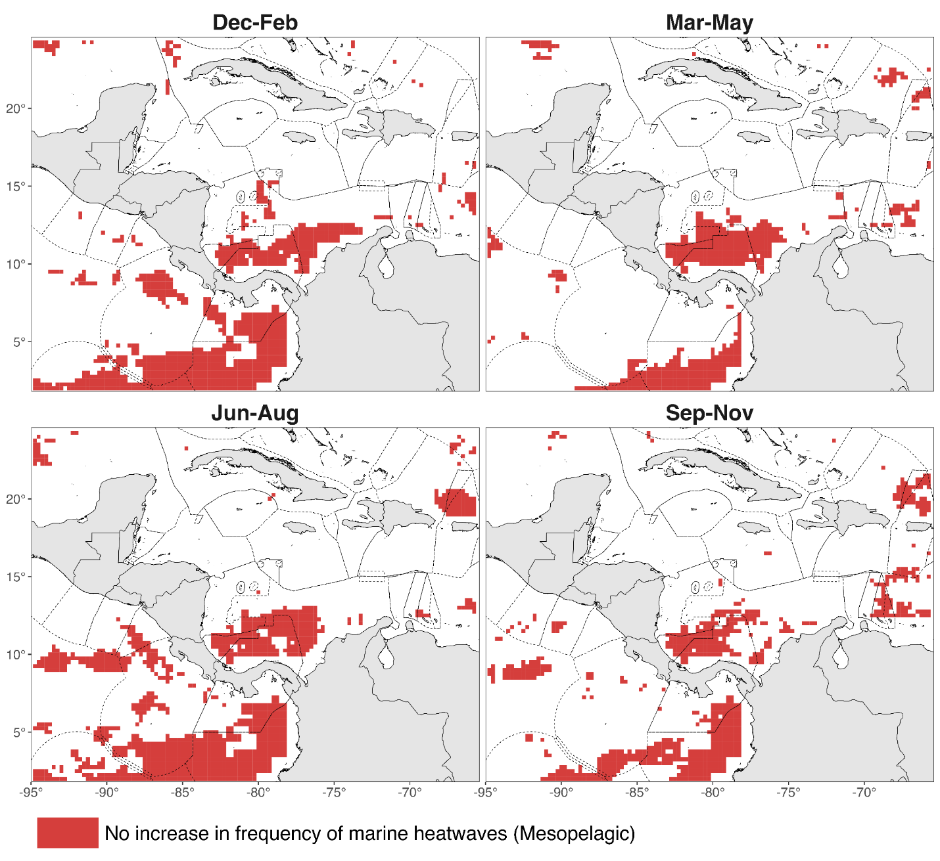
Fig S12 Spatial distribution of historical temperature extreme events refugia within OSPESCA member-country EEZs identified for the mesopelagic layer (200 – 1000 m)

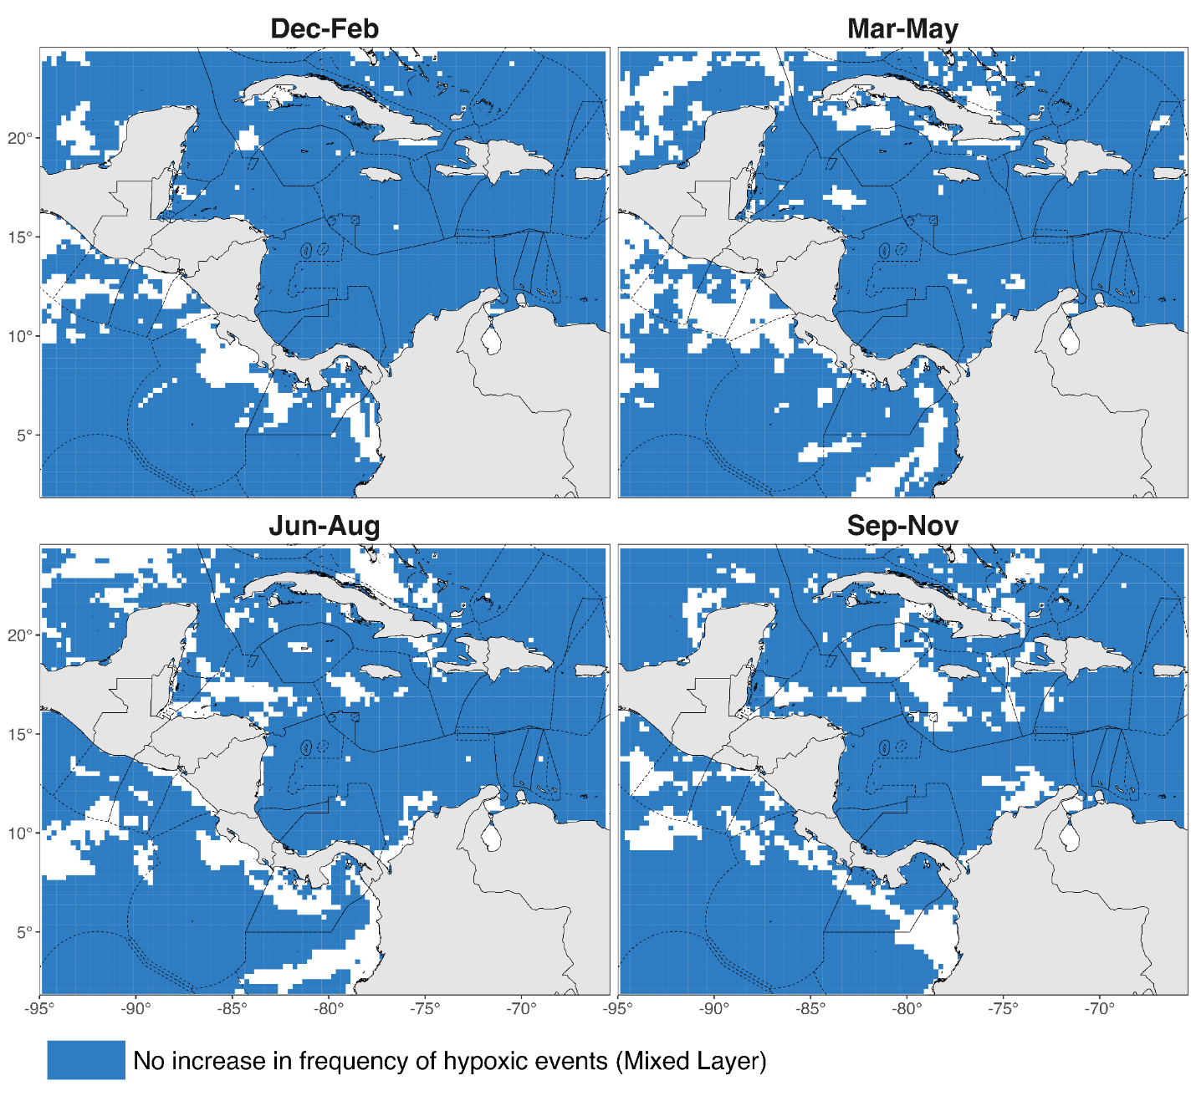
Fig S13 Spatial distribution of historical oxygen extreme events refugia within OSPESCA member-country EEZs identified for the mixed layer

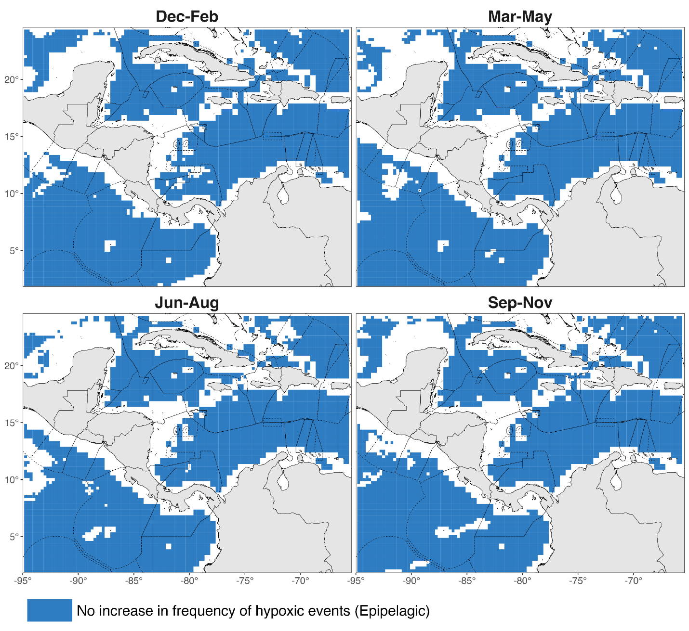
Fig S14 Spatial distribution of historical oxygen extreme events refugia within OSPESCA member-country EEZs identified for the epipelagic layer (mixed layer – 200 m)

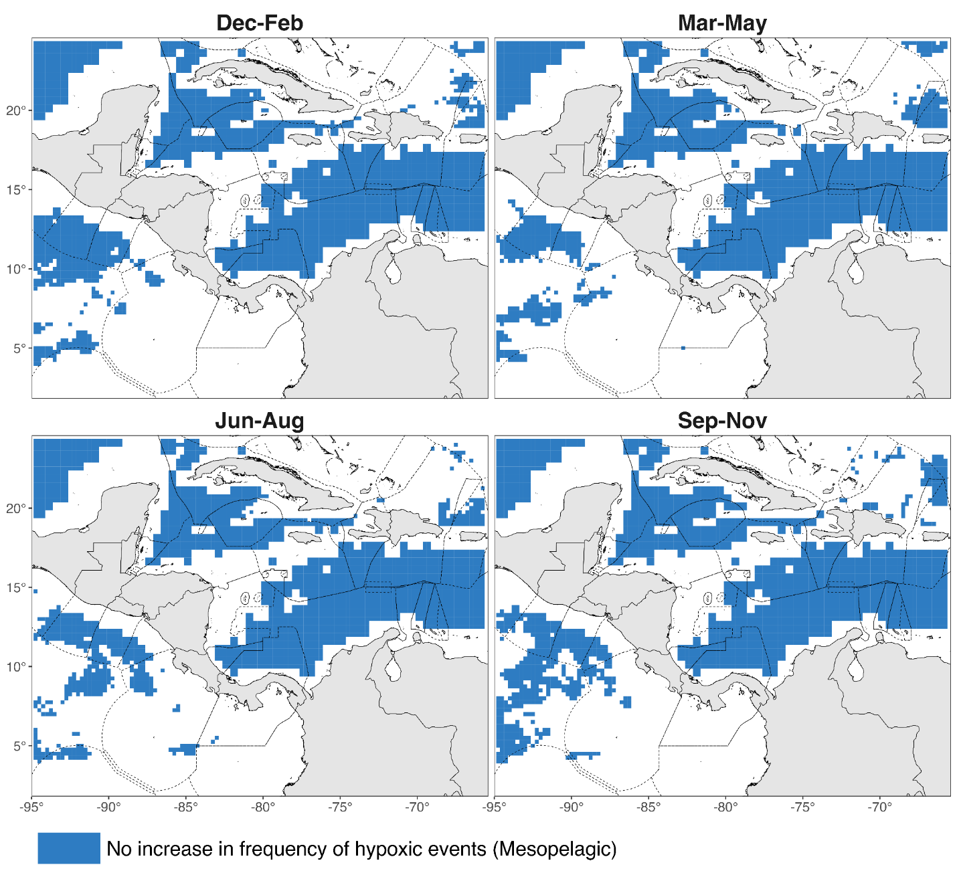
Fig S15 Spatial distribution of historical oxygen extreme events refugia within OSPESCA member-country EEZs identified for for the mesopelagic layer (200 – 1000 m)

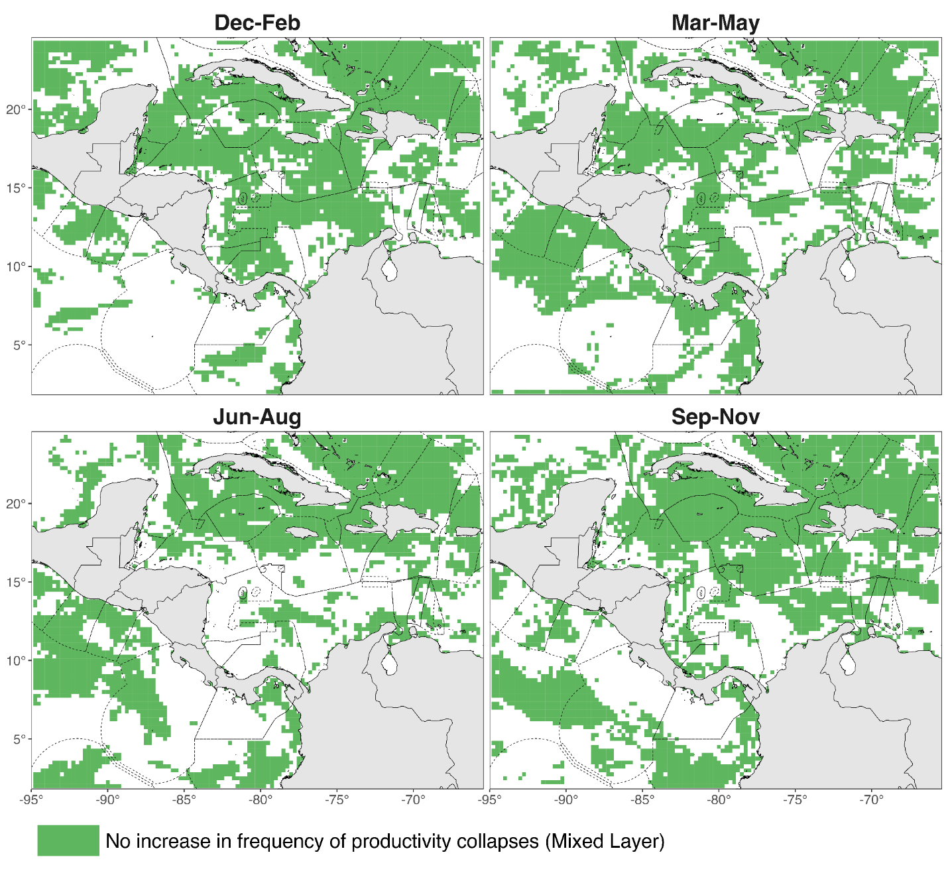
Fig S16 Spatial distribution of historical chlorophyll extreme events refugia within OSPESCA member-country EEZs identified for the mixed layer

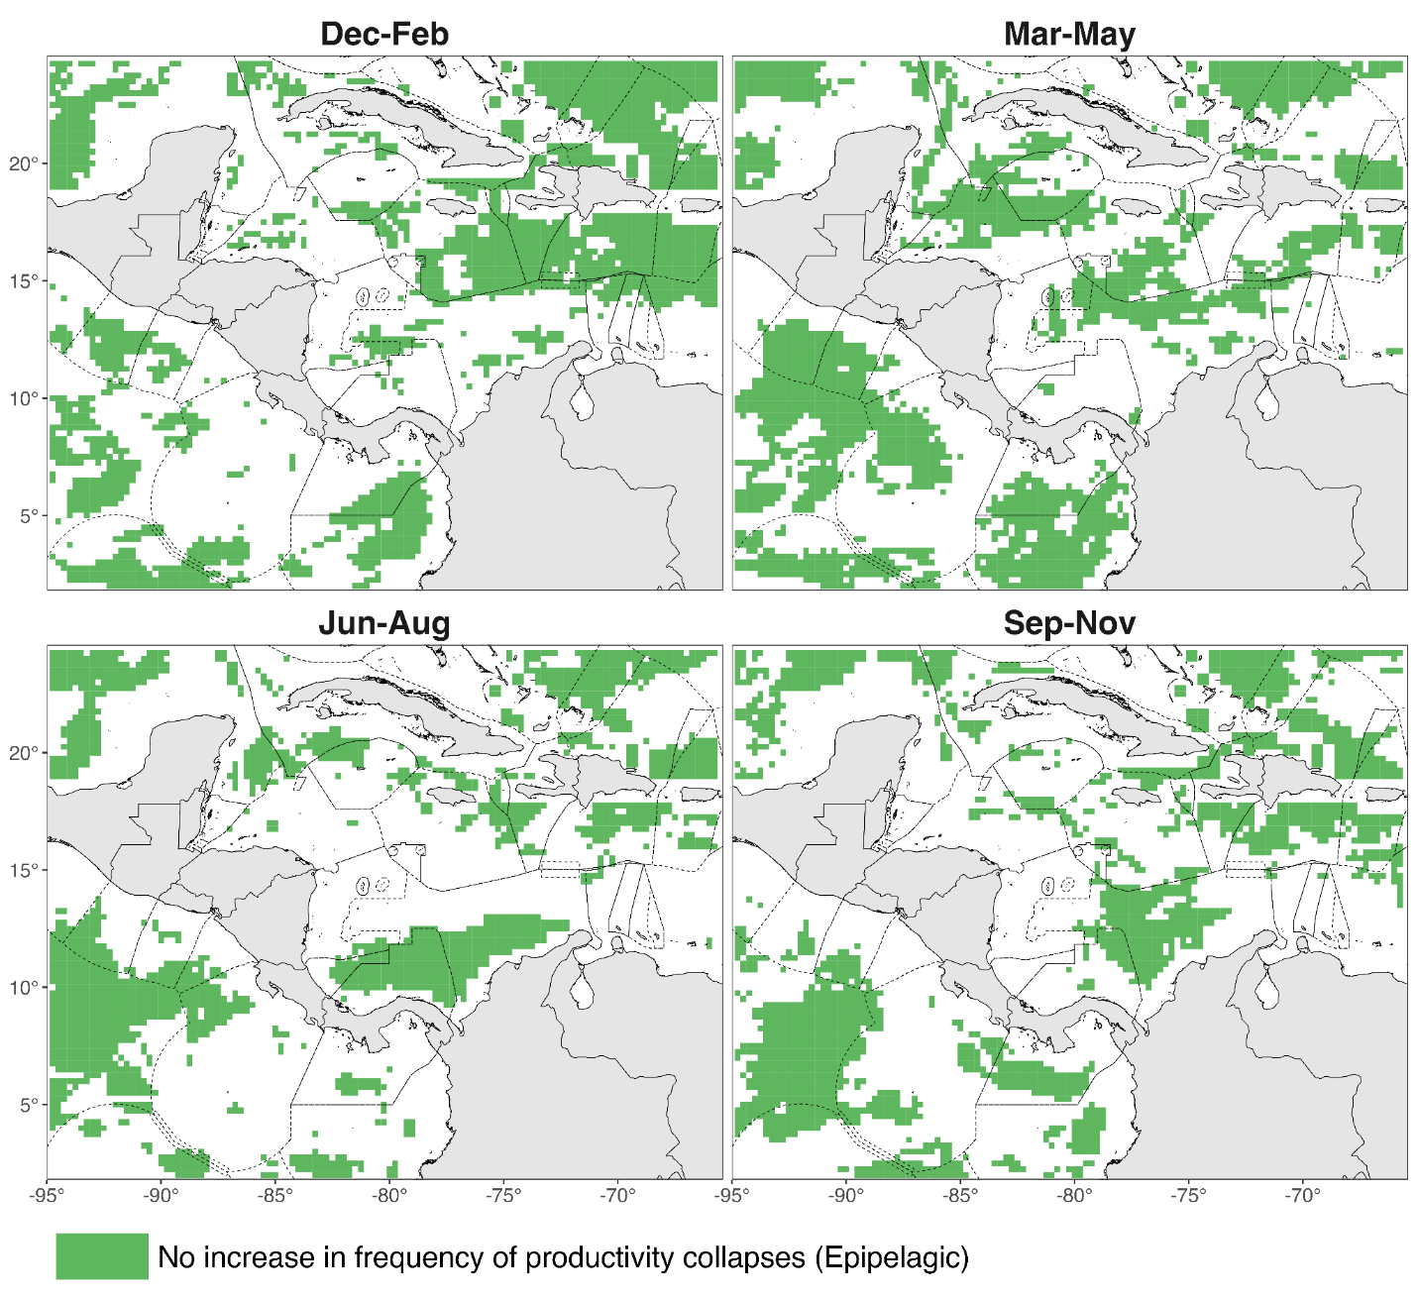
Fig S17 Spatial distribution of historical chlorophyll extreme events refugia within OSPESCA member-country EEZs identified for the epipelagic layer (mixed layer – 200 m)

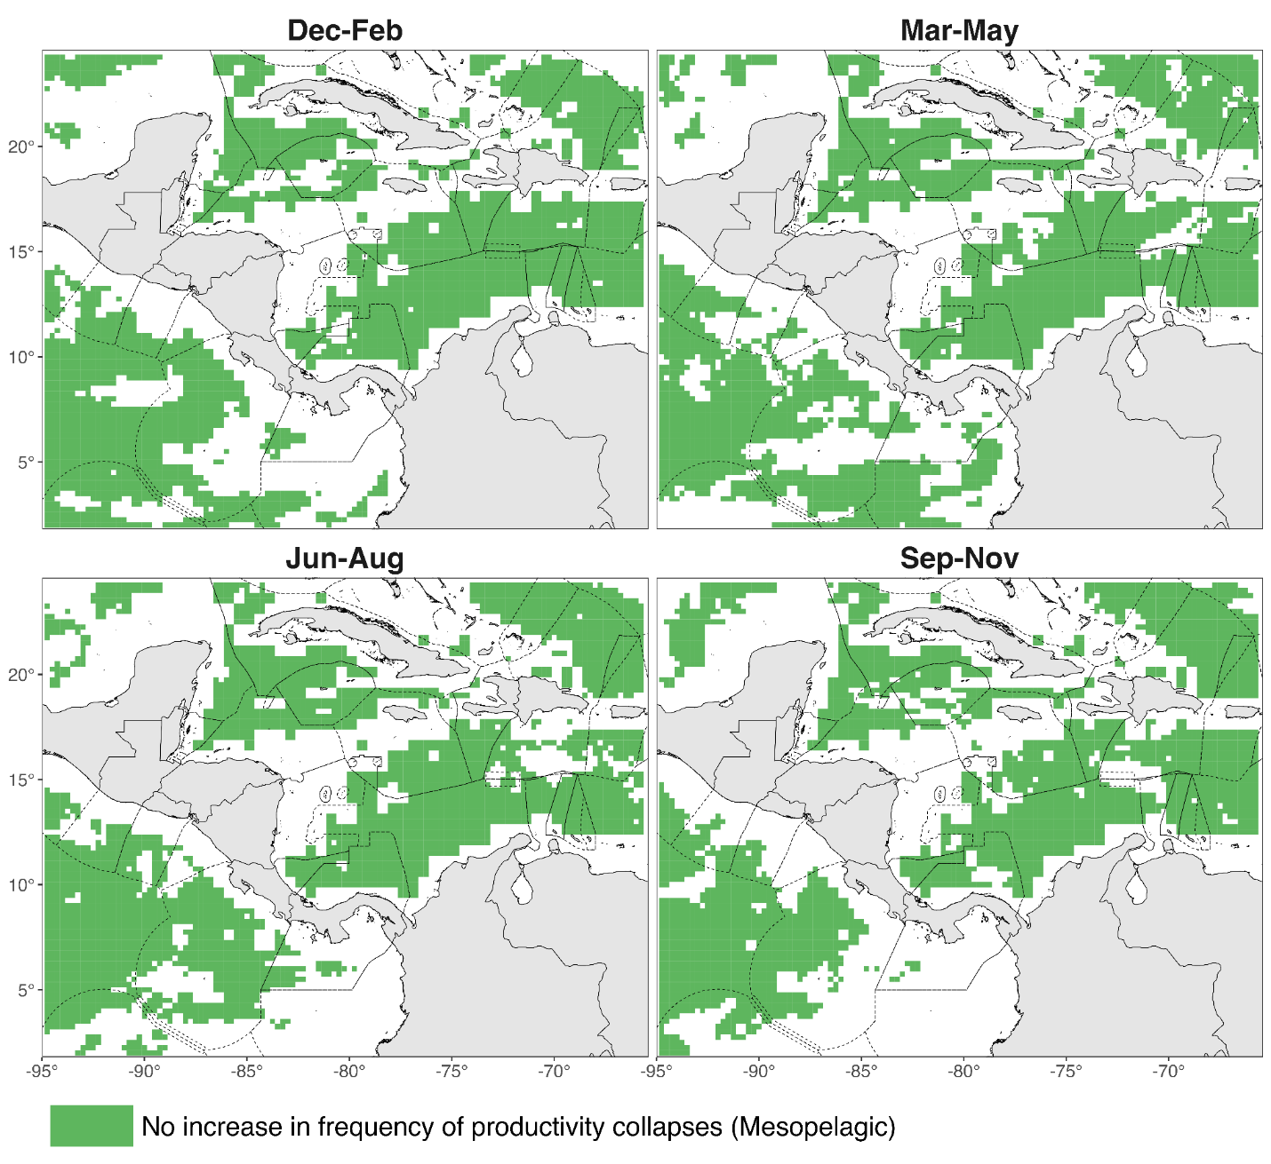
Fig S18 Spatial distribution of historical chlorophyll extreme events refugia within OSPESCA member-country EEZs identified for the mesopelagic layer (200 – 1000 m)

