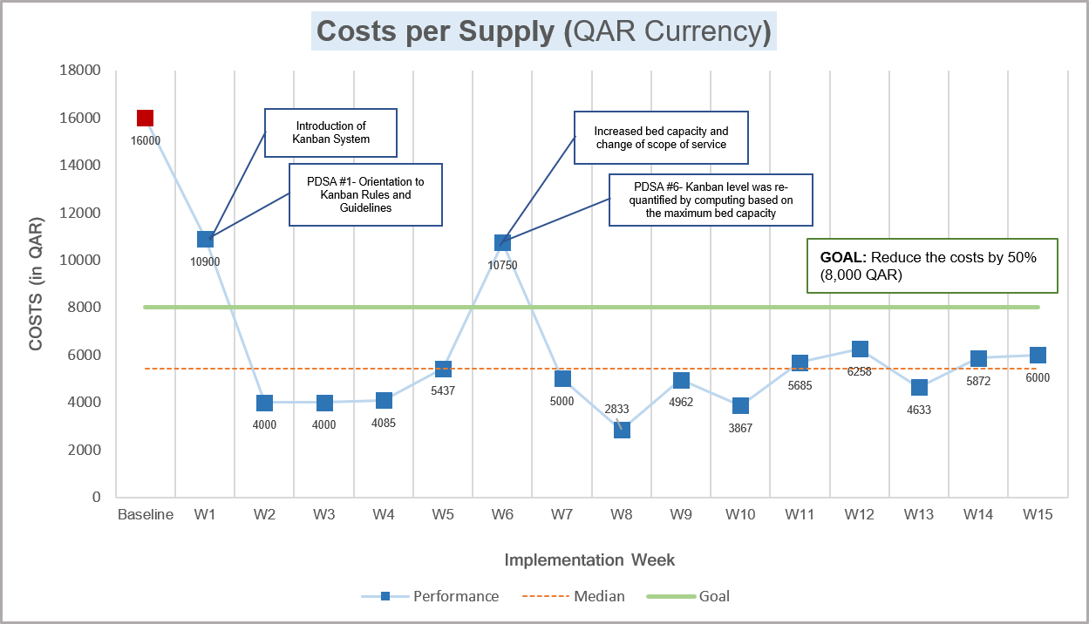

Graph 1 Costs per Supply in a weekly basis
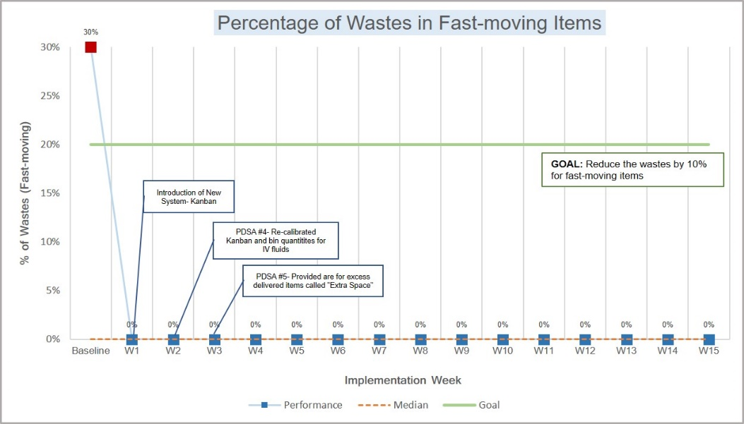

Graph 2 Percentage of Wastes in Fast-Moving Items
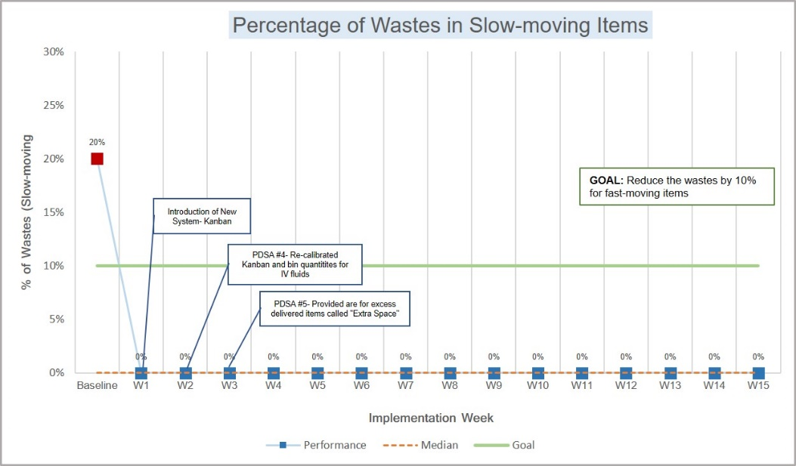

Graph 3 Percentage of Wastes in Slow-Moving Items

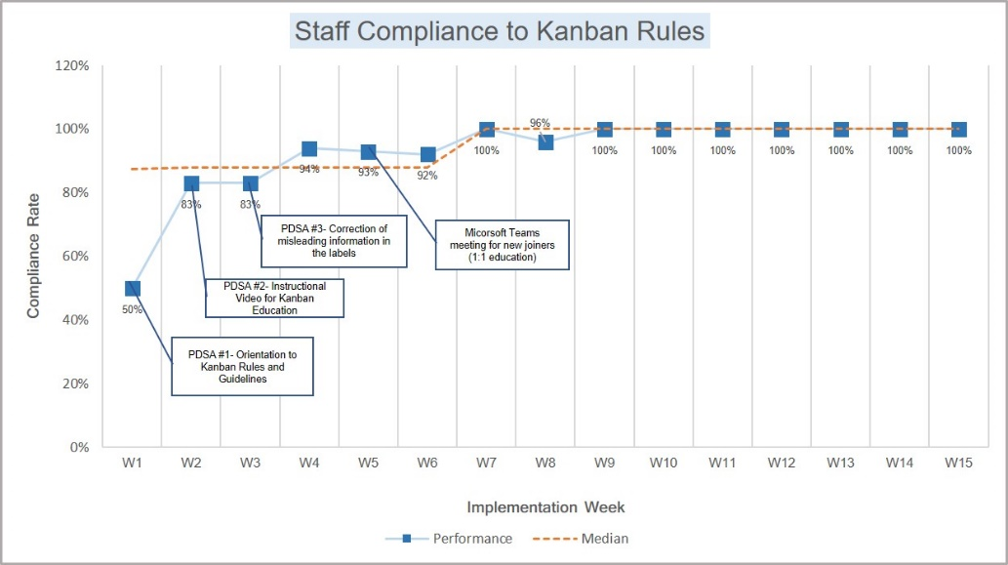

Graph 4 Staff Compliance to Kanban Guidelines

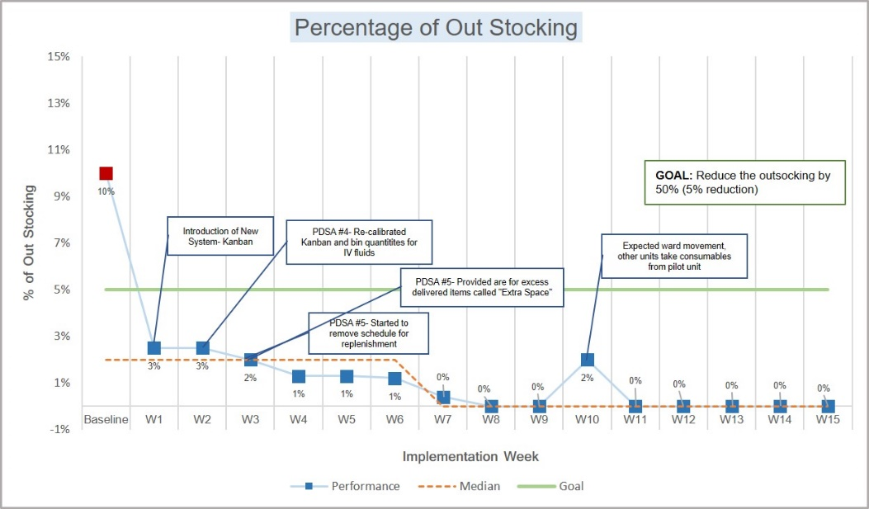

Graph 5 Percentage of Out Stocking of Consumable Items

