Supplementary materials

Figure numbers: 3
Table numbers: 2

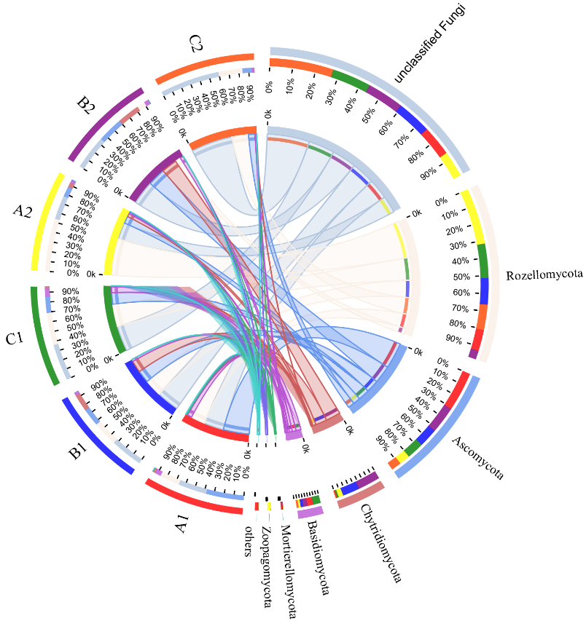
Fig. S1 Circos diagram of sediment fungal communities at the phylum level at each site.

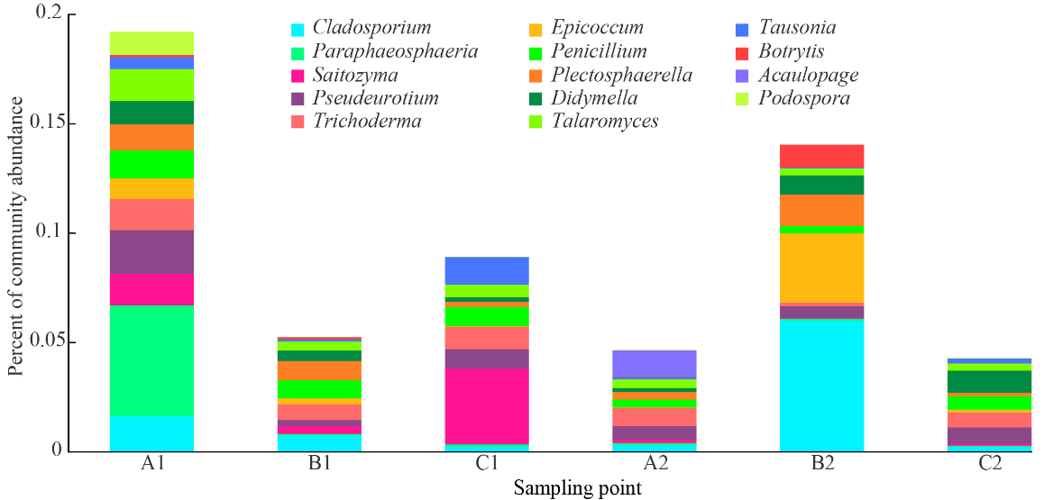
Fig. S2 Histogram of sediment fungal community structure at the genus level at each site.

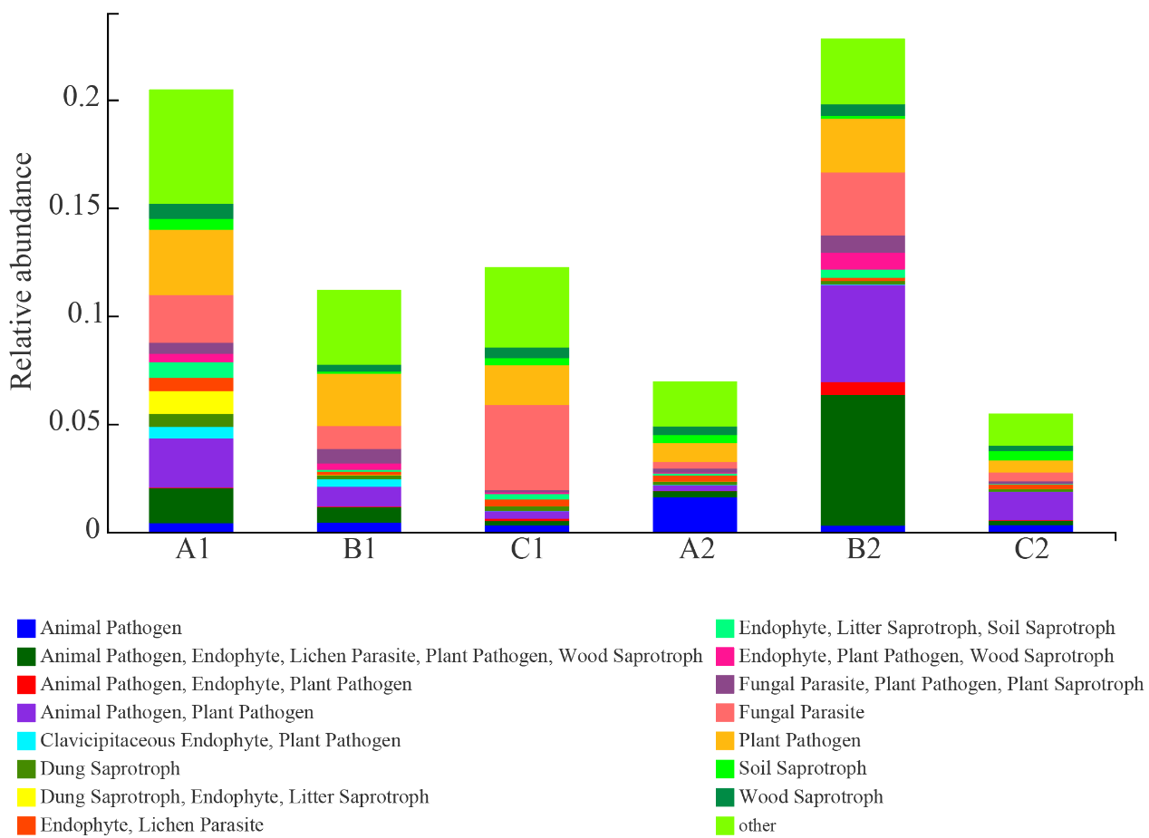
Fig. S3 Histogram of the utilization functions of sediment fungal communities at each site. The utilization function is expressed as the relative abundance of the fungal community with this function.

Table S1 Comparison of sediment physicochemical properties of sediments at different sampling sites. The data are the mean ± standard deviation values (n=3). Different lowercase letters denote significant differences between sampling sites at P < 0.05. The maximum values in each column are denoted by “a”.
site | pH | TC/g·kg⁻¹ | TN/g·kg⁻¹ | TP/mg·kg⁻¹ | TOC/g·kg⁻¹ | AN/mg·kg⁻¹ | C/N
A1 | 8.08±0.07b | 6.08±0.24c | 0.75±0.05b | 455.67±21.24c | 4.91±0.24c | 112.67±3.60a | 8.11±0.26c
B1 | 8.21±0.05a | 6.35±0.23c | 0.72±0.08b | 694.33±28.51a | 5.24±0.60c | 72.87±1.20b | 8.85±0.13c
C1 | 8.09±0.09b | 15.37±0.71a | 1.02±0.08a | 606.00±16.00b | 12.11±1.03a | 115.13±1.94a | 15.02±0.47a
A2 | 7.93±0.08b | 11.98±0.62b | 0.98±0.06a | 606.33±23.79b | 9.63±0.47b | 115.50±3.50a | 12.23±0.69b
B2 | 8.35±0.14a | 5.72±0.51c | 0.36±0.02d | 563.67±22.08b | 4.68±0.46c | 20.53±2.34d | 15.92±1.82a
C2 | 8.00±0.05b | 6.51±0.49c | 0.53±0.05c | 554.00±35.00b | 5.48±0.40c | 65.47±3.25c | 12.27±0.79b

Table S2 Correlation coefficients between sediment physicochemical properties and sediment fungal α-diversity indexes.
diversity index | pH | TC | TN | TP | SOC | AN | C/N
Ace | −0.595* | 0.382 | 0.525* | −0.406 | 0.372 | 0.682** | −0.233
Chao | −0.589* | 0.388 | 0.530* | −0.410 | 0.378 | 0.688** | −0.230
Shannon | 0.101 | 0.199 | 0.314 | −0.243 | 0.179 | 0.396 | −0.207
Simpson | −0.461 | 0.161 | 0.134 | 0.098 | 0.178 | 0.100 | 0.095
*P<0.05; **P<0.01

