12 Supplement
Supplementary Figure 1. Clinical scores and ASFV-G-ΔI177L detection in spare sows. (A) Time course of clinical scores in pre-immunized sows initially vaccinated before pregnancy and designated as spare animals for boost at day 40 (blue circles) or day 80 (blue squares) of gestation. The timing of euthanasia for sows #285 and #289 († d15) is indicated. (B) Time course of clinical scores in naïve sows vaccinated at day 40 (red circles) or day 80 (red squares) of gestation, including animals later used as spare animals (#196, #299) and animals reaching the HEP (#262, #288, #194, #226, #326, #332). The day of euthanasia for each sow is indicated († d97–d147). (C) ASFV genome loads in blood and selected organs from spare animals (#285, #289, #196, #299) at necropsy, shown as genome copies per mg tissue or ml blood scale. Open circles and squares distinguish spare animals according to vaccination time point. N.d., not detected. (D) Semi-quantitative scores of infectious ASFV detected by HAT in mandibular lymph nodes (mandLN), gastrohepatic lymph nodes (ghLN), spleen, lung, uterus, and salivary gland from pre-immunized spare sows (#285, #289). Scores range from 2 to 8, with the scale shown in the color bar; white boxes with an “X” denote tissues not sampled.

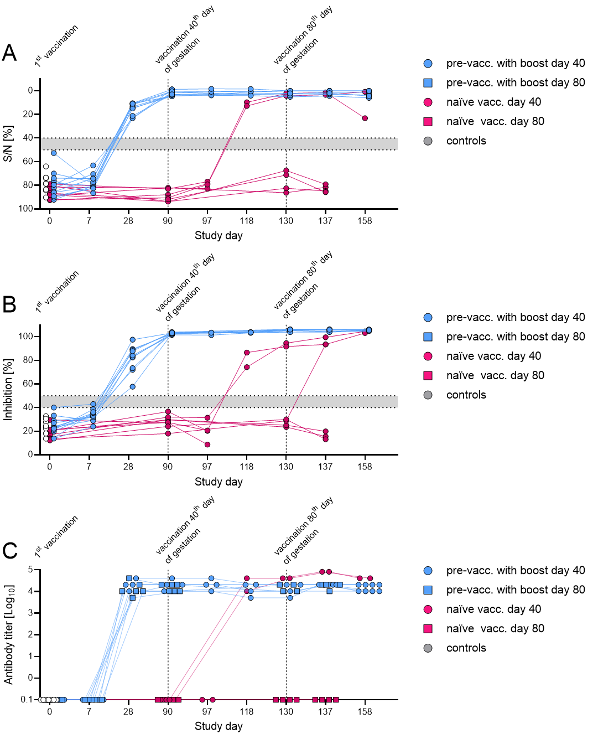
Supplementary Figure 2. ASFV-specific antibody kinetics in sows after vaccination before and during gestation. (A) ASFV-p32-specific antibodies measured by blocking ELISA, expressed as sample-to-negative ratio (S/N, %), in pre-immunized sows boosted at day 40 (blue circles) or day 80 (blue squares) of gestation, naïve sows vaccinated for the first time at day 40 (red circles) or day 80 (red squares) of gestation, and unvaccinated controls (grey circles). Individual animals are shown over time from initial vaccination through gestational vaccination and up to the end of the study. (B) ASFV-p72-specific antibodies measured by competitive ELISA, expressed as percent inhibition (% inhibition), in the same groups of sows over time. (C) ASFV-specific, semi-quantitative antibody titers measured by IPT, in pre-immunized and naïve sows and controls over the course of the study. Horizontal dashed lines indicate the assay cut-off range. Results above the grey area were considered positive.

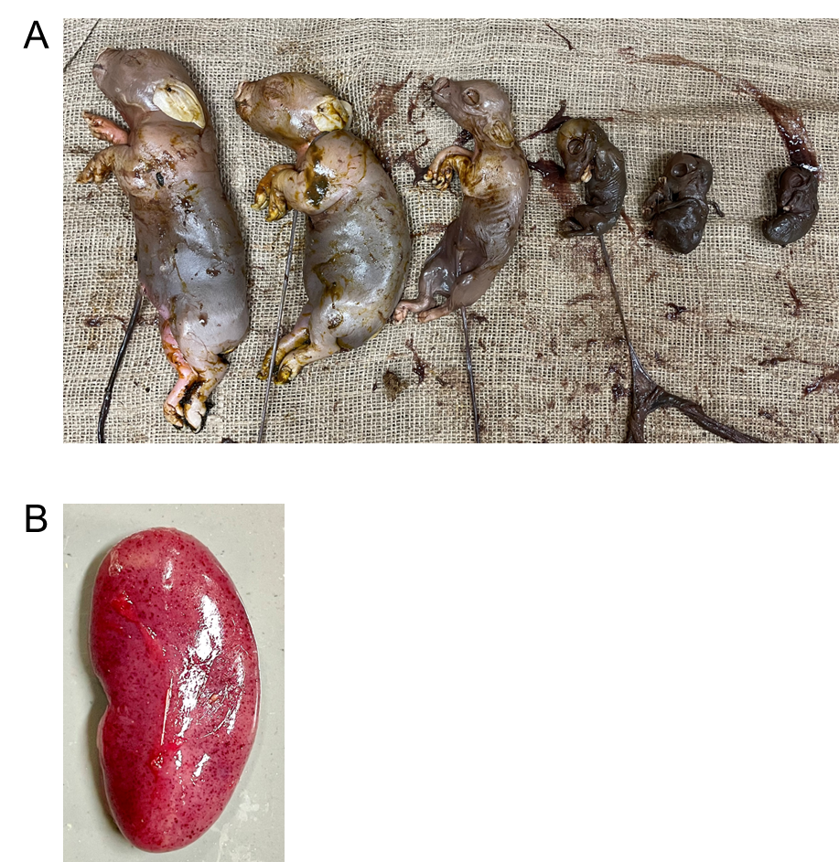
Supplementary Figure 3. Representative images of offspring of sow #203. (A) The sow gave birth to n = 5 mummified fetuses and n = 6 stillborn, partially decomposed piglets. Three representative individuals are shown. (B) Petechiae in the kidney of a piglet, which was born alive, but had to be euthanized on the 3rd day of life.

 | Study day → | 0 | 7 | 15 | 49 | 50 | 51 | 52 | 53 | 85 | 90 | 97 | 104 | 117 | 130 | 137 | 144 | 145 | 147 | 158 | 164 | 165 | 166 | 167 | 168 | 169 | 178 | 198
 | Gestation → | no |  |  | yes |  |  |  |  |  |  |  |  |  |  |  |  |  |  |  |  |  |  |  |  |  | no
Group | Sow ID ↓
G2. prevacc.  with boost day 40 | 246 | I |  |  |  |  |  |  |  |  | I |  |  |  |  |  |  |  |  |  | F
G2. prevacc.  with boost day 40 | 268 | I |  |  |  |  |  |  |  |  | I |  |  |  |  |  |  |  |  |  |  |  | F
G2. prevacc.  with boost day 40 | 269 | I |  |  |  |  |  |  |  |  | I |  |  |  |  |  |  |  |  |  |  |  |  |  | F
G2. prevacc.  with boost day 40 | 280 | I |  |  |  |  |  |  |  |  | I |  |  |  |  |  |  |  |  |  |  |  |  | F
G2. prevacc.  with boost day 40 | 285 (spare animal) | I |  | E (HEP)
G2. prevacc.  with boost day 40 | 289 (spare animal) | I |  | E (HEP)
G3. prevacc.  with boost day 80 | 196 (spare animal) | I |  |  |  |  |  |  |  |  |  |  | E (spare)
G3. prevacc.  with boost day 80 | 275 | I |  |  |  |  |  |  |  |  |  |  |  |  | I |  |  |  |  |  |  |  | F
G3. prevacc.  with boost day 80 | 291 | I |  |  |  |  |  |  |  |  |  |  |  |  | I |  |  |  |  |  |  |  |  | F
G3. prevacc.  with boost day 80 | 299 (spare animal) | I |  |  |  |  |  |  |  |  |  |  | E (spare)
G3. prevacc.  with boost day 80 | 312 | I |  |  |  |  |  |  |  |  |  |  |  |  | I |  |  |  |  |  |  |  |  | F
G3. prevacc.  with boost day 80 | 324 | I |  |  |  |  |  |  |  |  |  |  |  |  | I |  |  |  |  |  |  |  |  | F
G2. naïve  vacc. day 40 | 203 |  |  |  |  |  |  |  |  |  | I |  |  |  |  |  |  |  |  |  |  |  |  |  |  | F
G2. naïve  vacc. day 40 | 262 |  |  |  |  |  |  |  |  |  | I | E (abort)
G2. naïve  vacc. day 40 | 288 |  |  |  |  |  |  |  |  |  | I |  | E (HEP)
G2. naïve  vacc. day 40 | 314 |  |  |  |  |  |  |  |  |  | I |  |  |  |  |  |  |  |  |  |  |  | F
G3. naïve  vacc. day 80 | 194 |  |  |  |  |  |  |  |  |  |  |  |  |  | I |  |  |  | E (HEP)
G3. naïve  vacc. day 80 | 226 |  |  |  |  |  |  |  |  |  |  |  |  |  | I |  |  |  | E (HEP)
G3. naïve  vacc. day 80 | 326 |  |  |  |  |  |  |  |  |  |  |  |  |  | I |  |  | E (HEP)
G3. naïve  vacc. day 80 | 332 |  |  |  |  |  |  |  |  |  |  |  |  |  | I |  |  |  | E (HEP)
G1.  controls | 257 |  |  |  |  |  |  |  |  |  |  |  |  |  |  |  |  |  |  |  | F
G1.  controls | 264 |  |  |  |  |  |  |  |  |  |  |  |  |  |  |  |  |  |  |  |  | F
G1.  controls | 278 |  |  |  |  |  |  |  |  |  |  |  |  |  |  |  |  |  |  |  |  |  | F |  |  |  | dead
G1.  controls | 287 |  |  |  |  |  |  |  |  |  |  |  |  |  |  |  |  |  |  |  |  |  | F
G1.  controls | 284 |  |  |  |  |  |  |  |  |  |  |  |  |  |  |  |  |  |  |  |  |  |  |  | F
G1.  controls | 293 |  |  |  |  |  |  |  |  |  |  |  |  |  |  |  |  |  |  |  |  | F
G1.  controls | 300 |  |  |  |  |  |  |  |  | E (n.p.)
G1.  controls | 301 |  |  |  |  |  |  |  |  | E (n.p.)
G1.  controls | 321 (spare animal) |  |  |  |  |  |  |  |  | E (abort)
G1.  controls | 317 (spare animal) |  |  |  |  |  |  |  |  | E (n.p.)
Supplementary Table 1. Detailed overview of immunizations, euthanasia, and farrowing of each individual sow over the course of the study.
Legend: I = Immunization, E = Euthanasia, HEP = humane endpoint, F = farrowing, n.p. = not pregnant
Supplementary Table 2. IPT results of stillborn piglets and piglets that died/had to be euthanized before the 7th day of life.
Group |  | Offspring ID
Group | Sow ID | F1 | F2 | F3 | F4 | F5 | F6 | F7 | F8 | F9 | F10 | F11 | F12 | F13 | F14 | F15 | F16 | F17 | F18
G3. prevacc. with boost day 80 | 275 | 2560 | 2560 | neg | neg | neg | neg
G3. prevacc. with boost day 80 | 291 | neg | neg | neg | neg | neg | neg | neg | neg | neg | neg
G2. naïve  vacc. day 40 | 203 | 10240 | 5120 | 10240 | neg | neg | neg | neg | neg
G2. naïve  vacc. day 40 | 314 | 40960 | 20480 | 5120 | 5120 | neg | neg
G3. naïve  vacc. day 80 | 194 | neg | neg | neg | neg | neg | neg | neg | neg | neg | neg | neg | neg | neg | neg | neg
G3. naïve  vacc. day 80 | 226 | neg | neg | neg | neg | neg | neg | neg | neg | neg | neg | neg | neg | neg | neg | neg | neg | neg | neg
G3. naïve  vacc. day 80 | 326 | neg | neg | neg | neg | neg | neg | neg | neg | neg | neg | neg | neg | neg
G3. naïve  vacc. day 80 | 332 | neg | neg | neg | neg | neg | neg | neg | neg | neg | neg | neg | neg | neg | neg | neg | neg | neg
Legend: neg = negative result, numbers indicate last plasma dilution with positive result, blue cells indicate

