Supplementary File 2
Figure S1 — Participant flow
Manuscript: “Timing of antenatal care initiation, contact frequency, and adverse maternal and perinatal outcomes at a district hospital in Zanzibar, Tanzania: an analytical cross-sectional study.”
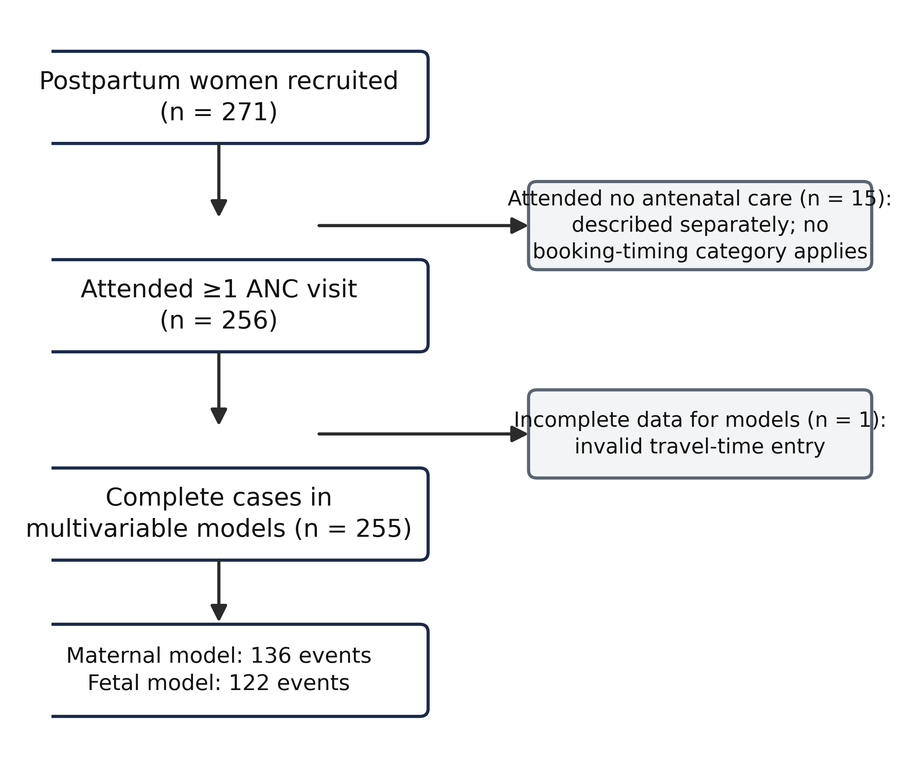
Figure S1. Participant flow. Of 271 postpartum women recruited consecutively, 256 had attended at least one antenatal care visit and were included in the analyses of booking timing and contact frequency; 15 women who attended no antenatal care are described separately. Complete data for the multivariable models were available for 255 women.

