Supplementary material
Covalent versus noncovalent chlorogenic acid binding: Divergent effects on the gastrointestinal fate and allergenic potential of soybean 7S globulin

Penghui Zhangª, Ze Yunª, Jiahao Li^{a,b}, Xin Yuanª, Jingwen Maª, Lingjun Ma^{a,b}, Fang Chenª, Xiaosong Huª, Junfu Ji^{a,b*}
ª College of Food Science and Nutritional Engineering, National Engineering Research Center for Fruit and Vegetable Processing, China Agricultural University, Key Lab of Fruit and Vegetable Processing, Ministry of Agriculture and Rural Affairs, Beijing 100083, China
^{b} Sanya Institute, China Agricultural University, Sanya, Hainan, 572025, China

* Corresponding author:
Junfu Ji, Ph.D.
E-mail address: junfu.ji@cau.edu.cn
Table S1. Preparation protocol for electrolyte stock solutions (800 mL) of Simulated Gastric Fluid (SGF) and Simulated Intestinal Fluid (SIF).
Species | KCl | KH₂PO₄ | NaHCO₃ | NaCl | MgCl₂  (H₂O)₆ | (NH₄)₂CO₃ | HCl | H₂O
Level  (mol/L) | 0.5 | 0.5 | 1 | 2 | 0.15 | 0.5 | 6 | N/A
SGF  (μL) | 13800 | 1800 | 25000 | 23600 | 800 | 1000 | 2600 | 731400
SIF  (μL) | 13600 | 1600 | 85000 | 19200 | 2200 | N/A | 1400 | 677000
Note: CaCl₂ is not included in the electrolyte stock solution and will be added separately prior to the digestion experiment.
Table S2. Relative contents of secondary structures in soybean 7S globulin and chlorogenic acid–7S globulin complexes during simulated gastrointestinal digestion
Digestion stage | Sample | α-helix | β-sheet | β-turn | Random coil
Before  digestion | CK | 16.97% | 29.39% | 16.97% | 36.68%
Before  digestion | N-0.3 | 14.45% | 32.18% | 16.83% | 36.54%
Before  digestion | N-0.5 | 15.63% | 31.18% | 16.97% | 36.30%
Before  digestion | N-1 | 13.53% | 32.93% | 16.67% | 36.88%
Before  digestion | C-0.3 | 13.40% | 33.15% | 16.69% | 36.76%
Before  digestion | C-0.5 | 15.62% | 30.98% | 16.96% | 36.44%
Before  digestion | C-1 | 12.63% | 33.86% | 16.50% | 37.02%
After  gastric  digestion | CK | 13.65% | 33.79% | 16.98% | 35.58%
After  gastric  digestion | N-0.3 | 11.46% | 37.00% | 16.80% | 34.75%
After  gastric  digestion | N-0.5 | 12.18% | 35.66% | 16.73% | 35.43%
After  gastric  digestion | N-1 | 12.53% | 35.29% | 16.81% | 35.37%
After  gastric  digestion | C-0.3 | 11.85% | 36.17% | 16.76% | 35.31%
After  gastric  digestion | C-0.5 | 12.64% | 35.06% | 16.85% | 35.45%
After  gastric  digestion | C-1 | 12.98% | 34.78% | 16.91% | 35.34%
After  intestinal  digestion | CK | 11.81% | 35.90% | 16.63% | 35.74%
After  intestinal  digestion | N-0.3 | 11.20% | 36.96% | 16.64% | 35.20%
After  intestinal  digestion | N-0.5 | 11.38% | 36.46% | 16.62% | 35.62%
After  intestinal  digestion | N-1 | 11.38% | 36.36% | 16.60% | 35.66%
After  intestinal  digestion | C-0.3 | 11.19% | 36.78% | 16.55% | 35.40%
After  intestinal  digestion | C-0.5 | 11.60% | 36.27% | 16.63% | 35.50%
After  intestinal  digestion | C-1 | 11.51% | 36.29% | 16.60% | 35.60%

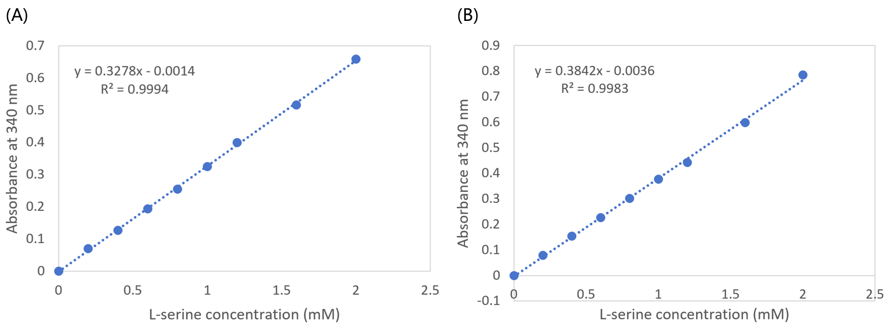
Fig. S1. L-serine calibration curves used for the determination of free amino groups during in vitro gastrointestinal digestion. (A) Calibration curve for gastric digestion samples. (B) Calibration curve for intestinal digestion samples.

