Table 1 List of Variables
Variable | Abbreviations | Type of Variable | References
Handicraft Purchase Intention | HPI | DV | [1], [2]
Attitude | AT | IV | [3], [4]
Cultural Identity | CI | IV | [5]
Subjective Norm | SN | IV | [6], [5]
Motivation | MT | IV | [7]
Impulse Buying tendency | IBT | IV | [8], [9]
Destination Identity | DI | IV | [10]
Source: Literature Review

Table 2 Demographic Characteristics of the Data
Variable | Categories | Frequency | Percentage
Gender | Female | 338 | 67.6
Gender | Male | 162 | 32.4
Age | Below 20 Years | 42 | 8.4
Age | 21-35 | 209 | 41.8
Age | 36-50 | 183 | 36.6
Age | 51 and above | 66 | 13.2
Education | High School | 3 | 0.6
Education | Graduate | 127 | 25.4
Education | Postgraduate | 190 | 38.0
Education | PHD | 106 | 21.2
Education | others | 74 | 14.8
Status | Tourists | 397 | 79.4
Status | Jaipur Residents | 103 | 20.6
Occupation | Salaried | 358 | 71.6
Occupation | Business | 27 | 5.4
Occupation | Student | 106 | 21.2
Occupation | Retired | 9 | 1.8
Income | 5 Lakhs and Below | 62 | 12.4
Income | 6-10 Lakhs | 55 | 11.0
Income | 11-15 Lakhs | 65 | 13.0
Income | 16 Lakhs and Above | 83 | 16.6
Income | Others | 78 | 15.6
Income | Housewife | 157 | 31.4
Income | Total | 500 | 100.0
Source: Fieldwork 2024-25
Table 3 Measurement Model Assessment
Constructs | Items | VIF | Indicator Loadings | Cronbach's Alpha | Composite Reliability (CR) (rho_a) | Composite Reliability (CR) (rho_c) | Average Variance Extracted (AVE)
Attitude (AT) | ﻿AT2 | 3.112 | 0.911 | 0.898 | 0.901 | 0.936 | 0.83
Attitude (AT) | AT3 | 3.279 | 0.924
Attitude (AT) | AT4 | 2.324 | 0.898
Cultural Identity (CI) | CI1 | 2.209 | 0.802 | 0.868 | 0.869 | 0.91 | 0.716
Cultural Identity (CI) | CI2 | 2.625 | 0.855
Cultural Identity (CI) | CI3 | 2.513 | 0.869
Cultural Identity (CI) | CI4 | 1.717 | 0.857
Destination Identity (DI) | DI2 | 2.089 | 0.881 | 0.882 | 0.89 | 0.919 | 0.74
Destination Identity (DI) | DI3 | 1.955 | 0.907
Destination Identity (DI) | DI4 | 1.386 | 0.786
Destination Identity (DI) | DI5 | 2.109 | 0.864
Handicrafts Purchase Intention (HPI) | HPI2 | 2.571 | 0.889 | 0.879 | 0.884 | 0.925 | 0.804
Handicrafts Purchase Intention (HPI) | HPI3 | 2.319 | 0.912
Handicrafts Purchase Intention (HPI) | HPI4 | 1.627 | 0.889
Impulse Buying Tendency (IBT) | IBT1 | 2.338 | 0.822 | 0.827 | 0.836 | 0.897 | 0.743
Impulse Buying Tendency (IBT) | IBT2 | 2.584 | 0.888
Impulse Buying Tendency (IBT) | IBT3 | 2.312 | 0.875
Motivation (MT) | MT1 | 2.842 | 0.758 | 0.84 | 0.844 | 0.892 | 0.675
Motivation (MT) | MT2 | 3.359 | 0.818
Motivation (MT) | MT3 | 1.825 | 0.858
Motivation (MT) | MT4 | 2.321 | 0.848
Subjective Norms (SN) | SN1 | 1.322 | 0.739 | 0.756 | 0.779 | 0.86 | 0.673
Subjective Norms (SN) | SN2 | 1.739 | 0.835
Subjective Norms (SN) | SN3 | 1.802 | 0.881
Source: Fieldwork 2024
Table 4 Discriminant Validity HTMT
 | AT | CI | DI | HPI | IBT | MT | SN
AT
CI | 0.839
DI | 0.547 | 0.677
HPI | 0.539 | 0.759 | 0.846
IBT | 0.492 | 0.68 | 0.74 | 0.67
MT | 0.484 | 0.724 | 0.686 | 0.609 | 0.883
SN | 0.731 | 0.799 | 0.769 | 0.807 | 0.81 | 0.861
should be <0.85 or <0.90
Source: Fieldwork 2024

Table 5 Path Coefficient Analysis
Hypothesis | Relationships | Original sample (O) | Sample mean (M) | Standard deviation (STDEV) | T statistics (|O/STDEV|) | P values | Hypothesis Results
H1 | AGE -> HPI | -0.047 | -0.046 | 0.04 | 1.182 | 0.237 | Rejected
H2 | GENDER -> HPI | 0.164 | 0.164 | 0.067 | 2.451 | 0.014 | Accepted
H3 | INCOME -> HPI | -0.104 | -0.103 | 0.038 | 2.754 | 0.006 | Accepted
H4 | CI -> AT | 0.786 | 0.785 | 0.034 | 23.062 | 0 | Accepted
H5 | CI -> MT | 0.116 | 0.116 | 0.059 | 1.949 | 0.051 | Accepted
H6 | DI -> IBT | 0.383 | 0.384 | 0.035 | 10.791 | 0 | Accepted
H7 | DI -> MT | 0.238 | 0.238 | 0.04 | 6.016 | 0 | Accepted
H8 | SN -> IBT | 0.402 | 0.401 | 0.036 | 11.222 | 0 | Accepted
H9 | SN -> MT | 0.457 | 0.457 | 0.056 | 8.105 | 0 | Accepted
H10 | IBT -> AT | 0.083 | 0.083 | 0.061 | 1.364 | 0.173 | Rejected
H11 | IBT -> HPI | 0.364 | 0.362 | 0.052 | 7.013 | 0 | Accepted
H12 | MT -> AT | -0.129 | -0.128 | 0.055 | 2.338 | 0.019 | Accepted
H13 | MT -> HPI | 0.107 | 0.108 | 0.052 | 2.04 | 0.041 | Accepted
H14 | AT -> HPI | 0.26 | 0.262 | 0.045 | 5.755 | 0 | Accepted
Source: Data Analysis using SMART PLS

Table 6 Coefficient of Determination (R²) and Predictive Power Q²
Endogenous Constructs | R-square | R-square adjusted | Q²
AT | 0.572 | 0.569 | 0.563
HPI | 0.407 | 0.404 | 0.534
IBT | 0.507 | 0.505 | 0.503
MT | 0.538 | 0.536 | 0.53
Source: Data Analysis using SMART PLS

Figure 1 Graphical Representation of Consumer Responses

Source: Field Survey

Figure 2 Measurement Model

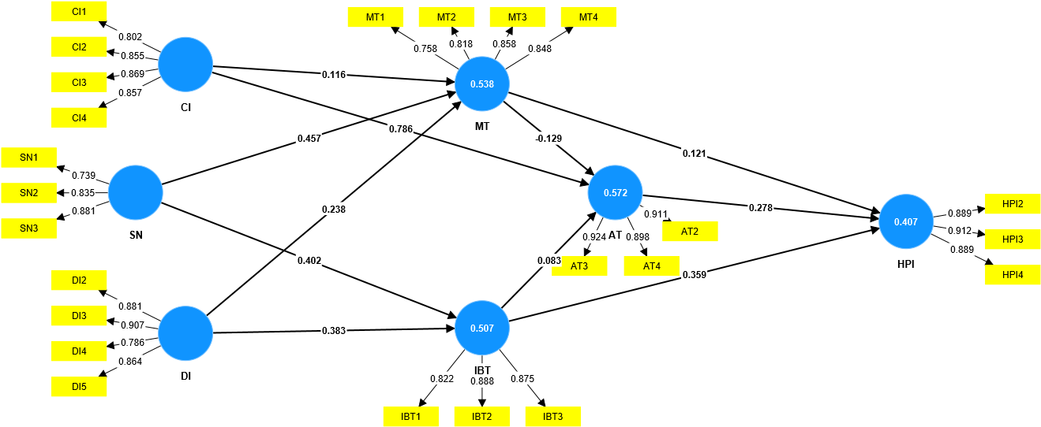
Source: Data Analysis using SMART PLS
Figure 3 Structural Model
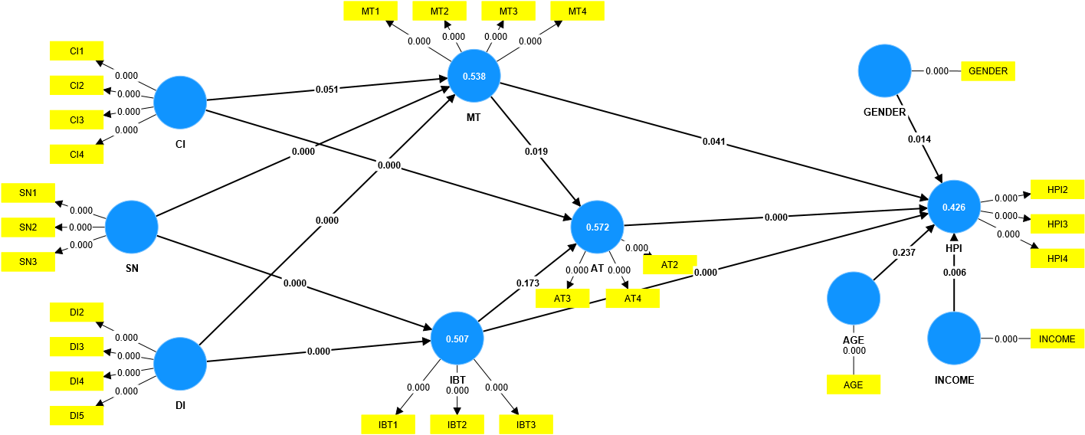
Source: Data Analysis using SMART PLS

