Visible-Light-Active Photosensitized TiO₂ Nanomaterials for Antimicrobial Photodynamic Inactivation: Interfacial Photochemistry and Iodide Potentiation

Paweł Repetowski^{1,2}, Konrad Miazga¹, Jakub M. Kwieciński ³ and Janusz M. Dąbrowski¹*
¹ Faculty of Chemistry, Jagiellonian University, 30-387 Kraków, Poland
² Doctoral School of Exact and Natural Sciences, Jagiellonian University, 30-348 Kraków, Poland
³Faculty of Biochemistry, Biophysics and Biotechnology, Jagiellonian University, Krakow, Poland
*Corresponding author e-mail addresses: jdabrows@chemia.uj.edu.pl

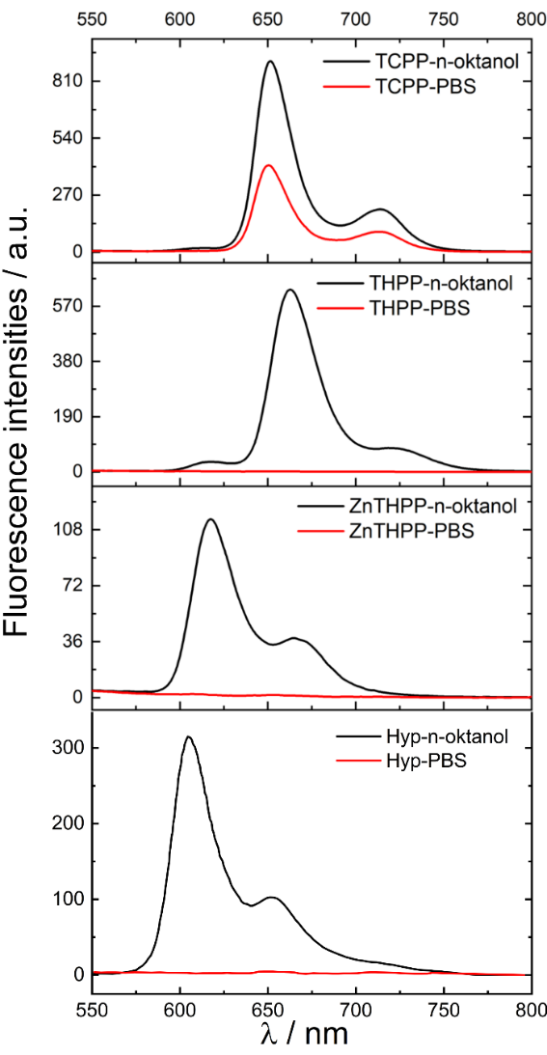
Figure S1 Fluorescence emission spectra of the free photosensitizers recorded in n-octanol and PBS during the n-octanol/PBS partition analysis.
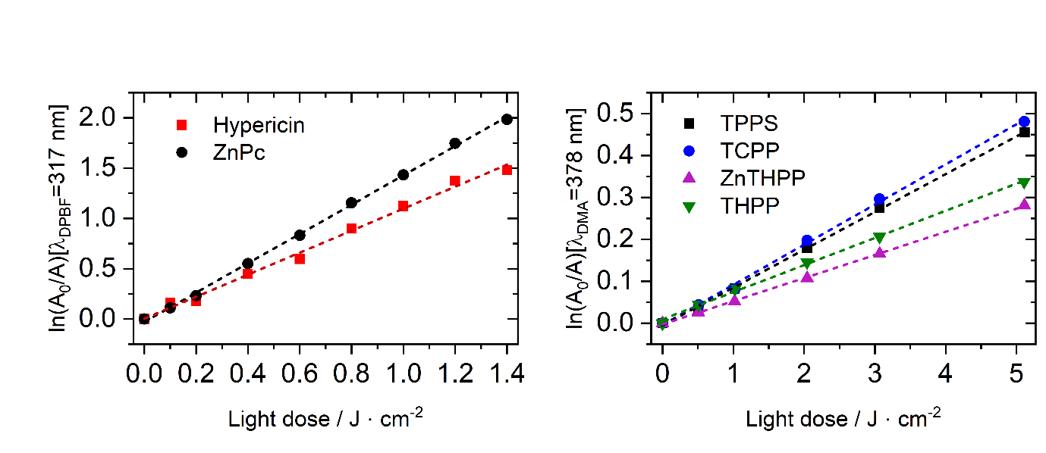
Figure S2 First-order kinetic plots used for determination of singlet oxygen quantum yields (Φ_{Δ}) of the free photosensitizers by DMA or DPBF photooxidation.

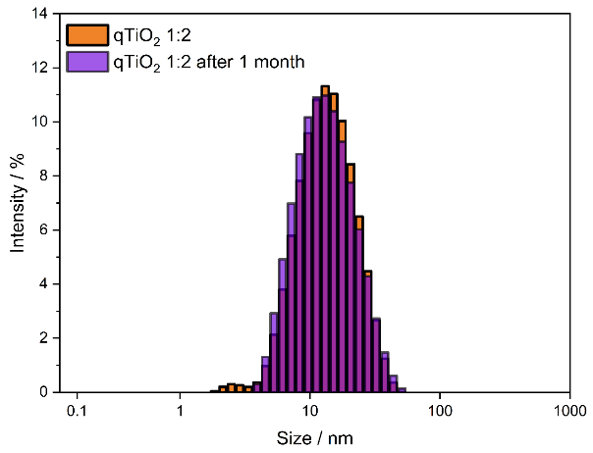
Figure S3 Dynamic light scattering (DLS) size distribution profiles of the optimized bare qTiO₂ colloidal dispersion immediately after synthesis (initial) and following one month of dark storage.

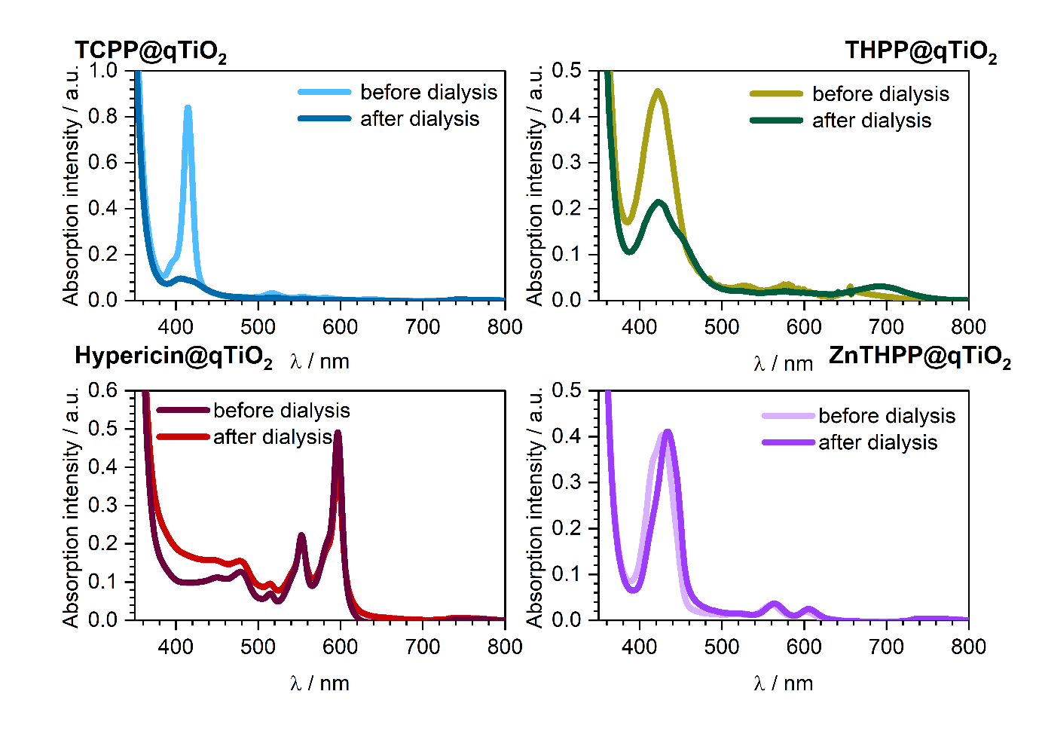
Figure S4 UV–Vis absorption spectra of the photosensitizer/qTiO₂ dispersions before and after dialysis, showing retention of the characteristic chromophore absorption bands following removal of low-molecular-weight components.

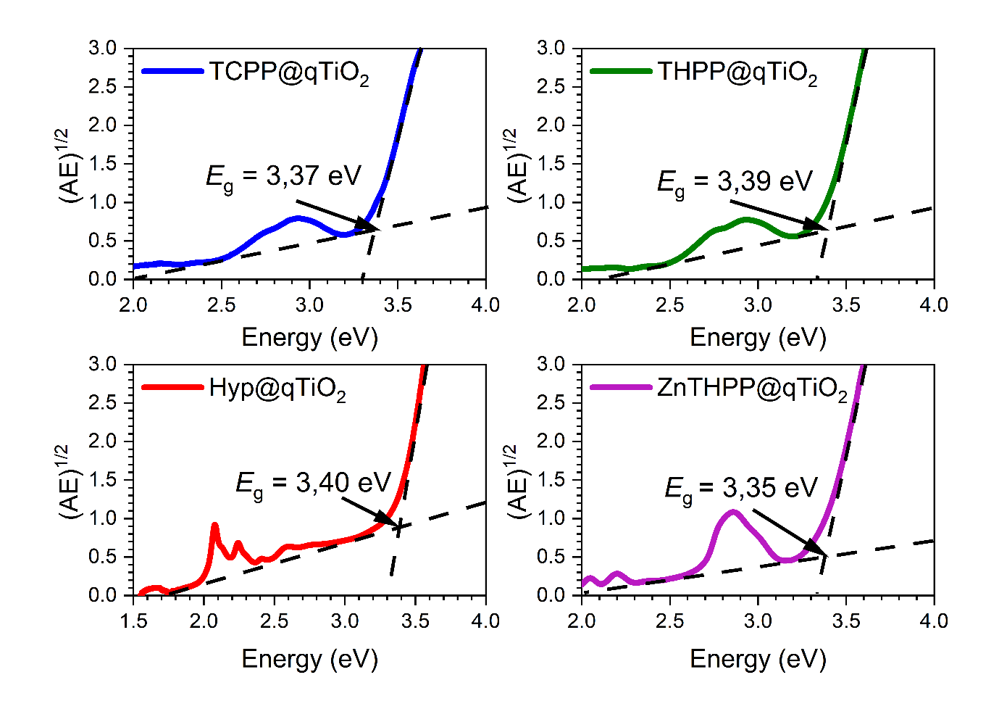
Figure S5 Tauc plots for the indirect band gap determination of the functionalized qTiO₂ nanomaterials (TCPP@qTiO₂, THPP@qTiO₂, ZnTHPP@qTiO₂, and Hyp@qTiO₂).

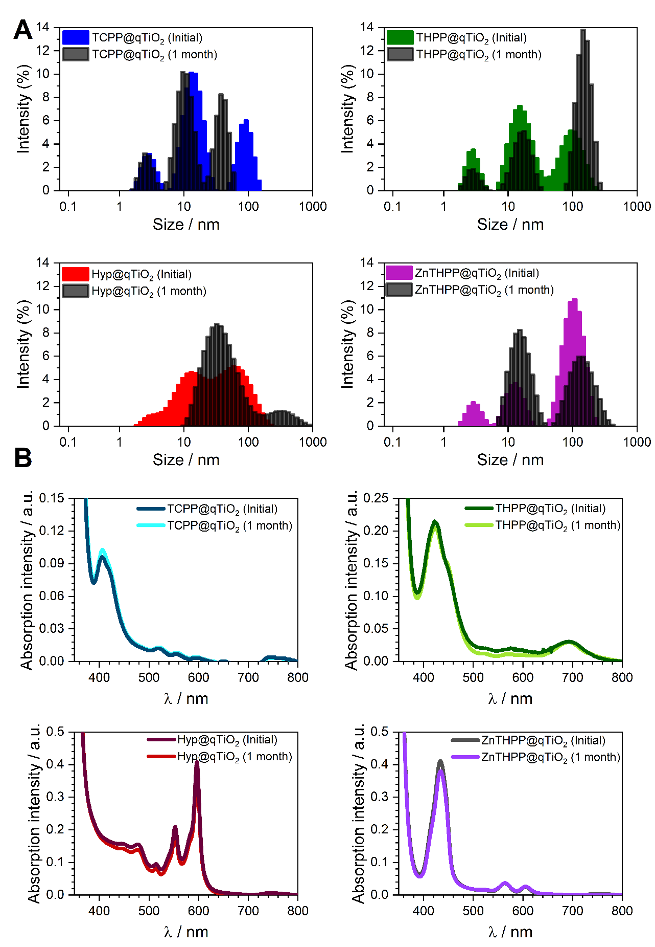
Figure S6 Long-term colloidal stability of the functionalized nanomaterials. (A) DLS size distribution profiles and (B) UV-Vis absorption spectra recorded immediately post-synthesis and after one month of storage in the dark.

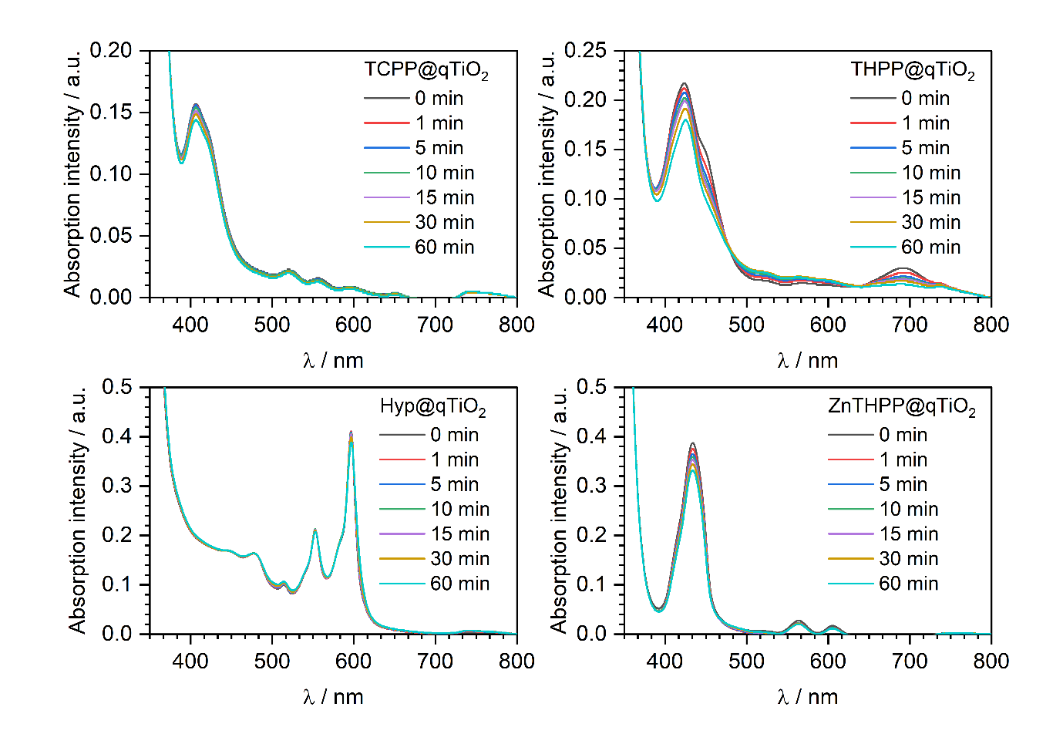
Figure S7 Photostability of the functionalized qTiO₂ materials during 60 min of visible-light irradiation.
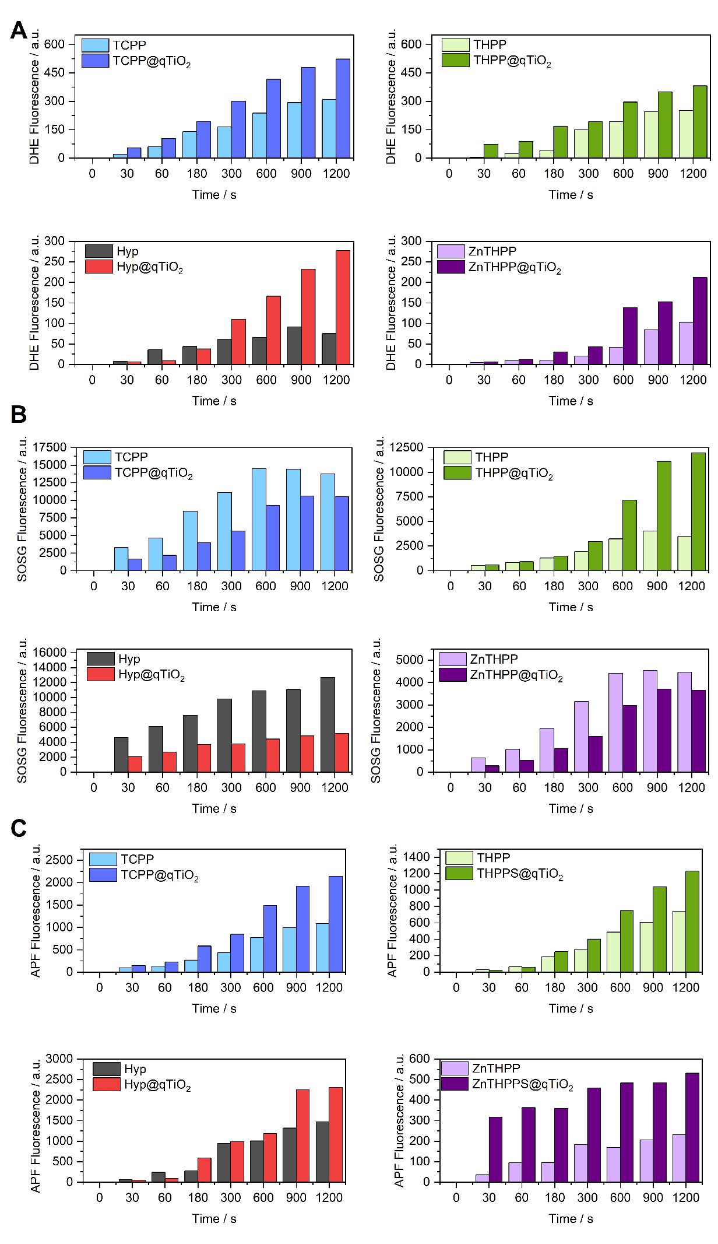
Figure S8 Time-dependent fluorescence signals of ROS-sensitive probes for the free photosensitizers and corresponding qTiO₂-functionalized materials: (A) DHE, (B) SOSG, and (C) APF.

