Supporting figures

INCLUDED HEALTH FACILITIES (148)
- Health facilities which registered in DHIS2
- Health facilities with trained staffs to report routine neonatal sepsis data
- Reported neonatal sepsis data least once during the study period

EXCLUDED HEALTH FACILITIES
(10) Health facilities were excluded due to
- -Incomplete data of >5%
- -No reported data at all
- Missing important variables

HEALTH FACILITIES IN FINAL ANALYSIS (138) Health facilities with complete data in DHIS2

Fig 1: Enrolment of the health facilities reporting neonatal sepsis data (study participants) from January, 2021 to December, 2025

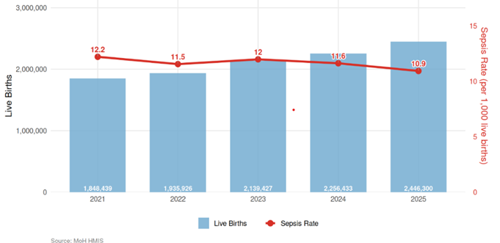
Fig 2: Tanzania mainland trends of neonatal sepsis rate per 1,000 live births from 2021 to 2025
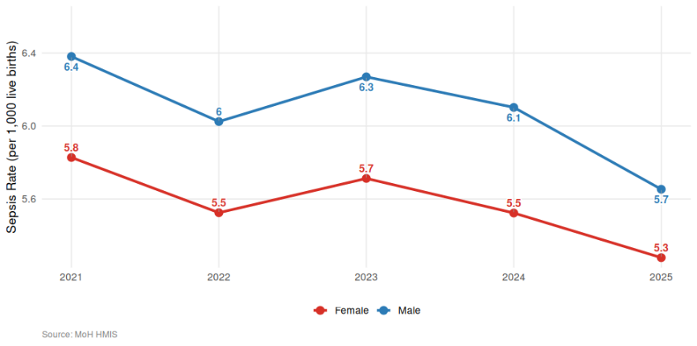
Fig 3: Tanzania mainland Neonatal sepsis rate per 1,000 live births trends by sex from 2021 to 2025

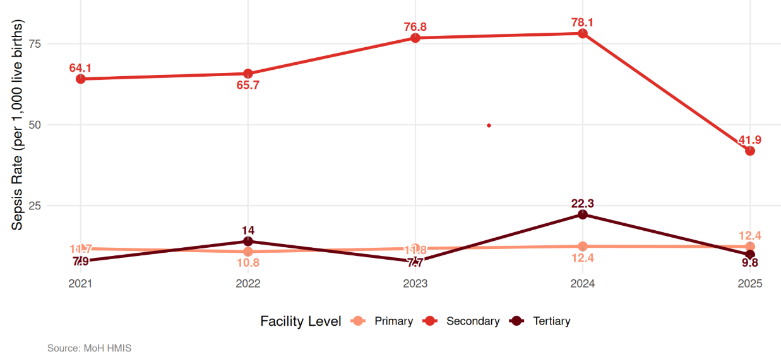
Fig4: Tanzania mainland neonatal sepsis rate trend per 1,000 live births by health facilities levels from 2021 t0 2025
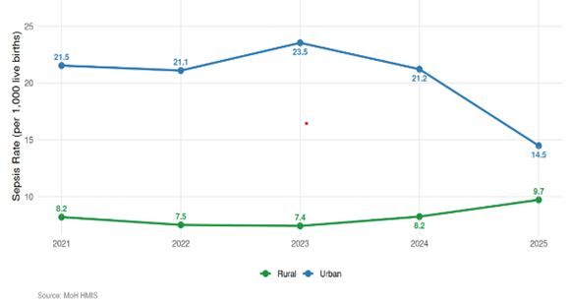
Fig 5: Tanzania mainland neonatal sepsis rate trend per 1,000 live births by locations from 2021 t0 2025

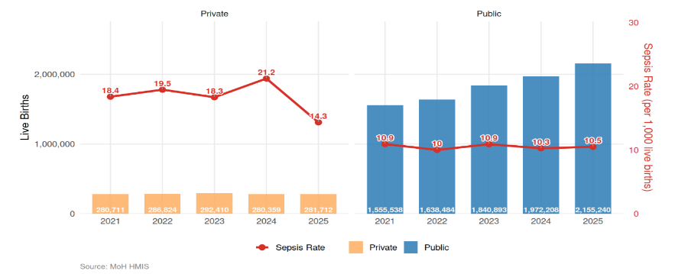
Fig 6: Tanzania mainland Neonatal sepsis rate per 1,000 live births trends by facilities' ownership from 2021 to 2025

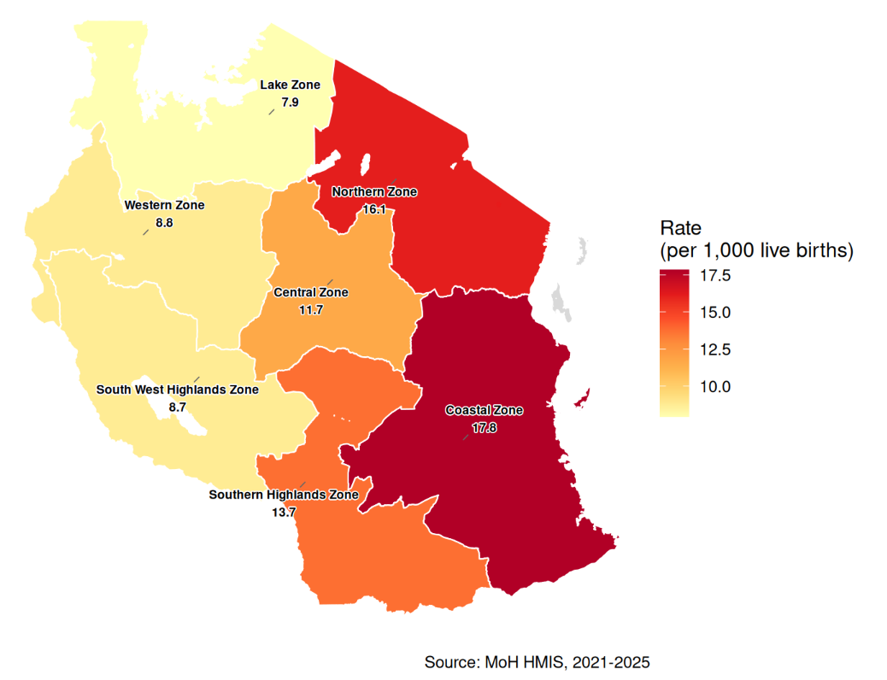
Fig 7: Tanzania mainland neonatal sepsis rate per 1,000 live births distribution by zones pooled 2021-2025

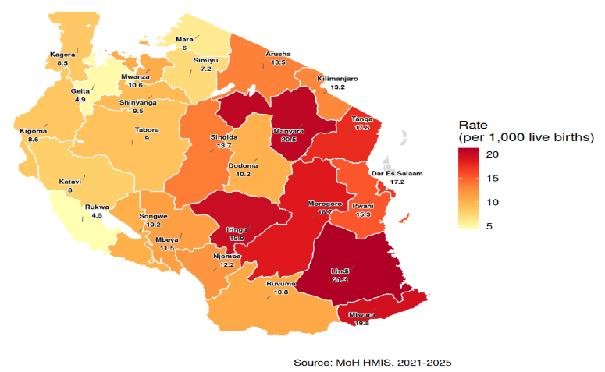
Fig 8: Tanzania mainland neonatal sepsis rate per 1,000 live births distribution by regions pooled 2021-2025

