Supplementary Materials

Supplementary Table S1. Interobserver agreement of preoperative CT assessments
CT variable | Assessment | N | Agreement statistic | kappa | 95% CI
Pulmonary artery relationship | Grade 0–3 | 101 | Weighted Cohen's kappa | 1.00 | 1.00–1.00
Bronchial relationship | Grade 0–2 | 100 | Weighted Cohen's kappa | 1.00 | 1.00–1.00
Fibrosis grade | Mild/moderate/severe | 101 | Weighted Cohen's kappa | 0.55 | 0.37–0.72

Supplementary Table S2. Conventional maximum-likelihood multivariable logistic regression sensitivity analysis for conversion to thoracotomy.
Variable | N | OR | 95% CI | P value
cT3-4 | 100 | 51.82 | 10.10-265.89 | <0.001
Pulmonary artery grade (per level) | 100 | 2.18 | 1.12-4.24 | 0.022
Bronchial grade (per level) | 100 | 3.70 | 1.45-9.43 | 0.006
Fibrosis grade (per level) | 100 | 0.57 | 0.22-1.46 | 0.243

The model included the same four prespecified covariates as the principal Firth penalized logistic regression model.

Supplementary Figure S1. Representative CT examples of pulmonary artery relationship grades 0–3.
Representative anonymized preoperative CT images illustrating pulmonary artery relationship grades 0–3 according to the study-specific semiquantitative anatomical grading criteria.

Supplementary Figure S2. Representative CT examples of bronchial relationship grades 0–2.
Representative anonymized preoperative CT images illustrating bronchial relationship grades 0–2 according to the study-specific semiquantitative anatomical grading criteria.

Supplementary Figures
Supplementary Figure S1. Representative CT examples of pulmonary artery relationship grades 0-3.
Supplementary Figure S2. Representative CT examples of bronchial relationship grades 0-2.
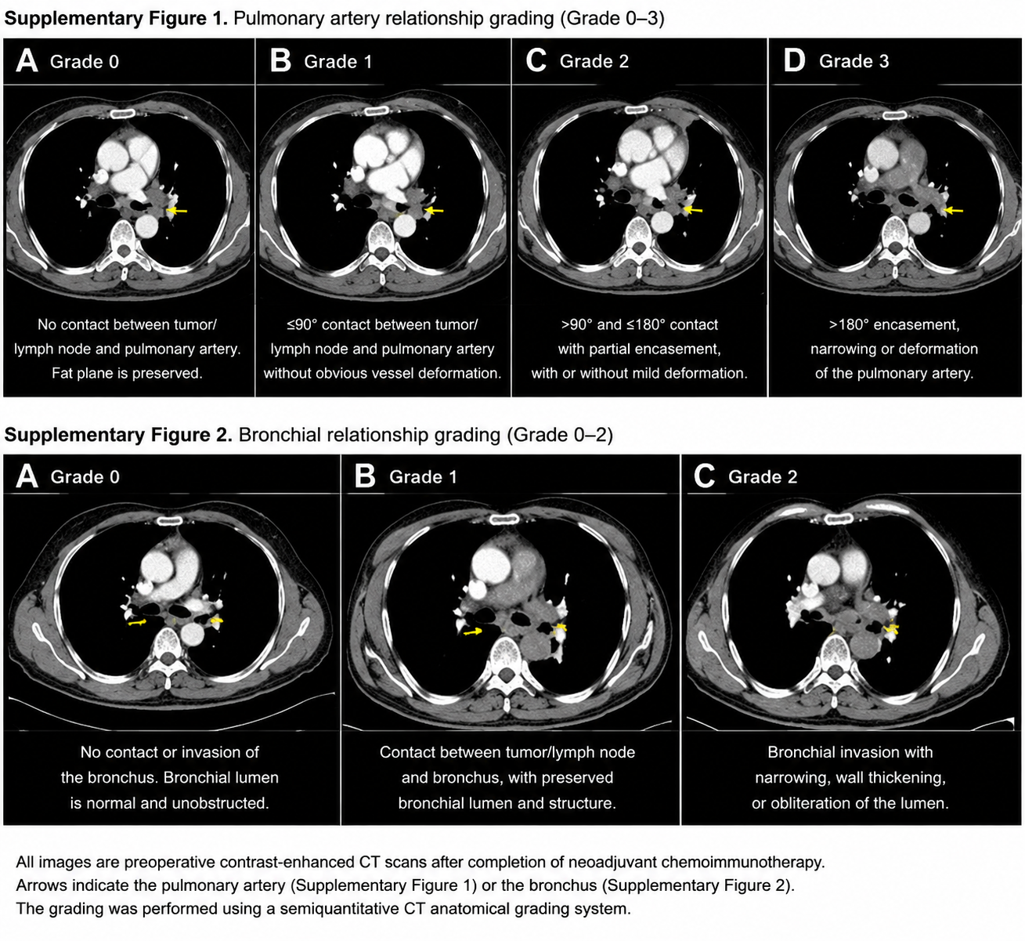
Supplementary Figure S3. Exploratory apparent ROC analysis of factors associated with conversion to thoracotomy.
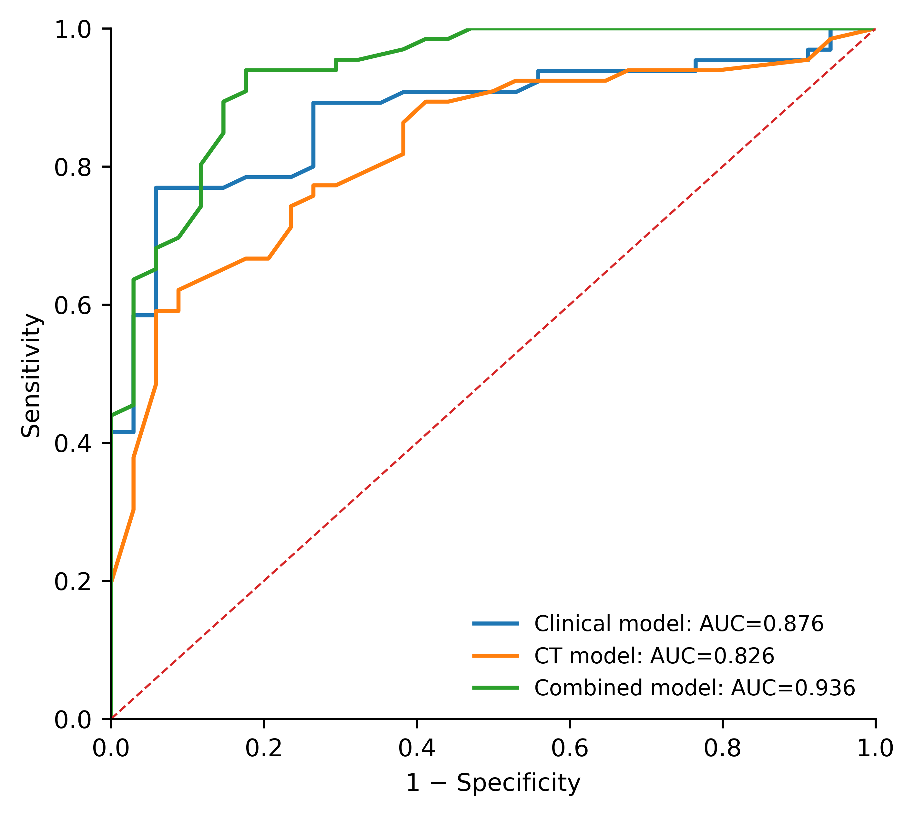
Supplementary Figure S4. Operative time according to conversion status.
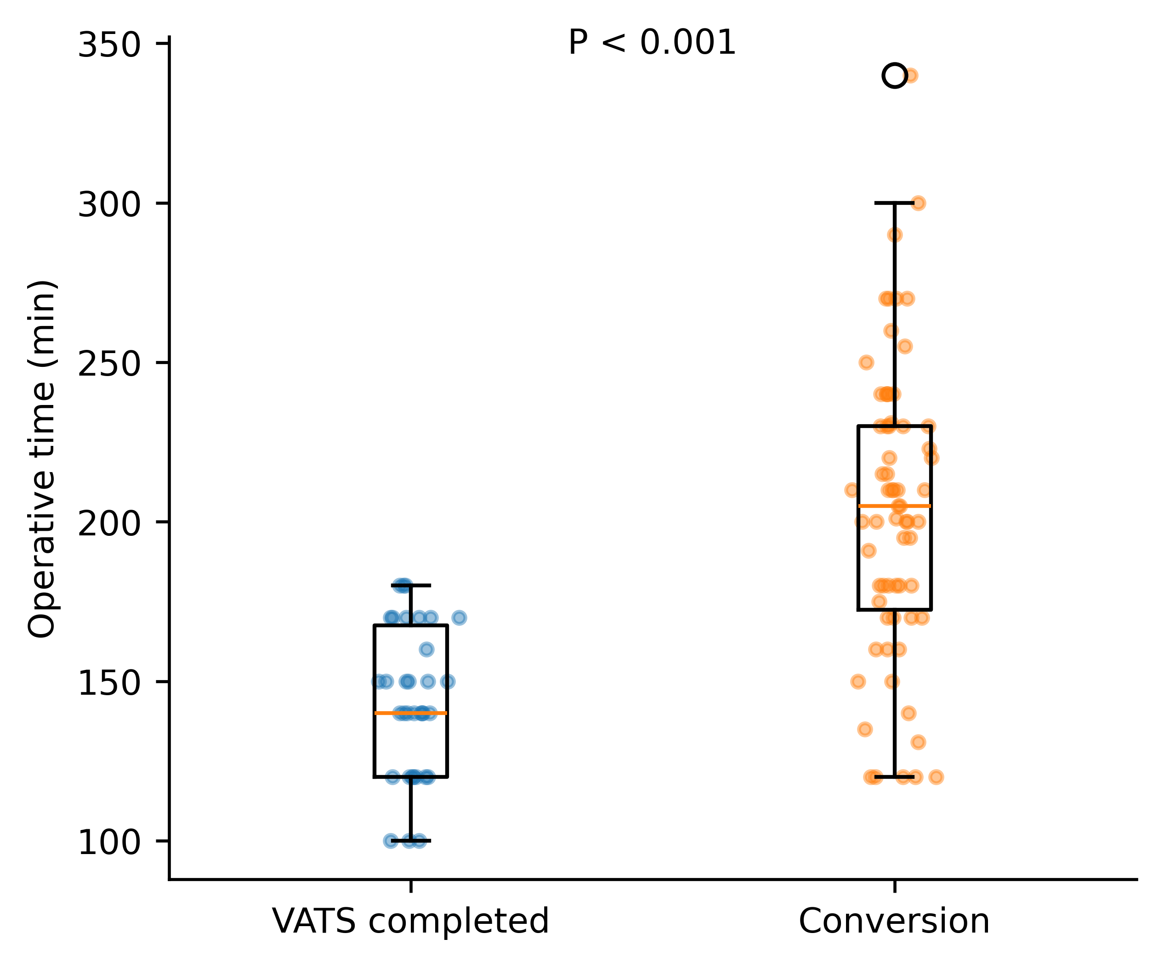
Supplementary Figure S5. Intraoperative blood loss according to conversion status.
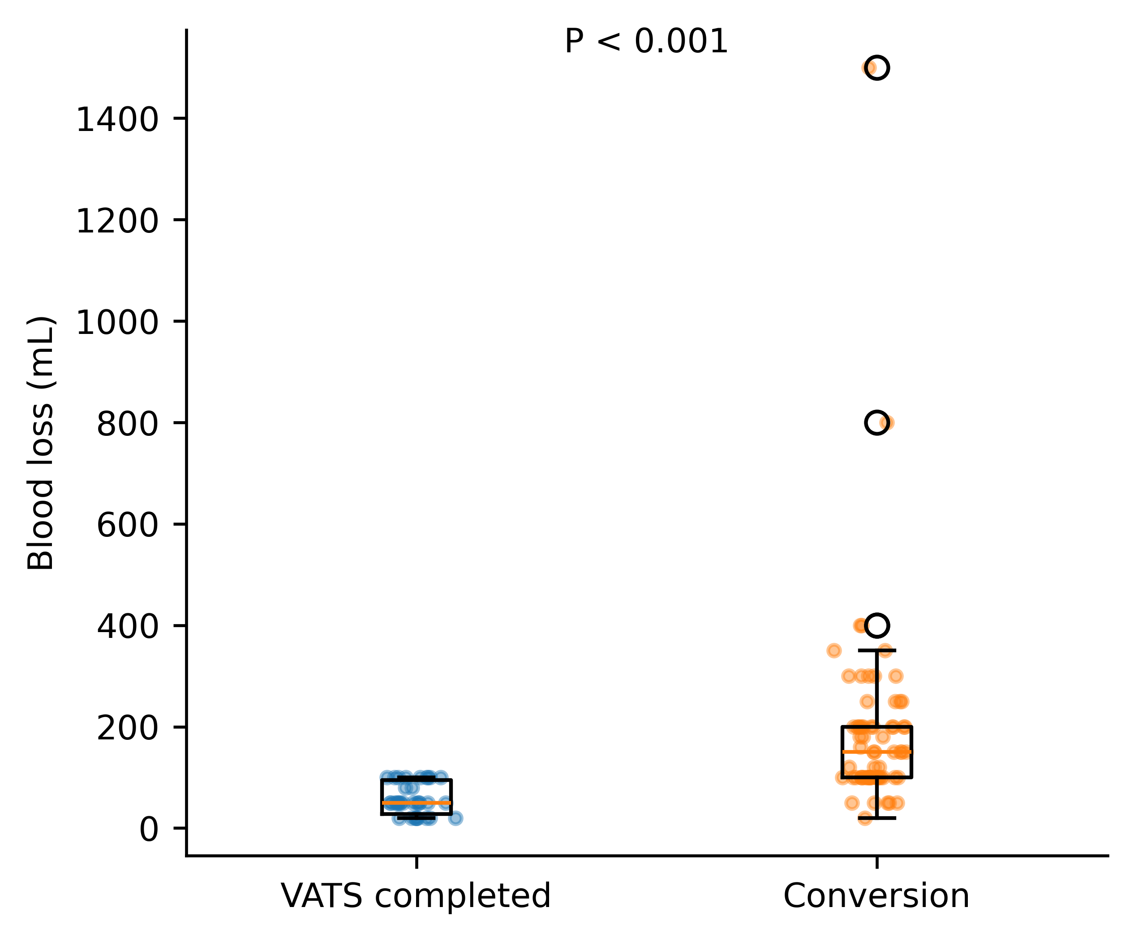
Supplementary Figure S6. Exploratory apparent calibration analysis of the combined model.
