Beyond keratinases: Oxidoreductase-Mediated Pathways Underlying Feather Degradation Mechanism by Streptomyces sp. G11C
Valentina González^{1,2,3,4}, Néstor Serna-Cardona^{1,2,3,4}, María José Vargas-Straube², Agustina Undabarrena^{2,3}, Roger Karlsson⁵, Leonarda Alarcon⁵, Michael Seeger^{2,3,4} and Beatriz Cámara^{2,3,4}*

Supplementary Figures
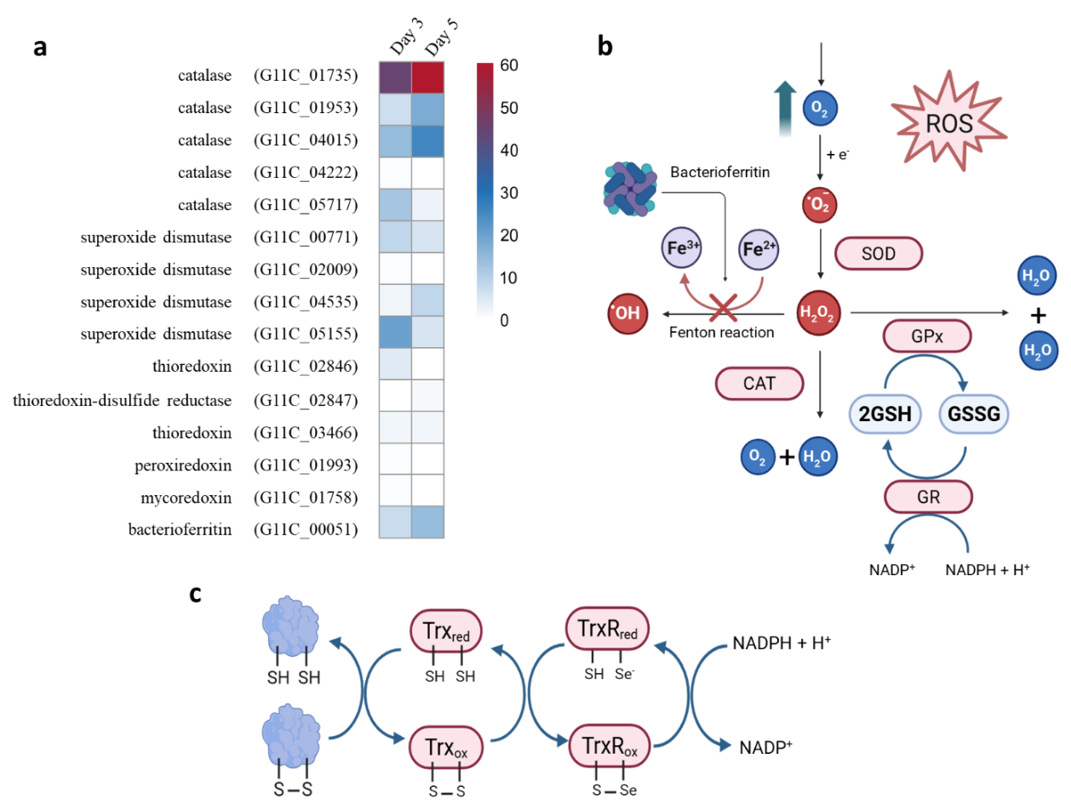

Figure S1. Antioxidant and ROS defense mechanisms potentially involved in feather degradation by Streptomyces sp. G11C. (a) Heatmap showing the relative abundance of proteins (PSMs) associated with oxidative stress response and redox homeostasis across the analyzed conditions. Color intensity reflects normalized spectral counts, with red indicating higher abundance and blue indicating lower abundance. (b) Schematic representation of reactive oxygen species (ROS) generation and detoxification pathways. Superoxide (O₂⁻) is converted to hydrogen peroxide (H₂O₂) by superoxide dismutase (SOD), which is further detoxified to water by catalase (CAT) or glutathione peroxidase (GPx). The glutathione cycle is sustained by glutathione reductase (GR), regenerating reduced glutathione (GSH) from oxidized glutathione (GSSG) using NADPH. Additionally, bacterioferritin is depicted as a key component in iron sequestration, limiting Fe²⁺ availability and thereby preventing Fenton-type reactions that generate highly reactive hydroxyl radicals (•OH). (c) Proposed role of the thioredoxin system as an alternative antioxidant and reductive pathway. Reduced thioredoxin (Trx_red) catalyzes the reduction of disulfide bonds (S–S) in substrate proteins, becoming oxidized (Trx_ox), and is subsequently regenerated by thioredoxin reductase (TrxR) using NADPH. This system contributes to redox homeostasis and may facilitate keratin destabilization by targeting disulfide bonds.

Supplementary Tables

Table S1. Raw data of proteins identified in each sample from the proteomic analysis (XLSX file)

Table S2. TerD family proteins from Streptomyces coelicolor A3(2) used for phylogenetic analysis
Gene ID | Accession Number (Sanssouci et al., 2011) | NCBI Reference Sequence | Length  (amino acids)
Tdd1 | NP_733509 | WP_003978221.1 | 191
Tdd2 | NP_625316 | WP_011027524.1 | 440
Tdd3 | NP_626169 | WP_011028040.1 | 399
Tdd4 | NP_626228 | WP_011028068.1 | 671
Tdd5 | NP_626229 | WP_003976854.1 | 192
Tdd6 | NP_626611 | WP_003976440.1 | 331
Tdd7 | NP_626614 | WP_003976437.1 | 191
Tdd8 | NP_626615 | WP_003976436.1 | 191
Tdd9 | NP_626877 | WP_011028473.1 | 395
Tdd10 | NP_627918 | WP_003975213.1 | 194
Tdd11 | NP_627953 | WP_011029219.1 | 694
Tdd12 | NP_628123 | WP_011029326.1 | 482
Tdd13 | NP_628449 | WP_003974698.1 | 191
Tdd14 | NP_629343 | WP_011030110.1 | 584
Tdd15 | NP_629930 | WP_011030468.1 | 202
Tdd16 | NP_630413 | WP_011030820.1 | 190
Tdd17 | NP_631349 | WP_011031571.1 | 434

Table S3. Most abundant proteins detected in the proteomic analysis of Streptomyces sp. G11C grown on feathers.
Protein ID | Protein annotation | MW (kDa) | Predicted cellular localization | COG category¹ | Mean Peptide-spectrum matches (PSMs)²
 |  |  |  |  | D3 - Cell | D3 - SN | D5 - Cell | D5 - SN | Total PSMs
G11C_03013 | S8 family peptidase | 53.4 | Extracellular | O | 18 | 72 | 19 | 453 | 561
G11C_05151 | S8 family serine peptidase | 115.3 | Extracellular | O | 69 | 70 | 59 | 53 | 250
G11C_03178 | molecular chaperone DnaK | 66.7 | Cytoplasmic | O | 7 | 114 | 5 | 106 | 232
G11C_00779 | family 2B encapsulin nanocompartment shell protein | 51.7 | Cytoplasmic | T | 54 | 73 | 20 | 34 | 180
G11C_02936 | immune inhibitor A | 87.9 | Extracellular | M | 43 | 25 | 41 | 44 | 153
G11C_04958 | dihydrolipoyl dehydrogenase | 48.9 | Cytoplasmic | C | 5 | 50 | 9 | 72 | 135
G11C_01510 | S1 family peptidase | 30.1 | Extracellular | O | 6 | 7 | 17 | 99 | 129
G11C_01828 | TerD family protein | 20.2 | Cytoplasmic | T | 6 | 86 | 3 | 25 | 119
G11C_03026 | ABC transporter substrate-binding protein | 59.9 | Cellwall | E | 37 | 41 | 15 | 16 | 107
G11C_01735 | catalase | 53.8 | Cytoplasmic | P | 4 | 42 | 5 | 56 | 106
G11C_00116 | branched-chain amino acid ABC transporter substrate-binding protein | 43.5 | Unknown | E | 22 | 46 | 8 | 28 | 104
G11C_01994 | TerD family protein | 20.4 | Cytoplasmic | T | 3 | 44 | 3 | 48 | 98
G11C_00159 | phosphoglycerate kinase | 41.9 | Cytoplasmic | G | 0 | 73 | 1 | 17 | 91
G11C_00235 | S8 family serine peptidase | 51.9 | Extracellular | O | 23 | 15 | 28 | 20 | 86
G11C_04059 | TerD family protein | 20.1 | Cytoplasmic | T | 3 | 23 | 3 | 57 | 84
G11C_05149 | aminopeptidase N | 94.2 | Cytoplasmic | E | 0 | 59 | 0 | 24 | 83
G11C_00852 | glycerophosphodiester phosphodiesterase | 42.6 | Cytoplasmic | C | 24 | 17 | 14 | 28 | 82
G11C_02220 | dihydrolipoyl dehydrogenase | 50.1 | Cytoplasmic | C | 1 | 30 | 3 | 48 | 81
G11C_00115 | leucyl aminopeptidase | 51.3 | Cytoplasmic | E | 30 | 15 | 5 | 30 | 80
¹COG categories: C (energy production and conversion), E (amino acid transport and metabolism), G (carbohydrate transport and metabolism), M (cell wall/membrane/envelope biogenesis), O (post-translational modification, protein turnover, and chaperones), P (inorganic ion transport and metabolism), and T (signal transduction mechanisms).
² PSM values represent the average across biological replicates.

Table S4. Candidate proteins supporting the proposed model of feather keratin degradation by Streptomyces sp. G11C.
Protein ID | Annotation | Proposed role in keratin degradation | Predicted cellular localization | Predominant subcellular localization¹ | Model component (Fig. 6)²
G11C_01828 | TerD family protein | Morphological differentiation and substrate colonization | Cytoplasmic | Extracellular | I and IX
G11C_01994 | TerD family protein | Morphological differentiation and substrate colonization | Cytoplasmic | Extracellular | I and IX
G11C_04059 | TerD family protein | Morphological differentiation and substrate colonization | Cytoplasmic | Extracellular | I and IX
G11C_02544 | Lysozyme | Cell wall remodeling during hyphal growth | Extracellular | Extracellular | I and IX
G11C_00564 | M23 metallopeptidase | Peptidoglycan remodeling | Unknown | Extracellular | I and IX
G11C_04917 | M15 metallopeptidase | Peptidoglycan remodeling | Extracellular | Extracellular | I and IX
G11C_04461 | M15 metallopeptidase | Peptidoglycan remodeling | Unknown | Cellular | I and IX
G11C_02990 | Lytic polysaccharide monooxygenase | Oxidative modification of keratin-associated glycans | Extracellular | Extracellular | II
G11C_02174 | Lytic polysaccharide monooxygenase | Oxidative modification of keratin-associated glycans | Unknown | Extracellular | II
G11C_03647 | Lytic polysaccharide monooxygenase | Oxidative modification of keratin-associated glycans | Unknown | Extracellular | II
G11C_01517 | Lytic polysaccharide monooxygenase | Oxidative modification of keratin-associated glycans | Unknown | Extracellular | II
G11C_04958 | Dihydrolipoyl dehydrogenase | Putative disulfide bond reduction | Cytoplasmic | Extracellular | II
G11C_02220 | Dihydrolipoyl dehydrogenase | Putative disulfide bond reduction | Cytoplasmic | Extracellular | II
G11C_03013 | S8 serine protease | Major keratinase | Extracellular | Extracellular | III
G11C_05151 | S8 serine protease | Keratin hydrolysis | Extracellular | Cellular and Extracellular | III
G11C_01510 | S1 serine protease | Keratin hydrolysis | Extracellular | Extracellular | III
G11C_02936 | M6 metalloprotease | Keratin hydrolysis | Extracellular | Cellular and Extracellular | III
G11C_00115 | Leucyl aminopeptidase | Peptide processing | Cytoplasmic | Cellular and Extracellular | IV
G11C_05004 | Aminopeptidase | Peptide processing | Extracellular | Cellular and Extracellular | IV
G11C_05149 | Aminopeptidase | Peptide processing | Cytoplasmic | Extracellular | IV
G11C_04917 | Carboxypeptidase | Peptide processing | Extracellular | Extracellular | IV
G11C_03659 | Carboxypeptidase | Peptide processing | Extracellular | Extracellular | IV
G11C_04461 | Oligopeptidase | Peptide processing | Unknown | Cellular | IV
G11C_03907 | Oligopeptidase | Peptide processing | Unknown | Cellular and Extracellular | IV
G11C_03747 | γ-Glutamyl transferase | Generation of cysteinyl-containing reducing compounds | Extracellular | Cellular | V
G11C_03026 | ABC transporter substrate-binding protein | Peptide/amino acid uptake | Cellwall | Cellular and Extracellular | VI
G11C_00116 | ABC transporter substrate-binding protein | Peptide/amino acid uptake | Unknown | Extracellular | VI
G11C_05075 | MFS transporter | Nutrient uptake | Membrane | Cellular and Extracellular | VI
G11C_03897 | MFS transporter | Nutrient uptake | Membrane | Extracellular | VI
G11C_00420–G11C_00423 | Succinate dehydrogenase complex | Central metabolism and energy generation | Membrane | Cellular and extracellular | VI
G11C_01735 | Catalase | ROS detoxification | Cytoplasmic | Extracellular | VIII
G11C_01953 | Catalase | ROS detoxification | Cytoplasmic | Extracellular | VIII
G11C_00771 | Superoxide dismutase | ROS detoxification | Cytoplasmic | Extracellular | VIII
G11C_02009 | Superoxide dismutase | ROS detoxification | Unknown | Cellular | VIII
G11C_02846 | Thioredoxin-related protein | Redox homeostasis | Cytoplasmic | Extracellular | VIII
G11C_02847 | Thioredoxin-related protein | Redox homeostasis | Cytoplasmic | Extracellular | VIII
G11C_03466 | Thioredoxin-related protein | Redox homeostasis | Cytoplasmic | Extracellular | VIII
G11C_03178 | DnaK chaperone | Protein folding and stabilization | Cytoplasmic | Extracellular | VII

¹Represents the predominant predicted cellular localization, determined according to the mean number of PSMs.
²Roman numerals correspond to the model components represented in Figure 6: I, mechanical keratinolysis and substrate colonization; II, keratin destabilization and structural denaturation; III, proteolytic attack by keratinases; IV, hydrolysis by exo- and oligopeptidases; V, cysteine metabolism and production of reducing agents; VI, amino acid uptake and intracellular metabolism; VII, cellular regulation and morphological differentiation; VIII, oxidative stress and antioxidant defense; and IX, transcription, translation, and enzyme production.

