Supplementary Figures and Figure legends
Supplementary Figure 1
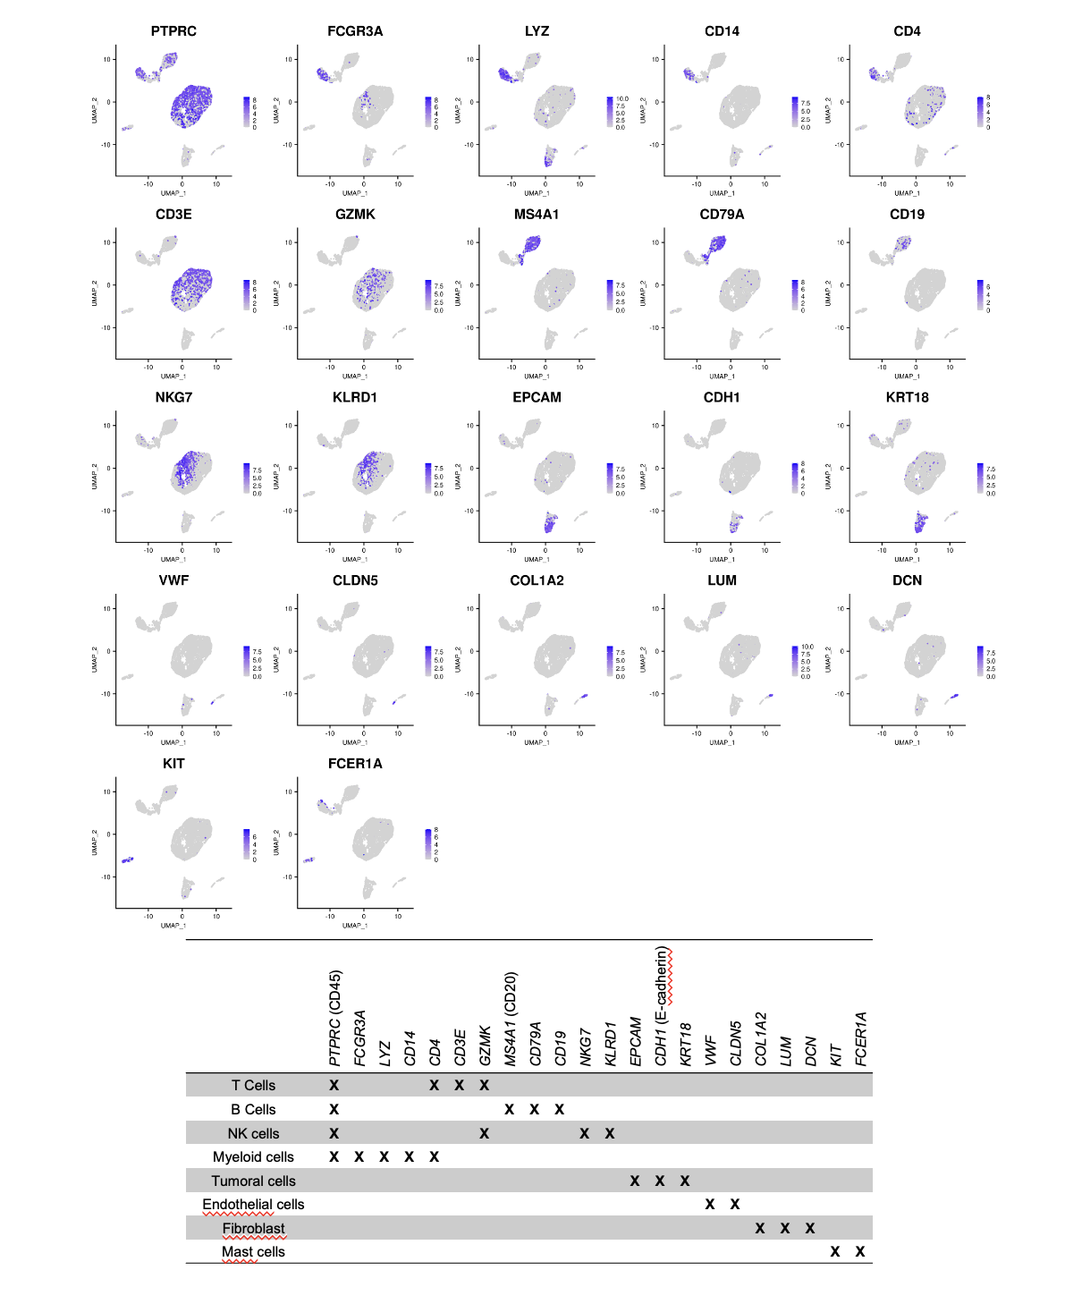
Supplementary Figure 1: Cell-type annotation of single-cell RNA-seq clusters.
UMAP feature plots showing the expression of canonical marker genes used to identify major cell populations within the TME. The accompanying Table summarizes marker gene expression across annotated cell types according to published literature.
Supplementary Figure 2
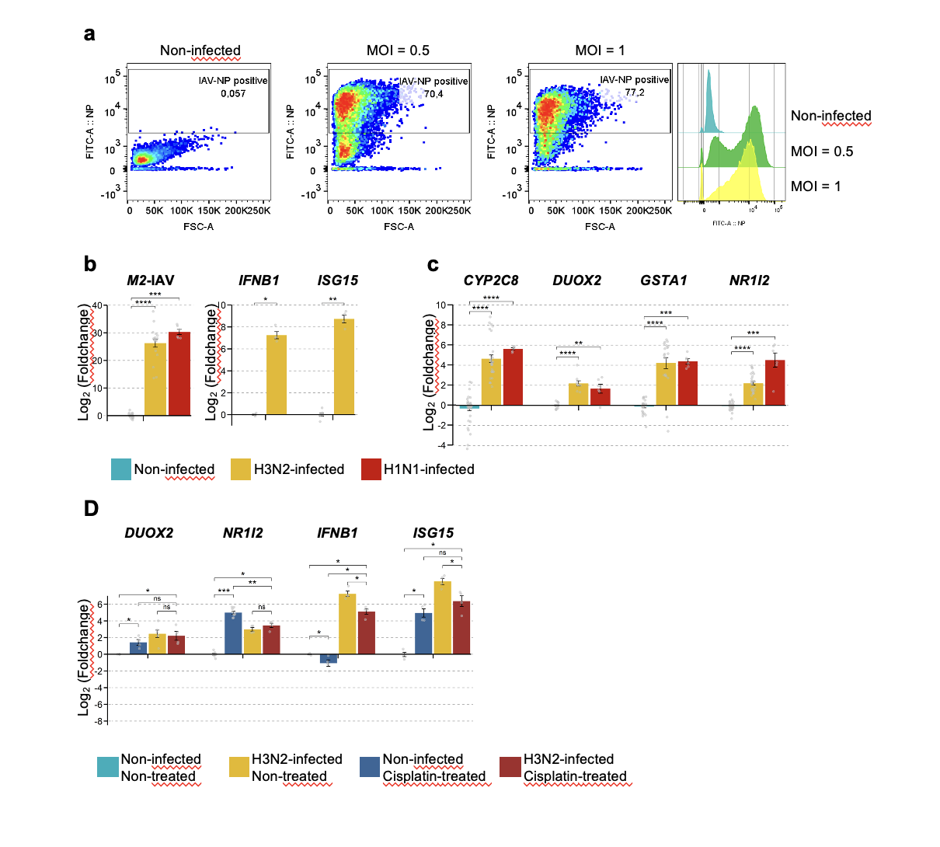
Supplementary Figure 2: Validation of IAV infection and REVIS-DM induction in A549 cells.
A549 cells were infected with IAV (MOI = 1). (a) Flow cytometry analysis of infected cells using an anti-IAV nucleoprotein (NP) antibody. (b-c) RT–qPCR analysis showing log₂ fold changes in viral (M2) and antiviral response genes (b), and xenobiotic metabolism genes (c) in infected versus non-infected cells. (d) RT–qPCR analysis of gene expression in infected versus non-infected cells and/or treated with cisplatin (10 µM). For panels b-d, fold changes and P-values were calculated relative to untreated, non-infected controls at 24 h. Statistical significance was determined using the Wilcoxon test.
Supplementary Figure 3
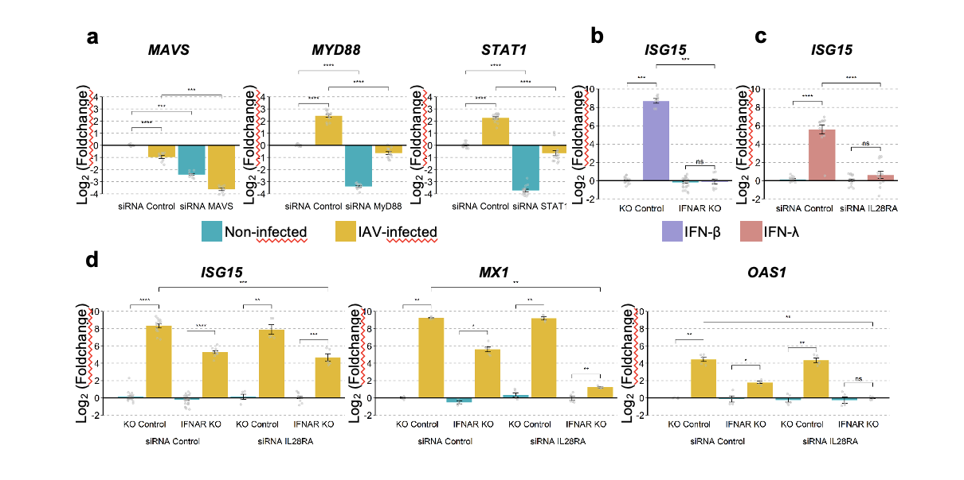
Supplementary Figure 3: Validation of Gene Silencing by siRNA and CRISPR/Cas9-Mediated Knockout.
Experiments were performed in A549 cells, and gene silencing or pathway inhibition was validated by RT–qPCR. (a) Validation of MAVS, MYD88, and STAT1 silencing following siRNA transfection and IAV infection (H3N2, MOI = 1). (b) Validation of IFNAR1 knockout (KO) cells generated using CRISPR/Cas9 following FN-β stimulation (100 ng/mL) by analysis of ISG15 expression. (c) Validation of IL28RA silencing following IFN-λ stimulation (100 ng/mL) by analysis of ISG15 expression. (d) Expression of ISG15, MX1, and OAS1 following combined inhibition of type I and type III IFN signaling in IFNAR1 KO cells transfected with IL28RA siRNA and infected with IAV (MOI = 1).
Statistical analyses were performed using the Wilcoxon test. Data are presented as log₂ fold change relative to untreated control cells, and represent at least three independent biological replicates. *P < 0.05; **P < 0.01; ***P < 0.001; ****P < 0.0001.

Supplementary Figure 4
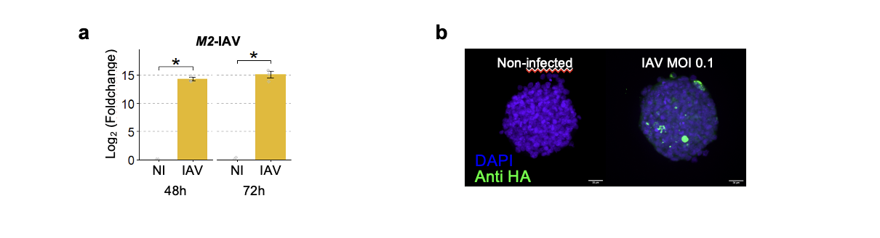
Supplementary Figure 4: Validation of IAV infection of A549 spheroids.
(a) RNA was extracted from A549 spheroids infected at MOI = 0.1 and the M2 IAV protein expression was assayed by RT qPCR. (b) Images showing A549 spheroids infected at MOI = 0.1, strained with DAPI and anti-HA antibody, and imaged using a spinning-disk microscope.

