Title: Responses of Secondary Metabolites and Transcriptomes in Tea Cultivar ‘Zhong Ming 6’ (Camellia sinensis) under Blue Light and Red Light
Journal name: Plant growth Regulation
Aktar Shirin 1, Yazhen Zhang 1, Peng Mao 1, Yuping Lei 1, Peixian Bai 1, Yongxin Wang 1, Li Ruan 1, Hanshuo Xun1, Liyun Wu 1, Hao Cheng 1, Liyuan Wang 1*, Kang Wei 1*
- Key Laboratory of Tea Biology and Resources Utilization, Ministry of Agriculture, National Center for Tea Improvement, Tea Research Institute Chinese Academy of Agricultural Sciences (TRICAAS), Hangzhou 310008, China
*Corresponding author: Phone: +86-571-86650575. Fax: +86-571-86650056 E-mail: wangly@tricaas.com (L.W.);
**Corresponding author: Phone: +86-18519242703. Fax: 0086-0571-86650056 E-mail: weikang@tricaas.com

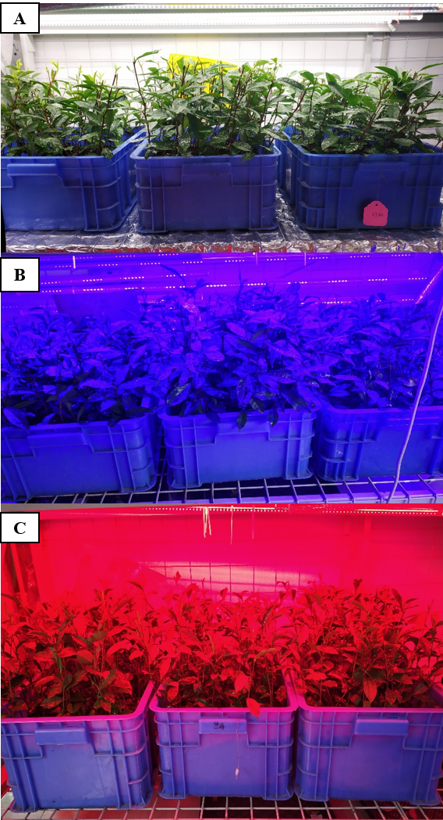
Fig. S3. The effects of different light A. White Light (WL) B. Blue light (BL) and C. Red Light (RL) on Zhong ming6 (Camellia sinensis) plant in Plastic Box in growth room

