Polysorbate 20-Assisted PEG Precipitation for Isolating Sub-100 nm of Turmeric-Derived Exosome-like Nanoparticles with Superior Colloidal Stability
Anitya Shukla¹, Nidhi Srivastava^{*1}, Niranjan Meher^{*1}
¹Department of Biotechnology, National Institute of Pharmaceutical Education and Research (NIPER-Raebareli) Lucknow (UP)- 226002 (India).
*¹ E-mail: nmchem.iitg@gmail.com; Phone: +91 9078962335

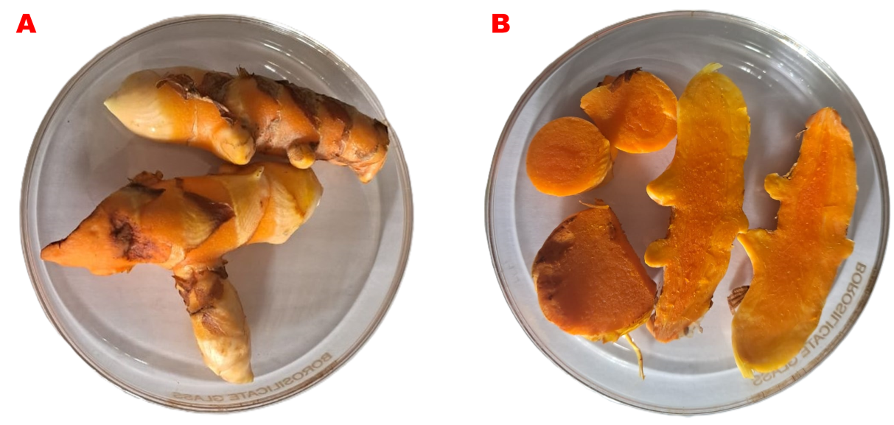
Figure S1. Morphological appearance of turmeric rhizomes. External morphology (A) transverse and longitudinal sections (B).

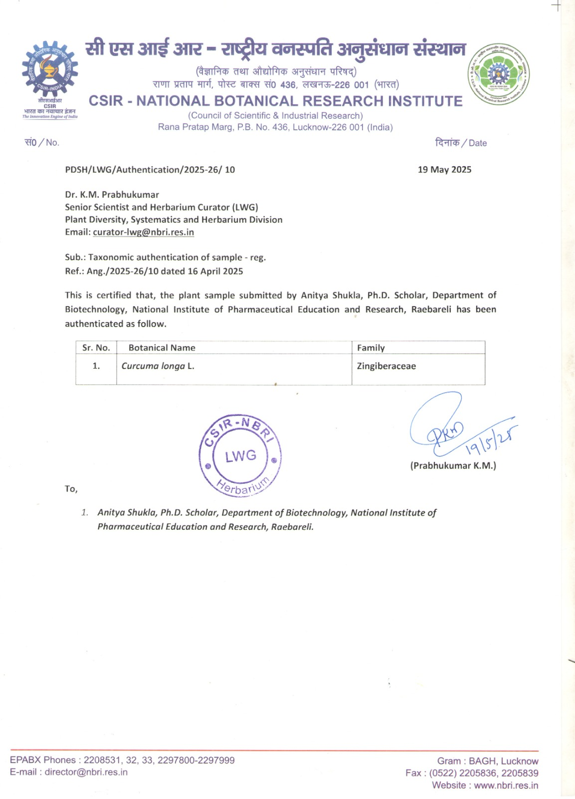

Figure S2. Herbarium specimen of Curcuma longa L. authentication report.

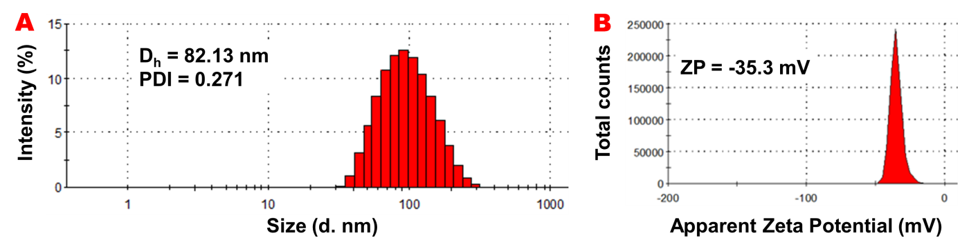
Figure S3. Hydrodynamic diameter, Polydispersity Index (A) and Zeta potential (B) of TDEs in water+P20.

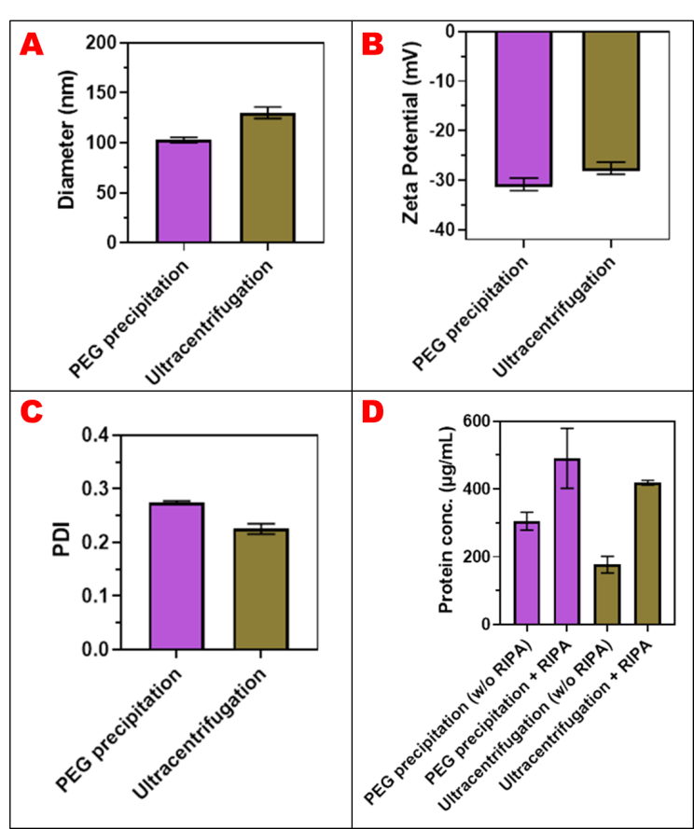

Figure S4. Comparison between PEG-based isolation and ultracentrifugation methods. Hydrodynamic diameter (A) surface charge (B) polydispersity index (C) and protein content (D) of TDEs. The samples were incubated at 4 °C and data were acquired at RT (n=3, Mean ± SD).
Table S1. Summary of PEG-based isolation and ultracentrifugation methods
 | Hydrodynamic diameter in nm |  | Zeta Potential in mV
Method | PEG precipitation | UC | PEG precipitation | UC
Reading 1 | 99.87 | 123.7 | -31.5 | -28.9
Reading 2 | 105.1 | 131.4 | -29.4 | -27.4
Reading 3 | 103.3 | 134.9 | -31.7 | -26.5
Avg. | 102.75 | 130 | -30.8667 | -27.6
S.D. | 2.16 | 4.67 | 1.04 | 0.98
 | Protein estimation without RIPA in µg/mL |  | Protein estimation with RIPA in µg/mL
Method | PEG precipitation | UC | PEG precipitation | UC
Reading 1 | 299.14 | 190.73 | 422.43 | 416.05
Reading 2 | 334.21 | 190.73 | 458.56 | 426.68
Reading 3 | 282.13 | 148.22 | 590.35 | 413.92
Avg. | 305.16 | 176.56 | 490.44 | 418.88
S.D. | 21.68 | 20.039 | 72.16 | 5.58

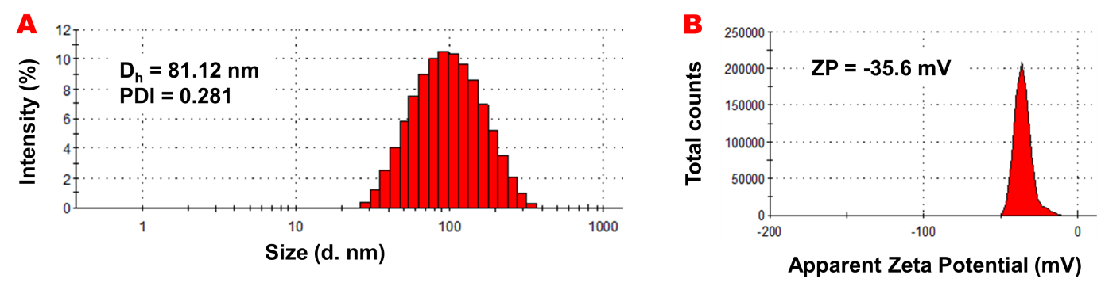
Figure S5. Hydrodynamic diameter, Polydispersity Index (A) and Zeta potential (B) of TDEs in water.

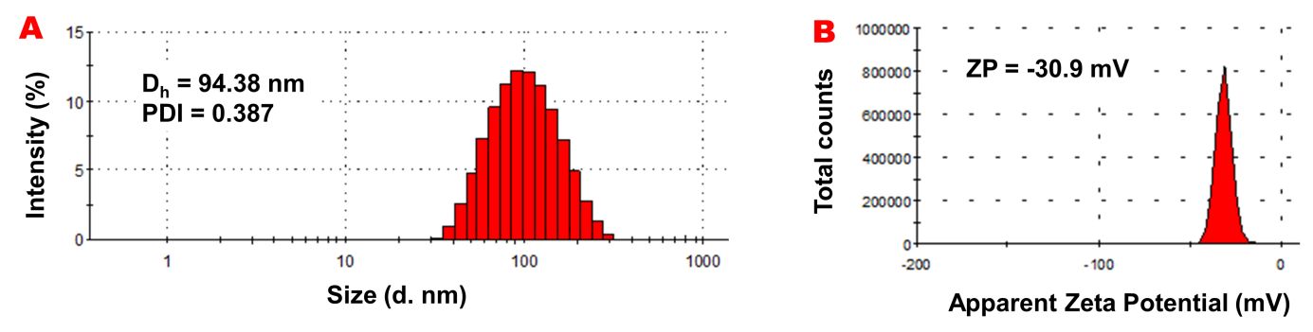
Figure S6. Hydrodynamic diameter, Polydispersity Index (A) and Zeta potential (B) of TDEs in PBS (150 mM).

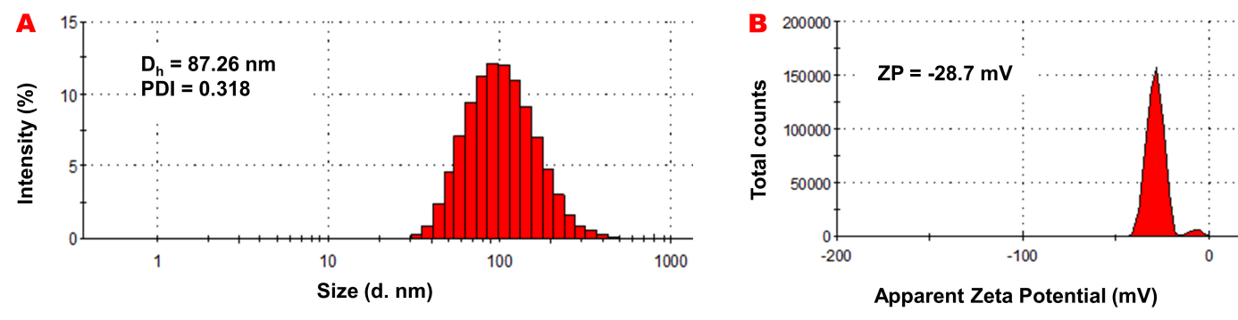

Figure S7. Hydrodynamic diameter, Polydispersity Index (A) and Zeta potential (B) of TDEs in PBS+P20.

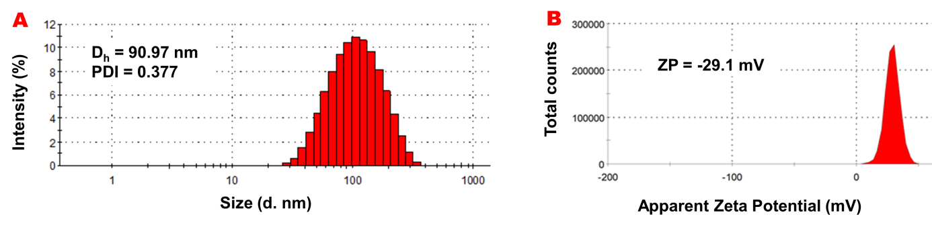
Figure S8. Hydrodynamic diameter, Polydispersity Index (A) and Zeta potential (B) of TDEs in NaCl (154 mM).

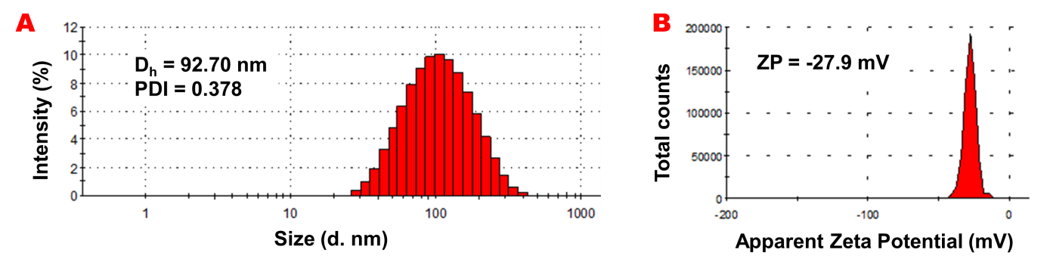
Figure S9. Hydrodynamic diameter, Polydispersity Index (A) and Zeta potential (B) of TDEs in PBS+NaCl.

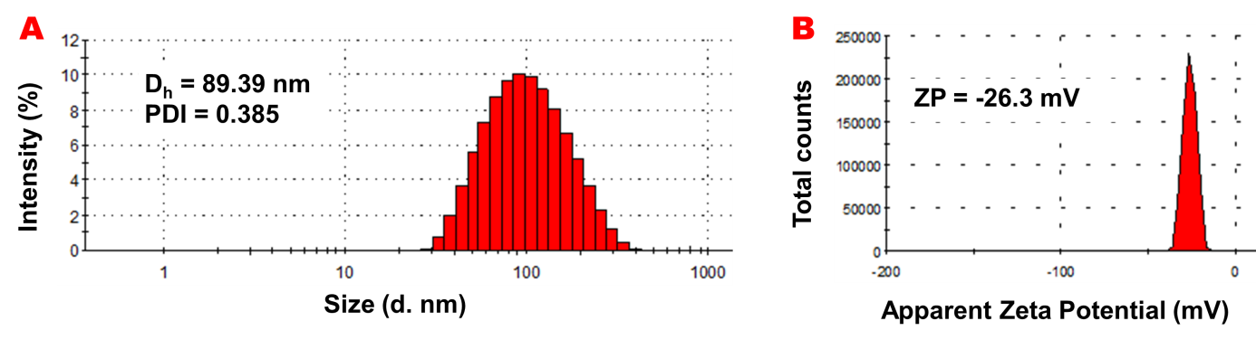
Figure S10. Hydrodynamic diameter, Polydispersity Index (A) and Zeta potential (B) of TDEs in PBS+NaCl+P20.

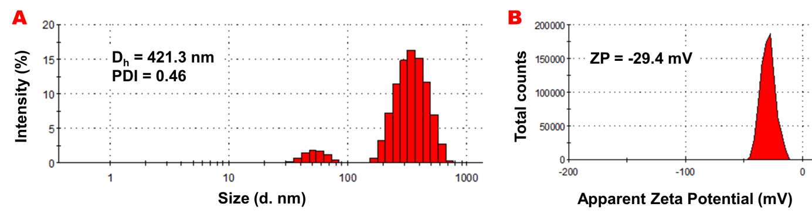
Figure S11. Hydrodynamic diameter, Polydispersity Index (A) and Zeta potential (B) of TDEs in reproduced reported protocol.

Table S2. Summary of the effect of suspension media on TDEs isolation

Hydrodynamic diameter in nm
Media | Reading 1 | Reading 2 | Reading 3 | Avg. | S.D.
Reported protocol | 413.9 | 419.2 | 436.2 | 423.1 | 9.51
H₂O | 81.12 | 88.55 | 84.92 | 84.86 | 3.03
H₂O+P20 | 82.13 | 86.38 | 86.26 | 84.92 | 1.97
PBS | 86.75 | 94.59 | 94.38 | 91.90 | 3.64
PBS+P20 | 82.59 | 86.05 | 87.26 | 85.3 | 1.98
NaCl | 84.96 | 90.97 | 90.41 | 88.78 | 2.71
PBS+NaCl | 98.65 | 92.7 | 84.36 | 91.90 | 5.86
PBS+NaCl+P20 | 95.62 | 89.39 | 92.32 | 92.44 | 2.54
Zeta Potential in mV
Media | Reading 1 | Reading 2 | Reading 3 | Avg. | S.D.
Reported protocol | -27.8 | -29.5 | -31 | -29.43 | 1.30
H₂O | -36.6 | -33.7 | -35.6 | -35.3 | 1.20
H₂O+P20 | -35.3 | -35.5 | -37.5 | -36.1 | 0.99
PBS | -32.4 | -31.9 | -30.9 | -31.73 | 0.62
PBS+P20 | -31.5 | -28.7 | -28.4 | -29.53 | 1.39
NaCl | -27.8 | -29.1 | -33.7 | -30.2 | 2.53
PBS+NaCl | -28 | -27.9 | -29.6 | -28.5 | 0.77
PBS+NaCl+P20 | -26.3 | -24.3 | -28.6 | -26.4 | 1.75

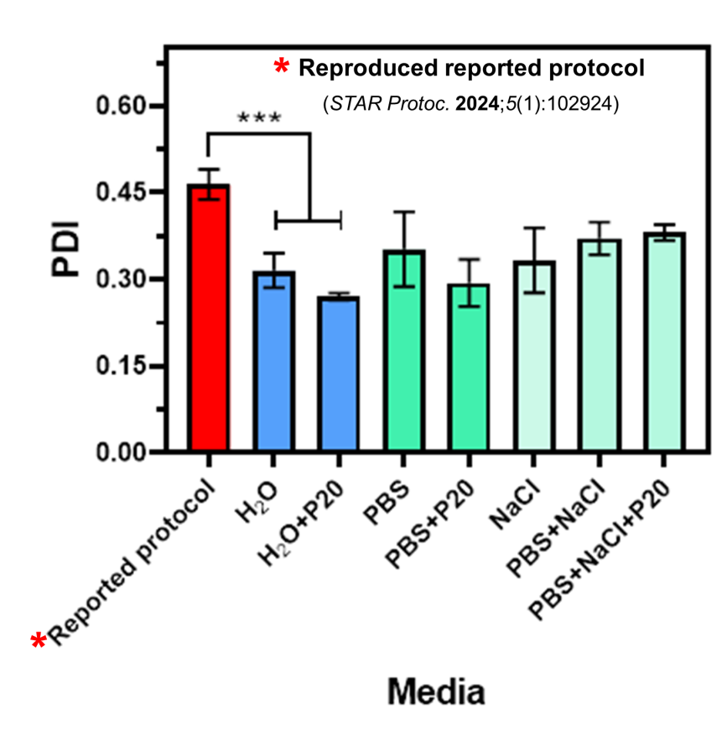
Figure S12. Effect of buffer treatments on TDEs isolation. Polydispersity index measured after preparation in various solutions: *Reproduced reported protocol, H₂O, H₂O+P20, PBS, PBS+P20, NaCl, PBS+NaCl and PBS+NaCl+P20. The reported data is an average of three scans (n=3, Mean ± SD).
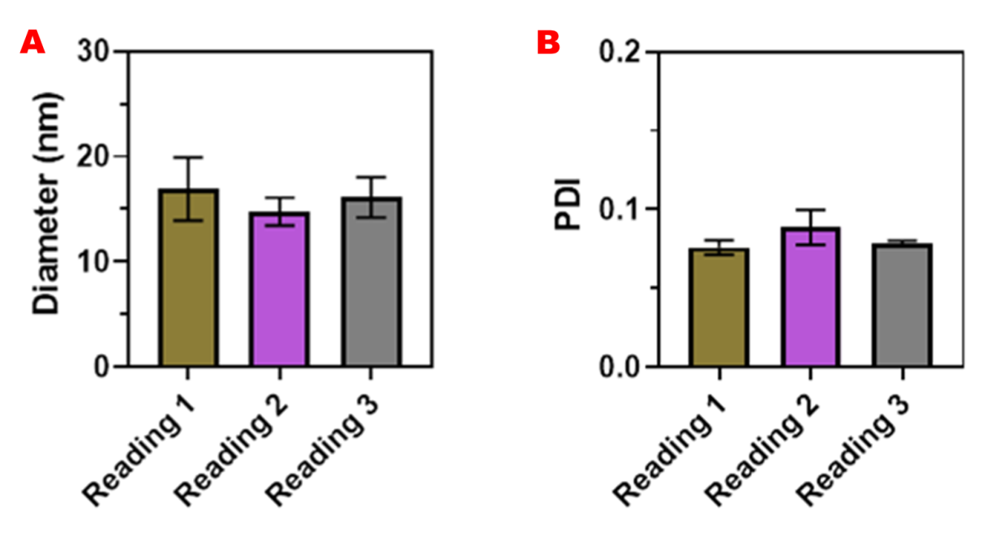
Figure S13. Characterization of Polysorbate 20 micelles at 4 mM (0.5%) obtained by DLS. Hydrodynamic diameter (A) and polydispersity index analysis (B) of P20 suspended in ultrapure water. Samples were incubated at 4 °C, and measurements were acquired at RT. Data are presented as mean ± SD (n = 3).
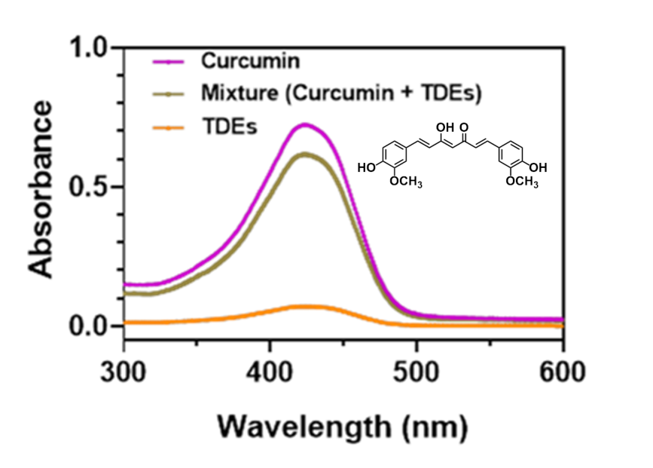
Figure S14. UV-Vis Absorption Spectra of Mixture (Curcumin + TDEs), Curcumin and TDEs.

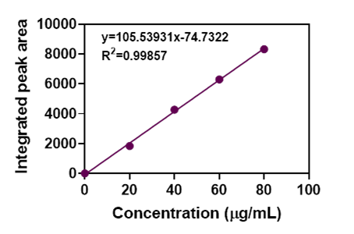

Figure S15. Calibration curve of curcumin (0–80 µg/mL) obtained using HPLC, showing the regression equation y = 105.539x − 74.732 with a correlation coefficient (R²) of 0.9986.

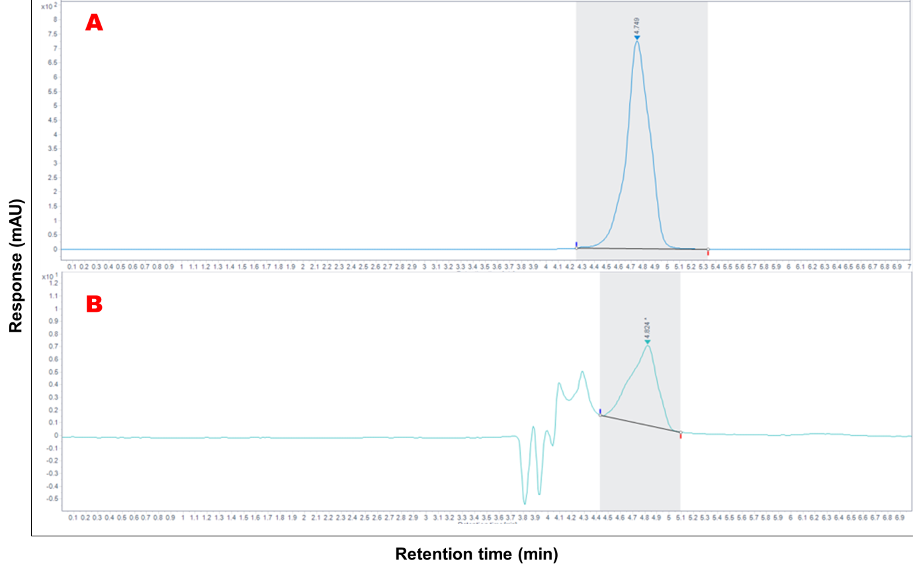
Figure S16. HPLC chromatograms of standard curcumin (A) and TDEs (B), showing retention times at approximately 4.75 and 4.82 min, respectively, confirming the presence of curcumin in TDEs.

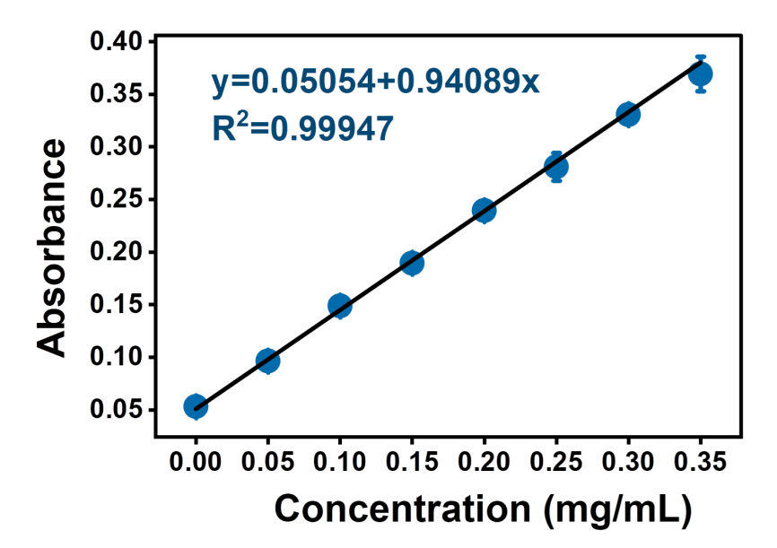
Figure S17. Standard graph for BSA protein (R²=0.999) using Lowry method. Absorbance was recorded at 660 nm (n=3, Mean ± SD).
Table S3: Standard graph data for BSA protein
Groups | Absorbance |  |  | Average | Blank correction
Blank | 0.051 | 0.049 | 0.059 | 0.053 | 0
0.050 (mg/mL) | 0.094 | 0.098 | 0.097 | 0.096 | 0.043
0.100 (mg/mL) | 0.145 | 0.147 | 0.154 | 0.148 | 0.0956
0.150 (mg/mL) | 0.189 | 0.185 | 0.194 | 0.189 | 0.136
0.200 (mg/mL) | 0.238 | 0.239 | 0.241 | 0.239 | 0.186
0.250 (mg/mL) | 0.286 | 0.266 | 0.291 | 0.281 | 0.228
0.300 (mg/mL) | 0.324 | 0.335 | 0.333 | 0.330 | 0.277
0.350 (mg/mL) | 0.363 | 0.357 | 0.388 | 0.369 | 0.316

Table S4. Summary of protein estimation of TDEs without or with RIPA treatment with five different batches
Protein content data of five different batches in µg/mL
Batch | Batch 1 |  | Batch 2 |  | Batch 3 |  | Batch 4 |  | Batch 5
Treatment | w/o RIPA | with RIPA | w/o RIPA | with RIPA | w/o RIPA | with RIPA | w/o RIPA | with RIPA | w/o RIPA | with RIPA
Reading 1 | 266.85 | 523.5 | 251.1 | 411.7 | 188.7 | 364.2 | 214.2 | 537.3 | 299.3 | 562.9
Reading 2 | 258.1 | 532.2 | 252.6 | 403.6 | 200.0 | 372.9 | 232.1 | 483.3 | 277.4 | 531.5
Reading 3 | 321.6 | 543.2 | 268.1 | 414.6 | 197.4 | 362.7 | 206.2 | 490.6 | 288.9 | 556.2
Reading 4 | 261.7 | 537.3 | 275.1 | 422.4 | 212.1 | 370.1 | 252.9 | 543.9 | 304.1 | 543.2
Avg. | 277.1 | 534.1 | 261.7 | 413.1 | 199.5 | 367.5 | 226.4 | 513.8 | 292.4 | 548.4
S.D. | 25.9 | 7.2 | 10.2 | 6.7 | 8.3 | 4.2 | 17.9 | 27.1 | 10.2 | 12.1

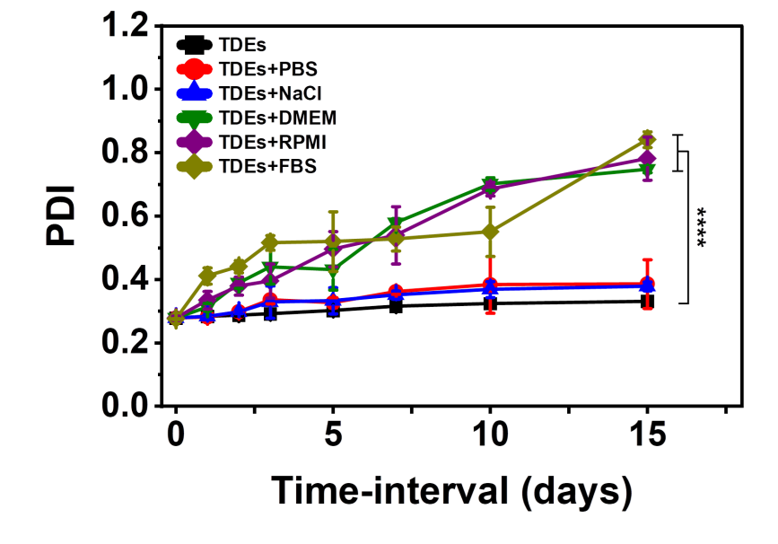
Figure S18. Polydispersity index of TDEs suspended in 150 mM PBS, 154 mM NaCl, RPMI, DMEM and FBS media. The samples were incubated at 4 °C and data were acquired at RT. The reported data is an average of three scans (n=3, Mean ± SD).

Table S5: Size summary of the effect of different media on the stability of TDEs for 15 days
Hydrodynamic diameter in nm in different media
 | Media | TDEs | TDEs+PBS | TDEs+NaCl | TDEs+DMEM | TDEs+RPMI | TDEs+FBS
Day 0 | Reading 1 | 82.13 | 82.13 | 82.13 | 82.13 | 82.13 | 99.87
Day 0 | Reading 2 | 83.38 | 83.38 | 83.38 | 83.38 | 83.38 | 105.1
Day 0 | Reading 3 | 84.26 | 84.26 | 84.26 | 84.26 | 84.26 | 103.3
Day 0 | Avg. | 83.25 | 83.25 | 83.25 | 83.25 | 83.25 | 102.75
Day 0 | S.D. | 0.87 | 0.87 | 0.87 | 0.87 | 0.87 | 2.16
Day 1 | Reading 1 | 82.12 | 83.18 | 84.56 | 103 | 111 | 122.8
Day 1 | Reading 2 | 83.65 | 84.25 | 84.19 | 101 | 120 | 114.8
Day 1 | Reading 3 | 84.55 | 85.55 | 85.98 | 108 | 129 | 127.1
Day 1 | Avg. | 83.44 | 84.32 | 84.91 | 104 | 120 | 121.56
Day 1 | S.D. | 1.00 | 0.97 | 0.77 | 2.94 | 7.34 | 5.09
Day 2 | Reading 1 | 83.67 | 89.49 | 97 | 125.4 | 170.2 | 157.2
Day 2 | Reading 2 | 85.13 | 86.62 | 92 | 170.2 | 153 | 167.2
Day 2 | Reading 3 | 84.65 | 88.75 | 89 | 165.1 | 138 | 144.9
Day 2 | Avg. | 84.48 | 88.28 | 92.66 | 153.56 | 153.73 | 156.43
Day 2 | S.D. | 0.60 | 1.22 | 3.3 | 20.02 | 13.15 | 9.12
Day 3 | Reading 1 | 83.39 | 97.5 | 106 | 223.3 | 195.3 | 157.3
Day 3 | Reading 2 | 85.37 | 100.1 | 108 | 199 | 249.5 | 158.1
Day 3 | Reading 3 | 85.75 | 103.4 | 112 | 211 | 204.4 | 162.5
Day 3 | Avg. | 84.83 | 100.33 | 108.66 | 211.1 | 216.4 | 159.3
Day 3 | S.D. | 1.03 | 2.41 | 2.49 | 9.92 | 23.7 | 2.28
Day 5 | Reading 1 | 84.12 | 122.4 | 123 | 219.6 | 216.9 | 152.9
Day 5 | Reading 2 | 85.08 | 131.8 | 120 | 308.3 | 337.5 | 173.3
Day 5 | Reading 3 | 86.55 | 123.2 | 130.1 | 287.4 | 300.9 | 176.9
Day 5 | Avg. | 85.25 | 125.8 | 124.36 | 271.76 | 285.1 | 167.7
Day 5 | S.D. | 0.99 | 4.25 | 4.23 | 37.86 | 50.48 | 10.56
Day 7 | Reading 1 | 85.93 | 114.3 | 128.7 | 363.4 | 450.5 | 155.5
Day 7 | Reading 2 | 86.21 | 134.6 | 132.6 | 420.1 | 363 | 177
Day 7 | Reading 3 | 86.81 | 135.7 | 124.8 | 351.7 | 419.4 | 164.1
Day 7 | Avg. | 86.31 | 128.2 | 128.7 | 378.4 | 410.96 | 165.53
Day 7 | S.D. | 0.36 | 9.83 | 3.18 | 29.87 | 36.21 | 8.83
Day 10 | Reading 1 | 86.93 | 132.1 | 134.5 | 526.5 | 602.3 | 174.8
Day 10 | Reading 2 | 88.21 | 126.7 | 126.6 | 573.8 | 556 | 163.9
Day 10 | Reading 3 | 89.61 | 138.8 | 141 | 583.6 | 543.8 | 178.5
Day 10 | Avg. | 88.25 | 132.53 | 134.03 | 561.3 | 567.36 | 172.4
Day 10 | S.D. | 1.09 | 4.94 | 5.88 | 24.93 | 25.19 | 6.19
Day 15 | Reading 1 | 90.4 | 151.6 | 150.7 | 780.7 | 683.9 | 215.8
Day 15 | Reading 2 | 89.76 | 126.5 | 155.1 | 734.9 | 785.9 | 192.7
Day 15 | Reading 3 | 91.05 | 150.6 | 143.1 | 624.2 | 665.8 | 186.9
Day 15 | Avg. | 90.40 | 142.9 | 149.63 | 713.26 | 610.66 | 198.46
Day 15 | S.D. | 0.52 | 11.60 | 4.95 | 65.69 | 52.86 | 12.48
Hydrodynamic diameter in nm in different media
 | Media |  | TDEs | TDEs+PBS | TDEs+NaCl | TDEs+DMEM | TDEs+RPMI
Day 0 | Reading 1 |  | 82.13 | 82.13 | 82.13 | 82.13 | 82.13
Day 0 | Reading 2 |  | 83.38 | 83.38 | 83.38 | 83.38 | 83.38
Day 0 | Reading 3 |  | 84.26 | 84.26 | 84.26 | 84.26 | 84.26
Day 0 | Avg. |  | 83.25 | 83.25 | 83.25 | 83.25 | 83.25
Day 0 | S.D. |  | 0.87 | 0.87 | 0.87 | 0.87 | 0.87
Day 1 | Reading 1 |  | 82.12 | 83.18 | 84.56 | 103 | 111
Day 1 | Reading 2 |  | 83.65 | 84.25 | 84.19 | 101 | 120
Day 1 | Reading 3 |  | 84.55 | 85.55 | 85.98 | 108 | 129
Day 1 | Avg. |  | 83.44 | 84.32 | 84.91 | 104 | 120
Day 1 | S.D. |  | 1.00 | 0.97 | 0.77 | 2.94 | 7.34
Day 2 | Reading 1 |  | 83.67 | 89.49 | 97 | 125.4 | 170.2
Day 2 | Reading 2 |  | 85.13 | 86.62 | 92 | 170.2 | 153
Day 2 | Reading 3 |  | 84.65 | 88.75 | 89 | 165.1 | 138
Day 2 | Avg. |  | 84.48 | 88.28 | 92.66 | 153.56 | 153.73
Day 2 | S.D. |  | 0.60 | 1.22 | 3.3 | 20.02 | 13.15
Day 3 | Reading 1 |  | 83.39 | 97.5 | 106 | 223.3 | 195.3
Day 3 | Reading 2 |  | 85.37 | 100.1 | 108 | 199 | 249.5
Day 3 | Reading 3 |  | 85.75 | 103.4 | 112 | 211 | 204.4
Day 3 | Avg. |  | 84.83 | 100.33 | 108.66 | 211.1 | 216.4
Day 3 | S.D. |  | 1.03 | 2.41 | 2.49 | 9.92 | 23.7
Day 5 | Reading 1 |  | 84.12 | 122.4 | 123 | 219.6 | 216.9
Day 5 | Reading 2 |  | 85.08 | 131.8 | 120 | 308.3 | 337.5
Day 5 | Reading 3 |  | 86.55 | 123.2 | 130.1 | 287.4 | 300.9
Day 5 | Avg. |  | 85.25 | 125.8 | 124.36 | 271.76 | 285.1
Day 5 | S.D. |  | 0.99 | 4.25 | 4.23 | 37.86 | 50.48
Day 7 | Reading 1 |  | 85.93 | 114.3 | 128.7 | 363.4 | 450.5
Day 7 | Reading 2 |  | 86.21 | 134.6 | 132.6 | 420.1 | 363
Day 7 | Reading 3 |  | 86.81 | 135.7 | 124.8 | 351.7 | 419.4
Day 7 | Avg. |  | 86.31 | 128.2 | 128.7 | 378.4 | 410.96
Day 7 | S.D. |  | 0.36 | 9.83 | 3.18 | 29.87 | 36.21
Day 10 | Reading 1 |  | 86.93 | 132.1 | 134.5 | 526.5 | 602.3
Day 10 | Reading 2 |  | 88.21 | 126.7 | 126.6 | 573.8 | 556
Day 10 | Reading 3 |  | 89.61 | 138.8 | 141 | 583.6 | 543.8
Day 10 | Avg. |  | 88.25 | 132.53 | 134.03 | 561.3 | 567.36
Day 10 | S.D. |  | 1.09 | 4.94 | 5.88 | 24.93 | 25.19
Day 15 | Reading 1 |  | 90.4 | 151.6 | 150.7 | 780.7 | 683.9
Day 15 | Reading 2 |  | 89.76 | 126.5 | 155.1 | 734.9 | 785.9
Day 15 | Reading 3 |  | 91.05 | 150.6 | 143.1 | 624.2 | 665.8
Day 15 | Avg. |  | 90.40 | 142.9 | 149.63 | 713.26 | 610.66
Day 15 | S.D. |  | 0.52 | 11.60 | 4.95 | 65.69 | 52.86

Table S6: Surface charge summary of the effect of different media on the stability of TDEs for 15 days.
Zeta Potential in mV in different media
 | Media | TDEs | TDEs+PBS | TDEs+NaCl | TDEs+DMEM | TDEs+RPMI | TDEs+FBS
Day 0 | Reading 1 | -31.8 | -31.8 | -31.8 | -31.8 | -31.8 | -31.5
Day 0 | Reading 2 | -32.5 | -32.5 | -32.5 | -32.5 | -32.5 | -29.4
Day 0 | Reading 3 | -31.8 | -31.8 | -31.8 | -31.8 | -31.8 | -31.7
Day 0 | Avg. | -32.03 | -32.03 | -32.03 | -32.03 | -32.03 | -30.86
Day 0 | S.D. | 0.33 | 0.33 | 0.33 | 0.33 | 0.33 | 1.04
Day 1 | Reading 1 | -31.5 | -29.7 | -31.2 | -27.4 | -27.3 | -24.7
Day 1 | Reading 2 | -31.6 | -30.1 | -29.3 | -28.9 | -27.1 | -24.2
Day 1 | Reading 3 | -31.9 | -30.7 | -31.2 | -28.8 | -27.8 | -27
Day 1 | Avg. | -31.66 | -30.16 | -30.56 | -28.36 | -27.4 | -25.3
Day 1 | S.D. | 0.17 | 0.41 | 0.89 | 0.68 | 0.29 | 1.21
Day 2 | Reading 1 | -31.7 | -28.5 | -34.1 | -23.1 | -22.2 | -22.9
Day 2 | Reading 2 | -30.2 | -27.3 | -28.7 | -25.1 | -21.4 | -16.3
Day 2 | Reading 3 | -31.3 | -30.4 | -28.4 | -24.4 | -22.3 | -22.7
Day 2 | Avg. | -31.06 | -28.73 | -30.4 | -24.2 | -21.96 | -20.63
Day 2 | S.D. | 0.63 | 1.28 | 2.62 | 0.83 | 0.40 | 3.06
Day 3 | Reading 1 | -31.8 | -27.3 | -26.8 | -19.8 | -20.3 | -18.7
Day 3 | Reading 2 | -30.1 | -32.2 | -24.6 | -22.8 | -21.5 | -17.6
Day 3 | Reading 3 | -30.4 | -26.5 | -33.4 | -21.4 | -22.5 | -24.2
Day 3 | Avg. | -30.76 | -28.66 | -28.26 | -21.33 | -21.43 | -20.16
Day 3 | S.D. | 0.74 | 2.52 | 3.74 | 1.23 | 0.89 | 2.88
Day 5 | Reading 1 | -28.2 | -25.8 | -24.6 | -17.5 | -17.7 | -18.6
Day 5 | Reading 2 | -29.3 | -24.7 | -31.7 | -18.2 | -18.8 | -22.2
Day 5 | Reading 3 | -30 | -25.6 | -23.8 | -17.9 | -18.1 | -19.1
Day 5 | Avg. | -29.16 | -25.36 | -26.7 | -17.86 | -18.2 | -19.96
Day 5 | S.D. | 0.74 | 0.47 | 3.55 | 0.28 | 0.45 | 1.59
Day 7 | Reading 1 | -28.6 | -23.2 | -34.1 | -17.4 | -15.7 | -17.9
Day 7 | Reading 2 | -29.3 | -23.5 | -21.9 | -14.5 | -18.1 | -17.8
Day 7 | Reading 3 | -27.1 | -23.8 | -23.2 | -11.2 | -13.5 | -18
Day 7 | Avg. | -28.33 | -23.5 | -26.4 | -14.36 | -15.76 | -17.9
Day 7 | S.D. | 0.92 | 0.24 | 5.47 | 2.53 | 1.88 | 0.08
Day 10 | Reading 1 | -25.7 | -22.3 | -20.4 | -11.1 | -11.8 | -14.3
Day 10 | Reading 2 | -26.6 | -22.7 | -27.3 | -10.3 | -12.3 | -14.2
Day 10 | Reading 3 | -25.4 | -22.6 | -20.2 | -9.34 | -9.83 | -18
Day 10 | Avg. | -25.9 | -22.53 | -22.63 | -10.24 | -11.31 | -15.5
Day 10 | S.D. | 0.51 | 0.17 | 3.30 | 0.72 | 1.07 | 1.76
Day 15 | Reading 1 | -24.6 | -20.8 | -19.8 | -7.95 | -12.8 | -17.5
Day 15 | Reading 2 | -25.6 | -22.6 | -24.9 | -5.45 | -4.68 | -14.8
Day 15 | Reading 3 | -23.8 | -19.8 | -18.8 | -8.19 | -9.03 | -11.1
Day 15 | Avg. | -24.66 | -21.06 | -21.16 | -7.19 | -8.83 | -14.5
Day 15 | S.D. | 0.73 | 1.15 | 2.67 | 1.24 | 3.32 | 2.62
Zeta Potential in mV in different media
 | Media |  | TDEs | TDEs+PBS | TDEs+NaCl | TDEs+DMEM | TDEs+RPMI
Day 0 | Reading 1 |  | -31.8 | -31.8 | -31.8 | -31.8 | -31.8
Day 0 | Reading 2 |  | -32.5 | -32.5 | -32.5 | -32.5 | -32.5
Day 0 | Reading 3 |  | -31.8 | -31.8 | -31.8 | -31.8 | -31.8
Day 0 | Avg. |  | -32.03 | -32.03 | -32.03 | -32.03 | -32.03
Day 0 | S.D. |  | 0.33 | 0.33 | 0.33 | 0.33 | 0.33
Day 1 | Reading 1 |  | -31.5 | -29.7 | -31.2 | -27.4 | -27.3
Day 1 | Reading 2 |  | -31.6 | -30.1 | -29.3 | -28.9 | -27.1
Day 1 | Reading 3 |  | -31.9 | -30.7 | -31.2 | -28.8 | -27.8
Day 1 | Avg. |  | -31.66 | -30.16 | -30.56 | -28.36 | -27.4
Day 1 | S.D. |  | 0.17 | 0.41 | 0.89 | 0.68 | 0.29
Day 2 | Reading 1 |  | -31.7 | -28.5 | -34.1 | -23.1 | -22.2
Day 2 | Reading 2 |  | -30.2 | -27.3 | -28.7 | -25.1 | -21.4
Day 2 | Reading 3 |  | -31.3 | -30.4 | -28.4 | -24.4 | -22.3
Day 2 | Avg. |  | -31.06 | -28.73 | -30.4 | -24.2 | -21.96
Day 2 | S.D. |  | 0.63 | 1.28 | 2.62 | 0.83 | 0.40
Day 3 | Reading 1 |  | -31.8 | -27.3 | -26.8 | -19.8 | -20.3
Day 3 | Reading 2 |  | -30.1 | -32.2 | -24.6 | -22.8 | -21.5
Day 3 | Reading 3 |  | -30.4 | -26.5 | -33.4 | -21.4 | -22.5
Day 3 | Avg. |  | -30.76 | -28.66 | -28.26 | -21.33 | -21.43
Day 3 | S.D. |  | 0.74 | 2.52 | 3.74 | 1.23 | 0.89
Day 5 | Reading 1 |  | -28.2 | -25.8 | -24.6 | -17.5 | -17.7
Day 5 | Reading 2 |  | -29.3 | -24.7 | -31.7 | -18.2 | -18.8
Day 5 | Reading 3 |  | -30 | -25.6 | -23.8 | -17.9 | -18.1
Day 5 | Avg. |  | -29.16 | -25.36 | -26.7 | -17.86 | -18.2
Day 5 | S.D. |  | 0.74 | 0.47 | 3.55 | 0.28 | 0.45
Day 7 | Reading 1 |  | -28.6 | -23.2 | -34.1 | -17.4 | -15.7
Day 7 | Reading 2 |  | -29.3 | -23.5 | -21.9 | -14.5 | -18.1
Day 7 | Reading 3 |  | -27.1 | -23.8 | -23.2 | -11.2 | -13.5
Day 7 | Avg. |  | -28.33 | -23.5 | -26.4 | -14.36 | -15.76
Day 7 | S.D. |  | 0.92 | 0.24 | 5.47 | 2.53 | 1.88
Day 10 | Reading 1 |  | -25.7 | -22.3 | -20.4 | -11.1 | -11.8
Day 10 | Reading 2 |  | -26.6 | -22.7 | -27.3 | -10.3 | -12.3
Day 10 | Reading 3 |  | -25.4 | -22.6 | -20.2 | -9.34 | -9.83
Day 10 | Avg. |  | -25.9 | -22.53 | -22.63 | -10.24 | -11.31
Day 10 | S.D. |  | 0.51 | 0.17 | 3.30 | 0.72 | 1.07
Day 15 | Reading 1 |  | -24.6 | -20.8 | -19.8 | -7.95 | -12.8
Day 15 | Reading 2 |  | -25.6 | -22.6 | -24.9 | -5.45 | -4.68
Day 15 | Reading 3 |  | -23.8 | -19.8 | -18.8 | -8.19 | -9.03
Day 15 | Avg. |  | -24.66 | -21.06 | -21.16 | -7.19 | -8.83
Day 15 | S.D. |  | 0.73 | 1.15 | 2.67 | 1.24 | 3.32

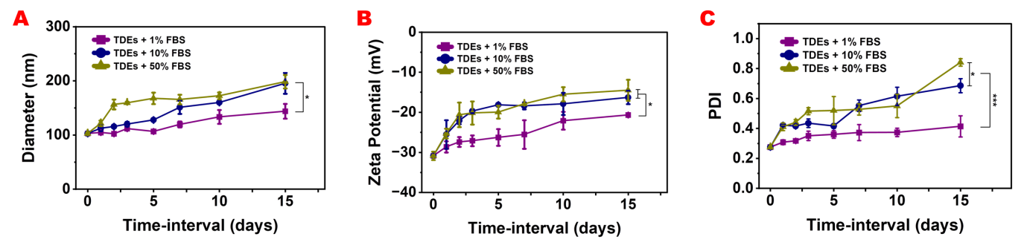
Figure S19. Effect of FBS on the stability of TDEs. Hydrodynamic diameter (A), surface charge (B) and polydispersity index (C) of TDEs suspended in media containing 1%, 10%, and 50% FBS. The samples were incubated at 4 ºC and data were acquired at RT (n=3, Mean ± SD)
Table S7: Summary of the effect of different concentrations of FBS on the stability of TDEs for 15 days.
Summary of the effect of FBS on the stability of TDEs
 |  | Hydrodynamic diameter in nm |  |  | Zeta Potential in mV
 | Media | 1% FBS | 10% FBS | 50% FBS | 1% FBS | 10% FBS | 50% FBS
Day 0 | Reading 1 | 99.87 | 99.87 | 99.87 | -31.5 | -31.5 | -31.5
Day 0 | Reading 2 | 105.1 | 105.1 | 105.1 | -29.4 | -29.4 | -29.4
Day 0 | Reading 3 | 103.3 | 103.3 | 103.3 | -31.7 | -31.7 | -31.7
Day 0 | Avg. | 102.75 | 102.75 | 102.75 | -30.86 | -30.86 | -30.86
Day 0 | S.D. | 2.16 | 2.16 | 2.16 | 1.04 | 1.04 | 1.04
Day 1 | Reading 1 | 104.7 | 119.7 | 122.8 | -28.5 | -27.1 | -24.7
Day 1 | Reading 2 | 105 | 107.3 | 114.8 | -30.4 | -20.6 | -24.2
Day 1 | Reading 3 | 104.3 | 110.1 | 127.1 | -27 | -28.9 | -27
Day 1 | Avg. | 104.66 | 112.36 | 121.56 | -28.63 | -25.53 | -25.3
Day 1 | S.D. | 0.28 | 5.30 | 5.09 | 1.39 | 3.56 | 1.21
Day 2 | Reading 1 | 100.1 | 114 | 157.2 | -26.8 | -22.8 | -22.9
Day 2 | Reading 2 | 104.6 | 118.7 | 167.2 | -29.1 | -22.6 | -16.3
Day 2 | Reading 3 | 102 | 113.8 | 144.9 | -26.3 | -20.8 | -22.7
Day 2 | Avg. | 102.23 | 115.5 | 156.43 | -27.4 | -22.06 | -20.63
Day 2 | S.D. | 1.84 | 2.26 | 9.12 | 1.21 | 0.89 | 3.06
Day 3 | Reading 1 | 113 | 126.1 | 157.3 | -28.1 | -19 | -18.7
Day 3 | Reading 2 | 109.8 | 116.1 | 158.1 | -28 | -20.1 | -17.6
Day 3 | Reading 3 | 112.3 | 118.1 | 162.5 | -25.2 | -20 | -24.2
Day 3 | Avg. | 111.7 | 120.1 | 159.3 | -27.1 | -19.7 | -20.16
Day 3 | S.D. | 1.37 | 4.32 | 2.28 | 1.34 | 0.49 | 2.88
Day 5 | Reading 1 | 104.6 | 127.9 | 152.9 | -29.2 | -18.4 | -18.6
Day 5 | Reading 2 | 108.2 | 127.2 | 173.3 | -24.6 | -18.2 | -22.2
Day 5 | Reading 3 | 106.8 | 128.2 | 176.9 | -25 | -17.8 | -19.1
Day 5 | Avg. | 106.53 | 127.76 | 167.7 | -26.26 | -18.13 | -19.96
Day 5 | S.D. | 1.48 | 0.41 | 10.56 | 2.08 | 0.24 | 1.59
Day 7 | Reading 1 | 127.1 | 134.8 | 155.5 | -27.1 | -17.3 | -17.9
Day 7 | Reading 2 | 117.6 | 163.9 | 177 | -20.6 | -18.6 | -17.8
Day 7 | Reading 3 | 113.9 | 154.5 | 164.1 | -28.9 | -19.4 | -18
Day 7 | Avg. | 119.53 | 151.06 | 165.53 | -25.53 | -18.4 | -17.9
Day 7 | S.D. | 5.55 | 12.12 | 8.83 | 3.56 | 0.86 | 0.08
Day 10 | Reading 1 | 121.8 | 162.2 | 174.8 | -19.6 | -16.8 | -14.3
Day 10 | Reading 2 | 151.1 | 158.5 | 163.9 | -21.7 | -15.2 | -14.2
Day 10 | Reading 3 | 127.3 | 159.2 | 178.5 | -25 | -21.7 | -18
Day 10 | Avg. | 133.4 | 159.96 | 172.4 | -22.1 | -17.9 | -15.5
Day 10 | S.D. | 12.71 | 1.60 | 6.19 | 2.22 | 2.76 | 1.76
Day 15 | Reading 1 | 124.7 | 174.7 | 215.8 | -20.4 | -16.2 | -17.5
Day 15 | Reading 2 | 155.8 | 221 | 192.7 | -20.3 | -18.4 | -14.8
Day 15 | Reading 3 | 150.8 | 190.4 | 186.9 | -21.3 | -14.3 | -11.1
Day 15 | Avg. | 143.76 | 195.36 | 198.46 | -20.66 | -16.3 | -14.5
Day 15 | S.D. | 13.63 | 19.22 | 12.48 | 0.44 | 1.67 | 2.62

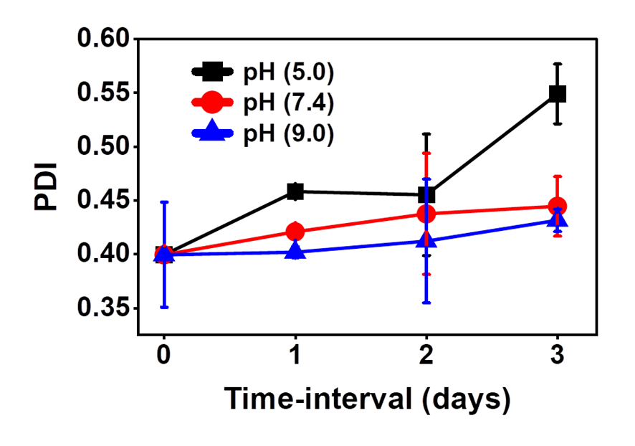
Figure S20. Polydispersity index of TDEs at three different pH values i.e. 5.0, 7.4 and 9.0. The samples were incubated at 4 °C and data were acquired at RT. The reported data is an average of three scans (n=3, Mean ± SD).

Table S8. Summary of the effect of pH variation on TDEs characterization
Hydrodynamic diameter in nm
Treatment | pH 5.0 |  |  |  | pH 7.4 |  |  |  | pH 9.0
Treatment | Day 0 | Day 1 | Day 2 | Day 3 | Day 0 | Day 1 | Day 2 | Day 3 | Day 0 | Day 1 | Day 2 | Day 3
Reading 1 | 117.9 | 127.7 | 138.2 | 154.5 | 117.9 | 104.9 | 107.4 | 118 | 117.9 | 116.4 | 118.4 | 133.6
Reading 2 | 114 | 134.9 | 143.7 | 140.7 | 114 | 116.9 | 115.9 | 110.8 | 114 | 117.8 | 120.9 | 132.4
Reading 3 | 122.1 | 136 | 149 | 152.4 | 122.1 | 132 | 130.5 | 129.5 | 122.1 | 121.2 | 118.7 | 120.8
Avg. | 118 | 132.86 | 143.63 | 149.2 | 118 | 117.93 | 117.93 | 119.43 | 118 | 118.46 | 119.33 | 128.93
S.D. | 3.30 | 3.68 | 4.40 | 6.07 | 3.30 | 11.08 | 9.54 | 7.70 | 3.3 | 2.01 | 1.11 | 5.7
Zeta Potential in mV
Treatment | pH 5.0 |  |  |  | pH 7.4 |  |  |  | pH 9.0
Treatment | Day 0 | Day 1 | Day 2 | Day 3 | Day 0 | Day 1 | Day 2 | Day 3 | Day 0 | Day 1 | Day 2 | Day 3
Reading 1 | -31.3 | -23.2 | -17.9 | -13.3 | -31.3 | -28.1 | -27.6 | -26.3 | -31.3 | -27.9 | -24.7 | -24.1
Reading 2 | -30.7 | -27.5 | -21.5 | -14 | -30.7 | -27.6 | -28.3 | -27.9 | -30.7 | -25.4 | -28.5 | -25.4
Reading 3 | -30.4 | -26.1 | -21.3 | -15 | -30.4 | -30.1 | -28 | -28.3 | -30.4 | -25.3 | -24.1 | -25.9
Avg. | -30.8 | -25.6 | -20.23 | -14.1 | -30.8 | -28.6 | -27.96 | -27.5 | -30.8 | -26.2 | -25.76 | -25.13
S.D. | 0.37 | 1.79 | 1.65 | 0.69 | 0.37 | 1.08 | 0.28 | 0.86 | 0.37 | 1.20 | 1.94 | 0.75

Table S9. Summary of protein estimation data with pH 5.0, 7.4 and 9.0
Protein concentration in µg/mL
Treatment | pH 5.0 | pH 5.0 + RIPA | pH 7.4 | pH 7.4 + RIPA | pH 9.0 | pH 9.0 + RIPA
Reading 1 | 284.02 | 572.43 | 359.99 | 690.04 | 334.06 | 557.82
Reading 2 | 289.13 | 591.42 | 359.26 | 736.06 | 331.50 | 587.04
Reading 3 | 299.72 | 351.81 | 410.76 | 629.41 | 338.81 | 378.84
Avg. | 290.96 | 505.22 | 376.67 | 685.17 | 334.79 | 507.90
S.D. | 6.54 | 108.75 | 24.10 | 43.67 | 3.02 | 92.03

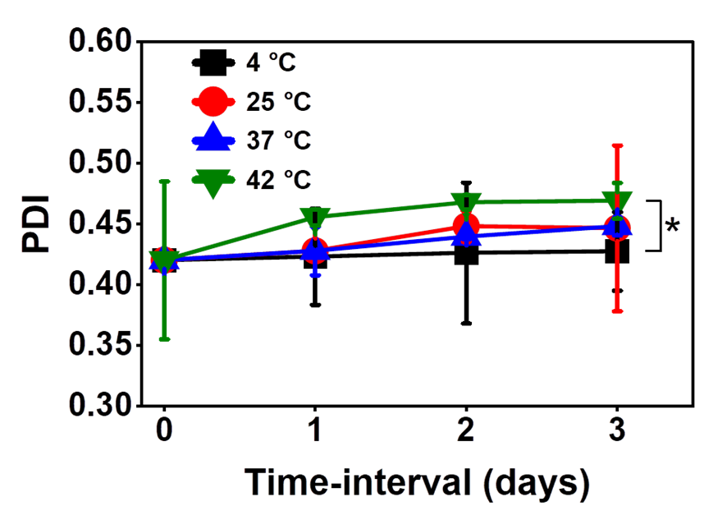
Figure S21. Polydispersity index of TDEs at four different temperatures i.e. 4 °C, 25 °C, 37 °C and 42 °C. The samples were incubated at 4 °C and data were acquired at RT. The reported data is an average of three scans (n=3, Mean ± SD).

Table S10. Summary of the effect of different temperature variation on TDEs characterization
Hydrodynamic diameter in nm
Treatment | Temperature 4 °C |  |  |  | Temperature 25 °C |  |  |  | Temperature 37 °C |  |  |  | Temperature 42 °C
Treatment | Day 0 | Day 1 | Day 2 | Day 3 | Day 0 | Day 1 | Day 2 | Day 3 | Day 0 | Day 1 | Day 2 | Day 3 | Day 0 | Day 1 | Day 2 | Day 3
Reading 1 | 88.7 | 92.1 | 93.2 | 92.1 | 88.7 | 86.8 | 90.8 | 97.9 | 88.7 | 86.8 | 99.9 | 102.6 | 88.7 | 106.1 | 112.2 | 127.5
Reading 2 | 89.9 | 89.3 | 94.1 | 95.1 | 89.9 | 90.3 | 90.6 | 97.8 | 89.9 | 90.2 | 99.1 | 103.4 | 89.9 | 106.2 | 110.7 | 124.5
Reading 3 | 92.1 | 92.2 | 94.3 | 96.3 | 92.1 | 93.8 | 92.7 | 98.8 | 92.1 | 93.8 | 100 | 102..2 | 92.1 | 106.2 | 109.5 | 136
Avg. | 90.3 | 91.2 | 93.9 | 94.5 | 90.3 | 90.3 | 91.4 | 98.3 | 90.3 | 90.3 | 99.6 | 102.7 | 90.3 | 106.1 | 110.8 | 129.3
S.D. | 1.4 | 1.3 | 0.5 | 1.7 | 1.4 | 2.8 | 0.9 | 0.4 | 1.4 | 2.8 | 0.4 | 0.5 | 1.4 | 0.04 | 1.10 | 4.8
Zeta Potential in mV
Treatment | Temperature 4 °C |  |  |  | Temperature 25 °C |  |  |  | Temperature 37 °C |  |  |  | Temperature 42 °C
Treatment | Day 0 | Day 1 | Day 2 | Day 3 | Day 0 | Day 1 | Day 2 | Day 3 | Day 0 | Day 1 | Day 2 | Day 3 | Day 0 | Day 1 | Day 2 | Day 3
Reading 1 | -38.3 | -37.5 | -33.9 | -33 | -38.3 | -34.5 | -31.2 | -31.1 | -38.3 | -31.9 | -28.5 | -28.4 | -38.3 | -27.1 | -27.6 | -25.2
Reading 2 | -30.3 | -35.9 | -33.8 | -35.1 | -30.3 | -33 | -34.1 | -31.3 | -30.3 | -32.4 | -31.1 | -28 | -30.3 | -30.3 | -28.8 | -23.1
Reading 3 | -36.6 | -35.3 | -35.6 | -33.7 | -36.6 | -30.3 | -32.8 | -34.2 | -36.6 | -30.9 | -31.6 | -30.4 | -36.6 | -32.5 | -19.1 | -25.3
Avg. | -35.1 | -36.2 | -34.4 | -33.9 | -35.1 | -32.6 | -32.7 | -32.2 | -35.1 | -31.7 | -30.4 | -28.9 | -35.1 | -29.9 | -25.2 | -24.5
S.D. | 3.4 | 0.9 | 0.8 | 0.8 | 3.4 | 1.7 | 1.2 | 1.4 | 3.4 | 0.6 | 1.3 | 1.1 | 3.4 | 2.2 | 4.3 | 1.0

Table S11. Summary of protein estimation data with temperature 4, 25, 37 and 42 °C
Protein concentration in µg/mL
Treatment | Temp 4 °C | Temp 4 °C + RIPA | Temp 25 °C | Temp 25 °C + RIPA | Temp 37 °C | Temp 37°C + RIPA | Temp 42 °C | Temp 42 °C + RIPA
Reading 1 | 548.5 | 777.7 | 506.8 | 752.8 | 346.5 | 711.2 | 323.8 | 583.3
Reading 2 | 549.2 | 797.4 | 507.9 | 779.8 | 353.7 | 782.1 | 308.1 | 565.1
Reading 3 | 551.7 | 760.9 | 564.2 | 777.7 | 495.8 | 578.2 | 312.8 | 664.4
Avg. | 549.9 | 778.6 | 526.3 | 770.2 | 398.7 | 690.5 | 314.9 | 604.3
S.D. | 1.3 | 14.9 | 26.7 | 12.3 | 68.7 | 84.4 | 6.5 | 43.2

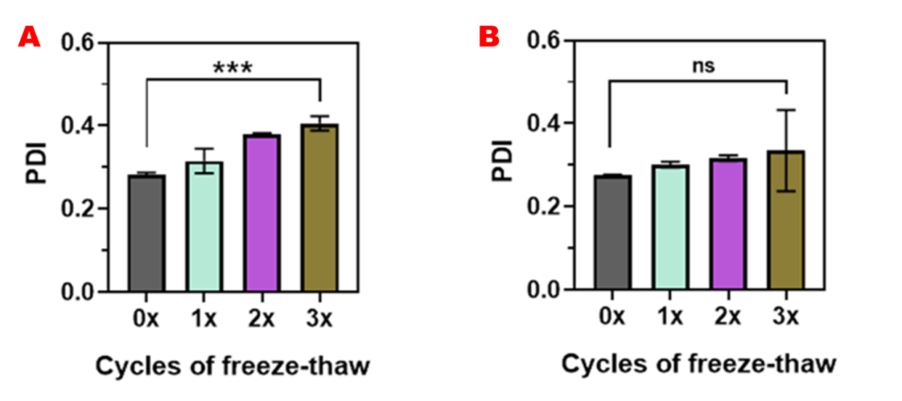
Figure S22. Polydispersity index of TDEs during freeze-thaw cycles at −20 ºC (A) and −80 ºC (B). The reported data is an average of three scans (n=3, Mean ± SD).

Table S12. Summary of hydrodynamic diameter and zeta potential and protein content data of TDEs during freeze-thaw cycles
 | Hydrodynamic diameter in nm |  |  |  | Zeta Potential in mV
Cycles | 0x | 1x | 2x | 3x | 0x | 1x | 2x | 3x
Reading 1 | 77.1 | 81.1 | 92.1 | 124.9 | -38.3 | -33 | -28 | -28.8
Reading 2 | 76.6 | 88.5 | 93.4 | 117.5 | -30.3 | -35.1 | -31 | -29.1
Reading 3 | 77.8 | 84.9 | 96.1 | 126 | -36.6 | -33.7 | -31 | -27.3
Avg. | 77.2 | 84.8 | 93.8 | 122.8 | -35.1 | -33.9 | -30 | -28.4
S.D. | 0.5 | 3.0 | 1.6 | 3.7 | 3.4 | 0.8 | 1.4 | 0.7
 | Protein estimation without RIPA in µg/mL |  |  |  | Protein estimation with RIPA in µg/mL
Cycles | 0x | 1x | 2x | 3x | 0x | 1x | 2x | 3x
Reading 1 | 240.7 | 210.9 | 192.1 | 146.3 | 481.4 | 416.3 | 519.7 | 382.5
Reading 2 | 260.3 | 215.2 | 209.5 | 172.1 | 562.2 | 534.4 | 436.8 | 346.3
Reading 3 | 234.7 | 253.3 | 182.6 | 145.0 | 554.8 | 433.5 | 412.3 | 329.5
Avg. | 245.2 | 226.5 | 194.7 | 154.4 | 532.8 | 484 | 456.3 | 352.7
S.D. | 10.9 | 19.0 | 11.1 | 12.4 | 36.4 | 50.4 | 45.9 | 22.1

Table S13. Summary of Cell viability (%) of HEK293 cells treated with different concentrations of TDEs.
Concentrations (µg/mL) | n=1 | n=2 | n=3 | Avg. | S.D.
0 | 86.99 | 104.45 | 108.52 | 99.99 | 9.33
50 | 102.41 | 116.08 | 104.74 | 107.74 | 5.97
100 | 144.02 | 112.01 | 111.14 | 122.39 | 15.29
150 | 143.14 | 127.43 | 100.37 | 123.65 | 17.66
200 | 160.65 | 143.92 | 120.68 | 141.75 | 16.38
250 | 82.24 | 118.63 | 130.42 | 110.43 | 20.50
300 | 83.56 | 120.85 | 98.95 | 101.12 | 15.30
350 | 126.25 | 84.52 | 107.53 | 106.1 | 17.06
400 | 104.96 | 133.42 | 85.92 | 108.1 | 19.51

