Supplementary Information

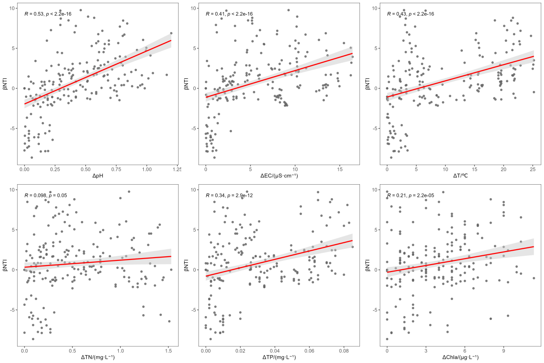
Fig. S1 Correlations between physicochemical parameters and βNTI of the overall planktonic bacterial community
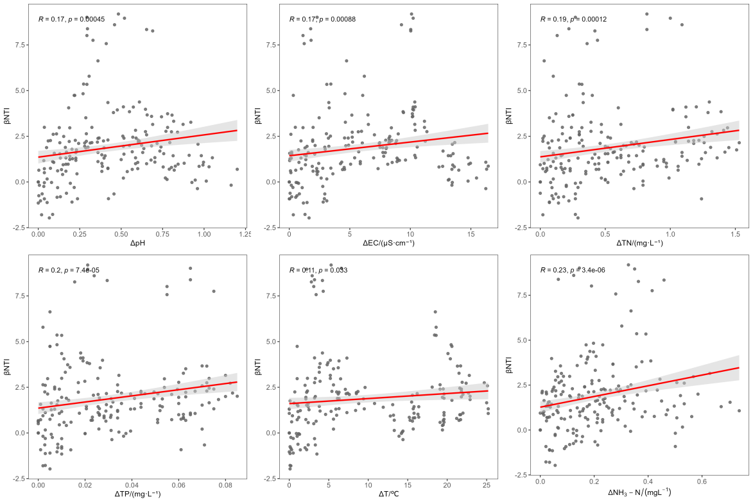
Fig. S2 Correlations between physicochemical parameters and βNTI of abundant planktonic bacterial subcommunities
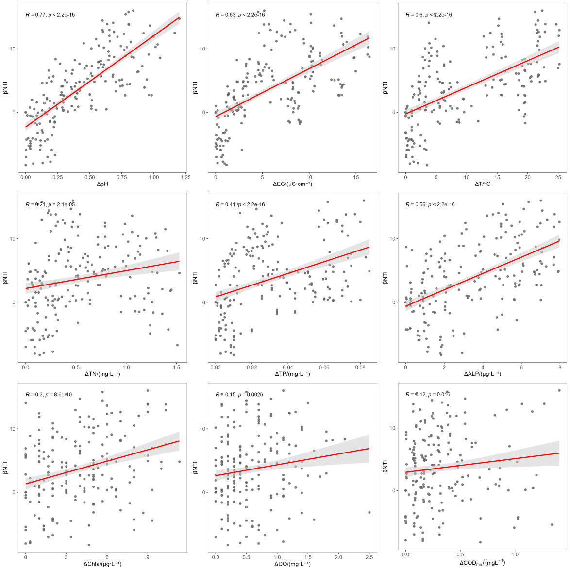
Fig. S3 Correlations between physicochemical parameters and βNTI of rare planktonic bacterial subcommunities
Table S1 PCR primers, reaction system, and amplification program used in this study
Primer sequences (5′–3′) | PCR reaction system (20 µL) | PCR amplification program | Amplicon size (bp)
338F：ACTCCTACGGGAGGCAGCAG | 2×Pro Taq 10 µL，338F（5 µM）0.8 µL，806R（5 µM）0.8 µL，Template DNA 10 ng/µL，加ddH₂O补至20 µL。 | 30 cycles of 95 °C for 30 s, 50 °C for 30 s, and 72 °C for 45 s; followed by a final extension at 72 °C for 10 min and holding at 4 °C. | ~468
806R：GGACTACHVGGGTWTCTAAT |  |  | ~468

Table S2 Physicochemical parameters of surface water in Guandaoqiao Reservoir across four seasons
Season | Sampling site | pH | EC | DO  mg·L⁻¹ | T  （℃） | COD_{Mn}  mg·L⁻¹ | BOD₅  mg·L⁻¹ | NH₃-N  mg·L⁻¹ | TN  mg·L⁻¹ | TP  mg·L⁻¹ | DTP  mg·L⁻¹ | PP  mg·L⁻¹ | DOP  mg·L⁻¹ | SRP  mg·L⁻¹ | ALP  nmol·L⁻¹·min⁻¹ | Chla  μg·L⁻¹
Spring | L1 | 8.64 | 30.07 | 5.40 | 26.20 | 5.80 | 3.30 | 0.66 | 0.86 | 0.07 | 0.02 | 0.05 | 0.01 | 0.01 | 14.51 | 23.00
Spring | L2 | 8.47 | 29.87 | 5.30 | 26.80 | 5.80 | 3.60 | 0.67 | 2.28 | 0.08 | 0.02 | 0.06 | 0.00 | 0.01 | 14.41 | 25.00
Spring | L3 | 8.44 | 30.00 | 5.20 | 23.70 | 5.73 | 3.60 | 0.69 | 2.10 | 0.08 | 0.02 | 0.06 | 0.01 | 0.01 | 13.33 | 23.67
Spring | L4 | 8.41 | 30.83 | 4.60 | 26.10 | 5.65 | 3.80 | 0.90 | 2.37 | 0.08 | 0.02 | 0.06 | 0.01 | 0.02 | 12.61 | 25.00
Spring | L5 | 8.61 | 30.07 | 5.70 | 24.80 | 5.80 | 3.30 | 0.56 | 2.10 | 0.08 | 0.02 | 0.07 | 0.01 | 0.01 | 11.48 | 25.33
Spring | L6 | 8.23 | 53.68 | 6.77 | 26.13 | 5.24 | 3.30 | 0.64 | 1.45 | 0.05 | 0.02 | 0.03 | 0.00 | 0.02 | 9.79 | 19.67
Summer | L1 | 8.36 | 38.87 | 5.70 | 32.40 | 5.64 | 3.80 | 0.74 | 0.92 | 0.11 | 0.02 | 0.09 | 0.00 | 0.01 | 15.38 | 20.00
Summer | L2 | 8.25 | 38.97 | 5.00 | 32.10 | 5.64 | 3.60 | 0.83 | 1.15 | 0.11 | 0.02 | 0.09 | 0.00 | 0.01 | 14.76 | 24.67
Summer | L3 | 8.25 | 38.33 | 5.00 | 32.20 | 5.33 | 3.80 | 0.95 | 1.06 | 0.12 | 0.02 | 0.10 | 0.00 | 0.01 | 13.58 | 28.00
Summer | L4 | 8.25 | 37.80 | 5.20 | 35.60 | 6.32 | 3.40 | 0.88 | 1.01 | 0.12 | 0.02 | 0.10 | 0.00 | 0.01 | 12.91 | 29.33
Summer | L5 | 8.28 | 38.30 | 5.60 | 33.30 | 6.67 | 3.50 | 0.61 | 0.84 | 0.13 | 0.02 | 0.11 | 0.01 | 0.01 | 15.39 | 28.00
Summer | L6 | 7.59 | 43.70 | 5.67 | 34.00 | 5.31 | 3.43 | 0.72 | 1.37 | 0.06 | 0.02 | 0.04 | 0.00 | 0.02 | 6.08 | 13.67
Autumn | L1 | 7.73 | 40.43 | 5.00 | 30.00 | 5.50 | 3.50 | 1.19 | 1.48 | 0.05 | 0.02 | 0.03 | 0.00 | 0.02 | 9.75 | 26.67
Autumn | L2 | 7.95 | 40.10 | 5.50 | 29.00 | 5.57 | 3.40 | 1.02 | 1.28 | 0.06 | 0.02 | 0.04 | 0.00 | 0.02 | 14.48 | 25.00
Autumn | L3 | 7.96 | 40.27 | 3.90 | 30.00 | 5.47 | 3.60 | 0.52 | 1.08 | 0.06 | 0.02 | 0.03 | 0.01 | 0.02 | 9.70 | 23.00
Autumn | L4 | 7.86 | 40.23 | 5.30 | 31.00 | 5.90 | 3.30 | 0.49 | 0.98 | 0.06 | 0.02 | 0.04 | 0.01 | 0.01 | 9.47 | 20.00
Autumn | L5 | 7.83 | 41.23 | 6.40 | 30.00 | 5.81 | 3.20 | 0.45 | 0.96 | 0.06 | 0.02 | 0.04 | 0.02 | 0.00 | 8.72 | 18.00
Autumn | L6 | 8.23 | 41.08 | 5.70 | 29.33 | 5.81 | 3.53 | 0.54 | 1.23 | 0.05 | 0.02 | 0.03 | 0.01 | 0.01 | 9.67 | 16.67
Winter | L1 | 7.66 | 43.20 | 5.40 | 10.40 | 5.72 | 3.20 | 0.63 | 1.60 | 0.05 | 0.02 | 0.03 | 0.01 | 0.01 | 7.47 | 19.00
Winter | L2 | 7.68 | 43.53 | 5.20 | 10.60 | 5.72 | 3.10 | 0.66 | 1.58 | 0.05 | 0.03 | 0.02 | 0.01 | 0.02 | 7.70 | 20.00
Winter | L3 | 7.44 | 43.50 | 4.50 | 10.90 | 5.26 | 3.50 | 0.68 | 1.31 | 0.05 | 0.02 | 0.02 | 0.01 | 0.01 | 8.39 | 19.00
Winter | L4 | 7.59 | 44.83 | 4.30 | 10.50 | 5.51 | 3.40 | 0.68 | 1.31 | 0.05 | 0.02 | 0.03 | 0.01 | 0.02 | 7.42 | 21.00
Winter | L5 | 7.65 | 46.30 | 5.50 | 10.40 | 5.40 | 3.40 | 0.72 | 1.38 | 0.05 | 0.02 | 0.03 | 0.01 | 0.01 | 7.67 | 19.00
Winter | L6 | 7.97 | 43.59 | 6.43 | 10.00 | 5.15 | 3.33 | 0.46 | 1.35 | 0.04 | 0.02 | 0.03 | 0.00 | 0.02 | 8.86 | 13.33

Table S3 Seasonal mean values of physicochemical parameters in surface water of Guandaoqiao Reservoir and Longtai River
Parameter | Unit | Spring | Summer | Autumn | Winter | Whole-reservoir mean | Mean of Longtai River
pH | — | 8.51 ± 0.09a | 8.28 ± 0.04b | 7.87 ± 0.08c | 7.60 ± 0.09d | 8.07 | 8.00
EC | μS·cm-1 | 30.17 ± 0.34d | 38.45 ± 0.42c | 40.45 ± 0.40b | 44.27 ± 1.16a | 38.34 | 45.78
DO | mg·L-1 | 5.24 ± 0.36b | 5.30 ± 0.30a | 5.22 ± 0.81c | 4.98 ± 0.49d | 5.19 | 6.14
T | ℃ | 25.52 ± 1.12c | 33.12 ± 1.31a | 30.00 ± 0.63b | 10.56 ± 0.19d | 24.80 | 24.87
CODMn | mg·L-1 | 5.76 ± 0.06b | 5.92 ± 0.50a | 5.65 ± 0.17c | 5.52 ± 0.18d | 5.71 | 5.38
BOD5 | mg·L-1 | 3.5 ± 0.19b | 3.6 ± 0.16a | 3.4 ± 0.14c | 3.3 ± 0.15c | 3.5 | 3.4
NH3-N | mg·L-1 | 0.70 ± 0.11c | 0.80 ± 0.12a | 0.73 ± 0.31b | 0.68 ± 0.03d | 0.73 | 0.59
TN | mg·L-1 | 1.94 ± 0.55a | 1.00 ± 0.11d | 1.16 ± 0.20c | 1.44 ± 0.13b | 1.39 | 1.35
TP | mg·L-1 | 0.08 ± 0.01b | 0.12 ± 0.01a | 0.06 ± 0.003c | 0.05 ± 0.002c | 0.08 | 0.05
DTP | mg·L-1 | 0.019± 0.002c | 0.017± 0.001d | 0.021± 0.002b | 0.023± 0.002a | 0.020 | 0.019
PP | mg·L-1 | 0.061 ± 0.01b | 0.103 ± 0.01a | 0.039 ± 0.01c | 0.027± 0.003d | 0.058 | 0.031
DOP | mg·L-1 | 0.006± 0.002c | 0.004± 0.001d | 0.007 ± 0.01b | 0.008± 0.001a | 0.006 | 0.005
SRP | mg·L-1 | 0.013± 0.001b | 0.013± 0.001b | 0.014± 0.01ab | 0.015± 0.001a | 0.014 | 0.014
ALP | nmol·L-1·min-1 | 13.27 ± 1.14b | 14.40 ± 1.00a | 10.42 ± 2.06c | 7.73 ± 0.35d | 11.46 | 8.60
Chla | μg·L-1 | 24.4 ± 0.9b | 26.0 ± 3.4a | 22.5 ± 3.2c | 19.6 ± 0.8d | 23.1 | 15.8
Table S4 Illumina MiSeq high-throughput sequencing results of abundant planktonic bacterial subcommunities in surface water of Guandaoqiao Reservoir across four seasons
Sample | Number of ASVs | ACE | Chao | Shannon | Simpson | Coverage | Phylum | Class | Order | Family | Genus
SPSL1 | 61 | 61 | 61 | 2.968240 | 0.119430 | 1 | 6 | 9 | 17 | 24 | 28
SPSL2 | 64 | 64 | 64 | 3.375374 | 0.057770 | 1 | 6 | 9 | 18 | 25 | 29
SPSL3 | 67 | 67 | 67 | 3.428268 | 0.056054 | 1 | 6 | 10 | 19 | 27 | 31
SPSL4 | 65 | 65 | 65 | 3.355742 | 0.05751 | 1 | 6 | 9 | 18 | 25 | 29
SPSL5 | 61 | 61 | 61 | 3.189568 | 0.070009 | 1 | 6 | 9 | 17 | 24 | 28
Whole-reservoir | — | 64 | 64 | 3.197438 | 0.077449 | 1 | — | — | — | — | —
SPSL6 | 65 | 65 | 65 | 3.012879 | 0.073822 | 1 | 8 | 10 | 20 | 28 | 32
SUSL1 | 68 | 68 | 68 | 3.218976 | 0.063807 | 1 | 10 | 15 | 29 | 34 | 34
SUSL2 | 70 | 70 | 70 | 3.269510 | 0.064237 | 1 | 10 | 15 | 28 | 34 | 35
SUSL3 | 72 | 72 | 72 | 3.329691 | 0.058312 | 1 | 10 | 15 | 30 | 36 | 39
SUSL4 | 76 | 76 | 76 | 3.476958 | 0.053637 | 1 | 11 | 16 | 30 | 37 | 39
SUSL5 | 69 | 69 | 69 | 3.166632 | 0.076628 | 1 | 10 | 15 | 28 | 34 | 36
Whole-reservoir | — | 71 | 71 | 3.252353 | 0.065324 | 1 | — | — | — | — | —
SUSL6 | 64 | 64 | 64 | 3.072621 | 0.070340 | 1 | 6 | 9 | 20 | 26 | 30
AUSL1 | 70 | 70 | 70 | 2.863267 | 0.094925 | 1 | 10 | 14 | 27 | 34 | 37
AUSL2 | 64 | 64 | 64 | 2.596842 | 0.123706 | 1 | 10 | 14 | 28 | 35 | 37
AUSL3 | 77 | 77 | 77 | 3.595041 | 0.058955 | 1 | 10 | 14 | 28 | 34 | 36
AUSL4 | 69 | 0 | 69 | 3.406116 | 0.074849 | 1 | 10 | 14 | 28 | 35 | 36
AUSL5 | 48 | 0 | 48 | 1.314139 | 0.561525 | 1 | 9 | 13 | 23 | 29 | 31
Whole-reservoir | — | 42 | 66 | 2.555081 | 0.215192 | 1 | — | — | — | — | —
AUSL6 | 51 | 0 | 51 | 2.936610 | 0.051377 | 1 | 10 | 14 | 25 | 29 | 29
WISL1 | 45 | 45 | 45 | 1.923359 | 0.287570 | 1 | 5 | 8 | 13 | 16 | 20
WISL2 | 43 | 0 | 43 | 2.461419 | 0.184630 | 1 | 5 | 8 | 13 | 16 | 20
WISL3 | 47 | 0 | 47 | 2.661938 | 0.145890 | 1 | 6 | 9 | 15 | 20 | 22
WISL4 | 54 | 54 | 54 | 2.951949 | 0.070597 | 1 | 6 | 10 | 16 | 20 | 24
WISL5 | 46 | 0 | 46 | 2.770575 | 0.110183 | 1 | 5 | 8 | 14 | 18 | 21
Whole-reservoir | — | 20 | 47 | 2.519848 | 0.169774 | 1 | — | — | — | — | —
WISL6 | 50 | 50 | 50 | 2.924351 | 0.074640 | 1 | 6 | 9 | 16 | 21 | 25
Note: SPS, SUS, AUS, and WIS denote surface water samples in spring, summer, autumn, and winter, respectively; "L" indicates the sample, and the number following "L" denotes the sampling site number. The same applies below.
Table S5 Illumina MiSeq high-throughput sequencing results of rare planktonic bacterial subcommunities in surface water of Guandaoqiao Reservoir across four seasons
Sample | Number of ASVs | ACE | Chao | Shannon | Simpson | Coverage | Phylum | Class | Order | Family | Genus
SPSL1 | 355 | 355 | 355 | 5.005107 | 0.012028 | 1 | 19 | 35 | 81 | 116 | 159
SPSL2 | 402 | 402 | 402 | 5.328845 | 0.007407 | 1 | 23 | 48 | 101 | 151 | 204
SPSL3 | 393 | 393 | 393 | 5.242793 | 0.008490 | 1 | 24 | 47 | 104 | 158 | 212
SPSL4 | 480 | 480 | 480 | 5.415177 | 0.006976 | 1 | 24 | 46 | 95 | 149 | 206
SPSL5 | 387 | 387 | 387 | 5.225735 | 0.008780 | 1 | 22 | 42 | 102 | 157 | 199
Whole-reservoir | — | 403 | 403 | 5.243531 | 0.008736 | 1 | — | — | — | — | —
SPSL6 | 813 | 813 | 813 | 5.776187 | 0.006810 | 1 | 29 | 62 | 151 | 240 | 352
SUSL1 | 287 | 287 | 287 | 5.062212 | 0.009896 | 1 | 22 | 44 | 92 | 134 | 166
SUSL2 | 409 | 409 | 409 | 5.413591 | 0.006933 | 1 | 29 | 55 | 111 | 162 | 202
SUSL3 | 513 | 513 | 513 | 5.584120 | 0.005767 | 1 | 24 | 47 | 111 | 165 | 210
SUSL4 | 722 | 722 | 722 | 5.906398 | 0.004407 | 1 | 29 | 61 | 142 | 205 | 306
SUSL5 | 591 | 591 | 591 | 5.777424 | 0.004675 | 1 | 25 | 52 | 123 | 194 | 269
Whole-reservoir | — | 504 | 504 | 5.548749 | 0.006336 | 1 | — | — | — | — | —
SUSL6 | 800 | 800 | 800 | 5.707781 | 0.007118 | 1 | 34 | 79 | 174 | 255 | 377
AUSL1 | 277 | 277 | 277 | 4.849238 | 0.014930 | 1 | 25 | 48 | 100 | 135 | 187
AUSL2 | 354 | 354 | 354 | 5.348524 | 0.010003 | 1 | 26 | 52 | 112 | 169 | 225
AUSL3 | 427 | 427 | 427 | 5.580485 | 0.005724 | 1 | 23 | 50 | 109 | 165 | 222
AUSL4 | 388 | 388 | 388 | 5.352333 | 0.007914 | 1 | 23 | 46 | 92 | 144 | 196
AUSL5 | 280 | 280 | 280 | 4.923442 | 0.010221 | 1 | 23 | 41 | 88 | 130 | 167
Whole-reservoir | — | 345 | 345 | 5.356804 | 0.008358 | 1 | — | — | — | — | —
AUSL6 | 276 | 276 | 276 | 4.826229 | 0.015214 | 1 | 21 | 39 | 88 | 130 | 163
WISL1 | 215 | 215 | 215 | 5.059563 | 0.008594 | 1 | 17 | 36 | 82 | 107 | 140
WISL2 | 154 | 154 | 154 | 4.773839 | 0.009920 | 1 | 20 | 33 | 79 | 98 | 111
WISL3 | 442 | 442 | 442 | 5.783130 | 0.003997 | 1 | 21 | 45 | 116 | 163 | 231
WISL4 | 427 | 427 | 427 | 5.677945 | 0.004785 | 1 | 22 | 45 | 121 | 173 | 226
WISL5 | 387 | 387 | 387 | 5.650400 | 0.004698 | 1 | 20 | 41 | 99 | 150 | 207
Whole-reservoir | — | 325 | 325 | 5.388975 | 0.006399 | 1 | — | — | — | — | —
WISL6 | 621 | 621 | 621 | 5.607548 | 0.009174 | 1 | 30 | 58 | 122 | 192 | 291
Table S6 ASV IDs and taxonomic information of keystone species in planktonic bacterial communities in surface water of Guandaoqiao Reservoir across four seasons
Season | Taxa | Number of ASVs | Phylum | Class | Genus
Spring | Abundant subcommunities | ASV47 | Pseudomonadota | Gammaproteobacteria | Acidibacter
Spring | Abundant subcommunities | ASV61 | Bacteroidota | Bacteroidia | norank_f__NS11-12_marine_group
Spring | Abundant subcommunities | ASV103 | Actinomycetota | Actinobacteria | hgcI_clade
Spring | Abundant subcommunities | ASV329 | Bacteroidota | Bacteroidia | Fluviicola
Spring | Intermediate taxa | ASV72 | Actinomycetota | Actinobacteria | unclassified_f__Microbacteriaceae
Spring | Intermediate taxa | ASV258 | Pseudomonadota | Gammaproteobacteria | Acinetobacter
Spring | Intermediate taxa | ASV2449 | Pseudomonadota | Gammaproteobacteria | Limnohabitans
Spring | Rare subcommunities | ASV131 | Pseudomonadota | Gammaproteobacteria | unclassified_f__Oxalobacteraceae
Spring | Rare subcommunities | ASV237 | Pseudomonadota | Alphaproteobacteria | norank_f__Mitochondria
Spring | Rare subcommunities | ASV518 | Pseudomonadota | Alphaproteobacteria | norank_o__Elsterales
Spring | Rare subcommunities | ASV551 | Pseudomonadota | Alphaproteobacteria | norank_o__Elsterales
Spring | Rare subcommunities | ASV599 | Pseudomonadota | Gammaproteobacteria | Pseudomonas
Spring | Rare subcommunities | ASV2489 | Bacteroidota | Bacteroidia | Dinghuibacter
Summer | Intermediate taxa | ASV3306 | Actinomycetota | Acidimicrobiia | CL500-29_marine_group
Summer | Intermediate taxa | ASV3317 | Pseudomonadota | Gammaproteobacteria | unclassified_f__Comamonadaceae
Summer | Rare subcommunities | ASV3469 | Pseudomonadota | Alphaproteobacteria | norank_c__Alphaproteobacteria
Autumn | Abundant subcommunities | ASV599 | Pseudomonadota | Gammaproteobacteria | Pseudomonas
Autumn | Abundant subcommunities | ASV1572 | Pseudomonadota | Gammaproteobacteria | Delftia
Autumn | Intermediate taxa | ASV1072 | Pseudomonadota | Gammaproteobacteria | Stenotrophomonas
Autumn | Intermediate taxa | ASV3346 | Pseudomonadota | Alphaproteobacteria | Hirschia
Autumn | Intermediate taxa | ASV3570 | Patescibacteria | Parcubacteria | norank_o__GWA2-38-13b
Autumn | Rare subcommunities | ASV4422 | Pseudomonadota | Alphaproteobacteria | Hyphomicrobium
Autumn | Rare subcommunities | ASV11842 | Cyanobacteriota | Cyanobacteriia | unclassified_f__Nostocaceae
Winter | Abundant subcommunities | ASV32 | Actinomycetota | Actinobacteria | Aurantimicrobium
Winter | Abundant subcommunities | ASV204 | Actinomycetota | Acidimicrobiia | CL500-29_marine_group
Winter | Abundant subcommunities | ASV2809 | Pseudomonadota | Alphaproteobacteria | Brevundimonas
Winter | Rare subcommunities | ASV969 | Bacteroidota | Kapabacteria | norank_o__Kapabacteriales
Winter | Rare subcommunities | ASV2762 | Pseudomonadota | Alphaproteobacteria | Brevundimonas

