Serum Calcium Dynamics and Respiratory Support Trajectories in Critically Ill Children with Lower Respiratory Tract Infections
Supplementary Material
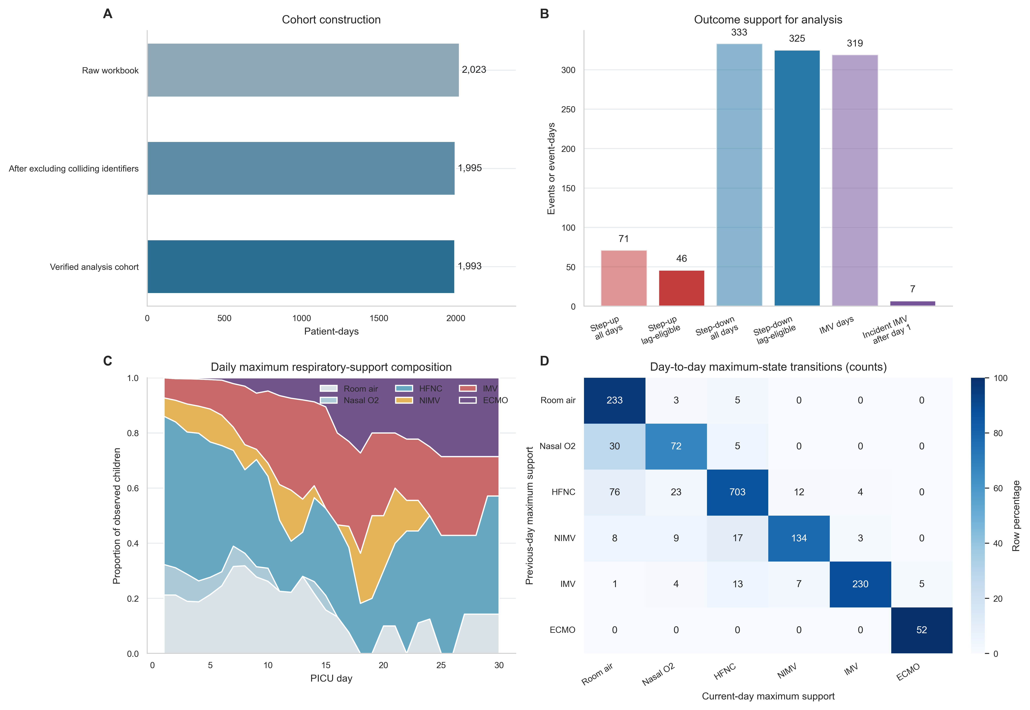
Figure S1. Cohort, outcome availability, and respiratory-support transitions. (A) Audited cohort construction. (B) Source-recorded within-day step-up and step-down event-days, lag-eligible events, prevalent IMV days (including ECMO days with IMV recorded), and eligible incident IMV events. (C) Daily composition of the maximum recorded respiratory-support level. (D) Separate previous-day-to-current-day maximum-support transition matrix. Across 1,649 consecutive day pairs, the daily maximum rose on 37 days and fell on 188 days. These derived counts are distinct from the 46 source-recorded step-up and 325 source-recorded step-down event-days used in the primary models. The 46 total upward ladder steps in panel D do not represent 46 upward event-days. Only seven eligible incident IMV events followed a non-IMV day, so no adjusted incident-onset model was fitted.

Table S1. Complete primary GEE results, exposure standardization, and software verification
Outcome | Exposure | N / events | Mean (SD) | Adjusted OR (95% CI) | p | q
Step-up | Sodium | 1,649 / 46 | 137.835 (2.962) | 0.964 (0.765–1.214) | 0.753 | 0.857
Step-up | Potassium | 1,649 / 46 | 4.432 (0.529) | 1.074 (0.796–1.450) | 0.640 | 0.857
Step-up | Chloride | 1,642 / 46 | 101.684 (3.889) | 0.968 (0.753–1.244) | 0.801 | 0.857
Step-up | Calcium | 1,643 / 46 | 9.301 (0.687) | 1.313 (0.919–1.877) | 0.135 | 0.809
Step-up | Magnesium | 1,649 / 46 | 2.081 (0.309) | 1.091 (0.830–1.434) | 0.534 | 0.857
Step-up | Phosphorus | 1,648 / 46 | 4.400 (0.920) | 1.023 (0.800–1.308) | 0.857 | 0.857
Step-down | Sodium | 1,649 / 325 | 137.835 (2.962) | 1.087 (0.966–1.223) | 0.168 | 0.349
Step-down | Potassium | 1,649 / 325 | 4.432 (0.529) | 1.018 (0.893–1.161) | 0.787 | 0.787
Step-down | Chloride | 1,642 / 323 | 101.684 (3.889) | 0.969 (0.863–1.087) | 0.592 | 0.710
Step-down | Calcium | 1,643 / 324 | 9.301 (0.687) | 1.274 (1.126–1.442) | 0.00012 | 0.00071
Step-down | Magnesium | 1,649 / 325 | 2.081 (0.309) | 1.097 (0.960–1.253) | 0.175 | 0.349
Step-down | Phosphorus | 1,648 / 324 | 4.400 (0.920) | 1.054 (0.926–1.199) | 0.427 | 0.640
ORs are reported per empirical SD increase in the previous-day concentration. Models use an independence working correlation and adjust for standardized log PICU day, previous-day support level, age, sex, and admission PRISM, with patient-cluster sandwich standard errors. Step-up and step-down are source-recorded within-day binary indicators. N excludes each child's first observed day and varies by electrolyte.
All 12 primary models were independently reproduced in R and Python. The maximum absolute beta difference was 7.22 × 10⁻¹⁶, and the maximum absolute robust SE difference was 4.30 × 10⁻¹⁶.

Table S2ª. Consolidated extension, sensitivity, and exploratory analyses
Analysis family | Outcome or contrast | Exposure | Analysis size | Estimate (95% CI) | p | q
A. Calcium-focused extensions and sensitivity analyses
Primary reference | Next-day step-down | Previous-day calcium | 1,643 days / 324 events | OR 1.27 (1.13–1.44) | 0.00012 | 0.00071
Event persistence^{b} | Sustained de-escalation (no re-escalation on available day +1/+2) | Previous-day calcium | 1,494 days / 175 events | OR 1.34 (1.14–1.58) | 0.00035 | NA
Event persistence | Failed de-escalation (re-escalation on available day +1/+2) | Previous-day calcium | 1,330 days / 11 events | OR 1.40 (0.84–2.34) | 0.202 | NA
Within/between decomposition | Next-day step-down | Within-patient day-to-day calcium | 1,643 days / 324 events | OR 1.27 (1.12–1.44) | 0.00025 | NA
Within/between decomposition | Next-day step-down | Between-patient average calcium | 1,643 days / 324 events | OR 1.12 (1.00–1.25) | 0.057 | NA
Additional adjustment | Next-day step-down | Calcium with full acid–base panel | 1,643 days / 324 events | OR 1.26 (1.11–1.43) | 0.00037 | NA
Additional adjustment | Next-day step-down | Calcium with electrolyte replacement, furosemide, and steroid use | 1,643 days / 324 events | OR 1.21 (1.07–1.37) | 0.003 | NA
Source sensitivity | Next-day step-down | Calcium, duplicated trajectories excluded | 328 children | OR 1.25 (1.10–1.41) | 0.00040 | NA
B^{c}. Day-to-day electrolyte change and source-recorded transitions
Change-score GEE | Step-up | Sodium | 1,649 days / 46 events | OR 1.12 (0.86–1.47) | 0.397 | 0.757
Change-score GEE | Step-up | Potassium | 1,649 days / 46 events | OR 1.13 (0.85–1.49) | 0.403 | 0.757
Change-score GEE | Step-up | Chloride | 1,636 days / 46 events | OR 0.92 (0.74–1.16) | 0.505 | 0.757
Change-score GEE | Step-up | Calcium | 1,637 days / 46 events | OR 0.94 (0.70–1.26) | 0.673 | 0.808
Change-score GEE | Step-up | Magnesium | 1,649 days / 46 events | OR 1.13 (0.86–1.48) | 0.383 | 0.757
Change-score GEE | Step-up | Phosphorus | 1,647 days / 46 events | OR 1.03 (0.78–1.35) | 0.850 | 0.850
Change-score GEE | Step-down | Sodium | 1,649 days / 325 events | OR 0.90 (0.79–1.02) | 0.111 | 0.668
Change-score GEE | Step-down | Potassium | 1,649 days / 325 events | OR 1.00 (0.89–1.13) | 0.964 | 0.964
Change-score GEE | Step-down | Chloride | 1,636 days / 323 events | OR 1.06 (0.93–1.21) | 0.383 | 0.765
Change-score GEE | Step-down | Calcium | 1,637 days / 323 events | OR 0.99 (0.88–1.12) | 0.934 | 0.964
Change-score GEE | Step-down | Magnesium | 1,649 days / 325 events | OR 0.99 (0.87–1.13) | 0.937 | 0.964
Change-score GEE | Step-down | Phosphorus | 1,647 days / 324 events | OR 1.07 (0.94–1.22) | 0.286 | 0.765
C. Time to first de-escalation
Discrete-time survival | First step-down | Sodium | 1,199 at-risk days / 257 events | HR 1.04 (0.92–1.19) | 0.512 | 0.689
Discrete-time survival | First step-down | Potassium | 1,199 at-risk days / 257 events | HR 0.99 (0.87–1.12) | 0.837 | 0.837
Discrete-time survival | First step-down | Chloride | 1,194 at-risk days / 255 events | HR 0.93 (0.81–1.06) | 0.260 | 0.596
Discrete-time survival | First step-down | Calcium | 1,194 at-risk days / 256 events | HR 1.19 (1.05–1.34) | 0.006 | 0.034
Discrete-time survival | First step-down | Magnesium | 1,199 at-risk days / 257 events | HR 1.08 (0.94–1.23) | 0.298 | 0.596
Discrete-time survival | First step-down | Phosphorus | 1,198 at-risk days / 256 events | HR 1.04 (0.91–1.19) | 0.574 | 0.689
D. Calcium dose-response and temporal specificity
Calcium quartiles | Next-day step-down | Q2 vs Q1 | 1,643 days / 324 events | OR 1.66 (1.15–2.39) | 0.006 | NA
Calcium quartiles | Next-day step-down | Q3 vs Q1 | 1,643 days / 324 events | OR 1.60 (1.12–2.28) | 0.010 | NA
Calcium quartiles | Next-day step-down | Q4 vs Q1 | 1,643 days / 324 events | OR 1.72 (1.20–2.46) | 0.003 | NA
Temporal specificity | Next-day step-down | Previous day (lag-1) | 1,643 days | OR 1.27 (1.13–1.44) | 0.00012 | NA
Temporal specificity | Next-day step-down | Two days before (lag-2) | 1,301 days | OR 1.10 (0.96–1.26) | 0.177 | NA
Temporal specificity | Next-day step-down | Three days before (lag-3) | 1,016 days | OR 1.14 (0.98–1.33) | 0.089 | NA
Temporal specificity | Next-day step-down | Next day (reverse-time control) | 1,299 days | OR 1.26 (1.08–1.47) | 0.003 | NA
E^{d}. Ordinal maximum-support transition model
Proportional odds | Improvement on support ladder | Sodium | 1,649 days | POR 1.01 (0.87–1.16) | 0.902 | 0.930
Proportional odds | Improvement on support ladder | Potassium | 1,649 days | POR 0.92 (0.79–1.07) | 0.281 | 0.842
Proportional odds | Improvement on support ladder | Chloride | 1,642 days | POR 1.01 (0.87–1.17) | 0.930 | 0.930
Proportional odds | Improvement on support ladder | Calcium | 1,643 days | POR 1.13 (0.98–1.32) | 0.099 | 0.595
Proportional odds | Improvement on support ladder | Magnesium | 1,649 days | POR 1.05 (0.90–1.23) | 0.560 | 0.930
Proportional odds | Improvement on support ladder | Phosphorus | 1,648 days | POR 1.02 (0.88–1.19) | 0.749 | 0.930
Patient-cluster bootstrap CI | Improvement on support ladder | Calcium | 1,643 days / 300 resamples | POR 1.13 (0.97–1.30) | NA | NA
F^{e}. Patient-level cumulative electrolyte-disturbance burden
Negative-binomial burden | IMV-day rate (per observed day) | Hypomagnesemia burden (0% to 100%) | 344 children | IRR 9.25 (2.11–40.47) | 0.003 | NA
Negative-binomial burden | IMV-day rate (per observed day) | Hypophosphatemia burden (0% to 100%) | 344 children | IRR 1.61 (0.06–41.10) | 0.774 | NA
Negative-binomial burden | Observed PICU days | Hypomagnesemia burden (0% to 100%) | 344 children | IRR 3.19 (1.06–9.62) | 0.039 | NA
Negative-binomial burden | Observed PICU days | Hypophosphatemia burden (0% to 100%) | 344 children | IRR 1.06 (0.48–2.34) | 0.878 | NA
ª Unless otherwise stated, estimates are reported per empirical SD increase and use the primary adjustment set with patient-cluster robust standard errors. Benjamini–Hochberg q values are calculated within the change-score, time-to-first-de-escalation, and ordinal families. NA indicates that an adjusted q value was not calculated, or that a p value was not estimated for the bootstrap row. Rows without family-specific q values are exploratory.
^{b} Sustained step-down required at least one available record on day +1 or +2 and no recorded step-up or increase above the event-day maximum on either available day.
^{c} Change scores are current-day minus previous-day values modeled against the current-day source-recorded transition indicator. These analyses are concurrent rather than prospective.
^{d} Ordinal models use model-based standard errors. The bootstrap row reports the model POR with a percentile CI from 300 patient-cluster resamples.
^{e} Patient-level negative-binomial models use alpha fixed at 1 and HC1 robust standard errors, adjusted for age, admission PRISM, sex, pneumonia, and bronchopneumonia. The IMV-day model uses log observed days as an offset. Burden IRRs compare 0% with 100% of observed days below cutoffs of 1.7 for magnesium and 3.0 for phosphorus.

