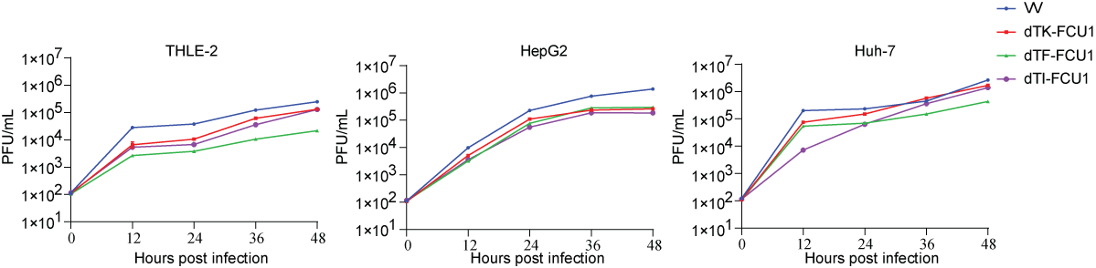
Figure S1. Replication profiles of recombinant VACV strains.
Growth curves for the indicated VACV strains in a normal human hepatocyte cell line (THLE-2), human hepatocarcinoma cell lines (Huh-7 and HepG2). The cells were infected with indicated VACV strains at MOI=0.005. At the specific time points, cultures were collected and assessed for viral titers using Vero cells. The data depict the mean values ± SD of three separate experiments conducted independently.
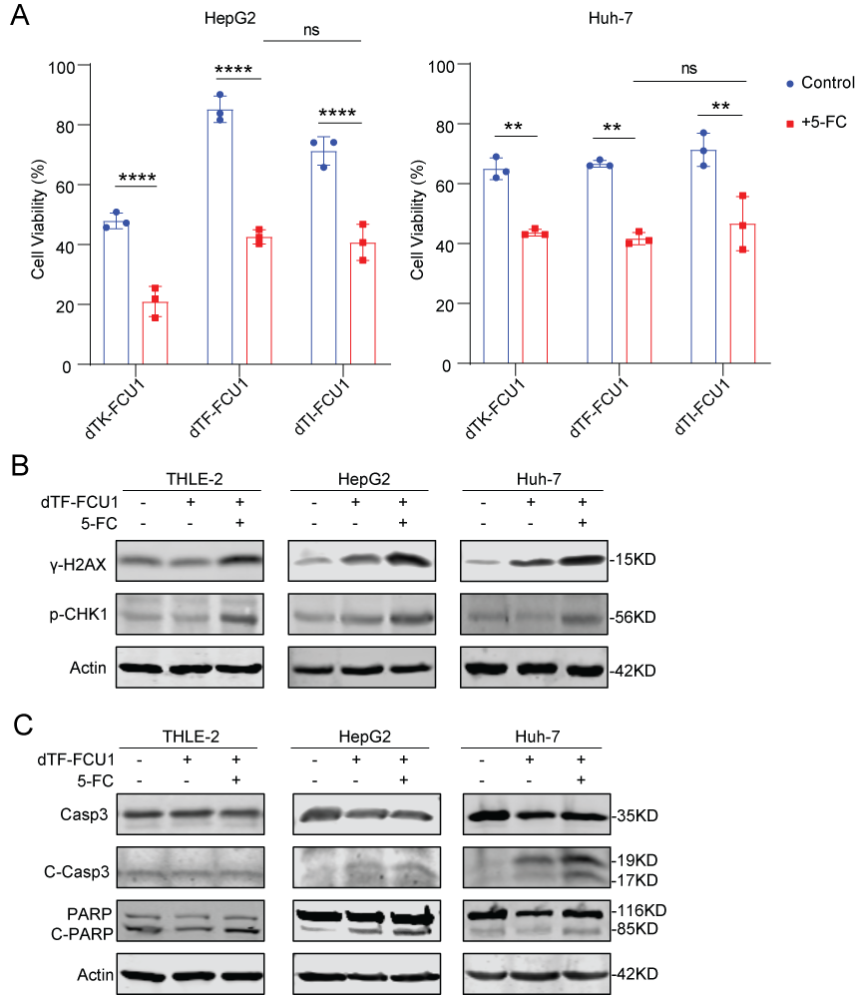
Figure S2. The combination of 5-FC and dTF-FCU1 induces significant damage to hepatocarcinoma cells.
(A) Evaluation of cytotoxicity from the combination of oncolytic viruses and prodrug activation. Cells were infected with indicated VACVs at MOI=0.001. 48 hours later, 5-FC at a final concentration of 1mM was added. Cell viability was evaluated 96 hours post-infection using the CCK8 assay. Results were normalized against control cells without virus or drug, set at 100% viability. Statistical analysis was performed with one-way ANOVA. Data are presented as mean ± SD of three replicates. *p < 0.05; **p < 0.01; ***p < 0.001; ****p < 0.0001; ns, not significant. (B-C) Assessment of double-stranded DNA damage (B) and the subsequent apoptosis (C). Cells were infected with dTF-FCU1 at MOI=0.001. After 48 hours, either 1mM 5-FC or an equal volume of 0.9% NaCl was added to the cell culture.
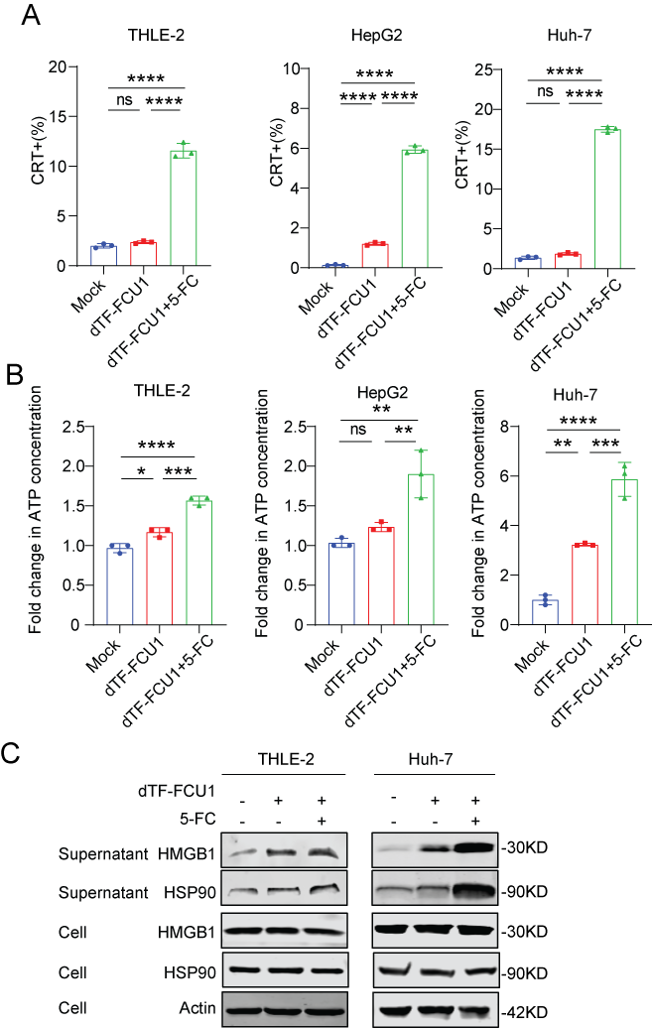
Figure S3. Detection of immunogenic cell death signals with hepatocarcinoma cells.
(A) The proportion of cells positive for surface calreticulin protein (CRT). Cells were infected with dTF-FCU1 at MOI=0.01. 2 hours post- infection, 5-FC (1mM) or 0.9% NaCl was added. 48 hours post-infection, cells were collected for Flow cytometry. Statistical analysis was performed with one-way ANOVA. (B) The relative content of ATP was detected in the supernatant. Cells were exposed to dTF-FCU1 at MOI=0.001. Two days post-infection, 1mM 5-FC was added. Another two days later, supernatant was collected to measure the ATP content. Statistical analysis was performed with one-way ANOVA. (C) Western blots to detect ICD markers HSP90 and HMGB1 in cell lysis and culture supernatant infected with the same treatment as (B). The data represents the results of three independent replicates, shown as the mean ± SD. *p < 0.05; **p < 0.01; ***p < 0.001; ****p < 0.0001; ns, not significant.
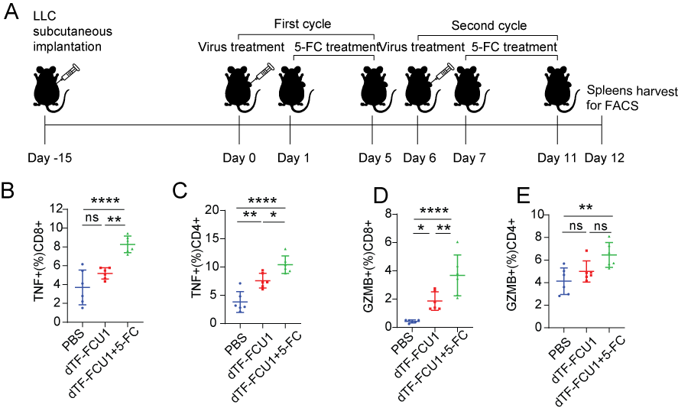
Figure S4. T lymphocyte activation in spleen by flow cytometry
(A) Schematic diagram of treatment regimen. Spleens were harvested 24 hours after the final administration of the two treatment cycles. (B) The ratio of CD8⁺TNF⁺T cells to CD8⁺T cells. Statistical analysis was performed with one-way ANOVA. (C) The ratio of CD4⁺TNF⁺T cells to CD4⁺T cells. Statistical analysis was performed with one-way ANOVA. (D) The ratio of CD8⁺GZMB⁺T cells to CD8⁺T cells. Statistical analysis was performed with one-way ANOVA. (E) The ratio of CD4⁺GZMB⁺T cells to CD4⁺T cells. Statistical analysis was performed with one-way ANOVA. Data are presented as mean values ±SD. *p < 0.05; **p < 0.01; ***p < 0.001; ****p < 0.0001; ns, not significant.

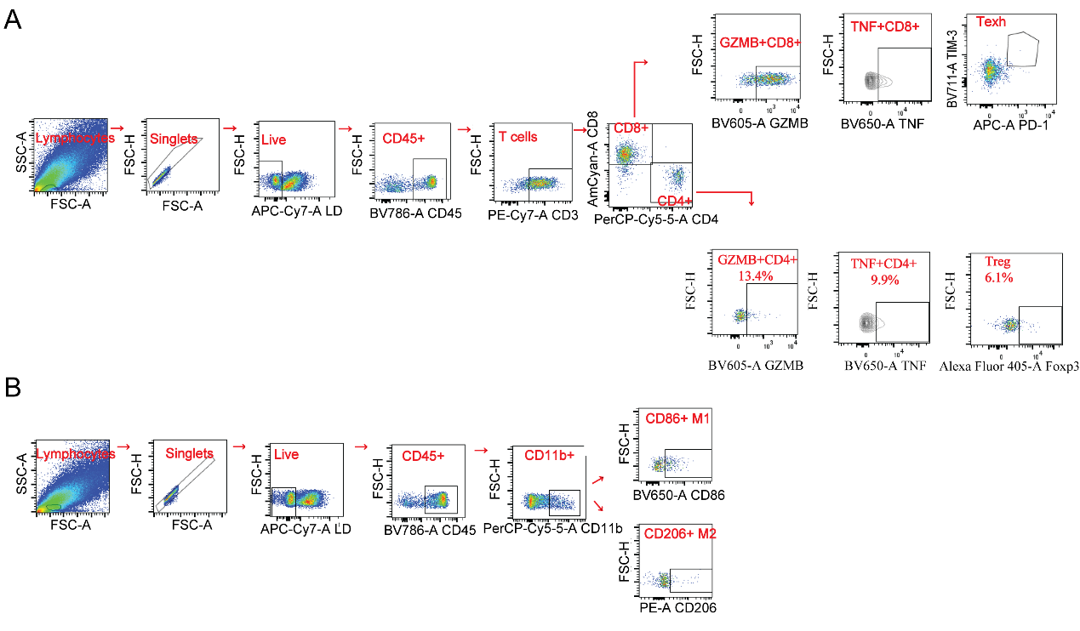
Figure S5. Gating strategy of flow cytometry to locate T cells (A) and TAMs (B).

