Code name | Picture | Appearance | Elevation | Colony nature | Colony color
A-KKU20 | 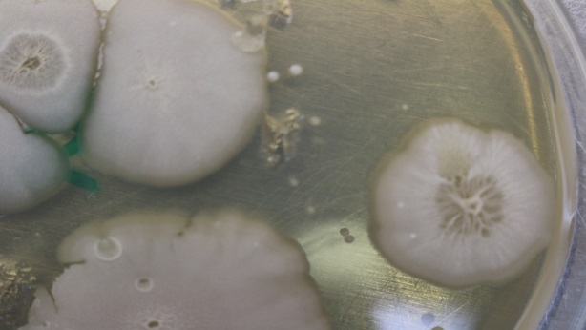 | Asymmetrical | Raised | Rough | White
B-KKU20 | 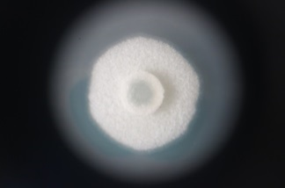 | Asymmetrical | Raised | Rough | White
C-KKU20 | 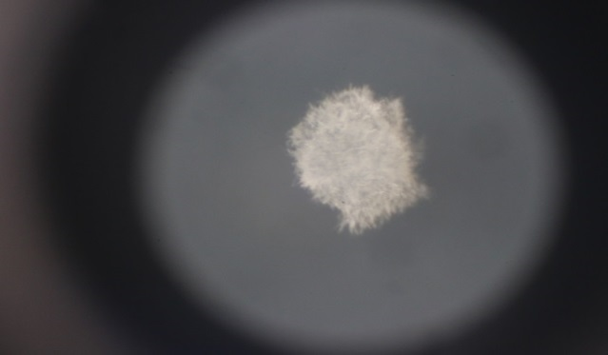 | Asymmetrical | Flat | Rough | White
D-KKU20 | 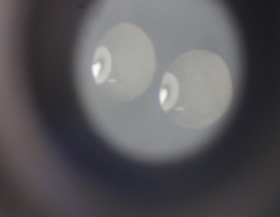 | Ovoid | Flat | Smooth and shiny | colorless
E-KKU20 | 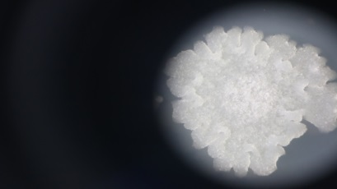 | Asymmetrical | Flat | Rough | White
F-KKU20 | 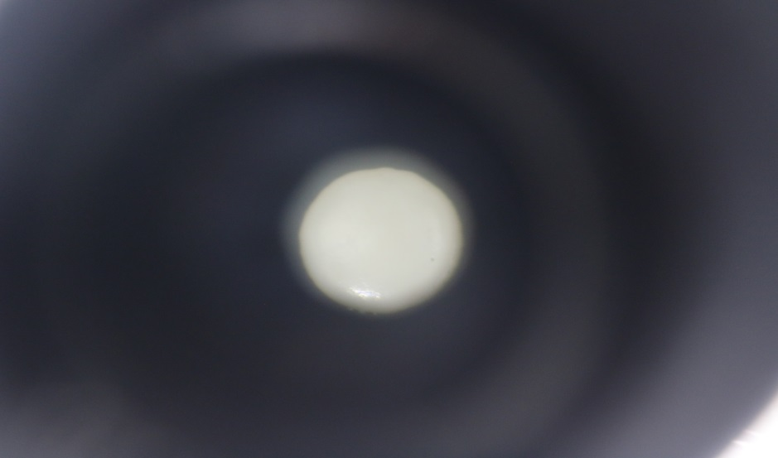 | Ovoid | Convex | Smooth | White
G-KKU20 | 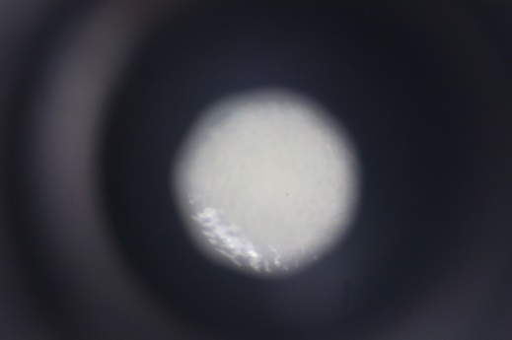 | Ovoid | Convex | Rough | Turbid
H-KKU20 | 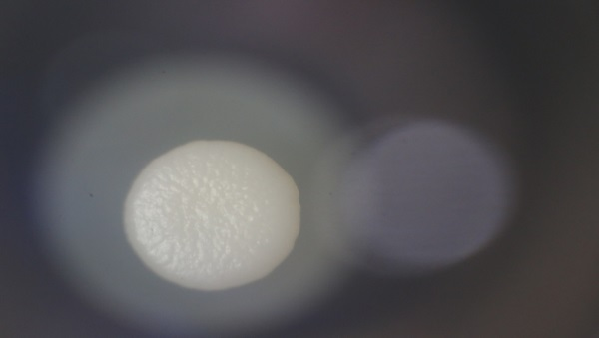 | Ovoid | Convex | Rough | White
I-KKU20 | 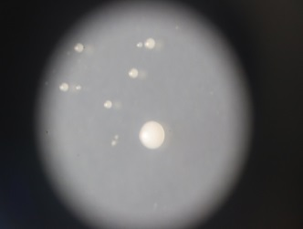 | Ovoid | Flat | Smooth | White
J-KKU20 | 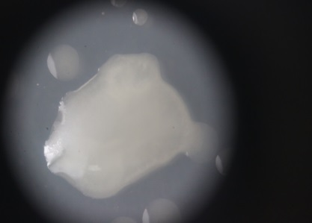 | Asymmetrical | Flat | Smooth | Colorless
K-KKU20 | 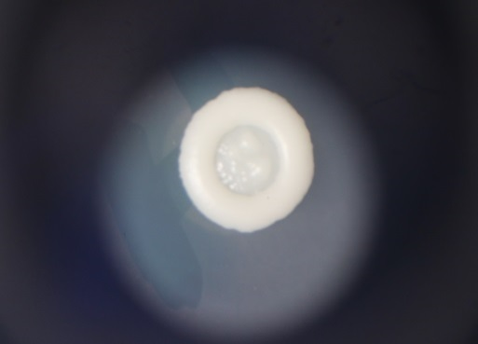 | Ovoid | Convex | Rough | White

Table 1. Colonies morphology of ruminal yeast strains of Thai-Holstein-Friesian

Isolates | Gene bank  Accession No. | Nearest Species  with Accession No. | Nucleotide  Identity (%) | No. of Nucleotide  Differences
H-KKU20 | MH545928 | Pichia kudriavzevii | 572/572 (100) | 0
I-KKU20 | U45749 | Candida tropicalis | 570/570 100 | 0
C-KKU20 | EU651849 | Galactomyce spp. | 552/553 (99.82) | 1

Table 2. Identification of isolated yeast from rumen fluids

