FIGURE LENGENDS
Fig. S1 Urease activities (UA) (a), β-glucosidase activities (BG) (b), Catalase activities (CA) (c) and Sucrase activities (SA) (d) in 2020 and 2021 under CK, NPK, M, and MNPK. Bars show mean ± SD (n = 3). Different lowercase letters indicate significant differences among treatments within the same year (LSD, P < 0.05). Results of two-way ANOVA are shown as Year (Y), Treatment (T), and their interaction (Y × T): * P < 0.05, ** P < 0.01, ns indicates no significant differences at P < 0.05.
Fig. S2 Bacterial necromass carbon (BNC) (a) and fungal necromass carbon (FNC) (b) in 2020 and 2021 under CK, NPK, M, and MNPK. Bars show mean ± SD (n = 3). Different lowercase letters indicate significant differences among treatments within the same year (LSD, P < 0.05). Results of two-way ANOVA are shown as Year (Y), Treatment (T), and their interaction (Y × T): * P < 0.05, ** P < 0.01, ns indicates no significant differences at P < 0.05.

Fig. S1
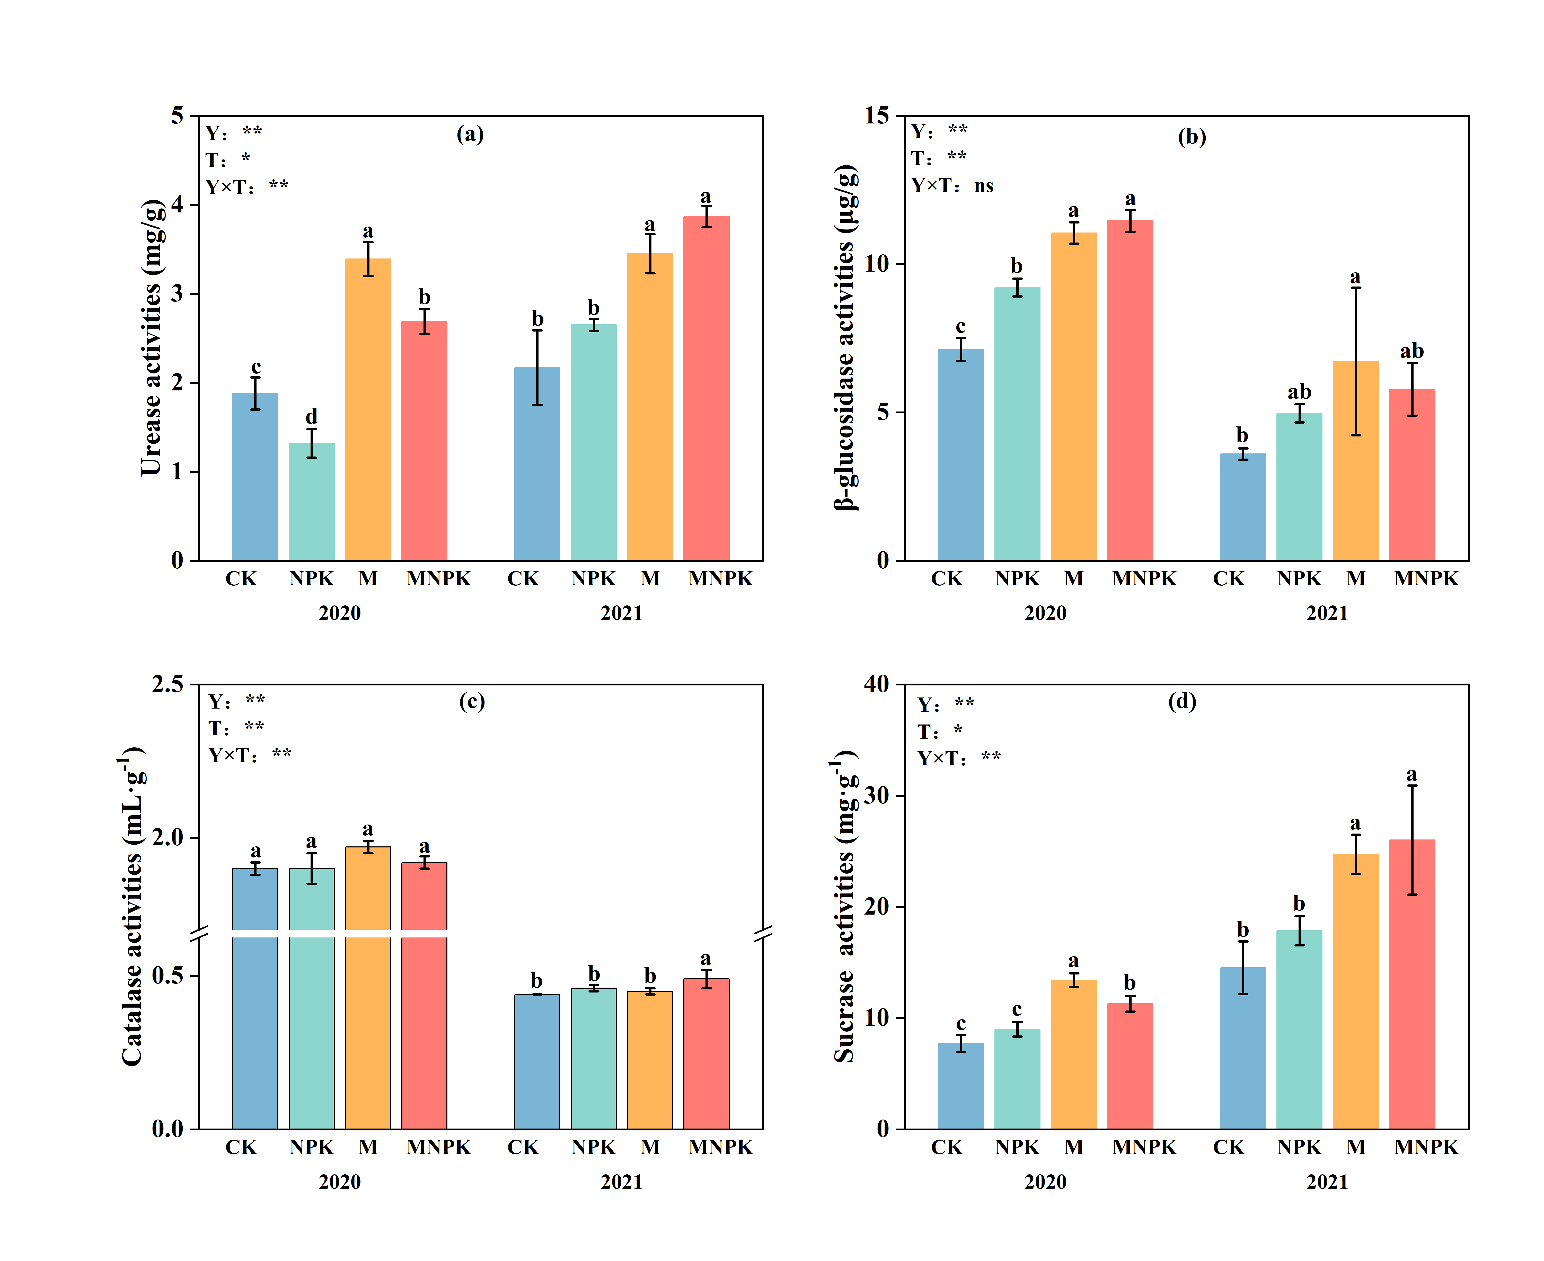

Fig. S2

