SUPPLEMENTARY METHODS
Alternative Clustering Approaches
To evaluate utility of the latent class analysis (LCA) solution, we applied three alternative clustering methods to the 14 continuous cardiometabolic variables. Whereas LCA operates on binary indicators, these methods leverage the full distributional information of the original continuous measurements, thereby providing a complementary assessment of cluster stability across both data representations and analytic frameworks. All alternative methods were constrained to a 4-cluster solution to enable direct comparison with the optimal LCA-derived classification; however k=4 was also the best-supported solution between k=3-5 (balancing between cluster resolution and complexity) across all clustering methods considered.
Prior to all continuous clustering analyses, cardiometabolic variables were standardized to z-scores (mean = 0, SD = 1) to ensure equal contribution of each variable to the distance or covariance calculations, given that the 14 indicators were measured on different scales.
(A) Latent Profile Analysis (LPA)
Latent profile analysis (LPA) extends the LCA framework to continuous observed variables by modelling the joint distribution of observed indicators as a finite mixture of multivariate normal distributions, where each mixture component corresponds to a latent profile. A 4-profile model was estimated using the mclust package in R, which employs an expectation-maximization (EM) algorithm for model fitting. This decomposition gives rise to a family of 14 parsimonious covariance structures ranging from the most constrained (EEI: equal volume, equal shape, axis-aligned) to the most flexible (VVV: variable volume, variable shape, variable orientation). All 14 covariance parameterizations were fitted for the 4-profile solution. The VVE parameterization (variable volume, variable shape and equal orientation) yielded the highest BIC and was retained. Each participant was assigned to the profile for which they had the highest posterior membership probability. Heatmaps illustrating the standardised cardiometabolic indicator means across latent profiles, along with associations between these profiles and wearable-derived sleep and physical activity metrics, are presented in Figures S2 and S3, respectively.
(B) K-Medoids Clustering (k-medoids)
K-medoids clustering is a partitional algorithm that, like k-means, assigns observations to a pre-specified number of clusters but differs in that cluster centres are defined by actual data points (medoids) rather than centroids. This property confers greater robustness to outliers and skewed distributions, which are common features of cardiometabolic data. A 4-cluster solution was estimated using the Partitioning Around Medoids (PAM) algorithm via the cluster package in R, with Euclidean distance as the dissimilarity metric. Heatmaps illustrating the standardised cardiometabolic indicator means across k-medoid profiles, along with associations between these profiles and wearable-derived sleep and physical activity metrics, are presented in Figures S4 and S5, respectively.
(C) Self-Organising Maps with K-Medoids Clustering (SOM)
Self-organising maps (SOMs) are a form of unsupervised artificial neural network that projects high-dimensional data onto a lower-dimensional (typically two-dimensional) grid of nodes while preserving the topological relationships among observations. This two-stage approach first reduces the complexity of the multivariate cardiometabolic space and then applies a clustering algorithm to the reduced representation, which can reveal structure that may be obscured in the original high-dimensional space. An SOM was trained on the standardised cardiometabolic data using the Numero package in R (1). The Numero package employs a balanced circular map topology with an automated grid size determined by the dataset dimensions. Following SOM training, the centroid vectors associated with each map node were extracted and subjected to k-medoids (PAM) clustering using Euclidean distance. Each participant was then assigned the cluster label of their best-matching SOM node. The resulting SOM component planes for all 14 cardiometabolic indicators are presented in Figure S6, where colour gradients represent standardised variable values across the map surface and numbered labels (1–4) denote the four identified clusters. Heatmaps illustrating the standardised cardiometabolic indicator means across SOM profiles, along with associations between these profiles and wearable-derived sleep and physical activity metrics, are presented in Figures S7 and S8, respectively.
Discriminant Validity
To compare the discriminant validity of the cluster solutions derived from each method, we computed partial eta-squared (partial η²) values from adjusted linear regression models (controlling for age, sex, ethnicity, and medication use) for each of the 12 wearable-derived sleep and physical activity metrics, with cluster membership as the independent variable. Partial η² quantifies the proportion of variance in each outcome attributable to cluster membership after accounting for covariates, with larger values indicating greater between-cluster differentiation. For each clustering method, we calculated the mean partial η² averaged across all 12 metrics as a summary measure of overall discriminant validity. The LCA-derived solution demonstrated the highest average discriminant validity across metrics (0.044) compared to the three alternative approaches (k-medoids: 0.043, SOM: 0.039, LPA: 0.027; Figure S9; Table S2), suggesting that clusters derived from binary cardiometabolic indicators via LCA yielded the most behaviourally distinct groupings with respect to objectively measured sleep and physical activity patterns.

SUPPLEMENTARY FIGURES
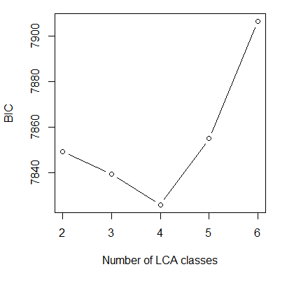
Figure S1 Bayesian Information Criterion (BIC) values across different numbers of latent classes in the Latent Class Analysis (LCA). The optimal model is indicated by the lowest BIC value, observed at the 4-class solution (BIC ≈ 7,825), suggesting that a 4-class model provides the best balance between model fit and parsimony.
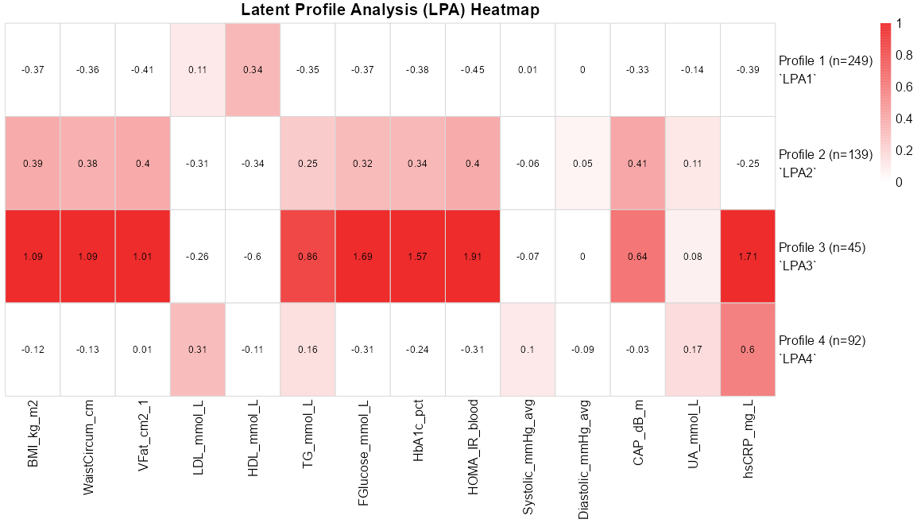
Figure S2 Heatmap of standardised cardiometabolic indicator means across latent profile clusters. Heatmap illustrating standardised cardiometabolic indicator means within each of the four latent classes identified using latent profile analysis (LPA). Darker red shading indicates higher standardised cardiometabolic indicator means. Abbreviations: HDL, high-density lipoprotein; LDL, low-density lipoprotein; FPG, fasting plasma glucose; HbA1c, glycated haemoglobin; HOMA-IR, homeostatic model assessment of insulin resistance; SBP, systolic blood pressure; DBP, diastolic blood pressure; hsCRP, high-sensitivity C-reactive protein.
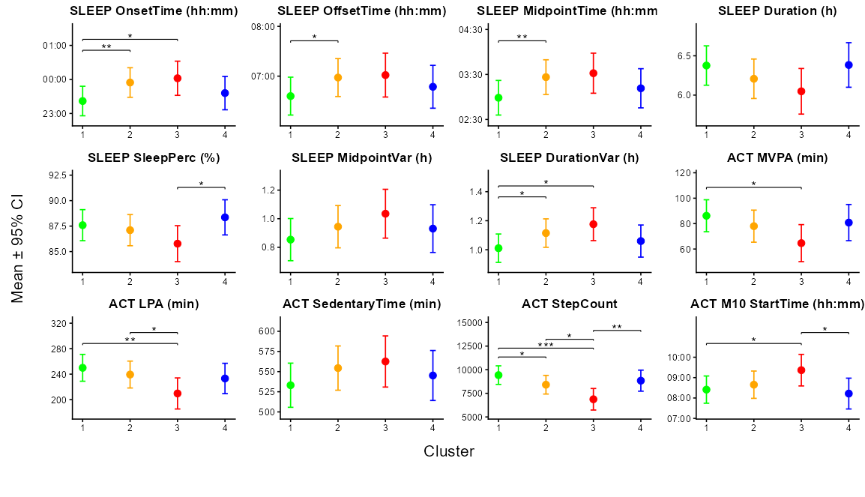Figure S3 Associations between cardiometabolic phenotypes and wearable-derived sleep and physical activity metrics. Estimated marginal means (±95% confidence intervals) of multidimensional sleep and physical activity metrics across the four latent cardiometabolic clusters identified by latent class analysis, from regression models adjusted for age, sex, ethnicity and medication use (blood pressure, cholesterol and diabetes). Significant differences between clusters are indicated by asterisks (*p<0.05, **p<0.01, ***p<0.001).

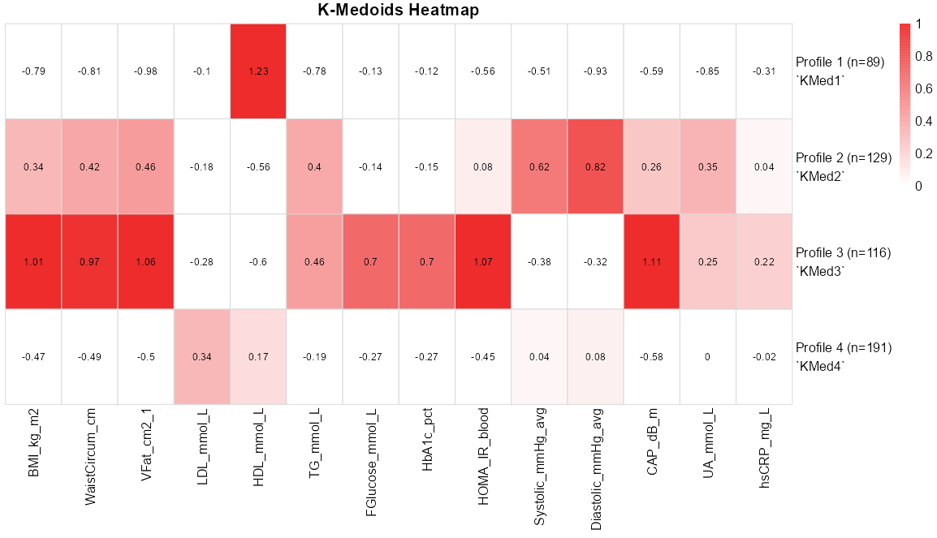
Figure S4 Heatmap of standardised cardiometabolic indicator means across k-medoids clusters. Heatmap illustrating standardised cardiometabolic indicator means within each of the four classes identified using k-medoids. Darker red shading indicates higher standardised cardiometabolic indicator means. Abbreviations: HDL, high-density lipoprotein; LDL, low-density lipoprotein; FPG, fasting plasma glucose; HbA1c, glycated haemoglobin; HOMA-IR, homeostatic model assessment of insulin resistance; SBP, systolic blood pressure; DBP, diastolic blood pressure; hsCRP, high-sensitivity C-reactive protein.
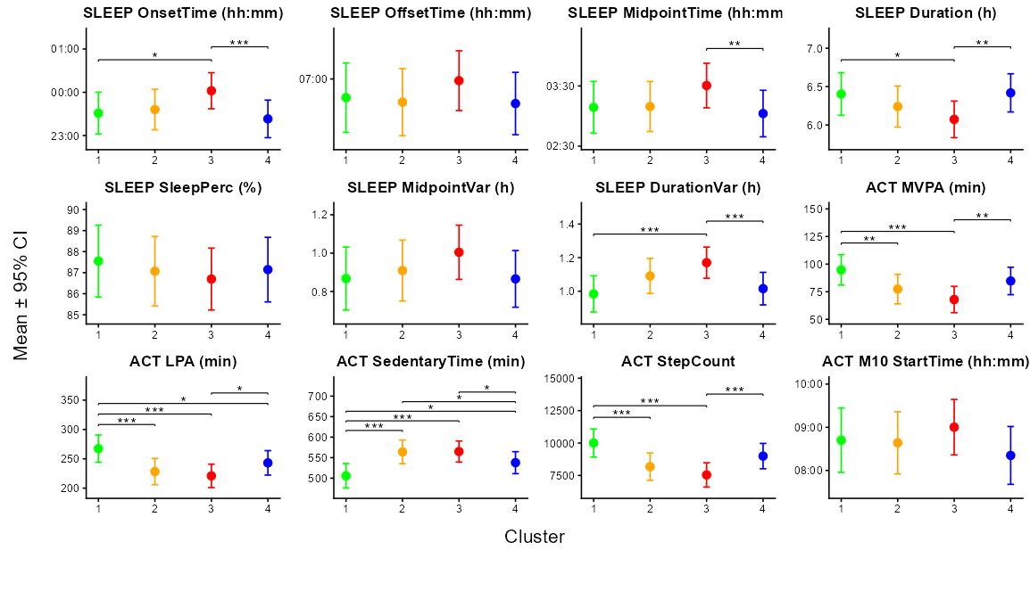Figure S5 Associations between cardiometabolic phenotypes and wearable-derived sleep and physical activity metrics. Estimated marginal means (±95% confidence intervals) of multidimensional sleep and physical activity metrics across the four latent cardiometabolic clusters identified by k-medoids, from regression models adjusted for age, sex, ethnicity and medication use (blood pressure, cholesterol and diabetes). Significant differences between clusters are indicated by asterisks (*p<0.05, **p<0.01, ***p<0.001).
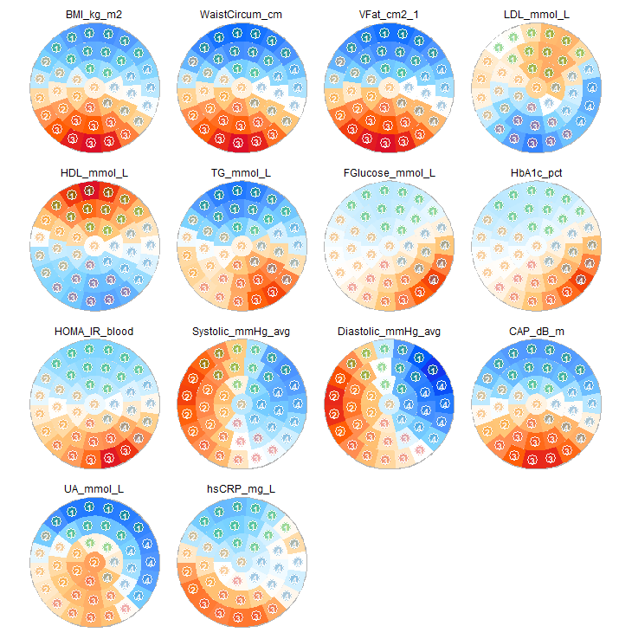
Figure S6 Self-organising map (SOM) component planes of 14 cardiometabolic indicators with k-medoids cluster assignment. Each sub-panel represents a self-organising map (SOM) unit, with colours indicating the standardized value of the corresponding variable (blue = lower values; white = intermediate values; red = higher values). Similar colour patterns across component planes indicate correlated variables and reveal underlying multidimensional relationships. Cluster labels (1–4) on each map node were derived from k-medoids (PAM) clustering of the SOM centroids. Visual inspection of the component planes revealed co-localisation of elevated BMI, waist circumference, visceral fat area, triglycerides, HOMA-IR, and uric acid in Cluster 3, suggesting a profile characterised by central adiposity and insulin resistance. HDL cholesterol displayed an opposing spatial gradient, with the highest values concentrated in Cluster 1 where adiposity markers were also the lowest. LDL cholesterol also showed elevated values in Cluster 1, largely independent of the adiposity and blood pressure gradients. Systolic and diastolic blood pressure exhibited strong spatial concordance, with the highest values localised in Cluster 2, indicating a hypertensive phenotype partially independent of the adiposity-driven cluster. Cluster 4 was largely characterised by elevated fasting glucose and HbA1c in the absence of pronounced adiposity, suggesting a dysglycaemic phenotype. Abbreviations: BMI, body mass index; VFat, visceral fat area; LDL, low-density lipoprotein cholesterol; HDL, high-density lipoprotein cholesterol; TG, triglycerides; FGlucose, fasting glucose; HbA1c, glycated haemoglobin; HOMA-IR, homeostatic model assessment of insulin resistance; CAP, controlled attenuation parameter; UA, uric acid; hsCRP, high-sensitivity C-reactive protein.
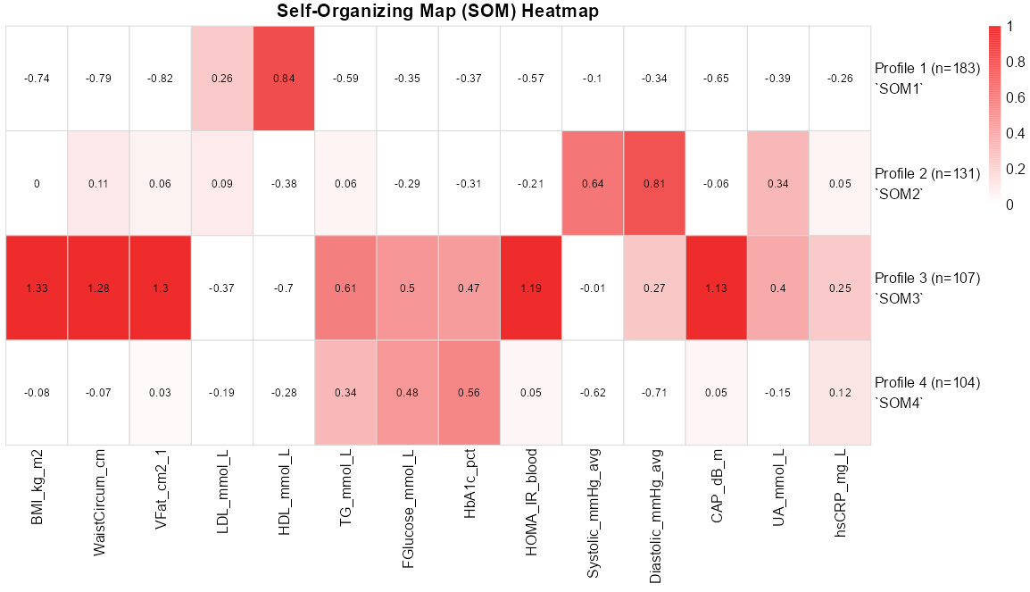
Figure S7 Heatmap of standardised cardiometabolic indicator means across self-organising map (SOM) clusters. Heatmap illustrating standardised cardiometabolic indicator means within each of the four classes identified using self-organising maps followed by k-medoids. Darker red shading indicates higher standardised cardiometabolic indicator means. Abbreviations: HDL, high-density lipoprotein; LDL, low-density lipoprotein; FPG, fasting plasma glucose; HbA1c, glycated haemoglobin; HOMA-IR, homeostatic model assessment of insulin resistance; SBP, systolic blood pressure; DBP, diastolic blood pressure; hsCRP, high-sensitivity C-reactive protein.
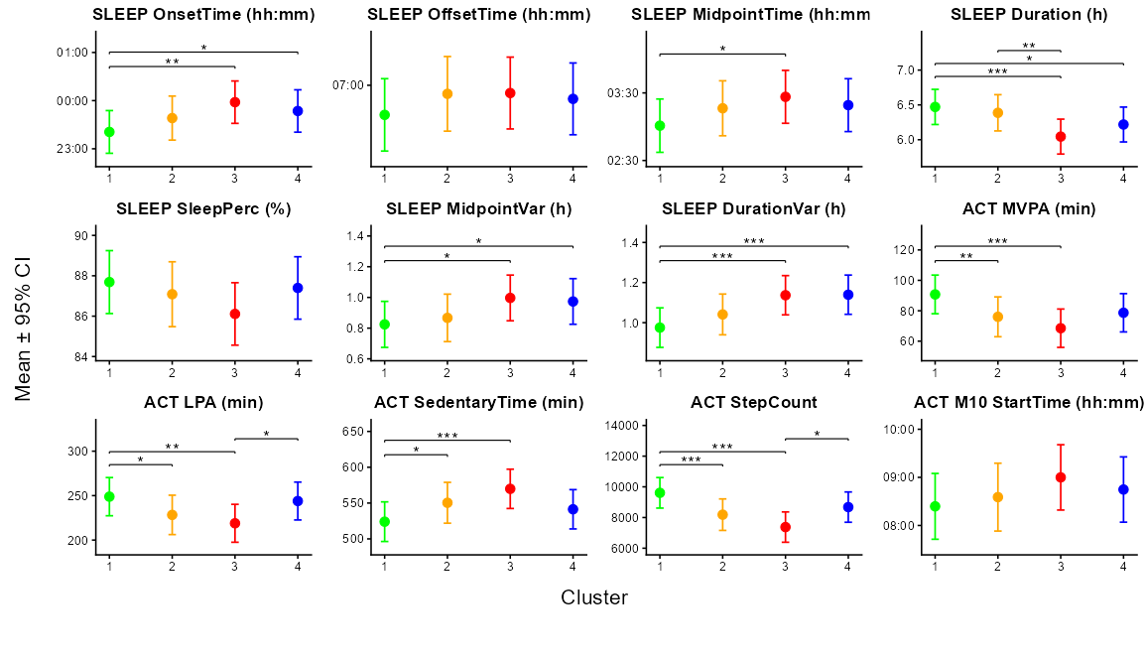Figure S8 Associations between cardiometabolic phenotypes and wearable-derived sleep and physical activity metrics. Estimated marginal means (±95% confidence intervals) of multidimensional sleep and physical activity metrics across the four latent cardiometabolic clusters identified by self-organising maps followed by k-medoids, from regression models adjusted for age, sex, ethnicity and medication use (blood pressure, cholesterol and diabetes). Significant differences between clusters are indicated by asterisks (*p<0.05, **p<0.01, ***p<0.001).
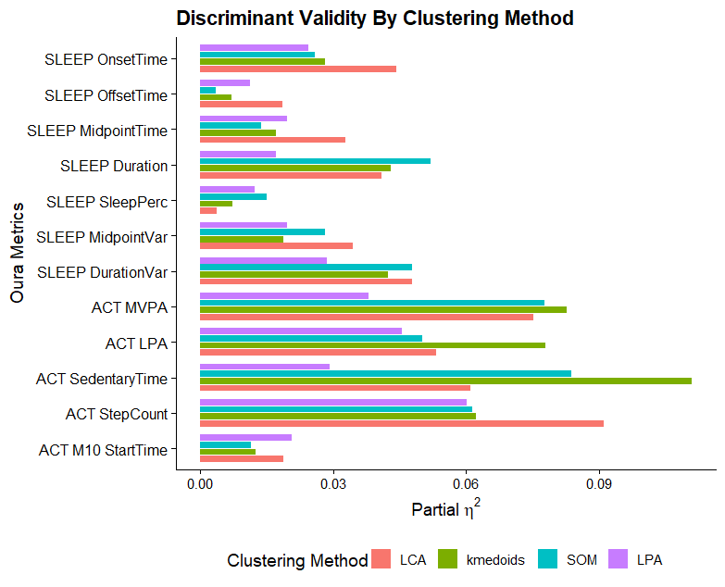
Figure S9 Discriminant validity of cluster solutions across four clustering methods. Horizontal bars represent partial eta-squared (partial η²) values from adjusted linear regression models (controlling for age, sex, ethnicity, and medication use) for each of the 12 wearable-derived sleep and physical activity metrics, with cluster membership as the independent variable. Higher values indicate greater between-cluster differentiation on a given metric. Clustering methods shown are latent class analysis (LCA; applied to binary indicators), k-medoids, self-organising maps with k-medoids (SOM), and latent profile analysis (LPA; all applied to continuous data). All solutions were constrained to four clusters. ACT = actigraphy; MVPA = moderate-to-vigorous physical activity; LPA = light physical activity; M10 = most active 10-hour period; Var = intraindividual variability; Perc = percentage.

SUPPLEMENTARY TABLES
Table S1 Operational definitions of sleep variables used, adapted from (2).
Sleep Dimension | Sleep Variable | Units | Operational Definition
Timing | Sleep Onset | hh:mm | Time of the first epoch of detected sleep
Timing | Sleep Offset | hh:mm | Time of the last epoch of detected sleep
Timing | Sleep Midpoint | hh:mm | Time halfway between sleep onset and offset
Duration | Sleep Duration | h | Sum of all sleep epochs detected as sleep between sleep onset and offset
Continuity | Sleep Percentage | % | % of all sleep epochs detected as sleep between sleep onset and offset
Regularity | Midpoint Variability | h | Standard deviation of sleep midpoint over all days logged during the baseline period (1 month)
Regularity | Duration Variability | h | Standard deviation of sleep duration over all days logged during the baseline period (1 month)

Table S2. Partial eta-squared (η²ₚ) values summarising overall discriminant validity of wearable-derived sleep and physical activity metrics across clustering methods. Mean and median partial eta-squared values were computed across all wearable-derived outcome variables for each clustering method, reflecting the proportion of variance in sleep and physical activity metrics explained by cluster membership after adjusting for covariates. Higher values indicate greater discriminatory capacity of the derived cardiometabolic profiles with respect to wearable-derived behavioural outcomes. The LCA-derived solution demonstrated the greatest between-cluster differentiation on behavioural outcomes on average. Abbreviations: LCA, latent class analysis; LPA, latent profile analysis; SOM, self-organising map.
Clustering Method | Mean partial-eta | Median partial-eta
LCA | 0.0438 | 0.0426
LPA | 0.0270 | 0.0220
k-medoids | 0.0430 | 0.0353
SOM | 0.0397 | 0.0380

SUPPLEMENTARY REFERENCES
1. Gao S, Mutter S, Casey A, Makinen VP. Numero: a statistical framework to define multivariable subgroups in complex population-based datasets. Int J Epidemiol. 2019;48(2):369-74.
2. Chee MW, Baumert M, Scott H, Cellini N, Goldstein C, Baron K, et al. World Sleep Society recommendations for the use of wearable consumer health trackers that monitor sleep. Sleep Med. 2025;131:106506.

