Supporting Information

Excessive force-induced root resorption depends on macrophage YAP activation
Danqing He^{1#}, Liyuan Chen^{1,2#}, Shuyue Zhu¹, Zimo Zhao¹, Huajie Yu², Boyang Zhang³, Shiying Zhang¹, Yuwei Liu³, Zhuowen Gu¹, Wei Wang^{3*}, Yan Liu^{1*}
¹Department of Orthodontics, Central Laboratory, Peking University School and Hospital for Stomatology & National Center for Stomatology & National Clinical Research Center for Oral Diseases & National Engineering Research Center of Oral Biomaterials and Digital Medical Devices & Beijing Key Laboratory of Digital Stomatology & Research Center of Engineering and Technology for Computerized Dentistry Ministry of Health & NMPA Key Laboratory for Dental Materials & National Engineering Research Center of Oral Biomaterials and Digital Medical Devices, Beijing 100081, China.
²Peking University Hospital of Stomatology Fourth Division, Beijing, China.
³Department of Immunology, School of Basic Medical Sciences, NHC Key Laboratory of Medical Immunology, Medicine Innovation Center for Fundamental Research on Major Immunology-related Diseases, Peking University, Beijing, China.
#These authors contributed equally: Danqing He，Liyuan Chen.
*Corresponding author. Email: orthoyan@bjmu.edu.cn (Y.L.)，wangwei83427@bjmu.edu.cn (W.W)

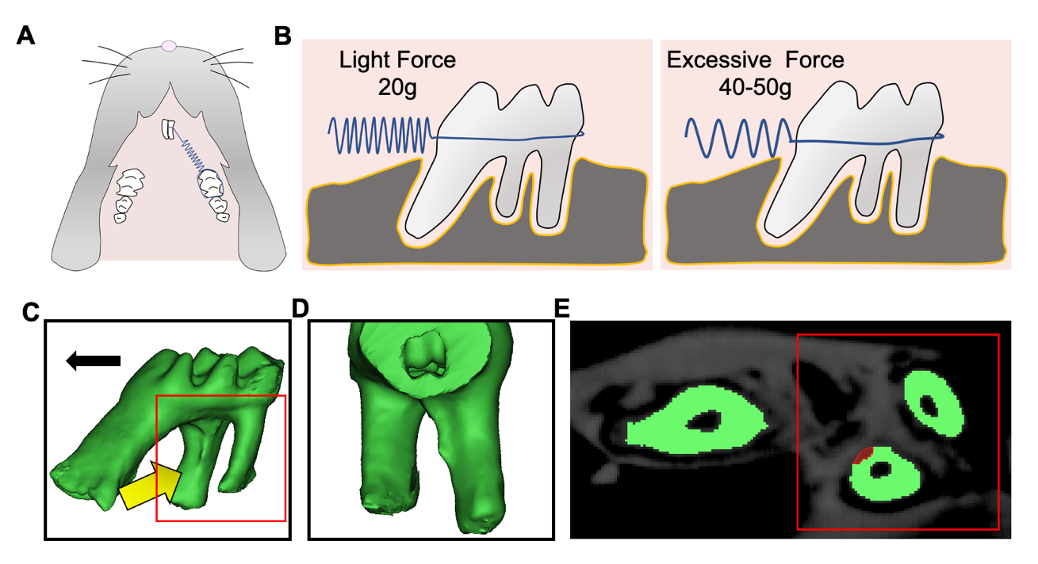Appendix Fig. 1 A Schematic of the mechanical force on the first molar on overhead view. B. Schematic of the mechanical force on the first molar. Light force is nearly 20 g and excessive force is 40-50 g. C. Micro–CT images show maxillary first molars. The arrow represents the observation direction. The red box represents the observation area. D. Micro–CT images show magnified distal roots of the maxillary first molars. E. The distal roots were segmented and the resorption area is red. The red box represents the observation area.
Appendix Fig. 2 A, B. Representative flow cytometry graphs show the expressions of CD3⁺ T lymphocytes and NK11⁺ cells macrophages in the maxilla after force loading.

Appendix Fig. 3 A. Representative immunohistochemical staining images of the macrophage-related proteins CD68 in the compression side of distobuccal roots were detected. B. Representative immunohistochemical staining images of the inflammation-related protein TNF-α in the compression side of distobuccal roots were detected. Large boxed areas show high magnification views of the small boxed areas. The arrow represents the direction of force application. Scale bar: 40 μm. n = 5; ***P < 0.001 versus Con.
Appendix Fig. 4 Representative immunofluorescence images of Fig. 1D. Dashed lines mark the outline of distobuccal roots. n = 5. The arrow represents the direction of force application.
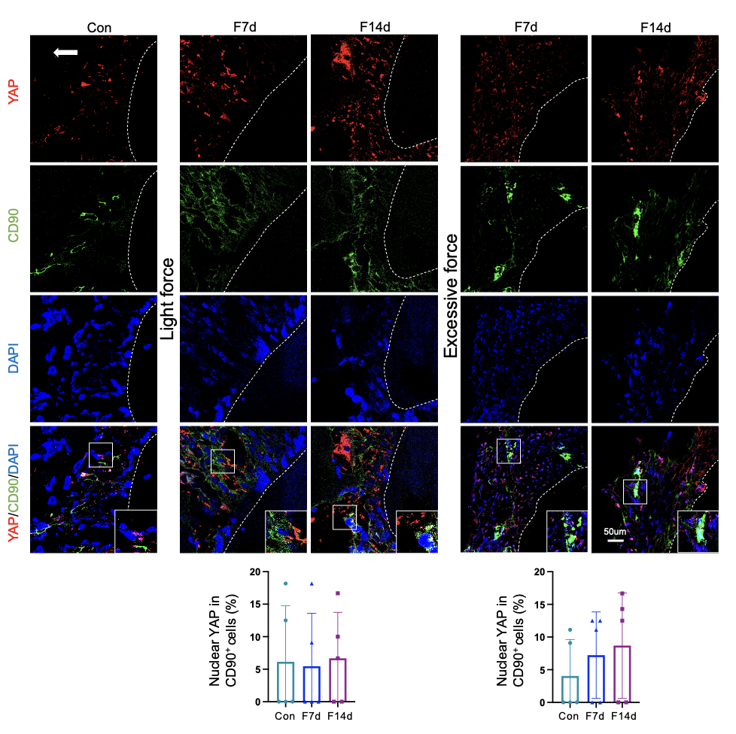
Appendix Fig. 5 Representative immunofluorescence images on the compression side of distobuccal roots. Dashed lines mark the outline of distobuccal roots. Large boxed areas show high-magnification views of the small boxed areas. Scale bar: 50 μm. n = 5. The arrow represents the direction of force application.

Appendix Fig. 6 Representative PCR genotyping results for Yap1^{flox/flox}; Lyz2-Cre mice and Yap1^{flox/flox} controls. A. Yap1-loxp genotyping showing mutant and wild-type bands at 283 bp and 222 bp, respectively. B. Lyz2-Cre genotyping showing mutant and wild-type bands at 721 bp and 346 bp, respectively. M, DNA marker; Water, negative control; MT, mutant; WT, wild type.
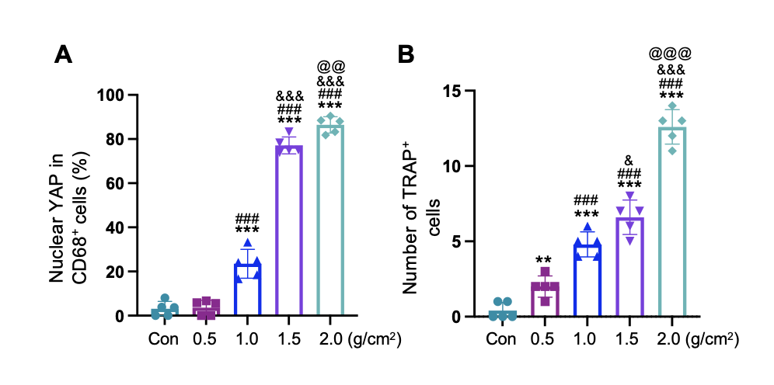
Appendix Fig. 7 A. Statistical results of Fig. 3H (Immunocytofluorescent images of nuclear YAP in CD68⁺ cells under different force loading for 24 h in vitro). n = 5. ***P < 0.001 versus Con; ###P < 0.001 versus 0.5g/cm²; &&&P < 0.001 versus 1.0g/cm², @@ P < 0.01 versus 1.5g/cm². B. Statistical results of Fig. 3J (images of TRAP staining of RAW264.7 after odontoclast/osteoclast induction). n = 5. **P < 0.01, ***P < 0.001 versus Con; #P < 0.05, ###P < 0.001 versus 0.5g/cm²; &P < 0.05, &&&P < 0.001 versus 1.0g/cm², @@ P < 0.01 versus 1.5g/cm².

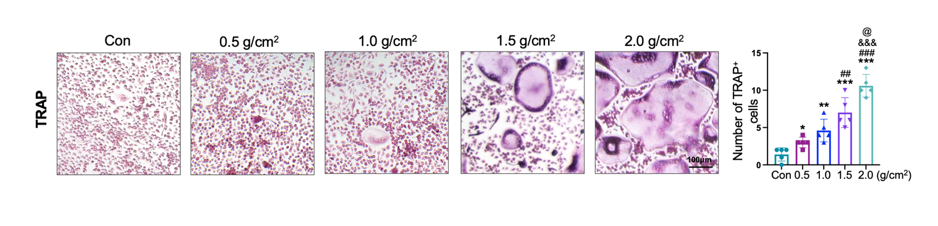
Appendix Fig. 8 Representative images of TRAP staining of BMMs after odontoclast/osteoclast induction by M-CSF and RANKL. Scale bar: 100 μm. n = 5. *P < 0.05, **P < 0.01, ***P < 0.001 versus Con; ##P < 0.01, ###P < 0.001 versus 0.5g/cm²; &&&P < 0.001 versus 1.0g/cm², @ P < 0.05 versus 1.5g/cm².

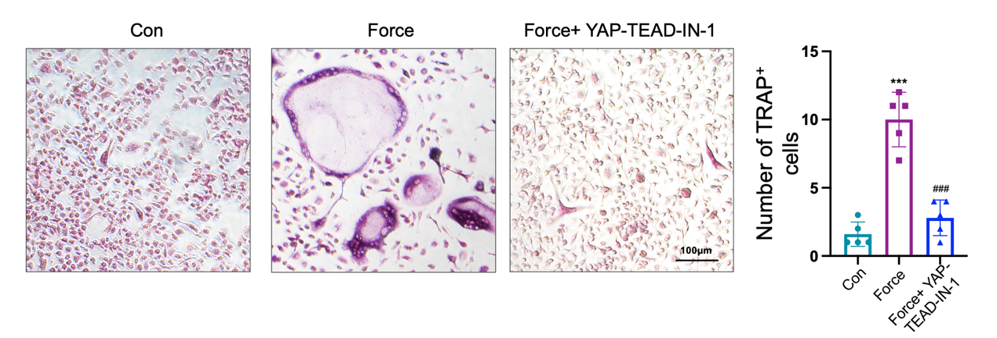
Appendix Fig. 9 Representative images of TRAP staining of BMMs after odontoclast/osteoclast induction by M-CSF and RANKL. Scale bar: 100 μm. n = 5. ***P < 0.001 versus Con; ###P < 0.001 versus Force.

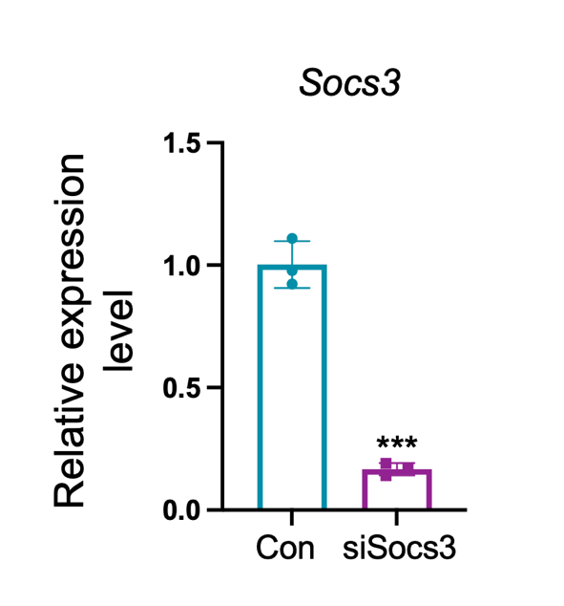
Appendix Fig. 10 qPCR of Socs3 expressions in RAW264.7 after siSocs3 application. n = 3. ***P < 0.001 versus Con.
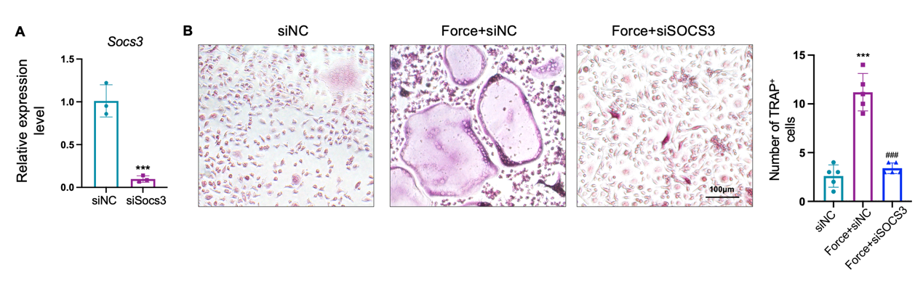
Appendix Fig. 11 A. qPCR of Socs3 expressions in BMMs after siSocs3 application. n = 3. ***P < 0.001 versus siNC. B. Representative images of TRAP staining of BMMs after odontoclast/osteoclast induction by M-CSF and RANKL. Scale bar: 100 μm. n = 5. ***P < 0.001 versus Con; ###P < 0.001 versus Force.
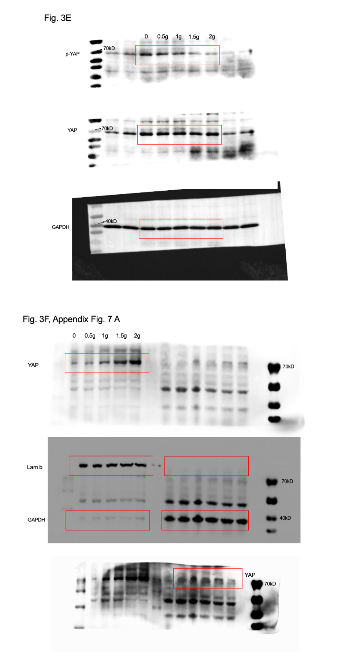
Appendix Fig. 12 The original images of Western blotting.

