Plasma Metabolomics Profile in Young Adults with a History of Extrauterine Growth Restriction: The BIORICA-10 Study

Laura Palomino-Fernández1#, Inmaculada Velasco2,#, Oscar Daniel Rangel-Huerta3,*, Katherine Flores-Rojas1, María de la Cruz Rico4,5,6, Ángel Gil4,5,7, Juan Roa2,5, Belén Pastor-Villaescusa1,6,γ, Mercedes Gil-Campos1,7,γ

1 University of Cordoba, Metabolism and Investigation Unit, Reina Sofia University Hospital, Maimonides Institute of Biomedicine Research of Cordoba (IMIBIC), 14004 Cordoba, Spain
2 Department of Cell Biology, Physiology and Immunology, University of Cordoba, Reina Sofia University Hospital, Maimonides Institute of Biomedicine Research of Cordoba (IMIBIC), 14004 Cordoba, Spain
3 Norwegian Veterinary Institute, Chemistry and Toxicology Section, P.O. Box 64, N-1431 Ås, Norway
4 Department of Biochemistry and Molecular Biology II, School of Pharmacy, Institute of Nutrition and Food Technology "José Mataix", Biomedical Research Center, University of Granada, 18016 Granada, Spain
5Instituto de Investigación Biosanitaria IBS.GRANADA, Complejo Hospitalario Universitario de Granada, 18014 Granada, Spain
6 Primary Care Interventions for the Prevention of Chronic Perinatal and Developmental Diseases in Mothers and Children (RICORS-SAMID, RD21/0012/0008); Spanish Network for Research in Maternal, Neonatal, Child and Developmental Health (RICORS-SAMID, RD24/0013/0007), Carlos III Health Institute (ISCIII), 28029 Madrid, Spain
7Consorcio CIBER, M.P. Fisiopatología de la Obesidad y Nutrición (CIBEROBN), Instituto de Salud Carlos III (ISCIII), 28029 Madrid, Spain

#Equal contribution
γEqual contribution

*Correspondence to: Oscar Daniel Rangel-Huerta (odrangel@spectraminds.io)

Contents
Supplementary Methods 3
S1. Metabolite-derived ratios and metabolic indices 3
Supplementary Table S1. Metabolite-derived ratios and calculated metabolic indices 3
S2. Reagents and analytical standards 6
Supplementary Table S2. Reagents, analytical standards and isotopically labelled internal standards used for metabolomics analyses 6
S3. Plasma Extraction and sample preparation 9
S4. Instrumental analysis 10
Semi-quantitative determination of lipid metabolites using LC-MS/MS and LC-qTOF 10
Supplementary Table S3. UHPLC gradient program for LC-qTOF analysis 10
Supplementary Table S4. UHPLC gradient program for LC-MS/MS analysis 11
Semi-quantitative determination of organic acids and sugar metabolites using GC-(EI)-QQQ 11
Supplementary Results 12
Supplementary Table S5. Differential plasma metabolites between EUGR and reference groups after false discovery rate correction 12
Supplementary Table S6. Principal component loadings for the three-component PCA performed in the EUGR group 15
Supplementary Table S7. Principal component loadings for the three-component PCA performed in the reference group 17
Supplementary Table S9. Variable loadings and stability values from DIABLO model integrating metabolomic, inflammatory and biochemical datasets 20
Supplementary Fig. S1. 22
Supplementary Fig. S2. 23
Supplementary Fig. S3. 24
Supplementary Abbreviations 25

Supplementary Methods

S1. Metabolite-derived ratios and metabolic indices

Supplementary Table S1. Metabolite-derived ratios and calculated metabolic indices
This table summarizes the metabolite ratios and calculated sums used to estimate metabolic pathway activity and physiological process. Ratios were derived from quantified plasma metabolites to enable a comprehensive interpretation of the data.

Metabolites | Ratio | Description
Ala + Arg + Asn + Asp + Cys + Gln + Glu + Gly + His + Ile + Leu + Lys + Met + Phe + Pro + Ser + Thr + Trp + Tyr + Val | Sum of amino acids | AAs are the basic units of proteins and contain an amino group and a carboxylic group
Phe + Trp + Tyr | Sum of aromatic amino acids | Indicator of the development of insulin resistance and nutritional status
Ala + Arg + Asn + Asp + Cys + Gln + Glu + Gly + His + Met + Pro + Ser + Thr + Val | Sum of solely glucogenic AAs | An indicator for gluconeogenic activity and endogenous glucose production
His + Ile + Leu + Lys + Met + Phe + Thr + Trp + Val | Sum of essential amino acids | An indicator of the nutritional status
Ala + Arg + Asn + Asp + Cys + Gln + Glu + Gly + Pro + Ser + Tyr | Sum of non-essential amino acids | An indicator for protein turn-over
Asn/Asp | Ratio of asparagine to aspartate | Indicator of asparagine synthetase activity
Pro/Phe | Ratio of proline to phenylalanine | Altered degradation of the amino acids leucine, isoleucine, and valine
Gly/Ser | Ratio of glycine to serine | Indicator of glycine synthesis
Glu/Gln | Ratio glutamate to-glutamine
Met/Phe | Ratio of methionine to phenylalanine | Indicator of folate metabolism
Pro/Cit | Ratio of proline to citrulline | Activity of ornithine aminotransferase and pyrroline-5-carboxylate reductase and an indirect indicator of the activity of arginase to nitric oxide synthase (NOS)
Cit/Orn | Ratio of citrulline to ornithine | Activity of ornithine carbamoyl phosphate transferase
Cit/Arg | Ratio of citrulline to arginine | Activity of NOS
Orn/Cit | Ratio of ornithine to citrulline | Urea cycle disorder that leads to the accumulation of ammonia in blood
ΣlysoPC C14-20:x | Sum of long-chain fatty acid lysophosphatidylcholines (LCFA-LysoPCs) | LysoPCs are derived from phosphatidylcholines via the partial hydrolysis by phospholipase activity (oxidative stress, mitochondrial dysfunction, and insulin resistance)
∑lysoPC Cxx:x | Sum of lysophosphatidylcholines (lysoPCs) | LysoPCs are derived from phosphatidylcholines via the partial hydrolysis by phospholipase activity
ΣlysoPC Cxx:1 | Sum of monounsaturated fatty acid lysophosphatidylcholines (MUFA-LysoPCs) | Linked to a MUFA-rich diet associated with cardiometabolic diseases
ΣlysoPC Cxx:2-4 | Sum of polyunsaturated fatty acid lysophosphatidylcholines (PUFA-LysoPCs) | Linked to the hydrolysis of phosphatidylcholines by phospholipase activity; Associated with cardiometabolic diseases, inflammation and neurological disorders
ΣlysoPC Cxx:0 | Sum of saturated fatty acid lysophosphatidylcholines (SFA-LysoPCs)
∑ lysoPC C24-28:x | Sum of very long-chain fatty acid lysophosphatidylcholines (VLCFA-lysoPCs) | Indicator of the peroxisomal disorder
C2-C18:2 + C5- M-DC + Cx-DC + Cx-OH + Cx:xOH | Sum of acylcarnitines | ACs are essential compounds for the oxidative catabolism of fatty acids and their profile is associated with inherited disorders of fatty acid and branched-chain amino acid catabolism
C14-C18:2 + C14:1-OH + C14:2-OH + C16-OH + C16:1-OH + C16:2-OH + C18:1-OH | Sum of long-chain acylcarnitines
C6-C12:1 + C7- DC + C12-DC | Sum of long-chain acylcarnitines
C5:1-DC + Cx:1 + Cx:1-OH | Sum of monounsaturated fatty acid acylcarnitines | High levels of MUFAs may be a consequence of a MUFA-rich diet associated with cardiometabolic diseases
Cx:2 + Cx:2-OH | Sum of polyunsaturated fatty acid acylcarnitine | Altered PUFA levels are associated with cardiometabolic diseases and neurological disorders
C5-OH (C3-DCM) / C0 | Measure of overall ß-oxidation activity
C0 / C5-OH (C3- DC-M)
C3/C0 | Ratio of propionylcarnitine to free carnitine
C8 / C5-OH (C3- DC-M) | Carnitine uptake defect (NBS1)

S2. Reagents and analytical standards

Supplementary Table S2. Reagents, analytical standards and isotopically labelled internal standards used for metabolomics analyses
The table lists all analytical standards, internal standards, solvents and reagents employed for sample preparation, metabolite quantification and quality control across the GC-MS, LC-MS/MS and LC-qTOF analytical platforms.

Metabolite Class | Compounds | Isotopically Labeled Standards | Supplier
Bile Acids  (LC-qTOF) | - Cholic Acid  - Chenodeoxycholic Acid  - Deoxycholic Acid  - Hyodeoxycholic Acid  - Lithocholic Acid  - Ursodeoxycholic Acid  - Taurocholic Acid,  - Taurochenodeoxycholic Acid  - Taurodeoxycholic Acid  - Taurolithocholic Acid  - Glycocholic Acid  - Glycochenodeoxycholic Acid  - Glycodeoxycholic Acid  - Tauroursodeoxycholic Acid | - Cholic Acid-D5  - Taurocholic Acid-D5 | - Sigma Aldrich (Darmstadt, Germany)  - Toronto Research Chemicals (Toronto, Canada)
Fatty Acids  (LC-qTOF) | - Decanoic Acid (C10:0)  - Dodecanoic Acid (C12:0)  - Palmitic Acid (C16:0)  - Stearic Acid (C18:0)  - Oleic Acid (C18:1)  - Linoleic Acid (C18:2)  - Linolenic Acid (C18:3)  - Arachidic Acid (C20:0)  - Arachidonic Acid (C20:4) | - Myristic-D27  - 3-Hydroxytetradecanoic Acid-2,2,3,4,4-D5 | - Sigma Aldrich (Darmstadt, Germany)
Hormones  (LC-MS) | - Thyroxine (T4)  - Dehydroisoandrosterone 3-Sulfate (DHEAS)  - Estrone Sulfate  - Corticosterone | - Cortisol-D4 | - Sigma Aldrich (Darmstadt, Germany)
Metabolic intermediates  (GC-MS) | - 4-Hydroxy-3-Methoxymandelic Acid | - 4-Hydroxy-3-Methoxymandelic Acid-D3  - 3-(3-Hydroxy-4-Methoxyphenyl) Propionic Acid-D3 | - Sigma Aldrich (Darmstadt, Germany)  - Toronto Research Chemicals (Toronto, Canada)
LPE  (LC-qTOF) | - LPE 18:1  - LPE 16:0 |  | - Avanti Polar Lipids (Birmingham AL, USA)
LPC  (LC-qTOF) | - LPC 20:0, LPC 16:0, LPC 18:0, LPC 18:1, | - LPC 18:1-D7 | - Avanti Polar Lipids (Birmingham AL, USA)
Oxylipins (LC-MS) | - 12(13)-Dihome, 9(10)-Dihome, 9(S)-HODE, 13(S)-HODE, 12(13)-Epome, 9(10)-Epome, Thromboxane B2, 15(S)-HETE, 12(S)-HETE, | - AA-D8  - Oxy Deuterated Linoleic Acid Oxylipins | - Cayman Chemical (Michigan, USA)
Acylcarnitines  (LC-MS/MS) | - L-Carnitine (C0)  - O-Acetyl-L-Carnitine (C2:0)  - O-Propionyl-L-Carnitine (C3:0)  - O-Butyryl-L-Carnitine (C4:0)  - O-Isovaleryl-L-Carnitine (C5:0)  - O-Octanoyl-L-Carnitine (C8:0)  - O-Myristoyl-L-Carnitine (C14:0)  - O-Palmitoyl-L-Carnitine (C16:0)  - O-Glutaryl-L-Carnitine (C5:0-DC)  - O-3-Hydroxyisovaleryl-L-Carnitine (C5:0-OH)  - O-Dodecanoyl-L-Carnitine (C12:0)  - O-Octadecanoyl-L-Carnitine (C18:0)  - O-3-DL-Hydroxypalmitoyl-L-Carnitine (C16:0-OH) | - C0 (Trimethyl-D9)  - C2:0 (N-Methyl-D3)  - C3:0 (N-Methyl-D3)  - C4:0 (N-Methyl-D3)  - C5:0 (N,N,N-Methyl-D9)  - C8:0 (N-Methyl-D3)  - C14:0 (N,N,N-Methyl-D9)  - C16:0 (N-Methyl-D9) | - Cambridge Isotope Laboratories (Massachusetts, USA)
Abbreviations: LPC, Lysophosphatidylcholine; LPE, Lysophosphatidylethanolamine; HODE, Hydroxyoctadecadienoic Acid; Epome, Epoxyoctadecenoic Acid; Dihome, Dihydroxyoctadecenoic Acid.

S3. Plasma Extraction and sample preparation
Plasma samples were thawed at 4 °C. For the hydrophobic compounds, 50 µL of plasma was mixed with 200 μL of 100% MeOH and a set of labeled internal standards. The mixture was vortexed and centrifuged for 10 min at 15,000 rpm and 4 °C. The supernatants were vacuum-filtered through 1 ml Oasis HLB 96-well plates, and 500 µL of MeOH was added to elute. Then, 100 µL was collected for LC quadrupole time-of-flight (LC-qTOF) analysis. The remaining sample was evaporated to dryness using a SpeedVac concentrator. The residue was reconstituted with 50 μL MeOH and analyzed using LC/MS.
For the acylcarnitine determination, 30 µL of plasma was mixed with 270 μL of 100% MeOH containing a set of acylcarnitines labeled internal standards. The mixture was agitated for 15 s and spun at 4,700 rpm for 10 min at 4 °C. The supernatant was transferred to a different plate and injected into the LC-MS/MS system. Sample extraction for LC-based methods was conducted using the Agilent Bravo Automated Liquid Handling Platform in a semi-automated manner.
Sample preparation for GC-electronic ionization triple quadrupole (GC-(EI)-QQQ) required 50 μL of plasma, aliquoted to a 1.5 mL Eppendorf tube and mixed with 200 μL of a solution of MeOH:Water (8:2) containing internal standards. Samples were vortexed and centrifuged for 5 min at 15,000 rpm 4 ºC. Supernatants were transferred to a new tube and evaporated in a SpeedVac at 45 ºC. Samples were reconstituted with 30 μL of methoxyamine and incubated for 90 min at 37 ºC, after which they were sylilated with 45 μL of MSTFA + 1 % TMCS at room temperature for 60 min.

S4. Instrumental analysis

Semi-quantitative determination of lipid metabolites using LC-MS/MS and LC-qTOF
Semi-quantitative determination of lipids was performed using a UHPLC 1290 Infinity II Series coupled to a QQQ/MS 6490 Series (Agilent Technologies, Sta. Clara, CA, USA). Chromatographic separation was performed using a CORTECS C18 Column, 1.6 µm, 2.1 × 150 mm (Waters). The column was eluted using a mobile phase comprising 100% water with 0.05% acetic acid (A) and 100% MeCN (B). The column temperature was 40 °C, and the injection volume was 2 μL. The source parameters applied to operate in negative Electrospray Ionization were as follows: the gas temperature was set at 225 °C and flow at 11 L/min. The sheath gas temperature was 300 °C, and the flow was 12 L/min; the nebulizer worked at 35 psi, the capillary voltage was set at 3500 V, and the nozzle voltage was kept at 5000 V.
The calibration curves obtained for each standard were used to quantify the respective analytes. A semi-quantitative analysis was conducted for the other compounds. The behavior of each compound was assessed, and the calibration curve selected for calculating its concentration exhibited the closest similarity in behavior.
A UHPLC 1290 Infinity II Series coupled with a qTOF 6550 Series from Agilent Technologies (Agilent Technologies, Santa Clara, CA, USA) was used to analyze the more hydrophobic lipids. Chromatographic separation was performed using an ACQUITY UPLC BEH C18 Column, 1.7 μm, 2.1 mm × 100 mm (Waters, Framingham, USA). The column was eluted using a mobile phase comprising 100% water with 0.05% acetic acid (A), 100% MeCN (B), and 100% 2-propanol (C). The column temperature was 40 °C, and the injection volume was 2 μL. The gradient conditions are shown in Supplementary Table S3. Lipid species were identified by matching their accurate mass and tandem mass spectra. In addition, the chromatographic behavior of pure standards for each family and bibliographic information were used to ensure their identification.

Supplementary Table S3. UHPLC gradient program for LC-qTOF analysis
Time (min) | %B | Flow (mL/min)
0 | 2 | 0.4
1.5 | 2 | 0.4
2.25 | 7.5 | 0.4
8.0 | 30 | 0.4
11 | 50 | 0.4
25.0 | 85 | 0.4
26.0 | 95 | 0.4
30.0 | 95 | 0.4
30.1 | 2 | 0.4
31.0 | 2 | 0.4
34.0 | 2 | 0.4

For the LC-MS/MS determination of acylcarnitines, the analysis was performed using a UHPLC 1290 Infinity II Series coupled to a QQQ/MS 6470 Series, both from Agilent Technologies (Agilent Technologies, Santa Clara, CA, USA). Chromatographic separation was performed using an analytical column Kinetex 2.6 µm Polar C18, 100 Å, 150 × 2.1 mm (Phenomenex, USA). mobile phases comprised 100% water with 0.1% formic acid (A) and 100% MeOH with 0.1% formic acid (B). The column temperature was 20 °C, and the injection volume was 1 µL. The gradients are listed in Supplementary Table S4. The source parameters applied to operate in positive electrospray ionization (ESI) were as follows: the gas temperature was set at 200 °C and the flow at 6 L/min. The sheath gas temperature was 375 °C, and the flow was 11 L/min; the nebulizer worked at 30 psi, the capillary voltage was set at 3500 V, and the nozzle voltage was kept at 0 V.

Supplementary Table S4. UHPLC gradient program for LC-MS/MS analysis
Time (min) | %B | %C | Flow (mL/min)
0 | 50 | 0 | 0.4
1 | 50 | 0 | 0.4
10.3 | 85 | 0 | 0.4
11 | 50 | 50 | 0.4
14.7 | 50 | 50 | 0.4
14.8 | 50 | 0 | 0.4
15.8 | 50 | 0 | 0.4

Semi-quantitative determination of organic acids and sugar metabolites using GC-(EI)-QQQ
Organic acids and sugar metabolites were analyzed using a GC-QQQ 7010B with an HP5-MS UI capillary column (30 × 250 0.25 μm film thickness) from Agilent Technologies (Agilent Technologies, Sta. Clara, CA, USA). The carrier gas used for chromatographic separation was helium with a purity of over 99.999%. The solution was allowed to flow at a constant rate of 1.1 mL/min. The GC oven was initially set to 60 °C. The samples were injected in split mode (1:20) at an injection temperature of 250 °C. Detection was achieved using MS in electron ionization (70 eV) mode and full-scan monitoring mode (m/z 50–600) at an acquisition rate of 5 spectra/s. The ion source temperature was set to 250 °C, and that of the quadrupole was set to 200 °C.
The organic acids were identified and semi-quantified using pure analytical standards. Specifically, ions were selected and used for quantitation based on their impact electron spectra (70 eV) and the main specific ions described in the recorded spectral library Fiehn-pct-2013.

Supplementary Results

Supplementary Table S5. Differential plasma metabolites between EUGR and reference groups after false discovery rate correction
The table includes 51 metabolites showing statistically significant differences between study groups after adjustment for multiple testing using the Benjamini-Hochberg false discovery rate (FDR). Data are presented as median and quartiles based on variable distribution. The q-value corresponds to the FDR-adjusted p-value. Only metabolites with q<0.05 were considered statistically significant.

 |  | Control |  | EUGR |  | q-value (FDR) ª
 |  | Median | IQR | Median | IQR | q-value (FDR) ª
Aminoacids | Aspartate | 0.57 | 0.48-0.64 | 0.92 | 0.81-1.01 | <0.001
Aminoacids | Erythronate | 0.03 | 0.03-0.04 | 0.05 | 0.04-0.05 | <0.001
Aminoacids | Glutamate | 2.12 | 1.69-2.54 | 6.04 | 5.01-7.40 | <0.001
Aminoacids | Glutamine | 32.02 | 29.5-35.8 | 26.9 | 23.3-30.1 | 0.005
Aminoacids | Glycerate | 0.46 | 0.4-0.56 | 1.17 | 1-1.48 | <0.001
Aminoacids | Glycerol-1-phosphate | 0.18 | 0.15-0.22 | 0.28 | 0.25-0.32 | <0.001
Aminoacids | Ornithine | 25.54 | 19.7-30.6 | 21.59 | 16.6-23.8 | 0.025
Aminoacids | Threonate | 1.17 | 0.99-1.46 | 1.56 | 1.37-1.68 | <0.001
Carboxylic acids | α-ketoglutarate | 0.88 | 0.73-1.06 | 1.22 | 0.97-1.47 | <0.001
Carboxylic acids | Pyruvate | 11.12 | 9.64-13.5 | 10.3 | 7.5-11.7 | 0.028
Carboxylic acids | X4-Hydroxyproline | 0.39 | 0.27-0.51 | 0.58 | 0.44-0.9 | <0.001
Oxylipins | 5(S)-HEPE | 0 | 0-0.03 | 0.1 | 0.08-0.15 | <0.001
Oxylipins | 5(S)-HETE | 0.03 | 0.02-0.05 | 0.54 | 0.4-0.74 | <0.001
Oxylipins | 9(S)-HODE | 0.88 | 0.68-1.32 | 1.5 | 1.1-2.11 | <0.001
Oxylipins | 12(S)-HETE | 0.07 | 0.04-0.11 | 0.32 | 0.23-0.4 | <0.001
Oxylipins | 13(S)-HODE | 1.62 | 1.23-2.13 | 2.34 | 1.87-3 | 0.007
Oxylipins | 13-oxoODE | 0.51 | 0.41-0.57 | 0.78 | 0.69-1.07 | <0.001
Oxylipins | 14,15-DHET | 0.23 | 0.17-0.27 | 0.27 | 0.25-0.29 | 0.039
Oxylipins | 15(S)-HETE | 0.07 | 0.05-0.1 | 0.3 | 0.26-0.36 | <0.001
LPC | LPC(14.0) sn1 | 0.08 | 0.06-0.1 | 0.11 | 0.09-0-15 | 0.009
LPC | LPC(14:0) sn2 | 0.014 | 0.01-0.018 | 0.02 | 0.014-0.03 | <0.001
LPC | LPC(15:0) sn1 | 0.056 | 0.05-0.07 | 0.08 | 0.06-0.1 | <0.001
LPC | LPC(15:0) sn2 | 0.012 | 0.01-0.015 | 0.016 | 0.012-0.02 | <0.001
LPC | LPC(16:0) sn1 | 5.76 | 5-6.5 | 7.52 | 7.1-8.3 | <0.001
LPC | LPC(16:0) sn2 | 1.15 | 0.98-1.3 | 1.75 | 1.52-1.9 | <0.001
LPC | LPC(16:1) sn1 | 0.1 | 0.07-0.12 | 0.13 | 0.1-0.16 | <0.001
LPC | LPC(16:1) sn2 | 0.017 | 0.013-0.02 | 0.021 | 0.016-0.03 | <0.001
LPC | LPC(18:0) sn1 | 2.01 | 1.6-2.26 | 2.97 | 2.73-3.3 | <0.001
LPC | LPC(18:0) sn2 | 0.34 | 0.27-0.39 | 0.55 | 0.5-0.64 | <0.001
LPC | LPC(20.0) sn1 | 0.011 | 0.009-0.013 | 0.014 | 0.01-0.016 | 0.017
LPC | LPC(20.1) sn1 | 0.022 | 0.017-0.025 | 0.03 | 0.025-0.04 | <0.001
LPC | LPC(20.1) sn2 | 0.003 | 0.003-0.004 | 0.004 | 0.003-0.006 | 0.003
LPC | LPC(20.2) sn1 | 0.023 | 0.017-0.03 | 0.031 | 0.025-0.04 | <0.001
LPC | LPC(20.2) sn2 | 0.005 | 0.004-0.006 | 0.007 | 0.005-0.007 | 0.017
LPC | LPC(22.4) sn1 | 0.008 | 0.006-0.01 | 0.013 | 0.009-0.02 | <0.001
LPE | LPE(18.0) sn1 | 0.108 | 0.09-0.136 | 0.137 | 0.114-0.16 | 0.024
LPE | LPE(18.0) sn2 | 0.017 | 0.015-0.02 | 0.022 | 0.017-0.024 | 0.031
Fatty acids | FA 18:3-iso1 | 0.072 | 0.048-0.1 | 0.1 | 0.07-0.13 | 0.039
Fatty acids | FA 20:3-iso2 | 0.017 | 0.012-0.02 | 0.024 | 0.02-0.028 | 0.021
Fatty acids | FA 20:3-iso3 | 0.12 | 0.08-0.15 | 0.17 | 0.14-0.2 | <0.001
Fatty acids | FA 20:4 | 0.4 | 0.29-0.53 | 0.76 | 0.68-0.94 | <0.001
Fatty acids | FA 20:5 | 0.032 | 0.021-0.04 | 0.05 | 0.035-0.07 | 0.03
Fatty acids | FA 22:5-iso1 | 0.038 | 0.029-0.05 | 0.05 | 0.038-0.06 | 0.028
Biliar acids | GCA | 1.43 | 0.81-2.56 | 0.92 | 0.53-1.62 | 0.048
Biliar acids | TCA | 0.013 | 0.008-0.023 | 0.007 | 0.005-0.009 | <0.001
Biliar acids | TCDCA | 0.021 | 0.01-0.056 | 0.014 | 0.008-0.03 | 0.026
Hormones | Androsterone sulfate | 44.33 | 30.33-68.5 | 28.05 | 14.71-42-94 | 0.017
Hormones | Estrone 3-sulfate | 0.06 | 0.038-0.11 | 0.025 | 0.02-0.05 | 0.006
Hormones | 5α-androstan-3,17-diol monosulfate (iso1) | 0.17 | 0.09-0.25 | 0.086 | 0.05-0.13 | 0.021
Hormones | 5α-androstan-3,17-diol monosulfate (iso2) | 0.51 | 0.29-0.76 | 0.267 | 0.155-0.48 | 0.012
Acylcarnitines | C18.1 | 0.103 | 0.08-0.24 | 0.085 | 0.07-0.11 | 0.025
ª q-values were calculated using the Benjamini-Hochberg procedure (FDR<0.05).

Abbreviations: C18:1: octadecenoylcarnitine; EUGR: Extrauterine growth restriction; FA 18:3: α-Linolenic acid (ALA); FA 20:3: Dihomo-γ-linolenic acid (DGLA); FA 20:4: Arachidonic acid; FA 20:5: eicosapentaenoic acid (EPA); FA 22:5: Docosapentaenoic acid (DPA, ω-6); FDR: false discovery rate; GCA: Glycocholic acid (biliary acid); LPC: Lysophosphatidylcholine; LPC(14:0): Lysophosphatidylcholine containing myristic acid; LPC(15:0): Lysophosphatidylcholine containing pentadecanoic acid; LPC(16:0): Lysophosphatidylcholine containing palmitic acid; LPC(16:1): Lysophosphatidylcholine containing palmitoleic acid; LPC(18:0): Lysophosphatidylcholine containing stearic acid; LPC(20:0): lysophosphatidylcholine containing arachidic acid; LPC(20:1): lysophosphatidylcholine containing gadoleic acid; LPC(20:2): lysophosphatidylcholine containing eicosadienoic acid; LPC(22:4): lysophosphatidylcholine containing docosatetraenoic acid; LPE: Lysophosphatidylethanolamine; LPE(18:0): lysophosphatidylethanolamine containing stearic acid; TCA: taurocholic acid; TCDCA: taurochenodeoxycholic acid; 5(S)-HEPE: 5(S)-Hydroxyeicosapentaenoic acid (oxylipin); 5(S)-HETE: 5(S)-Hydroxyeicosatetraenoic acid (oxylipin); 9(S)-HODE: 9(S)-Hydroxyoctadecadienoic acid (oxylipin); 12(S)-HETE: 12(S)-Hydroxyeicosatetraenoic acid (oxylipin); 13(S)-HODE: 13(S)-Hydroxyoctadecadienoic acid (oxylipin); 13-oxoODE: 13-Oxo-octadecadienoic acid (oxylipin); 14,15-DHET: 14,15-Dihydroxyeicosatrienoic acid (oxylipin); 15(S)-HETE: 15(S)-Hydroxyeicosatetraenoic acid (oxylipin).
* sn1 and sn2 indicate the position at which the acid binds, * iso- indicate the isomer
** Data highlighted in bold when the value is higher in one of the two groups

Supplementary Table S6. Principal component loadings for the three-component PCA performed in the EUGR group
Variables contributing to the first three principal components of the PCA model generated for participants with a history of EUGR. Only variables with absolute loading values ≥0.40 are presented.

 | Principal Componentª
 | Comp 1:  Hormones, oxylipins, pyruvate | Comp 2:  LPC, LPE and oxylipins | Comp 3:  FA, oxylipins and intermediate metabolism
Variance (%) | 13.9 | 12.0 | 9.2
Cumulative proportion of variance (%) | 13.9 | 25.9 | 35.1
Metabolites
Horm 5alpha-androstan-3,17-diol monosulfate-iso2 | 0.768 | NA | NA
Horm androsterone sulfate | 0.765 | NA | NA
Horm 5alpha-androstan-3,17-diol monosulfate-iso1 | 0.682 | -0.424 | NA
C18:2 | 0.670 | NA | NA
Horm epiandrosterone sulfate | 0.666 | NA | NA
15(S)-HETE | 0.599 | NA | NA
9(S)-HODE | 0.572 | 0.397 | NA
Horm etiocholanolone glucuronide/androsterone glucuronide | 0.565 | NA | NA
13-oxoODE | 0.542 | NA | NA
13(S)-HODE | 0.540 | 0.404 | NA
5(S)-HEPE | 0.536 | NA | NA
Pyruvate | 0.527 | NA | NA
5(S)-HETE | 0.509 | NA | 0.435
Horm Estrone 3-sulfate | 0.463 | NA | 0.450
Horm Cortisol | 0.442 | NA | NA
C18:0 | 0.435 | NA | NA
a-ketoglutarate | 0.423 | NA | NA
12(S)-HETE | 0.420 | NA | NA
LPC(20:0) sn1 | NA | 0.827 | NA
LPC(20:2) sn1 | NA | 0.782 | NA
LPE(18:0) sn2 | NA | 0.766 | NA
LPE(18:0) sn1 | NA | 0.735 | NA
LPC(20:2) sn2 | NA | 0.718 | NA
LPC(20:1) sn1 | NA | 0.673 | NA
LPC(20:1) sn2 | NA | 0.646 | NA
LPC(18:1) sn1 | NA | 0.638 | NA
LPC(18:1) sn2 | NA | 0.572 | NA
Glycerol-1-phosphate | NA | 0.513 | NA
LPC(22:4) sn1 | NA | 0.501 | NA
FA 20:0 | NA | 0.453 | NA
9,10-EpOME | NA | 0.429 | NA
LPE(22:6) sn1 | NA | 0.413 | NA
LPE(22:6) sn2 | NA | 0.413 | NA
FA 20:3-iso3 | NA | NA | 0.741
14,15-DHET | NA | NA | 0.729
FA 20:4 | NA | NA | 0.720
FA 22:5-iso1 | NA | NA | 0.716
FA 20:3-iso2 | NA | NA | 0.713
FA 18:3-iso1 | NA | NA | 0.588
d-Threitol | NA | NA | -0.569
11,12-DHET | NA | NA | 0.531
PG E3 | 0.439 | NA | 0.481
GCA | NA | NA | -0.472
2-HydroxyButyrate | NA | NA | -0.428
Threoniate | NA | NA | -0.410
Ornithine | NA | NA | -0.400
Abbreviations: C18:0: Stearic acid; C18:2: Linoleic acid; EUGR: Extrauterine growth restriction; FA 18:3: α-Linolenic acid (ALA); FA 20:0: Arachidic acid; FA 20:3: Dihomo-γ-linolenic acid (DGLA); FA 20:4: Arachidonic acid; FA 22:5: Docosapentaenoic acid (DPA, ω-6); GCA: Glycocholic acid (biliary acid); LPC: Lysophosphatidylcholine; LPC(18:1): Lysophosphatidylcholine containing oleic acid; LPC(20:0): lysophosphatidylcholine containing arachidic acid; LPC(20:1): lysophosphatidylcholine containing gadoleic acid; LPC(20:2): lysophosphatidylcholine containing eicosadienoic acid; LPC(22:4): lysophosphatidylcholine containing docosatetraenoic acid; LPE: Lysophosphatidylethanolamine; LPE(18:0): lysophosphatidylethanolamine containing stearic acid; LPE(22:6): lysophosphatidylethanolamine containing docosahexaenoic acid (DHA); 5(S)-HEPE: 5(S)-Hydroxyeicosapentaenoic acid (oxylipin); 5(S)-HETE: 5(S)-Hydroxyeicosatetraenoic acid (oxylipin); 9,10-EpOME: 9,10-Epoxyoctadecenoic acid (oxylipin); 9(S)-HODE: 9(S)-Hydroxyoctadecadienoic acid (oxylipin); 11,12-DHET: 11,12-dihydroxyeicosatrienoic acid (oxylipin); 12(S)-HETE: 12(S)-Hydroxyeicosatetraenoic acid (oxylipin); 13(S)-HODE: 13(S)-Hydroxyoctadecadienoic acid (oxylipin); 13-oxoODE: 13-Oxo-octadecadienoic acid (oxylipin); 14,15-DHET: 14,15-Dihydroxyeicosatrienoic acid (oxylipin); 15(S)-HETE: 15(S)-Hydroxyeicosatetraenoic acid (oxylipin); PG E3: Prostaglandin E3 (oxylipin); PCA: Principal component análisis.
* sn1 and sn2 indicate the position at which the acid binds,
* iso- indicate the isomer
ªPrincipal component analysis for those metabolites showing median differences between EUGR and control groups. Load factors ≥0.4 are displayed.

Supplementary Table S7. Principal component loadings for the three-component PCA performed in the reference group
Variables contributing to the first three principal components of the PCA model generated for the reference healthy group. Only variables with absolute loading values ≥0.40 are presented.

 | Principal Component
 | Comp 1:  LPC, Aa and intermediate metabolism | Comp 2:  FA, LPC and LPE | Comp 3:  Hormones, oxylipins, pyruvate
Variance (%) | 12.7 | 11.7 | 9.7
Cumulative proportion of variance (%) | 12.7 | 24.4 | 34.1
Metabolites

LPC(18:1) sn1 | 0.838 | NA | NA
LPC(18:1) sn2 | 0.784 | NA | NA
LPC(20:2) sn1 | 0.746 | NA | NA
LPC(20:1) sn1 | 0.707 | NA | NA
LPC(20:0) sn1 | 0.676 | NA | NA
LPE(18:0) sn1 | 0.675 | NA | NA
LPC(22:4) sn1 | 0.569 | NA | NA
13(S)-HODE | 0.554 | NA | NA
GCA | 0.540 | NA | NA
Ribonate | 0.495 | NA | NA
9,10-EpOME | 0.494 | NA | NA
Ornithine | 0.486 | NA | NA
Xylonate | 0.461 | NA | NA
Horm etiocholanolone glucuronide/androsterone glucuronide | 0.440 | NA | NA
9(S)-HODE | 0.429 | NA | NA
Glutamine | 0.415 | NA | NA
d-Threitol | 0.408 | NA | NA
FA 16:1-iso1 | NA | 0.936 | NA
FA 20:3-iso2 | NA | 0.930 | NA
FA 20:0 | NA | 0.929 | NA
FA 20:5 | NA | 0.928 | NA
LPC(20:1) sn2 | NA | 0.924 | NA
LPE(18:0) sn2 | NA | 0.919 | NA
LPC(20:2) sn2 | NA | 0.789 | NA
LPE(22:6) sn2 | NA | 0.421 | NA
FA 20:3-iso3 | NA | NA | 0.747
FA 20:4 | NA | NA | 0.725
5(S)-HETE | NA | NA | 0.712
FA 18:3-iso1 | NA | NA | 0.657
C18:1 | NA | NA | 0.635
Horm 5alpha-androstan-3,17-diol monosulfate-iso2 | NA | NA | 0.549
C18:2 | NA | NA | 0.548
14,15-DHET | NA | NA | 0.540
FA 22:5-iso1 | NA | NA | 0.540
Horm androsterone sulfate | NA | NA | 0.537
Horm 5alpha-androstan-3,17-diol monosulfate-iso1 | NA | NA | 0.532
Horm epiandrosterone sulfate | NA | NA | 0.510
15(S)-HETE | NA | NA | 0.476
12(S)-HETE | NA | NA | 0.458
Pyruvate | NA | NA | 0.403
Abbreviations: Aas: amino acids; C18:1: Oleic acid; C18:2: Linoleic acid; FA: Fatty acids; FA 16:1: Palmitoleic acid; FA 18:3: α-Linolenic acid (ALA); FA 20:0: Arachidic acid; FA 20:3: Dihomo-γ-linolenic acid (DGLA); FA 20:3: Eicosatrienoic acid; FA 20:4: Arachidonic acid; FA 20:5: Eicosapentaenoic acid; FA 22:5: Docosapentaenoic acid (ω-6); GCA: Glycocholic acid (Biliary acid); LPC: Lysophosphatidylcholine; LPC(18:1): lysophosphatidylcholine containing oleic acid; LPC(20:0): lysophosphatidylcholine containing arachidic acid; LPC(20:1): lysophosphatidylcholine containing gadoleic acid; LPC(20:2): lysophosphatidylcholine containing eicosadienoic acid; LPC(22:4): lysophosphatidylcholine containing docosatetraenoic acid; LPE: Lysophosphatidylethanolamine; LPE(18:0): lysophosphatidylethanolamine containing stearic acid; LPE(22:6): lysophosphatidylethanolamine containing docosahexaenoic acid (DHA); 5(S)-HETE: 5(S)-Hydroxyeicosatetraenoic acid (oxylipin); 9,10-EpOME: 9,10-Epoxyoctadecenoic acid; 12(S)-HETE: 12(S)-Hydroxyeicosatetraenoic acid (oxylipin); 13(S)-HODE: 13(S)-Hydroxyoctadecadienoic acid (oxylipin); 14,15-DHET: 14,15-Dihydroxyeicosatrienoic acid (oxylipin); 15(S)-HETE: 15(S)-Hydroxyeicosatetraenoic acid (oxylipin). PCA: Principal component análisis. * sn1 and sn2 indicate the position at which the acid binds, * iso- indicate the isomer

ªPrincipal component analysis for those metabolites showing median differences between EUGR and control groups. Load factors ≥0.4 are displayed.

Supplementary Table S8. Variable loadings and stability values from the sparse PLS-DA model discriminating EUGR and control participants
The table summarizes the variables selected by the sPLS-DA model according to their contribution to group discrimination. Stability values correspond to the proportion of cross-validation iterations in which each variable was selected.

Feature | Loading Component 1 | Loading Component 2 | Stability
5(S)-HETE | 0.47 | NA | 1.00
Glutamate | 0.44 | NA | 1.00
15(S)-HETE | 0.42 | NA | 1.00
Glu/Gln ratio | 0.41 | NA | 1.00
Glycerate | 0.36 | NA | 1.00
Aspartate | 0.23 | NA | 1.00
12(S)-HETE | 0.18 | NA | 1.00
FA 20:4 | 0.12 | NA | 0.89
5(S)-HEPE | 0.09 | NA | 0.49
LPC(16:0) sn2 | 0.03 | NA | 1.00
C18:1 | NA | -0.73 | 1.00
C18:2 | NA | -0.68 | 1.00
Abbreviations: C18.1: Octadecenoilcarnitine; C18.2: Octadecdienoilcarnitine; FA 20:4: Arachidonic acid; LPC(16:0): lysophosphatidylcholine palmitic palmitic acid; 5(S)-HEPE: 5(S)-hydroxyicosapentaenoic acid (oxylipin); 5(S)-HETE: 5(S)-hydroxyeicosatetraenoic acid (oxylipin); 12(S)-HETE: 12(S)-hydroxyeicosatetraenoic acid (oxylipin); 15(S)-HETE: 15(S)-hydroxyeicosatetraenoic acid * sn1 and sn2 indicate the position at which the acid binds,

Supplementary Table S9. Variable loadings and stability values from DIABLO model integrating metabolomic, inflammatory and biochemical datasets
Variables selected by the DIABLO multiblock integration model combining metabolomic, inflammatory and biochemical data. Loading values indicate each variable´s contribution to the latent components, whereas stability values represent selection frequency during cross-validation.

Variable | Loading | Stability¹ | Variable | Loading | Stability¹
Acylcarnitines (LC-MS) |  |  | LC-MS
C8.1 | 1 | 0.42 | 12(S)-HETE | 0.57 | 1
GC-MS |  |  | 15(S)-HETE | 0.56 | 1
Glutamate | 0.55 | 1 | 5(S)-HETE | 0.54 | 1
Aspartate | 0.44 | 1 | 5(S)-HEPE | 0.26 | 1
Glycerol-1-phosphate | 0.42 | 1 | 13-oxoODE | 0.13 | 1
Glycerate | 0.41 | 1 | 9(S)-HODE | 0.01 | 0.62
X4-Hydroxyproline | 0.27 | 1 | LC-qTOF
α-ketoglutarate | 0.21 | 1 | LPC (18:0/sn2) | 0.45 | 1
Erythronate | 0.18 | 1 | LPC (18:0/sn1) | 0.44 | 1
Threonate | 0.08 | 0.99 | LPC (16:0/sn2) | 0.44 | 1
X2-Hydroxyisobutyrate | 0.04 | 0.91 | LPC (16:0/sn1) | 0.42 | 1
Ethanolamine | 0.03 | 0.73 | FA 20:4n-6 | 0.34 | 1
Lactate | 0.02 | 0.56 | LPC(20:1/sn1) | 0.23 | 0.99
Inflammatory biomarkers |  |  | LPC(20:2/sn1) | 0.23 | 0.99
Resistin | -0.89 | 1 | FA 20:3n-3 | 0.12 | 0.98
Adiponectin | -0.45 | 1 | LPC(15:0/sn1) | 0.08 | 0.91
NGF | 0.03 | 0.51 | LPC(20:0/sn1) | 0.06 | 0.75
Ratios |  |  | LPC(22:4/sn1) | 0.04 | 0.75
∑lysoPC Cxx:x | 0.73 | 1 | Biochemical parameters
Glu/Gln | 0.68 | 1 | Hb | 0.97 | 0.91
ΣlysoPC C14-20:x | 0.02 | 1 | Cr | -0.26 | 0.48
¹Loading: signed contribution to the component. Stability: proportion of CV folds in which the variable was selected.

Abbreviations: ∑lysoPC Cxx:x- Sum of lysophosphatidylcholines , ΣlysoPC C14-20:x- Sum of long-chain fatty acid lysophosphatidylcholines, C8.1- Octenoilcarnitin, Cr – Creatinin, GC-MS: Gas chromatography/mass spectrometry, Glu/Gln ratio - Ratio glutamate to-glutamine, FA 20:3n-3 - dihomo-gamma-linolenic acid (DGLA), FA 20:4n-6 – arachidonic acid, Hb – hemoglobin, LC-MS: Liquid chromatography–mass spectrometry, LC-qTOF: liquid chromatography-quadrupole time-of-flight, LPC(15:0) – lysophosphatidylcholine containing pentadecanoic acid, LPC(16:0) – lysophosphatidylcholine containing palmitic acid, LPC(18:0) – lysophosphatidylcholine containing stearic acid, LPC(20:0) – lysophosphatidylcholine containing arachidic acid, LPC(20:1) – lysophosphatidylcholine containing gadoleic acid, LPC(20:2) – lysophosphatidylcholine containing eicosadienoic acid, LPC(22:4) – lysophosphatidylcholine containing docosatetraenoic acid NGF- Nerve Growth Factor, 5(S)-HEPE- 5-hydroxyicosapentaenoic acid, 5(S)-HETE - 5-Hydroxyeicosatetraenoic acid, 9(S)-HODE - 9(S)-Hydroxyoctadecadienoic acid, 12(S)-HETE - 12-Hydroxyeicosatetraenoic acid, 13-oxoODE - 13- oxooctadecadienoic acid, 15(S)-HETE - 15-Hydroxyeicosatetraenoic acid

Supplementary Table S10. Variable loadings and stability values from the DIABLO model including dietary intake
Variables selected by the DIABLO multiblock integration model after incorporating dietary intake variables. Loading values indicate each variable´s contribution to the latent components, whereas stability values represent selection frequency during cross-validation.

Variable | Loading | Stability¹ | Variable | Loading | Stability¹
Acylcarnitines (LC-MS) |  |  | LC-MS
C5-DC | 1 | 0.49 | 12(S)-HETE | -0.59 | 0.99
GC-MS |  |  | 15(S)-HETE | 0.56 | 0.99
Glutamate | -0.65 | 1 | 5(S)-HETE | -0.5 | 0.99
Aspartate | -0.43 | 1 | 5(S)-HEPE | -0.23 | 0.98
Glycerate | -0.42 | 0.99 | 13-oxoODE | -0.12 | 0.98
Glycerol.1.phosphate | -0.33 | 0.99 | 9(S)-HODE | -0.04 | 0.97
X4.Hydroxyproline | -0.27 | 0.99 | Biochemical parameters
Erythronate | -0.2 | 0.97 | HOMA-IR | -0.72 | 1
LCqTOF |  |  | Insulin | -0.61 | 0.96
LPC (16:0/sn2) | -1 | 0.81 | Hb | -0.32 | 0.85
Inflammatory biomarkers (xMAP) |  |  | Diet
Resistin | 0.92 | 0.99 | Nuts | 0.93 | 0.76
Adiponectin | 0.37 | 0.99 | Olive oil | 0.31 | 0.66
TNF-α | 0.1 | 0.71 | Vegetables group | 0.2 | 0.53
Ratios
Glu/Gln | -1 | 0.89
¹Loading: signed contribution to the component. Stability: proportion of CV folds in which the variable was selected.

Abbreviations: C5-DC – glutarylcarnitine, LPC(16:0) – lysophosphatidylcholine containing palmitic acid, Glu/Gln ratio - Ratio glutamate to-glutamine, Hb- hemoglobin, HOMA-IR- Homeostatic Model Assessment of Insulin Resistance, TNF-α: tumor necrosis factor-α, 5(S)-HEPE- 5-hydroxyicosapentaenoic acid, 5(S)-HETE - 5-Hydroxyeicosatetraenoic acid, 9(S)-HODE - 9(S)-Hydroxyoctadecadienoic acid, 12(S)-HETE - 12-Hydroxyeicosatetraenoic acid, 13-oxoODE - 13- oxooctadecadienoic acid, 15(S)-HETE - 15-Hydroxyeicosatetraenoic acid

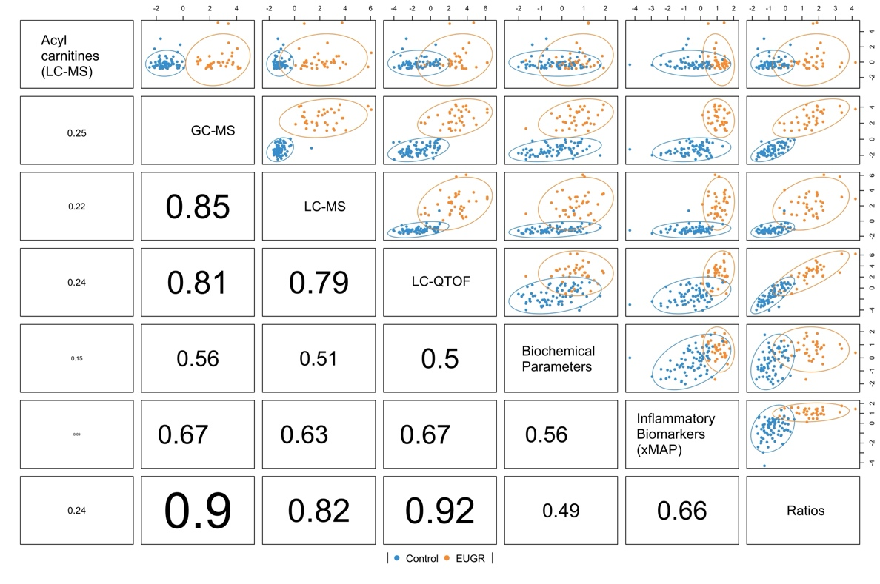
Supplementary Fig. S1. Correlation matrix from the DIABLO model integrating metabolomic, inflammatory and biochemical datasets
The heatmap illustrates pairwise correlations between latent components derived from each data block included in the multiblock integration analysis. Higher correlation coefficients indicate stronger agreement between datasets.

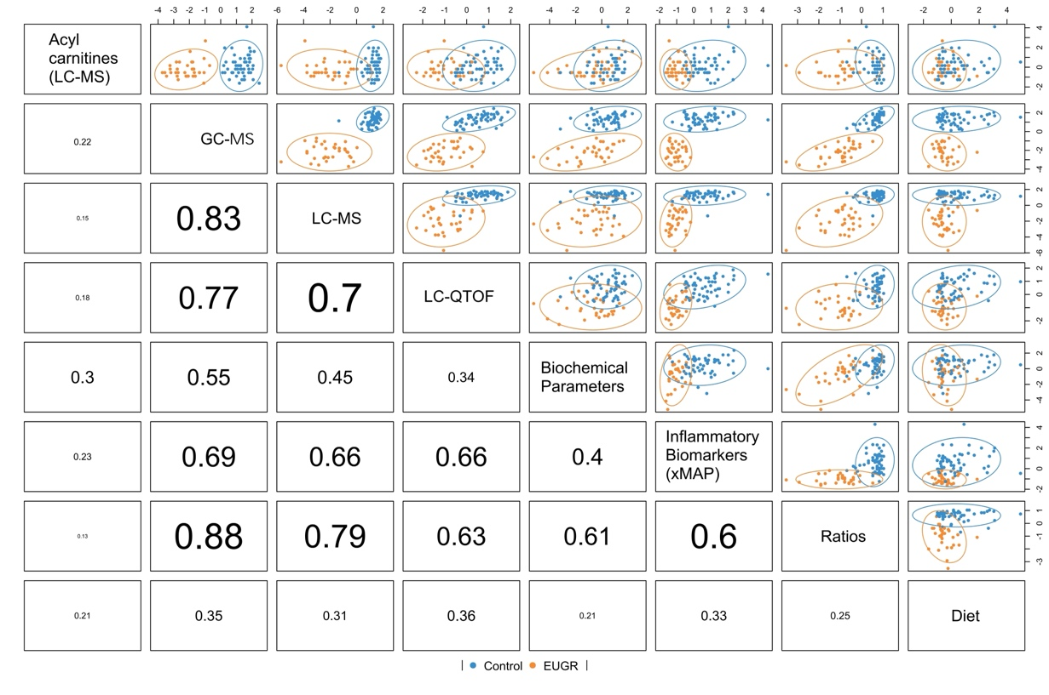
Supplementary Fig. S2. Correlation matrix from the DIABLO model after incorporating dietary intake variables.
The heatmap illustrates correlations among latent components after incorporation of dietary intake variables into the multiblock integration model. Higher correlation coefficients indicate stronger agreement between datasets.
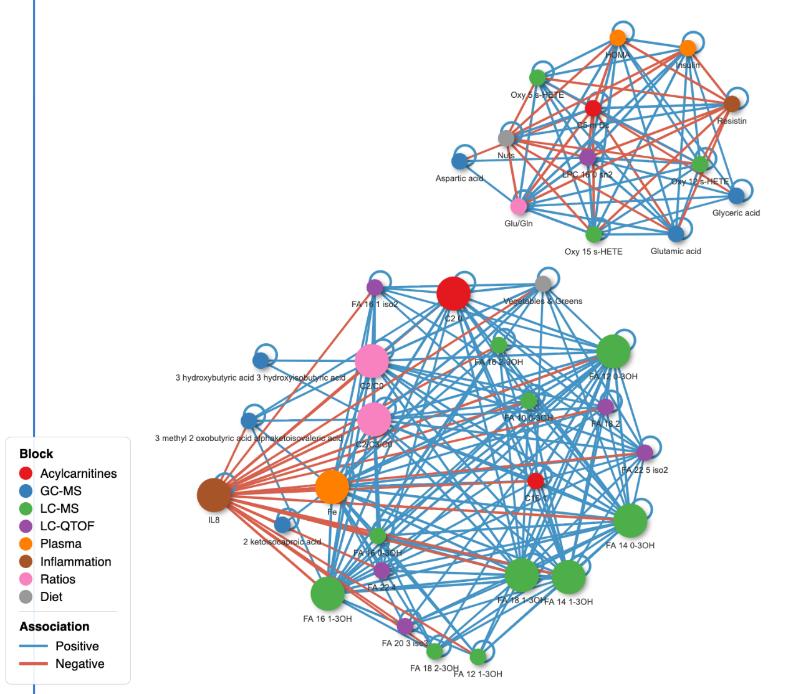
Supplementary Fig. S3. Correlation network of variables selected by the DIABLO model
The network displays the significant associations, stratified into two distinct clusters. The size of each node corresponds to its degree of connectivity within the network. Nodes represent variables and are colored according to their corresponding block (purple, LC-qTOF; red, acylcarnitines; green, LC-MS; blue, GC-MS; brown, inflammatory biomarkers; orange, biochemical parameters; grey, diet; pink, calculated ratios). Edges represent robust correlations between variables, with blue lines indicating positive associations and red line indicating negative associations. Only associations with a correlation threshold above 0.8 are displayed.

Supplementary Abbreviations

- OXYLIPINS
- 5(S)-HEPE– 5(S)-hydroxyicosapentaenoic acid
- 5(S)-HETE– 5(S)-Hydroxyeicosatetraenoic acid
- 9,10-DiHOME– 9,10-dihydroxyoctadecenoic acid
- 9,10-EpOME– 9,10 epoxyoctadecenoic acid
- 9(S)-HODE– 9(S)-Hydroxyoctadecadienoic acid
- 9(S)-HOTrE–9(S)-hydroxy-octadecatrienoic acid
- 9-oxoODE– 9-oxoctadecadienoic acid
- 11,12-DHET– 11,12-dihydroxyeicosatrienoic acid
- 12,13-EpOME– 12,13-epoxyoctadecenoic acid
- 12(S)-HETE–12(S)-Hydroxyeicosatetraenoic acid
- 13(S)-HODE– 13(S)-Hydroxyoctadecadienoic acid (13-HODE)
- 13(S)-HOTrE– 13(S)- hydroxyoctadecatrienoic acid
- 13-oxoODE– 13- oxooctadecadienoic acid
- 14,15-DHET– 14,15-Dihydroxyeicosatrienoic acid
- 15,16-EpODE– 15,16-epoxyoctadecadienoic acid
- 15(S)-HETE–15(S)-Hydroxyeicosatetraenoic acid
- 15,16-DiHODE–15,16-dihydroxyoctadecadienoic acid
- 20-HETE– 20-Hydroxyeicosatetraenoic acid
- PG E3– Prostaglandin E3
- PG F2a– Prostaglandin F2α
- TX B2– Tromboxano B2

- LPC: LYSOPHOSPHATIDYLCHOLINES
- LPC(14:0) – lysophosphatidylcholine containing myristic acid
- LPC(15:0) – lysophosphatidylcholine containing pentadecanoic acid
- LPC(16:0) – lysophosphatidylcholine palmitic palmitic acid
- LPC(16:1) – lysophosphatidylcholine containing palmitoleic acid
- LPC(18:0) – lysophosphatidylcholine containing stearic acid
- LPC(18:1) – lysophosphatidylcholine containing oleic acid
- LPC(18:2) – lysophosphatidylcholine containing linoleic acid
- LPC(18:3) – lysophosphatidylcholine containing linolenic acid
- LPC(20:0) – lysophosphatidylcholine containing arachidic acid
- LPC(20:1) – lysophosphatidylcholine containing gadoleic acid
- LPC(20:2) – lysophosphatidylcholine containing eicosadienoic acid
- LPC(20:3) – lysophosphatidylcholine containing dihomo-γ-linolenic acid
- LPC(20:4) – lysophosphatidylcholine containing arachidonic acid
- LPC(20:5) – lysophosphatidylcholine containing eicosapentaenoic acid (EPA)
- LPC(22:4) – lysophosphatidylcholine containing docosatetraenoic acid
- LPC(22:5) – lysophosphatidylcholine containing docosapentaenoic acid (DPA)
- LPC(22:6) – lysophosphatidylcholine containing docosahexaenoic acid (DHA)
* sn1 and sn2 indicate the position at which the acid binds
- LPE: LYSOPHOSPHATIDYLETHANOLAMINES
- LPE(16:0) – lysophosphatidylethanolamine containing palmitic acid
- LPE(18:0) – lysophosphatidylethanolamine containing stearic acid
- LPE(18:1) – lysophosphatidylethanolamine containing oleic acid
- LPE(18:2) – lysophosphatidylethanolamine containing linoleic acid
- LPE(20:3) – lysophosphatidylethanolamine containing dihomo-γ-linolenic acid
- LPE(20:4) – lysophosphatidylethanolamine containing arachidonic acid
- LPE(20:5) – lysophosphatidylethanolamine containing eicosapentaenoic acid (EPA)
- LPE(22:6) – lysophosphatidylethanolamine containing docosahexaenoic acid (DHA)
- * sn1 and sn2 indicate the position at which the acid binds
- BILIARY ACIDS (BA)
- CA – cholic acid
- CDCA – chenodeoxycholic acid
- DCA – deoxycholic acid
- GCA – glycocholic acid
- GCDCA – glycochenodeoxycholic acid
- GCDCA-S – glycochenodeoxycholic acid sulfate
- GDCA – glycodeoxycholic acid
- GDCA-S – glycodeoxycholic acid sulfate
- GLCA – glycolithocholic acid
- GUDCA-S – glycoursodeoxycholic acid sulfate
- LCA – lithocholic acid
- TCA – taurocholic acid
- TCDCA – taurochenodeoxycholic acid
- TDCA – taurodeoxycholic acid
- TUDCA – tauroursodeoxycholic acid
- THDCA – taurohyodeoxycholic acid
- UDCA – ursodeoxycholic acid
- HDCA – hyodeoxycholic acid

- FATTY ACIDS (FA)
- 16:1n-7 – palmitoleic acid
- 18:2n-6 – linoleic acid
- 18:3n-3 – α-linolenic acid
- 18:3n-6 – γ-linolenic acid
- 18:4n-3 – stearidonic acid
- 20:0n-3 – arachidic acid
- 20:3n-3 - dihomo- γ -linolenic acid (DGLA)
- 20:4n-6 – arachidonic acid
- 20:5n-3 – eicosapentaenoic acid (EPA)
- 22:5n-3 – docosapentaenoic acid (DPA)
- 22:6n-3 – docosahexaenoic acid (DHA)
* iso- indicate the isomer
- ACYLCARNITINES
- Short chain
- C2 – acetylcarnitine
- C3 – propionylcarnitine
- C4 – butyrylcarnitine
- C4 (iso-C4) – isobutyrylcarnitine
- C5 (iso-C5) – isovalerylcarnitine
- C5-DC – glutarylcarnitine
- Medium chain
- C6 – hexanoylcarnitine
- C8 – octanoylcarnitine
- C8:1 – octenoylcarnitine
- C10 – decanoylcarnitine
- C10:1 – decenoylcarnitine
- C12 – dodecanoylcarnitine
- C12-OH – hydroxy-dodecanoylcarnitine
- C12:1 – dodecenoylcarnitine
- Long chain
- C14 – tetradecanoylcarnitine
- C14-OH – hydroxy-tetradecanoylcarnitine
- C14:1 – tetradecenoylcarnitine
- C14:2 – tetradecadienoylcarnitine
- C16 – hexadecanoylcarnitine
- C16-OH – hydroxy-hexadecanoylcarnitine
- C16:1 – hexadecenoylcarnitine
- C18 – octadecanoylcarnitine
- C18:1 – octadecenoylcarnitine
- C18:2 – octadecadienoylcarnitine

