INDEX
Figures
Figure 1: Fish bone diagram of the findings from interviews and observations in the antenatal clinics
Figure 2: Algorithm for actions for maternal nutritional services in antenatal care OPD
Figure 3: PDSA cycles

Tables
Table 1: Accuracy of height measurement as per OSCE checklist
Table 2: Accuracy of weight measurement as per OSCE checklist
Table 3: Accuracy of blood pressure measurement as per OSCE checklist
Table 4: OSCE checklist for measurement of height
Table 5: OSCE checklist for measurement of weight
Table 6: OSCE checklist for measurement of blood pressure
Table 7: Outcome indicators for assessment of nutrition status
Table 8: Outcome indicators for clinical examination
Table 9: Outcome indicators for biochemical examination
Table 10: Outcome indicators for counselling services
Table 11: Study tools used for assessment of maternal nutrition services

Study tools
1.Key informant interview guide for medical officers and female health supervisors
2. Focused group discussion guide for ASHAs and HW-Fs
3. Questionnaire for Training needs assessment

4. Exit interview Questionnaire

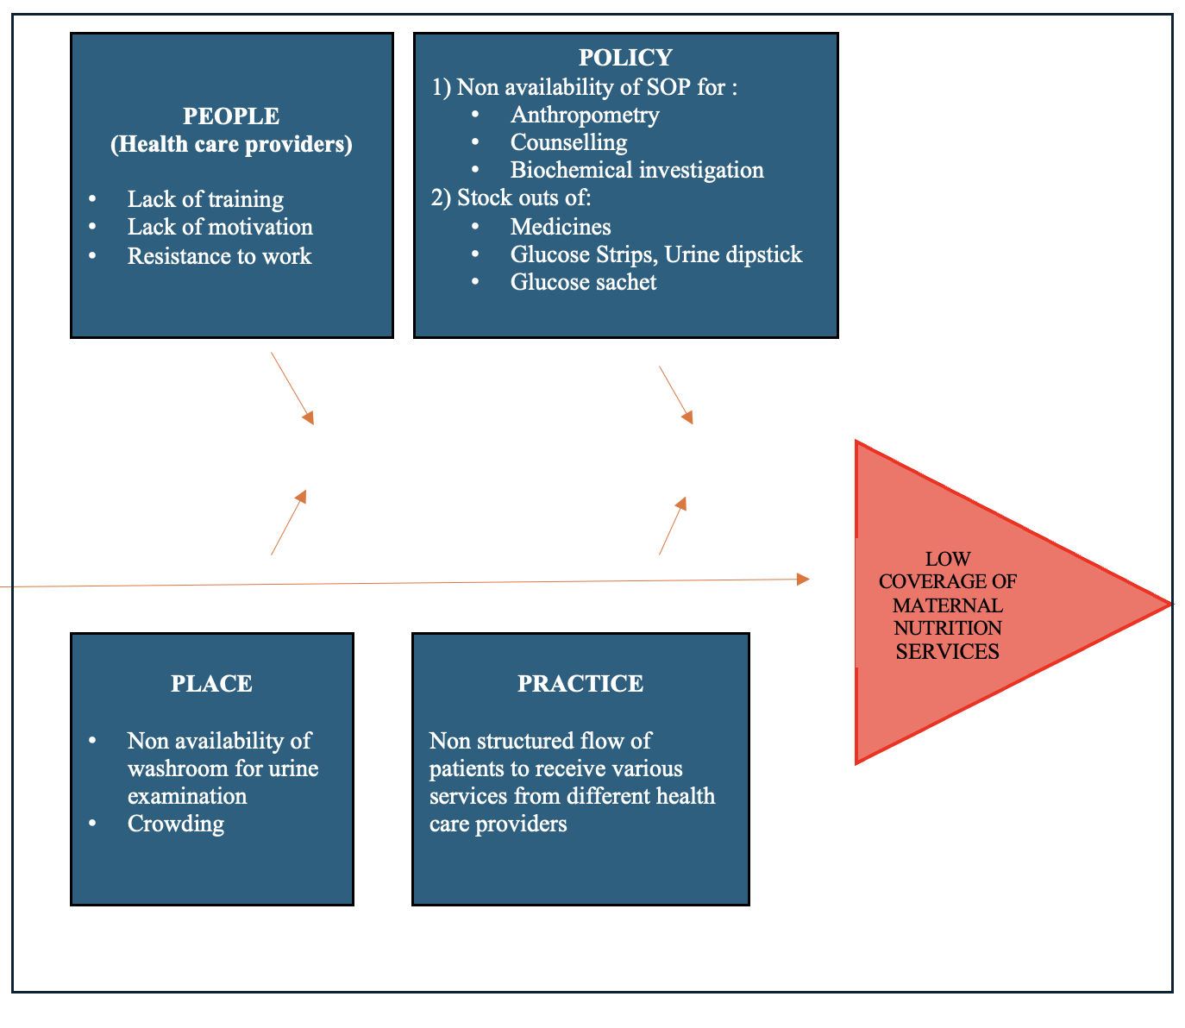
Figure 1: Fish bone diagram of the findings from interviews and observations in the antenatal clinics
Figure 2: Algorithm for actions for maternal nutritional services in antenatal care OPD

Source: National Centre of Excellence and Advanced Research on Diets (NCEARD). Maternal Nutrition Toolkit

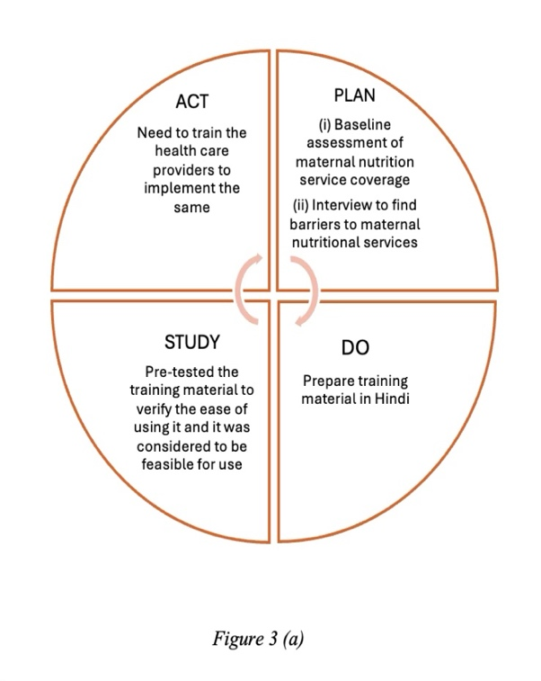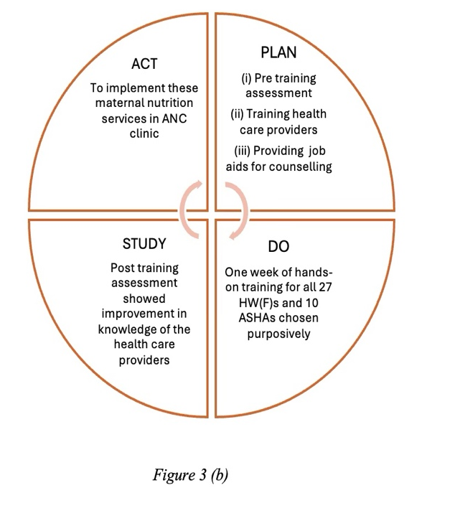
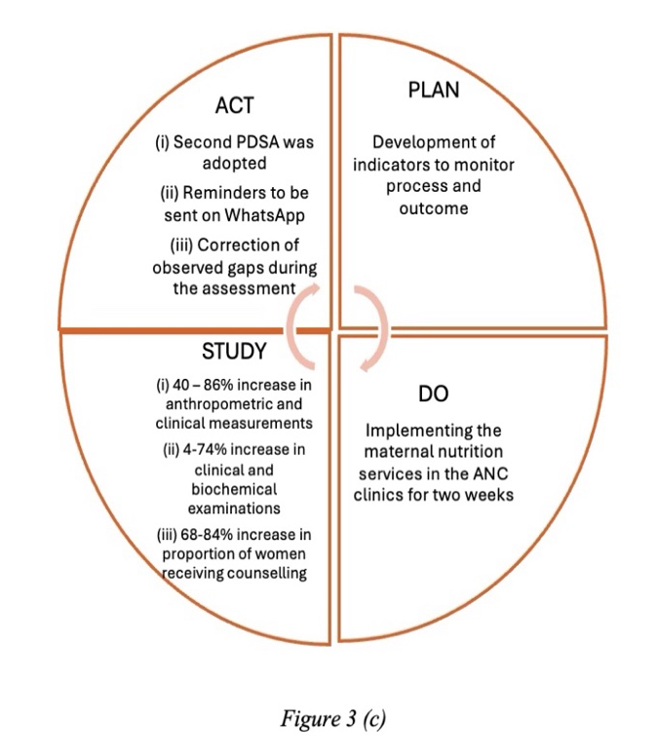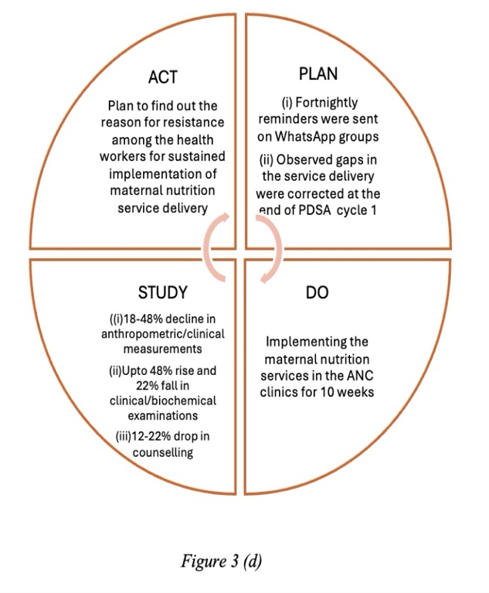
Figure 3 (a-d): PDSA cycles; 5(a) First PDSA cycle, 5(b) Second PDSA cycle, 5(c) Third PDSA cycle, 5(d) Fourth PDSA cycle
Table 1: Accuracy of height measurement as per OSCE checklist (N = 50)

S. No | Steps | Baseline assessment  n (%) | Endline assessment after two weeks  n (%) | p-value | Endline assessment after three months  n (%) | p-value
1 | Asked to remove footwear, head gear and scarf/veil before stepping onto the stadiometer | 39 (78%) | 50 (100%) | <0.001 | 45 (90%) | 0.17
2 | Asked to stand on the board of Stadiometer facing the experimenter | 47 (94%) | 50 (100%) | 0.24 | 50 (100%) | 0.24
3 | Told to stand with: Feet together, Heels against the back board, Knees straight, looking straight ahead with eyes at the same level as the ears. | 32 (64%) | 50 (100%) | <0.001 | 36 (72%) | 0.52

Table 2: Accuracy of weight measurement as per OSCE checklist (N = 50)

S. No | Steps | Baseline assessment n (%) | Endline assessment after two weeks  n (%) | p- value | Endline assessment after three months  n (%) | p-value
1 | Asked to remove footwear and socks before stepping onto the weighing scale | 15 (30%) | 44 (88%) | <0.001 | 36 (72%) | <0.001
2 | Checked if the pregnant women’s feet were on either side of the scale | 40 (80%) | 50 (100%) | <0.001 | 43 (86%) | 0.6
3 | Told to stand still, face forward, place arms on the side | 15 (30%) | 45 (90%) | <0.001 | 42 (84%) | <0.001

Table 3: Accuracy of blood pressure measurement as per OSCE checklist (N = 50)

S. No | Steps | Baseline assessment  n (%) | Endline assessment after two weeks  n (%) | p-value | Endline assessment after three months  n (%) | p-value
1 | Asked to relax ideally for 5 minutes | 30 (60%) | 36 (72%) | 0.29 | 20 (40%) | 0.07
2 | Asked to sit on a chair with their feet on the floor, uncrossed and back supported | 0 (0) | 34 (68%) | <0.001 | 42 (84%) | <0.001
3 | Told to not talk, read or use electronic devices during the rest period or during the assessment and the same was followed by the health worker | 12 (24%) | 40 (80%) | <0.001 | 33 (66%) | <0.001
4 | Cuff of the sphygmomanometer positioned on the pregnant woman’s bare upper arm (a light sleeve is acceptable) and centred over the brachial artery | 20 (40%) | 34 (68%) | 0.01 | 41 (82%) | <0.001
5 | Arm supported so that the middle of the cuff is at heart level | 24 (48%) | 38 (76%) | 0.01 | 39 (78%) | <0.001

Table 4: OSCE checklist for measurement of height

S. No | Steps | Methods to measure
1 | Asked to remove footwear, head gear and scarf/veil before stepping onto the stadiometer | Observation
2 | Asked to stand on the board of Stadiometer facing the experimenter | Observation
3 | Told to stand with: Feet together, Heels against the back board, Knees straight, looking straight ahead with eyes at the same level as the ears. | Observation

Table 5: OSCE checklist for measurement of weight
S. No | Steps | Source
1 | Asked to remove footwear and socks before stepping onto the weighing scale | Observation
2 | Checked if the pregnant women’s feet were on either side of the scale | Observation
3 | Told to stand still, face forward, place arms on the side | Observation

Table 6: OSCE checklist for measurement of blood pressure
S. No | Steps | Source
1 | Asked to relax ideally for 5 minutes | Observation
2 | Asked to sit on a chair with their feet on the floor, uncrossed and back supported | Observation
3 | Told to not talk, read or use electronic devices during the rest period or during the assessment and the same was followed by the health worker | Observation
4 | Cuff of the sphygmomanometer positioned on the pregnant woman’s bare upper arm (a light sleeve is acceptable) and centred over the brachial artery | Observation
5 | Arm supported so that the middle of the cuff is at heart level | Observation

Table 7: Outcome indicators for assessment of nutrition status
S. No | Outcome indicators | Source
1 | Proportion of pregnant women whose height was measured following the steps as per the OSCE based checklist, in the right order | Observation
2 | Proportion of pregnant women whose weight was measured following the steps as per the OSCE based checklist, in the right order | Observation
3 | Proportion of pregnant women whose BMI was measured in the first trimester | MCP Card
4 | Proportion of pregnant women whose weight gain was monitored | MCP Card
5 | Proportion of pregnant women whose blood pressure was measured following the OSCE based checklist steps in the right order | Observation

Table 8: Outcome indicators for clinical examination
S.No | Outcome indicators | Source
1 | Proportion of pregnant women who were examined for pallor | Exit interview of pregnant women
2 | Proportion of pregnant women who were examined for goitre | Exit interview of pregnant women
3 | Proportion of pregnant women who were examined for fluorosis | Exit interview of pregnant women
4 | Proportion of pregnant women who were examined for pedal edema / puffiness of face | Exit interview of pregnant women

Table 9: Outcome indicators for biochemical examination
S.No | Outcome indicators | Source
1 | Proportion of pregnant women whose hemoglobin level was measured at each trimester | MCP Card
2 | Proportion of pregnant women whose urine examination was done to detect albumin and sugar at each trimester | MCP Card
3 | Proportion of pregnant women whose Oral Glucose Tolerance test was done at first and third trimester | MCP Card

Table 10: Outcome indicators for counselling service
S.No | Outcome indicators | Source
1 | Proportion of pregnant women who were counselled regarding diet | Exit interview of pregnant women
2 | Proportion of pregnant women who were counselled regarding breast feeding | Exit interview of pregnant women
3 | Proportion of pregnant women who were counselled regarding family planning | Exit interview of pregnant women

Table 11: Study tools used for assessment of maternal nutrition services
S.No | Tools | Purpose
1 | Objective structured clinical examination (OSCE) checklist | For assessment of height, weight and blood pressure measurements following the right steps in the right order
2 | Exit Interview | To confirm their receipt of clinical examinations (pallor, jaundice, goitre, oedema) and counselling services (dietary, breastfeeding and family planning methods)
3 | Semi-structured interview guides for Focused Group Discussions (FGD) and Key informant Interviews (KII) | To explore the perception of the health care providers on barriers in delivering different maternal nutrition services and their suggestions on what can be improved
4 | Training needs assessment questionnaire | To assess confidence, frequency of services provision and the preferred areas for training.

Study tools
Key informant interview guide for medical officers and female health supervisors

Personal profile
- Age
- Current work position : Medical Officer / female Health Supervisor
- Years of total work experience in the PHC
___________________________________________________________________________
1.What are your roles in the antenatal clinic?

2.What challenges do you face while supervising the health care providers?

3.Do you feel like HW-Fs and ASHAs are delivering their services as expected of them?

4.What are the common complaints you hear from families of pregnant and lactating women?

5.Do you have any suggestions for improving maternal services in the antenatal clinics?

********************************************

Focused group discussion guide for ASHAs and HW-Fs

Personal profile
1. Age
2. Current work position : Medical Officer / female Health Supervisor
3. Years of total work experience in the PHC
___________________________________________________________________________
1.What services are you currently providing to pregnant and lactating women ? (counselling, what kinds of counselling, anthropometry, what kinds of anthropometry)

2.Do you face any difficulty in delivering these services?

3. Were you provided any training on the same?

4.What are the common complaints you hear from families of pregnant and lactating women?

5.Do you have any suggestions for improving maternal services in the antenatal clinics?

********************************************

Questionnaire for Training needs assessment

Section | Questions
Personal  details | 1. Age  2. Years of experience  3. HW-F / ASHA
Knowledge and Skills  Assessment | (For HW-F only)  A. Examination and Screening  1) How confident are you in conducting physical examination of pregnant women?  a. Not confident  b. Somewhat confident  c. Moderately confident  d. Very confident  e. Extremely confident  2) When do you measure blood pressure in a pregnant woman?  a. Never  b. Once in entire pregnancy  c. Once in three months  d. Every OPD visit  3) When do you measure urine sugar and albumin in a pregnant woman?  a. Never  b. Once in entire pregnancy  c. Once in three months  d. Every OPD visit  4) When do you measure blood glucose level in a pregnant woman?  a. Never  b. Once in entire pregnancy  c. Once in three months  d. Every OPD visit
(For HW-F only)
B. Asking about medical problems
1) How well are you able to ask pregnant women about their medical problems?
a. Not able
b. Somewhat able
c. Moderately able
d. Very able
e. Extremely able

2) How often do you document medical problems?
a. Never
b. Once in entire pregnancy
c. Once in three months
d. Every OPD visit

(For both HW-F and ASHAs )
C. Anthropometry
1)How confident are you in measuring the weight of pregnant women?
a. Not confident
b. Somewhat confident
c. Moderately confident
d. Very confident
e. Extremely confident

2)How confident are you in measuring the height of pregnant women?
a. Not confident
b. Somewhat confident
c. Moderately confident
d. Very confident
e. Extremely confident

3)How confident are you in measuring the mid upper arm circumference of pregnant women?
a. Not confident
b. Somewhat confident
c. Moderately confident
d. Very confident
e. Extremely confident
(For both HW-F and ASHAs)
D. Dietary counselling
1) How knowledgeable are you about the nutritional requirements of pregnant women?
a. Not knowledgeable
b. Somewhat knowledgeable
c. Moderately knowledgeable
d. Very knowledgeable
e. Extremely knowledgeable

2) How confident are you in providing dietary counselling to pregnant women?
a. Not confident
b. Somewhat confident
c. Moderately confident
d. Very confident
e. Extremely confident

Training  Preferences | (For both HW-F and ASHAs)  1) What topics would you like to trained in?  a. Examination and Screening  b. History Taking  c. Anthropometry  d. Diet Counselling  e. Antenatal Clinic and VHND  f. Community Engagement  2)Preferred Training Method  a. Workshops  b. Online/App based  c. Printed Materials

********************************************

Exit interview questionnaire
S.No | Question | Yes/No
1 | Were your eyes, tongue, oral cavity or palms examined for pallor in this visit?
2 | Were you asked to stretch your neck or was it palpated for any swelling or growth in this visit? (Goitre)
3 | Were your teeth assessed for discoloration in this visit? (Fluorosis)
4 | Were your feet examined for swelling or face for puffiness in this visit?  (Pedal/facial edema)
5 | Were you provided any dietary counselling in this visit?
6 | Were you counselled regarding breast feeding in this visit?
7 | Were you counselled regarding family planning in this visit?

