SUPPLEMENTARY INFORMATION
Extreme early-spring polar jet shifts reduce warm-season runoff in the snow-dominated upper Colorado River Basin
Yuan Qiu¹, James S. Famiglietti¹, Guo-Yue Niu², Ali Behrangi²
¹School of Sustainability, Arizona State University, Tempe, USA
²Department of Hydrology and Atmospheric Sciences, The University of Arizona, Tucson, USA
Correspondence to: yuan.qiu.2@asu.edu
This file contains Supplementary Tables 1–7, Supplementary Figures 1–6, and Supplementary References.

Supplementary Table 1. Simulated changes in the warm-season water budget of the UCRB due to extreme PJS shifts (units: km³). Percentage changes relative to the 1981–2021 mean are shown in parentheses. The neutral year is 1993. Because forcing is replaced only in March, warm-season precipitation changes are zero.
Variable | 1981–2021  mean | All forcing  changes | Temperature  changes only | Precipitation  changes only
Precipitation | 32.46 ± 9.80 | 0 | 0 | 0
Runoff | 13.69 ± 5.52 | −3.19 ± 0.44  (−23.3 ± 3.2%) | −0.35 ± 0.15 | −2.65 ± 0.43
ET | 50.72 ± 7.38 | −2.28 ± 1.19  (−4.5 ± 2.3%) | −0.28 ± 0.09 | −1.71 ± 0.97
May 1 SWE | 12.49 ± 6.50 | −4.16 ± 1.21  (−33.3 ± 9.7%) | −0.61 ± 0.31 | −3.35 ± 1.04

Supplementary Table 2. Same as Supplementary Table 1, but the neutral year is 2021.
Variable | 1981–2021  mean | All forcing  changes | Temperature  changes only | Precipitation  changes only
Precipitation | 32.46 ± 9.80 | 0 | 0 | 0
Runoff | 13.69 ± 5.52 | −1.73 ± 0.41  (−12.6 ± 3.0%) | −0.73 ± 0.22 | −1.00 ± 0.43
ET | 50.72 ± 7.38 | −1.52 ± 1.02  (−3.0 ± 2.0%) | −0.50 ± 0.18 | −1.06 ± 0.78
May 1 SWE | 12.49 ± 6.50 | −2.40 ± 1.00  (−19.2 ± 8.0%) | −1.24 ± 0.55 | −1.28 ± 0.71

Supplementary Table 3. Unadjusted and partial correlations between March PJSL and UCRB-mean March temperature, precipitation, and SWEA. Partial correlations control separately for ENSO, PDO, and AO. Temperature and precipitation analyses span 1981–2024 (n = 44); the SWEA analysis spans 1982–2023 (n = 42).
Variable | Unadjusted r | Partial r, controlling for ENSO | Partial r, controlling for PDO | Partial r, controlling for AO
Temperature | 0.47 (p < 0.01) | 0.48 (p < 0.01) | 0.51 (p < 0.01) | 0.40 (p < 0.01)
Precipitation | −0.31 (p = 0.04) | −0.26 (p = 0.10) | −0.29 (p = 0.05) | −0.32 (p = 0.04)
SWEA | −0.53 (p < 0.01) | −0.53 (p < 0.01) | −0.55 (p < 0.01) | −0.49 (p < 0.01)

Supplementary Table 4. March PJSL projections from 13 CMIP6 model runs under SSP585. Linear trends are calculated over 1979–2100, and mean differences are calculated as 2061–2100 minus 1981–2020. Extreme years are defined as years in which March PJSL exceeds the run-specific 90th percentile calculated over 1979–2025; counts are reported for 1981–2020 and 2061–2100, respectively. Statistical significance is defined as p < 0.10.
Model run | Linear trend (°N per decade) | Mean difference (°N) | Extreme-year count, 1981–2020/2061–2100
ACCESS-CM2_r5i1p1f1 | −0.01 (p = 0.82) | −0.31 (p = 0.48) | 4/4
CanESM5_r1i1p2f1 | 0.11 (p = 0.17) | 1.12 (p = 0.15) | 1/1
CESM2_r11i1p1f1 | −0.44 (p = 0.01) | −4.10 (p = 0.01) | 5/2
CNRM-ESM2–1_r1i1p1f2 | −0.02 (p = 0.83) | −0.21 (p = 0.78) | 3/3
EC-Earth3_r1i1p1f1 | 0.20 (p = 0.07) | 1.81 (p = 0.05) | 3/11
EC-Earth3-Veg_r1i1p1f1 | 0.02 (p = 0.86) | −0.23 (p = 0.84) | 5/4
FGOALS-g3_r1i1p1f1 | −0.21 (p = 0.03) | −2.18 (p = 0.03) | 4/1
GISS-E2–1-G_r1i1p1f2 | 0.11 (p = 0.18) | 0.35 (p = 0.63) | 5/2
MPI-ESM1–2-HR_r3i1p1f1 | −0.14 (p = 0.08) | −1.73 (p = 0.02) | 5/1
MPI-ESM1–2-LR_r7i1p1f1 | 0.02 (p = 0.86) | −0.47 (p = 0.64) | 2/3
NorESM2-MM_r1i1p1f1 | −0.25 (p = 0.20) | −2.38 (p = 0.19) | 5/4
TaiESM1_r1i1p1f1 | −0.14 (p = 0.37) | −1.60 (p = 0.28) | 4/0
UKESM1–0-LL_r2i1p1f2 | −0.22 (p = 0.04) | −1.41 (p = 0.14) | 4/2
Summary | 5 of 13 runs show northward trends;  1 is significant | 3 of 13 runs show  northward mean shifts; 1 is significant | 2 of 13 runs show increases, 8 show decreases, and 3 show no change

Supplementary Table 5. Same as supplementary Table 4, but for the SSP370 scenario.
Model run | Linear trend (°N per decade) | Mean difference (°N) | Extreme-year count, 1981–2020/2061–2100
ACCESS-CM2_r5i1p1f1 | 0.14 (p = 0.03) | 1.12 (p = 0.06) | 3/5
CanESM5_r1i1p2f1 | 0.14 (p = 0.16) | 1.47 (p = 0.11) | 1/3
CESM2_r11i1p1f1 | −0.44 (p = 0.02) | −4.12 (p = 0.03) | 5/2
CNRM-ESM2–1_r1i1p1f2 | −0.16 (p = 0.09) | −1.19 (p = 0.13) | 4/2
EC-Earth3_r1i1p1f1 | 0.15 (p = 0.20) | 1.18 (p = 0.23) | 4/11
EC-Earth3-Veg_r1i1p1f1 | 0.11 (p = 0.44) | 0.42 (p = 0.74) | 5/5
FGOALS-g3_r1i1p1f1 | −0.27 (p = 0.01) | −2.73 (p < 0.01) | 4/0
GISS-E2–1-G_r1i1p1f2 | 0.07 (p = 0.35) | 0.25 (p = 0.72) | 1/0
MPI-ESM1–2-HR_r3i1p1f1 | −0.11 (p = 0.17) | −1.07 (p = 0.14) | 5/1
MPI-ESM1–2-LR_r7i1p1f1 | −0.02 (p = 0.86) | 0.28 (p = 0.78) | 5/1
NorESM2-MM_r1i1p1f1 | −0.01 (p = 0.97) | −0.28 (p = 0.88) | 4/4
TaiESM1_r1i1p1f1 | −0.27 (p = 0.10) | −2.31 (p = 0.13) | 4/1
UKESM1–0-LL_r2i1p1f2 | −0.03 (p = 0.76) | −0.16 (p = 0.89) | 4/4
Summary | 5 out of 13 runs show northward trends;  1 is significant | 6 out of 13 runs show  northward mean shifts; 1 is significant | 4 out of 13 runs show increases, 6 show decreases, and 3 show no change

Supplementary Table 6. CMIP6 model runs analyzed in this study.
Model | Variant | Center | Resolution
ACCESS-CM2¹ | r5i1p1f1 | Commonwealth Scientific and Industrial Research Organization | 1.25 ° × 1.25 °
CanESM5² | r1i1p2f1 | Canadian Climate Center | 2.8 ° × 2.8 °
CESM2³ | r11i1p1f1 | National Center for Atmospheric Research | 0.94 ° × 1.25 °
CNRM-ESM2–1⁴ | r1i1p1f2 | Centre Européen de Recherche et de Formation Avancée en Calcul Scientifique | 1.4 ° × 1.4 °
EC-Earth3⁵ | r1i1p1f1 | EC-Earth Consortium | 0.7 ° × 0.7 °
EC-Earth3-Veg⁵ | r1i1p1f1 | EC-Earth Consortium | 0.7 ° × 0.7 °
FGOALS-g3⁶ | r1i1p1f1 | Chinese Academy of Sciences | 2 °×2 °
GISS-E2–1-G⁷ | r1i1p1f2 | National Aeronautic and Space Administration | 2 ° × 2.5 °
MPI-ESM1–2-HR⁸ | r3i1p1f1 | Max Planck Institute | 0.94 ° × 0.94 °
MPI-ESM1–2-LR⁹ | r7i1p1f1 | Max Planck Institute | 1.9 ° × 1.9 °
NorESM2-MM¹⁰ | r1i1p1f1 | NorESM Climate modeling Consortium | 0.94 ° × 1.25 °
TaiESM1¹¹ | r1i1p1f1 | Research Center for Environmental Changes | 0.94 ° × 1.25 °
UKESM1–0-LL¹² | r2i1p1f2 | Met Office Hadley Centre | 1.25 ° × 1.25 °
Supplementary Table 7. Highest-ranked neutral-year candidates. Here,
$dist$ denotes the three-dimensional Euclidean distance in standardized space; the remaining columns report z scores of March PJSL, UCRB-mean March temperature, and UCRB-mean March precipitation.
Year | $$dist$$ | $$Z_{PJSL}$$ | $$Z_{T}$$ | $$Z_{P}$$
2014 | 0.67 | 0.04 | 0.38 | −0.31
1993 | 0.71 | −0.52 | 0.06 | 0.42
2021 | 0.75 | −0.24 | −0.43 | 0.00

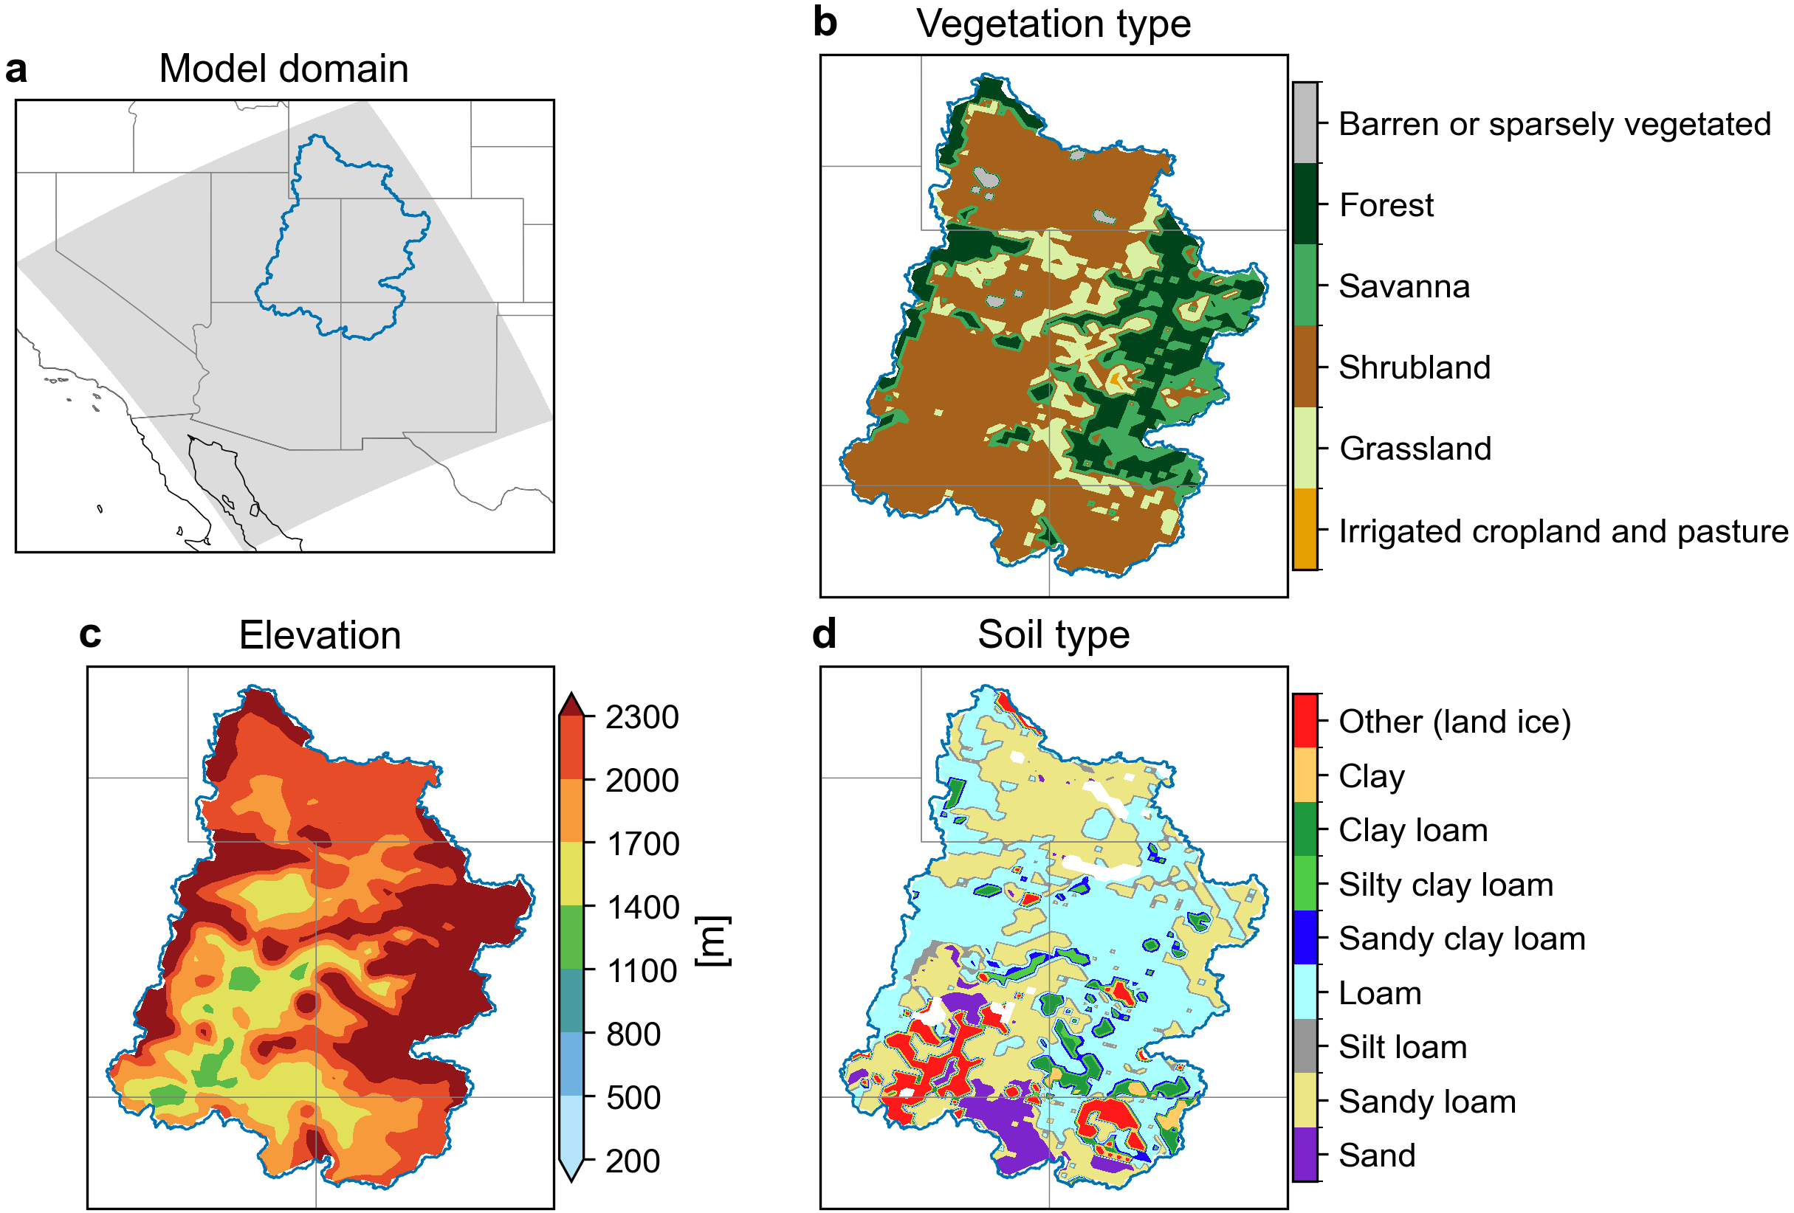
Supplementary Figure 1. Noah-MP model configuration. (a) Model domain (gray shading) and the UCRB boundary (blue outline). Spatial distribution of (b) main vegetation types, (c) elevation (m), and (d) soil types within the UCRB.

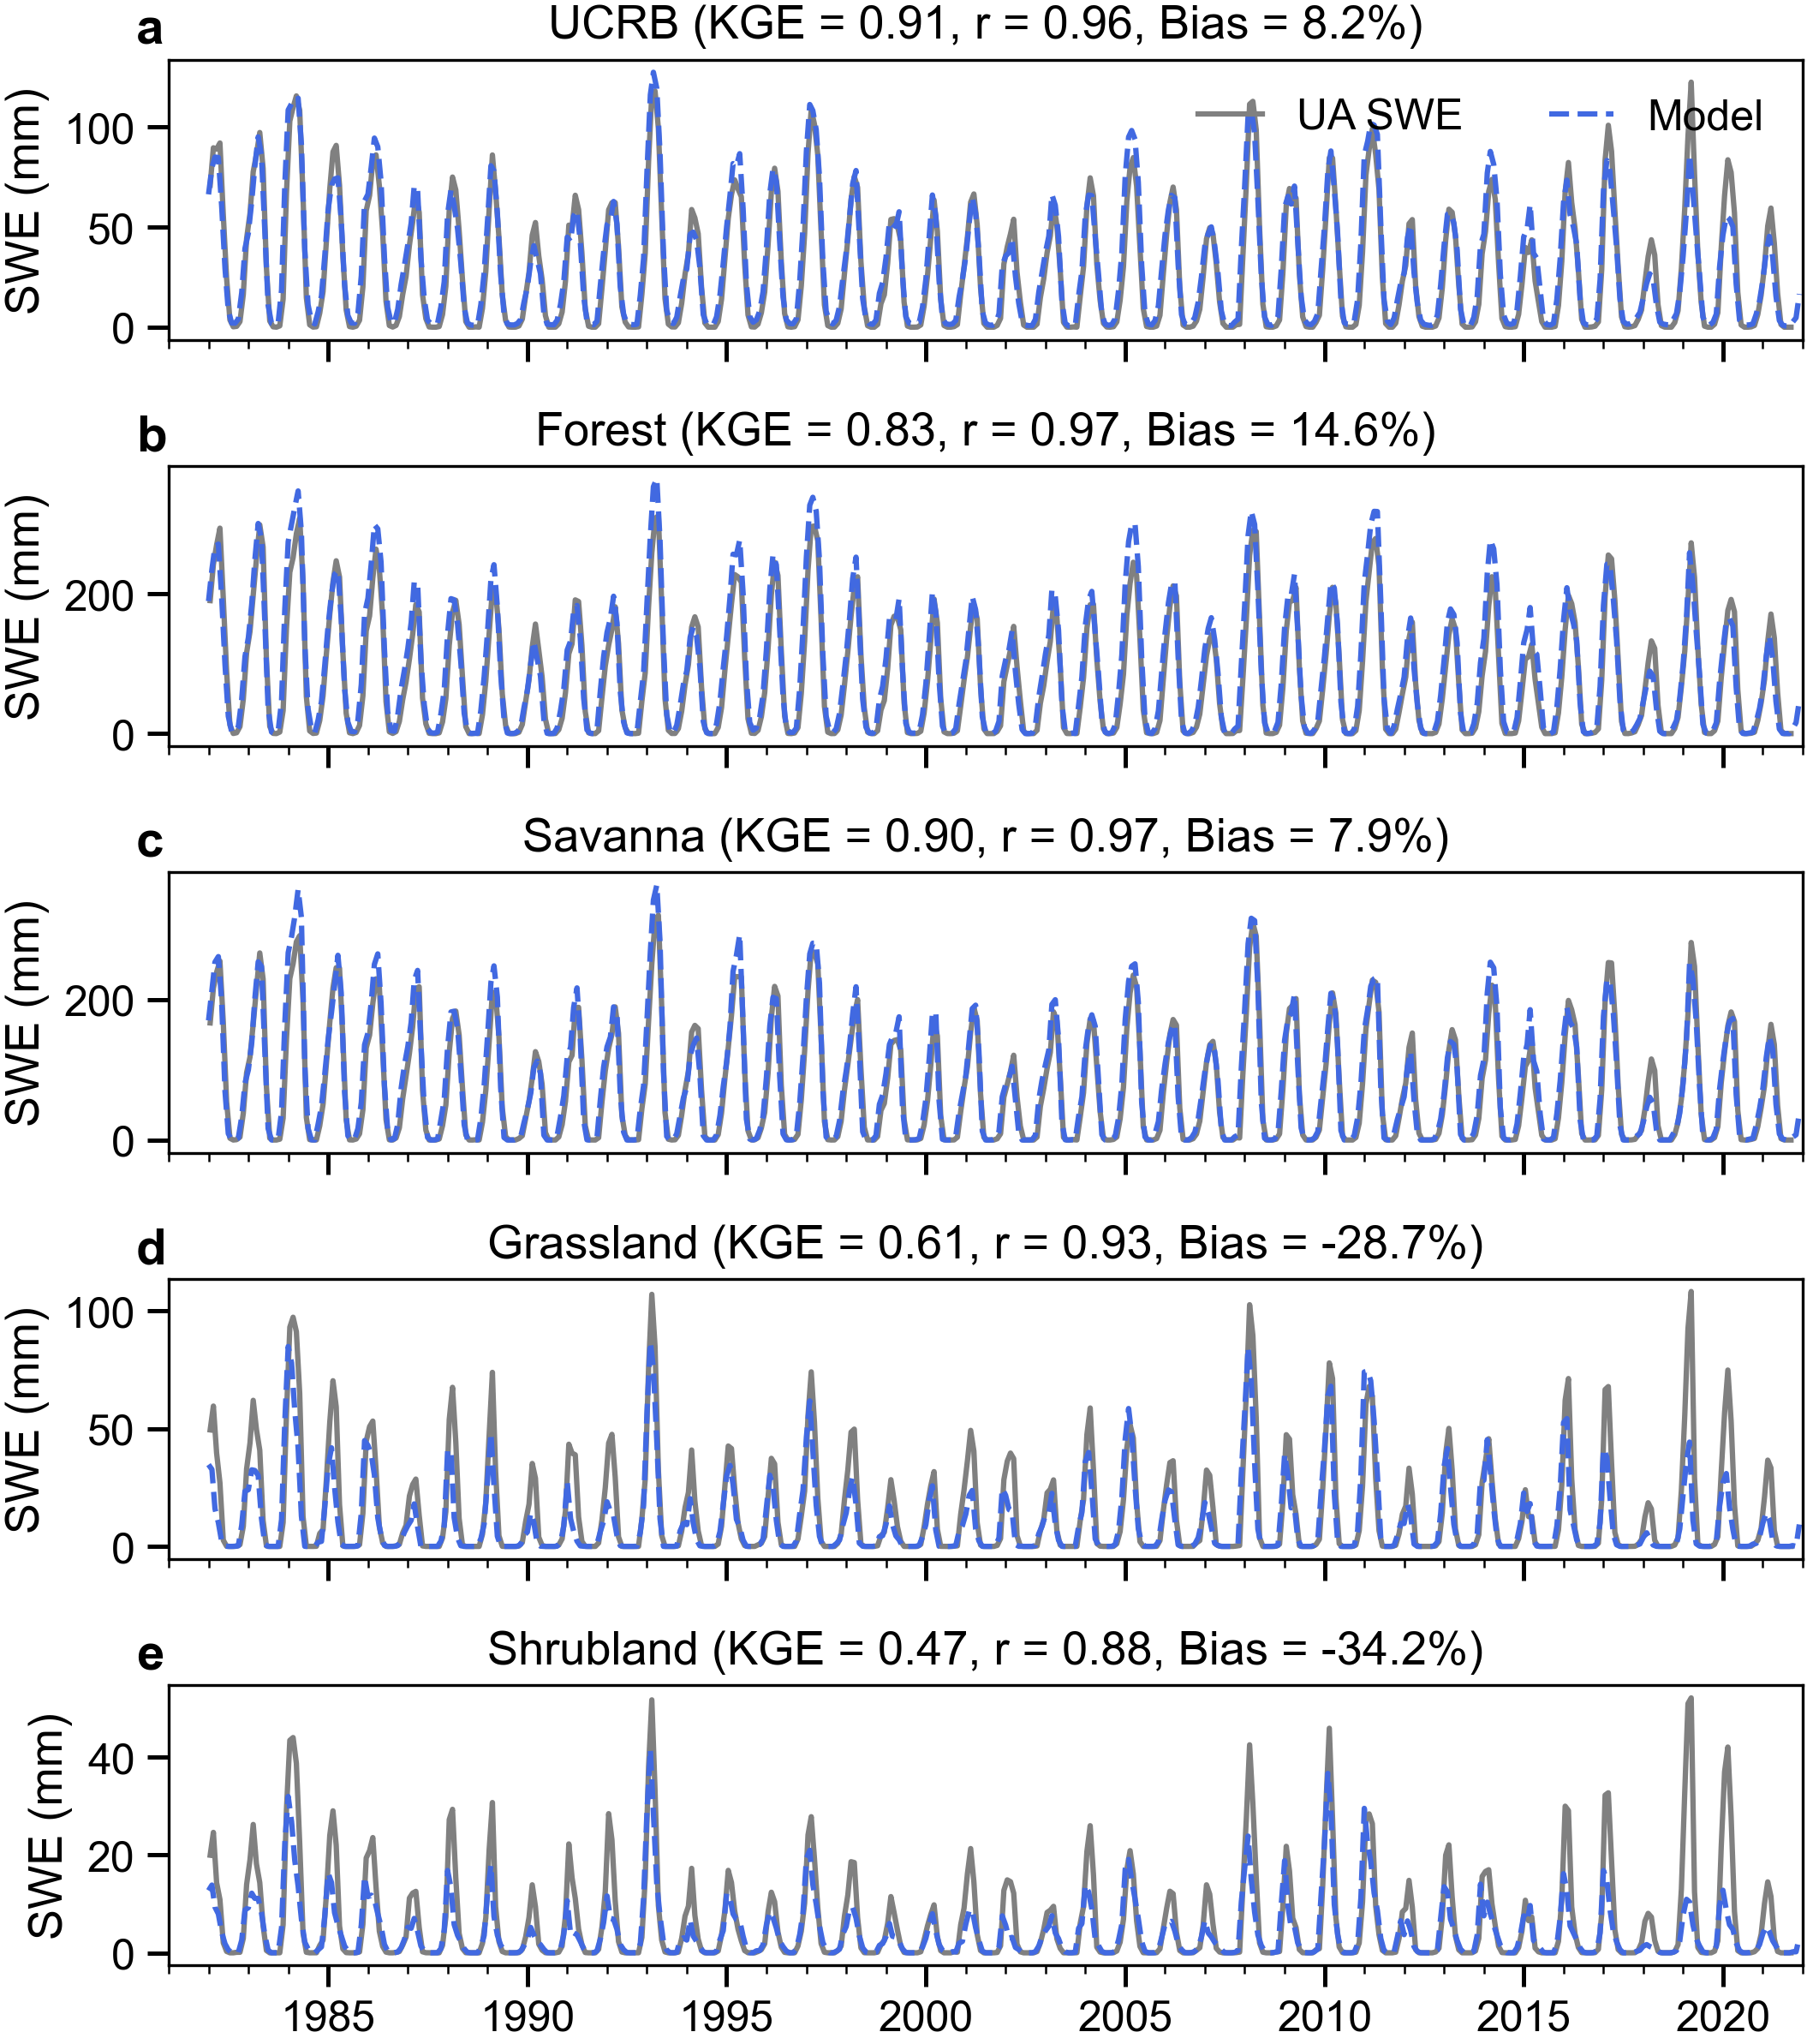
Supplementary Figure 2. Time series of monthly SWE for the UCRB and its main vegetation types during 1982–2021 from the UA SWE product (gray solid line) and the Noah-MP model (blue dashed line). The KGE, correlation coefficient (r), and relative mean bias are shown.

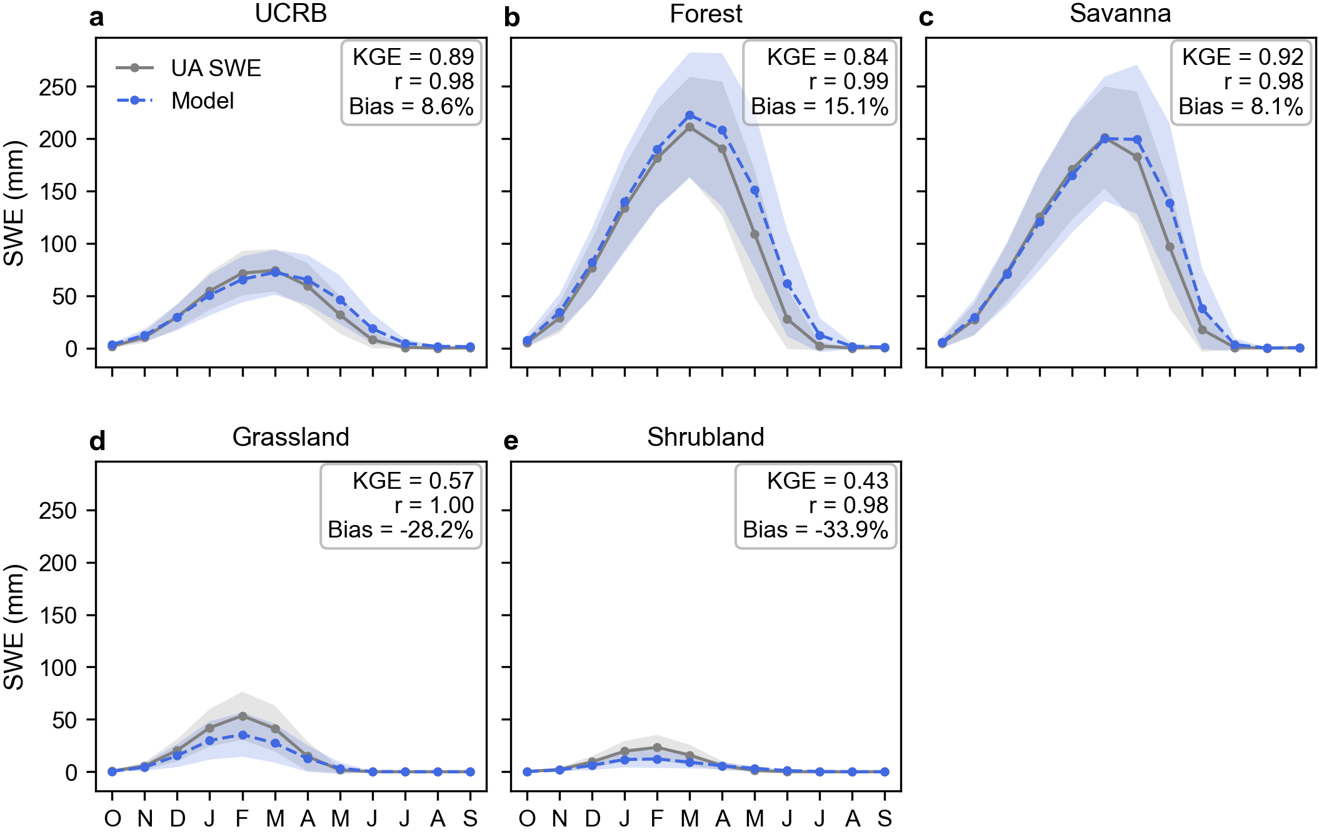
Supplementary Figure 3. Mean annual cycles of monthly SWE for the UCRB and the main vegetation types, based on 1982–2021 data from the UA SWE product (gray solid line) and the Noah-MP model (blue dashed line). The KGE, correlation coefficient (r), and relative mean bias are shown. Shading indicates ±1 standard deviation across grid cells.

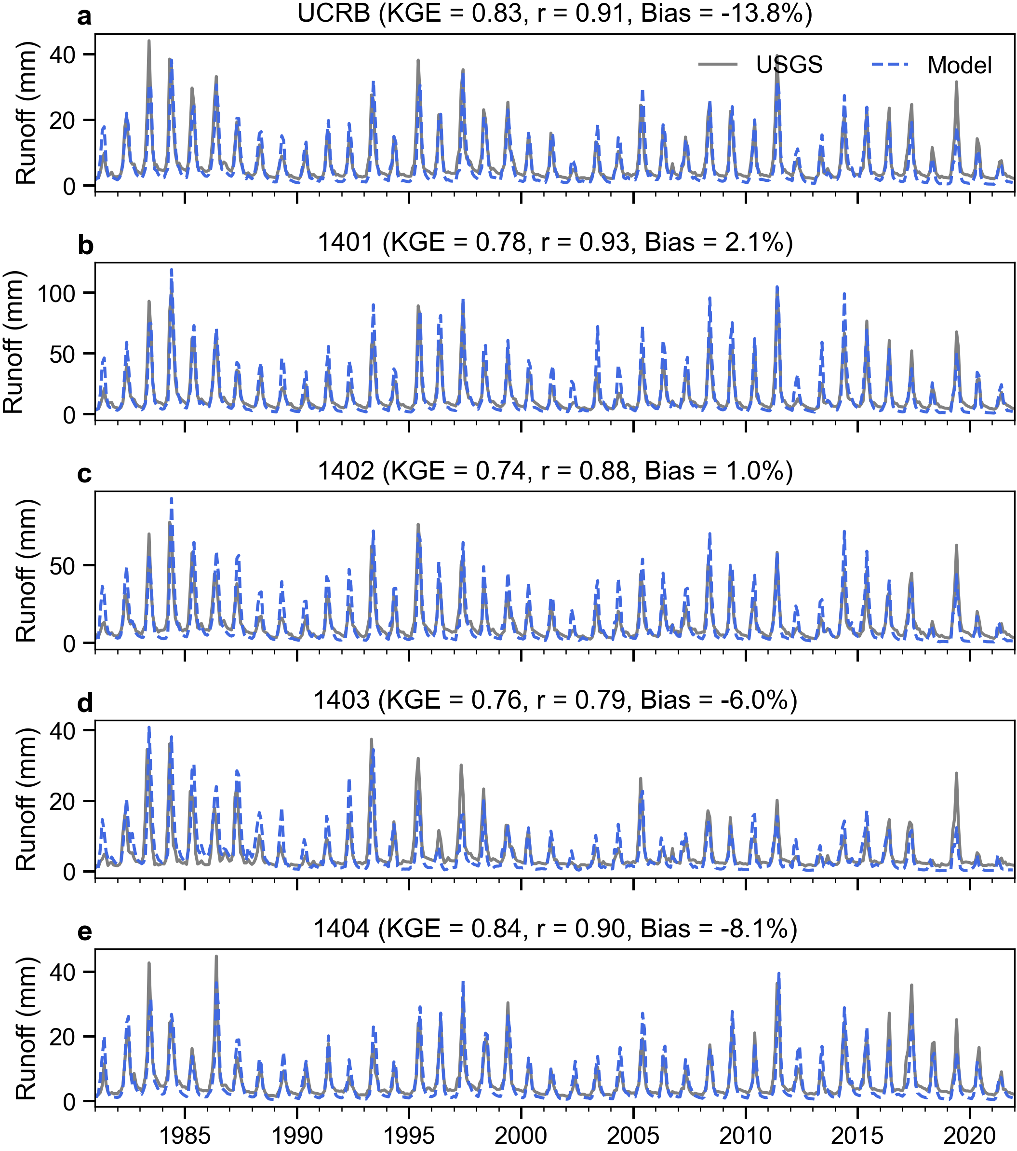
Supplementary Figure 4. Time series of monthly runoff averaged over the UCRB and four of the eight subbasins (1401, 1402, 1403, and 1404) for 1981–2021 from the USGS runoff product (gray solid line) and the Noah-MP model (blue dashed line). The KGE, correlation coefficient (r), and relative mean bias are shown.

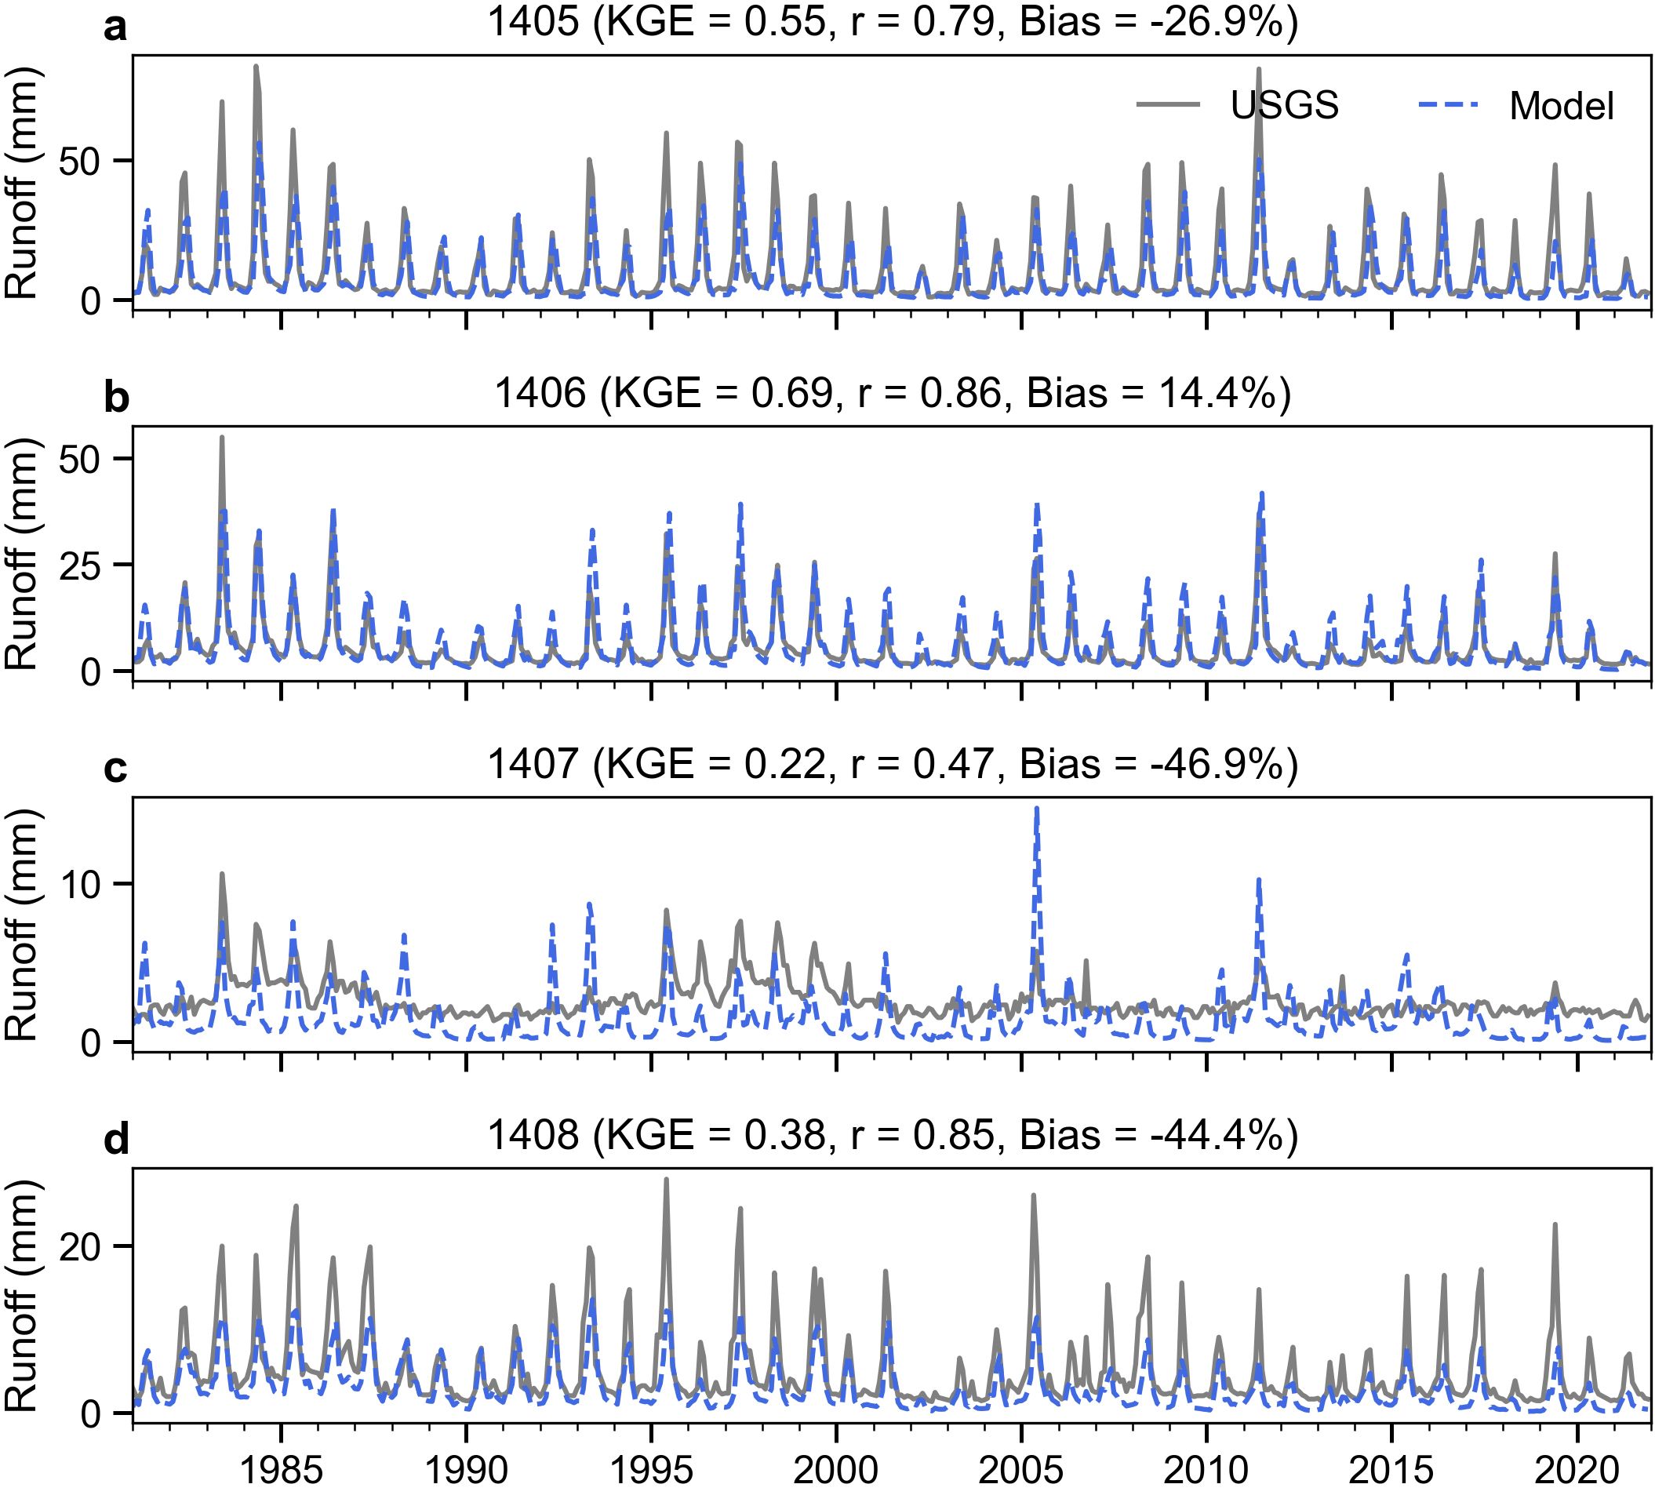
Supplementary Figure 5. Time series of monthly runoff averaged over UCRB subbasins 1405, 1406, 1407, and 1408 for 1981–2021 from the USGS runoff product (gray solid line) and the Noah-MP model (blue dashed line). The KGE, correlation coefficient (r), and relative mean bias are shown.

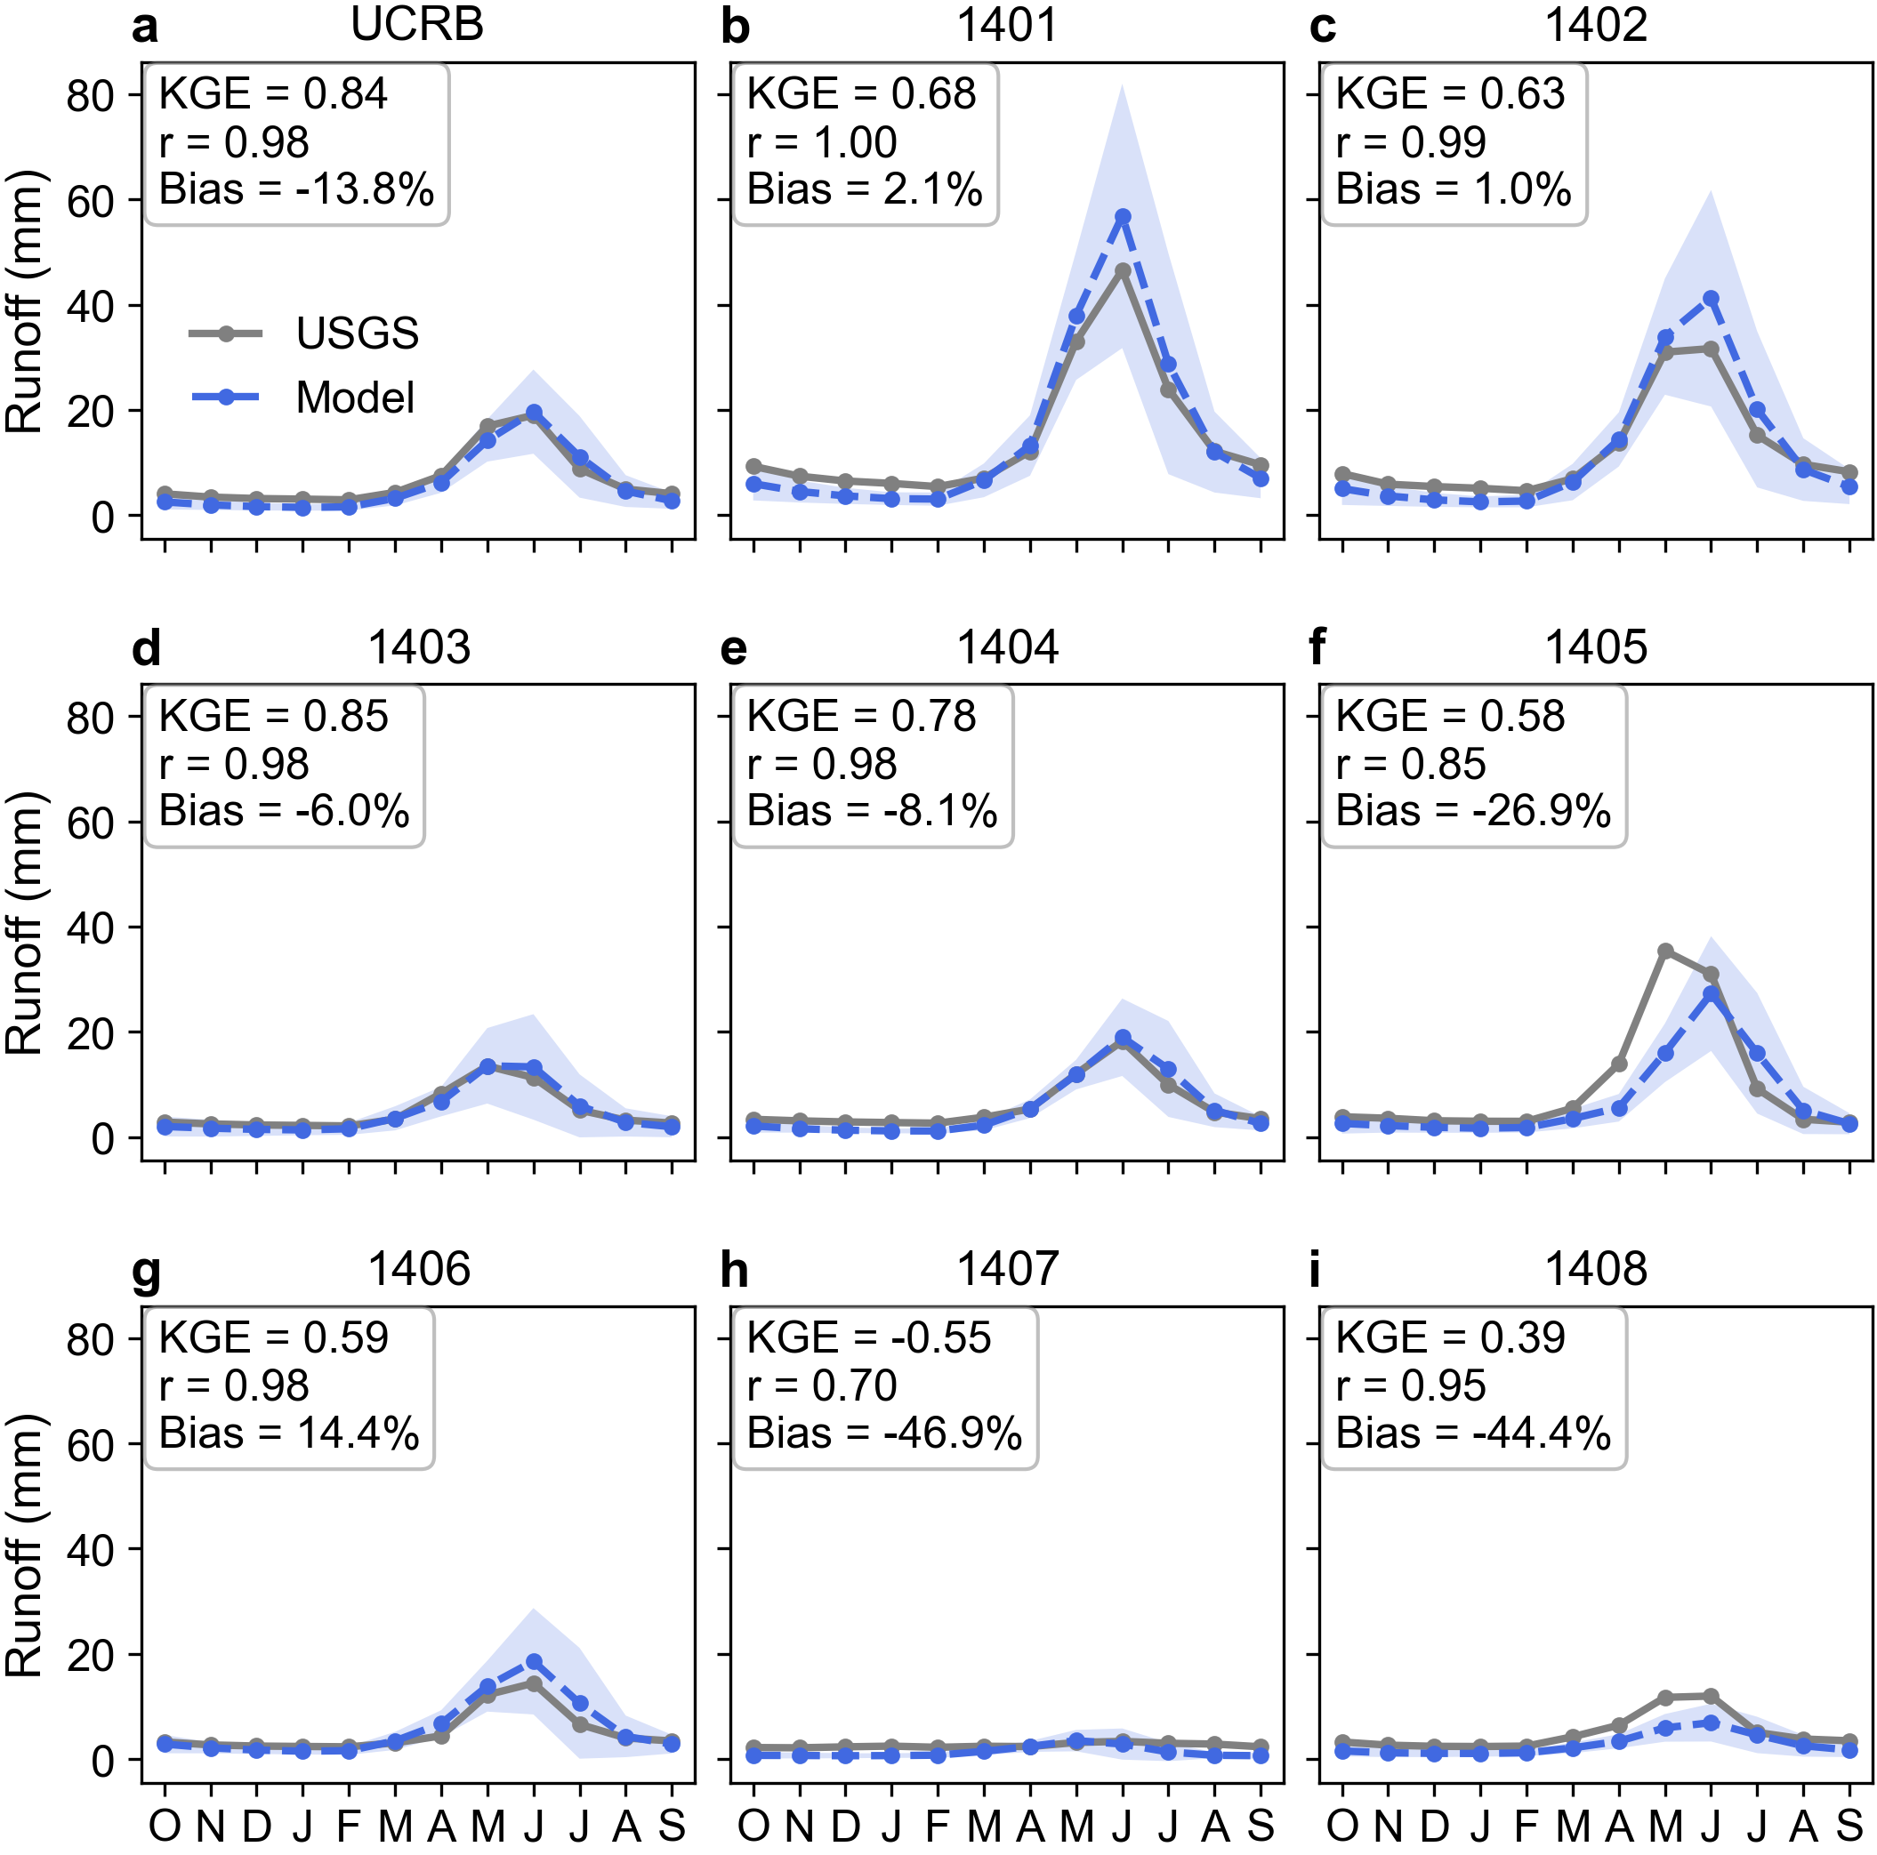
Supplementary Figure 6. Mean annual cycle of monthly runoff averaged over the UCRB and each of the eight subbasins for 1981–2021 from the USGS runoff product (gray solid line) and the Noah-MP model (blue dashed line). The KGE, correlation coefficient (r), and relative mean bias are shown. Shading indicates ±1 standard deviation across model grid cells.

Supplementary References
1. Bi, D., Dix, M., Marsland, S., O’Farrell, S., Sullivan, A., Bodman, R., et al. Configuration and spin-up of ACCESS-CM2, the new generation Australian community climate and earth system simulator coupled model. Journal of Southern Hemisphere Earth Systems Science, 70(1), 225-251 (2020).
2. Swart, N. C., Cole, J. N., Kharin, V. V., Lazare, M., Scinocca, J. F., Gillett, N. P., et al. The Canadian earth system model version 5 (CanESM5.0.3). Geoscientific Model Development, 12(11), 4823-4873 (2019).
3. Danabasoglu, G., Lamarque, J. F., Bacmeister, J., Bailey, D., DuVivier, A., Edwards, J., et al. The community earth system model version 2 (CESM2). Journal of Advances in Modeling Earth Systems, 12(2), e2019MS001916 (2020).
4. Séférian, R., Nabat, P., Michou, M., Saint‐Martin, D., Voldoire, A., Colin, J., et al. Evaluation of CNRM Earth system model, CNRM‐ESM2‐1: Role of Earth system processes in present‐day and future climate. Journal of Advances in Modeling Earth Systems, 11(12), 4182-4227 (2019).
5. Döscher, R., Acosta, M., Alessandri, A., Anthoni, P., Arneth, A., Arsouze, T., et al. The EC-Earth3 Earth system model for the climate model intercomparison project 6. Geoscientific Model Development Discussions, 2021, 1-90 (2021).
6. Li, L., Yu, Y., Tang, Y., Lin, P., Xie, J., Song, M., et al. The flexible global ocean‐atmosphere‐land system model grid‐point version 3 (FGOALS‐g3): Description and evaluation. Journal of Advances in Modeling Earth Systems, 12(9), e2019MS002012 (2020).
7. Kelley, M., Schmidt, G. A., Nazarenko, L. S., Bauer, S. E., Ruedy, R., Russell, G. L., et al. GISS-E2.1: Configurations and climatology. Journal of Advances in Modeling Earth Systems, 12(8), e2019MS002025 (2020).
8. Gutjahr, O., Putrasahan, D., Lohmann, K., Jungclaus, J. H., von Storch, J.-S., Brüggemann, N., et al. Max Planck Institute earth system model (MPI-ESM1.2) for the high-resolution model intercomparison project (HighResMIP). Geoscientific Model Development, 12(7), 3241-3281 (2019).
9. Mauritsen, T., Bader, J., Becker, T., Behrens, J., Bittner, M., Brokopf, R., et al. Developments in the MPI‐M Earth System Model version 1.2 (MPI-ESM1.2) and its response to increasing CO2. Journal of Advances in Modeling Earth Systems, 11(4), 998-1038 (2019).
10. Seland, Ø., Bentsen, M., Olivié, D., Toniazzo, T., Gjermundsen, A., Graff, L., et al. Overview of the Norwegian Earth System Model (NorESM2) and key climate response of CMIP6 DECK, historical, and scenario simulations, Geosci. Model Dev., 13, 6165–6200 (2020).
11. Wang, Y. C., Hsu, H. H., Chen, C. A., Tseng, W. L., Hsu, P. C., Lin, C. W., et al. Performance of the Taiwan earth system model in simulating climate variability compared with observations and CMIP6 model simulations. Journal of Advances in Modeling Earth Systems, 13(7), e2020MS002353 (2021).
12. Sellar, A. A., Walton, J., Jones, C. G., Wood, R., Abraham, N. L., Andrejczuk, M., et al. Implementation of UK Earth system models for CMIP6. Journal of Advances in Modeling Earth Systems, 12(4), e2019MS001946 (2020).

