Supplementary Information for

Enhanced vegetation drought resistance associated with elephant disturbance in Africa

Minxuan Sun et al.

Corresponding author: Wei Li, wli2019@tsinghua.edu.cn

This file includes:

Supplementary Methods 1, 2
Supplementary Texts 1-10
Supplementary Discussion 1-4
Supplementary Figures 1-43
Supplementary Tables 1-8
References

Supplementary Methods

Supplementary Method 1 Paired sites methods and sensitivity tests
We used paired sites selection method to calculate the difference in vegetation structure, land surface temperature (LST) and vegetation drought resistance between nearby areas with and without elephants (Fig. S35). We established moving 0.25° × 0.25° grid cells as control units to minimize biases from the confounding factors. The chosen size of grid cells (0.25° × 0.25°) was a compromise of similar environmental conditions and enough valid pixels for both paired sites^{1, 2, 3}. Data with various spatial resolutions (Table S5) were first resampled to 0.01° (~ 1 km). To ensure enough samples for comparison with each 0.25° × 0.25° grid cell, we only selected grid cells with areas with and without elephants both greater than 5% of the total area of the 0.25° × 0.25° grid cell. To be more explicit, the selected 0.25° × 0.25° grid cell with 625 (= 25 × 25) 0.01° pixels in total must have >31 (≈ 625 × 5%) 0.01° pixels for areas with elephants and >31 0.01° pixels for areas without elephants. If there are insufficient pixels, we searched the surrounding eight grid cells to match the paired area. We also controlled for covariates in the paired sites selection methods to exclude confounding factors other than elephant existence, including the 100 m resolution Human Footprint Index (HFI) ⁴, protected area status from the world database on protected areas (WDPA) ⁵, elevation and slope from the ~1 km Global 30 Arc-Second Elevation (GTOPO30) dataset. These variables were all resampled to 0.01° (~ 1 km). We filtered out 0.01° pixels with HFI > 15 in each 0.25° × 0.25° moving grid cell. We strictly controlled protected area in the paired sites with and without elephants (i.e., in each pair, both sites are either inside or outside protected areas), and we also excluded 0.25° × 0.25° grid cells with differences in elevation between areas with and without elephants greater than 200 m, and differences in slope greater than 10° (Fig. S35a).
In addition, we conducted substantial sensitivity tests to justify the robustness of the paired sites method (Table S8, Fig. S35b, Supplementary Text 9).

Supplementary Method 2 Machine-learning model for explaining drought resistance difference
We used CatBoost⁶, a categorical-based gradient boosting decision tree algorithm, to develop a binary classification model for predicting the sign of ΔResistance. CatBoost addresses the general problem of prediction shift due to target leakage in gradient boosting algorithms through ordering boosting⁷, and thus it has enhanced resilience against noisy and outlier data. It can deal adequately with heterogeneous data that includes both categorical and continuous variables⁸. Additionally, CatBoost uses oblivious trees as a base predictor, reducing the risk of overfitting⁹.
ΔResistance from both NDVI and SIF data is categorized as 1 when it is higher than 0 and as -1 when it is lower than 0. Driving factors for ΔResistance include climate-related variables (SPEI, land surface temperature (LST), evapotranspiration (ΔET)), vegetation-related factors (tree height, tree cover, above ground biomass (AGB)), soil factors (bulk density, clay fraction and soil organic carbon (SOC)) and elephant density. For all variables, except elephant density, both the average value and difference between nearby forests with and without elephants are used. Detailed information for each variable is listed in Table S6. The CatBoost model was trained and optimized for hyperparameters using 70% of the full set of samples, while the remaining 30% were used for evaluating model performance. In this process, we used random search and ten-fold cross-validation from Scikit-learn in Python. The trained model can accurately predict variations in the sign of ΔResistance, yielding an area under the curve (AUC) value of 0.81 and 0.78 (AUC=1 means that the classifier can perfectly distinguish all binary points, while AUC=0 means that the classifier incorrectly predicts all negatives as positives and all positives as negatives), and average precision values of 0.73 and 0.69 for the NDVI and SIF data, respectively. Information on model setting and accuracy is detailed in Table S7.
We used Shapley values to estimate the feature contribution of each variable¹⁰. The Shapley value quantifies the relative contributions of each feature, representing its anticipated marginal impact on the predictions. The SHAP package¹¹ in Python was employed to approximate Shapley values for each predictor based on the fitted model. Additionally, we visualized the marginal effects of all variables by plotting the kernel density distributions of the Shapley values (Fig. S15), which indicates how predictions vary when a specific feature is changed.

Supplementary Texts

Supplementary Text 1 Separating forest and savanna elephants based on habitat types
Impacts of elephant disturbances may vary between forest and savanna elephants. We calculated the structure and function of vegetation in areas with forest elephants and savanna elephants and controlled forest and savanna habitat types between the areas with and without elephants (Fig. S3, S4). The distinction between forest and savanna elephant ranges from the African Elephant Database (AED) was identified using a genetic distribution map from Mondol et al. (2015)^{12, 13, 14} (Fig. S2). Note that these ranges may not perfectly align with the land cover types. For example, some savanna elephant ranges overlap with dry forest areas, while some forest elephant ranges are in savanna areas (Fig. S2). Therefore, we further controlled the land cover types in addition to the elephant ranges. We used the habitat data from Jung et al. (2020)¹⁵, which integrates land cover, climate and land use datasets based on the International Union for Conservation of Nature (IUCN) classification scheme. We excluded mixed regions between savannas and forests (Fig. S2, i.e., savannas overlapped with forest elephant range and forests overlapped with savanna elephant range, accounting for 18.7% of all regions), because elephants move around, making it difficult to separate the impact of savanna and forest elephants in these mixed regions. These results from this test also confirmed that elephants significantly increased tree height and tree cover, decreased LST and enhanced vegetation drought resistance in both forests and savannas (Fig. S3), only except that the cooling effect became nonsignificant in savannas influenced by savanna elephants during the years before the EI Niño event (2012-2014) (Fig. S3d). Elephants appear to have a greater impact on vegetation structure in forests influenced by forest elephants, while differences in their effects on LST between forests and savannas are less pronounced (Fig. S3c, d). Effects of drought resistance defined by SIF are stronger for savanna elephants on savannas than forest elephants on forests (Fig. S3f).
There seems to a “drag effect” in the scatterplot between ΔLST and ΔTree height (Fig. 3c), contributed by some data points with high ΔTree height values (mostly >10 m), which “drag” the regression line shallower. After excluding these points, the slope of ΔLST against ΔTree height for the remaining points becomes steeper (Fig. S38a). We found that these high ΔTree height points are mostly located in Central African forests (Fig. S38c, d), and this is consistent with the results that elephants have a greater impact on vegetation structure in forest ecosystems than in the savannas (Fig. S3a, b). However, this “drag effect” does not appear in the relationships between ΔLST and ΔTree cover, or between ΔResistance and ΔLST (Fig. 3d, Fig. S16). A likely explanation is that while elephants significantly enhance vegetation structure in forests, the already high baseline tree cover in Central Africa may quickly saturate, limiting the cooling effects of additional canopy height. This is further supported by the separate analyses of forest and savanna lands, defined by the habitat data from Jung et al. (2020)¹⁵, which show a steeper regression slope between ΔLST and ΔTree height in savannas than in forests (Fig. S38b).

Supplementary Text 2 Sensitivity tests for protected areas and stable forests
Because about a half of the elephant area is in protected areas (Fig. S33) in which vegetation is usually well preserved with less human disturbances and grows better, the differences in tree height (ΔTree height), tree cover (ΔTree cover) and drought resistance (ΔResistance) between areas with and without elephants could be caused by the effectiveness of the protected area rather than by elephants. Therefore, we further analyzed ΔTree height, ΔTree cover and ΔResistance in areas with and without elephants, when both types of areas located inside or both located outside protected areas. Protected ranges were downloaded from the world database on protected areas (WDPA) ⁵. The results are consistent with that elephants exhibited increased tree height, tree cover and drought resistance in protected areas with elephants than in nearby protected areas without elephants, and in unprotected areas with elephants than in nearby unprotected areas without elephants (Fig. S6).
We also tested areas without any disturbances in the past 20 years to remove other historical vegetation disturbances. Specifically, we used the “stable forest extent” (i.e., “areas with small differences between the years 2000 and 2020 forest height data that have no indication of forest disturbance”) map for 2000-2020 from Potapov et al.¹⁶ (https://glad.umd.edu/dataset/GLCLUC2020/). We then calculated ΔTree height, ΔTree cover and ΔResistance in areas with and without elephants within these non-disturbed areas. Within these areas, the results consistently showed that tree height, tree cover and drought resistance is significantly higher in areas with elephants than in nearby areas without elephants (Fig. S30).

Supplementary Text 3 Sensitivity test using field-observed presence of elephants
The elephant habitat boundaries from the African Elephant Specialist Group (AfESG), based on surveys and questionnaires¹⁷, may induce uncertainties because some regions may not have any elephants present (see Methods). Therefore, we further isolated regions with field-observed presence of elephants using the elephant observation sites from iNaturalist (https://www.inaturalist.org/observations). These observations, which include location information and photos for elephants, were uploaded and identified by zoologists. As of August 2024, there were 16,700 observations available, including 15,722 of savanna elephants and 521 of forest elephants. We selected 2,555 observations in the paired areas with and without elephants during drought (Fig. S9a) and conducted two tests. In the first test, we assume that if elephants are present at one or multiple locations in a given 0.25° × 0.25° grid cell, the entire elephant habitat range in this 0.25° × 0.25° grid cell should have real elephant activities because elephants move around (Fig. S39a). We thus calculated differences in tree height, tree cover, LST and resistance across the entire area with elephants, where at least one field-observed elephant presence site exists, compared to areas without elephants, in each 0.25° × 0.25° moving grid cell (Fig. S39a). In the second test, we tried to represent the elephant movements in a wider area from the 2,555 elephant photos and minimize the location biases (e.g., photos usually taken within national parks or near roads). We thus added buffers of 1 to 9 km at an interval of 2 km around each elephant observation sites, and compared these buffered areas with equally sized, randomly selected areas without elephants (Fig. S39b). This process was repeated 10 times, and the average results were taken. Overall, the results are highly consistent that forests with elephants exhibited increased tree height and tree cover, decreased LST and enhanced vegetation drought resistance (Fig. S9b-e), except for the difference in LST with 1 and 3 km buffer areas (Fig. S9d). Additionally, a larger buffer area is associated with a lower p-value for differences in tree height and LST between areas with and without elephants (Fig. S9b, d), suggesting that small-scale analyses may introduce bias (e.g. near roads or buildings) and a larger activity space may better capture the ecological signals of elephant disturbance.
In addition, we incorporated another field-observed data from the living planet database (livingplanetindex.org/data_portal), which compiles population time series from thousands of monitored wildlife sites across marine, terrestrial, and freshwater ecosystems¹⁸ (LPI 2025). These data contribute to the Living Planet Index (LPI), a widely used indicator of global biodiversity trends, adopted by the convention on biological diversity for tracking progress toward its 2011-2020 targets and included in the post-2020 Kunming – Montreal Global Biodiversity Framework. There are 138 georeferenced records for African elephants in this dataset, including 111 sites with site-level information on individual counts (Specific_location = 1) and the remaining records for population estimates at broader regional scales. Some of these sites also document population dynamics spanning from the 1950s to 2020. These field observation data were primarily derived from publicly available literature and the African Elephant Status Reports released by the IUCN SSC African Elephant Specialist Group (AfESG), which also serve as the data source for the African Elephant Database used in our main analysis.
We applied the same two tests used for the photo evidence of elephant presence to the 111 LPI sites. The first test assumed that if one or more LPI sites were located within a 0.25° × 0.25° grid cell, the entire elephant habitat range (i.e., all 0.01° pixels with elephants) in this 0.25° × 0.25° grid cell was considered areas with elephant presence. The second test compared buffered (9 km) areas around elephant observations with randomly selected areas without elephants. After applying strict criteria for paired site selection, only 18 and 35 paired sites were successfully matched for the first and second tests, respectively (Fig. S40). Due to the small number of paired sites, only the second test showed a statistically significant increase in tree cover in areas with elephants compared to nearby areas without elephants (Fig. S40). The other results showed slightly increased tree height and tree cover in elephant areas, but did not reach a statistical significance level (Fig. S40). Low sample size (e.g., 18 paired sites in the first test) and the fact that many LPI sites lie in high‐density elephant regions—where heavy disturbance affects ecosystems negatively (see Supplementary Discussion 1)—likely limited our ability to detect clearer effects using these LPI sites.

Supplementary Text 4 Evidence of elephant influence on vegetation structure from the Kenya Long-term Exclosure Experiment (KLEE)
To further confirm the causal relationship between elephants and vegetation structure and to provide long-term site-based evidence, we conducted an analysis using data from the KLEE. KLEE comprises 18 herbivore exclosure plots (200 × 200 m each) established in 1995 in a semi-arid savanna ecosystem at the Mpala Research Center in Kenya¹⁹, where the woody vegetation is dominated by Acacia drepanolobium (>95%)²⁰. KLEE creates six large mammalian herbivore treatments using semi-permeable barriers that selectively admit or exclude different herbivores: (1) megaherbivores (elephants and giraffes), and mesoherbivores >35 kg (e.g., zebras, elands, gazelles, buffaloes) and cattle allowed (MWC), (2) megaherbivores and mesoherbivores allowed but cattle excluded (MW), (3) megaherbivores excluded but cattle and mesoherbivores allowed (WC), (4) megaherbivores and cattle excluded but mesoherbivores allowed (W), (5) cattle only (C), and (6) all large herbivores excluded (O).
Tree heights were recorded for all woody individuals within the center 100 × 100 m of each 200 × 200 m plot. Census data for all six treatments are available for 2015, but W and WC were not surveyed in 2005. For both years, we used MW and MWC plots with elephant access as treatment plots and O plots excluding all large herbivores as control plots. For 2015, we additionally compared W and MW as treatment plots against O as control plots to isolate the influence of mesoherbivores. Because the 2005 survey did not include individuals <1 m, consistent with the survey protocol used by Okello et al. (2008)²¹, we excluded trees <1 m from the 2015 data to ensure comparability. We then evaluated whether tree height differed among treatments using standard statistical tests. Specifically, we examined the distribution of tree height within each treatment group using the Shapiro–Wilk test and evaluated homogeneity of variances with Levene’s test^{22, 23}. Because the data were not normally distributed, group differences were evaluated using the nonparametric Kruskal–Wallis test, followed by pairwise Mann–Whitney U tests^{24, 25}.
The results showed that tree height in elephant accessible plots (MW and MWC) remained significantly greater than in the control plots (O) for both years (Fig. S10). In 2015, the mean tree height in MW was significantly greater than in both O and W, whereas O and W show no significant difference. In addition, tree density (tree counts divided by the surveyed area of three hectares) consistently declined from O to elephant accessible plots. These results provide convergent evidence for the long-term effects of elephant disturbance on vegetation structure by reducing stem density and competitive crowding through selective browsing, accelerating self-thinning dynamics and increasing growth opportunities for surviving individuals.
However, these results should be interpreted with caution. The comparison between MW and MWC against O did not isolate elephants alone, and the observed differences in MW and MWC reflect the combined effects of elephants and other herbivores present in those treatments. The comparison between W and MW also represents the combined effects of elephants and giraffes. In addition, pre-exclosure vegetation structure (before 1995) is not available, so initial equivalence between treatment and control plots cannot be confirmed. However, preliminary survey carried out between 1992 and 1995 indicate that pre-exclosure differences in vegetation structures were relatively small¹⁹. While these factors prevent attributing the effects exclusively to elephants, the direction and consistency of the results align with the continental-scale remote sensing patterns shown in our study.

Supplementary Text 5 Difference in evapotranspiration and albedo
Effects of forests on the local microclimate are primarily driven by two competing biophysical processes, evapotranspiration and albedo¹. Closed forests, have a higher ET rate than open land, causing a cooling effect due to more latent heat release. However, they generally exhibit a lower albedo than open land and thus absorb more shortwave radiation during daytime, leading, in contrast, to a warming effect. We use the 250-m FAO water productivity open access portal (WaPOR) ET data and the MCD43A3 500-m albedo data, and calculate ΔET and ΔAlbedo as the differences in nearby areas with and without elephants. Compared to areas without elephants, areas with elephants exhibit a significantly (p<0.001) higher ET (ΔET = 0.79±0.08) and a significantly (p<0.001) lower albedo (ΔAlbedo = -0.004±0.0003) (Fig. S8c, d) due to the higher tree height and the higher tree cover (Fig. 1 and Fig. 5e and Fig. S14). A possible explanation for the lower land surface temperature in areas with elephants compared with areas without elephants (ΔLST < 0, Fig. 3a, b) is that, in areas with elephants, the energy gain induced by a lower albedo is offset by a greater latent heat loss via a higher ET, resulting in a net cooling effect. Similar competing biophysical processes have been reported before between tropical forests and nearby open land¹ and between degraded forests and nearby interior forests³.
The increased tree height and tree cover induced by elephants could also lead to greater roughness and lower aerodynamic resistance, which would result in a more efficient transfer of sensible heat from the surface to the atmospheric boundary layer^{26, 27}, inducing a cooling effect. However, due to the lack of high-resolution and large-scale data for roughness and aerodynamic resistance, it is difficult to further analyze this potential underlying mechanism.

Supplementary Text 6 Partial correlation analysis
We examined the correlation between drought resistance difference (ΔResistance) with changes in vegetation structure (termed ΔVegetation_structure, and consisting of ΔTree height and ΔTree cover), controlling for SPEI and ΔLST individually and in combination. We find that if the controlling variable contains ΔLST, the correlation of ΔResistance with ΔTree height and ΔTree cover become either insignificant or from positive to negative. These results imply that the enhanced drought resistance is more controlled by the mediated microclimate during droughts than by the physiological properties of larger trees (Fig. 5 and Table S2).

Supplementary Text 7 Machine-learning attribution of the drought resistance difference
According to the machine-learning binary classification model, climate-related variables, in particular the difference in evapotranspiration (ΔET) and land surface temperature (ΔLST), contribute most to the sign of ΔResistance, (Fig. S15a). As higher evapotranspiration removes more heat, leading to a lower temperature, the relationships between ΔET and ΔResistance are positive (Fig. S15d). Similarly, as ΔLST increases, there is a decrease in ΔResistance, both from NDVI and SIF, indicating that the enhanced cooling effect in areas with elephants contributes to a stronger drought resistance (Fig. S15b). The most important soil-related variables are the difference in soil organic carbon (ΔSOC) and the difference in soil clay fraction (ΔClay) between nearby areas with and without elephants (Fig. S15c, e). ΔResistance from both NDVI and SIF exhibits a negative correlation with ΔSOC (Fig. S15c) but a positive one with ΔClay (Fig. S15e). Elephants can influence soil carbon and nutrients through toppling and killing trees²⁸, as well as depositing large amounts of excrement (100-200 kg in 20-30 daily defecations per elephant^{29, 30}). Additionally, the "foot-loading" of a walking elephant exerts considerable pressure, ranging from 510-660 g cm⁻², due to the weight of a mature African elephant (typically 3000-5000 kg²⁹). This substantial pressure can lead to significant compaction of surface sediments, altering soil aggregate structure. Thus, soil property changes induced by elephants may be another possible mechanism that enhances forest growth and its resistance to drought. However, we were not able to explore this further due to a lack of accurate soil data. ΔResistance, as defined by either NDVI or SIF, shows a positive relationship with vegetation-related variables (ΔTree height, ΔTree cover and ΔAGB) (Fig. S15a, f, n, q). The contribution of ΔTree height, which is the most prominent of the vegetation-related variables, is lower than ΔET and ΔLST (Fig. S15f). This finding also indirectly supports our hypothesis that changes in forest structure (tree height and tree cover) influence the drought resistance through microclimate effects such as ΔLST, rather than via a physiological capacity to resist droughts (e.g., larger trees have higher xylem tension, greater capacitance, more water storage and higher water use efficiency than small trees^{31, 32}). In addition, the direct contribution of elephant density to ΔResistance is not very large, and the relationship between them is relatively flat (Fig. S15o).
Variables calculated as differences between nearby areas with and without elephants collectively contribute more to ΔResistance than variables averaged between nearby areas. This indicates that specific differences in local forest environments may play a greater role in shaping the response to drought than the large-scale environmental status.

Supplementary Text 8 Relationship of drought resistance to tree height and tree canopy cover
We calculated paired sites of areas with short trees (tree height ≤ 10 m) and tall trees (tree height > 10 m), and paired sites of open canopies (tree cover ≤ 40 %) and dense canopies (tree cover > 40 %) during droughts, to analyze the relationship between drought resistance and tree size. We did two tests: 1) paired sites in all drought affected areas regardless of the presence or absence of elephants (Fig. S17a), and 2) paired sites in areas with drought-induced productivity reduction but without elephants (Fig. S17b). Both tests consistently show that the drought resistance of tall-dense trees, as defined by both the NDVI and SIF data, is significantly (p<0.001) higher than that of short-open trees. This result demonstrates that, regardless of the presence of elephants, tall and dense canopies show stronger drought resistance than short and open canopies in Africa.

Supplementary Text 9 Sensitivity tests

Supplementary Text 9.1 Sensitivity tests for the SPEI data and moving window sizes
The standardized precipitation evapotranspiration index (SPEI) data used to define drought is derived from the standardized difference between precipitation and potential evapotranspiration. However, due to limitations in the precipitation data resolution, most existing SPEI products have a coarser spatial resolution (0.5°), leading to potential uncertainties. We used a higher resolution SPEI dataset (0.05°) derived from the climate hazards group infrared precipitation with station data (CHIRPS) precipitation estimates and the global land evaporation Amsterdam model (GLEAM) potential evaporation estimates³³. Other SPEI products with a coarser spatial resolution (0.5°) were used in the sensitivity tests.
To validate our results, we tested both the 0.05° SPEI dataset and the 0.5° SPEI dataset sourced from the global SPEI database^{33, 34}. We investigated the 0.05° SPEI data using moving windows of 0.5° × 0.5° and 0.25° × 0.25°, and the 0.5° SPEI data with a moving window of 2° × 2°. As described in the main text, we used a paired sites selection method and supplemented with the nearest eight grid cells when the areas with (or without) elephants were insufficient (lower than 5% of the grid cell). We also examined the paired sites selection restricted to a 0.25° × 0.25° grid cell (excluding grid cells if the areas with or without elephants were insufficient) to assess the robustness of our findings, even though it may result in fewer paired samples. In summary, we ultimately conducted three sensitivity tests to compare vegetation structure and resistance between areas with elephants and without elephants: (1) paired sites supplemented from the nearest eight grid cells, 0.05° SPEI and a moving window of 0. 5° × 0.5° (Fig. S18a–c), (2) paired sites without supplementation from the nearest grid cells, 0.05° SPEI and a moving window of 0.25° × 0.25° (Fig. S18a, b, d), and (3) paired sites supplemented from the nearest eight grid cells, 0.5° SPEI and a moving window of 2° × 2° (Fig. S18a, b, e). These three additional sensitivity tests were used as a comparison with the results from paired sites supplemented from the nearest eight grid cells, 0.05° SPEI and a moving window of 0.25° × 0.25° (Fig. 1a, b and Fig. 4a, c) as described in the main text.
The results consistently show that areas with elephants exhibit a significantly (p<0.01) higher tree height and tree cover than the nearby areas without elephants (Fig. 1a, b and Fig. S18a, b). Additionally, drought resistance, defined by either NDVI or SIF, is also consistently higher in the areas with elephants than in the nearby areas without elephants (Fig. 4b and Fig. S18c–e) with the one exception being the difference in ΔResistance defined by SIF in Sensitivity test (3) (p=0.46) (Fig. S18e). Overall, these sensitivity tests show robust evidence of altered vegetation structure and function induced by elephants.
To further test whether our findings depend on the sample size, we conducted a subsample bootstrap sensitivity test³⁵ using paired sites of tree height and tree cover. We randomly down-sampled the full dataset to N = 100, 200, 500, 1000, 1500, 2000, and 2500, and, for each sample size, repeated the Wilcoxon test 500 times. For every subsample, we re-estimated differences in tree height and tree cover (ΔTree height and ΔTree cover) in areas with and without elephants, and calculated the standardized effect size (Cohen’s d). Cohen’s d is defined as the mean difference divided by the pooled standard deviation, providing a standardized measure of effect size^{36, 37}.
The subsampling analyses consistently show statistically significant effects (p < 0.05, Fig. S41a, b). The percentage of samples with p < 0.05 across the total 500 samples ranges from 81% for N = 100 to 100% for N > 200 for ΔTree height, and from 52% for N=100 to 100% for N > 500 for ΔTree cover. Standardized effect sizes (Cohen’s d) remain positive across all sample sizes, with mean Cohen’s d of ~0.29 for ΔTree height and ~0.21 for ΔTree cover, although variability is larger at smaller N (Fig. S41c, d). Even at the smallest subsample size (N = 100), median p values remained very low (6.0 × 10⁻³ and 4.6 × 10⁻² for ΔTree height and ΔTree cover, respectively) across the 500 samples. Although mean p value of ΔTree cover at N = 100 approached marginal significance (p = 0.1), mean p value of ΔTree height remained consistently significant (p < 0.05). These results indicate that the observed effects are not an artifact of large sample size but reflect a persistent ecological signal. Although the mean differences (expressed in their original units) appear numerically modest (1.15 ± 0.07 m and 2.82 ± 0.25 % for ΔTree height and ΔTree cover, Fig. 1a, b), their stability across all sample sizes (Fig. S41e, f) and the consistently positive standardized effect sizes (Cohen’s d, Fig. S41c, d) indicate a robust and ecologically meaningful contrast between areas with elephants and nearby areas without elephants. Even modest increases in vegetation structure can significantly alter surface energy and water fluxes, particularly through changes in evapotranspiration and albedo (Fig. S8c, d), thereby modifying biophysical processes (Fig. 3a, b and Fig. 5), enhancing vegetation drought resistance (Fig. 4), and contributing to cumulative climate impacts.

Supplementary Text 9.2 Excluding small areas with or without elephants in paired sites selection
In our analysis, we excluded small areas (i.e., ≤5% areas with or without elephants of each 0.25° × 0.25°grid cell, corresponding to ≤31 of the 625 (25 × 25) total 0.01° × 0.01° pixels, or approximately ≤86 km² near the equator) in paired sites selection (see Methods). This step helps improve the stability of paired site samples. To analyze the possible impacts of this 5% threshold value, we conducted additional tests using thresholds of 0% to 20% at an interval of 5% in paired sites selection. Across all tested thresholds, the results consistently show that areas with elephants exhibit increased tree height and tree cover, decreased LST, and enhanced vegetation drought resistance (Fig. S19). This suggests that the selection of threshold values has minimal impacts on our key findings.

Supplementary Text 9.3 Controlling confounding factors in the paired sites selection method
We included precipitation as a control factor in the paired sites selection method, using two 0.1° resolution precipitation datasets for 2015 and 2016: The Global Precipitation Measurement (GPM) precipitation data and the ERA5-Land monthly average data^{38, 39}. The spatial patterns of average annual precipitation in Africa are roughly consistent between the two datasets, despite some local discrepancies (Fig. S20a, b). The average annual precipitation is 683 ± 0.15 mm year⁻¹ from the GPM data and 723 ± 0.13 mm year⁻¹ from the ERA5 data (Fig. S20a, b). We calculated the differences in precipitation (ΔPrecipitation) between areas with and without elephants. The area fraction of selected paired sites with ΔPrecipitation smaller than 100 and 50 mm year⁻¹ are 93% and 75% based on the GPM data, and 68% and 45% based on the ERA5 data (Fig. S20a, b). We excluded paired sites with ΔPrecipitation > 50 mm, and further calculated the differences in tree height, tree cover, land surface temperature (LST) and resistance between areas with and without elephants. The results consistently exhibit a significantly (p < 0.001) higher tree height, tree cover and resistance, along with lower LST in areas with elephants than areas without elephants (Fig. S20c-h). However, it should be noted that the local precipitation derived from these global products has very large uncertainties, especially in regions in Africa without many meteorological stations.
In addition to the factors controlled in the paired sites method (Fig. S35a), there might other factors influencing elephant activities and the fair comparison of paired sites. For example, elephant movements are constrained by roads⁴⁰, water availability is crucial for elephant survival and affect their distribution, with elephants gathering around water sources^{41, 42}, and forest fragmentation leads to habitats loss for elephants^{43, 44}. Additionally, fire and herbivores have a complex feedback relationship, where herbivores influence fire regimes, while post-fire regrowth, with higher forage quality, attracts herbivores^{45, 46, 47, 48}. To control these confounding factors more strictly, we used 8 km resolution road density data⁴⁹, 1 km resolution river density data calculated from the HydroRIVERS vector data⁵⁰, 5 km resolution forest fragmentation index for 2020⁵¹, and total fire frequencies between 2015-2016 derived from the 250 m ESA MODIS Fire_cci Burned area pixel product⁵². We then calculated the differences in road density (ΔRoad_density), river density (ΔRiver_density), forest fragmentation index (ΔFFI), and fire frequency (ΔFire_frequency) between areas with and without elephants based on the paired sites selection method. The results show that areas with elephants have a significantly lower road density, and higher fire frequency compared to the nearby areas without elephants, suggesting possible confounding effects of these factors (Fig. S21a, d). We thus controlled for road density and fire frequency by excluding paired sites with the absolute difference in road density > 0.03, and the absolute difference in fire frequency > 0.2 between areas with and without elephants. The results still show consistently increased tree height and tree cover, decreased LST and enhanced drought resistance in areas with elephants than in areas without elephants (Fig. S21e–h).

Supplementary Text 9.4 Paired sites selection within the same ecological region
We also conducted the paired sites selection when constraining both sites within the same ecological region. Ecological regions were derived from the “Ecoregions 2017” map developed by Dinerstein et al. (2017)⁵³, which classifies global terrestrial ecosystems into 14 biomes. 13 of these biome types are present in Africa, including tropical and subtropical moist broadleaf forests, tropical and subtropical grasslands, savannas and shrublands, deserts and xeric shrublands, among others. Based on our paired site method (see Methods), we further restricted paired sites selection within the same ecoregion. The results consistently exhibit significantly higher (p < 0.001) tree height, tree cover, and drought resistance, along with lower LST in areas with elephants than in areas without elephants (Fig. S22).

Supplementary Text 9.5 Uncertainty of elephant habitat ranges
There might be uncertainties in the elephant habitat ranges, because they were empirically drawn by the African Elephant Specialist Group based on survey results and boundaries such as protected areas, rivers, or mountains (see Methods). To address these uncertainties, we further applied both inward and outward buffering ranges of 1-5 km for elephant habitat boundaries, and then calculated the differences between paired sites in areas with and without elephants. The results of increased tree height and tree cover, decreased LST and enhanced drought resistance remain consistent with different buffered elephant habitat ranges (Fig. S23).
Additionally, to ensure that areas without elephants have no elephant existence historically, we further calculated differences between areas with elephants and areas without elephants by excluding all possible elephant ranges (e.g., regions where elephants once existed but are now extinct). According to the definitions of “known”, “possible”, and “extinct” ranges in the African Elephant Database, we calculated differences between areas with “known” elephant ranges and areas without elephants, and also calculated differences between areas with “known” and “possible” elephant ranges and areas without elephants. In both cases, areas without elephants excluded the “known”, “possible”, and “extinct” ranges. The results show consistently higher tree height, tree cover and drought resistance in areas with elephants than areas without elephants (Fig. S24).

Supplementary Text 9.6 Balancing areas in paired sites
We further tested differences between areas with and without elephants by ensuring equal area coverage for both. In the first test, if a given fraction (e.g., 10%) of a 0.25° × 0.25° grid cell is covered by elephants and the remaining (90%) area without elephants, we searched the surrounding eight grid cells for a matching grid cell where the area without elephants is also about 10% (difference < 10%). If no such match was found, we randomly selected 10% of the area without elephants. In the second test for the same case, we directly randomly selected 10% of the area without elephants, without considering the surround grid cells. The random selections in both tests were repeated 10 times to derive the average results. The results from these tests are consistent with that elephants exhibited increased tree height and tree cover, decreased LST and enhanced vegetation drought resistance (Fig. S25).

Supplementary Text 9.7 Differences between areas with and without elephants using the matching method from Andam et al. (2008)⁵⁴
We further calculated differences in vegetation structures between areas with and without elephants using the “matching method” from Andam et al. (2008)⁵⁴. Because our study area and objectives differ from Andam et al. (2008), we slightly modified the selection of matching plots. Specifically, we established 2° × 2° moving grid cells (~40,000 km², comparable to 51,100 km² of Costa Rica in Andam et al. (2008)), and then randomly sampled 200 plots in each moving grid cell, each composed of 3 × 3 pixels at a 0.01° (~1 km) resolution. We included the human footprint index, elevation, slope, road density, river density, forest fragmentation index, fire frequency, and precipitation as covariates, since they may affect both vegetation structure and elephant activities. We then calculated Mahalanobis distances of these covariate matrixes between plots in areas with elephants and plots in areas without elephants. Each plot with elephants was matched with two closest plots without elephants, same as in Andam et al. (2008).
We assessed the differences in tree height and tree cover in areas with and without elephants, calculated by the paired sites method in our study and the matching method based on Andam et al. (2008). Following the method by Andam et al. (2008), we analyzed both unmatched plots (all randomly sampled plots in each 2° × 2° moving grid cell without controlling for covariates) and matched plots (selected plots after controlling for covariates) (Fig. S26). The results show a consistently higher tree height and tree cover in areas with elephants compared to areas without elephants (Fig. S26). The unmatched plots without controlling for covariates show greater increases compared to the original paired sites and the matched plots. Matched plots selected from nearest-neighbor small areas isolate the pure effect of elephant disturbance by minimizing the covariate bias, and it shows larger increases in tree height and tree cover than the original paired sites method. This suggests that elephants may have an even stronger impact on local vegetation than we estimated using the original paired sites method. However, the original paired sites method, which includes all areas with and without elephants within a moving grid cell, provides a more comprehensive representation of habitat changes, and we thus keep these results from the original paired sites method in the main text.

Supplementary Text 9.8 Sensitivity tests for drought resistance
Variations in vegetation responses to drought may induce uncertainties in estimating changes in drought resistance brought about by elephants. We calculated drought resistance in areas without elephants using the NDVI and SIF data and found that most vegetation experienced a productivity reduction during droughts (i.e., resistance value <1, Methods). This was particularly evident in the SIF-defined drought resistance (Fig. S27b), while productivity reduction in many forest areas was not detectable from the NDVI-defined resistance (Fig. S27a). We further analyzed ΔResistance in all drought affected areas and in areas with drought-induced productivity reduction. We found that the enhanced drought resistance induced by elephants is robust in both cases, but ΔResistance is higher in the areas with drought-induced productivity reduction (Fig. S27c, d and Fig. 4a-c).
In the main text, we describe the analysis of the annual mean NDVI and SIF in drought and pre-drought years. We also calculated resistance using NDVI and SIF values in the drought affected months during the growing season, which was defined by the start and end of the growing days using phenologies from the VIPPHEN_EVI2 v004 dataset⁵⁵. Growing season was calculated from 2012 to 2014, with minimum of start-growth days and maximum of end-growth days between 2012 to 2014, and applied for 2015 and 2016. Specifically, we used the monthly NDVI and SIF from 2015 during the drought events in 2015, the monthly data from 2016 during the drought events in 2016 and the mean values from 2015 and 2016 for areas affected by droughts in both years. The baseline for the non-drought affected state in 2012-2014 was matched to the same months as in the drought years of 2015-2016, and areas affected by droughts in 2012-2014 were further excluded. Drought resistance was then calculated as the ratio of NDVI (and SIF) during droughts to that before droughts (Eq. (2) and (3) in Methods). Based on the monthly NDVI and SIF during the drought periods, drought resistance is also higher in the areas with elephants than in the nearby areas without elephants (Fig. S28), consistent with results obtained using annual mean NDVI and SIF (Fig. 4). However, ΔResistance calculated using monthly values of NDVI and SIF during the drought-affected months in the growing season (Fig. S28a, b) is greater than that calculated with annual mean values (Fig. S28c, d).
The “green-up” phase may vary across different years, so using fixed periods for averaging NDVI and SIF may introduce uncertainty. To address this, we first derived the growing season months for each year from 2012 to 2016 using observation-based vegetation phenology data from Chen et al. (2024)⁵⁶. We then calculated NDVI and SIF averaged over the temporally resolved growing season months for each year. Drought resistance was then calculated as the ratio of NDVI (and SIF) during droughts to that before droughts (Eqs. (2) and (3) in Methods). Based on NDVI and SIF averaged over varying growing seasons across years, drought resistance is also higher in areas with elephants than in nearby areas without elephants (Fig. S29), consistent with the results from annual mean NDVI and SIF (Fig. 4). In fact, ΔResistance calculated in this test is even greater than that calculated using annual mean values (Fig. 4).

Supplementary Text 10 The long-term impacts of elephants on vegetation structure
The impacts of elephant disturbance on vegetation are not short-term but sustained for a long period. The detected changes in vegetation structure are therefore legacy effects from the historical presence of elephants. The extinct elephant ranges suggest that elephants were present in these areas at least a decade ago, which might reflect the legacy effects of past elephant activities. Therefore, we calculated the differences in the extinct elephant areas and areas without elephants. The results show that extinct elephant areas still have significantly higher tree height and tree cover (Fig. S31), indicating possible legacy effects from past elephant disturbances. Vegetation structure increases in the extant elephant areas are higher than those in the extinct elephant areas, suggesting ongoing effects of elephant disturbances. However, it should be noted that these results based on the extinct elephant areas should be interpreted with cautious because there may be other disturbances after elephant extinction.
In addition, we manually collected patch-level elephant range and density data from the survey data reported in the African Elephant Database (AED, https://africanelephantdatabase.org/), which includes records of elephant numbers, survey areas, and survey dates for each patch. While boundary data was unavailable, each survey patch contains a schematic outlining the extent. Some patches were labeled with protected area names, so we extracted all such patches and verified each one to ensure its shape matched the corresponding protected area in the World Database on Protected Areas (WDPA). After this verification process, we derived 295 patches and calculated the elephant density by dividing the number of elephants by the survey area. To define the historical range, we assumed that elephants within protected areas would not have been wiped out. That is if a protected area had elephants and was established before 1995, elephants are assumed to have been present and active in that area prior to 1995. Based on this assumption, we selected 210 survey patches located within protected areas established before 1995 as historical elephant range data.
Based on these historical elephant range and density data, we calculated the differences and analyzed the relationships between elephant density and changes in tree height (ΔTree height) and tree cover (ΔTree cover). These results were consistent with that tree height and tree cover in areas with elephants are significantly higher than those in nearby areas without elephants, and ΔTree height and ΔTree cover are significantly correlated with elephant population density (Fig. S32).
We found a threshold of approximately 0.6-1.5 elephants per km² (when ΔTree height and ΔTree cover = 0 in Fig. 2), beyond which increasing elephant density shifts its impact on vegetation from positive to negative (Fig. 2 and Fig. S32d, e), suggesting possible ecological degradation once the carrying capacity is exceeded. However, considering the legacy effects of elephant disturbance, the current positive associations might reflect the post-disturbance recovery from historically higher elephant densities, rather than the direct effects of current elephant presence. To explore this issue, we examined the legacy effects of elephants on vegetation structure by analyzing national-level population changes between the 2006 and 2015 surveys in the South African region, based on the African Elephant Status Report 2016⁵⁷. We categorized the countries in Africa into a high elephant density group (>0.6 individuals per km²) and a low elephant density group (<0.6 individuals per km²). We excluded countries such as Cameroon, Central African Republic, Congo, Equatorial Guinea, Ethiopia, Somalia, South Sudan, Angola, Zambia, Cote D'ivoire, Guinea, Guinea Bissau, Liberia, Senegal, Sierra Leone and Togo, where changes in elephant numbers between 2006 and 2015 were either minimal or largely attributed to differences in surveyed areas or a new entry population rather than actual population changes (Table S1). The remaining countries were further classified into four types based on changes in elephant population between 2006 and 2015 (Table S1): (1) high elephant densities with decreasing population (e.g., Botswana, Zimbabwe), (2) high densities with increasing population (e.g., South Africa, Swaziland), (3) low densities with decreasing population (e.g., Chad, DRC, Eritrea, Kenya, Tanzania, Mozambique, Mali, Niger and Nigeria), and (4) low densities with increasing population (e.g., Gabon, Rwanda, Uganda, Malawi, Namibia, Benin, Burkina Faso, Ghana). We compared the differences in vegetation structure for these four types.
The results show that, in areas with elephants, tree height and tree cover are significantly lower in high-density countries, and significantly higher in low-density countries, compared to nearby areas without elephants (Fig. S42). Furthermore, in high‐density countries, areas with rising elephant numbers experienced greater vegetation degradation from 2006 to 2015 than those with declining numbers, suggesting recovery when densities fall (Fig. S42a, b). Conversely, in low-density countries, increased elephant population from 2006 to 2015 was associated with greater positive differences in tree height and tree cover compared to areas with population decreases (Fig. S42c, d). It thus indicates that, within an appropriate density range, the introduction of elephants may positively influence vegetation structure. However, these results based on the national-level elephant density data should be interpreted with caution, due to varying baseline densities, climates, and other disturbances across countries.
Additionally, management practices at specific sites, including fencing or culling, may cause temporary absences of elephants that promote seedling recruitment. However, upon elephants return, elephants rapidly shape newly established cohorts^{58, 59, 60}, while their influence on the structure of surviving adult woody plants tends to be long-lasting. Consequently, such temporary absences may alter the strength of the signal but not the overall direction of elephant effects on vegetation structure.
It is also important to note that management interventions in protected areas can result in negative effects of elephants on vegetation structure. For example, in Kruger National Park (KNP), management records document periods of population control, particularly from 1967 to 1994, when culling was used to manage elephant numbers⁶¹. This was followed by fence removal and improved landscape connectivity⁶². Long-term surveys and genetic evidence suggest broad persistence and connected elephant populations across Greater Kruger, rather than sustained, spatially extensive absences^{63, 64}. However, in KNP, the influence of elephants on vegetation structure is likely negative^{48, 60} (Fig. S11c, d). This pattern is unlikely to result from short-term elephant absence and subsequent seedling recruitment. Instead, it reflects the substantial increase in elephant numbers following the cessation of culling in the mid-1990s, with aerial surveys reporting at least 17,086 individuals by 2015⁶⁵.

Supplementary Discussion

Supplementary Discussion 1 Relationships between vegetation structure change and elephant population density
Previous studies compared central African and Amazonian rainforests and showed that central African forests have lower average stem density, larger tree diameters, and higher mean aboveground biomass^{66, 67}. Elephants in Africa are suggested as a key driver of these differences. Elephants browse and kill small trees, resulting in decreased stem density. However, the chronic thinning of small trees also decreases competition for remaining trees, ultimately leading to greater aboveground biomass⁶⁸. Therefore, we found that tree height and tree cover are both significantly higher in areas with elephants than areas without elephants in our study (Fig. 1).
The differences in vegetation structure influenced by elephants significantly correlated with elephant density (Fig. 2). An inverted U relationship between aboveground biomass (AGB) and elephant density was found at a local site in Congo⁶⁸, where the differences in tree height and tree cover would first increase with increasing elephant densities, then decline, and ultimately approach zero as the habitat reaches the carrying capacity. It should be noted that this pattern was observed at the local scale, and it may vary at the large scale. Due to the limitations of the elephant density data at the large scale, which are reported at the country level⁵⁷, we did not find this trend at a larger scale, although there might be some weak increase-then-decrease trends in the relationship between differences in tree cover in savanna regions and elephant density (Fig. S11a, b).
Some studies reported that the negative impact of elephants is particularly evident in elephant-dense regions^{69, 70, 71, 72, 73, 74}. When elephants are highly concentrated beyond a density threshold, their preferred forage like grass and fruit become scarce, prompting elephants to strip bark, break branches, or uproot trees to meet their high nutritional demands^{69, 75}. This behavior may increase the vulnerability of trees to insects and fires. To verify this point, we calculated the differences in tree height and tree cover in four countries with the highest elephant densities (over 0.6 per km²): Zimbabwe, Botswana, Swaziland, and South Africa (Fig. S11c–f and Table S1). We found that tree height and tree cover are significantly lower in areas with elephants than nearby areas without elephants in these four countries (Fig. S11c–f).
In addition, the relationship between vegetation structure change and elephant density could also be impacted by human activities. For example, elephants moved more freely in the past, with fewer roads, fences, and less intensive human activity⁷⁶ (Fig. S43), which could alleviate the local pressure on the ecosystem. A previous study also showed that the elephant densities increased in the restricted conservation areas⁷⁷.

Supplementary Discussion 2 Causality of elephant disturbance on vegetation structure
To support the causality hypothesis of elephant presence on drought resistance, we have excluded as many confounding factors as possible to ensure that the only different “factor” of the paired site comparison is elephant presence (Method and Supplementary Method 1, Supplementary Text 9.1-9.8 and Fig. S35) and applying structural equation modeling (Method and Fig. 5e, and well-established rigorous causal inference analysis based on a machine learning method (Method and Fig.1c, d). While these analyses help minimize spurious associations, the certainty or exclusivity of the inferred mechanism cannot be fully ensured. Causal inference in ecology remains a long-standing challenge⁷⁸, especially at large scales where controlling for complex confounding factors and obtaining comprehensive covariate data are often infeasible⁷⁹. We have acknowledged these limitations and have presented the methods and findings transparently. Overall, our results indicate that elephant disturbance alters vegetation structure in ways that could improve drought resistance. This finding supports the value of conserving Africa’s megaherbivores but also calls for more detailed work to uncover the exact ecological pathways involved.

Supplementary Discussion 3 Appropriateness of the datasets used in this study
Due to lack of high-resolution tree height data for earlier years, we used the data from 2019, which introduces a temporal discrepancy with the elephant presence data from 2006-2015. However, the ecological functions of megaherbivores such as elephants might not be apparent in the short term since responses of vegetation structure and nutrient cycling to disturbance can take decades⁸⁰. The detected changes in vegetation structure could be legacy effects from the historical presence of elephants. While we may not be able to quantify the exact time scale of elephant impacts, the direction of elephant impacts on vegetation remains consistent over time, with their influence on vegetation structure lasting between 50 and 150 years⁶⁸. Therefore, the temporal mismatch (4~13 years) of elephant presence data for 2006-2015 and the canopy height/cover data (2019) may have very small influence on our main results, considering elephants existing in these regions since a long time ago and the long-term impacts on vegetation structure.
In addition, all the satellite-based data used in our study were published in peer-reviewed journals, and are widely used and well recognized by the scientific community (Table S5). We also tested alternative datasets, such as tree height data from Potapov et al. (2020)⁸¹ and from Lang et al. (2023)⁸² (Fig. 1a and Fig. S7a), and tree cover data from Reiner et al. (2023)⁸³ and from Hansen et al. (2013)⁸⁴ (Fig. 1b and Fig. S7b)), where available. Despite minor variations in the magnitudes, these tests consistently provide robust evidence of increased tree height and tree cover in areas with elephants than the nearby areas without elephants.
We integrated these datasets with resolutions ranging from 10 m to 1 km into a uniform resolution of 1 km for further analyses. The 1 km resolution was chosen as it is the finest resolution that can be applied consistently across all datasets. In addition, considering elephants are wide-ranging megaherbivores, averaging 5.3 km day⁻¹ ⁸⁵, they create many scattered small disturbances during their feeding routes. The 1 km resolution effectively captures these disturbances as a measurable ecosystem-scale pattern, while finer resolutions (e.g., 30 m) may fragment the disturbances into disconnected pixels, giving the appearance of randomness.

Supplementary Discussion 4 Spatial dependence of grid cells due to elephant movements
In this study, we used a paired sites selection method and supplemented with the nearest eight 0.25° × 0.25° grid cells when the areas with (or without) elephants were insufficient (i.e., less than 5% of the total grid cell area). This approach may introduce potential dependence between data points since elephants may move across neighboring grid cells, leading to repeated sampling. However, the unit of analysis is the 0.25° × 0.25° grid cells (~ 27.8 × 27.8 = 772.84 km² near the equator), which exceeds the average daily movement distance of elephants (5.3 km day⁻¹) and their annual home range size (195 km²)^{85, 86}. Therefore, this scale is larger than the possible spatial autocorrelation range of elephant-driven disturbance.
To assess the robustness of our findings, we also examined paired sites selection restricted to a 0.25° × 0.25° grid cell by simply excluding grid cells where the areas with or without elephants are insufficient. Even though the paired samples are fewer in this test, the results are consistent (see Supplementary Text 9.1). Regarding sample independence, we think that it is primarily about controlling covariates. We included sensitivity tests for controlling multiple covariates to ensure the robustness of the paired sites method. These covariates include protected area status, elevation, slope, human footprint, land cover, precipitation, road density, river density, forest fragmentation index, and fire frequency (see Methods, Supplementary Text 1, 2 and Supplementary Text 9.3).
In fact, the "matching method" from Andam et al. (2008) employs random selections of plots to make comparison⁵⁴. These randomly selected plots may not be connected spatially, which may help partly overcome the spatial dependences of neighboring grid cells.

Supplementary Figures
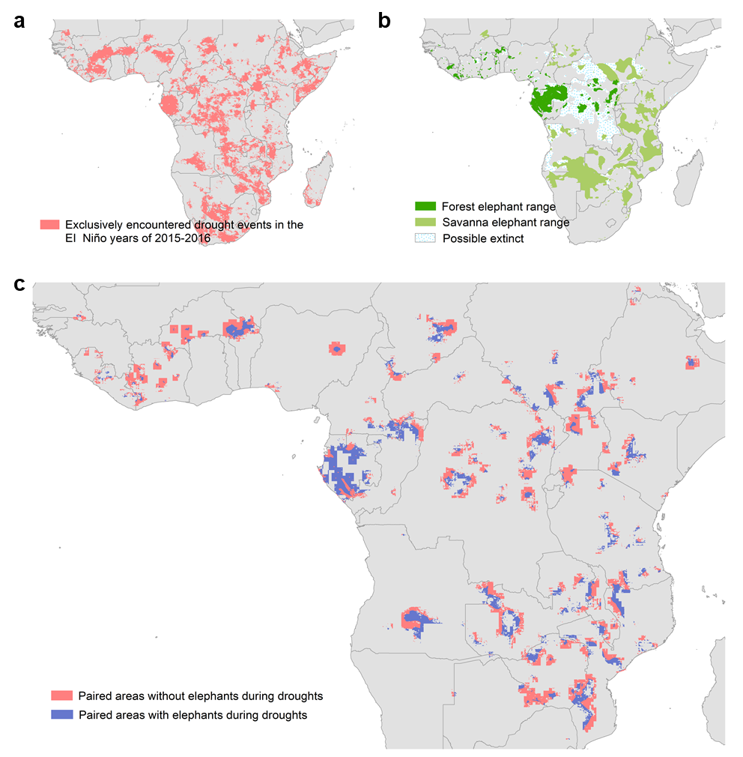
Fig. S1 Spatial distribution of drought events and elephant range. a, Regions that exclusively encountered drought events in the EI Niño years of 2015-2016. b, Elephant ranges were derived from the African Elephant Database (AED). c, Paired areas with and without elephants in regions that experienced droughts in 2015-2016.

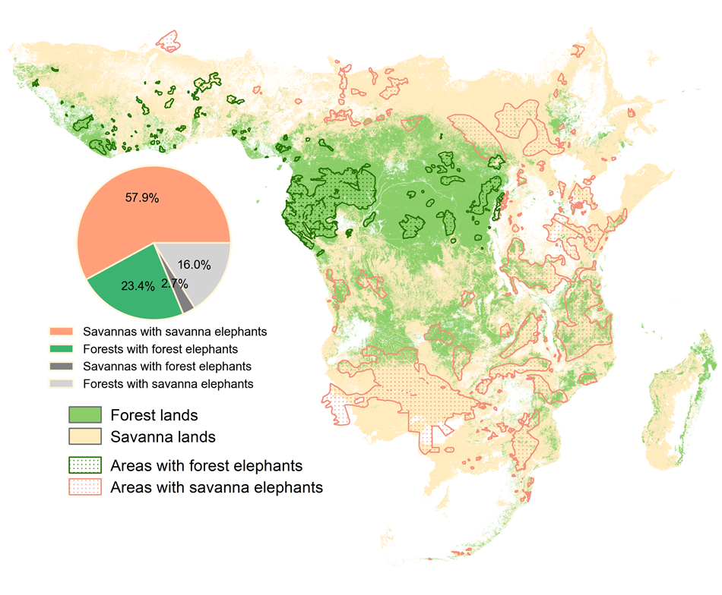
Fig. S2 Spatial distributions of forest elephant and savanna elephant range, and forest and savanna habitat types. Elephant ranges were derived from the African Elephant Database (AED). Forest and savanna land covers were derived from the habitat types data from Jung et al. (2020). The inset pie chart shows the areas of savannas with savanna elephants, forests with forest elephants and mixed regions (i.e., savannas overlapped with forest elephant range and forests overlapped with savanna elephant range).

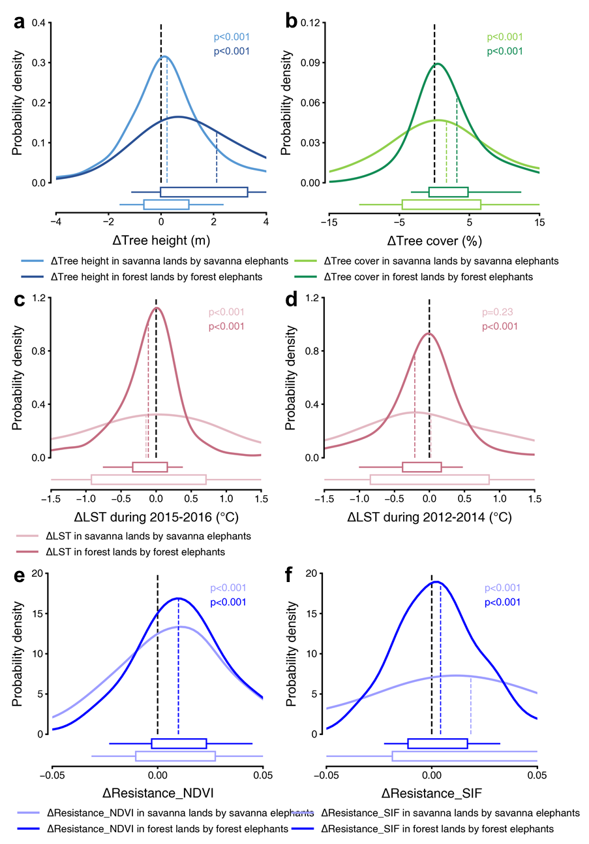
Fig. S3 Differences in vegetation structure and function between areas with and without elephants after separating savanna elephants and forest elephants and controlling savanna and forest habitat types. Forest and savanna covers were derived from the habitat types data from Jung et al. (2020) (Fig. S2). Kernel density distributions of ΔTree height (a), ΔTree cover (b), ΔLST in the EI Niño years (2015-2016) (c), ΔLST in the years before the EI Niño event (2012-2014) (d), and ΔResistance in grid cells with drought-induced productivity reduction defined by NDVI (e) and SIF (f) in savanna lands influenced by savanna elephants and in forest areas influenced by forest elephants. The boxes and whiskers represent the 10th, 25th, 75th and 90th percentiles. Colored dashed lines show the mean values.
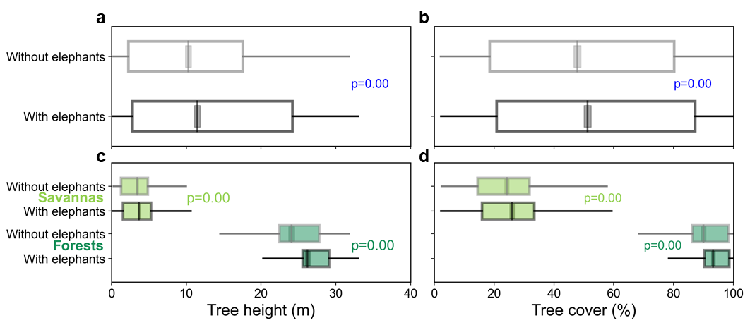
Fig. S4. Comparison of tree height and tree cover between areas with and without elephants. a and b directly present the comparison of tree height and tree cover between binary areas with and without elephants, complementing Fig. 1a and 1b. c and d directly present the comparison of tree height and tree cover between binary areas with and without elephants after controlling savanna and forest habitat types, complementing Fig. S3a and Fig. S3b. The boxes and whiskers represent the 10th, 25th, 75th and 90th percentiles. Gray lines within boxes show the mean values.

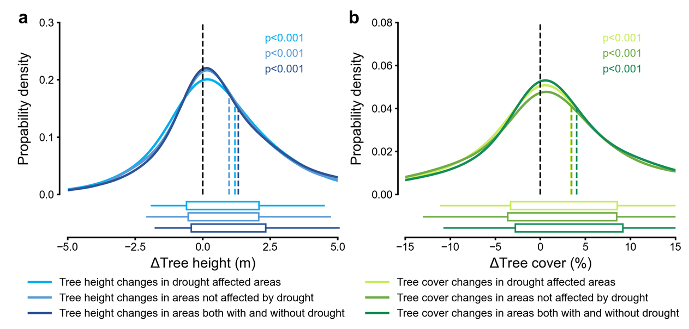
Fig. S5 Same as Fig. 1a and 1b, but for areas affected by drought, areas not affected by drought and all areas regardless of whether affected by drought during 2015-2016. Kernel density distributions of ΔTree height (a) and ΔTree cover (b) between the paired neighbor non-drought affected areas with and without elephants. The boxes and whiskers represent the 10th, 25th, 75th and 90th percentiles. Colored dashed lines show the mean values.

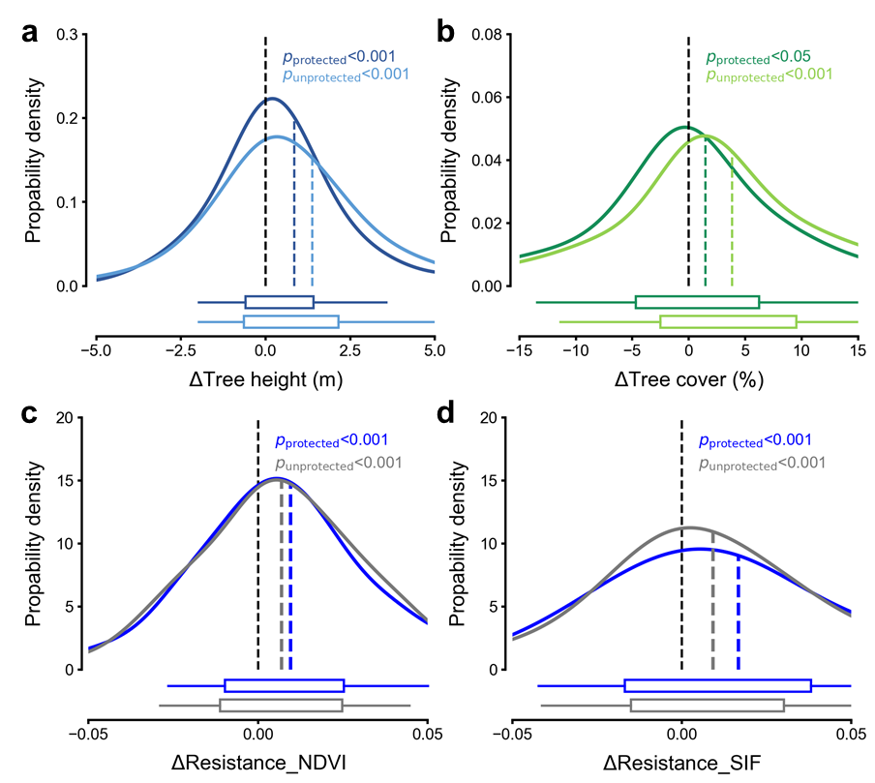
Fig. S6 Same as Fig. 1a, b, and Fig. 4b, but limited to the paired sites with and without elephants that are either both inside or both outside the protected areas. Dark colored lines represent paired sites both inside protected area, light colored and gray lines represent paired sites both outside protected area in Supplementary Text 2. Kernel density distributions of ΔTree height (a), ΔTree cover (b), and ΔResistance in grid cells with drought-induced productivity reduction defined by NDVI (c) and SIF (d). The boxes and whiskers represent the 10th, 25th, 75th and 90th percentiles. Colored dashed lines show the mean values.

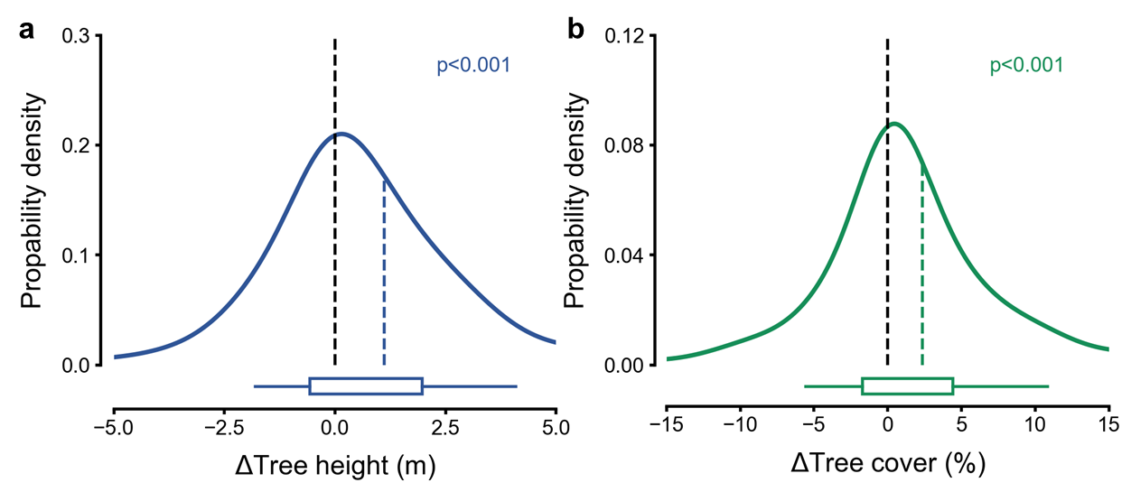
Fig. S7 Same as Fig. 1a and 1b, but using tree height data from Lang et al.⁸² and tree canopy cover data from Hansen et al.⁸⁴. Kernel density distributions of ΔTree height (a) and ΔTree cover (b) between the paired neighbor non-drought affected areas with and without elephants. The boxes and whiskers represent the 10th, 25th, 75th and 90th percentiles. Colored dashed lines show the mean values.

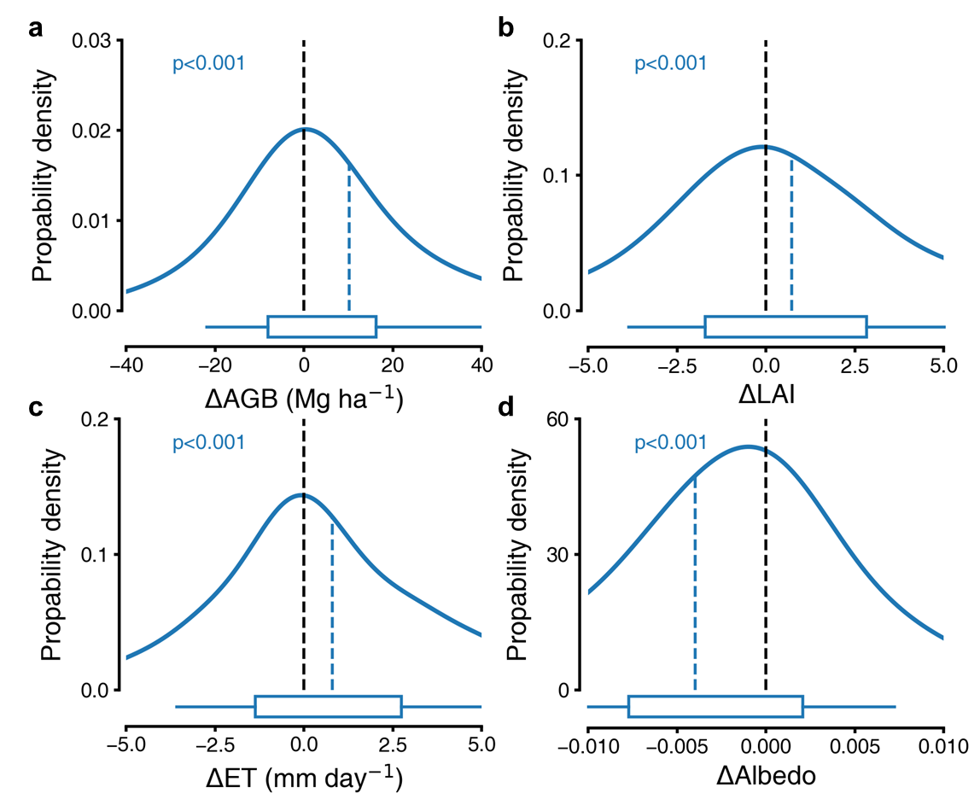
Fig. S8 Difference in above ground biomass (ΔAGB), leaf area index (ΔLAI), evapotranspiration (ΔET) and albedo (ΔAlbedo) between nearby areas with elephants and without elephants. Kernel density distributions of (ΔAGB) (a), ΔLAI (b), ΔET (c) and ΔAlbedo (d). The boxes and whiskers represent the 10th, 25th, 75th and 90th percentiles. Blue dashed lines show the mean values.
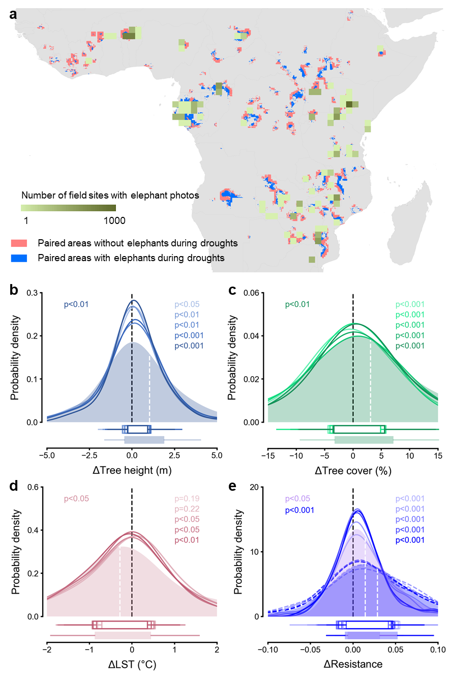
Fig. S9 Difference in vegetation structure and function between areas with and without elephants using field sites with elephant photos. Field sites with elephant photos of elephant presence were derived from iNaturalist (See Supplementary Text 3). (a) Spatial distribution and number of field sites with elephant photos within paired areas with and without elephants during droughts in each 1° × 1° grid cell. (b-e) difference in tree height (ΔTree height, b), tree cover (ΔTree cover, c), land surface temperature (ΔLST, d) and drought resistance (ΔResistance, e) between the areas with field sites with elephant photos of elephant presence and the nearby areas without elephants. Shaded areas represent the kernel density distributions from the first test, with white dashed lines showing the mean values. The colored lines, from light to dark, represent the kernel density distributions from the second test, with buffering ranges from 1 km to 9 km at an interval of 2 km around each field site with elephant photos (see Supplementary Text 3 and Fig. S39). Colored dashed lines show the mean values (N=154). The boxes and whiskers represent the 10th, 25th, 75th and 90th percentiles.
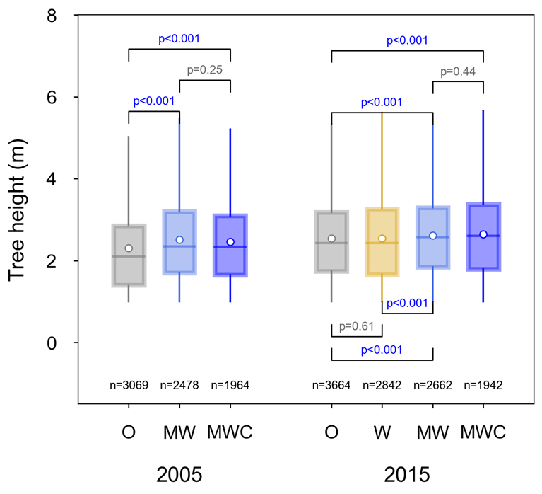
Fig. S10 Comparison of tree height between treatment (W, MW, MWC) and control (O) plots in the KLEE experiment. Trees taller than 1 m, based on surveys conducted in 2005 and 2015. The boxes and whiskers represent the 10th, 25th, 75th and 90th percentiles. White dots and horizontal represent mean and median values, respectively. Sample size (n) at the bottom correspond to the total number of trees recorded within the surveyed area (3 hectares across the north, center and south plots).

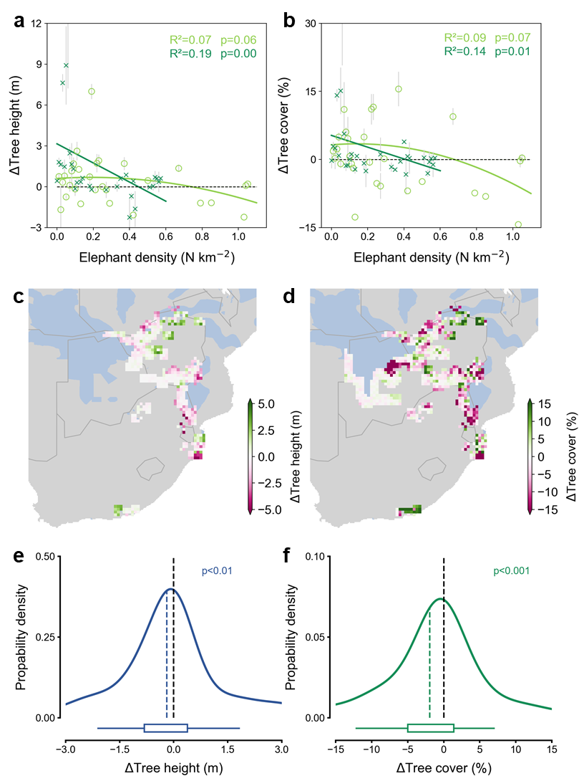
Fig. S11 Relationships between vegetation-structure differences and elephant density, including patterns in countries with high elephant densities. a, b, Relationships of ΔTree height (a) and ΔTree cover (b) with elephant density. Crosses and circles show mean differences across 0.25° × 0.25° grid cells grouped by elephant density for areas with forest and savanna elephants, respectively; error bars denote one standard error. Dark- and light-green curves show the corresponding polynomial regressions, with polynomial degree selected by the lowest p value. c, d, Spatial distributions of ΔTree height (c) and ΔTree cover (d) in four countries with elephant densities >0.6 individuals km⁻²: Zimbabwe, Botswana, Swaziland and South Africa. e, f, Kernel density distributions of the differences shown in c and d. Differences were calculated as values in areas with elephants minus those in nearby paired areas without elephants. Black and coloured dashed lines denote zero and mean values, respectively. Boxes and whiskers represent the 10th, 25th, 75th and 90th percentiles. The p values in e and f test whether the differences deviate from zero.
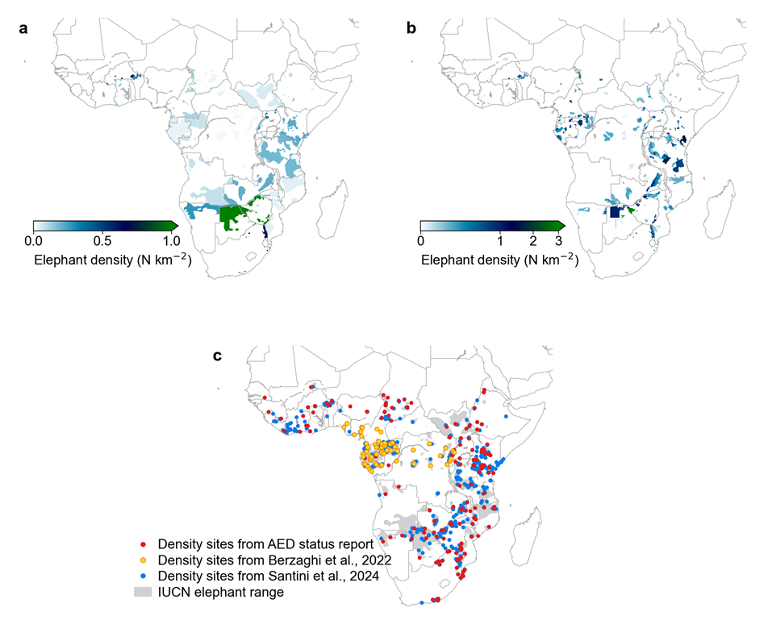
Fig. S12 Elephant population density map in country, patch and site level. a, Country level elephant density, calculated by dividing the national total elephant number by the elephant activity area in each country and assumed homogenous in the elephant area within each country. Elephant population and activity range data were derived from the IUCN Red List of Threatened Species (https://www.iucnredlist.org/). b, Patch level elephant density, derived by linking each elephant density record to the protected-area patch in which it occurs, thereby approximating the actively used elephant habit range. Surveyed elephant density records were compiled from the African Elephant Status Reports and published field studies, and protected area boundaries were obtained from the world database on protected areas (WDPA). c, Site level elephant density. Red, yellow, and blue dots represent site-level density data collected from the African Elephant Database (AED) status report (Thouless et al., 2016), from Berzaghi et al. (2022), and from Santini et al. (2024). Gray areas indicate the IUCN elephant ranges. Sites outside the IUCN boundaries were excluded and not shown here.

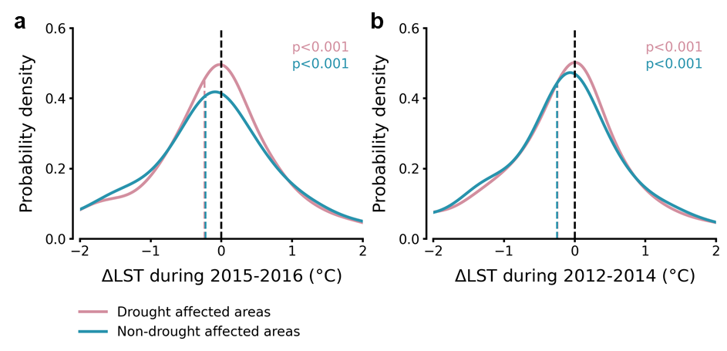
Fig. S13 Kernel density distribution of land surface temperature differences between drought and non-drought affected nearby areas with and without elephants (ΔLST). ΔLST of drought and non-drought affected areas in the EI Niño years (2015-2016) in the years before the EI Niño event (2012-2014) are shown in a and b. The boxes and whiskers represent the 10th, 25th, 75th and 90th percentiles. Colored dashed lines and numbers show the mean values.

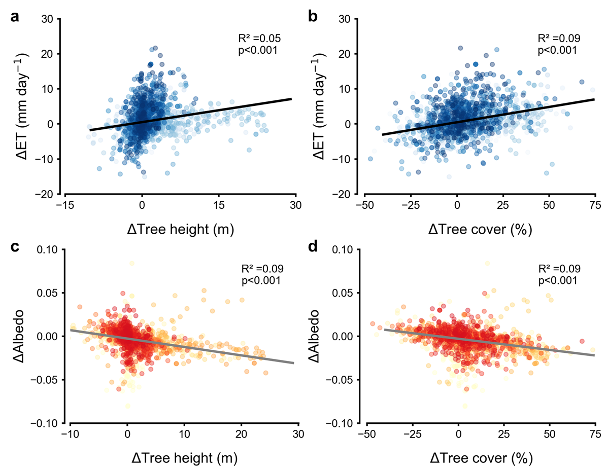
Fig. S14 Relationships between differences in tree height (ΔTree height) and tree cover (ΔTree cover) and differences in evapotranspiration (ΔET) and albedo (ΔAlbedo). Linear regressions were used to fit the relationships. Colored dots from light to dark indicate the data number from small to large. The black solid lines represent the fitted linear relationships.
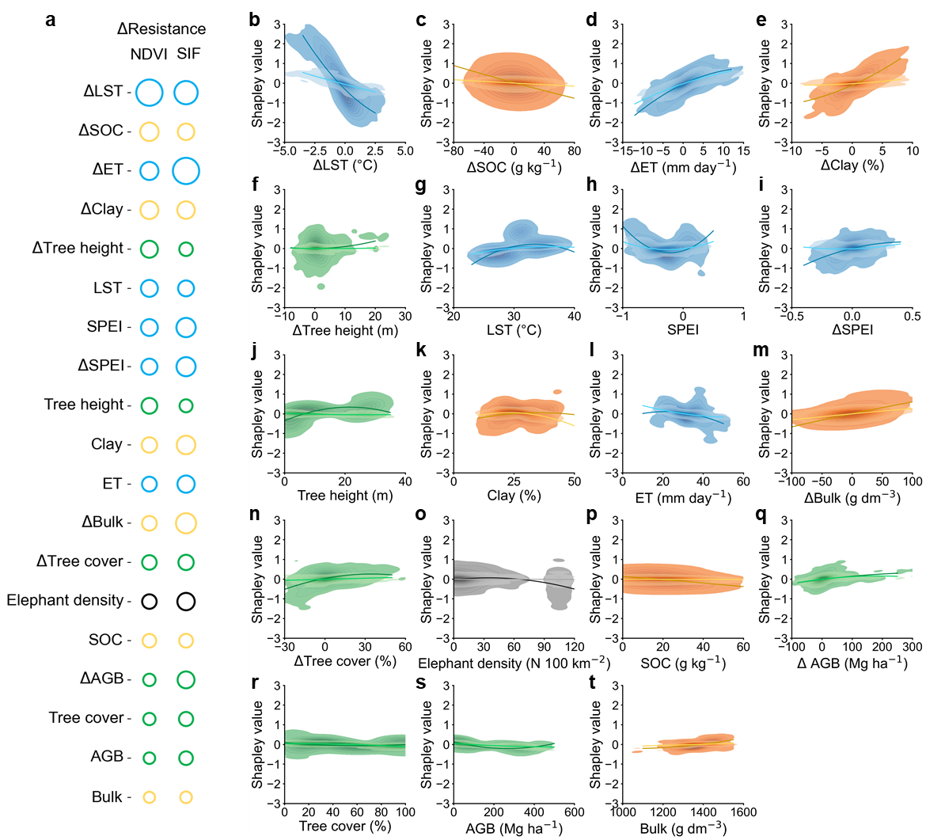
Fig. S15 Relative importance and partial dependence of factors determining the drought resistance difference. Blue, green, orange and black colors represent climate, vegetation, soil relative and elephant density factors, respectively. a, Relative importance of factors in predicting the difference in drought resistance between areas with and without elephants (ΔResistance defined with NDVI and SIF), evaluated through the Shapley Additive explanations (SHAP) values, which represent the marginal contribution of a given variable to ΔResistance. Larger dot size indicates higher importance. b-t, Partial dependence on all variables, calculated from the Shapley value distributions. Light blue, green, orange and black colors indicate ΔResistance from SIF data, while dark colors indicate ΔResistance from NDVI data. Color scales indicate the data density, and lines indicate the fitted line of polynomial regression curves. Variables included are climate-related variables (SPEI, land surface temperature (LST), evapotranspiration (ET)), vegetation-related factors (tree height, tree cover, above ground biomass (AGB)), soil factors (bulk density, clay fraction and soil organic carbon (SOC)) and elephant density. Considering variations in ecological heterogeneity related to climate, vegetation and soil data, we computed both the differences and averages between elephant-influenced areas and nearby paired non-elephant areas. We utilized a total of 19 parameters in machine learning training, detailed information on each variable is shown in Table S6.
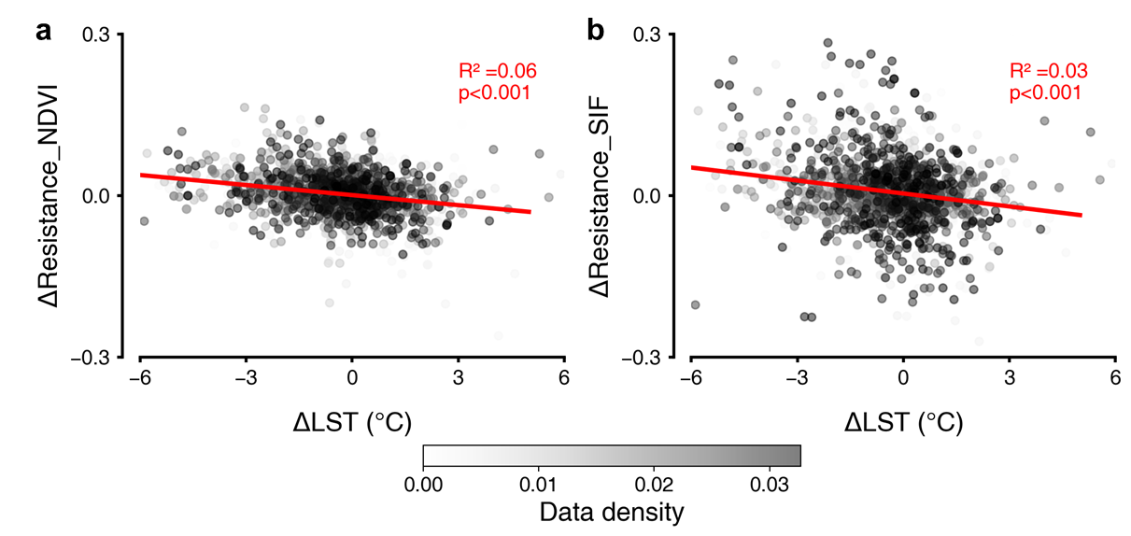
Fig. S16 Relationships between differences in drought resistance and ΔLST. Drought resistance is calculated as the relative changes in NDVI (a) and SIF (b) before and during the drought period, and ΔResistance is the difference between the paired neighbor areas with and without elephants. The red solid lines are the fitted linear regression lines.

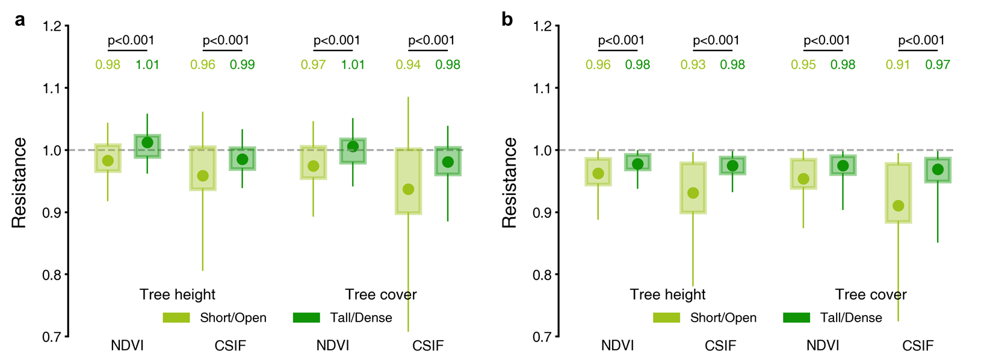
Fig. S17 Comparison of drought resistance in areas with short and open vegetation and areas with tall and dense vegetation. Drought resistance in all drought affected areas regardless of the presence of elephants is shown in a. Drought resistance in areas with drought-induced productivity reduction but without elephants is shown in b. Colored dots and numbers represent the mean values, calculated from the paired sites of areas with short trees (tree height ≤ 10 m) and tall trees (tree height >10 m), and the paired sites with open canopies (tree cover ≤ 40 %) and dense canopies (tree cover > 40 %) during droughts, regardless of the presence of elephants. The bottom and top of boxes indicate the first quartile and the third quartile of the data. The lower and upper whiskers indicate the 10th and 90th percentiles.

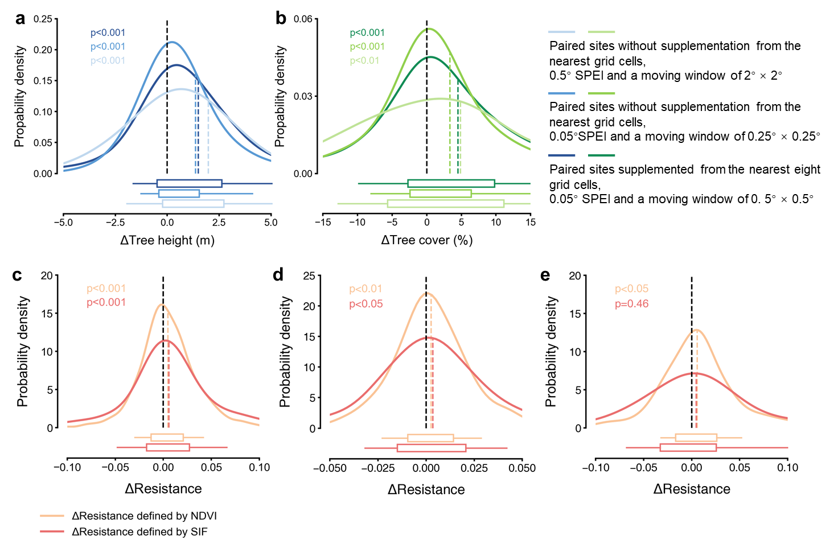
Fig. S18 Sensitivity of vegetation structure and drought resistance differences to SPEI resolution, moving-window size and paired-site supplementation. Kernel density distributions of ΔTree height (a) and ΔTree cover (b) between the paired neighbor areas with and without elephants. Colors from dark to light indicate results from sensitivity test (1) to (3): (1) paired sites supplemented from the nearest eight grid cells, 0.05° SPEI and a moving window of 0. 5° × 0.5°, (2) paired sites without supplementation from the nearest grid cells, 0.05°SPEI and a moving window of 0.25° × 0.25°, and (3) paired sites supplemented from the nearest eight grid cells, 0.5° SPEI and a moving window of 2° × 2°. c–e, Kernel density distributions of ΔResistance under sensitivity tests (1)-(3), respectively. Orange and red lines indicate ΔResistance defined by NDVI and SIF, respectively. Black and colored dashed lines indicate zero and mean values, respectively. Boxes and whiskers represent the 10th, 25th, 75th and 90th percentiles.

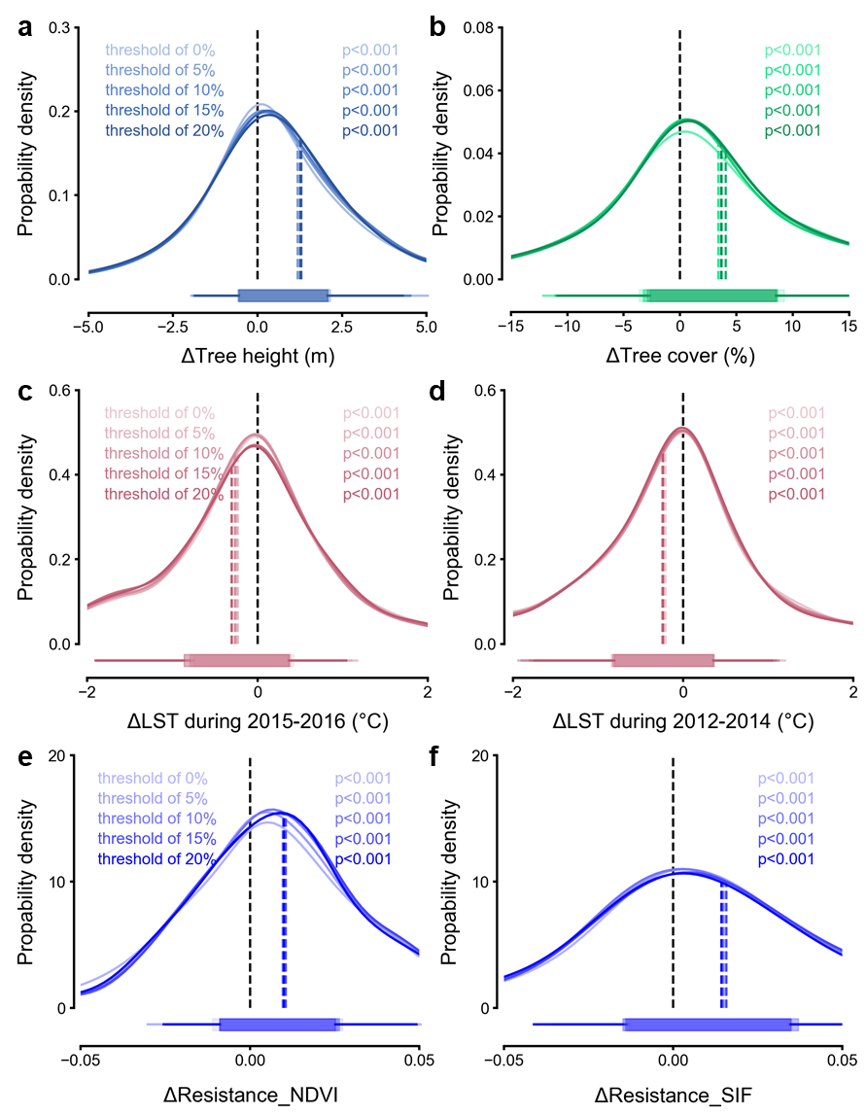
Fig. S19 Same as Fig. 1a, b, Fig. 3a, b, and Fig. 4b, but for the paired sites selection using different thresholds (0%, 5%, 10%, 15% and 20%) for areas with or without elephants. Kernel density distributions of ΔTree height (a), ΔTree cover (b), ΔLST in the EI Niño years (2015-2016) (c), ΔLST in the years before the EI Niño event (2012-2014) (d), and ΔResistance in grid cells with drought-induced productivity reduction defined by NDVI (e) and SIF (f). Colors from light to dark represent the thresholds from 0% to 20% at an interval of 5%. The boxes and whiskers represent the 10th, 25th, 75th and 90th percentiles. Colored dashed lines show the mean values.

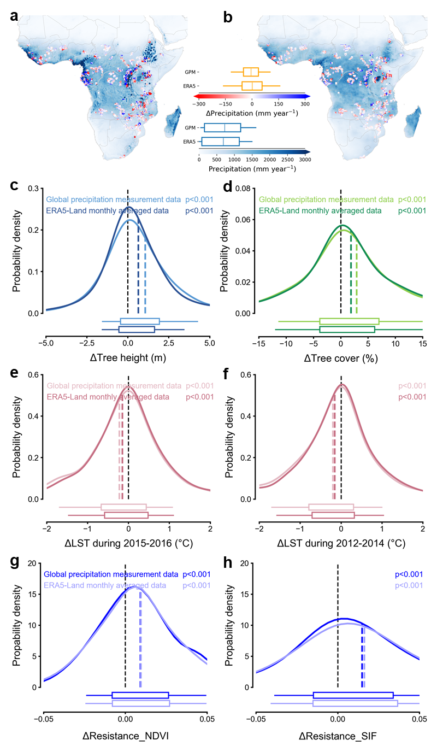
Fig. S20 Differences in variables between nearby areas with elephants and without elephants after controlling precipitation. Light lines represent differences after controlling precipitation from the Global Precipitation Measurement (GPM) data, while dark lines represent differences after controlling precipitation from the ERA5-Land monthly averaged data. (a, b) Spatial distribution of precipitation (mm year⁻¹) from the ERA5-Land monthly averaged data and the Global Precipitation Measurement (GPM) precipitation data. (c, d) Differences in tree height (ΔTree height) and tree cover (ΔTree cover) between nearby areas with and without elephants. (e, f) Differences in land surface temperature (ΔLST) in the EI Niño years (2015-2016) and in the years before the EI Niño event (2012-2014), between nearby areas with and without elephants. (g, h) Differences in drought resistance (ΔResistance) with drought-induced productivity reduction defined by NDVI and SIF, between nearby areas with and without elephants. The boxes and whiskers represent the 10th, 25th, 75th and 90th percentiles. Colored dashed lines show the mean values.
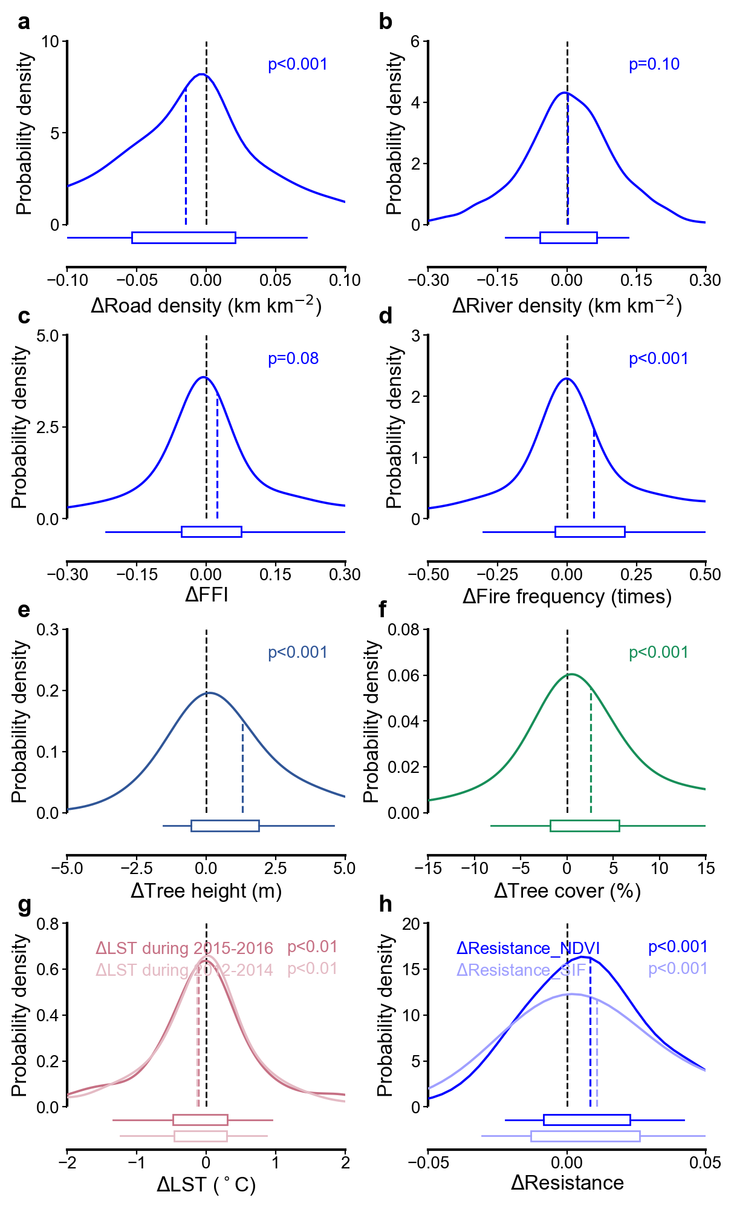
Fig. S21 Potential confounding effects of road density, river density, forest fragmentation and fire frequency, and vegetation responses after controlling for road density and fire frequency. a–d, Kernel density distributions of differences in road density (a), river density (b), forest fragmentation index (FFI; c) and fire frequency (d) between nearby paired areas with and without elephants. e–h, Differences in tree height (e), tree cover (f), land surface temperature (LST; g) and drought resistance (h) after excluding paired sites with an absolute difference in road density greater than 0.03 km km⁻² or an absolute difference in fire frequency greater than 0.2. In g, dark and light pink lines represent ΔLST during 2015–2016 and 2012–2014, respectively. In h, dark and light blue lines represent ΔResistance in grid cells with drought-induced productivity reduction defined by NDVI and SIF, respectively. Differences were calculated as values in areas with elephants minus those in paired areas without elephants. Black and colored dashed lines indicate zero and mean values, respectively. Boxes and whiskers represent the 10th, 25th, 75th and 90th percentiles. The p values indicate whether the differences deviate significantly from zero.

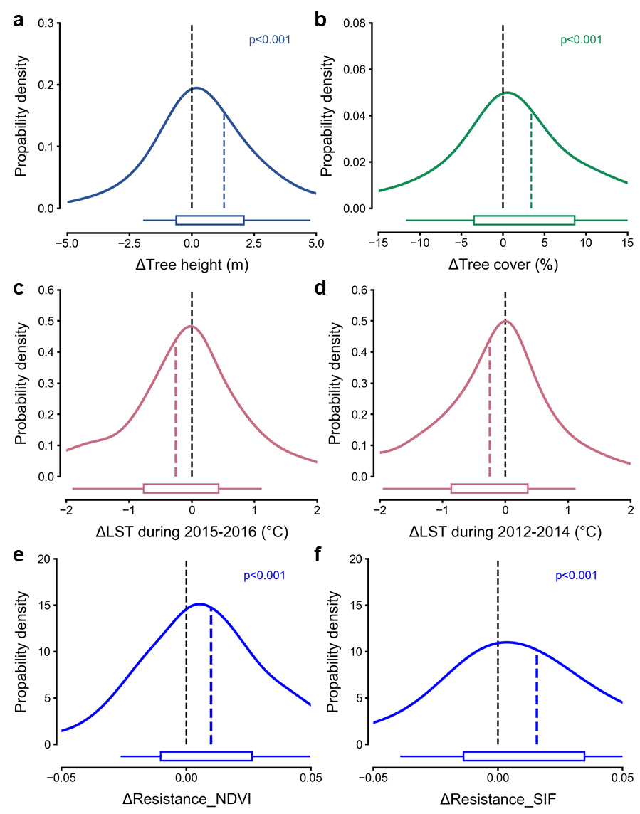
Fig. S22 Same as Fig. 1a, b, Fig. 3a, b, and Fig. 4b, but for the paired sites selection within the same ecological region. Ecoregions were derived from the “Ecoregions 2017” map by Dinerstein et al. (2017)⁵³. Kernel density distributions of ΔTree height (a), ΔTree cover (b), ΔLST in the EI Niño years (2015-2016) (c), ΔLST in the years before the EI Niño event (2012-2014) (d), and ΔResistance in grid cells with drought-induced productivity reduction defined by NDVI (e) and SIF (f). The boxes and whiskers represent the 10th, 25th, 75th and 90th percentiles. Colored dashed lines show the mean values.

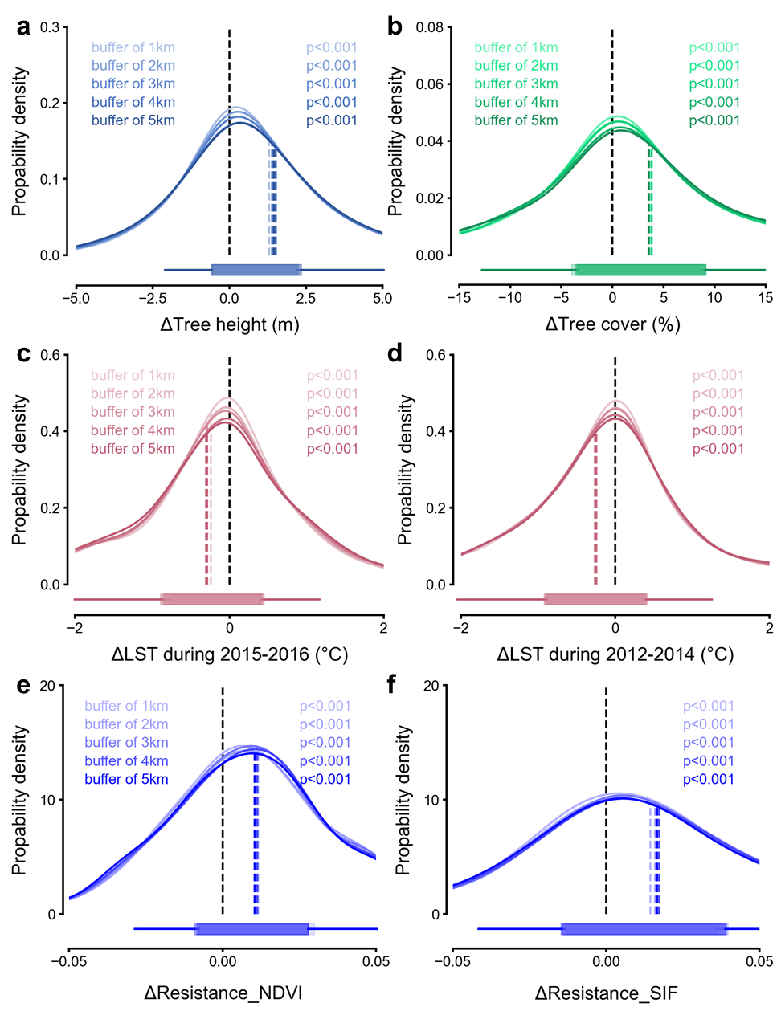
Fig. S23 Same as Fig. 1a, b, Fig. 3a, b, and Fig. 4b, but with applied buffering range of 1-5 km in- and out- elephant habitat boundaries. Kernel density distributions of ΔTree height (a), ΔTree cover (b), ΔLST in the EI Niño years (2015-2016) (c), ΔLST in the years before the EI Niño event (2012-2014) (d), and ΔResistance in grid cells with drought-induced productivity reduction defined by NDVI (e) and SIF (f). The colors from light to dark represent the in- and out- boundary buffers from 1 km to 5 km at an interval of 1 km. The boxes and whiskers represent the 10th, 25th, 75th and 90th percentiles. Colored dashed lines show the mean values.

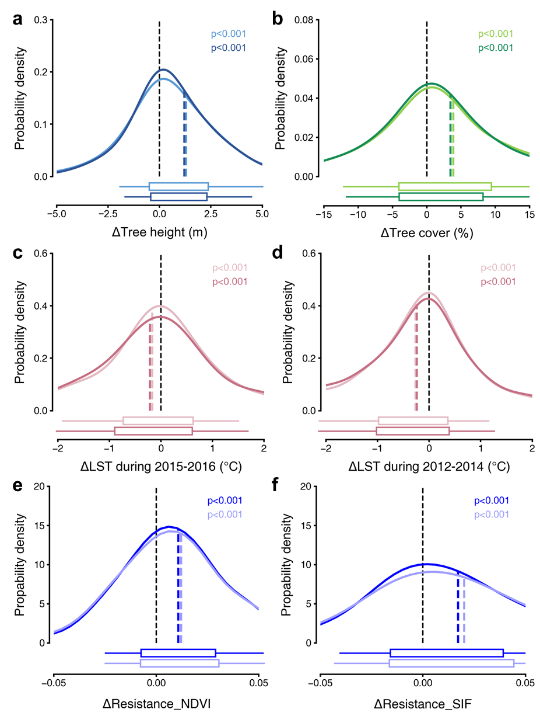
Fig. S24 Same as Fig. 1a, b, Fig. 3a, b, and Fig. 4b, but controlling areas without elephants by excluding regions with possible and extinct elephant presence. Light lines represent areas with elephants defined by “extant” and “possible” ranges in African Elephant Database (AED), while dark lines represent areas with elephants defined solely by “extant” ranges. In both cases, areas without elephants excluded “extant”, “possible” and “extinct” ranges (See Supplementary Text 9.5). Kernel density distributions of ΔTree height (a), ΔTree cover (b), ΔLST in the EI Niño years (2015-2016) (c), ΔLST in the years before the EI Niño event (2012-2014) (d), and ΔResistance in grid cells with drought-induced productivity reduction defined by NDVI (e) and SIF (f). The boxes and whiskers represent the 10th, 25th, 75th and 90th percentiles. Colored dashed lines show the mean values.

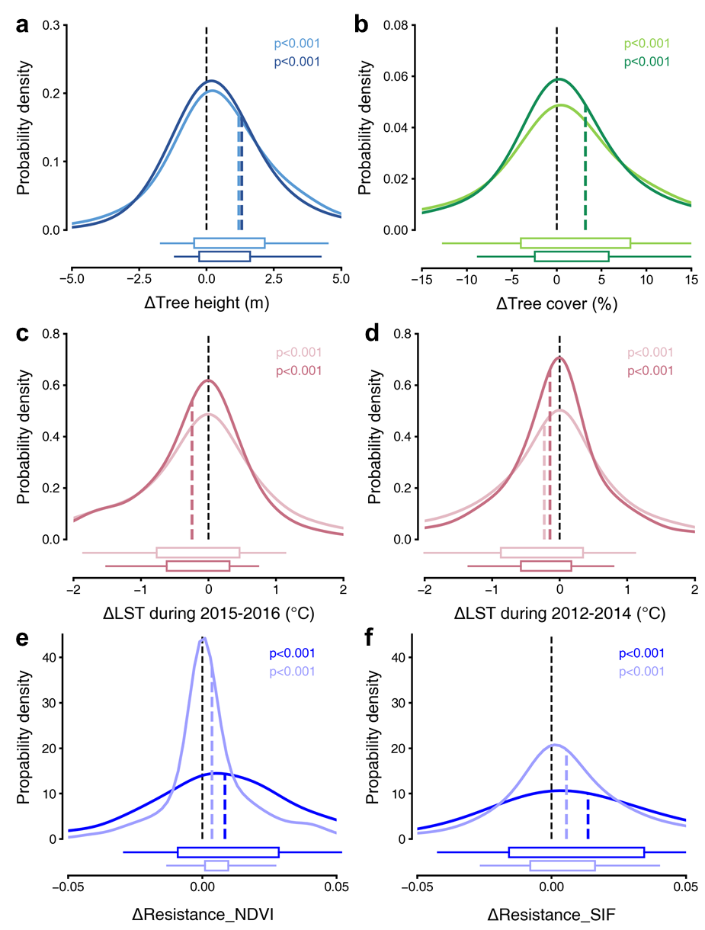
Fig. S25 Same as Fig. 1a, b, Fig. 3a, b, and Fig. 4b, but considering the areas of the paired sites with and without elephants to ensure the even sample sizes. Light and dark colored lines represent the first test and the second test in Supplementary Text 9.6, respectively. Kernel density distributions of ΔTree height (a), ΔTree cover (b), ΔLST in the EI Niño years (2015-2016) (c), ΔLST in the years before the EI Niño event (2012-2014) (d), and ΔResistance in grid cells with drought-induced productivity reduction defined by NDVI (e) and SIF (f). The boxes and whiskers represent the 10th, 25th, 75th and 90th percentiles. Colored dashed lines show the mean values.

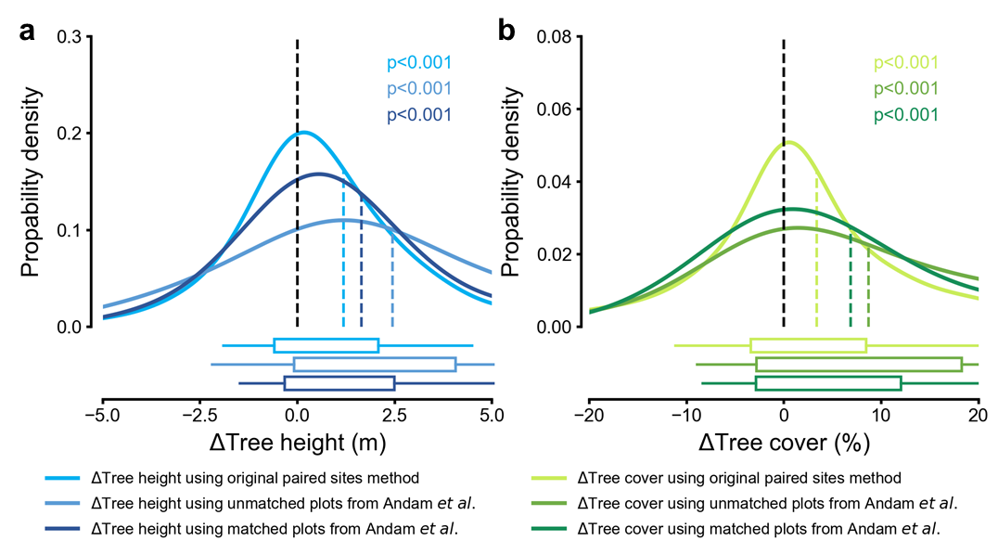
Fig. S26 Differences in tree height (ΔTree height) and tree cover (ΔTree cover) between nearby areas with elephants and without elephants based on various pair sites methods (Supplementary Text 9.7). Kernel density distributions of ΔTree height (a) and ΔTree cover (b) between the paired neighbor areas with and without elephants. The boxes and whiskers represent the 10th, 25th, 75th and 90th percentiles. Colored dashed lines show the mean values.
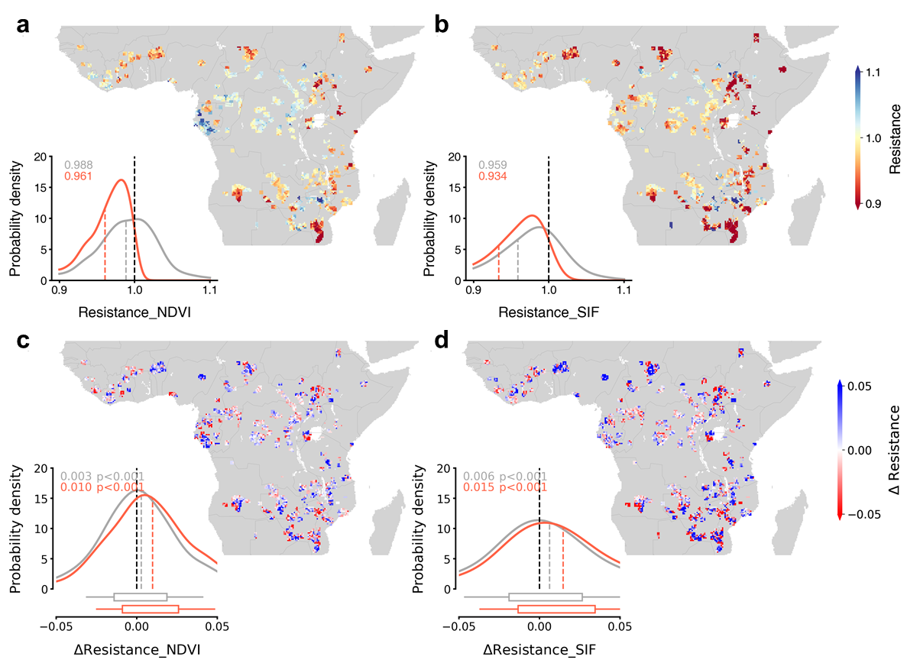
Fig. S27 Drought resistance in areas affected by droughts and difference in drought resistance between nearby areas with and without elephants. Drought resistance in areas without elephants is calculated as the relative changes in NDVI (a) and SIF (b) before and during the drought period. The kernel density distributions of drought resistance, represented by gray and orange lines, indicate drought resistance in all drought affected grid cells and the grid cells with drought-induced productivity reduction, respectively. ΔResistance, defined by NDVI (c) and SIF (d), is the difference between the paired neighbor areas with and without elephants. The kernel density distributions of ΔResistance, shown by gray and orange lines, indicate ΔResistance in all drought affected grid cells and the grid cells with drought-induced productivity reduction, respectively. The boxes and whiskers represent the 10th, 25th, 75th and 90th percentiles.
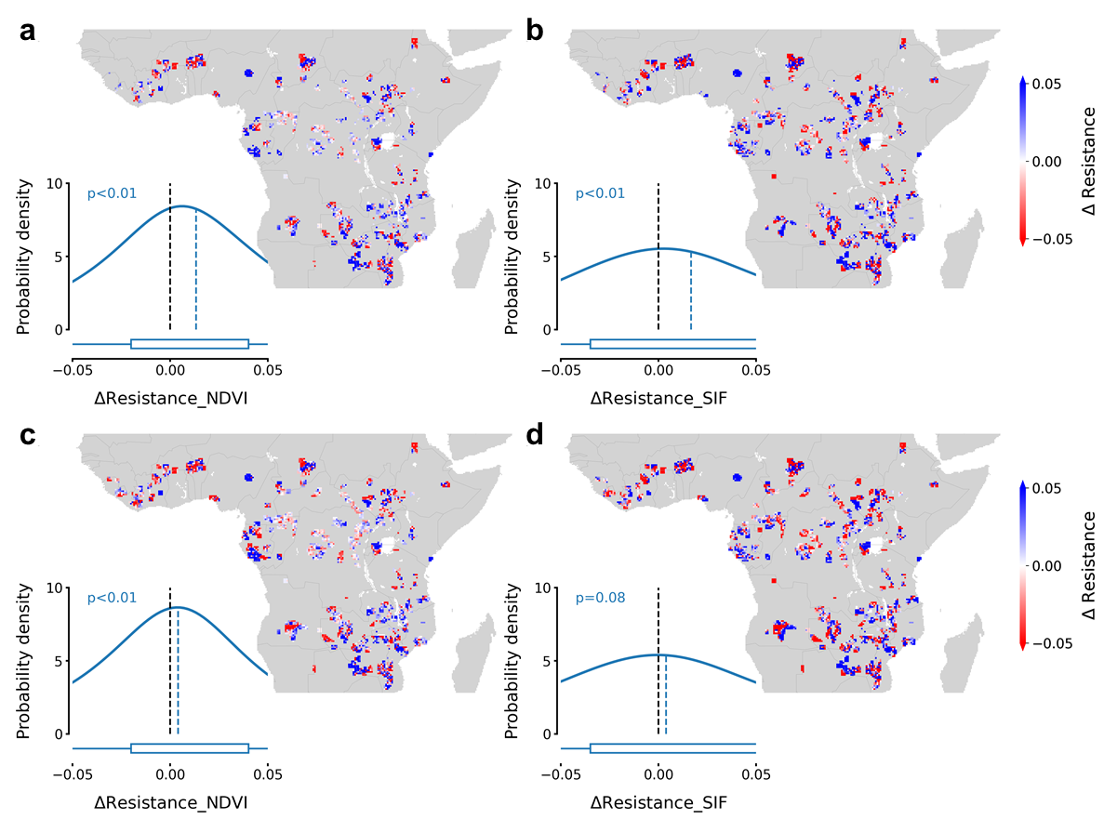
Fig. S28 Difference in drought resistance between nearby areas with and without elephants (ΔResistance) using resistance calculated from the drought-affected months. Drought resistance is calculated as the relative change in NDVI and SIF before and during the drought period, which is defined as the drought-affected months in the growing season. ΔResistance in grid cells with drought-induced productivity reduction, defined by NDVI and SIF, are shown in a and b. ΔResistance with all drought affected grid cells, as defined by NDVI and SIF, are shown in c and d. The kernel density distributions of ΔResistance are also shown with colored dashed lines indicating the mean values. The boxes and whiskers represent the 10th, 25th, 75th and 90th percentiles.

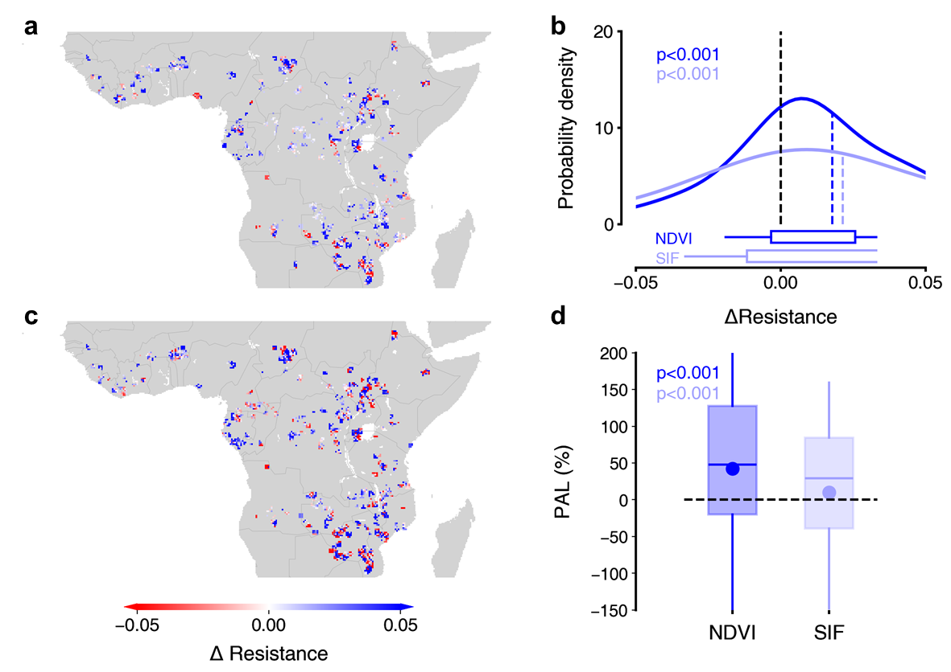
Fig. S29 Same as Fig. 4, but NDVI and SIF averaged over varying growing season months across years. NDVI and SIF values were averaged over the temporally resolved growing season months for each year from 2012 to 2016, using vegetation phenology data from Chen et al. (2024). Drought resistance is calculated as the relative changes in NDVI (a) and SIF (c) before and during the drought period. ΔResistance is the difference between paired neighbor areas with and without elephants. The kernel density distributions of ΔResistance are shown in b, with the colored dashed lines indicating the mean values. The percentage of avoided greenness or productivity loss (PAL) due to enhanced drought resistance caused by elephants in d is calculated as the changes in drought resistance induced by elephants (ΔResistance) relative to the vegetation greenness or productivity reduction affected by drought (Methods). The boxes and whiskers represent the 10th, 25th, 75th and 90th percentiles, and the blue dots and horizontal lines show the mean and median value of the data, respectively.

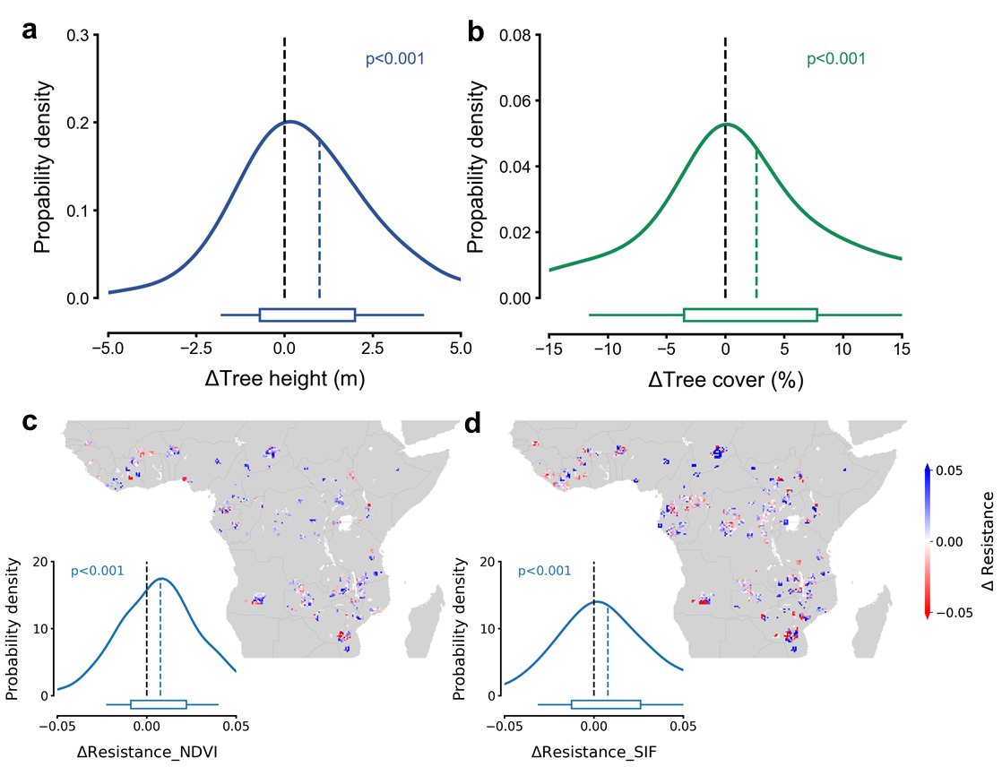
Fig. S30 Difference in tree height (ΔTree height), tree cover (ΔTree cover) and drought resistance (ΔResistance) with and without elephants within areas without other disturbances in the past 20 years. The “stable forest extent” between the years 2000 and 2020 from Potapov et al.¹⁶ was used to define areas without other disturbances in the past 20 years. ΔTree height and ΔTree cover with all drought affected grid cells are shown in a and b. ΔResistance in grid cells with drought-induced productivity reduction, defined by NDVI and SIF, are shown in c and d. The kernel density distributions of ΔResistance are also shown with colored dashed lines indicating the mean values. The boxes and whiskers represent the 10th, 25th, 75th and 90th percentiles.

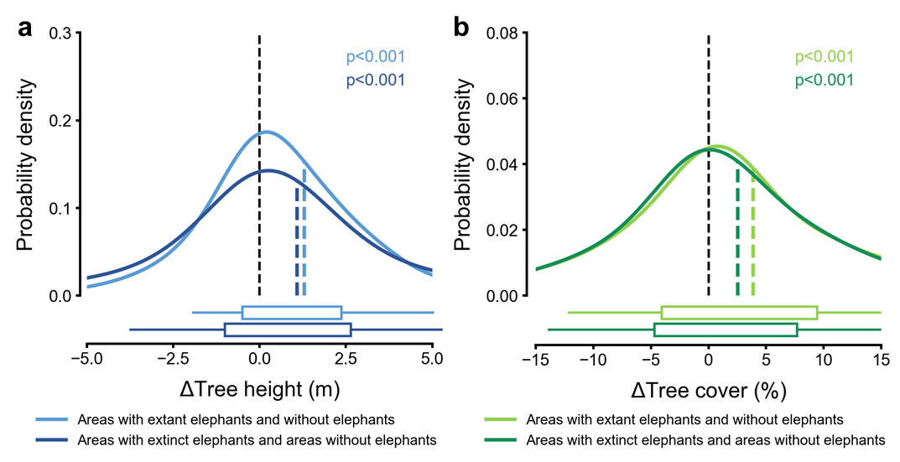
Fig. S31 Differences in tree height (ΔTree height) and tree cover (ΔTree cover) between areas with and without elephants. Light lines represent areas with extant elephants and areas without elephants, while dark lines represent areas with extinct elephants and areas without elephants. Kernel density distributions of ΔTree height (a) and ΔTree cover (b) between the paired neighbor areas with and without elephants. The boxes and whiskers represent the 10th, 25th, 75th and 90th percentiles. Colored dashed lines show the mean values.

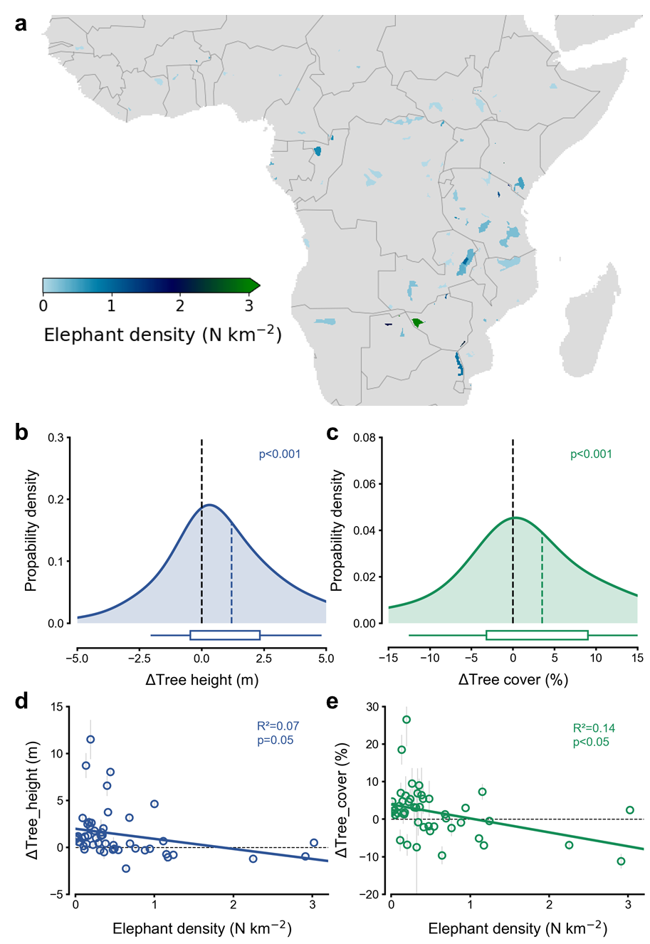
Fig. S32 Patch-level elephant ranges were extracted from the tables in the African Elephant Database (AED, https://africanelephantdatabase.org/report/2016/Africa/) and matched with protected area patches from the World Database on Protected Areas (WDPA) (i.e., matching shapes and names for elephant range patches in AED and protected areas in WDPA). Elephant density was calculated by dividing the number of elephants by the area of the survey patches. (a) Distribution of surveyed elephant patches and elephant population density. Kernel density distributions of ΔTree height (b) and ΔTree cover (c) between the paired neighbor areas with and without elephants. Colored dashed lines show the mean values. The boxes and whiskers represent the 10th, 25th, 75th and 90th percentiles. Relationship between ΔTree height (d) and ΔTree cover (e) with elephant density fitted with linear regressions. Circles represent ΔTree height or ΔTree cover averaged over all 0.25° × 0.25° grid cells with the same elephant density (rounded to integers), and error bars denote the standard error.
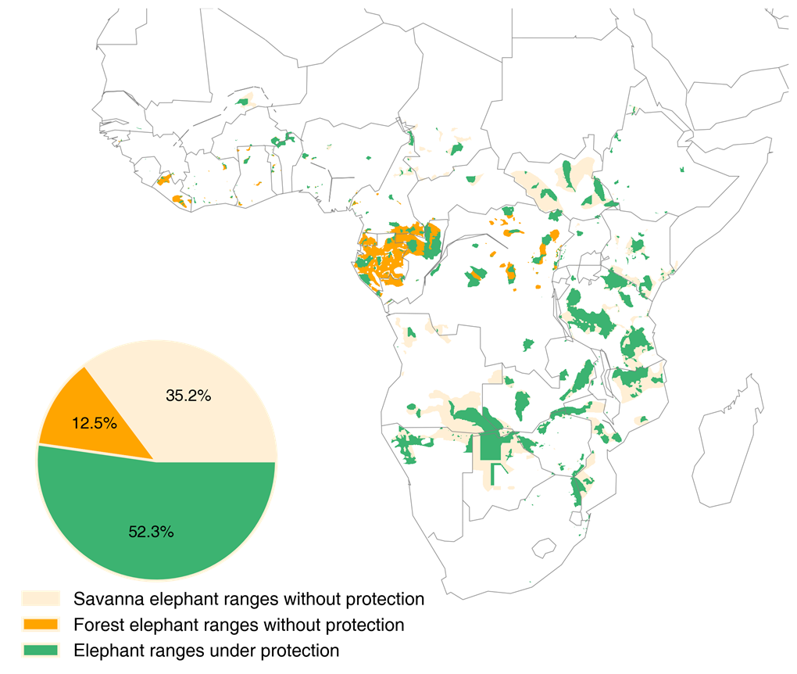
Fig. S33 Elephant ranges with and without protection in Africa, derived by overlaying the elephant ranges and the protected areas.

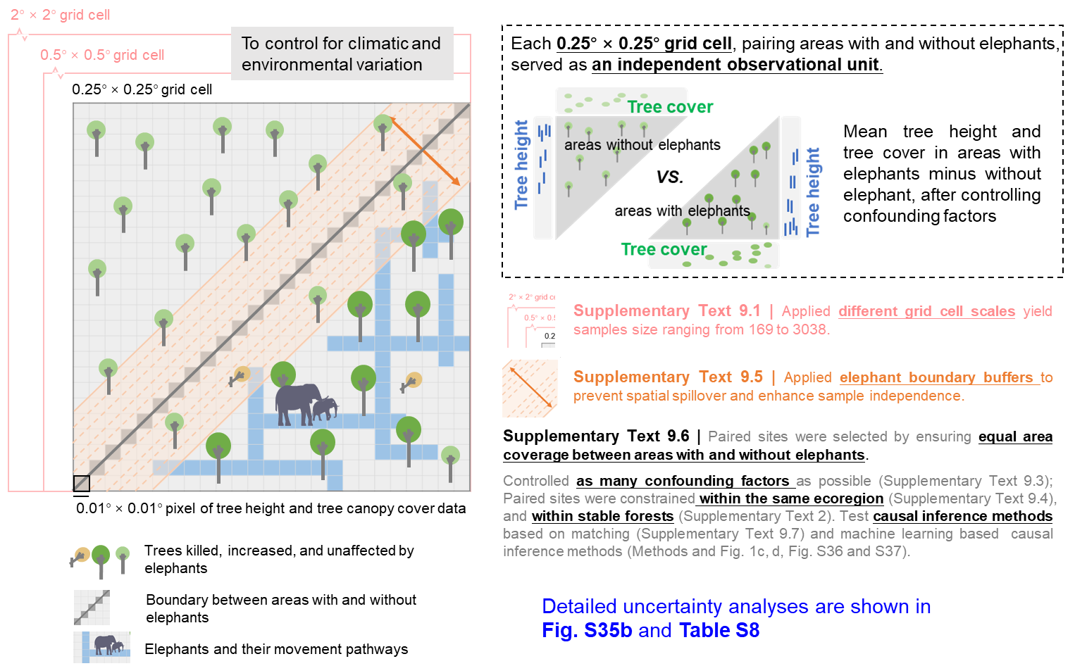
Fig. S34 Conceptual illustration of the paired site selection method and associated sensitivity tests for ensuring the independence of paired sites.

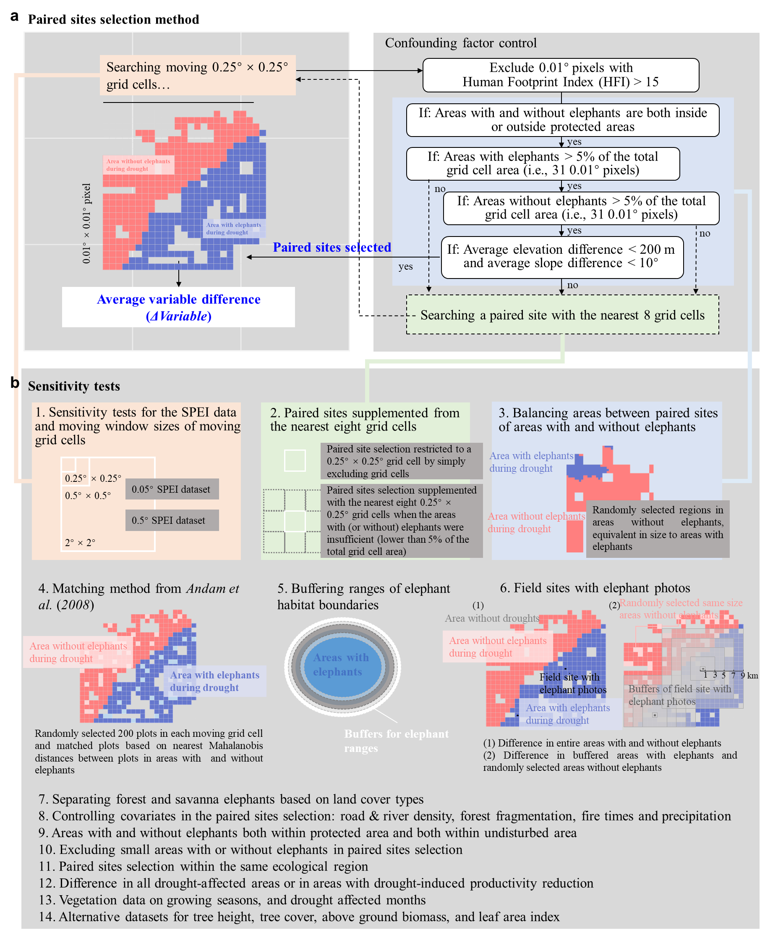
Fig. S35 Diagram of the paired sites selection method and the related sensitivity tests. (a) Paired sites selection method. Controlling factors and the differences in variables between areas with and without elephants are calculated using 0.01° pixels values within each moving 0.25° × 0.25° grid cell. Specifically, each 0.01° (~ 1 km) pixel is checked with elephant existence using the elephant habitat range and with controlling factors such as human footprint index (HFI), elevation and slope. If there are more than 31 0.01° pixels (i.e., >5% of the total 0.25° grid cell area) for both areas with and without elephants, this 0.25° grid cell is selected for comparison. (b) Sensitivity tests for the paired sites selection method (Supplementary Method 1 and Table S8).

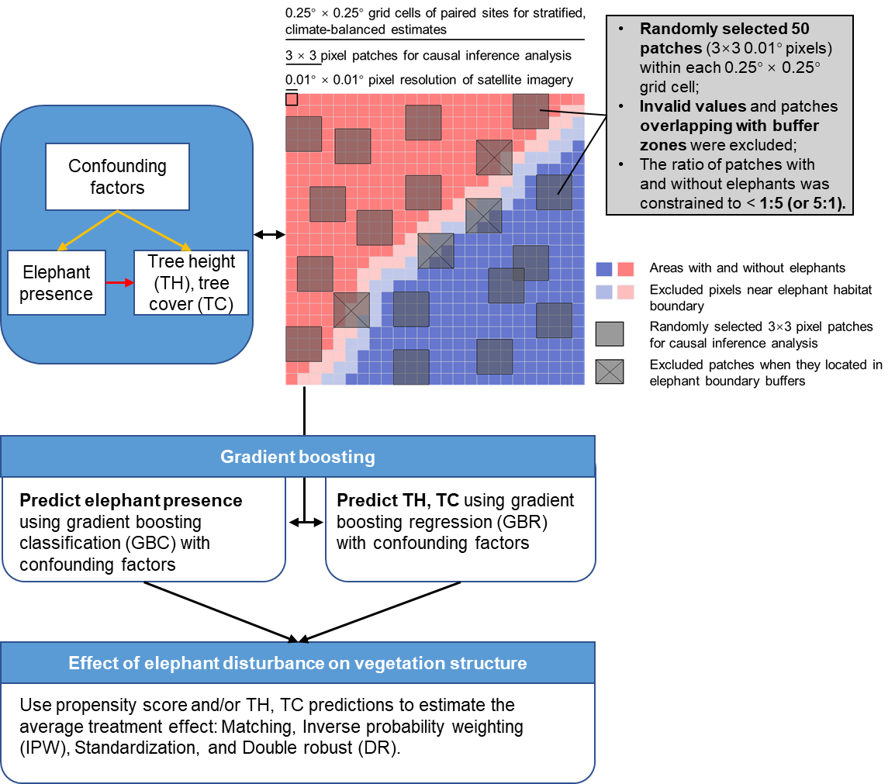
Fig. S36 Flowchart of the causal inference analysis based on machine learning.

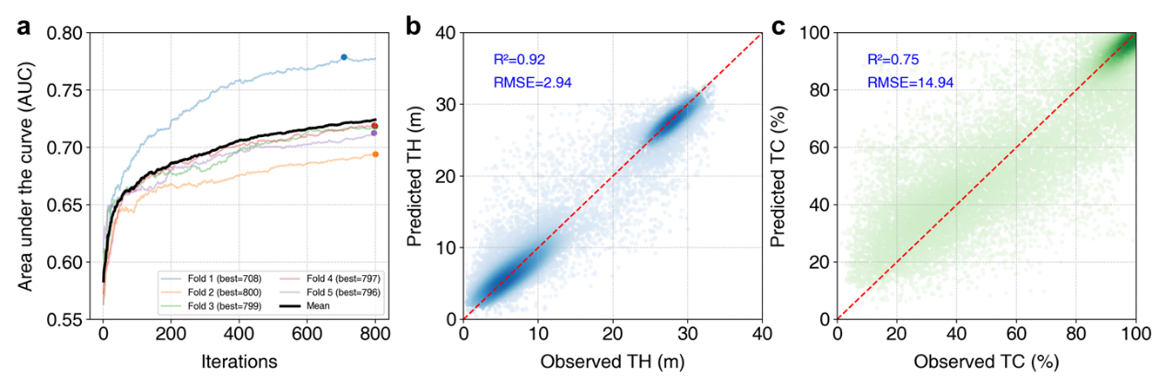
Fig. S37 Performance of the gradient boosting classification and regression models. a, Area under the receiver operating characteristic curve (AUC) of the gradient boosting classification model for predicting elephant presence. Colored lines show AUC trajectories from fivefold cross-validation, and dots mark the optimal iteration in each fold. b and c, Observed and predicted tree height (TH) and tree cover (TC) from the gradient boosting regression models. The red dashed lines represent the 1:1 line. R² and RMSE represent mean values across the five folds.

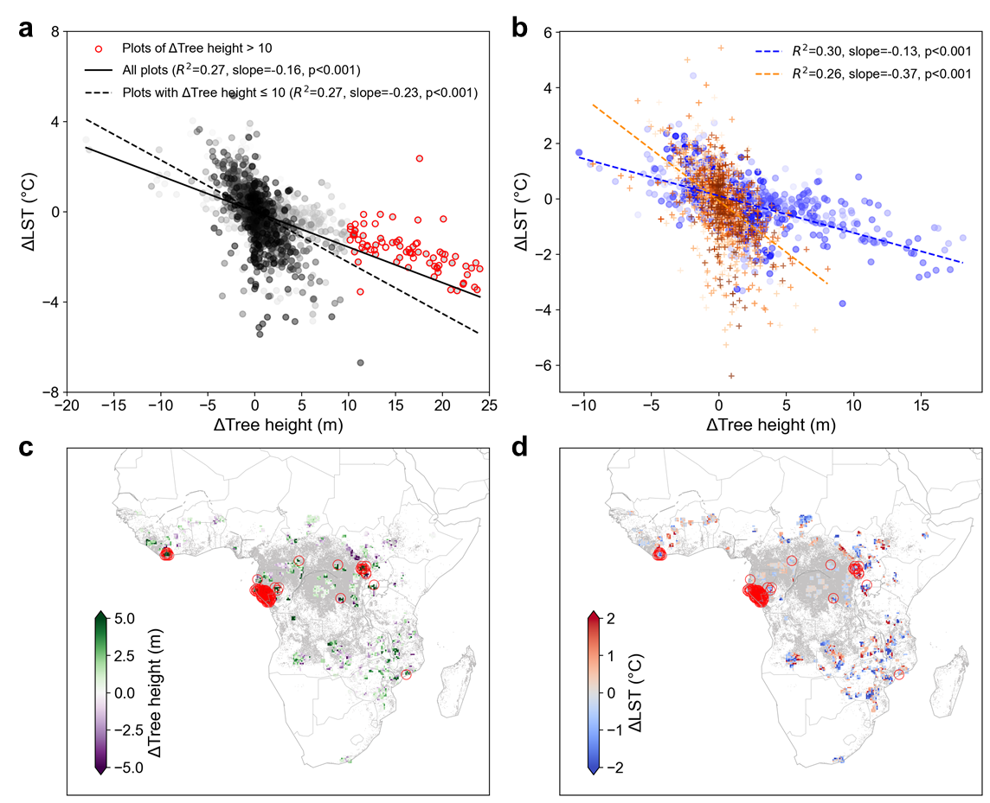
Fig. S38 Impacts of data points with high ΔTree height values on the regression of ΔLST against ΔTree height. A drag effect is observed in the relationship between ΔTree height and ΔLST (Fig. 3c). a, Linear regression of ΔLST against ΔTree height, same as Fig. 3c, with points having ΔTree height >10 m and ΔLST >-4 ℃ highlighted in red. b, Linear regression of ΔLST against ΔTree height, separately for savanna (orange dots and dashed lines) and forest areas (blue dots and dashed lines). Colored dots from light to dark indicate the data number from small to large. Colored dashed lines represent the fitted linear relationships. c and d, Spatial distribution of ΔTree height and ΔLST. The gray background indicates forest lands, and the red circles mark data points with high ΔTree height values (>10 m) and ΔLST >-4 ℃ that contribute to the “drag effect” (red circles in a).

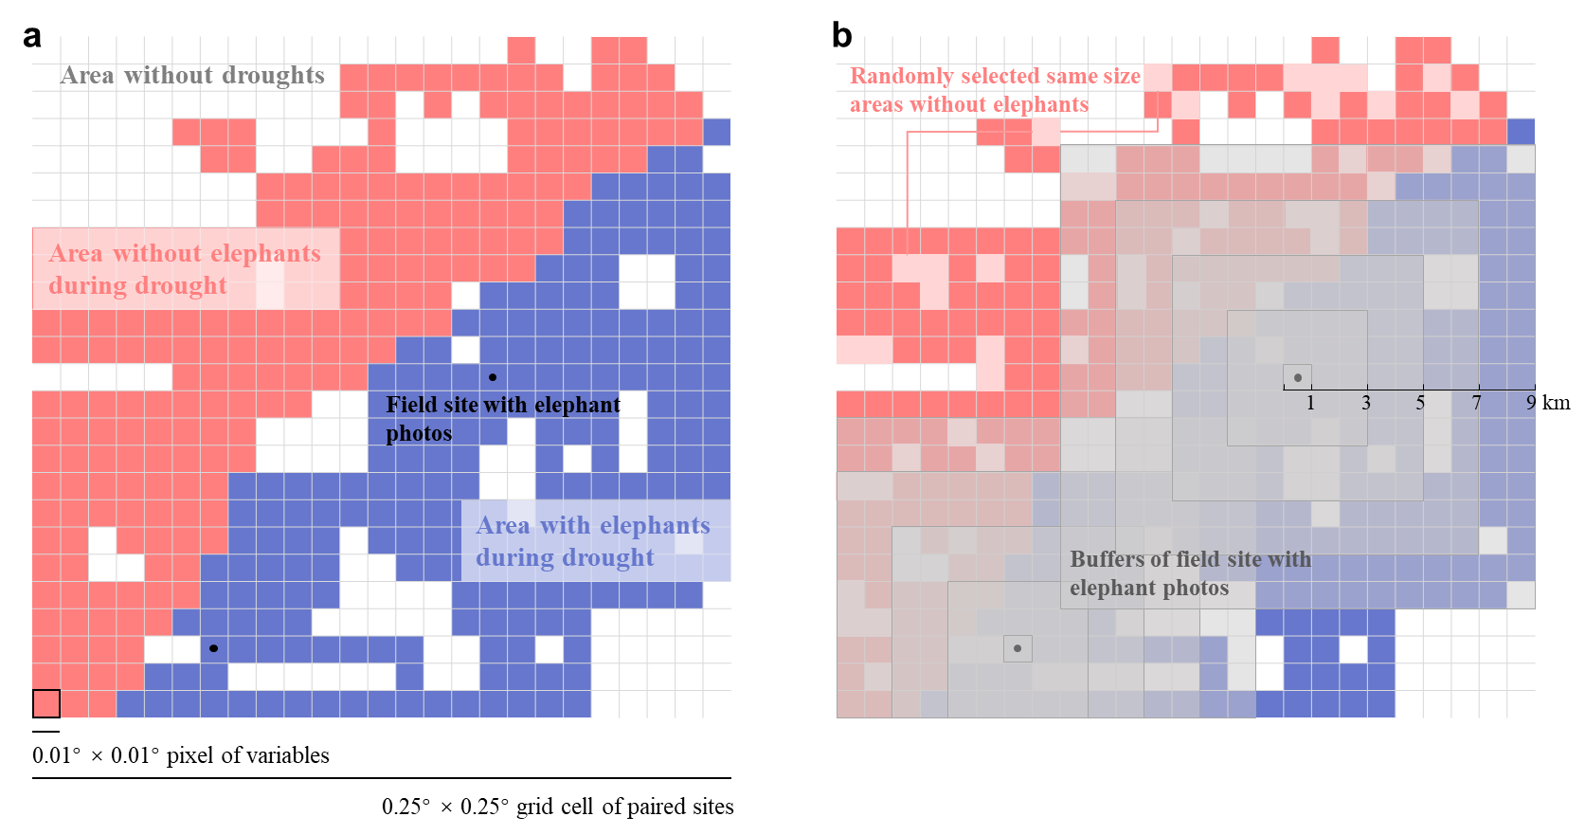
Fig. S39 Illustration of the paired sites method for field sites with elephant photos of elephant presence. (a) Difference in variables (e.g. tree height, tree cover, LST and resistance) across the entire area with elephants, where at least one field-observed elephant presence site exists, compared to areas without elephants in each 0.25° × 0.25° moving grid cell. (b) Difference in variables between buffered areas around the field sites with elephant photos and the areas without elephants with a randomly selected same size. The shaded blocks are buffers of 1 to 9 km at an interval of 2 km around each elephant observation site. The blue pixels within buffered areas represent areas with elephants, while the light pink pixels (randomly selected same size to areas with elephants) represent areas without elephants.

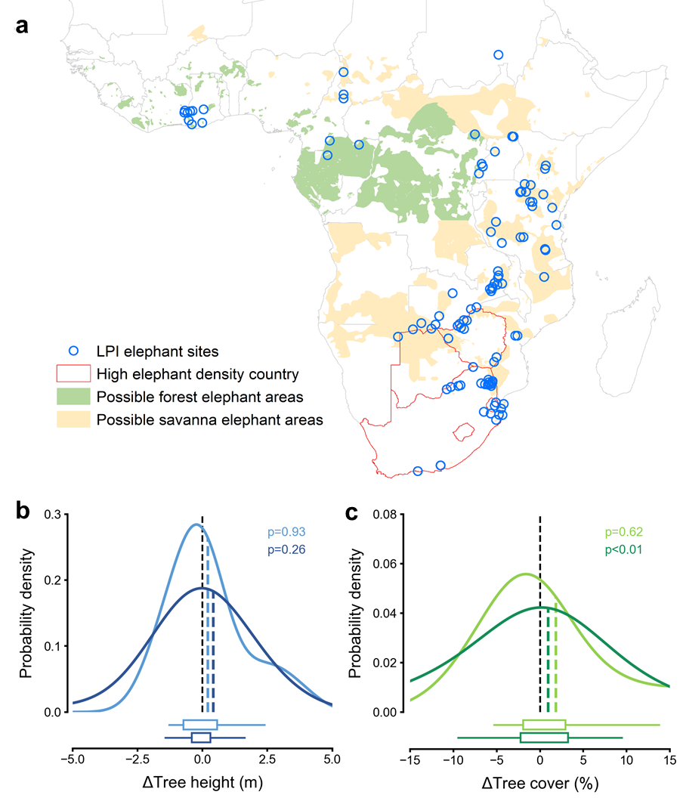
Fig. S40 Difference in vegetation structure between areas with and without elephants using Living Planet Index (LPI) elephant sites. LPI sites of elephant presence were derived from living planet database (livingplanetindex.org/data_portal, see Supplementary Text 3). (a) Spatial distribution of LPI sites. Green and yellow areas show the possible elephant areas as defined by “extant”, “possible”, and “extinct” ranges in African Elephant Database (AED). Only LPI sites located within the possible elephant areas were included in the analysis. Red boundary lines indicate high elephant density (> 0.6 individuals per km²) countries (Table S1), with 35 LPI sites falling within these countries. Kernel density distributions of ΔTree height (b) and ΔTree cover (c) between the paired neighbor areas with and without elephants. Light lines represent the first test that if one or more LPI sites were located within a 0.25° × 0.25° grid cell, the entire elephant habitat range in this 0.25° × 0.25° grid cell was representative of elephant area (N= 18 and 19 for ΔTree height and ΔTree cover). Dark lines represent the second test that compared 9 km buffered areas around elephant observations with randomly selected areas without elephants (N= 35 and 40 for ΔTree height and ΔTree cover). The boxes and whiskers represent the 10th, 25th, 75th and 90th percentiles. Colored dashed lines show the mean values.

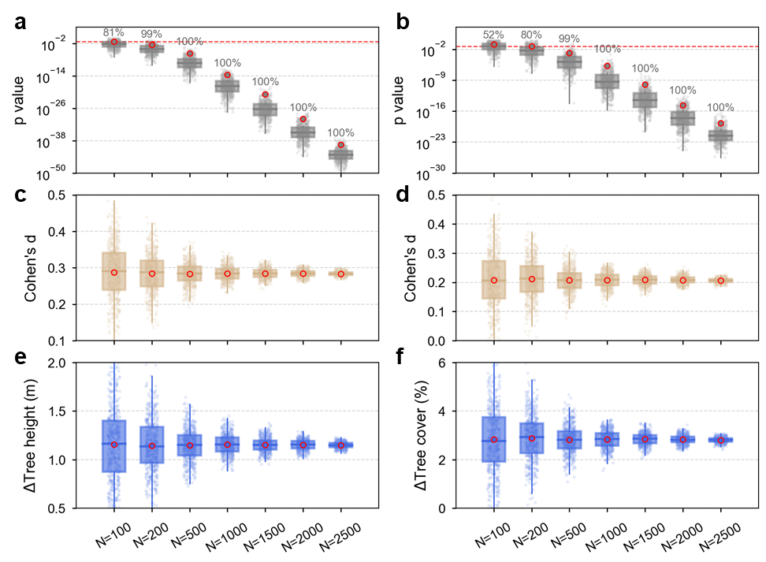
Fig. S41 Robustness of ΔTree height and ΔTree cover under bootstrap subsampling. The full paired sites were resampled 500 times at each subsample size (N = 100, 200, 500, 1000, 1500, 2000, 2500). For each subsample, the mean of p value (a, b) of paired Wilcoxon tests, the mean of standardized effect size (Cohen’s d, c, d) of ΔTree height and ΔTree cover, and the mean of ΔTree height (e) and ΔTree cover (f) are shown. The red dashed line in (a, b) represents the significance threshold (p value = 0.05), and the gray numbers indicate the percentage of samples with p values < 0.05 across the total 500 samples. The boxes and whiskers represent the 10th, 25th, 75th and 90th percentiles. Red circles and horizontal lines in the boxplots indicate mean and median values, respectively.

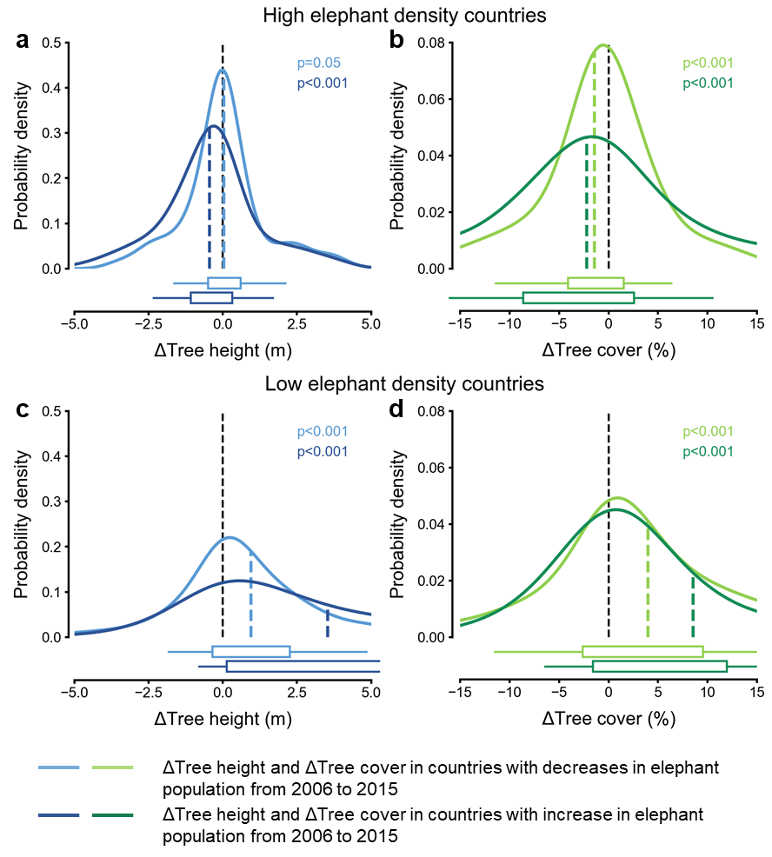
Fig. S42 Differences in tree height (ΔTree height) and tree cover (ΔTree cover) between areas with and without elephants. Light lines represent decreases in elephant population from 2006 to 2015, while dark lines represent increases in elephant population. ΔTree height and ΔTree cover between the paired neighbor areas with and without elephants in high elephant density countries are shown a and b, and those in low elephant density countries are shown in c and d. The boxes and whiskers represent the 10th, 25th, 75th and 90th percentiles. Colored dashed lines show the mean values.

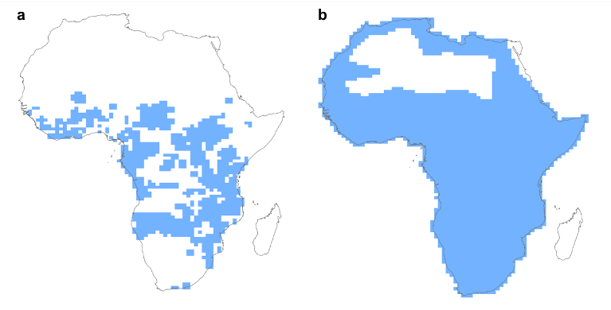
Fig. S43 African elephant ranges in the Phylogenetic Atlas of Mammal Macroecology (PHYLACINE 1.2.1) from Faurby et al., 2018. Current elephant ranges (a) and present natural ranges (b) are shown with a 96.5 × 96.5 km cell size between 30° N and 30° S. The present natural ranges could represent areas where elephants would live without anthropogenic pressures.

Supplementary Tables
Table S1 Statistics from the African elephant database. Elephant population data were derived from the African Elephant Status Report 2016⁵⁷ from the African Elephant Database (AED). The AED provides key statistics related to the conservation status of African elephants. It primarily relies on two fundamental variables: the number of elephants and their distribution range. "Area" denotes the estimated total range area in each country or region, and "Assessed" indicates the known area accounted for within the estimated total range (“Area”). "Density" is calculated from the “Estimate”, “Area”, and “Assessed” values using the formula: Estimate / (Area × Assessed). Countries shown in bold have high elephant densities (above 0.6 individuals per km²), while other countries have low elephant densities (below 0.6 individuals per km²).
Region | Country |  | Elephants |  | Range |  | Density (N km⁻²) | Change numbers | Main reason for change
Region | Country | Estimate 2006 | Estimate 2015 | ±95% confidence interval | Area (km²) | Assessed (%) | Density (N km⁻²) | Change numbers | Main reason for change
Central Africa | Cameroon | 179 | 6830 | 994 | 89718 | 68% | 0.11 | 6651 | New Population
Central Africa | Central African Republic | 929 | 702 | 245 | 24619 | 89% | 0.03 | -227 | Different Technique/ Different Area
Central Africa | Chad | 3885 | 794 | 0 | 61490 | 46% | 0.03 | -3091 | Repeat Survey
Central Africa | Congo | 772 | 6057 | 1222 | 150937 | 57% | 0.07 | 5285 | New Population/ Different Technique
Central Africa | Democratic Republic of Congo | 6507 | 1794 | 53 | 223248 | 51% | 0.02 | -4713 | Different Technique
Central Africa | Equatorial Guinea | 0 | 884 | 676 | 19701 | 100% | 0.04 | 884 | Different Area
Central Africa | Gabon | 2350 | 7058 | 2303 | 213373 | 101% | 0.03 | 4708 | Repeat Survey/ Different Technique/ New Guess
Eastern Africa | Eritrea | 96 | 0 | 0 | 5275 | 100% | 0 | -96 | New Guess
Eastern Africa | Ethiopia | 310 | 1017 | 0 | 22264 | 84% | 0.05 | 707 | Different Technique/ Different Area/ New Guess
Eastern Africa | Kenya | 23994 | 22809 | 0 | 130725 | 80% | 0.22 | -1185 | Data Degraded/ Repeat Survey/ Different Technique
Eastern Africa | Rwanda | 34 | 88 | 0 | 1079 | 99% | 0.08 | 54 | Different Technique
Eastern Africa | Somalia | 0 | 0 | 0 | 4525 | 68% | 0 | 0 | /
Eastern Africa | South Sudan | 20 | 7103 | 5911 | 309811 | 42% | 0.05 | 7083 | New Population
Eastern Africa | Tanzania | 136753 | 50433 | 8502 | 389921 | 70% | 0.18 | -86320 | Repeat Survey
Eastern Africa | Uganda | 3944 | 4923 | 2012 | 17048 | 79% | 0.37 | 979 | Repeat Survey
Southern Africa | Angola | 1619 | 3396 | 1562 | 323270 | 13% | 0.08 | 1777 | Different area
Southern Africa | Botswana | 154658 | 131626 | 12508 | 228073 | 56% | 1.03 | -23032 | Repeat Survey
Southern Africa | Malawi | 508 | 1307 | 0 | 7789 | 72% | 0.23 | 799 | Different technique
Southern Africa | Mozambique | 14847 | 10884 | 2229 | 320402 | 82% | 0.04 | -3963 | Repeat Survey
Southern Africa | Namibia | 15807 | 22754 | 4306 | 164069 | 51% | 0.27 | 6947 | Repeat Survey
Southern Africa | South Africa | 17847 | 18841 | 0 | 30651 | 92% | 0.67 | 994 | Repeat Survey/ New Guess
Southern Africa | Swaziland | 31 | 42 | 0 | 50 | 100% | 0.84 | 11 | Repeat Survey
Southern Africa | Zambia | 22251 | 21967 | 4704 | 170466 | 62% | 0.21 | -284 | Repeat Survey/ Different Area
Southern Africa | Zimbabwe | 93122 | 82630 | 8589 | 81228 | 97% | 1.05 | -10492 | Repeat Survey
West Africa | Benin | 1223 | 2984 | 1460 | 9112 | 99% | 0.33 | 1761 | Different Technique
West Africa | Burkina Faso | 4474 | 6850 | 2123 | 15110 | 80% | 0.57 | 2376 | Different Technique
West Africa | Cote D'ivoire | 188 | 189 | 135 | 14578 | 92% | 0.01 | 1 | Different Technique
West Africa | Ghana | 968 | 994 | 67 | 15181 | 50% | 0.13 | 26 | Data Degraded/ Repeat Survey
West Africa | Guinea | 214 | 0 | 0 | 1557 | 78% | 0 | -214 | Different Area
West Africa | Guinea Bissau | 0 | 0 | 0 | 1346 | 100% | 0 | 0 | /
West Africa | Liberia | 0 | 124 | 99 | 28950 | 45% | 0.01 | 124 | Different Area
West Africa | Mali | 357 | 253 | 0 | 25495 | 100% | 0.01 | -104 | New Guess
West Africa | Niger | 85 | 0 | 0 | 2333 | 100% | 0 | -85 | Different Technique
West Africa | Nigeria | 348 | 94 | 0 | 20088 | 56% | 0.01 | -254 | New Guess
West Africa | Senegal | 1 | 1 | 0 | 1090 | 100% | 0 | 0 | /
West Africa | Sierra Leone | 0 | 0 | 0 | 1353 | 64% | 0 | 0 | /
West Africa | Togo | 4 | 0 | 0 | 6307 | 65% | 0 | -4 | Data Degraded

Table S2 Partial correlations between the tree structure difference and ΔResistance after controlling for climate-related factors. Superscripts of *, ** and *** represent p≤ 0.05, p< 0.01and p< 0.001, respectively.
Dependent variable | ΔResistance_NDVI |  | ΔResistance_SIF
Independent variables  Control variables | ΔTree height | ΔTree cover | ΔTree height | ΔTree cover
/ | 0.15*** | 0.13*** | 0.077*** | 0.079***
SPEI | 0.158*** | 0.136*** | 0.098*** | 0.093***
ΔLST | -0.036 | -0.046 | -0.057** | -0.055*
ΔLST & SPEI | -0.026 | 0.039 | -0.035 | -0.041

Table S3 Explanatory variables used in the gradient-boosting models for the causal-inference analysis of tree height and tree cover.
Name of variable | Time | Spatial resolution | Unit | Source
Human footprint index | 2015-2016 | 100m | / | ⁴
Forest fragmentation index | 2020 | 5km | / | ⁵¹
Road density | 2014 | 8km | km/km² | ⁴⁹
Fire frequency | 2015-2016 | 250m | m | ESA MODIS Fire_cci Burned area pixel product
DEM | 2019 | 1km | M | GTOPO30 (https://www.usgs.gov/centers/eros/science/usgs-eros-archive-digital-elevation-global-30-arc-second-elevation-gtopo30)
Slope | 2018 | 1km | °
Soil organic carbon | 2019 | 0.05° | g/kg | https://files.isric.org/soilgrids/former/2017-03-10/aggregated/5km/
Clay fraction | 2019 | 0.05° | %
Bulk density | 2019 | 0.05° | g/dm³
Standard (19) World Climate Bioclimatic variables | 1970-2000 | 1km | / | World Climate dataset (https://worldclim.org/data/worldclim21.html)

Table S4 Results of the sequential equation modelling. Information is shown for three sections: validation, latent variable and regression. The validation section shows the model fitting metrics of the proposed model. The latent variable represents the difference in forest structure (ΔVegetation_structure) between areas with and without elephants, consisting of two forest structure variables: tree height (ΔTree height) and tree cover (ΔTree cover). The regression section shows the effects among the factors. The symbol “=~” represents the latent variable with its constituent indicators (ΔTree height and ΔTree cover). The symbol of “~” represents a regression between two variables.
Validation
Comparative fit index (CFI) | 0.95
Tucker-Lewis index | 0.90
Root mean square error of approximation (RMSEA) | 0.09
Standardized root mean square (SRMR) | 0.05
Latent Variable | Estimate |  | St.err |  | Z-value |  |  | P(>|z|) |  | St.lv |  | St.all
ΔVegetation_structure=~ΔTree height | 1 |  |  |  |  |  |  |  |  | 0.81 |  | 0.81
ΔVegetation_structure=~ΔTree cover | 1.06 |  | 0.05 |  | 22.85 |  |  | 0.00 |  | 0.86 |  | 0.86
Regression
ΔVegetation_structure~Elephant density | -0.04 |  | 0.02 |  | -2.40 |  |  | 0.02 |  | -0.06 |  | -0.06
ΔET~ΔVegetation_structure | 0.49 |  | 0.05 |  | 10.99 |  |  | 0.00 |  | 0.40 |  | 0.40
ΔAlbedo~ΔVegetation_structure | -0.51 |  | 0.03 |  | -15.32 |  |  | 0.00 |  | -0.42 |  | -0.42
ΔLST~ΔVegetation_structure | -0.73 |  | 0.05 |  | -16.00 |  |  | 0.00 |  | -0.60 |  | -0.60
ΔLST~ΔET | -0.26 |  | 0.03 |  | -8.48 |  |  | 0.00 |  | -0.26 |  | -0.26
ΔLST~ΔAlbedo | 0.03 |  | 0.03 |  | 0.77 |  |  | 0.44 |  | 0.03 |  | 0.03
SPEI~ΔVegetation_structure | -0.13 |  | 0.03 |  | -3.90 |  |  | 0.00 |  | -0.11 |  | -0.11
 | ΔResistance (base on NDVI data) |  |  |  |  |  | ΔResistance (base on CSIF data)
 | Estimate | St.err | Z-value | P(>|z|) | St.lv | St.all | Estimate |  | St.err | Z-value | P(>|z|) |  | St.lv | St.all
ΔResistance~ΔLST | -0.35 | 0.05 | -6.86 | 0.00 | -0.35 | -0.35 | -0.60 |  | 0.05 | -12.55 | 0.00 |  | -0.60 | -0.60
ΔResistance~SPEI | 0.11 | 0.03 | 4.34 | 0.00 | 0.11 | 0.11 | 0.14 |  | 0.02 | 6.23 | 0.00 |  | 0.14 | 0.15
ΔResistance~ΔVegetation_structure | -0.03 | 0.06 | -0.51 | 0.61 | -0.03 | -0.03 | -0.30 |  | 0.06 | -5.32 | 0.00 |  | -0.24 | -0.24
Table S5. Datasets of vegetation changes, LST and resistance used in this study.
Name of variable | Time | Spatial resolution | Description
Elephant data | 2006-2015 | polygon | The African Elephant Database (AED) includes elephant populations and elephant ranges, produced by the African Elephant Specialist Group (AfESG), downloaded from The IUCN Red List Threatened Species (IUCN, 2022): http://www.iucnredlist.org/.
Tree height | 2019 | 30 m | A 30 m resolution global forest canopy height map for the year 2019 based on the integration of GEDI and Landsat data (Potapov et al., 2021)
Tree height | 2020 | 10 m | A 10 m global canopy top height map with 10 m ground sampling distance based on Sentinel-2 images for the year 2020 using a deep learning approach (Lang et al., 2023)
Tree cover | 2019 | 30 m | A 10 m global tree canopy cover map for the year 2019 in the continental Africa based on 3 m PlanetScope satellite imagery using deep learning approach (Reiner et al., 2023)
Tree cover | 2010 | 30 m | A 30 m global tree cover map for the year 2010 estimated from Landsat 7 ETM+ data via a regression tree model (Hansen et al., 2010)
Land surface temperature | 2015-2016 | 1 km | A 1-km MODIS 8-day daytime land surface temperature dataset
Standardized precipitation evapotranspiration index (SPEI) | 2012-2016 | 0.5° | An annual-average global 0.5° gridded dataset of multiscalar drought index during 2012-2016 (Vicente-Serrano et al., 2009)
Standardized precipitation evapotranspiration index (SPEI) | 2012-2016 | 0.05° | An annual-average 0.05° gridded dataset of drought index in African during 2012-2016 (Peng et al., 2020)
Normalized difference vegetation index (NDVI)-defined resistance | 2012-2016 | 500 m | An annual-average 500 m MODIS Normalized Difference Vegetation Index during 2012-2016
Solar-induced fluorescence (SIF)-defined resistance | 2012-2016 | 0.05° | An annual-average 0.05° global spatially continuous SIF as indicators of photosynthesis during 2012-2016 (Zhang et al., 2018)

Table S6 Explanatory variables used in the binary classification models (Supplementary Method 2 and Supplementary Text 7).
Category | Name of variable | Abbreviation | Time | Spatial resolution | Unit | Description | Source
Vegetation-related | Tree height | ΔTree height &Tree height | 2019 | 30m | m | Differences and averages in tree height between areas with and without elephants in the drought affected regions | ⁸¹
Vegetation-related | Tree canopy cover | ΔTree cover & Tree cover | 2019 | 30m | % | Differences and averages in tree canopy cover between areas with and without elephants in the drought affected regions | ⁸³
Vegetation-related | Above ground biomass | ΔAGB & AGB | 2018 | 100m | Mg ha⁻¹ | Differences and averages in above ground biomass between areas with and without elephants in the drought affected regions | European Space Agency Climate Change Initiative (ESA CCI) (https://climate.esa.int/en/projects/biomass/data/)
Climate-related | Evapotranspiration | ΔET & ET | 2015,  2016 | 250m | mm/day | Differences and averages in evapotranspiration between areas with and without elephants in the drought affected regions | https://wapor.apps.fao.org/home/WAPOR_2/1
Climate-related | Standardized precipitation evapotranspiration index | ΔSPEI & SPEI | 2015,  2016 | 0.05° |  | Differences and averages of standardized precipitation evapotranspiration index between areas with and without elephants in the drought affected regions | https://data.ceda.ac.uk/neodc/spei_africa/data
Climate-related | Land surface temperature | ΔLST & LST | 2015,  2016 | 0.01° | ℃ | Differences and averages in land surface temperature between areas with and without elephants in the drought affected regions | MOD11
Soil factors | Soil organic carbon | ΔSOC & SOC | 2019 | 0.05° | g/kg | Differences and averages in soil organic carbon, clay fraction and bulk density between areas with and without elephants in the drought affected regions | https://files.isric.org/soilgrids/former/2017-03-10/aggregated/5km/
Soil factors | Clay fraction | ΔClay & Clay | 2019 | 0.05° | %
Soil factors | Bulk density | ΔBulk & Bulk | 2019 | 0.05° | g/dm³
 | Elephant density | Elephant density | 2016 | Polygon |  | Mean elephant densities in areas with elephants within each 0.25° × 0.25° grid cell in the drought affected regions

Table S7 CatBoost binary classification model hyperparameters and accuracy for predicting ΔResistance (Supplementary Method 2 and Supplementary Text 7).
Parameter | NDVI-resistance | SIF-resistance
subsample | 1 | 0.5
random_strength | 0 | 1
min_data_in_leaf | 50 | 50
learning_rate | 0.05 | 0.01
l2_leaf_reg | 1 | 1
iterations | 2000 | 1000
early_stopping_rounds | 50 | 30
depth | 8 | 10
colsample_bylevel | 0.75 | 1
border_count | 128 | 64
bagging_temperature | 0.0 | 0.5
Accuracy evaluation | Area under the curve (AUC) Score: 0.81  Accuracy: 0.73  Balanced Accuracy: 0.73  F1 Score: 0.75  Precision: 0.73  Recall: 0.78 | AUC Score: 0.78  Accuracy: 0.70  Balanced Accuracy: 0.70  F1 Score: 0.72  Precision: 0.69  Recall: 0.76

Table S8. List and brief description of sensitivity tests
Sensitivity Test | Brief Description | Corresponding Text
Separating forest and savanna elephants | We tested differences in vegetation structure and functions after separating forest and savanna elephants. | Supplementary Text 1
Areas with and without elephants both within protected area and both within undisturbed area | We analyzed differences in resistances between areas with and without elephants both within protected areas, and within undisturbed area. | Supplementary Text 2
Field sites with elephant photos | We tested field sites with elephant photos (i.e., witness of elephant presence) from iNaturalist (https://www.inaturalist.org/observations). | Supplementary Text 3
The Kenya Long-term Exclosure Experiment (KLEE) | We comparing tree height between plots accessible to elephants and fully excluded control plots. | Supplementary Text 4
Sensitivity tests for the SPEI data and moving window sizes of moving grid cells | We investigated the 0.05° and 0.5° SPEI data using moving windows of 0. 5° × 0.5°, 0.25° × 0.25° and 2° × 2°. | Supplementary Text 9.1
Paired sites supplemented from the nearest eight grid cells | We used a paired sites selection restricted to a 0.25° × 0.25° grid cell, and supplemented with the nearest eight grid cells when the areas with (or without) elephants is insufficient. | Supplementary Text 9.1
Excluding small areas with or without elephants in paired sites selection | We used thresholds of 0% to 20% at an interval of 5% in paired sites selection | Supplementary Text 9.2
Controlling covariates in the paired sites selection | We tested the differences in vegetation structure and functions between areas with and without elephants, after controlling for supplemented covariates, including precipitation, road density, river density, forest fragmentation index, and fire frequency. | Supplementary Text 9.3
Paired sites selection within the same ecological region | We conducted the paired sites selection when constraining both sites within the same ecological region. | Supplementary Text 9.4
Buffering ranges of elephant habitat boundaries | We tested the elephant ranges by added buffers of 1-5 km for the elephant habitat boundaries. | Supplementary Text 9.5
Balancing areas between paired sites of areas with and without elephants | We considered similar areas for the paired sites of areas with and without elephants to ensure the even sample size for comparison. | Supplementary Text 9.6
Matching method from Andam et al. (2008) | We calculated differences in vegetation structure using the "matching method" from Andam et al. (2008) to minimize the covariate bias. | Supplementary Text 9.7
Difference in all drought-affected areas or in areas with drought-induced productivity reduction | We calculated drought resistance in areas without elephants using the NDVI and SIF data in all drought affected areas and in areas with drought-induced productivity reduction. | The 1th paragraph in Supplementary Text 9.8
Vegetation data on growing seasons, and drought affected months | We calculated resistance using NDVI and SIF values in the drought affected months during the growing season. | The 2nd and 3rd paragraph in Supplementary Text 9.8
Alternative datasets for tree height, tree cover, above ground biomass, leaf area index | We testes different sources of vegetation structure data, and other vegetation data. | Fig. 1, Fig. S7, Fig. S8a, b
References

1. Li Y, Zhao M, Motesharrei S, Mu Q, Kalnay E, Li S. Local cooling and warming effects of forests based on satellite observations. Nat Commun 2015, 6: 6603.
2. Duveiller G, Hooker J, Cescatti A. The mark of vegetation change on Earth’s surface energy balance. Nature Communications 2018, 9(1): 679.
3. Zhu L, Li W, Ciais P, He J, Cescatti A, Santoro M, et al. Comparable biophysical and biogeochemical feedbacks on warming from tropical moist forest degradation. Nature Geoscience 2023, 16(3): 244-249.
4. Mu H, Xuecao L, Yanan W, Huang J, Du P, Su W, et al. A global record of annual terrestrial Human Footprint dataset from 2000 to 2018. Scientific Data 2022, 9: 176.
5. IUCN U-Wa. Protected Planet: The World Database on Protected Areas (WDPA) and World Database on Other Effective Area-based Conservation Measures (WD-OECM). 2024 [cited]Available from: www.protectedplanet.net
6. Hancock JT, Khoshgoftaar TM. CatBoost for big data: an interdisciplinary review. Journal of Big Data 2020, 7(1): 94.
7. Prokhorenkova L, Gusev G, Vorobev A, Dorogush AV, Gulin A. CatBoost: unbiased boosting with categorical features. Advances in Neural Information Processing Systems 31 (Nips 2018) 2018, 31.
8. Chen Y, Cheng X, Liu A, Chen Q, Wang C. Tracking lake drainage events and drained lake basin vegetation dynamics across the Arctic. Nat Commun 2023, 14(1): 7359.
9. Kohavi R, Li C-H. Oblivious decision trees graphs and top down pruning, 1995.
10. Rodríguez-Pérez R, Bajorath J. Interpretation of machine learning models using shapley values: application to compound potency and multi-target activity predictions. Journal of Computer-Aided Molecular Design 2020, 34(10): 1013-1026.
11. Lundberg S. Welcom to the SHAP documentation. 2018 [cited]Available from: https://shap.readthedocs.io/en/latest/index.html
12. Mondol S, Moltke I, Hart J, Keigwin M, Brown L, Stephens M, et al. New evidence for hybrid zones of forest and savanna elephants in Central and West Africa. Molecular Ecology 2015, 24(24): 6134-6147.
13. Gobush KS, Edwards, C.T.T, Maisels, F., Wittemyer, G., Balfour, D. & Taylor, R.D. African Forest Elephant(Loxodonta cyclotis). 2021 [cited]Available from: https://www.iucnredlist.org/species/181007989/204404464
14. Gobush KS, Edwards, C.T.T, Balfour, D., Wittemyer, G., Maisels, F. & Taylor, R.D. African Savanna Elephant(Loxodonta africana). 2022 [cited]Available from: https://www.iucnredlist.org/species/181008073/223031019
15. Jung M, Dahal PR, Butchart SHM, Donald PF, De Lamo X, Lesiv M, et al. A global map of terrestrial habitat types. Scientific Data 2020, 7(1): 256.
16. Potapov P, Hansen MC, Pickens A, Hernandez-Serna A, Tyukavina A, Turubanova S, et al. The Global 2000-2020 Land Cover and Land Use Change Dataset Derived From the Landsat Archive: First Results. Frontiers in Remote Sensing 2022, 3.
17. African Elephant Status Report 2007: an update from the African Elephant Database.
18. LPI. Living Planet Index database. 2025.
19. Young TP, Okello BD, Kinyua D, Palmer TM. KLEE: A long‐term multi‐species herbivore exclusion experiment in Laikipia, Kenya. African Journal of Range & Forage Science 1997, 14(3): 94-102.
20. Ngugi MW, Kimuyu DM, Sensenig RL, Odadi WO, Kiboi SK, Omari JK, et al. Fire and Herbivory Interactively Suppress the Survival and Growth of Trees in an African Semiarid Savanna. Fire; 2022.
21. Okello BD, Young TP, Riginos C, Kelly D, O’Connor TG. Short-term survival and long-term mortality of Acacia drepanolobium after a controlled burn. African Journal of Ecology 2008, 46(3): 395-401.
22. Shapiro SS, Wilk MB. An Analysis of Variance Test for Normality (Complete Samples). Biometrika 1965, 52: 591-611.
23. Levene H. Robust tests for equality of variances. 1961; 1961.
24. Kruskal WH, Wallis WA. Use of Ranks in One-Criterion Variance Analysis. Journal of the American Statistical Association 1952, 47(260): 583-621.
25. Mann HB, Whitney DR. On a Test of Whether one of Two Random Variables is Stochastically Larger than the Other. The Annals of Mathematical Statistics 1947, 18(1): 50-60.
26. Lee X, Goulden ML, Hollinger DY, Barr A, Black TA, Bohrer G, et al. Observed increase in local cooling effect of deforestation at higher latitudes. Nature 2011, 479(7373): 384-387.
27. Bright RM, Zhao K, Jackson RB, Cherubini F. Quantifying surface albedo and other direct biogeophysical climate forcings of forestry activities. Glob Chang Biol 2015, 21(9): 3246-3266.
28. Sitters J, Kimuyu DM, Young TP, Claeys P, Olde Venterink H. Negative effects of cattle on soil carbon and nutrient pools reversed by megaherbivores. Nature Sustainability 2020, 3(5): 360-366.
29. Haynes G. Elephants (and extinct relatives) as earth-movers and ecosystem engineers. Geomorphology 2012, 157-158: 99-107.
30. Sandhage-Hofmann A, Linstadter A, Kindermann L, Angombe S, Amelung W. Conservation with elevated elephant densities sequesters carbon in soils despite losses of woody biomass. Glob Chang Biol 2021, 27(19): 4601-4614.
31. Domec JC, Gartner BL. Relationship between growth rates and xylem hydraulic characteristics in young, mature and old-growth ponderosa pine trees. Plant, Cell & Environment 2003, 26(3): 471-483.
32. Daley MJ, Phillips NG, Pettijohn JC, Hadley J. Hydraulic responses to environmental perturbations in Tsuga canadensis and Betula lenta. Tree Physiology 2008, 28(9): 1341-1348.
33. Vicente‐Serrano SM, Beguerı́a S, López‐Moreno JI. A Multiscalar Drought Index Sensitive to Global Warming: The Standardized Precipitation Evapotranspiration Index. Journal of Climate 2009, 23: 1696-1718.
34. Peng J, Dadson S, Hirpa F, Dyer E, Lees T, Miralles DG, et al. A pan-African high-resolution drought index dataset. Earth System Science Data 2020, 12(1): 753-769.
35. Efron B, Tibshirani R. An introduction to the bootstrap. New York : Chapman & Hall: New York (State), United States, 1993.
36. Cohen J. Statistical power analysis for the behavioral sciences (2nd ed. Statistical power analysis for the behavioral sciences, 1988.
37. Lakens D. Calculating and reporting effect sizes to facilitate cumulative science: a practical primer for t-tests and ANOVAs. Frontiers in Psychology 2013, Volume 4 - 2013.
38. Huffman GJ, Stocker EF, Bolvin DT, Nelkin EJ, Tan J. GPM IMERG Final Precipitation L3 1 month 0.1 degree x 0.1 degree V07. Boulder, CO: Research Data Archive at the National Center for Atmospheric Research, Computational and Information Systems Laboratory; 2024.
39. Muñoz Sabater J. ERA5-Land monthly averaged data from 1950 to present. Copernicus Climate Change Service (C3S) Climate Data Store (CDS); 2019.
40. Blake S, Deem SL, Strindberg S, Maisels F, Momont L, Isia I-B, et al. Roadless Wilderness Area Determines Forest Elephant Movements in the Congo Basin. PLOS ONE 2008, 3(10): e3546.
41. Naidoo R, Brennan A, Shapiro AC, Beytell P, Aschenborn O, Du Preez P, et al. Mapping and assessing the impact of small‐scale ephemeral water sources on wildlife in an African seasonal savannah. Ecological Applications 2020, 30(8).
42. Matsa M, Shuche C, Musasa T, Defe R. Surface water distribution challenges and elephant impacts on woody species in Mana Pools National Park, Zimbabwe. Tropical Ecology 2022, 63(4): 604-614.
43. Ram AK, Yadav NK, Kandel PN, Mondol S, Pandav B, Natarajan L, et al. Tracking forest loss and fragmentation between 1930 and 2020 in Asian elephant (Elephas maximus) range in Nepal. Scientific Reports 2021, 11(1).
44. Chen Y, Ding N, Sun Y, Xiao C, Shi K, Dudgeon D. Is there scope for growth? Mapping habitat suitability for Asian elephant (Elephas maximus) across its range in China. Global Ecology and Conservation 2023, 47.
45. Archibald S, Bond WJ. Grazer movements: spatial and temporal responses to burning in a tall-grass African savanna. International Journal of Wildland Fire 2004, 13(3).
46. Klop E, Prins HHT. Diversity and species composition of West African ungulate assemblages: effects of fire, climate and soil. Global Ecology and Biogeography 2008, 17(6): 778-787.
47. Midgley JJ, Lawes MJ, Chamaillé‐Jammes S. Savanna woody plant dynamics: the role of fire and herbivory, separately and synergistically. Australian Journal of Botany 2010, 58: 1-11.
48. Shannon G, Thaker M, Vanak AT, Page BR, Grant R, Slotow R. Relative Impacts of Elephant and Fire on Large Trees in a Savanna Ecosystem. Ecosystems 2011, 14(8): 1372-1381.
49. Meijer JR, Huijbregts MAJ, Schotten KCGJ, Schipper AM. Global patterns of current and future road infrastructure. Environmental Research Letters 2018, 13(6): 064006.
50. Lehner B, Grill G. Global River Hydrography and Network Routing: Baseline Data and New Approaches to Study the World's Large River Systems. Hydrological Processes 2013, 27: 2171-2186.
51. Ma J, Li J, Wu W, Liu J. Global forest fragmentation change from 2000 to 2020. Nature Communications 2023, 14(1).
52. Chuvieco EP, M.L.; Lizundia-Loiola, J.; Storm, T.; Padilla Parellada, M. ESA Fire Climate Change Initiative (Fire_cci): MODIS Fire_cci Burned Area Pixel product, version 5.1.: Centre for Environmental Data Analysis, date of citation; 2018.
53. Dinerstein E, Olson D, Joshi A, Vynne C, Burgess N, Wikramanayake E, et al. An Ecoregion-Based Approach to Protecting Half the Terrestrial Realm. BioScience 2017, 1: 1-12.
54. Andam KS, Ferraro PJ, Pfaff A, Sanchez-Azofeifa GA, Robalino JA. Measuring the effectiveness of protected area networks in reducing deforestation. Proceedings of the National Academy of Sciences 2008, 105(42): 16089-16094.
55. Didan KB, A. NASA MEaSUREs Vegetation Index and Phenology (VIP) Phenology EVI2 Yearly Global 0.05Deg CMG. NASA EOSDIS Land Processes DAAC; 2016.
56. Chen S, Fu YH, Li M, Jia Z, Cui Y, Tang J. A new temperature–photoperiod coupled phenology module in LPJ-GUESS model v4.1: optimizing estimation of terrestrial carbon and water processes. Geosci Model Dev 2024, 17(7): 2509-2523.
57. Thoules; CR, Dublin; HT, Blanc; JJ, Skinner; DP, Daniel; TE, Taylor; RD, et al. African Elephant Status Report 2016: an update from the African Elephant Database; 2016.
58. Gordon CE, Greve M, Henley M, Bedetti A, Allin P, Svenning J-C. Elephant rewilding affects landscape openness and fauna habitat across a 92-year period. Ecological Applications 2023, 33(3): e2810.
59. O’Connor TG, Page BR. Simplification of the composition, diversity and structure of woody vegetation in a semi-arid African savanna reserve following the re-introduction of elephants. Biological Conservation 2014, 180: 122-133.
60. Asner GP, Levick SR, Kennedy-Bowdoin T, Knapp DE, Emerson R, Jacobson J, et al. Large-scale impacts of herbivores on the structural diversity of African savannas. Proceedings of the National Academy of Sciences 2009, 106(12): 4947-4952.
61. van Aarde R, Whyte I, Pimm S. Culling and the dynamics of the Kruger National Park African elephant population. Animal Conservation 1999, 2: 287-294.
62. Du Toit JT, Biggs H, Rogers KH, Sinclair ARE, Walker BH. The Kruger experience : ecology and management of savanna heterogeneity. Washington, D.C. : Island Press: District of Columbia, United States, 2003.
63. Louw S, MacFadyen S, Ferreira S, Hui C. Elephant population responses to increased density in Kruger National Park. KOEDOE - African Protected Area Conservation and Science 2021, 63.
64. Santos TL, Fernandes C, Henley MD, Dawson DA, Mumby HS. Conservation Genetic Assessment of Savannah Elephants (Loxodonta africana) in the Greater Kruger Biosphere, South Africa. Genes; 2019. p. 779.
65. Ferreira S, Greaver C, Simms C. Elephant population growth in Kruger National Park, South Africa, under a landscape management approach. KOEDOE - African Protected Area Conservation and Science 2017, 59.
66. Lewis S, Sonké B, Sunderland T, Kouob Begne S, Lopez-Gonzalez G, van der Heijden G, et al. Above-ground biomass and structure of 260 African tropical forests. Philosophical transactions of the Royal Society of London Series B, Biological sciences 2013, 368: 20120295.
67. Bennett AC, Dargie GC, Cuni-Sanchez A, Tshibamba Mukendi J, Hubau W, Mukinzi JM, et al. Resistance of African tropical forests to an extreme climate anomaly. Proc Natl Acad Sci U S A 2021, 118(21).
68. Berzaghi F, Longo M, Ciais P, Blake S, Bretagnolle F, Vieira S, et al. Carbon stocks in central African forests enhanced by elephant disturbance. Nature Geoscience 2019, 12(9): 725-729.
69. Khosa A, Ndagurwa HGT, Witkowski ETF, Mutematemi SA, Mrewa AT, Zisadza J, et al. The impact of elephants (Loxodonta africana) on the Baobab (Adansonia digitata) in a semi-arid savanna. Global Ecology and Conservation 2023, 46.
70. Abraham JO, Goldberg ER, Botha J, Staver AC. Heterogeneity in African savanna elephant distributions and their impacts on trees in Kruger National Park, South Africa. Ecology and Evolution 2021, 11(10): 5624-5634.
71. Davies AB, Asner GP. Elephants limit aboveground carbon gains in African savannas. Global Change Biology 2019, 25(4): 1368-1382.
72. Guldemond R, Van Aarde R. A Meta-Analysis of the Impact of African Elephants on Savanna Vegetation. The Journal of Wildlife Management 2008, 72(4): 892-899.
73. Jachmann H, Croes T. Effects of browsing by elephants on the Combretum/Terminalia woodland at the Nazinga Game Ranch, Burkina Faso, West Africa. Biological Conservation 1991, 57(1): 13-24.
74. Lombard AT, Johnson CF, Cowling RM, Pressey RL. Protecting plants from elephants: botanical reserve scenarios within the Addo Elephant National Park, South Africa. Biological Conservation 2001, 102(2): 191-203.
75. Tsegaye A, Bekele A, Atickem A. Dietary Composition and Food Preference of African Elephant (Loxodonta africana) in and around Chebra Churchura National Park, Ethiopia. 2022.
76. Wall J, Wittemyer G, Klinkenberg B, LeMay V, Blake S, Strindberg S, et al. Human footprint and protected areas shape elephant range across Africa. Current Biology 2021: 1-9.
77. Chafota J. Effects of Changes In Elephant Densities On the Environment and Other Species — How Much Do We Know ? ; 2000; 2000.
78. Yao L, Chu Z, Li S, Li Y, Gao J, Zhang A. A Survey on Causal Inference. ACM Trans Knowl Discov Data 2021, 15(5): Article 74.
79. Siegel K, Dee LE. Foundations and Future Directions for Causal Inference in Ecological Research. Ecology Letters 2025, 28(1): e70053.
80. Harrison RD, Tan S, Plotkin JB, Slik F, Detto M, Brenes T, et al. Consequences of defaunation for a tropical tree community. Ecology Letters 2013, 16(5): 687-694.
81. Potapov P, Li X, Hernandez-Serna A, Tyukavina A, Hansen MC, Kommareddy A, et al. Mapping global forest canopy height through integration of GEDI and Landsat data. Remote Sensing of Environment 2021, 253.
82. Lang N, Jetz W, Schindler K, Wegner JD. A high-resolution canopy height model of the Earth. Nature Ecology & Evolution 2023, 7(11): 1778-1789.
83. Reiner F, Brandt M, Tong X, Skole D, Kariryaa A, Ciais P, et al. More than one quarter of Africa's tree cover is found outside areas previously classified as forest. Nature Communications 2023, 14(1): 2258.
84. Hansen MC, Potapov PV, Moore R, Hancher M, Turubanova SA, Tyukavina A, et al. High-Resolution Global Maps of 21st-Century Forest Cover Change. Science 2013, 342(6160): 850-853.
85. Holdgate MR, Meehan CL, Hogan JN, Miller LJ, Soltis J, Andrews J, et al. Walking Behavior of Zoo Elephants: Associations between GPS-Measured Daily Walking Distances and Environmental Factors, Social Factors, and Welfare Indicators. PLOS ONE 2016, 11(7): e0150331.
86. Beirne C, Houslay TM, Morkel P, Clark CJ, Fay M, Okouyi J, et al. African forest elephant movements depend on time scale and individual behavior. Sci Rep 2021, 11(1): 12634.

