Supplementary Fig. 1 Pan-cancer PCSK9 expression, diagnostic performance, and survival in eight representative cancer types (COAD, KIRC, KIRP, LIHC, LUAD, PRAD, STAD, and THCA; 2 x 4 layout, row 1: COAD, KIRC, KIRP, LIHC; row 2: LUAD, PRAD, STAD, THCA). For each cancer type, tumor (red) versus normal (blue) PCSK9 expression boxplots, receiver operating characteristic (ROC) curves with area under the curve (AUC), and overall-survival Kaplan-Meier curves comparing PCSK9-high and PCSK9-low groups (median-stratified) are shown
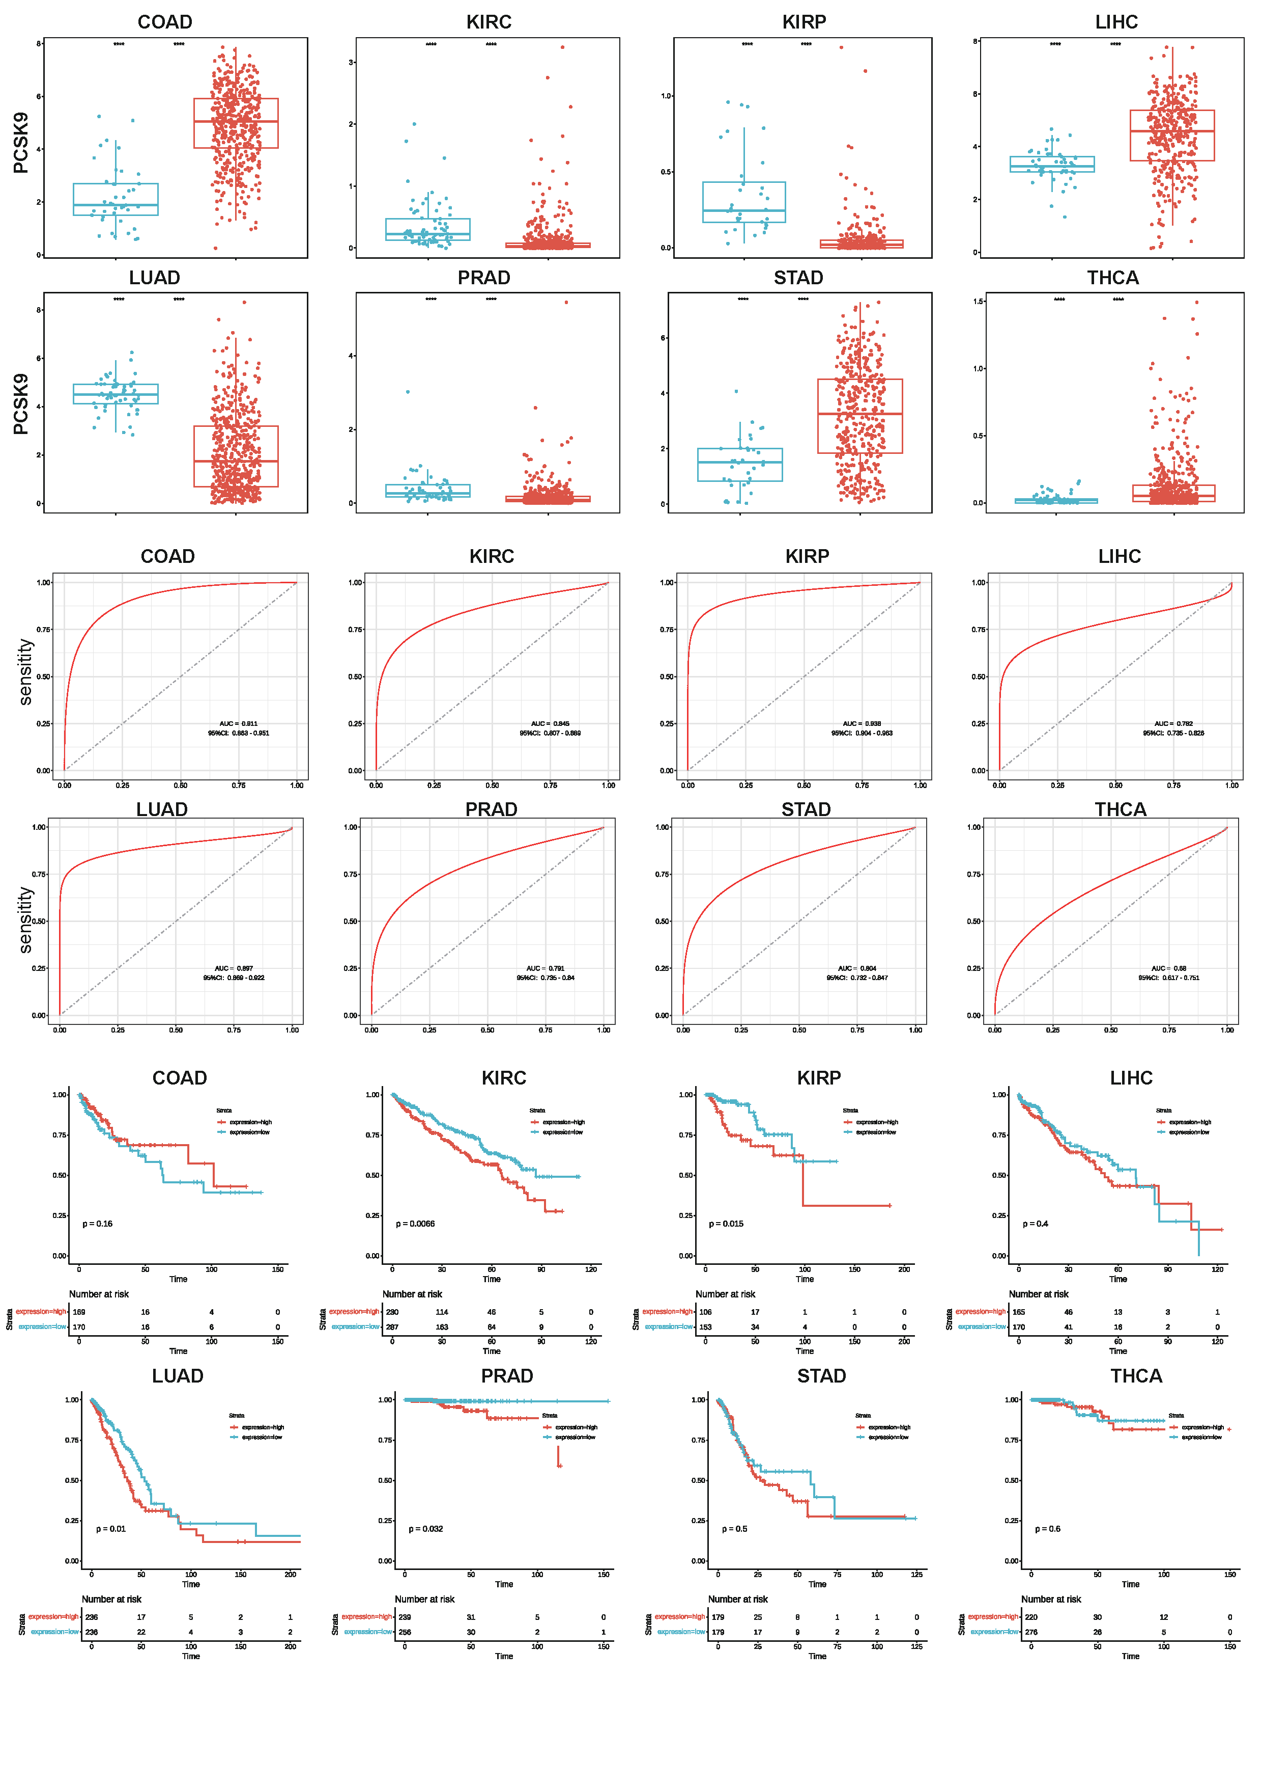
Supplementary Fig. 2 Spatial transcriptomics of hepatocellular carcinoma (HCC) Visium samples from Patient 1 and Patient 2. For each patient, spatial domain/cell-type annotation and in-situ expression of PCSK9 and key single-cell molecules (FGL1, JAG2, CD276, CD68) are shown on Visium array coordinates, together with PCSK9-macrophage co-localization and spatial autocorrelation
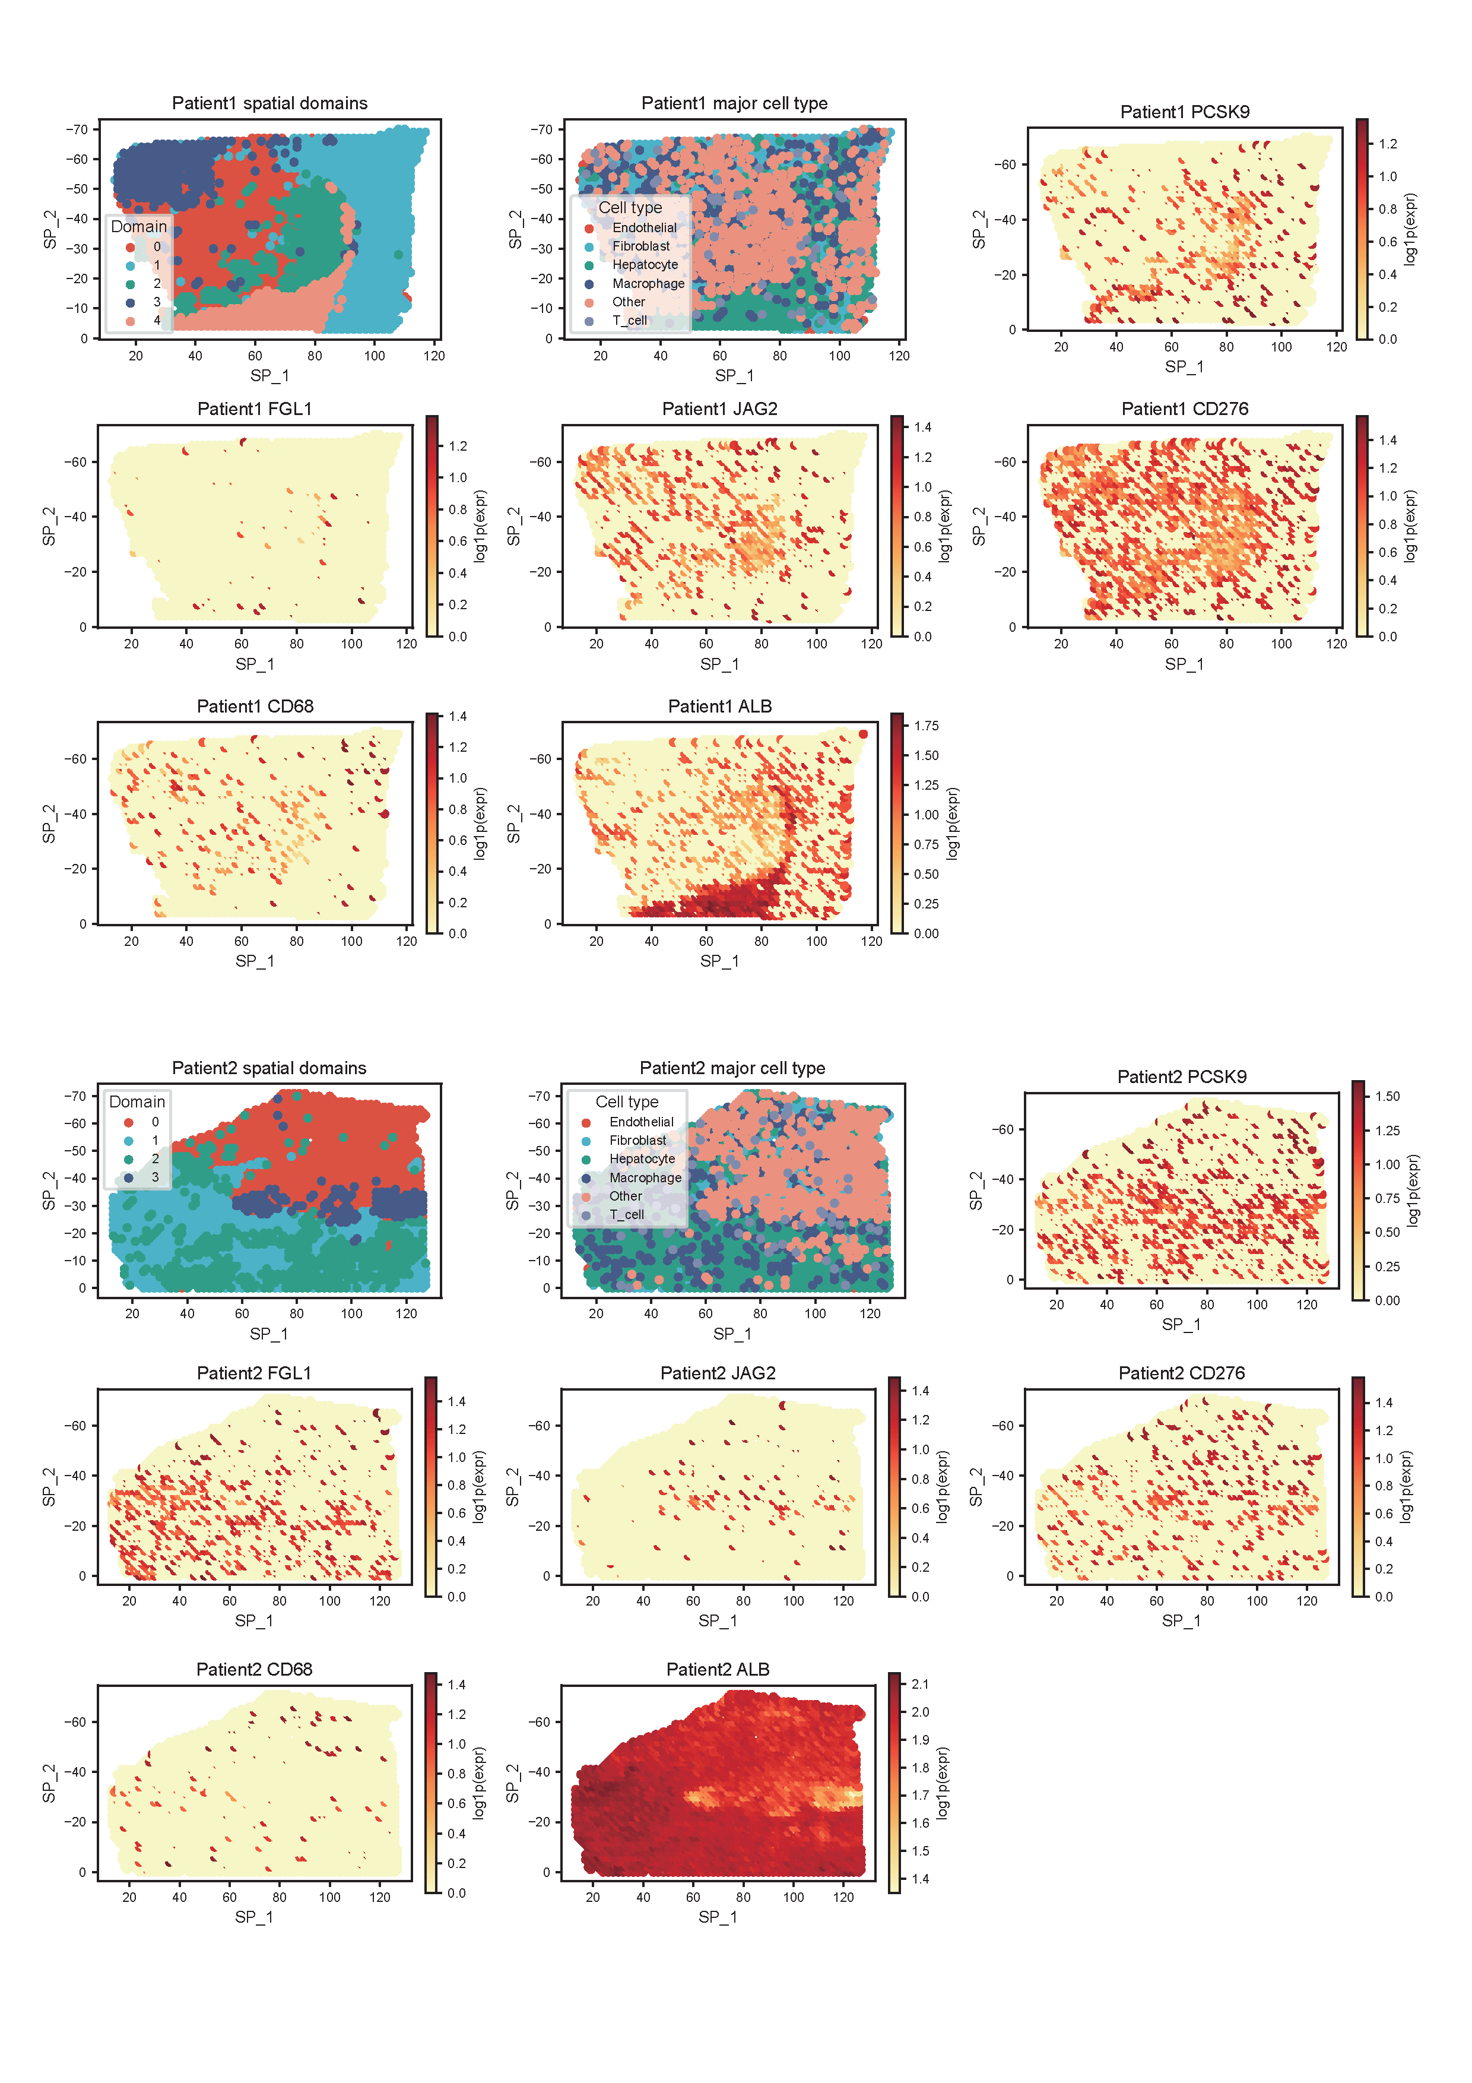
Supplementary Fig. 3 Spatial transcriptomics of the hepatocellular carcinoma (HCC) Visium sample from Patient 3. Spatial domain/cell-type annotation and in-situ expression of PCSK9 and key single-cell molecules (FGL1, JAG2, CD276, CD68) are shown on Visium array coordinates, with PCSK9-macrophage co-localization and spatial autocorrelation (Moran's I)
