Supplementary Materials
EAR-box
WUS-box
HD-box
Fig. S1 Multiple sequence alignment of WUS proteins and identification of key functional motifs. PlWUS, AtWUS, GmWUS, ZmWUS1, and OsWUS denote the WUS protein sequences from Paeonia lactiflora, Arabidopsis thaliana, Glycine max, Zea mays, and Oryza sativa, respectively. Conserved residues are highlighted with a blue background. The three core motifs: the HD-box (DNA-binding domain, pink dashed box, with the conserved core sequence WFQNIKARER), the WUS-box (protein-protein interaction domain, green dashed box), and the EAR-box (transcriptional repression domain, blue dashed box) are indicated. These motifs collectively dictate the transcriptional regulatory activity of WUS in stem cell homeostasis.

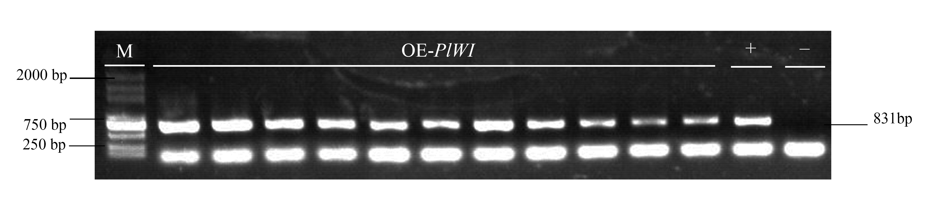
Fig. S2 PCR verification of the PIWUS gene integration in transgenic tobacco. M: DL2000 DNA marker. OE-PIWI: independent transgenic lines overexpressing the PIWUS-IPT fusion gene. +: positive control (plasmid DNA containing the target PlWUS gene). -: negative control (wild-type N. tabacum genomic DNA). The expected 831-bp amplicon confirms the stable genomic integration of the transgene.

Table. S1 The primers used in this work.
Primer name | Sequences
PlWUS-Fw-Spe | ATTACTAGTATGGAAGCTCAACAACCGCAGCAAAAC
PlWUS-Rv-Xho | ATTCTCGAGCTAATTCATTGATCGGCCGGTGTA
ipt-Fw- Xba | ATTTCTAGAATGGATCTGAGGCTCATCTTCGGCCCT
ipt-Rv- Sal | ATTGTCGACCTAGCACATGCCGAATGGTGGGC
Xbal-GRF-FW | ATTTCTAGAATGATGAGGTCGATGTCGCCGTTC
GRF-RV-TY | GCATCAGGTGCTGCTGCATTCCTTGAGGAGATTGAGAAC
GIF-FW-TY | GTTCTCAATCTCCTCAAGGAATGCAGCAGCACCTGATGC
Sal-GIF-RV | ATTGTCGACTTAGTTTCCATCATCATTAGATTTCAG
NtPDS-DT1-BsF | ATATATGGTCTCGATTGAGGCAAGAGATGTCCTAGGGTT
NtPDS-DT1-F0 | TGAGGCAAGAGATGTCCTAGGGTTTTAGAGCTAGAAATAGC
NtPDS-DT2-R0 | AACTCATCATCTTTCCATGCAGCAATCTCTTAGTCGACTCTAC
NtPDS-DT2-BsR | ATTATTGGTCTCGAAACTCATCATCTTTCCATGCAGCAA
U626FW-AscI | TACGGCGCGCCCGACTTGCCTTCCGCACAATACATCA
U629RV- Hind III | TGTTGACCTGCAGGCATGCAAGCTTATTGGTTTATC

