Methods
Study Site
This study was conducted in a wet evergreen forest at Kakachi and Upper Kodayar, located within the Kalakad-Mundanthurai Tiger Reserve (KMTR) in the southern Western Ghats, India (Fig. S1). Kakachi (8°33′N, 77°23′E) lies at an elevation of 1300 m and receives over 3500 mm of rainfall annually, distributed across both the SWM (June–August) and NEM (October–December) monsoon seasons. The mean maximum temperature is 24 °C and the minimum is 16 °C, ranging between 9 and 32 °C (Ganesh et al., 1996; Fig. 1). The vegetation at Kakachi and Upper Kodayar (henceforth Kakachi) is similar, shares 95% of the species, and is classified as a subtype of mid-elevation wet evergreen forest characterized by three dominant tree species: Cullenia exarillata, Palaquium ellipticum, and Aglaia bourdillonii (Ganesh et al., 1996; Pascal et al., 2004). We have recorded approximately 100 tree species from the site (ca. 100 km²), many of which are endemic to the Western Ghats. The relatively undisturbed forests of KMTR, spanning about 400 km², represent some of the last remaining intact wet evergreen forests in India (Ramesh et al., 1997).
Phenology Data Collection
Phenological monitoring of canopy and sub-canopy trees was initiated in the early 1990s to understand tree reproductive patterns in undisturbed and selectively logged forests at Kakachi and Upper Kodayar, respectively. At Kakachi, 729 individuals from 87 tree species were marked and monitored beginning in January 1991. In Upper Kodayar, 268 individuals representing 66 species were observed from April 1995 onward (see Supplementary Table 1 for the full species list). For analyses, we included only species with five or more individuals, resulting in a dataset of 71 species and 864 individuals.
Mature trees (>10 cm DBH) were tagged with aluminum plates bearing unique identification numbers. Trees were marked along forest trails covering 25 km² in the undisturbed Kakachi forest and 6 km² in the selectively logged Upper Kodayar forest, totaling approximately 30 km². Most tree species were identified for the first time in the area; voucher specimens were collected and deposited in the ATREE (Ashoka Trust for Research in Ecology and the Environment) Herbarium, Bangalore.
Phenological observations were conducted monthly by visually estimating the canopy cover (in percentage) of each phenophase—leaf flush, dry leaves, buds, flowers, unripe fruits, and ripe fruits—using 8×40 Olympus binoculars (MODEL, USA). In species where ripening is not accompanied by colour change (e.g., Palaquium ellipticum, Vepris binocularis, Myristica beddomei), fruits were classified as ripe when they had (a) attained full size, and/or (b) were observed being consumed by frugivores. In species with wind dispersal and fruits that dehisce, ripeness was inferred from seed or fruit fall beneath the parent tree, based on field experience (TG has been monitoring seed predation in the area since 1990; TG pers. obs.). Observations were conducted in the first half of each month, typically over 5–7 days. For this study, we focus on flowering and fruiting data collected over 22 years (1991–2012) to evaluate their relationship with local and global climate variables. Initial observations were made consistently by the first author and SD during the first seven years, and subsequently, TA and later AS were trained to ensure continuity, along with three additional observers to collect phenology data between 2000 and 2012. Training ensured broad consistency among observers.
Environmental Data
Local weather data (daily rainfall, maximum and minimum temperature) were obtained from a meteorological station at the Manimuthar tea estate, located 5 km from the study site at the same elevation and habitat. Monthly incoming solar radiation (kWh/m²/day) was obtained from the NASA POWER database, based on satellite data from 1991–2012 at a spatial resolution of 1° × 1° (Stackhouse et al., 2018; NASA, 2020). An oceanic index for ENSO, the Oceanic Niño Index (ONI), is defined as a three-month running mean of ERSST.v5 SST anomalies in the Niño 3.4 region (5°N-5°S, 120°-170°W), is used to describe ENSO variability (https://psl.noaa.gov/data/timeseries/month/). IOD strength was measured using the Dipole Mode Index (DMI), calculated as the difference in sea surface temperature anomalies between the western (10°S–10°N, 50°–70°E) and eastern (10°S–0°, 90°–108°E) tropical Indian Ocean. Positive DMI values indicate warmer waters in the western Indian Ocean and cooler waters in the east, while negative values represent the reverse pattern (Saji et al., 1999). If the mean DMI is above (below) 0.5 ◦C (−0.5 ◦C) for three consecutive months, a pIOD (negative IOD[nIOD]) event is detected (Lu et al. 2022). DMI data were sourced from https://psl.noaa.gov/gcos_wgsp/Timeseries/DMI/.
Statistical Analyses
Generalized additive models (GAMs) with beta regression were fit separately for flowering and fruiting proportions. Optimal lags were identified through systematic testing of lags 0-12 months for each predictor. edf = effective degrees of freedom from GAM penalized regression splines (edf ≈ 1 indicates linear relationship, edf > 1 indicates non-linear); χ² = approximate chi-square statistic testing whether smooth term differs significantly from zero; ΔAIC = improvement in Akaike Information Criterion relative to seasonal-only model (positive values indicate better fit); Dev. Expl. = deviance explained (%); Adj. R² = adjusted R-squared; — indicates predictor not significant at any lag tested (p > 0.05) or excluded from optimal model. All models include s(time, k=15) to control for long-term trends.
To evaluate lagged relationships between climate variables and phenological patterns, we did a wavelet coherence analysis and examined phase relationships between phenological and climatic variables using the phase‐angle information provided by wavelet coherence analysis (Detto et al 2018). In the cross‐wavelet plots, phase differences are represented by arrows: rightward arrows indicate in‐phase relationships (0°), leftward arrows indicate anti‐phase (180°), upward arrows indicate that the climatic variable leads the phenological variable by 90°, and downward arrows indicate the reverse. Intermediate arrow orientations correspond to intermediate phase lags. Phase angles (θ) were converted to time lags using the relation:
time lag=θ/360∘×period where period is the oscillation timescale (e.g. 1 year for annual cycles). For example, a phase difference of 30–60° corresponds to a lag of approximately 1–2 months at the annual scale, with the climatic variable leading the phenological response. Phase interpretation was restricted to regions within the Cone of Influence, a region that delineates the wavelet spectrum, separating the accurately computed wavelet coefficients from those that are inaccurate due to the wavelet extending beyond the ends of the signal and is enclosed by the 5% significance contour. All Wavelet analysis was done using the package biwavelet ver 0.14 in R 4.5.1

Band-pass filtering of climatic and teleconnection time series
To examine the interannual component of climatic variability and its association with large-scale climate modes, the monthly time series of flowering, fruiting, local climatic variables (maximum and minimum temperature, rainfall and insolation), ENSO (ONI) and IOD were decomposed using a band-pass filter. Prior to filtering, each series was standardized to zero mean and unit variance to place variables measured on different scales on a common basis. The filter was applied to the standardized monthly series to retain variability within the predefined interannual frequency band while removing higher-frequency seasonal fluctuations and lower-frequency trends. The resulting filtered series therefore represented the common low-frequency variability attributable to interannual climatic oscillations.
The filtered ENSO and IOD series were then compared with the corresponding filtered local climatic variables to examine temporal concordance in their interannual variability. The same procedure was applied to the phenological series to evaluate whether changes in the low-frequency climatic signal were accompanied by corresponding changes in flowering and fruiting. Filtered series were plotted together as normalized anomalies, allowing the timing and relative magnitude of peaks and troughs to be compared across variables. Periods of simultaneous excursions in the teleconnection and local climate series were examined, with particular attention to years characterized by concurrent ENSO and IOD anomalies, including the 1997–1998 event.
Because band-pass filtering isolates variability within a specified frequency range rather than testing instantaneous relationships, the filtered series were interpreted as evidence of temporal co-variation at interannual scales, rather than as evidence of direct causation. This analysis complemented the GAMs, which quantified lagged associations between climatic predictors and phenology, and the wavelet coherence analysis, which identified time-varying associations across multiple temporal scales.
All statistical tests were conducted at the α = 0.05 significance level, with marginal significance noted at α = 0.10. Analyses were performed using Python (v3.x) with the SciPy statistical library.

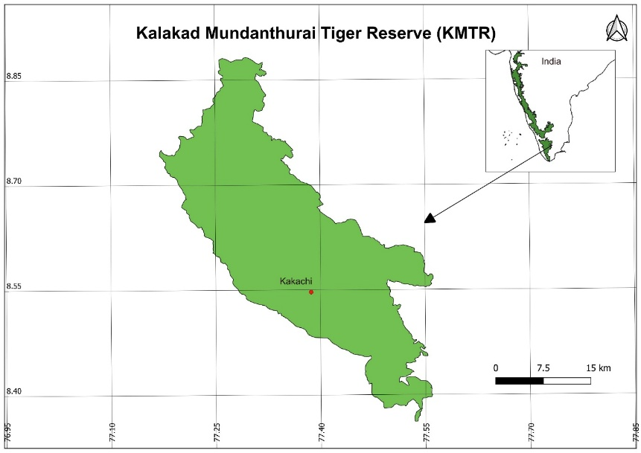

Fig S1. Map of the study area, Kakachi, showing its location in the Kalakad Mundanthurai Tiger reserve, southern Western Ghats, India.
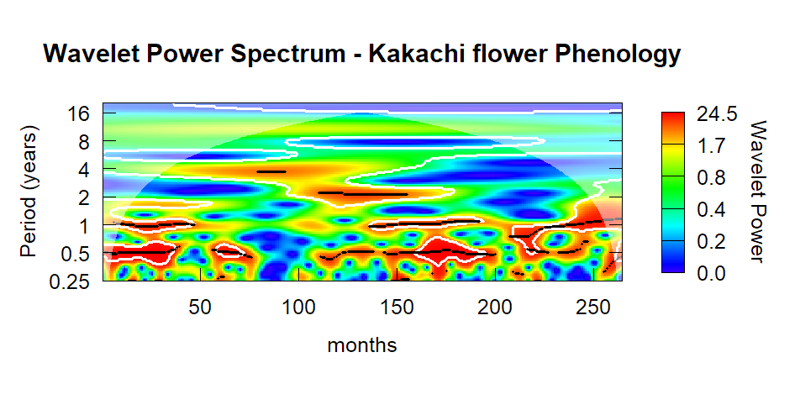
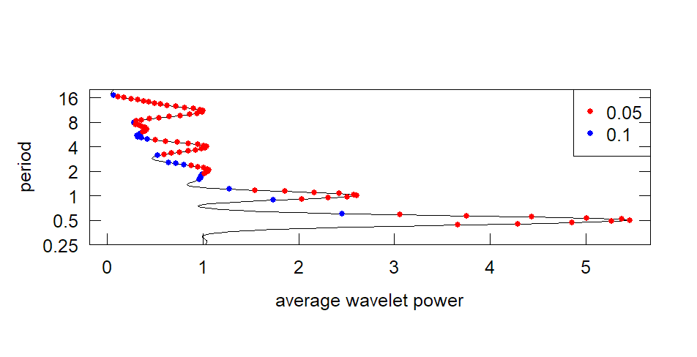
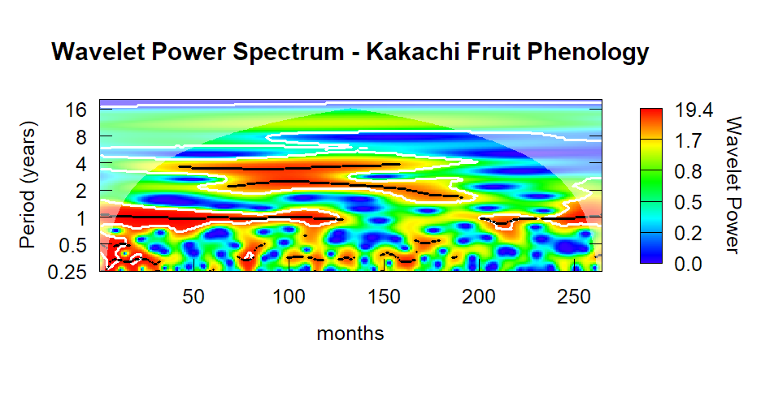
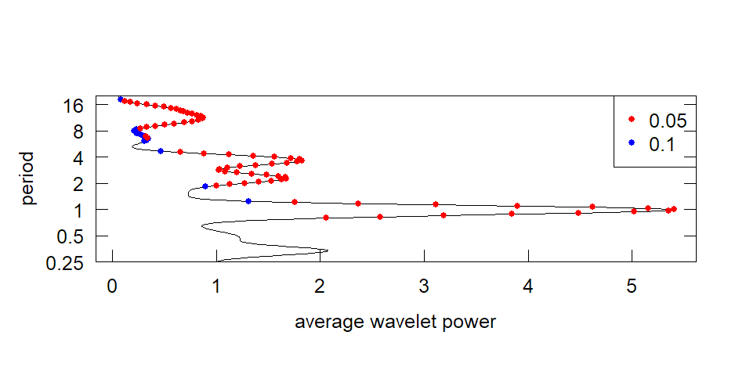
Fig. S2. Wavelet power spectra of community-level flowering and fruiting at Kakachi, 1991–2012. Panels above show the global wavelet power spectrum (averaged across the full time series) for (top flowering and (bottom) fruiting, with periodicity (months/years) on the y-axis and power on the x-axis. Dashed lines indicate the 95% significance threshold against a red-noise background spectrum. Flowering shows a dominant, statistically significant peak at 6–7-month periodicity; fruiting shows a dominant peak at 12-month (annual) periodicity, with no comparable sub-annual signal.

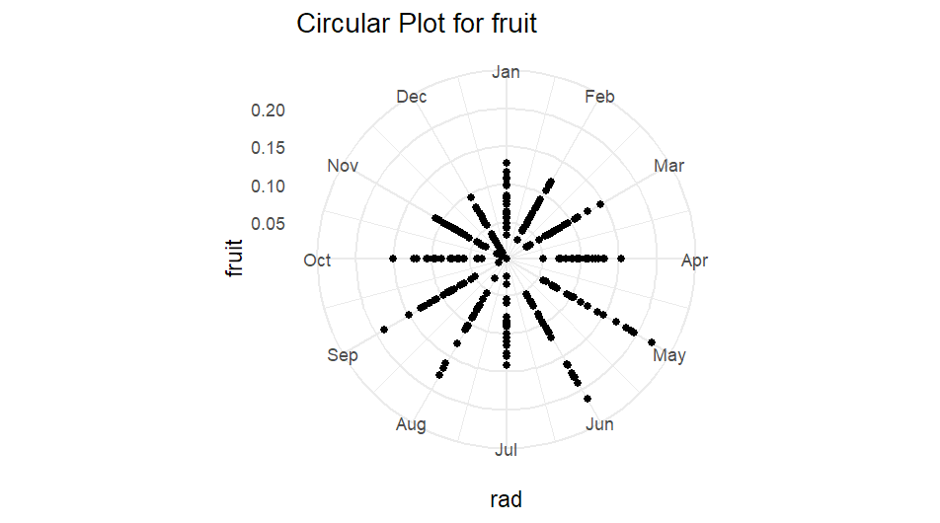
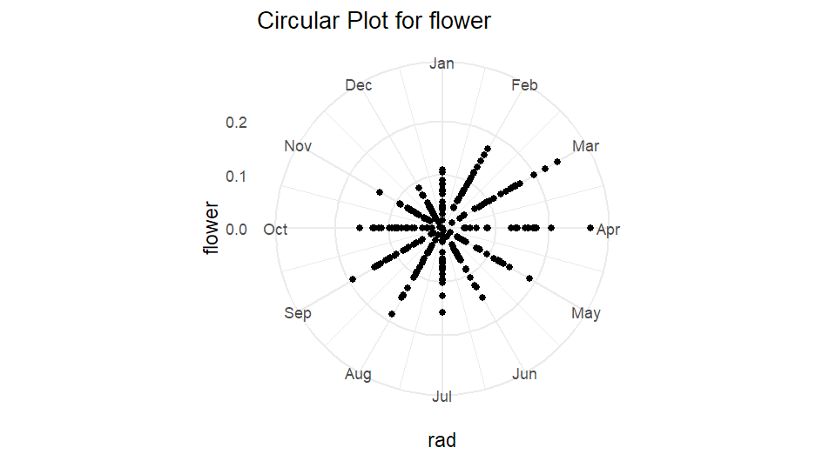
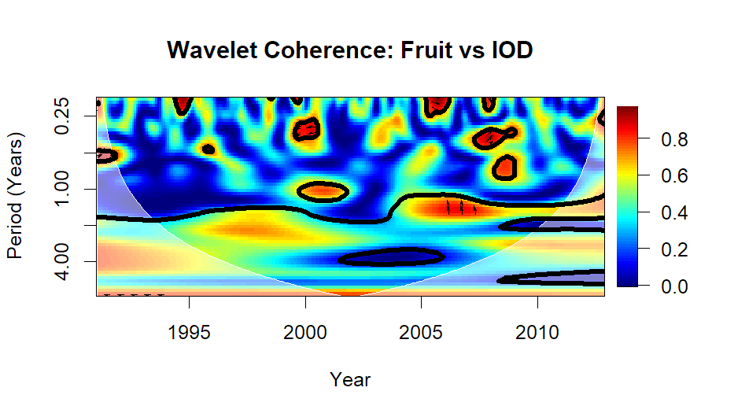
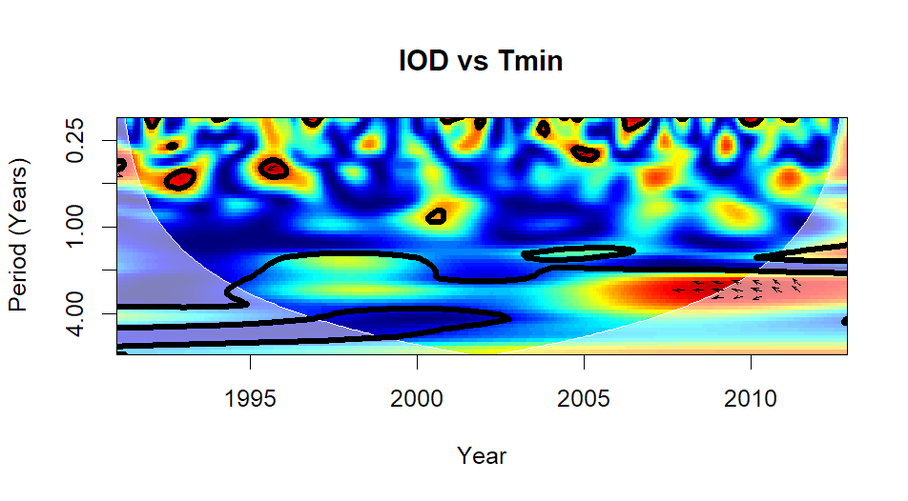
Fig S3. Wavelet coherence between ENSO, IOD, and regional climatic drivers. Warmer colours denote stronger coherence, with significant regions outlined in black and the cone of influence shaded darker.

Table S2. Nested GAM model comparison for community-level flowering and fruiting. All models fitted with beta regression (REML) and include cyclic month and year-trend smooths. S = seasonal climate (insolation, maximum temperature, minimum temperature, rainfall, each at the lag maximising explained deviance). ΔAIC is relative to the S seasonal baseline within each phenophase. ★ = best-supported model (lowest AIC). Dev. expl. = deviance explained (%).
Model | AIC | ΔAIC | Dev. expl. (%) | Adj. R²
—— Flowering ——
S (seasonal baseline) | -972.2 | 0.0 | 45.3 | 0.430
S + IOD ★ best | -981.0 | -8.8 | 48.9 | 0.462
S + ENSO + IOD | -978.1 | -5.9 | 49.4 | 0.463
IOD + ENSO (teleconnections only) | -974.0 | -1.8 | 46.1 | 0.446
S + ENSO | -972.5 | -0.3 | 46.8 | 0.444
—— Fruiting ——
S (seasonal baseline) | -1037.3 | 0.0 | 44.9 | 0.403
S + ENSO + IOD ★ best | -1089.6 | -52.3 | 58.7 | 0.501
ENSO + IOD (teleconnections only) | -1084.3 | -47.0 | 54.9 | 0.462
S + IOD | -1077.9 | -40.6 | 55.5 | 0.462
S + ENSO | -1077.2 | -39.9 | 54.6 | 0.485

Table S2. Species observed for phenology with their broad flowering and fruiting periods in the wet evergreen forests of southern Western Ghats, India.
Species | Family | Habitat | flowering period | fruiting period
Acronychia pedunculata | Rutaceae | Gap | early | both
Actinodaphane bourdillonii | Lauraceae | Gap | late | fruit in second dry season
Actinodaphane campanulata | Lauraceae | closed forest | early | fruit later in the same dry season
Aglaia bourdillonii | Meliaceae | closed forest | early | fruit second year late in 1st dry season
Aglaia tamilnadensis | Meliaceae | closed forest | early | fruit in the second dry season
Agrostistachys borneensis | Euphorbiaceae | closed forest | early | fruit second year early 1st dry season
Antidesma menasu | Euphorbiaceae | Gap | late | fruit second year early 1st dry season
Artocarpus heterophyllus | Moraceae | closed forest | continious | first dry season
Beilschmiedia wightii | Lauraceae | Gap | late | fruit in second dry season
Calophyllum austroindicum | Clusiaceae | closed forest | early | fruit second year late in 1st dry season
Canarium strictum | Burseraceae | Gap | early | fruit in second dry season
Canthium dicoccum | Rubiaceae | Gap | second | first dry season
Casearia ovata | Flacourtiaceae | closed forest | late | fruit in second dry season
Cinnamomum malabaricum | Lauraceae | closed forest | early | fruit in second dry season
Cinnamomum filipedicellatum | Lauraceae | closed forest | early | fruit later in the same dry season
Clerodendrum infortunatum | Verbenaceae | Gap | continious | both
Croton laccifer | Euphorbiaceae | Gap | second | second
Cryptocarya lawsonii | Lauraceae | Gap | second | first dry season
Cullenia exarillata | Bombacaceae | closed forest | early | fruit second year late in 1st dry season
Daphniphyllum | Daphniphyllaceae | Gap | early | fruit later in the same dry season
Dimocarpus | Sapindaceae | closed forest | late | fruit in second dry season
Diospyros malabarica-female | Ebenaceae | closed forest | early | fruit in second dry season
Diospyros buxifolia | Ebenaceae | closed forest | late | fruit second year early 1st dry season
Drypetes longifolia | Euphorbiaceae | closed forest | early | fruit second year late in 1st dry season
Elaeocarpus vensutus | Elaeocarpaceae | Gap | second | second
Elaeocarpus tuberculatus | Elaeocarpaceae | closed forest | late | fruit second year early 1st dry season
Elaeocarpus munronii | Elaeocarpaceae | Gap | second | second
Elaeocarpus serratus | Elaeocarpaceae | Gap | continious | continious
Epiprinus mallotiformis | Euphorbiaceae | closed forest | early | fruit later in the same dry season
Eugenia thwaitesii | Myrtaceae | closed forest | early | fruit later in the same dry season
Excocaria robusta | Euphorbiaceae | closed forest | second | second
Ficus microcarpa | Moraceae | Gap | early | fruit later in the same dry season
Garcinia rubra | Clusiaceae | closed forest | late | second
Glochidion fagifolium | Euphorbiaceae | closed forest | both | both
Gomphandra coriacea | Icacinaceae | closed forest | continious | first dry season
Goniothalamus wightii | Annonaceae | closed forest | late | second
Gordonia obtusa | Theaceae | Gap | early and late | both
Helicia travancorica | Proteaceae | Gap | late | fruit in second dry season
Heritiera papilio | Sterculiaceae | closed forest | early | fruit second year early 1st dry season
Holigarna nigra | Anacardiaceae | closed forest | early | fruit later in the same dry season
Hydnocarpus alpina | Flacourtiaceae | closed forest | early | fruit second year early 1st dry season
Isonandra lanceolata | Sapotaceae | closed forest | early | fruit later in the same dry season
Litsea glabrata | Lauraceae | Gap | second | second
Litsea insignis | Lauraceae | Gap | second | second
Litsea wightiana | Lauraceae | Gap | second | second
litsea mysornenis | Lauraceae | closed forest | second | second
Macaranga peltata | Euphorbiaceae | Gap | early | second
Mallotus tetracoccus | Euphorbiaceae | Gap | late | second
Mastixia arborea | Cornaceae | Gap | early | fruit in second dry season
Miliusa wightiana | Annonaceae | closed forest | continious | continious
Myristica beddomei | Myristicaceae | closed forest | early | fruit second year late in 1st dry season
Neolitsea cassia | Lauraceae | Gap | late | fruit in second dry season
Neolitsea fischeri | Lauraceae | closed forest | second | second
Nothopegia travancorica | Anacardiaceae | closed forest | late | fruit in second dry season
Nothopodytes nimmoniana | Icacinaceae | Gap | second | second
Octotropis travancorica | Rubiaceae | Gap | early | fruit later in the same dry season
Ormosia travancorica | Fabaceae | closed forest | early | fruit second year late in 1st dry season
Palaquium ellipticum | Sapotaceae | closed forest | late | fruit second year late in 1st dry season
Persea macrantha | Lauraceae | Gap | early | fruit later in the same dry season
Phoebe lanceolata | Lauraceae | Gap | early | fruit in second dry season
Nageia wallichiana | Podocarpaceae | closed forest | late | fruit second year early 1st dry season
Prunus ceylanica | Rosacaea | Gap | late | second
Rapanea wightiana | Myrsinaceae | Gap | early | fruit later in the same dry season
Scolopia crenata | Flacourtiaceae | Gap | late | fruit in second dry season
Syzygium sp | Myrtaceae | Gap | continious | continious
Syzygium montana | Myrtaceae | Gap | late | fruit in second dry season
Syzygium mundagam | Myrtaceae | closed forest | second | second
Tricalysia apiocarpa | Rubiaceae | closed forest | early | fruit in second dry season
Trichilia connoroides | Meliaceae | Gap | late | fruit in second dry season
Vepris bilocularis | Rutaceae | closed forest | early | fruit in second dry season
Viburnum punctatum | Caprifoliaceae | Gap | continious | continious

