Design, synthesis and antidiabetic biological evaluation of coumarin nitrogen-containing heterocycles derivatives via inhibition of TXNIP
Wanzhen Su^{*1}, Shengjie Zhang^{*2, 3}, Zhihong Ou¹, Pengfei Song⁴, Zhu Mi¹, Wenxia Han⁵, Kangfei Sun⁶, Yanan Li², Yang Yang², Libin Yang², Weize Li², Aiyun Li^{#1}, Li Guan^{#2}, Xiangying Jiao^{#1}
¹Key Laboratory of Cellular Physiology, Ministry of Education; Shanxi Key Laboratory of Aging-related Diseases Mechanisms and Translation; and the Department of Physiology, Shanxi Medical University, Taiyuan 030001, China
²College of pharmacy, Xi’an Medical University, Xi’an 710021, China
³School of Pharmaceutical Engineering, Shenyang Pharmaceutical University, Shenyang 110016, China
⁴Guangdong Provincial Key Laboratory of New Drug Screening, NMPA Key Laboratory for Research and Evaluation of Drug Metabolism, School of Pharmaceutical Sciences, Southern Medical University, Guangzhou 510515, China
⁵School of Health Services Management, Xi’an Medical University, Xi’an 710021, China
⁶School of Basic Medical Sciences, Shanxi Medical University, Taiyuan 030001, China
# Corresponding author.
E-mail address: jiaoxy@sxmu.edu.cn (X. Jiao), guanli@xiyi.edu.cn (L. Guan). laycpu0926@126.com (A. Li).
* These authors contributed equally to this work.

Fig S1 the ¹H-NMR spectrum of compound G2 (400MHz,CDCl₃)
Fig S2 the ¹H-NMR spectrum of compound G3 (400MHz,CDCl₃)
Fig S3 the ¹H-NMR spectrum of compound G4 (400MHz,CDCl₃)
Fig S4 the ¹H-NMR spectrum of compound G5 (400MHz,CDCl₃)
Fig S5 the ¹H-NMR spectrum of compound ZZ-1 (400MHz,CDCl₃)
Fig S6 the ¹H-NMR spectrum of compound ZZ-2 (400MHz,CDCl₃)
Fig S7 the ¹H-NMR spectrum of compound ZZ-3 (400MHz,CDCl₃)
Fig S8 the ¹H-NMR spectrum of compound ZZ-4 (400MHz,CDCl₃)
Fig S9 the ¹H-NMR spectrum of compound ZZ-5 (400MHz,CDCl₃)
Fig S10 the ¹H-NMR spectrum of compound ZZ-6 (400MHz,CDCl₃)
Fig S11 the ¹H-NMR spectrum of compound ZZ-7 (400MHz,CDCl₃)
Fig S12 the ¹H-NMR spectrum of compound ZZ-8 (400MHz,CDCl₃)
Fig S13 the ¹H-NMR spectrum of compound ZZ-9 (400MHz,CDCl₃)
Fig S14 the ¹H-NMR spectrum of compound ZZ-10 (400MHz,CDCl₃)
Fig S15 the ¹H-NMR spectrum of compound ZZ-11 (400MHz,CDCl₃)
Fig S16 the ¹H-NMR spectrum of compound ZZ-12 (400MHz,CDCl₃)
Fig S17 the ¹H-NMR spectrum of compound ZZ-13 (400MHz,CDCl₃)
Fig S18 the ¹H-NMR spectrum of compound ZZ-14 (400MHz,CDCl₃)
Fig S19 the ¹H-NMR spectrum of compound ZZ-15 (400MHz,CDCl₃)
Fig S20 the ¹H-NMR spectrum of compound ZZ-16 (400MHz,CDCl₃)
Fig S21 the ESI-MS spectrum of compound G2
Fig S22 the ESI-MS spectrum of compound G3
Fig S23 the ESI-MS spectrum of compound G4
Fig S24 the ESI-MS spectrum of compound G5
Fig S25 the ESI-MS spectrum of compound ZZ-1
Fig S26 the ESI-MS spectrum of compound ZZ-2
Fig S27 the ESI-MS spectrum of compound ZZ-3
Fig S28 the ESI-MS spectrum of compound ZZ-4
Fig S29 the ESI-MS spectrum of compound ZZ-5
Fig S30 the ESI-MS spectrum of compound ZZ-6
Fig S31 the ESI-MS spectrum of compound ZZ-7
Fig S32 the ESI-MS spectrum of compound ZZ-8
Fig S33 the ESI-MS spectrum of compound ZZ-9
Fig S34 the ESI-MS spectrum of compound ZZ-10
Fig S35 the ESI-MS spectrum of compound ZZ-11
Fig S36 the ESI-MS spectrum of compound ZZ-12
Fig S37 the ESI-MS spectrum of compound ZZ-13
Fig S38 the ESI-MS spectrum of compound ZZ-14
Fig S39 the ESI-MS spectrum of compound ZZ-15
Fig S40 the ESI-MS spectrum of compound ZZ-16
Fig S41 the ¹³C-NMR spectrum of compound ZZ-1 (100MHz, CDCl₃)
Fig S42 the ¹³C-NMR spectrum of compound ZZ-2 (100MHz, CDCl₃)
Fig S43 the ¹³C-NMR spectrum of compound ZZ-3 (100MHz, CDCl₃)
Fig S44 the ¹³C-NMR spectrum of compound ZZ-4 (100MHz, CDCl₃)
Fig S45 the ¹³C-NMR spectrum of compound ZZ-5 (100MHz, CDCl₃)
Fig S46 the ¹³C-NMR spectrum of compound ZZ-6 (100MHz, CDCl₃)
Fig S47 the ¹³C-NMR spectrum of compound ZZ-7 (100MHz, CDCl₃)
Fig S48 the ¹³C-NMR spectrum of compound ZZ-8 (100MHz, CDCl₃)
Fig S49 the ¹³C-NMR spectrum of compound ZZ-9 (100MHz, CDCl₃)
Fig S50 the ¹³C-NMR spectrum of compound ZZ-10 (100MHz, CDCl₃)
Fig S51 the ¹³C-NMR spectrum of compound ZZ-11 (100MHz, CDCl₃)
Fig S52 the ¹³C-NMR spectrum of compound ZZ-12 (100MHz, CDCl₃)
Fig S53 the ¹³C-NMR spectrum of compound ZZ-13 (100MHz, CDCl₃)
Fig S54 the ¹³C-NMR spectrum of compound ZZ-14 (100MHz, CDCl₃)
Fig S55 the ¹³C-NMR spectrum of compound ZZ-15 (100MHz, CDCl₃)
Fig S56 the 13C-NMR spectrum of compound ZZ-16 (100MHz, CDCl3)
Fig S57 the HPLC spectrum of compound ZZ-1
Fig S58 the HPLC spectrum of compound ZZ-2
Fig S59 the HPLC spectrum of compound ZZ-3
Fig S60 the HPLC spectrum of compound ZZ-4
Fig S61 the HPLC spectrum of compound ZZ-5
Fig S62 the HPLC spectrum of compound ZZ-6
Fig S63 the HPLC spectrum of compound ZZ-7
Fig S64 the HPLC spectrum of compound ZZ-8
Fig S65 the HPLC spectrum of compound ZZ-9
Fig S66 the HPLC spectrum of compound ZZ-10
Fig S67 the HPLC spectrum of compound ZZ-11
Fig S68 the HPLC spectrum of compound ZZ-12
Fig S69 the HPLC spectrum of compound ZZ-13
Fig S70 the HPLC spectrum of compound ZZ-14
Fig S71 the HPLC spectrum of compound ZZ-15
Fig S72 the HPLC spectrum of compound ZZ-16

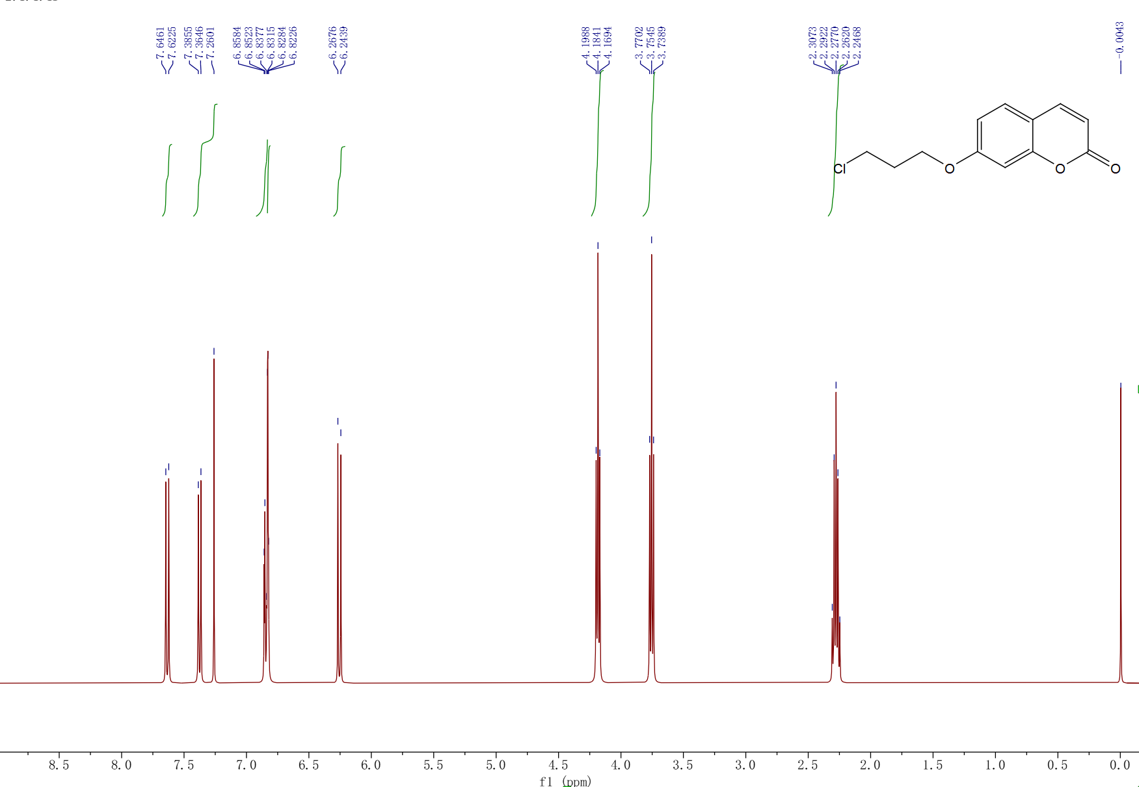

Fig S1 the ¹H-NMR spectrum of compound G2 (400 MHz,CDCl₃)
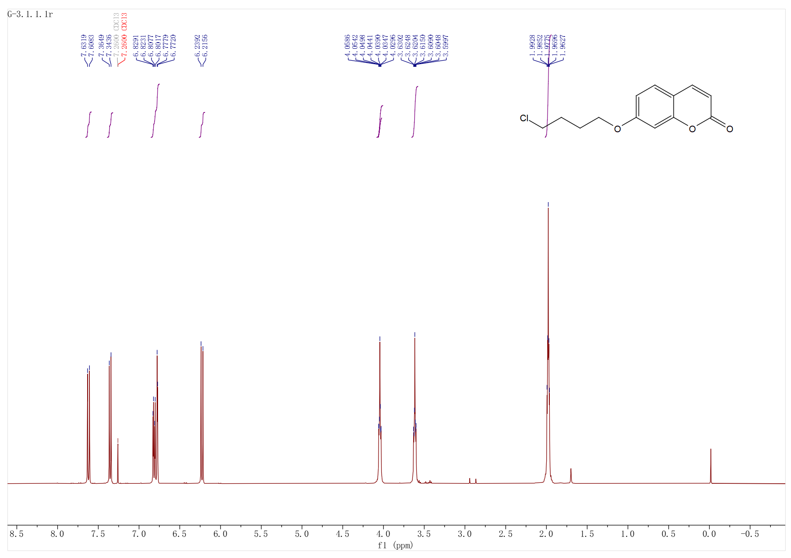

Fig S2 the ¹H-NMR spectrum of compound G3 (400 MHz,CDCl₃)
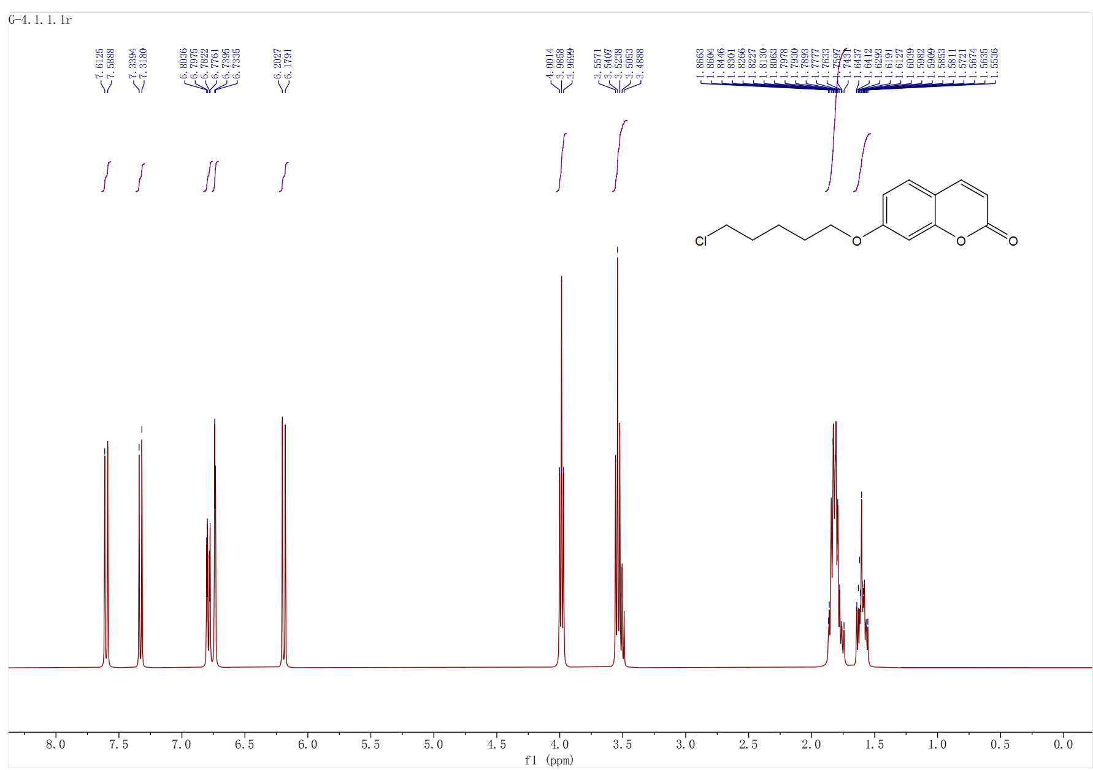

Fig S3 the ¹H-NMR spectrum of compound G4 (400 MHz,CDCl₃)

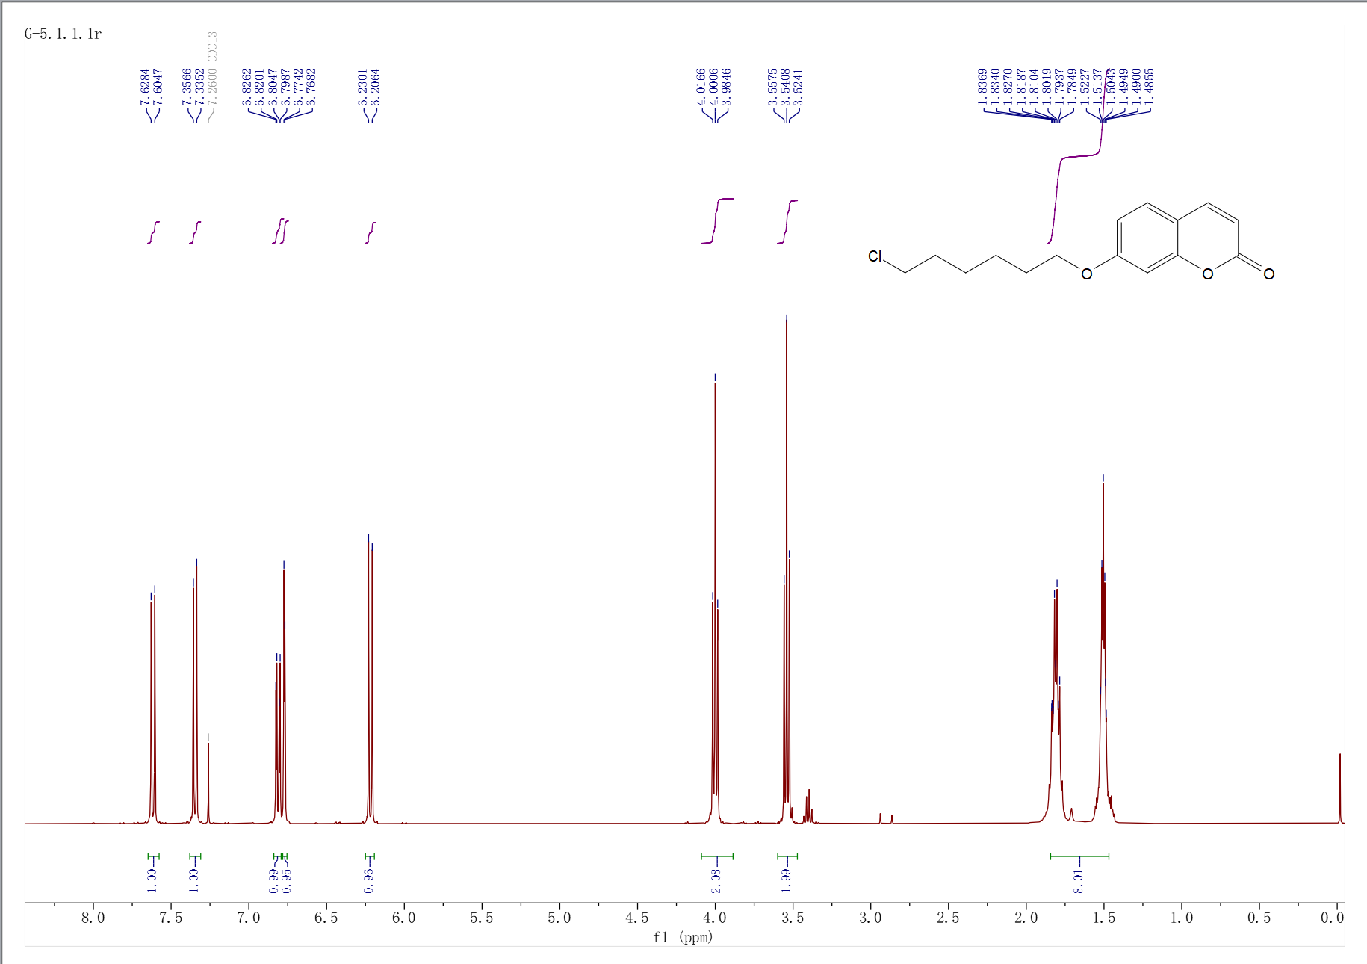

Fig S4 the ¹H-NMR spectrum of compound G5 (400 MHz,CDCl₃)

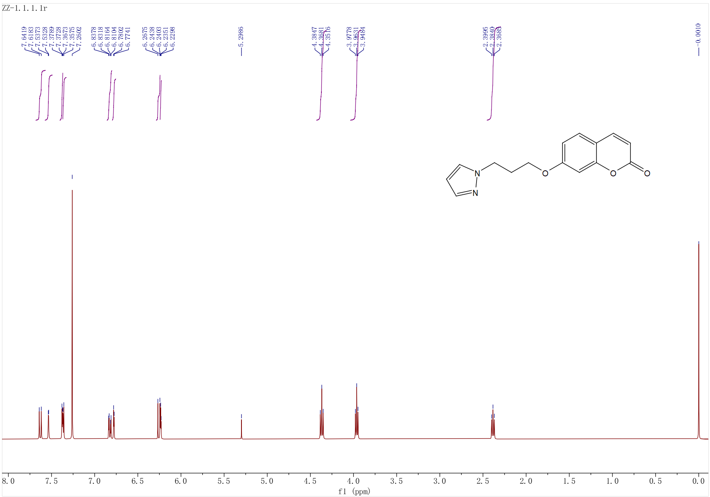

Fig S5 the ¹H-NMR spectrum of compound ZZ-1 (400 MHz,CDCl₃)

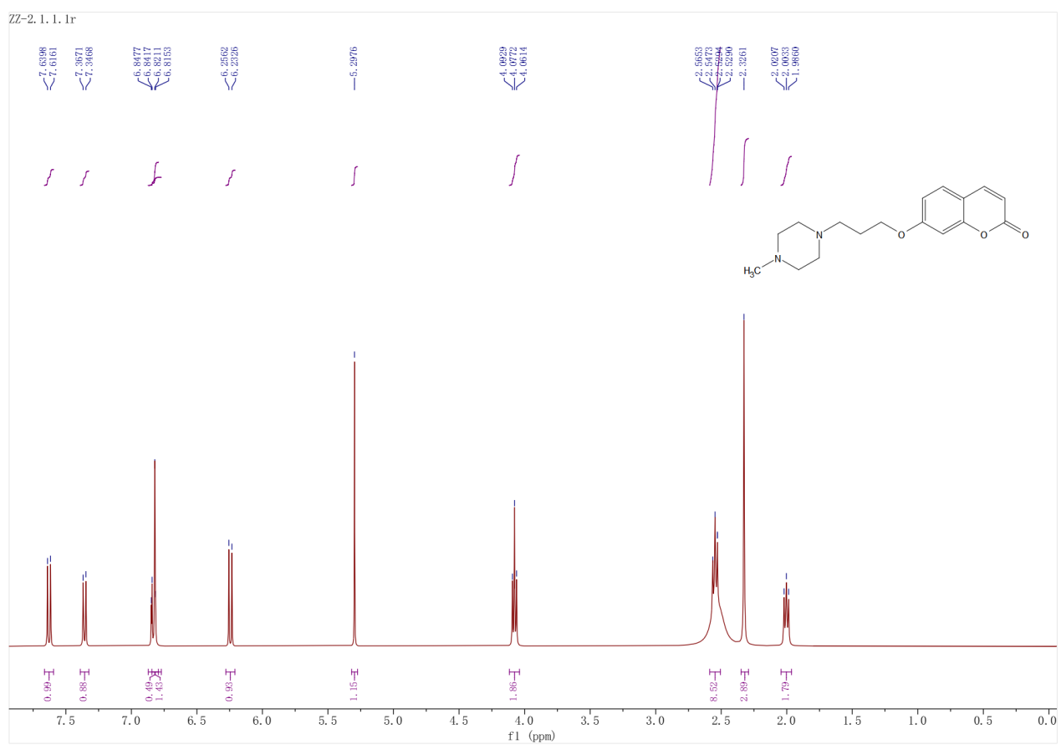

Fig S6 the ¹H-NMR spectrum of compound ZZ-2 (400 MHz,CDCl₃)
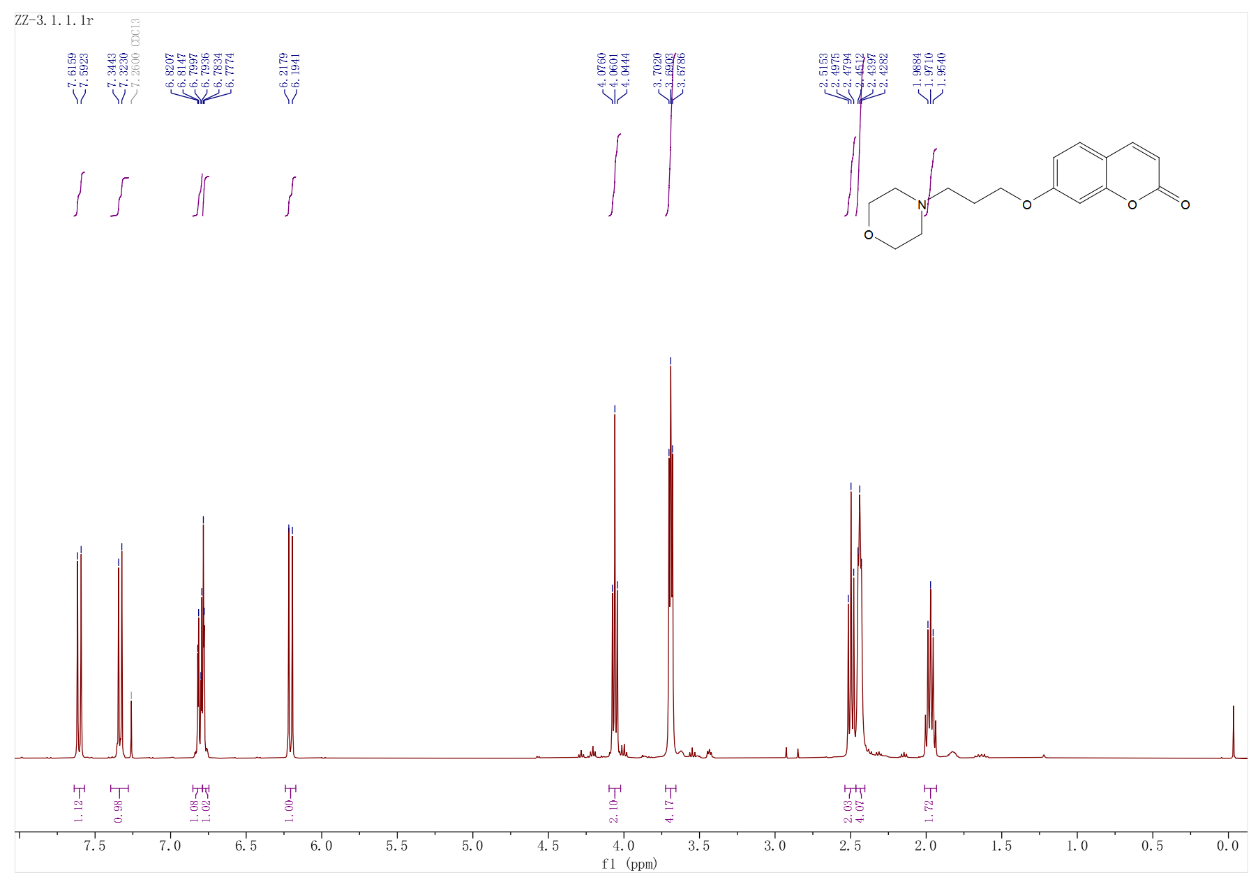

Fig S7 the ¹H-NMR spectrum of compound ZZ-3 (400 MHz,CDCl₃)

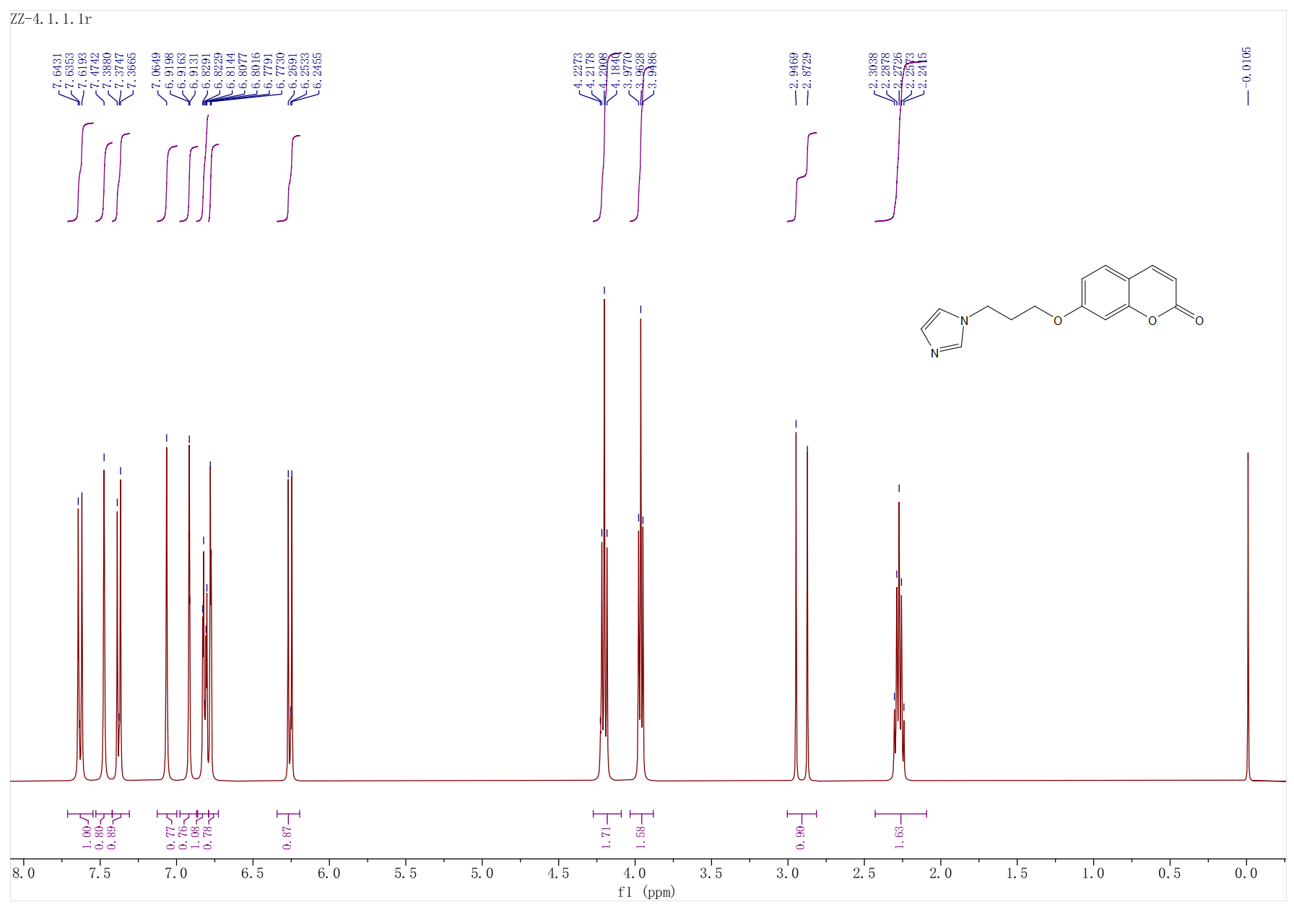

Fig S8 the ¹H-NMR spectrum of compound ZZ-4 (400 MHz,CDCl₃)
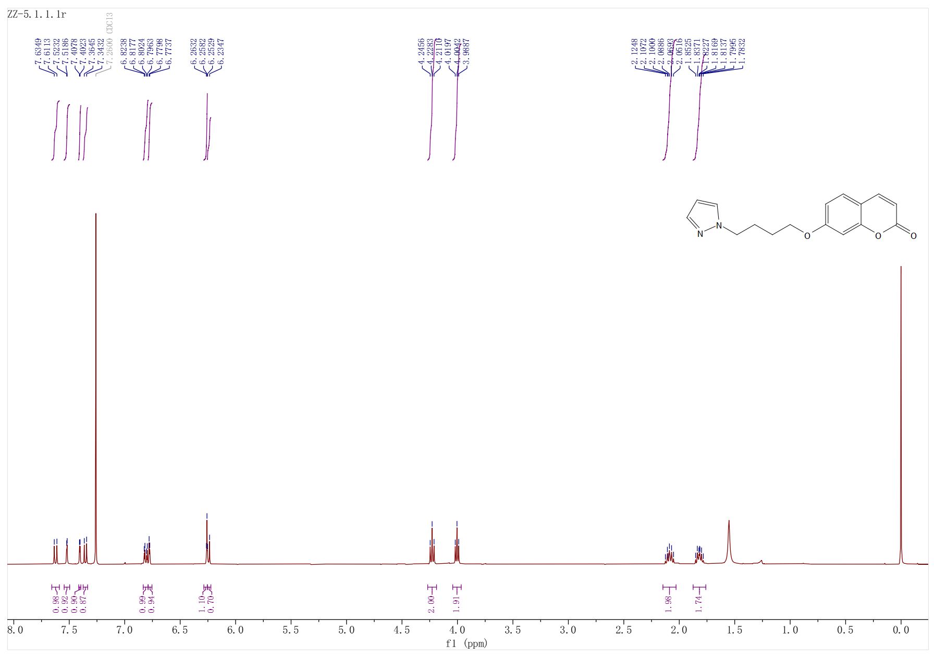

Fig S9 the ¹H-NMR spectrum of compound ZZ-5 (400 MHz,CDCl₃)
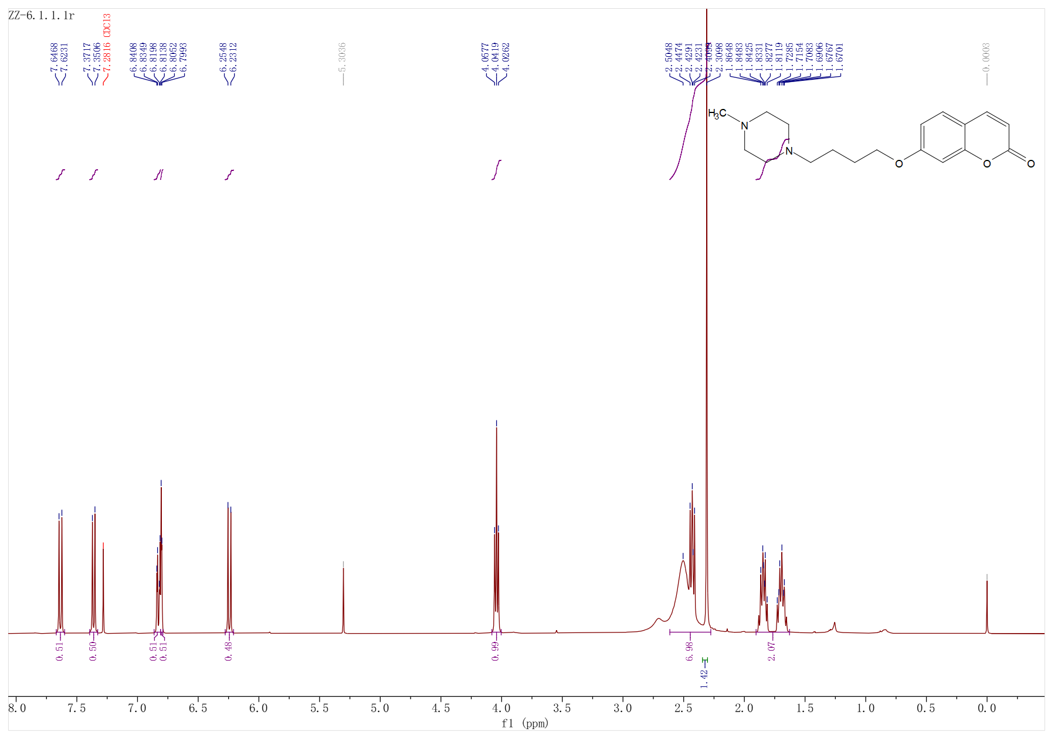
Fig S10 the ¹H-NMR spectrum of compound ZZ-6 (400 MHz,CDCl₃)

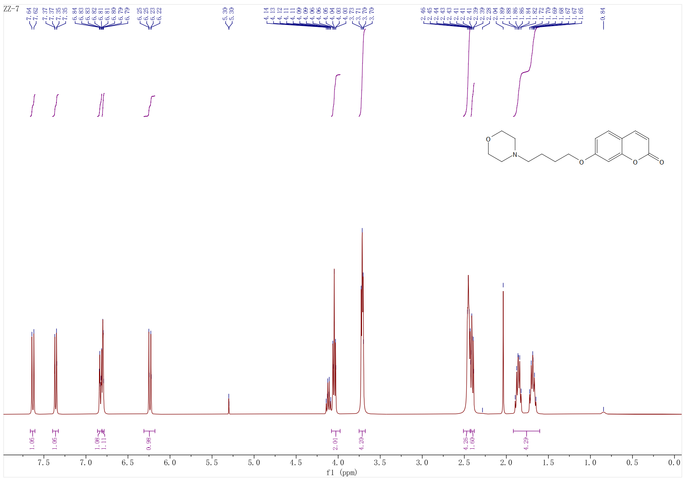

Fig S11 the ¹H-NMR spectrum of compound ZZ-7 (400 MHz,CDCl₃)
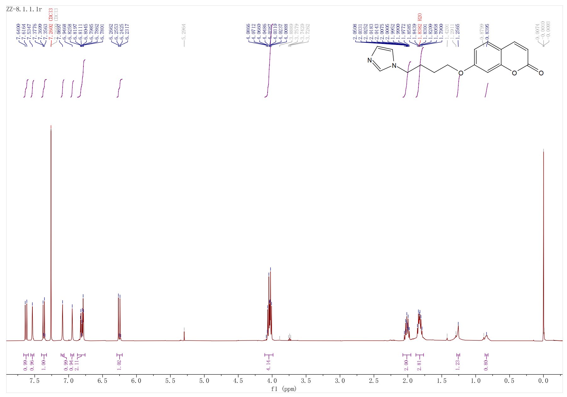

Fig S12 the ¹H-NMR spectrum of compound ZZ-8 (400 MHz,CDCl₃)

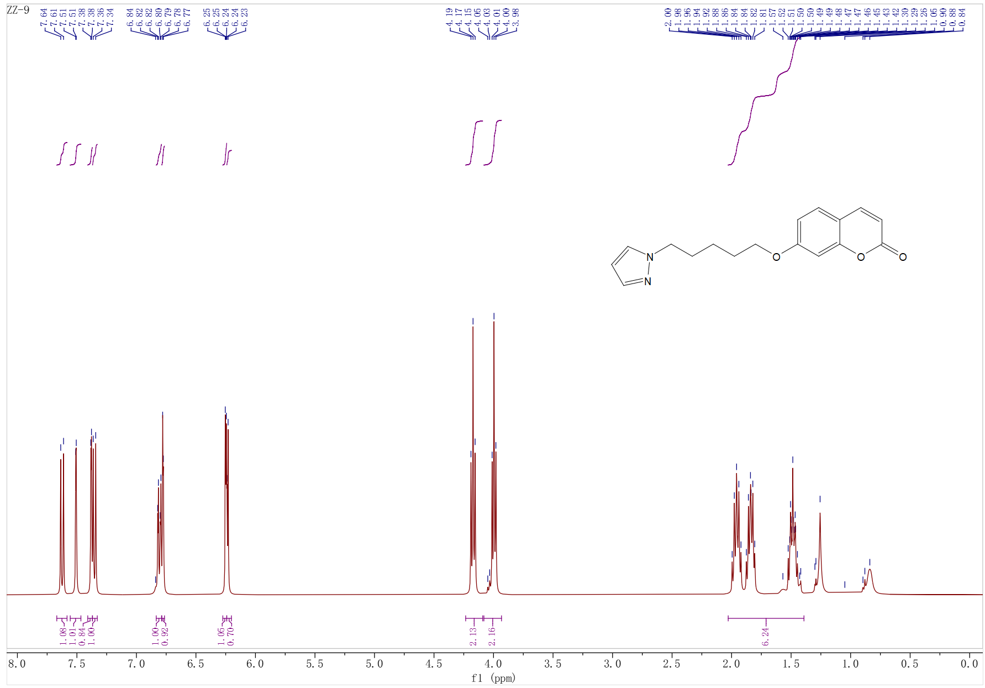

Fig S13 the ¹H-NMR spectrum of compound ZZ-9 (400 MHz,CDCl₃)
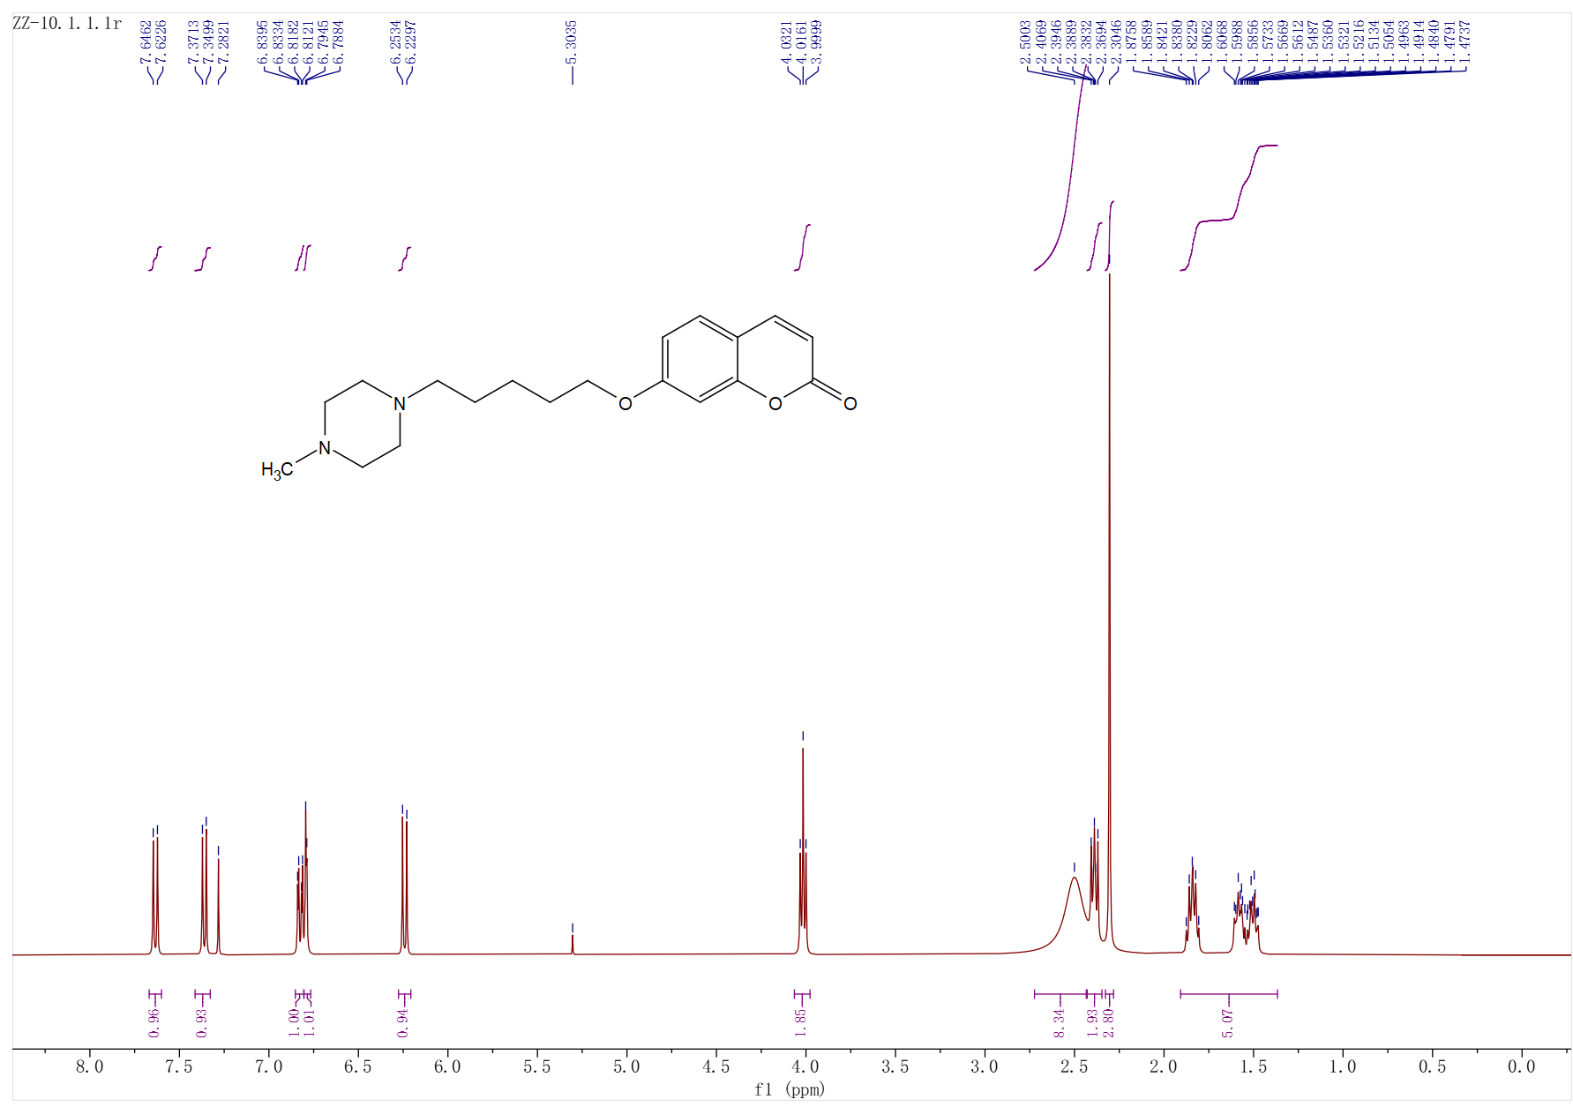
Fig S14 the ¹H-NMR spectrum of compound ZZ-10 (400 MHz,CDCl₃)

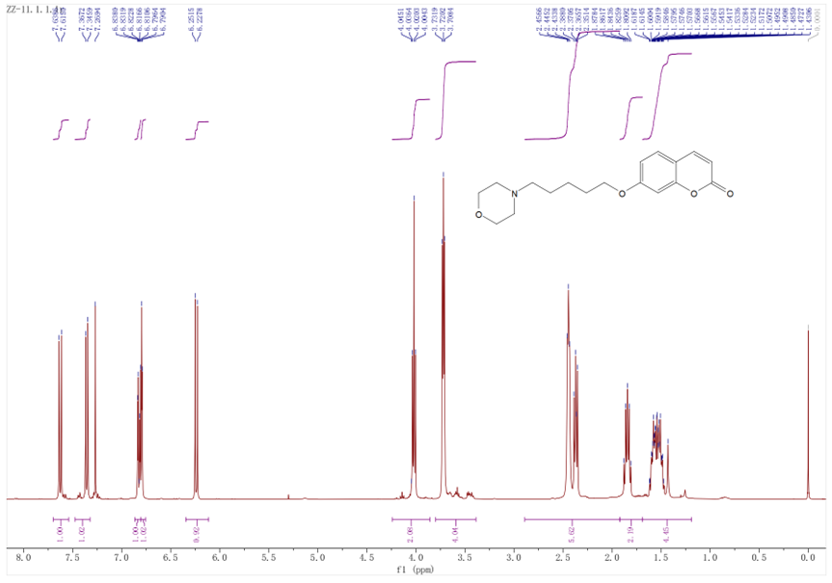

Fig S15 the ¹H-NMR spectrum of compound ZZ-11 (400 MHz,CDCl₃)

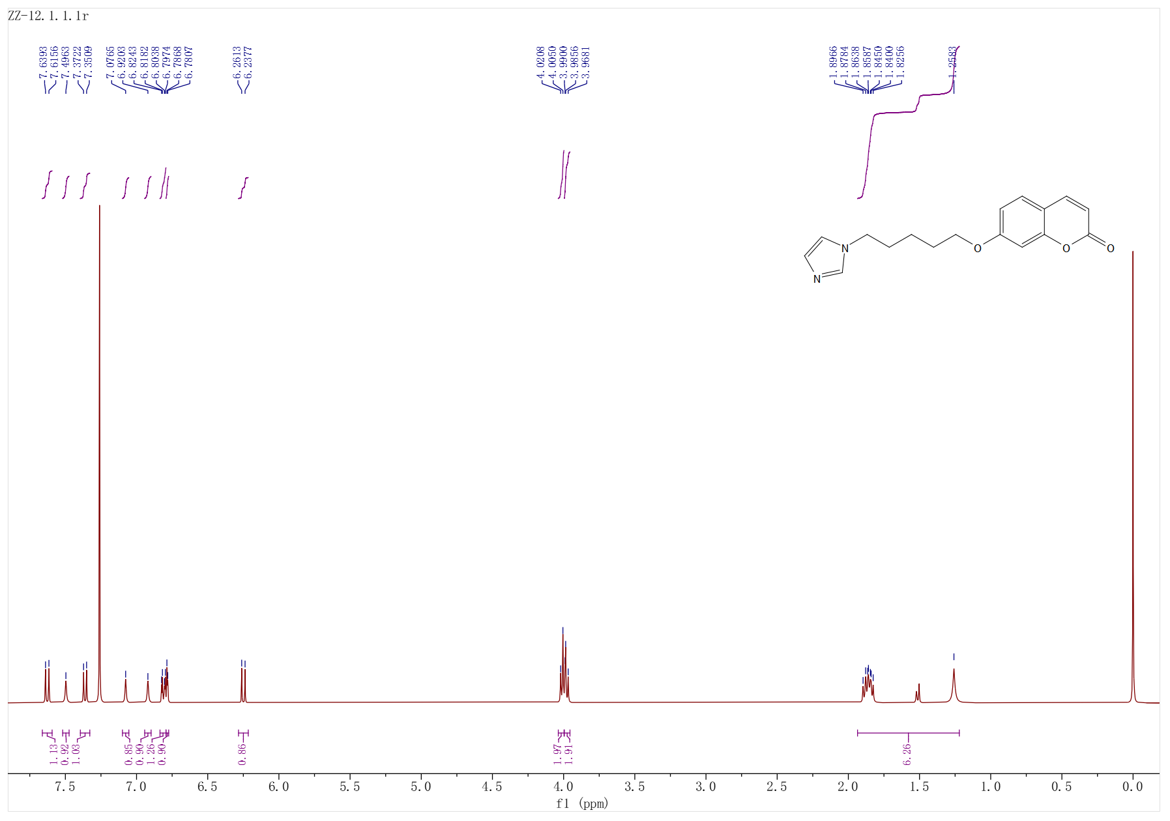

Fig S16 the ¹H-NMR spectrum of compound ZZ-12 (400 MHz,CDCl₃)

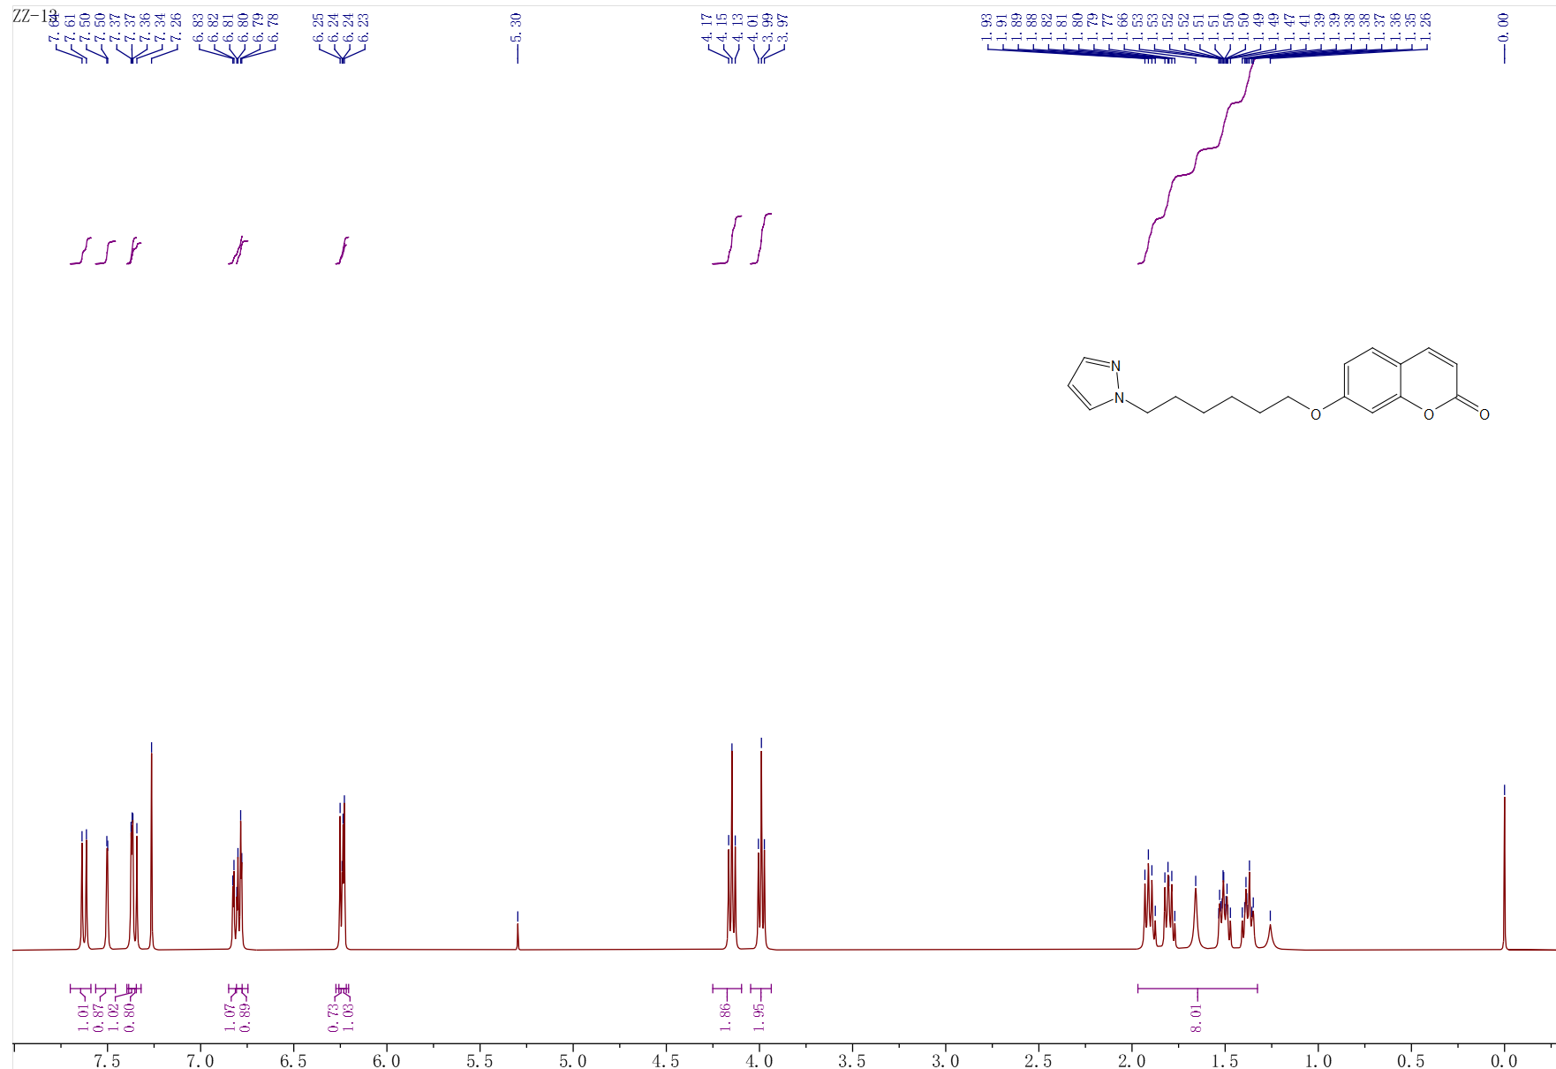
Fig S17 the ¹H-NMR spectrum of compound ZZ-13 (400 MHz,CDCl₃)
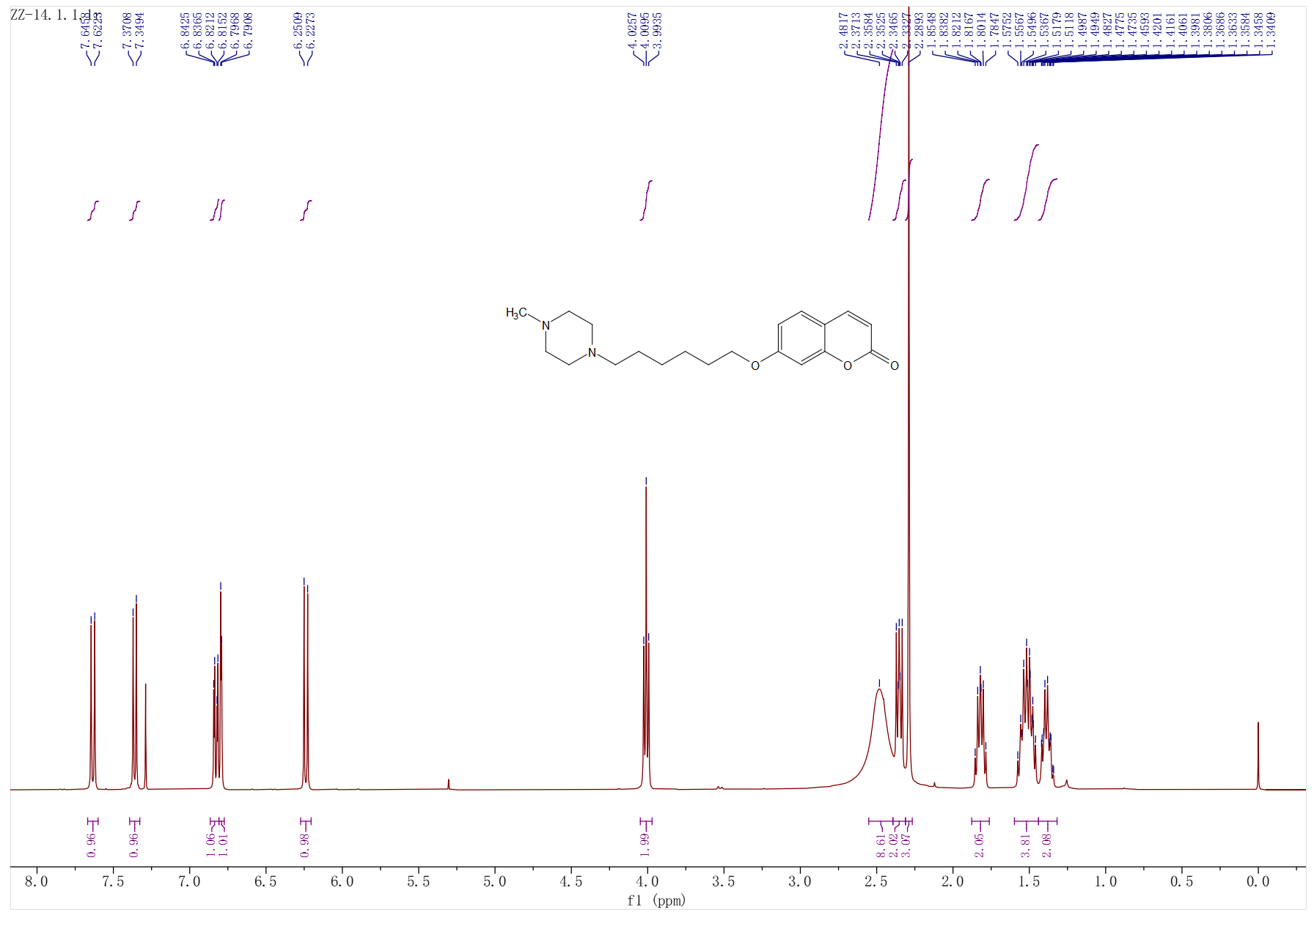
Fig S18 the ¹H-NMR spectrum of compound ZZ-14 (400 MHz,CDCl₃)

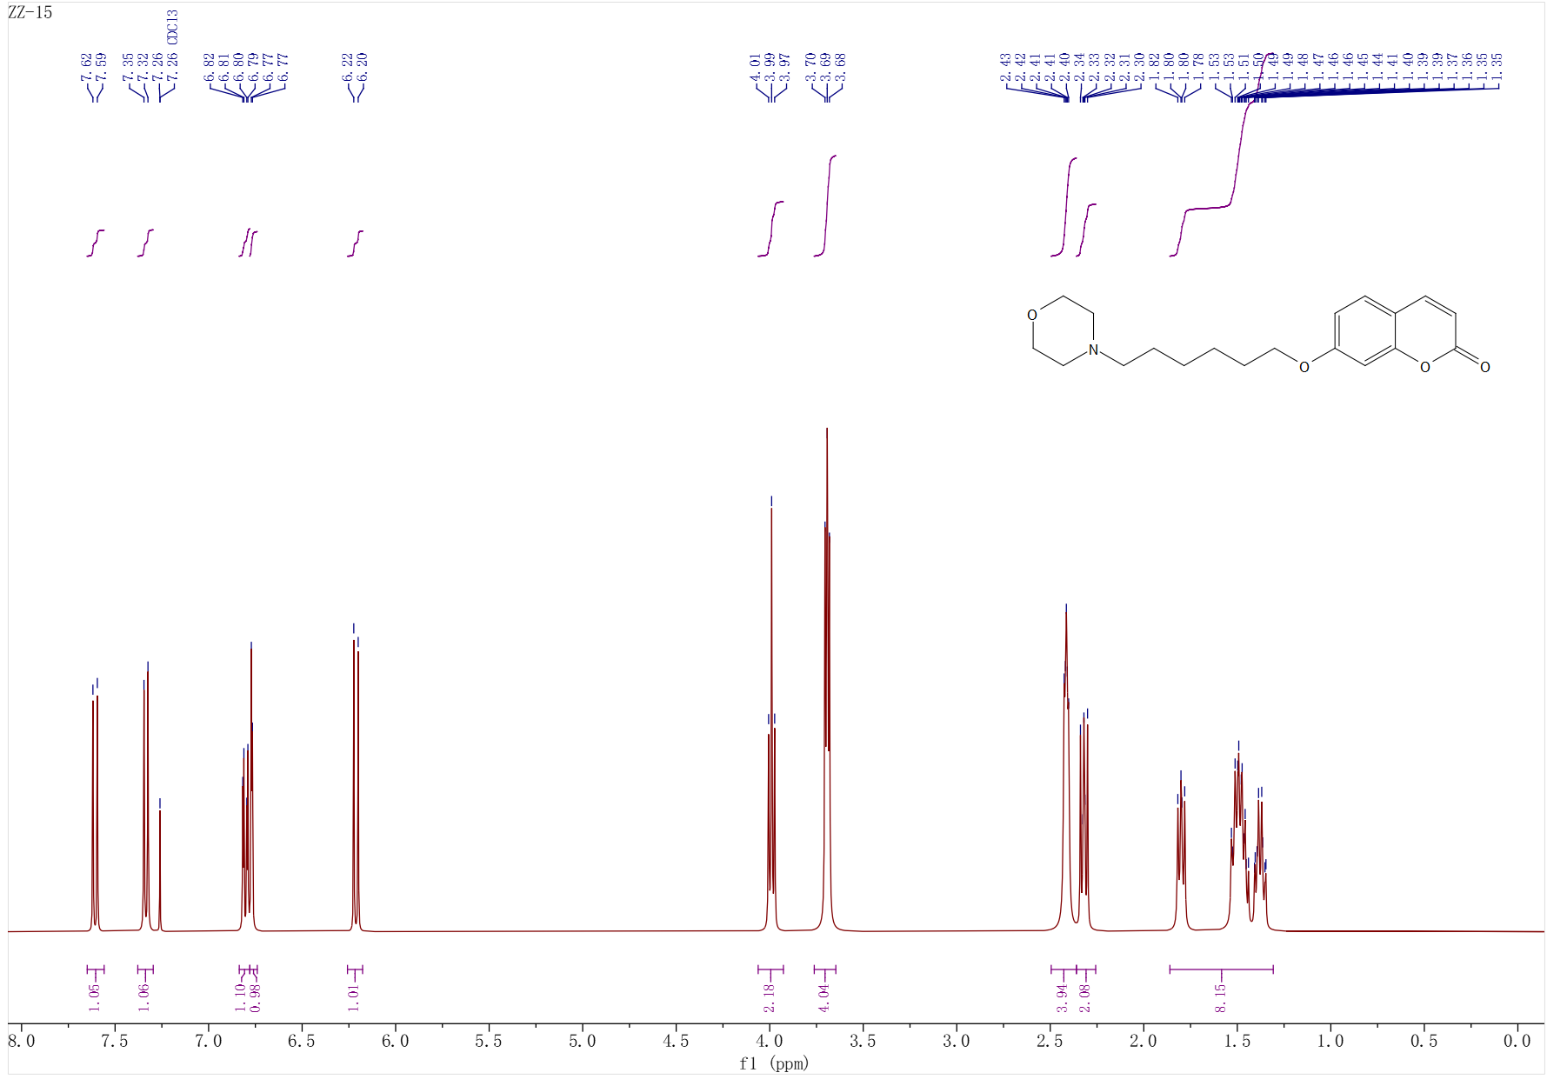

Fig S19 the ¹H-NMR spectrum of compound ZZ-15 (400 MHz,CDCl₃)

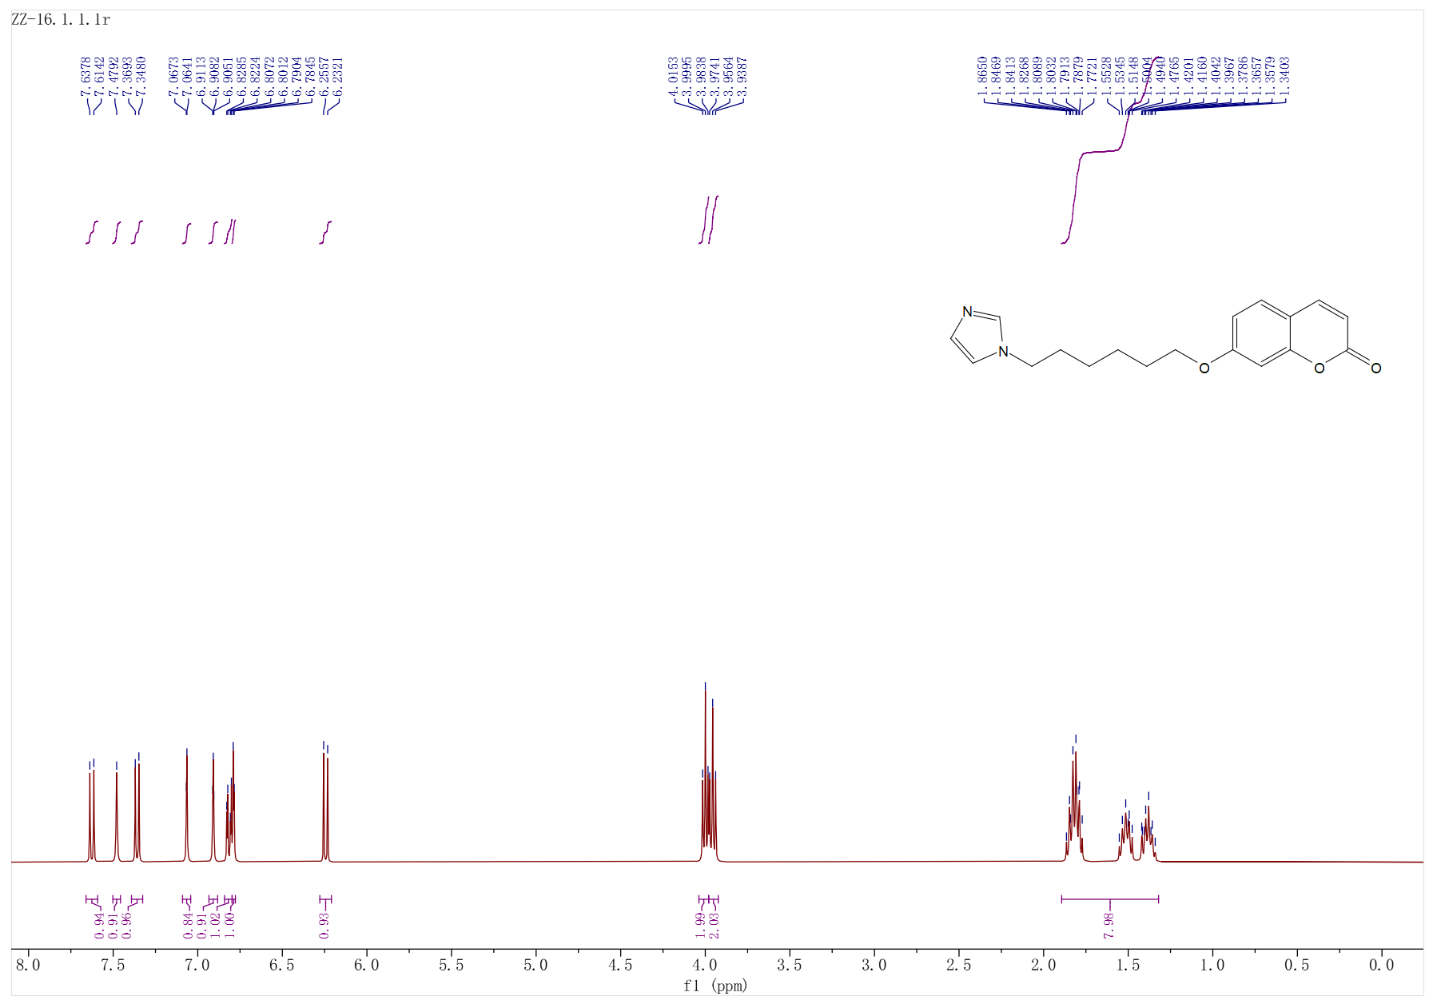

Fig S20 the ¹H-NMR spectrum of compound ZZ-16 (400 MHz,CDCl₃)

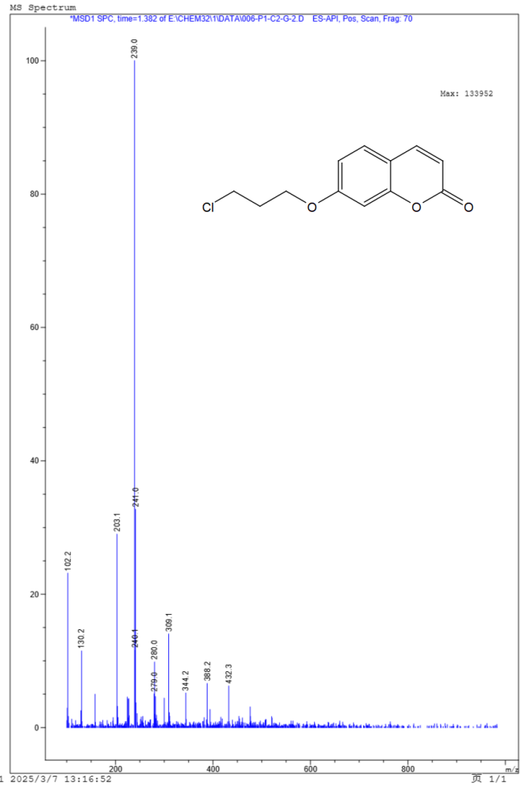
Fig S21 the ESI-MS spectrum of compound G2
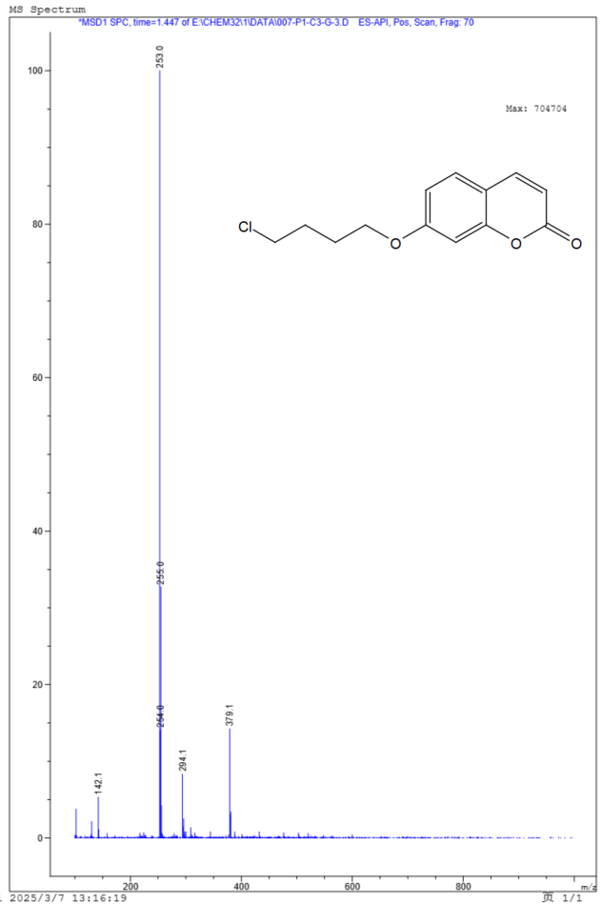
Fig S22 the ESI-MS spectrum of compound G3
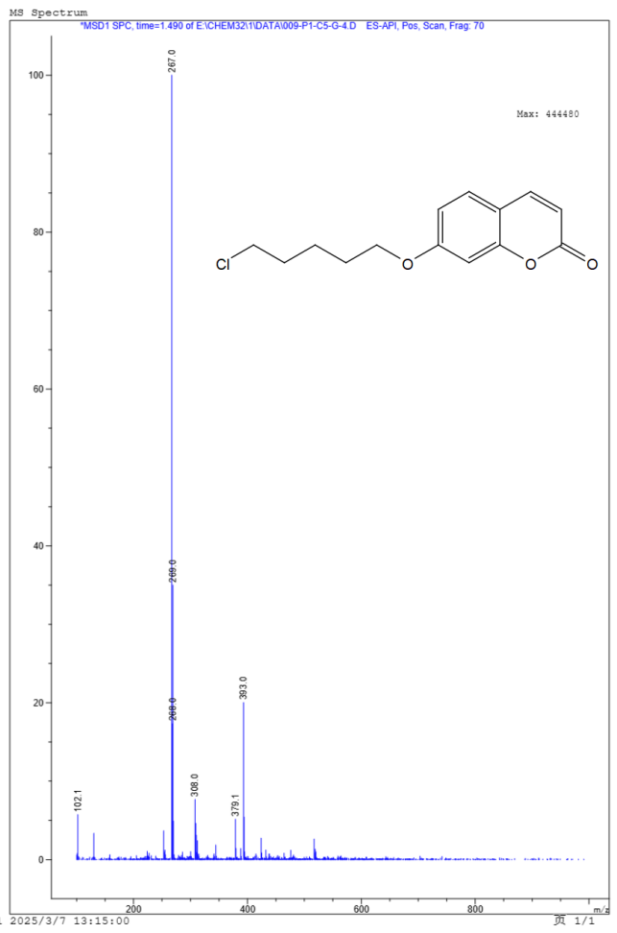
Fig S23 the ESI-MS spectrum of compound G4
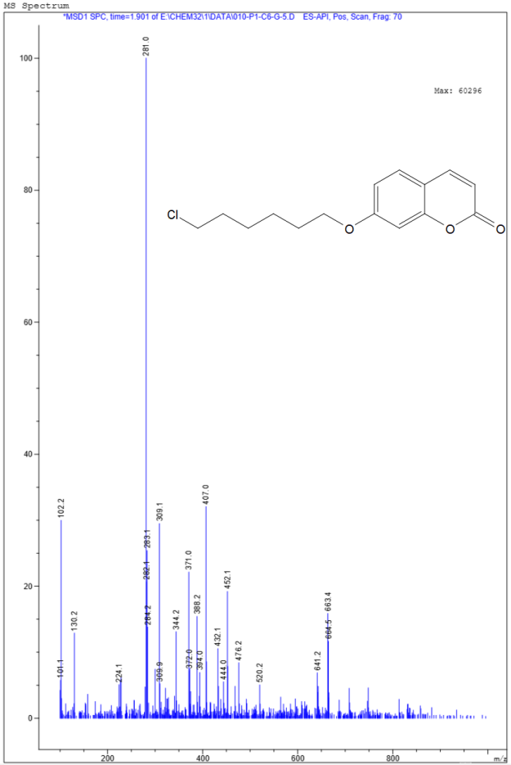

Fig S24 the ESI-MS spectrum of compound G5
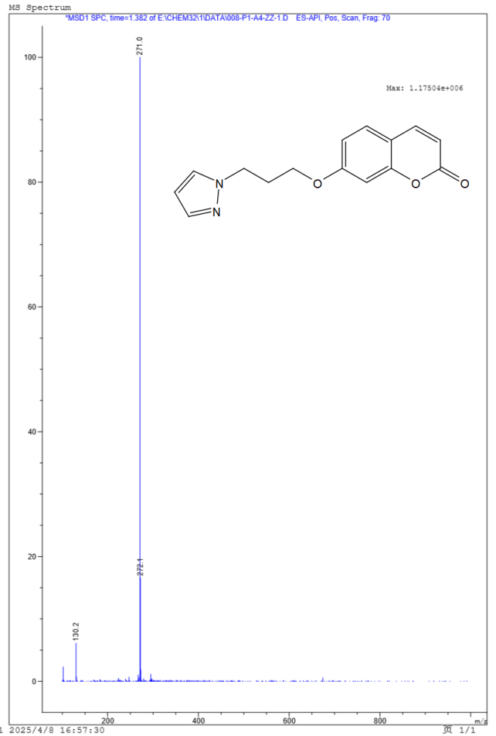
Fig S25 the ESI-MS spectrum of compound ZZ-1
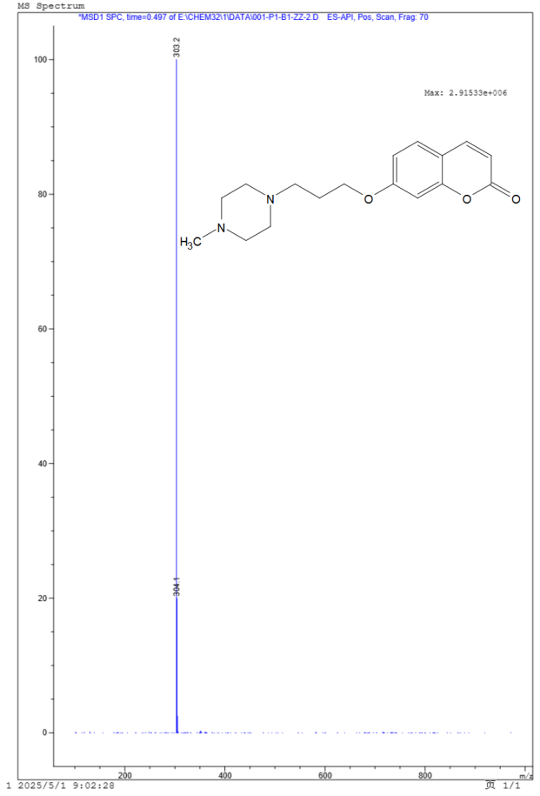
Fig S26 the ESI-MS spectrum of compound ZZ-2
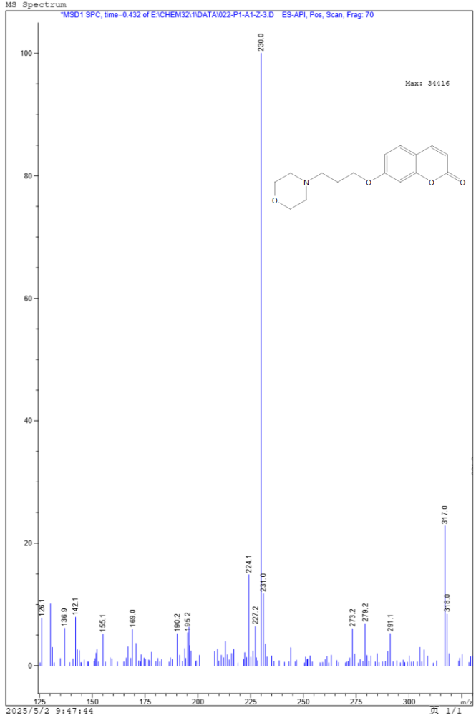
Fig S27 the ESI-MS spectrum of compound ZZ-3
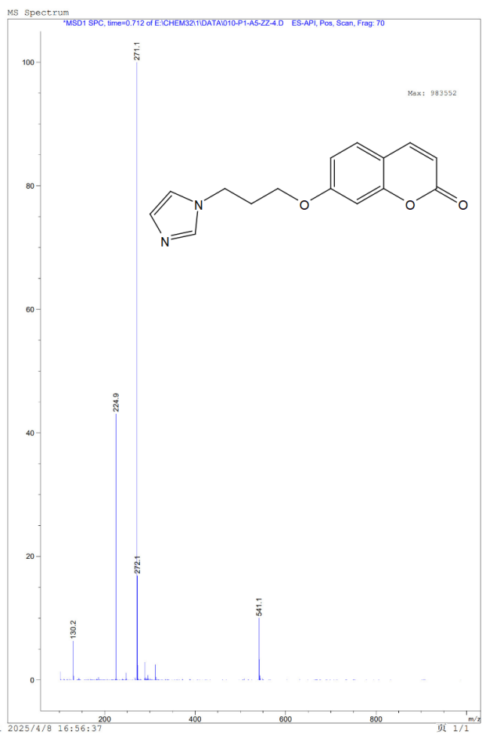
Fig S28 the ESI-MS spectrum of compound ZZ-4
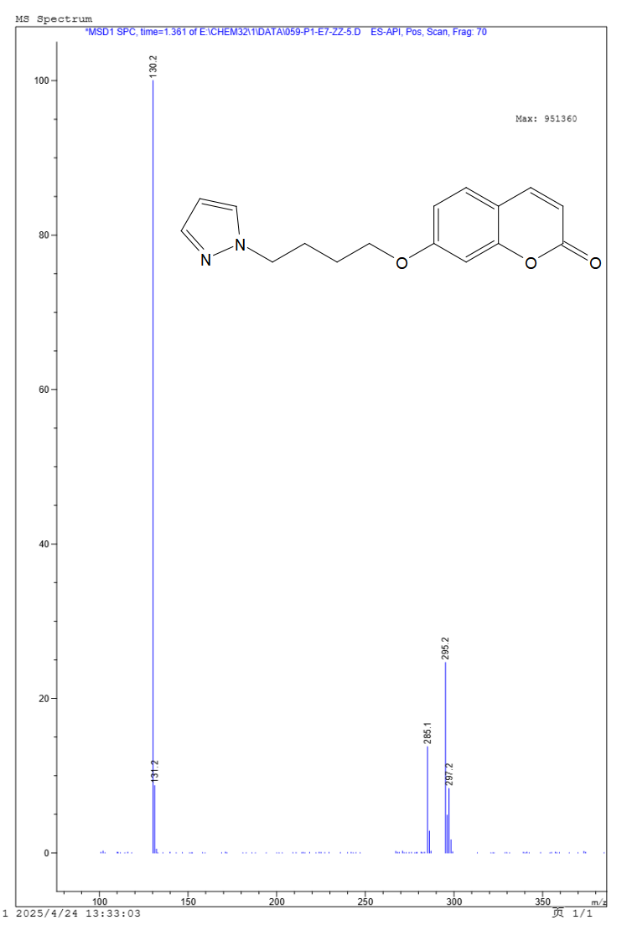
Fig S29 the ESI-MS spectrum of compound ZZ-5
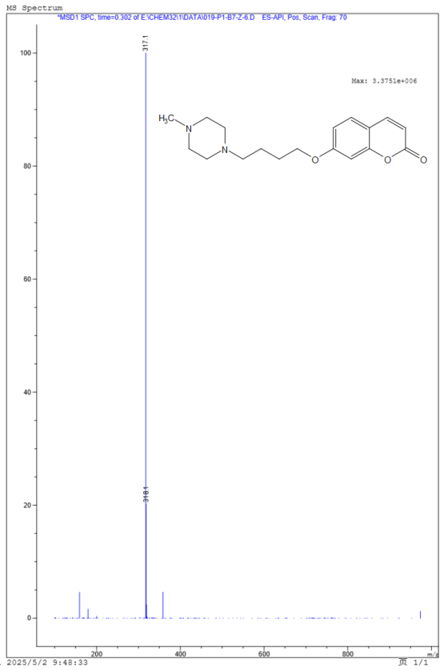
Fig S30 the ESI-MS spectrum of compound ZZ-6
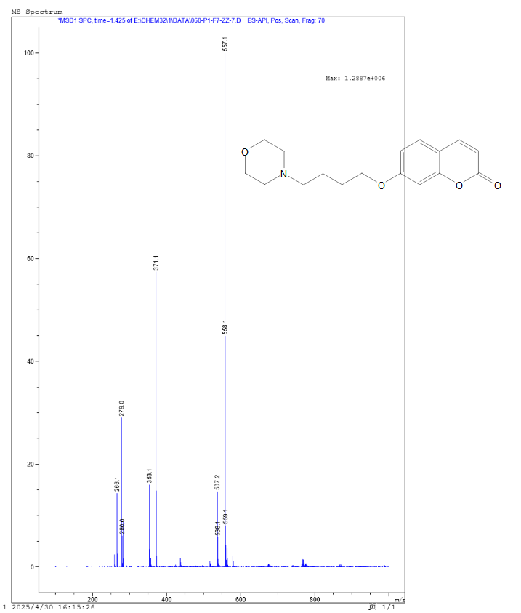
Fig S31 the ESI-MS spectrum of compound ZZ-7
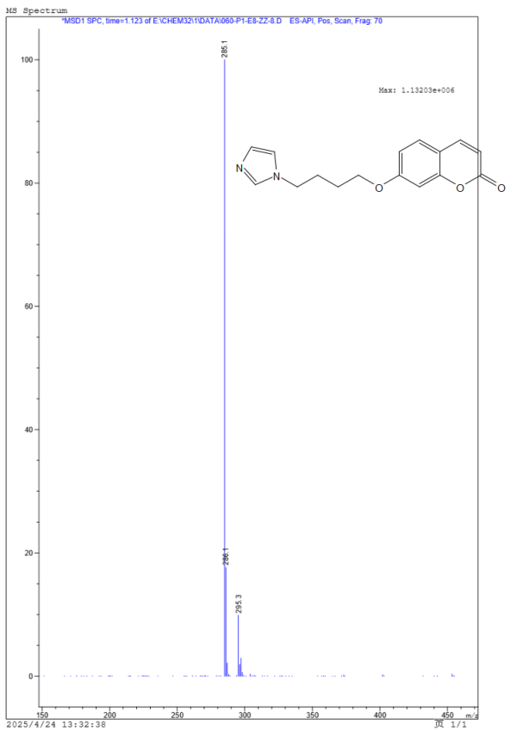
Fig S32 the ESI-MS spectrum of compound ZZ-8
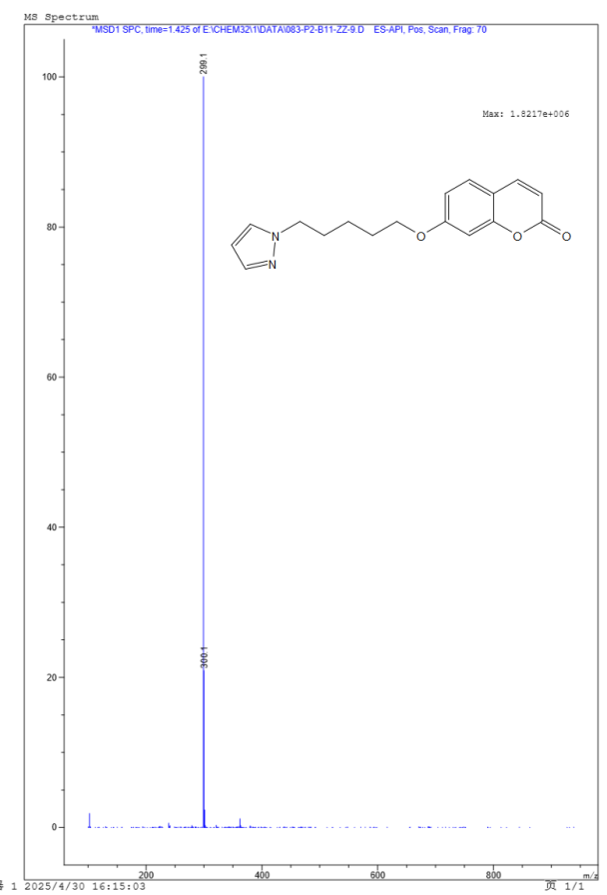
Fig S33 the ESI-MS spectrum of compound ZZ-9
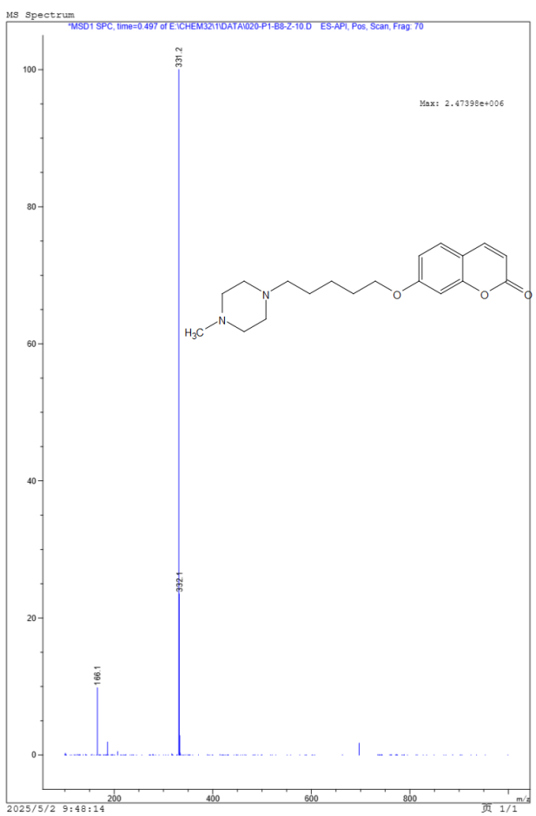
Fig S34 the ESI-MS spectrum of compound ZZ-10
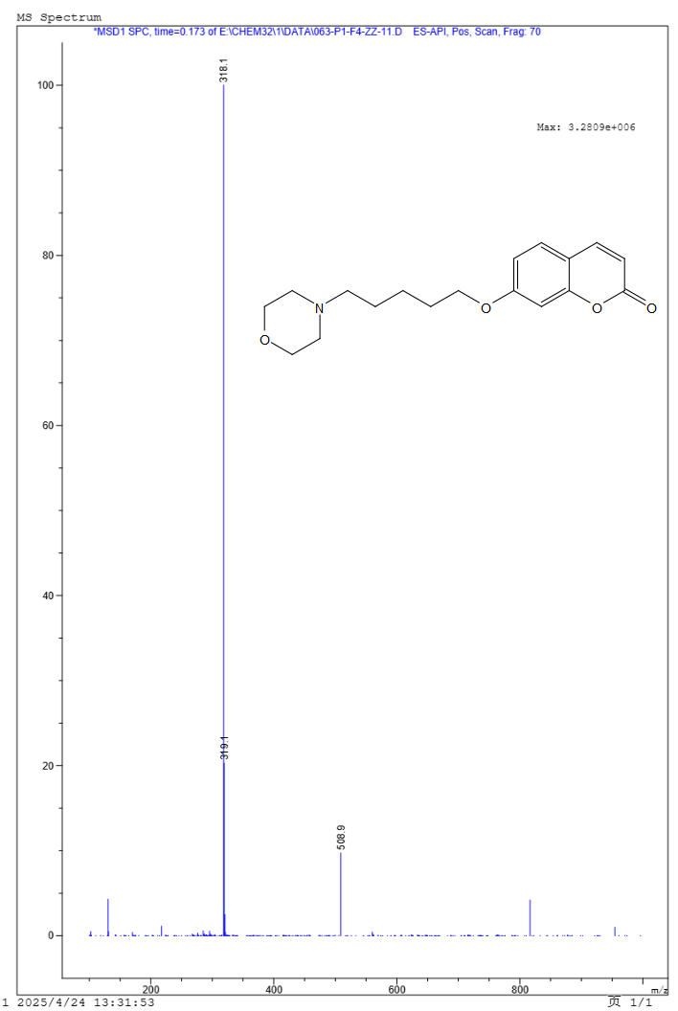
Fig S35 the ESI-MS spectrum of compound ZZ-11
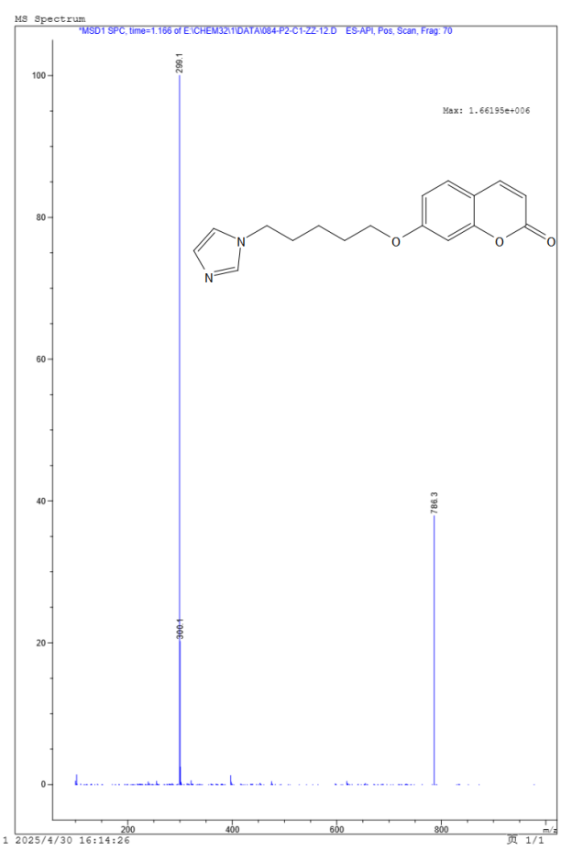
Fig S36 the ESI-MS spectrum of compound ZZ-12
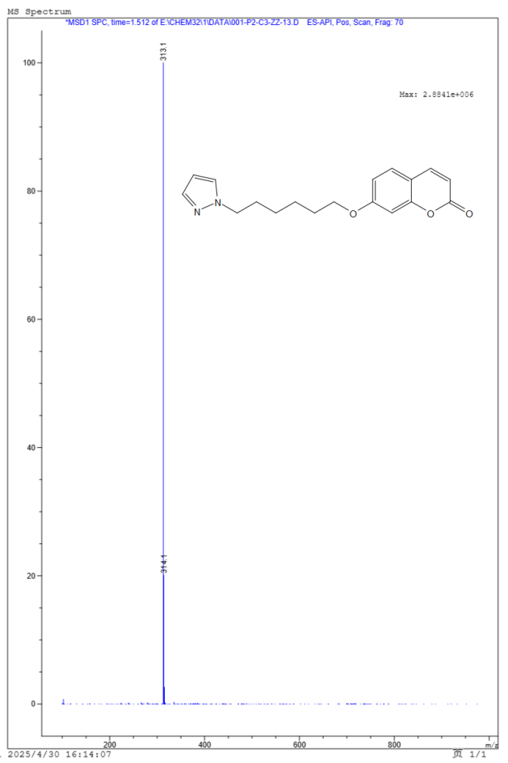
Fig S37 the ESI-MS spectrum of compound ZZ-13
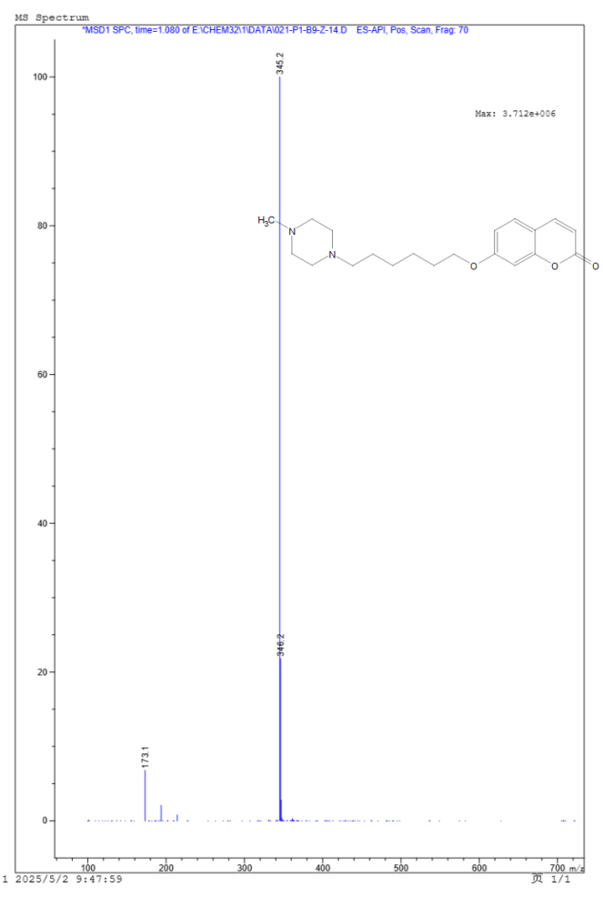
Fig S38 the ESI-MS spectrum of compound ZZ-14
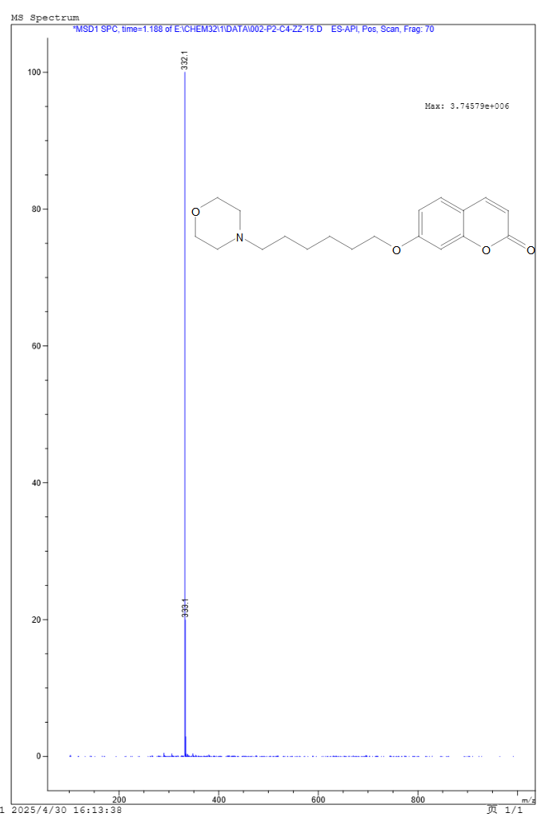
Fig S39 the ESI-MS spectrum of compound ZZ-15
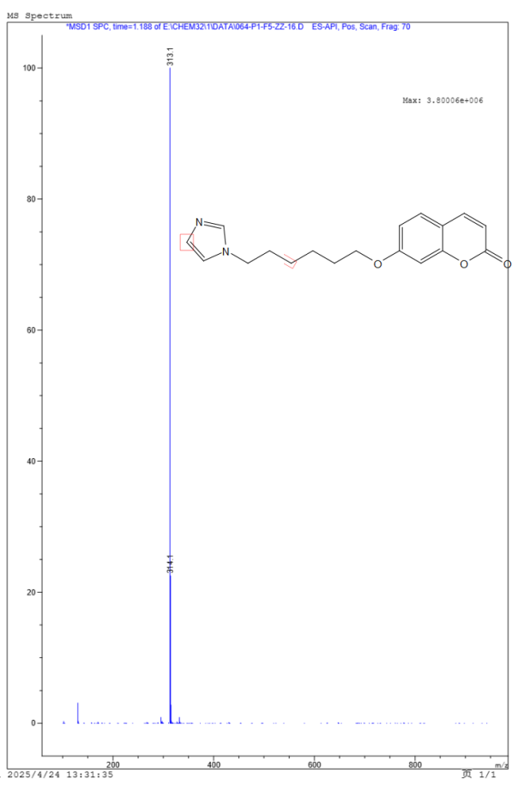
Fig S40 the ESI-MS spectrum of compound ZZ-16
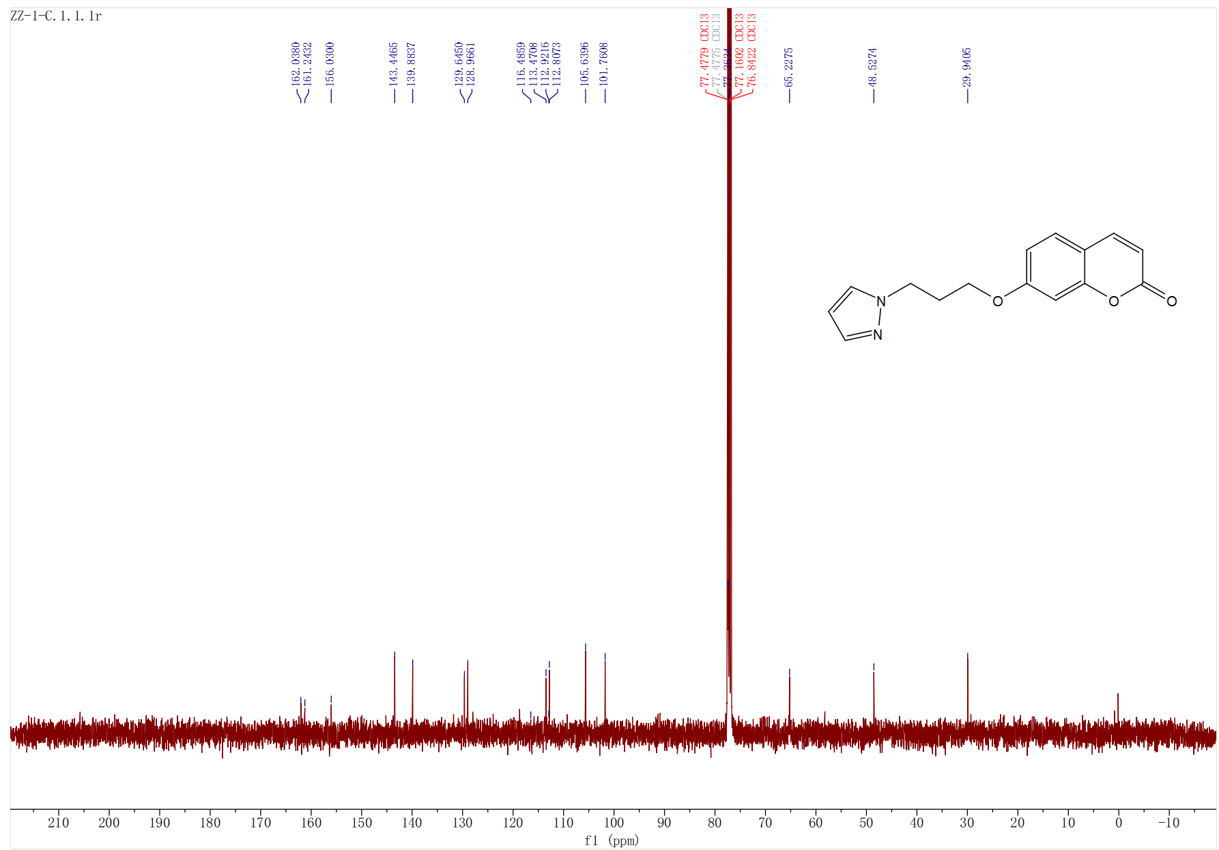
Fig S41 the ¹³C-NMR spectrum of compound ZZ-1 (100 MHz, CDCl₃)
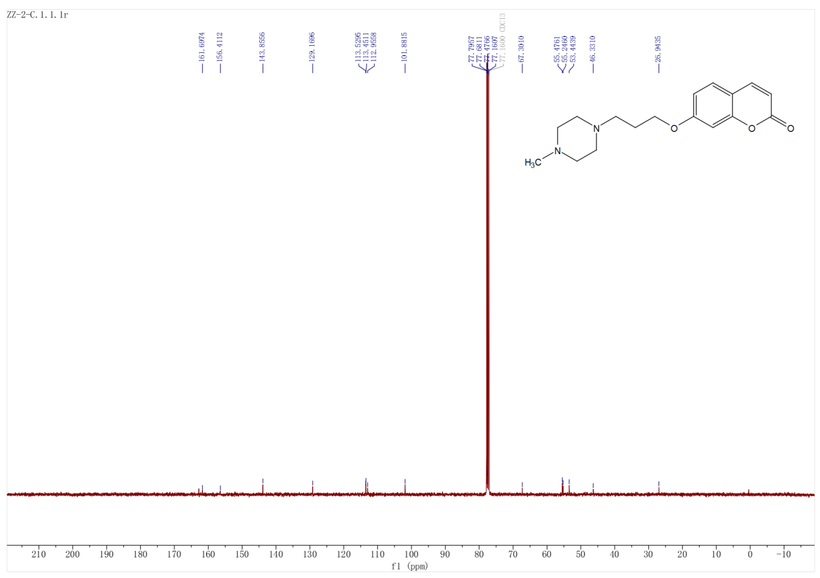
Fig S42 the ¹³C-NMR spectrum of compound ZZ-2 (100 MHz, CDCl₃)
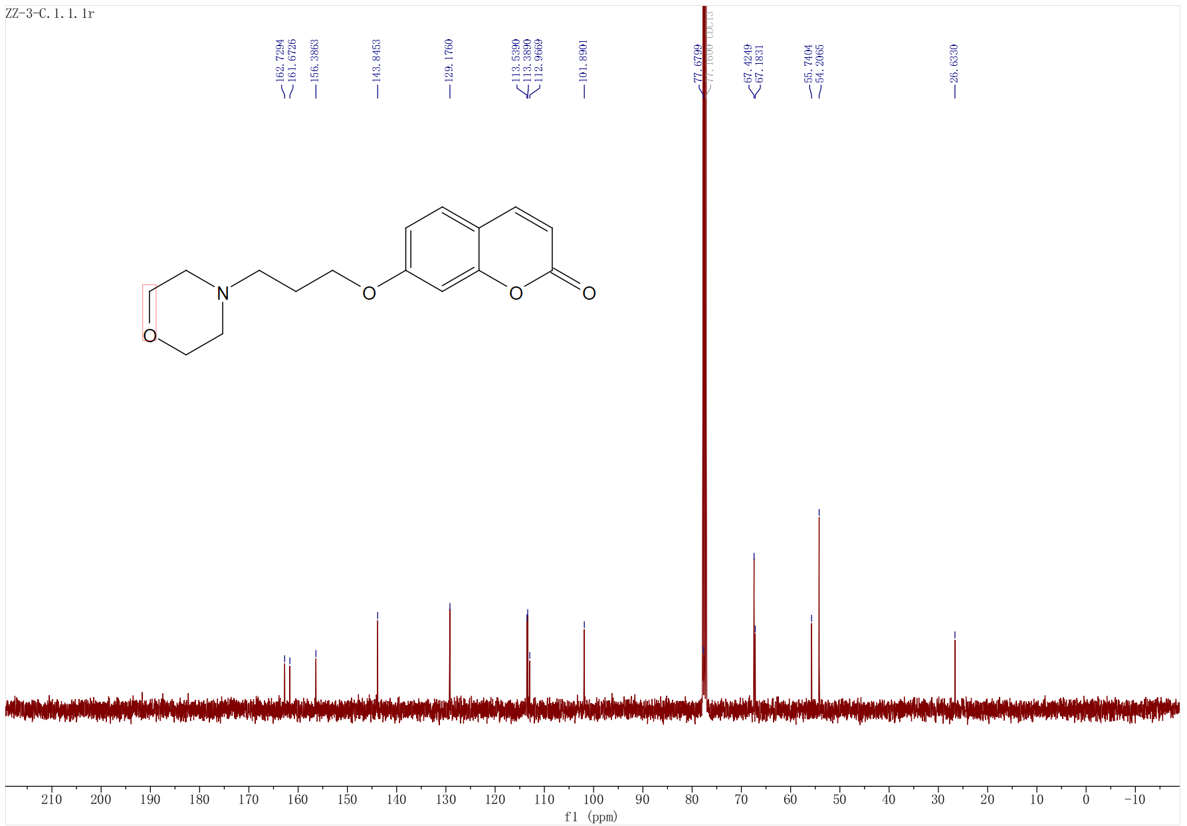
Fig S43 the ¹³C-NMR spectrum of compound ZZ-3 (100 MHz, CDCl₃)

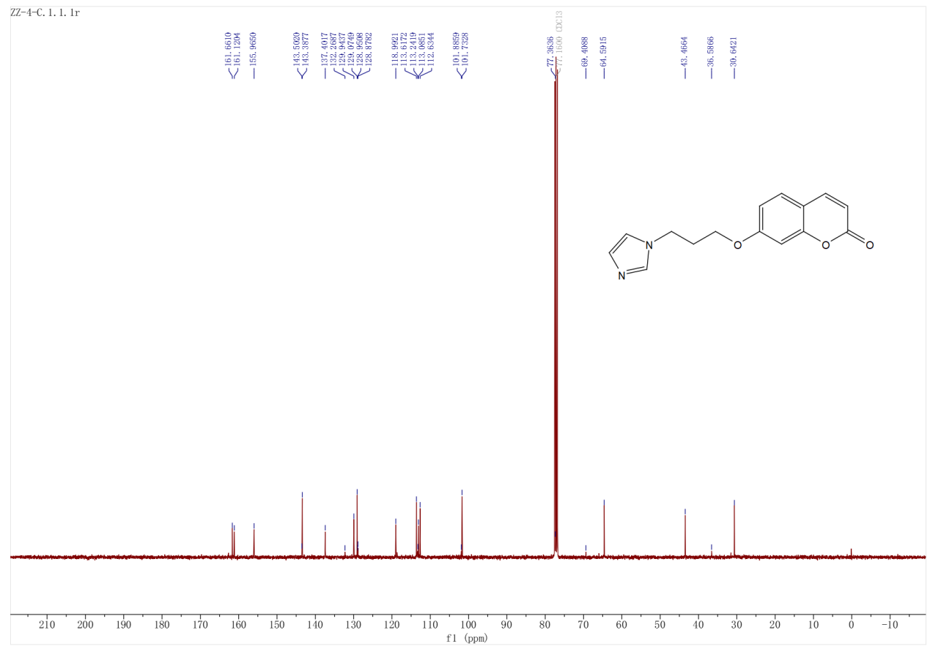

Fig S44 the ¹³C-NMR spectrum of compound ZZ-4 (100 MHz, CDCl₃)

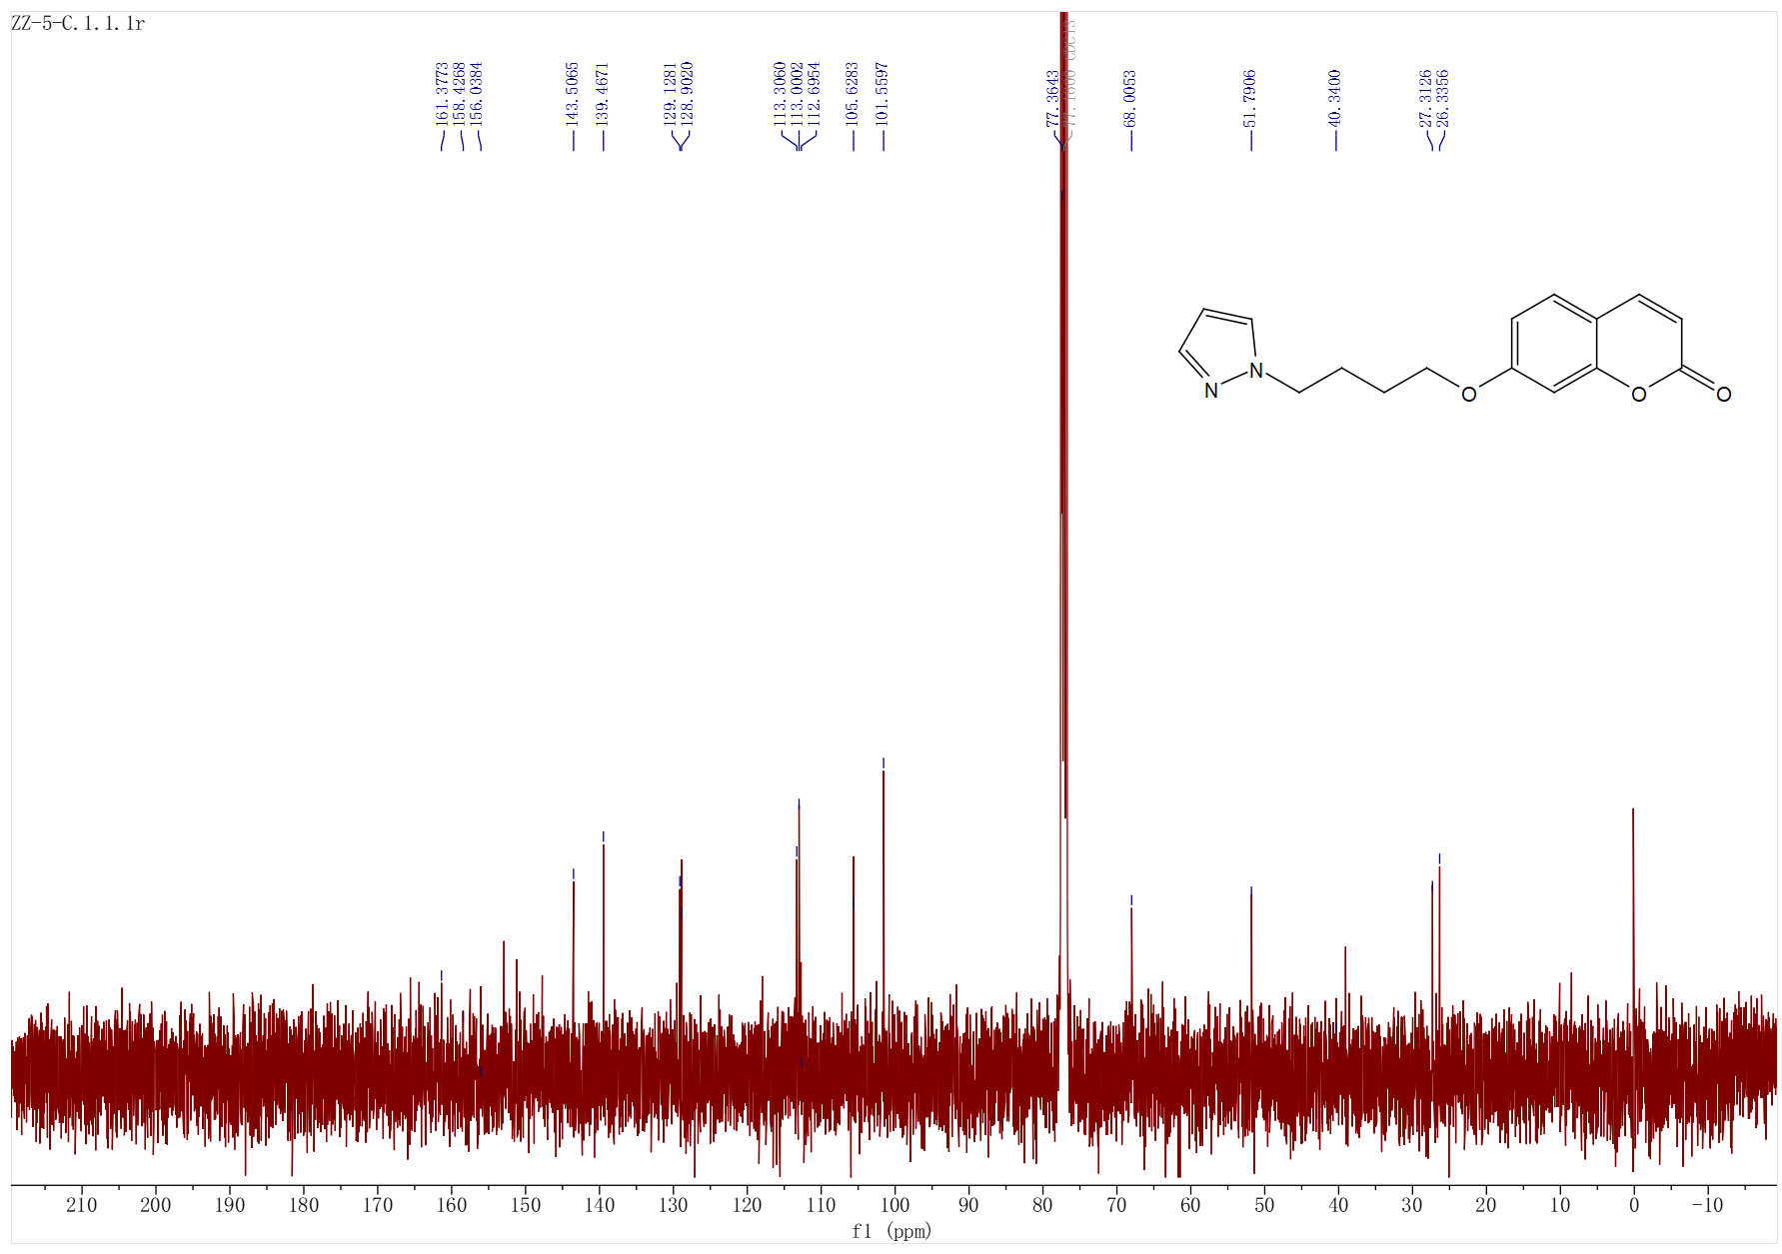

Fig S45 the ¹³C-NMR spectrum of compound ZZ-5 (100 MHz, CDCl₃)
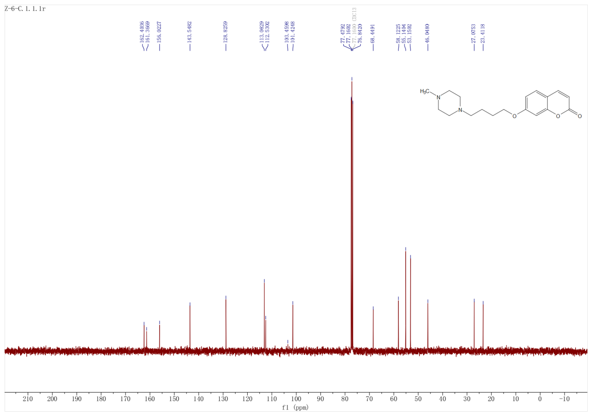
Fig S46 the ¹³C-NMR spectrum of compound ZZ-6 (100 MHz, CDCl₃)
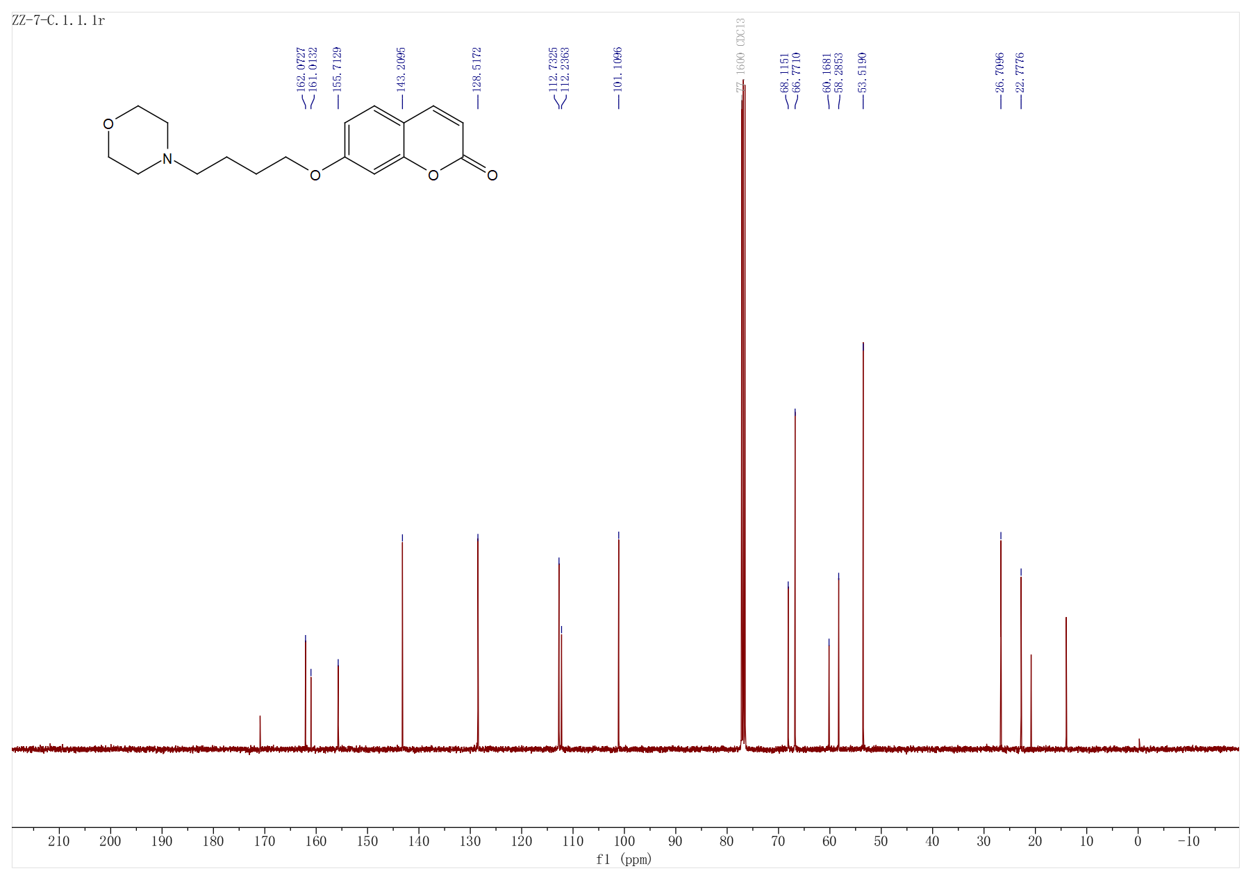
Fig S47 the ¹³C-NMR spectrum of compound ZZ-7 (100 MHz, CDCl₃)
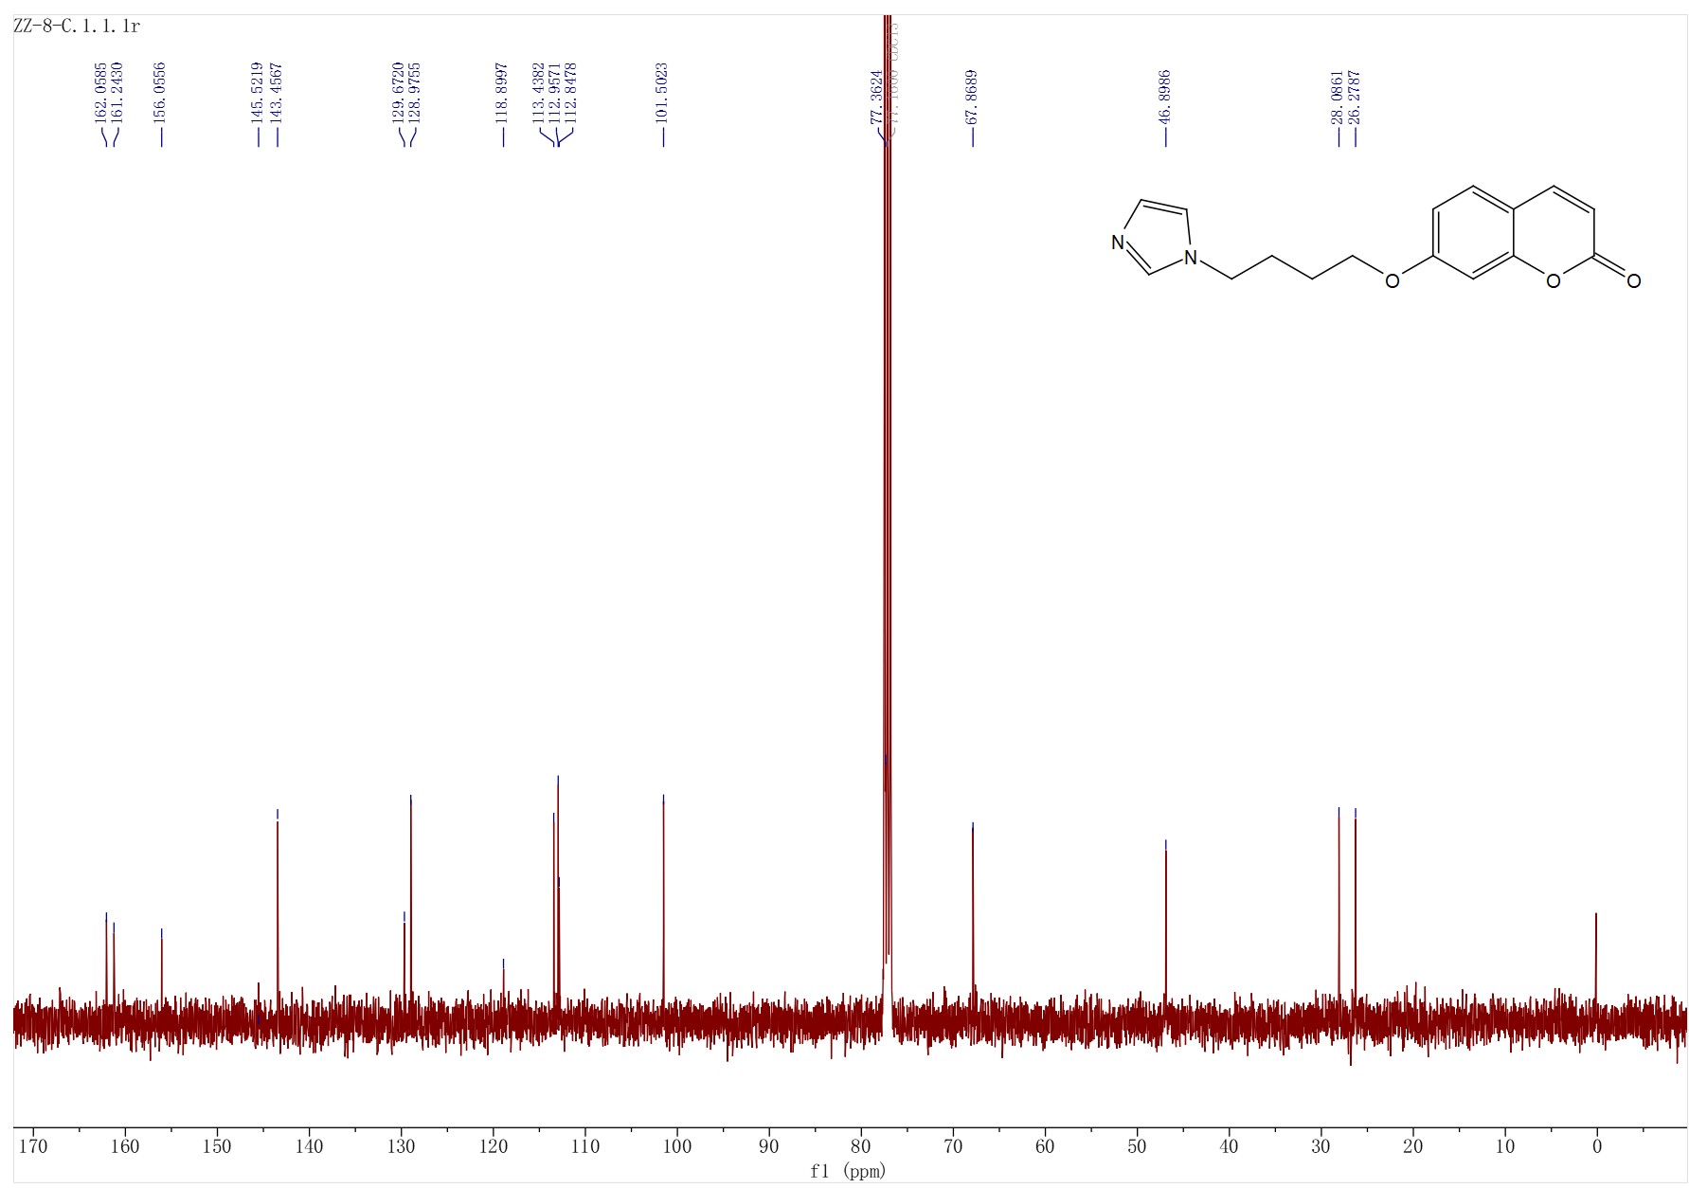

Fig S48 the ¹³C-NMR spectrum of compound ZZ-8 (100 MHz, CDCl₃)

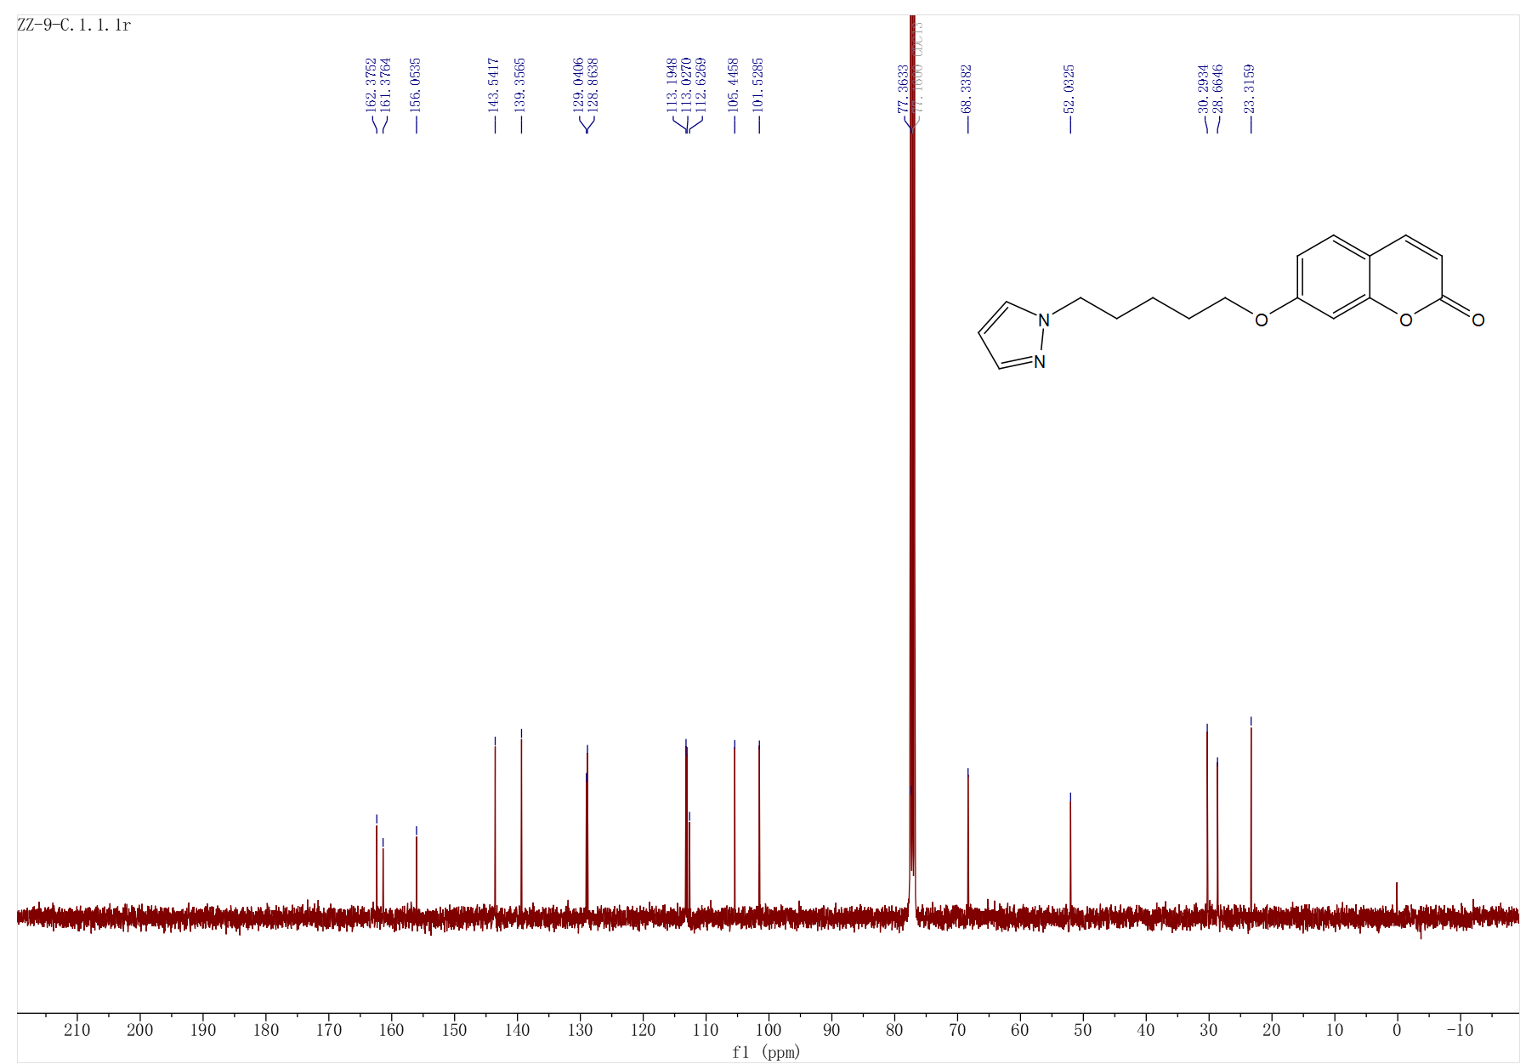

Fig S49 the ¹³C-NMR spectrum of compound ZZ-9 (100 MHz, CDCl₃)
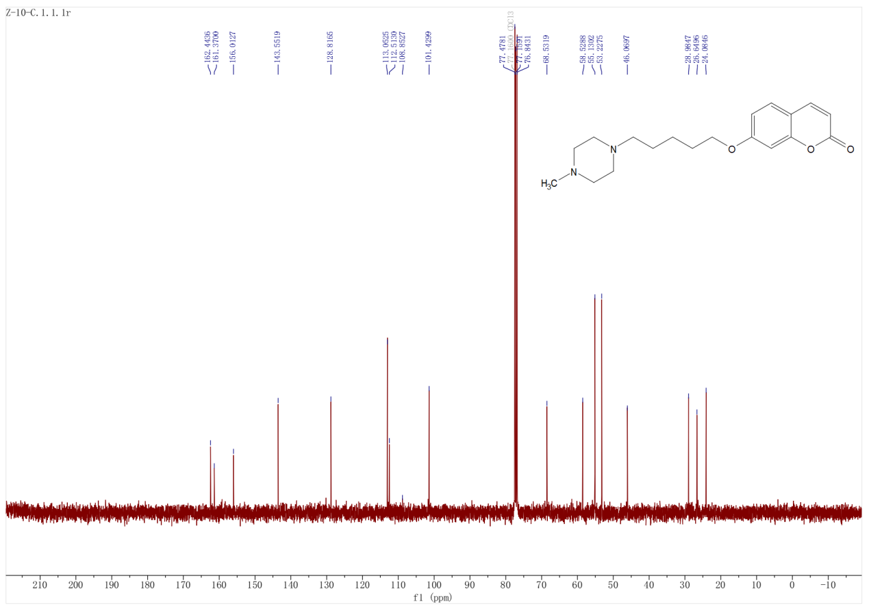
Fig S50 the ¹³C-NMR spectrum of compound ZZ-10 (100 MHz, CDCl₃)
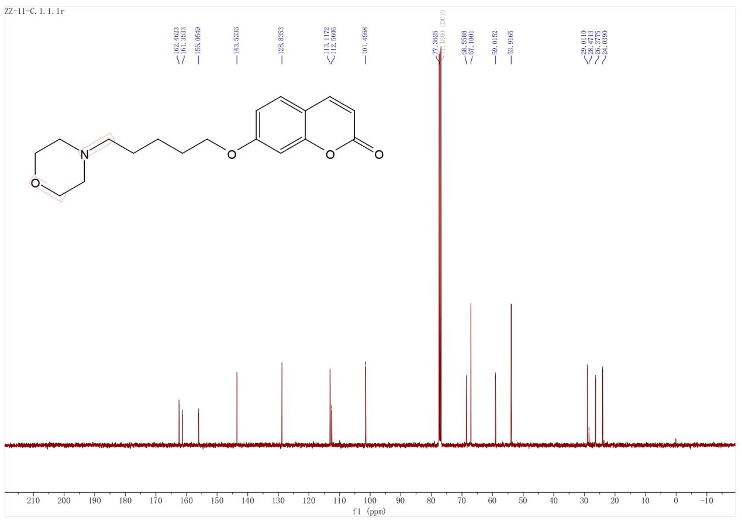Fig S51 the ¹³C-NMR spectrum of compound ZZ-11 (100 MHz, CDCl₃)
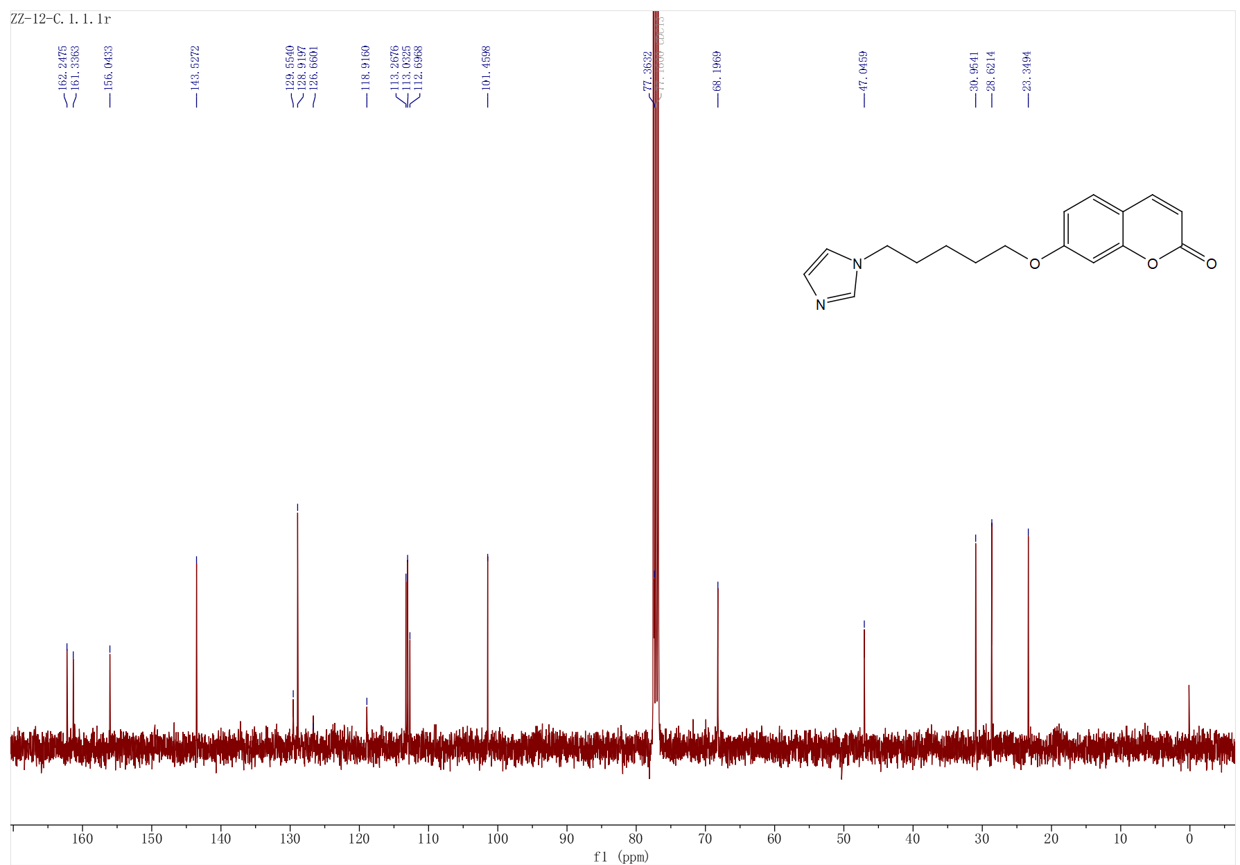
Fig S52 the ¹³C-NMR spectrum of compound ZZ-12 (100 MHz, CDCl₃)

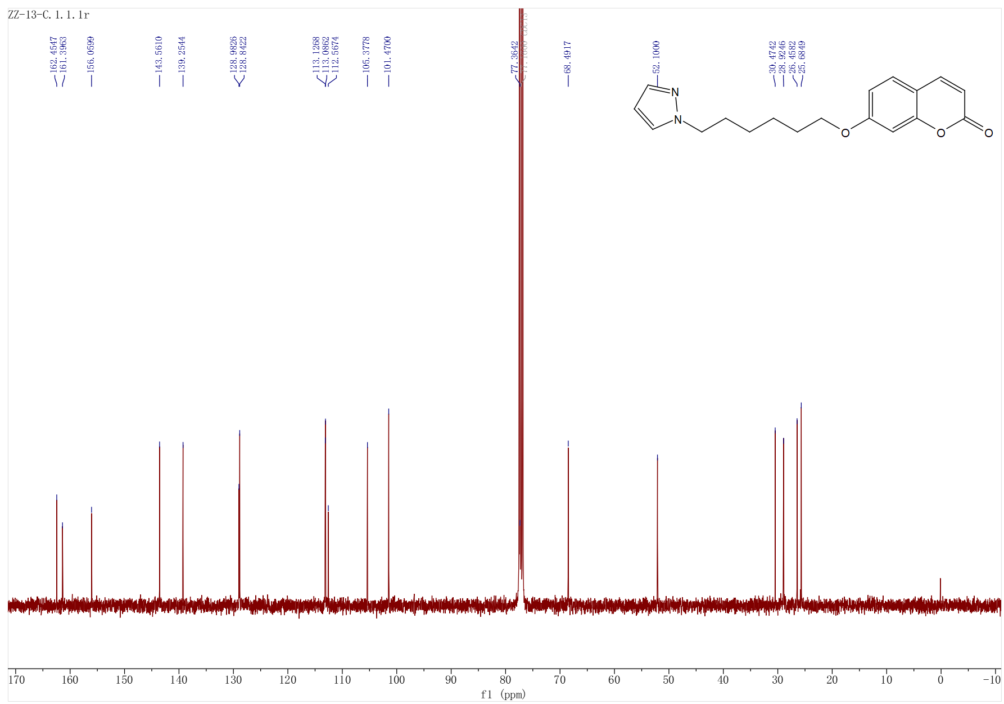
Fig S53 the ¹³C-NMR spectrum of compound ZZ-13 (100 MHz, CDCl₃)
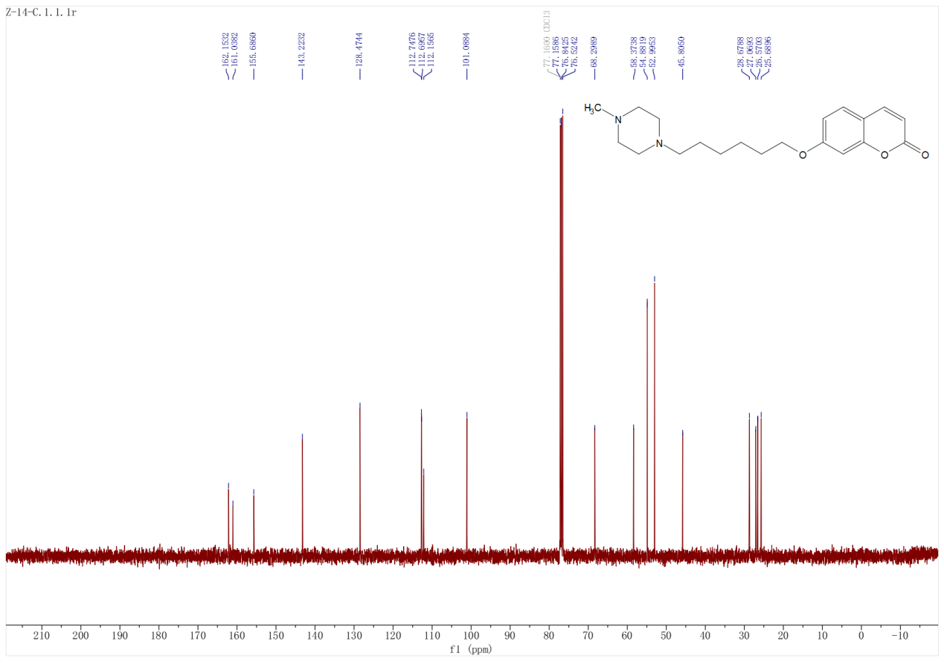
Fig S54 the ¹³C-NMR spectrum of compound ZZ-14 (100 MHz, CDCl₃)
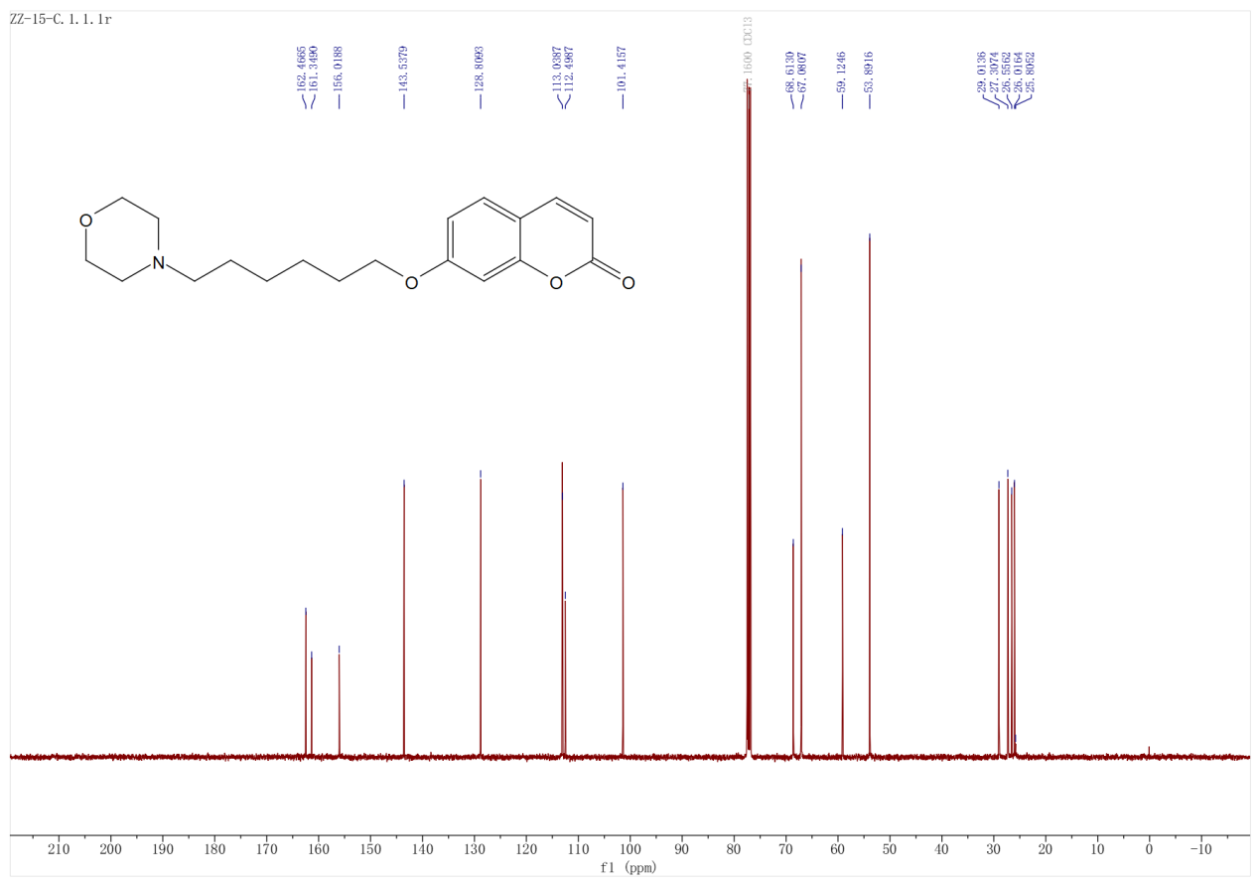
Fig S55 the ¹³C-NMR spectrum of compound ZZ-15 (100 MHz, CDCl₃)

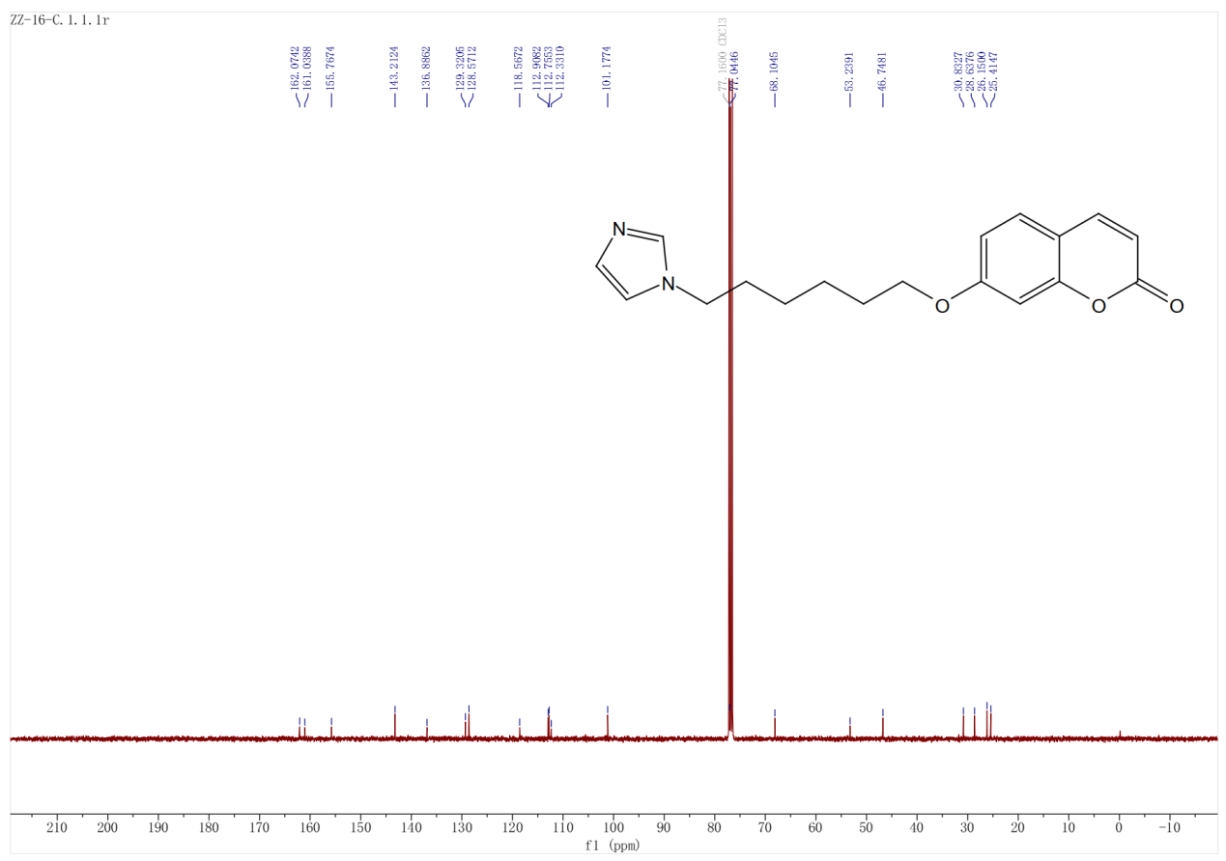
Fig S56 the ¹³C-NMR spectrum of compound ZZ-16 (100 MHz, CDCl₃)

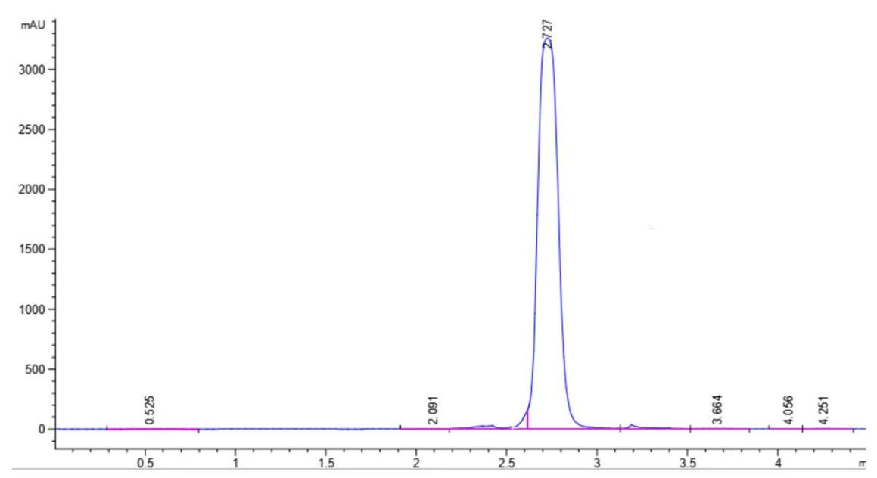
Fig S57 the HPLC spectrum of compound ZZ-1
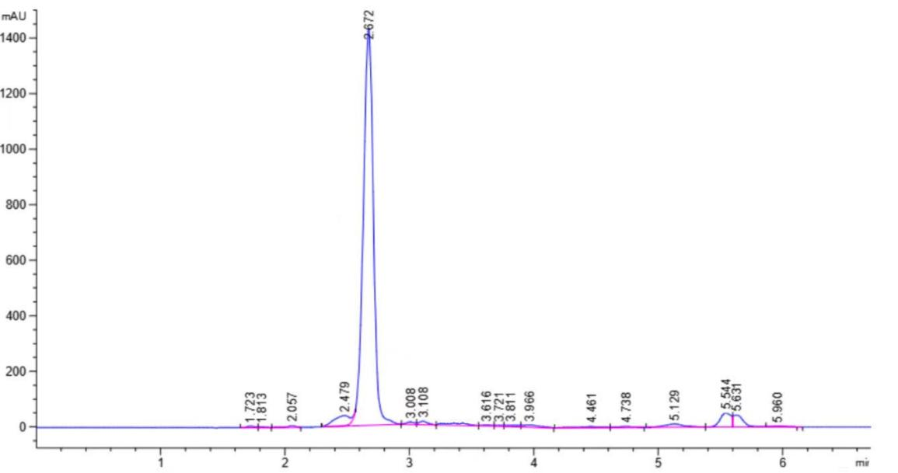
Fig S58 the HPLC spectrum of compound ZZ-2
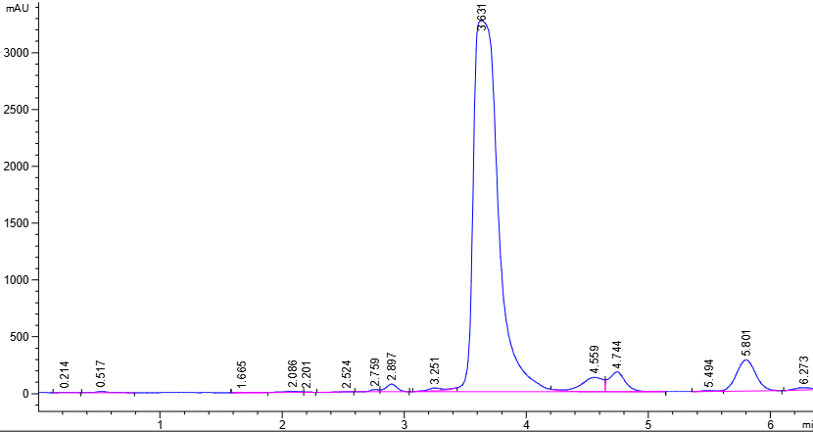
Fig S59 the HPLC spectrum of compound ZZ-3
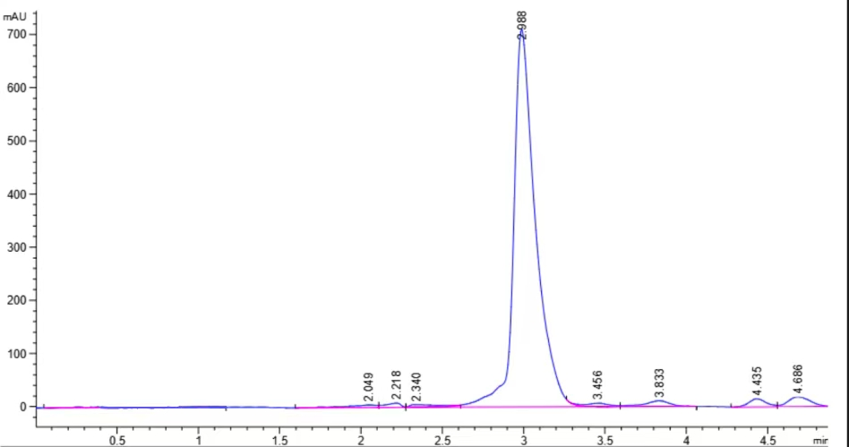
Fig S60 the HPLC spectrum of compound ZZ-4
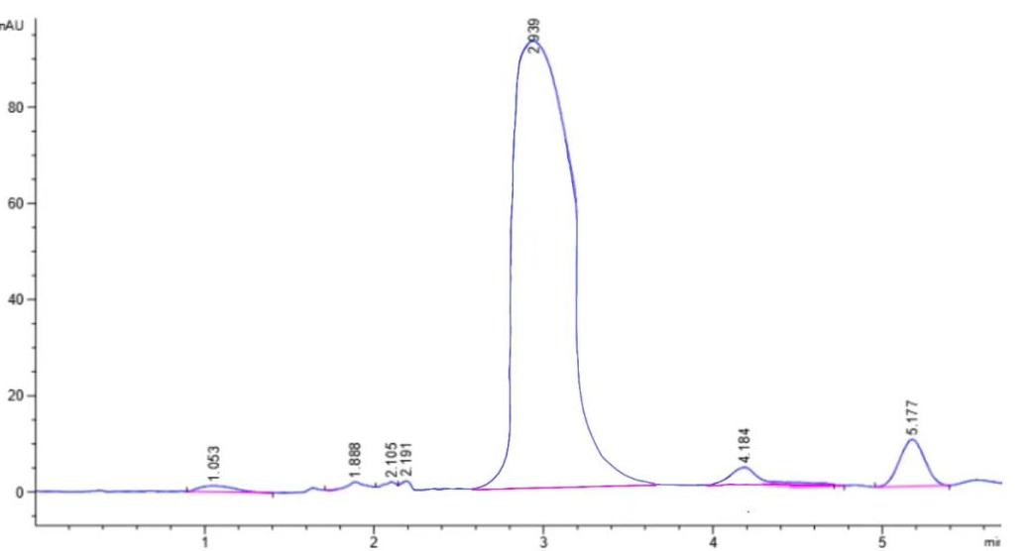
Fig S61 the HPLC spectrum of compound ZZ-5
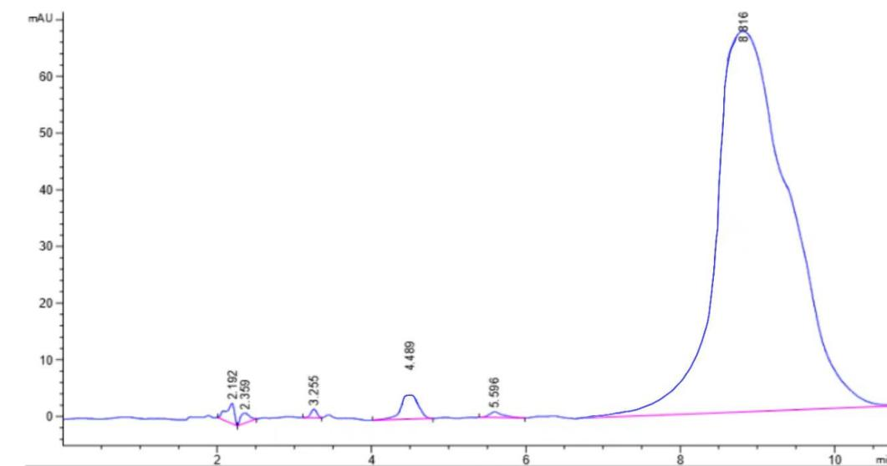
Fig S62 the HPLC spectrum of compound ZZ-6
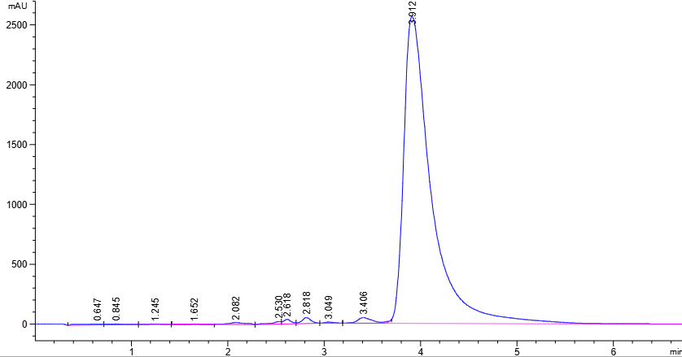
Fig S63 the HPLC spectrum of compound ZZ-7
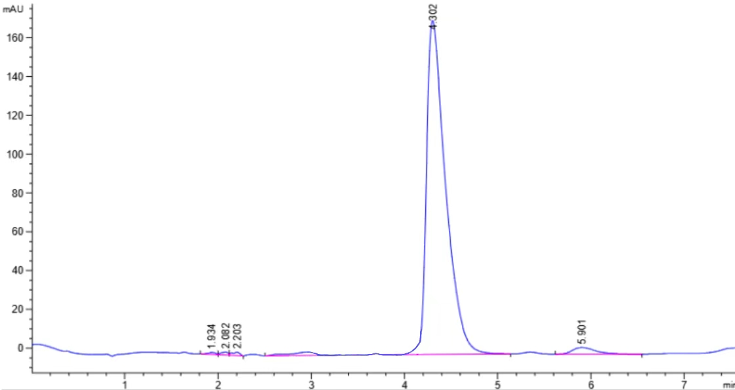
Fig S64 the HPLC spectrum of compound ZZ-8
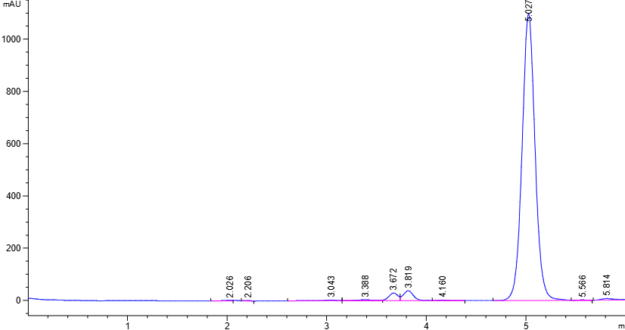
Fig S65 the HPLC spectrum of compound ZZ-9
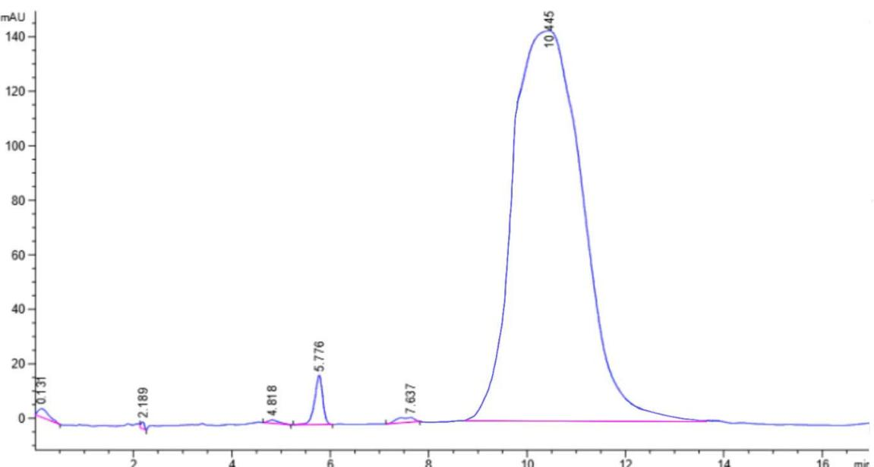
Fig S66 the HPLC spectrum of compound ZZ-10
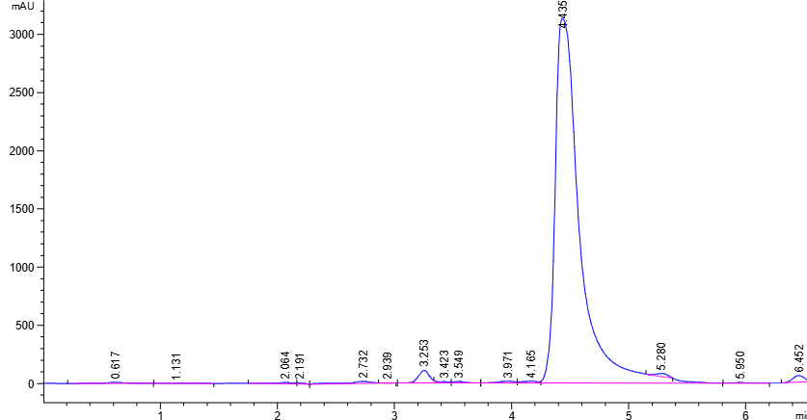
Fig S67 the HPLC spectrum of compound ZZ-11
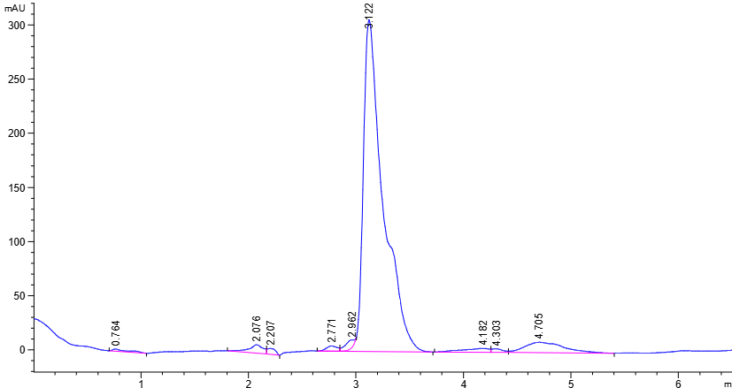
Fig S68 the HPLC spectrum of compound ZZ-12
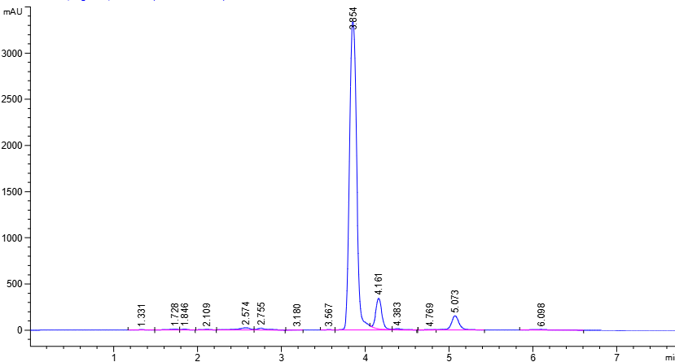
Fig S69 the HPLC spectrum of compound ZZ-13
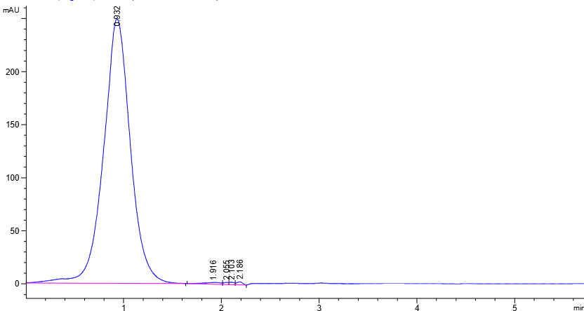
Fig S70 the HPLC spectrum of compound ZZ-14
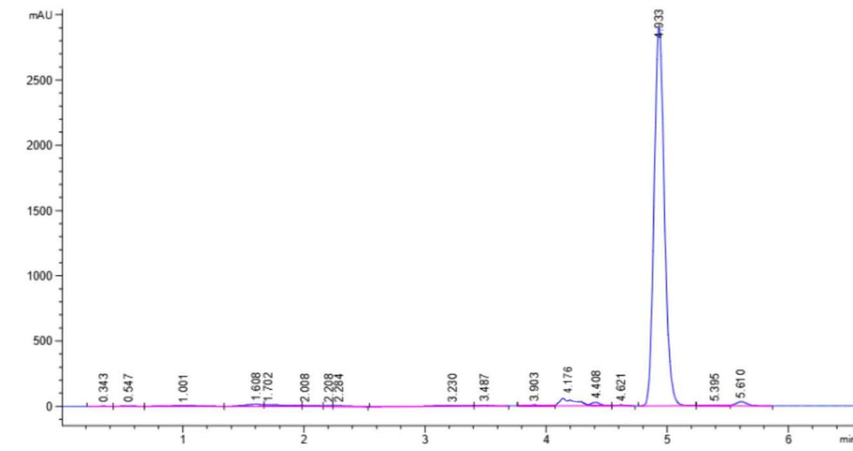
Fig S71 the HPLC spectrum of compound ZZ-15
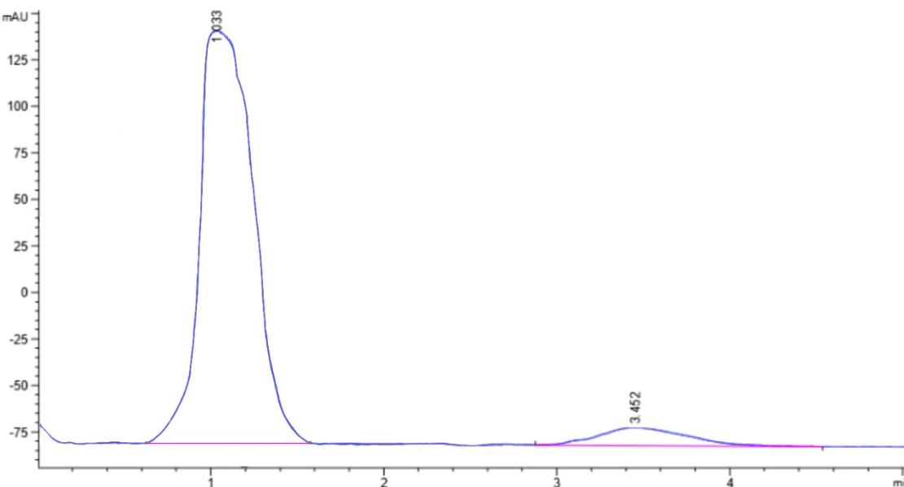
Fig S72 the HPLC spectrum of compound ZZ-16

