Supplementary Material
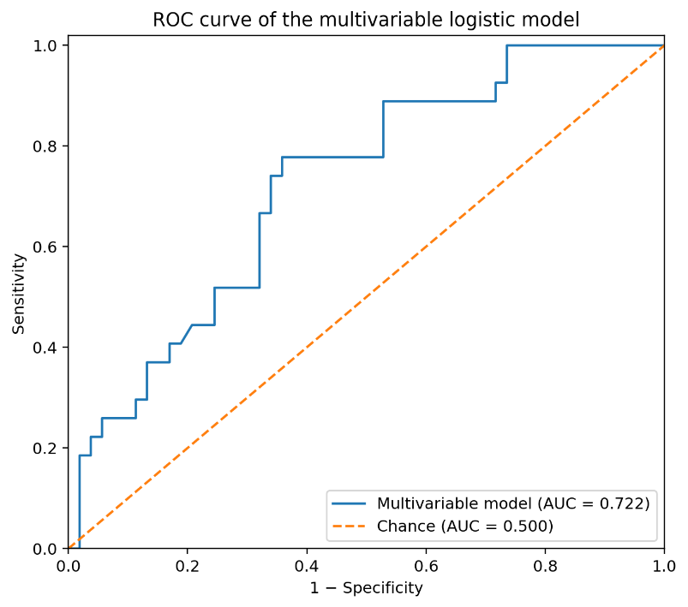
Supplementary Figure S1. ROC curve of the multivariable logistic regression model for abnormal rhinomanometry.

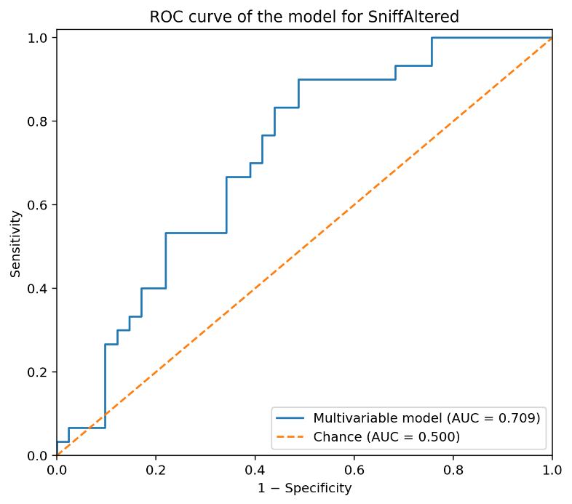
Supplementary Figure S2. ROC curve of the multivariable logistic regression model for an impaired Sniff Test.

