Appendix 1
Questionnaire for Assessing Student-Teachers' Perceptions of the Jigsaw Method Effectiveness
Thank you for your cooperation. Please complete the following questionnaire carefully.
Section One: Demographic Information
Gender: (a) Male (b) Female
Age:
(a) Under 20 years (b) 20-25 years (c) 25-30 years (d) Over 30 years
Field of Study:
(a) English Language Teaching (b) Translation Studies (c) Linguistics (d) English Language and Literature
Teaching Experience:
(a) Less than 1 year (b) 1-3 years (c) More than 3 years
Note: Please respond to each question based on your experiences in the Jigsaw method instructional classes. The options are presented on a 5-point Likert scale as follows:
5 – Strongly Agree
4 – Agree
3 – Neutral
2 – Disagree
1 – Strongly Disagree
Section Two: Assessment of Social-Cognitive Learning
1. In Jigsaw groups, I feel that I learn through interaction with group members.
5 – Strongly Agree 4 – Agree 3 – Neutral 2 – Disagree 1 – Strongly Disagree
2. Observing the translation process of other group members helped me improve my own methods.
5 – Strongly Agree 4 – Agree 3 – Neutral 2 – Disagree 1 – Strongly Disagree
3. The feedback I received from group members improved the accuracy of my translation.
5 – Strongly Agree 4 – Agree 3 – Neutral 2 – Disagree 1 – Strongly Disagree
4. Seeing others' translation methods helped me gain a better understanding of translation concepts.
5 – Strongly Agree 4 – Agree 3 – Neutral 2 – Disagree 1 – Strongly Disagree
Section Three: Assessment of Cooperative Learning
5. I easily share translation information and resources with others in the group.
5 – Strongly Agree 4 – Agree 3 – Neutral 2 – Disagree 1 – Strongly Disagree
6. In Jigsaw groups, we collectively identify translation problems and collaborate to solve them.
5 – Strongly Agree 4 – Agree 3 – Neutral 2 – Disagree 1 – Strongly Disagree
7. Interaction with group members in solving complex translation problems helped me discover new translation methods.
5 – Strongly Agree 4 – Agree 3 – Neutral 2 – Disagree 1 – Strongly Disagree
8. As a group, we decide on the best translation strategies for different texts.
5 – Strongly Agree 4 – Agree 3 – Neutral 2 – Disagree 1 – Strongly Disagree

Section Four: Assessment of Active Learning
9. In the translation learning process, I actively participate in Jigsaw group activities.
5 – Strongly Agree 4 – Agree 3 – Neutral 2 – Disagree 1 – Strongly Disagree
10. Group learning in Jigsaw classes helped strengthen my critical thinking skills in translation.
5 – Strongly Agree 4 – Agree 3 – Neutral 2 – Disagree 1 – Strongly Disagree
11. I use critical thinking and problem-solving to improve my translations.
5 – Strongly Agree 4 – Agree 3 – Neutral 2 – Disagree 1 – Strongly Disagree
12. In Jigsaw groups, I actively participated in exchanging opinions and revising translations.
5 – Strongly Agree 4 – Agree 3 – Neutral 2 – Disagree 1 – Strongly Disagree

Section Five: Assessment of the Jigsaw Method's Effectiveness in Improving Translation Skills
13. Using the Jigsaw method helped me gain a better understanding of translation principles and techniques.
5 – Strongly Agree 4 – Agree 3 – Neutral 2 – Disagree 1 – Strongly Disagree
14. The Jigsaw method improved the accuracy and quality of my translations.
5 – Strongly Agree 4 – Agree 3 – Neutral 2 – Disagree 1 – Strongly Disagree
15. Group learning through Jigsaw gave me more motivation to learn translation principles.
5 – Strongly Agree 4 – Agree 3 – Neutral 2 – Disagree 1 – Strongly Disagree
16. Compared to traditional teaching methods, the Jigsaw method was tangibly effective in improving my translation skills.
5 – Strongly Agree 4 – Agree 3 – Neutral 2 – Disagree 1 – Strongly Disagree

Section Six: Assessment of Group Interactions and Collaboration
17. In Jigsaw groups, interaction with group members helped me better understand complex translation concepts.
5 – Strongly Agree 4 – Agree 3 – Neutral 2 – Disagree 1 – Strongly Disagree
18. Collaboration with group members made me pay more attention to the translation process and improve it.
5 – Strongly Agree 4 – Agree 3 – Neutral 2 – Disagree 1 – Strongly Disagree
19. During group activities, I sought help from others to revise and improve my translations.
5 – Strongly Agree 4 – Agree 3 – Neutral 2 – Disagree 1 – Strongly Disagree

Appendix 2. Translation Skills Assessment Instrument (Pretest) - Page 95 of Select Readings: Upper-Intermediate
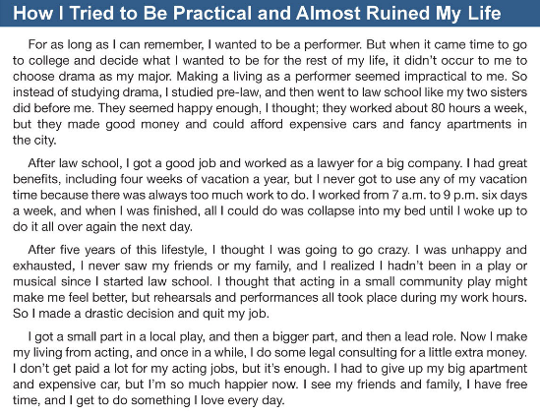

Appendix 3. Translation Skills Assessment Instrument (Posttest) - Page 119 of Select Readings: Upper-Intermediate
