Supplementary Information
For
Emerging Heat Wave Hotspots in Sri Lanka: The Role of Ocean–Atmosphere Coupling

Prabashvari Galagamage¹, Gayan Pathirana^{1,2*}, Xin Geng³, Dongxiao Wang⁴, Upul Premarthne¹
¹Department of Oceanography and Marine Geology, Faculty of Fisheries and Marine Sciences & Technology, University of Ruhuna, Matara, Sri Lanka.
²Center for Climate Change Studies, Matara, Sri Lanka.
³Nanjing University of Information Science & Technology, China.
⁴School of Marine Science, Sun Yat-sen University: Southern Marine Science and Engineering Guangdong Laboratory, Zhuhai, China.

*Correspondence to:
Dr. Gayan Pathirana (Email: upgpathirana@fish.ruh.ac.lk, Phone: +94717439611)
ORCID: https://orcid.org/0000-0002-4670-579X
Address: Department of Oceanography and Marine Geology, Faculty of Fisheries and Marine Sciences & Technology, University of Ruhuna, Matara, Sri Lanka.

Table S1 Observation Stations used for validation
Station no. | Station Name | Latitude N° | Longitude E° | Zone
1 | Bandarawela | 6.84 | 80.98 | Intermediate
2 | Jaffna | 9.68 | 80.03 | Dry
3 | Vavuniya | 8.75 | 80.5 | Dry
4 | Trincomalee | 8.58 | 81.25 | Dry
5 | Anuradhapura | 8.35 | 80.38 | Dry
6 | Maha Illuppallama | 8.12 | 80.47 | Dry
7 | Puttalam | 8.03 | 79.83 | Dry
8 | Batticaloa | 7.72 | 81.70 | Dry
9 | Kurunegala | 7.47 | 80.37 | Intermediate
10 | Katugastota | 7.33 | 80.63 | Wet
11 | Katunayaka | 7.17 | 79.88 | Wet
12 | Colombo | 6.90 | 79.87 | Wet
13 | Ratmalana | 6.82 | 79.88 | Wet
14 | Nuwara Eliya | 6.97 | 80.77 | Wet
15 | Badulla | 6.98 | 81.05 | Intermediate
16 | Ratnapura | 6.68 | 80.40 | Wet
17 | Galle | 6.03 | 80.22 | Wet
18 | Hambantota | 6.12 | 81.13 | Dry
19 | ‘Pottuvil | 6.88 | 81.83 | Dry

Table S2 Data used for the Study

Data | Time Period | Temporal Resolution  (Days) | Spatial Resolution  Latitude*Longitude | Data Source | Citation
2-m Air Temperature (t2m) | 1995 - 2024 | ~ 10, 950 | 0.25° × 0.25° | ERA5  ECMWF / | Hersbach et al., 2020
Vertical Velocity | 1995 - 2024 | ~ 10, 950 | 0.25° × 0.25° | ERA5  ECMWF | Hersbach et al., 2020
Surface winds | 1995 - 2024 | ~ 10, 950 | 0.25° × 0.25° | ERA5  ECMWF | Hersbach et al., 2020
OLR | 1995 - 2024 | ~ 10, 950 | 1° × 1° | NOAA CDR  HIRS | Lee, 2014
Shortwave Radiation | 1995 - 2024 | ~ 10, 950 | 0.25° × 0.25° | ERA5  ECMWF | Hersbach et al., 2020
Cloud Cover | 1995 - 2024 | ~ 10, 950 | 0.25° × 0.25° | ERA5  ECMWF | Hersbach et al., 2020
Total Precipitation | 1995 - 2024 | ~ 10, 950 | 0.25° × 0.25° | ERA5  ECMWF | Hersbach et al., 2020
SST | 1995 - 2024 | ~ 10, 950 | 0.25° × 0.25° | NOAA/NCDC  OISST | Reynolds et al., 2007
Relative Humidity (RH) | 1995 - 2024 | ~ 10, 950 | 0.25° × 0.25° | AgERA5 / Wageningen Environmental Research | Boogaard et al., 2020

Table S3 Seasonal Trends in Heat Wave Frequency, Maximum Intensity, and strongest Duration
HW Metric | Season | Slope | p_value | R²
Frequency | NEM | 0.0218 | 0.2282 | 0.3356
 | FIM | 0.0102 | 0.5882 | 0.0382
 | SWM | 0.0698 | 0.1069 | 0.3282
 | SIM | 0.0289 | 0.2823 | 0.0766
Maximum Intensity | NEM | -0.1829 | 0.0254 | 0.7512
 | FIM | 0.0159 | 0.8697 | 0.0036
 | SWM | -0.1212 | 0.2737 | 0.1677
 | SIM | 0.0409 | 0.5757 | 0.0213
Strongest Duration | NEM | 0.0212 | 0.9565 | 0.0008
 | FIM | -0.0640 | 0.5831 | 0.0393
 | SWM | 0.0776 | 0.4833 | 0.0726
 | SIM | 0.0408 | 0.7407 | 0.0075
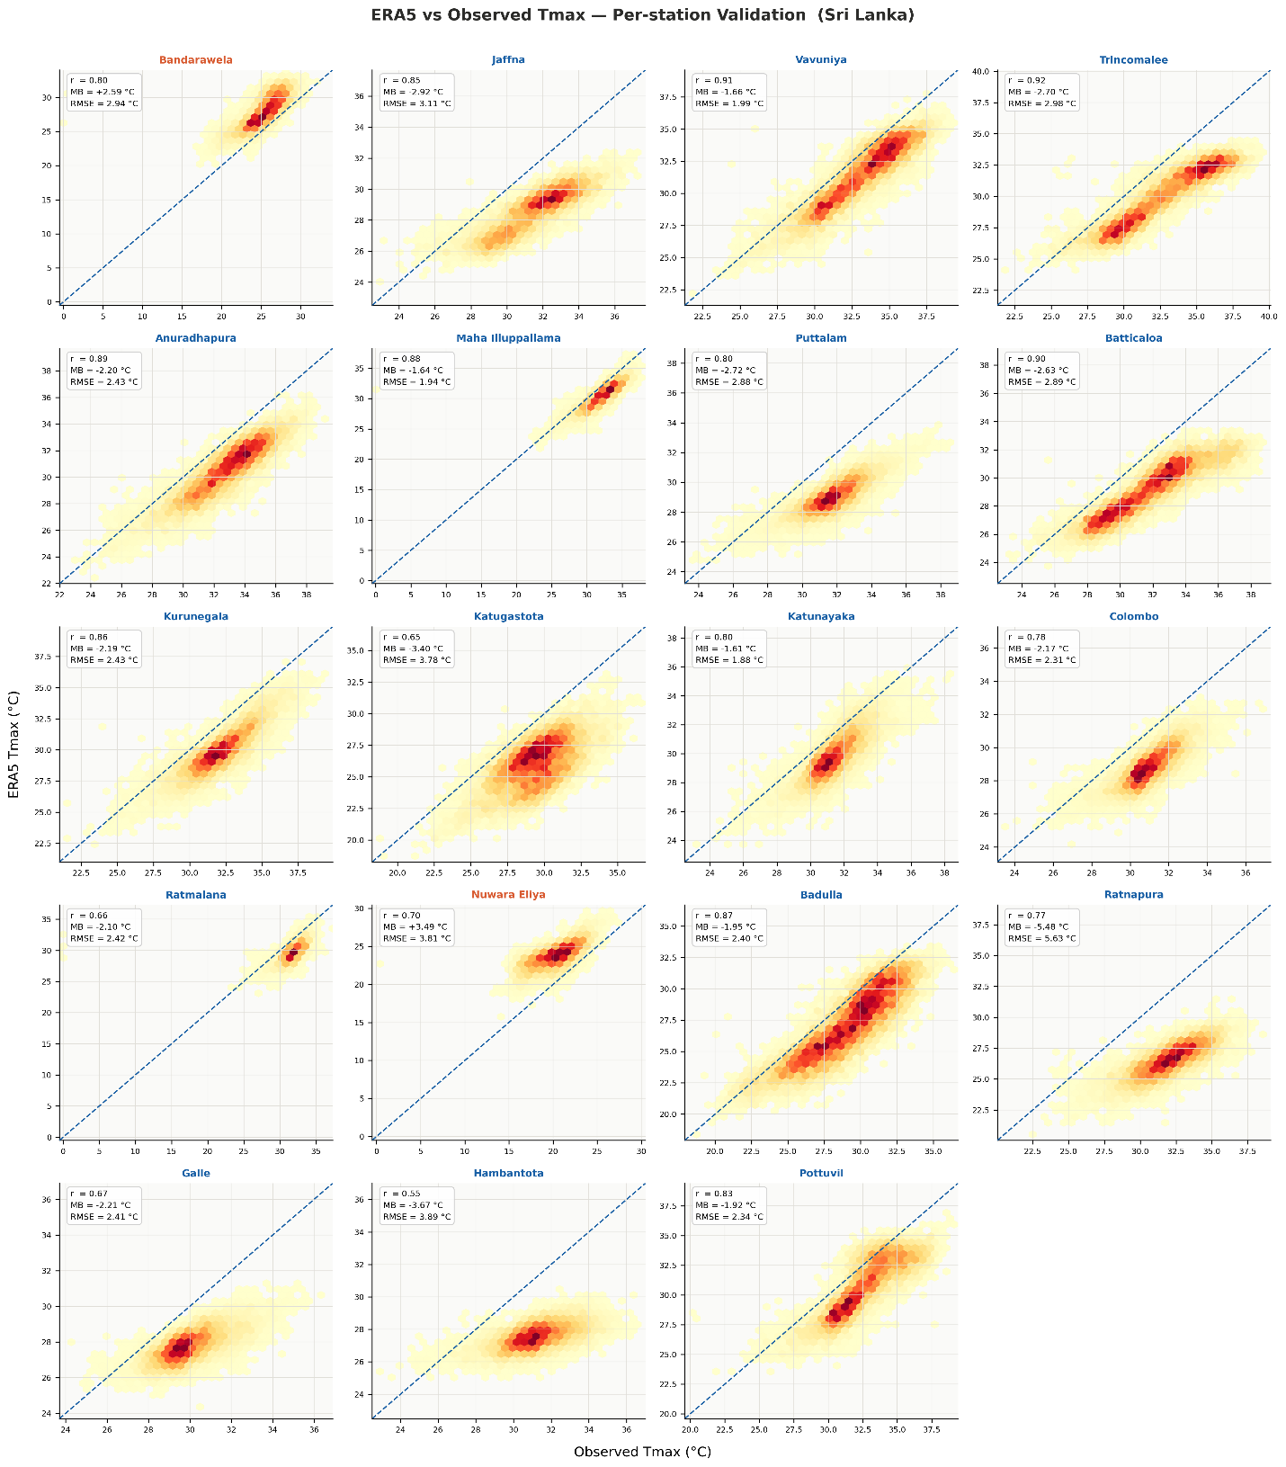

Fig. S1 Density scatter plots comparing ERA5 reanalysis daily maximum temperature (Tmax) against station-observed Tmax for 19 meteorological stations across Sri Lanka over the study period. Hexbin shading indicates point density (darker shades correspond to higher data density), and the dashed blue line denotes the 1:1 reference line. Pearson correlation coefficient (r) , mean bias (MB), and root-mean-square-error (RMSE) are reported for each station.
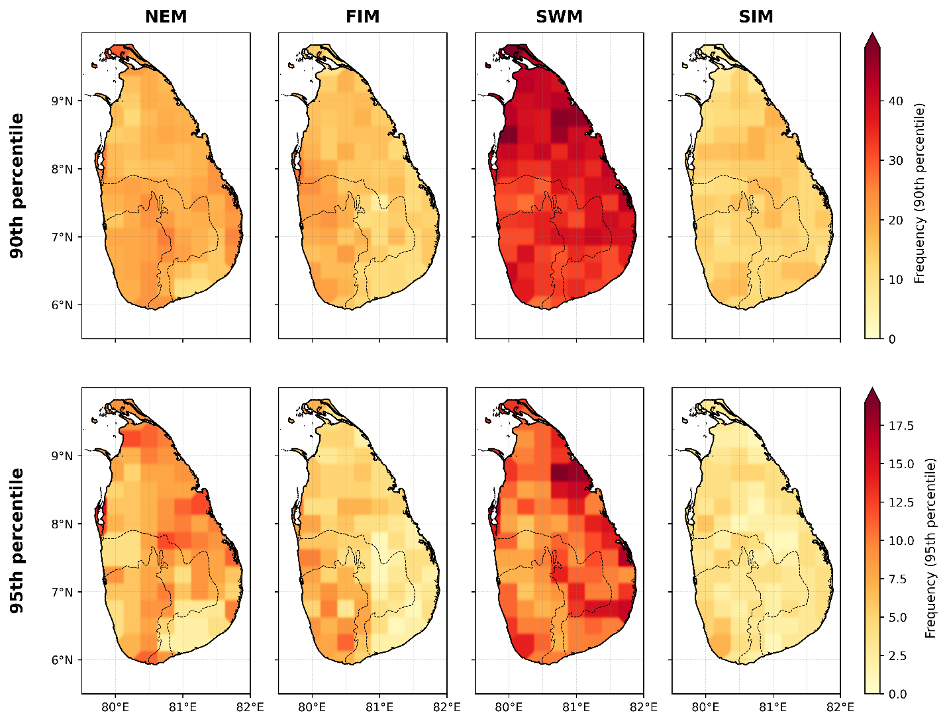
Fig. S2 Spatial distribution of Heat Wave frequency across Sri Lanka at the 90th and 95th percentile thresholds, shown separately for the four monsoon seasons: NEM, FIM, SWM, and SIM.

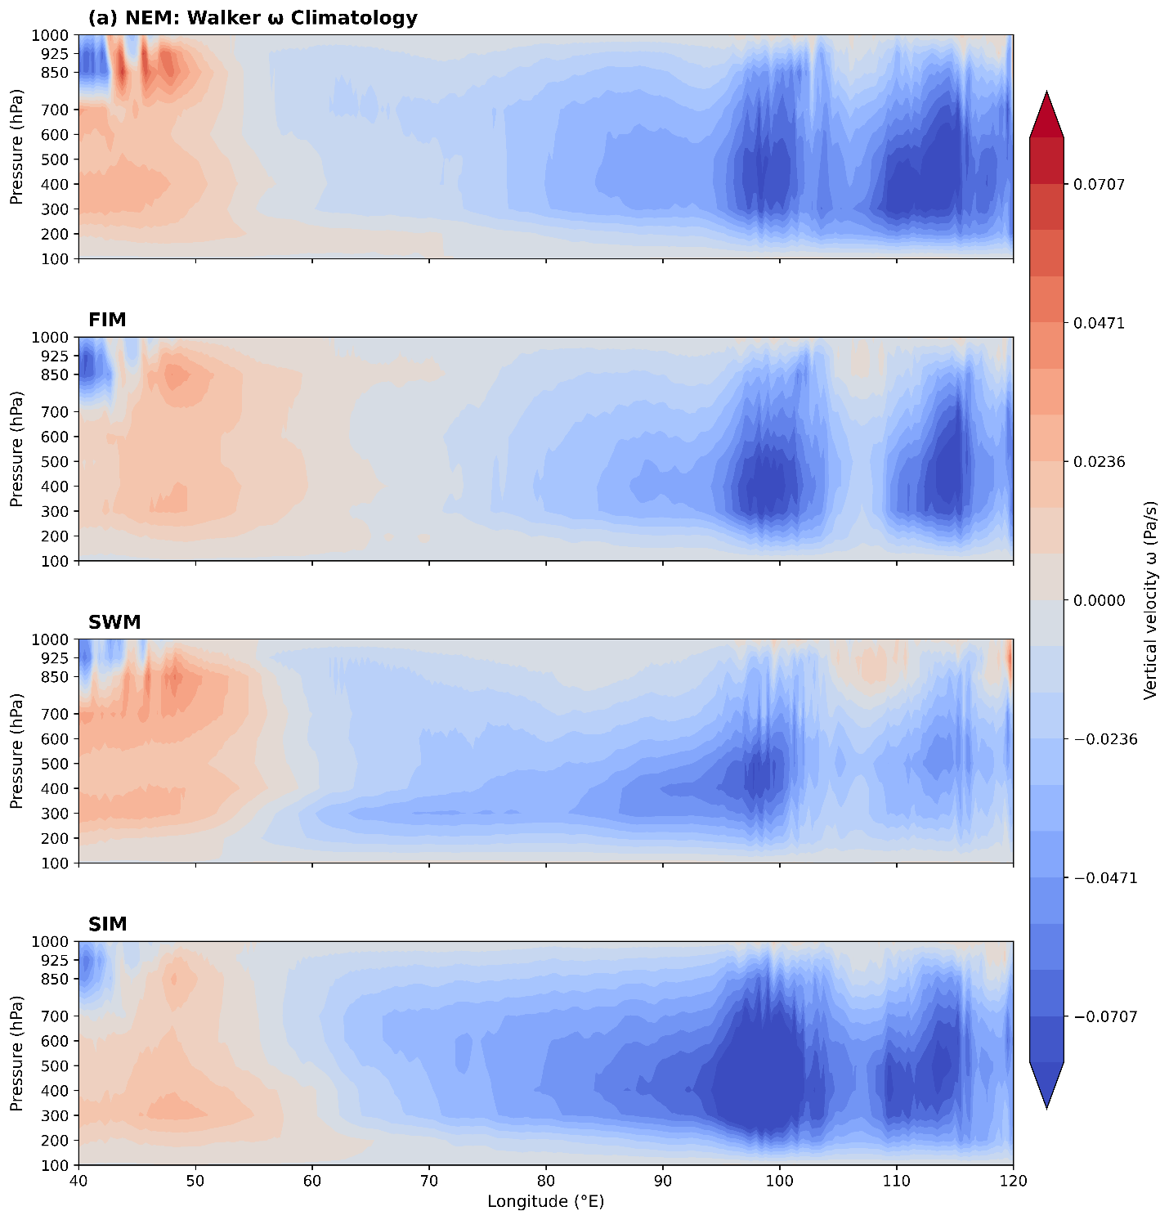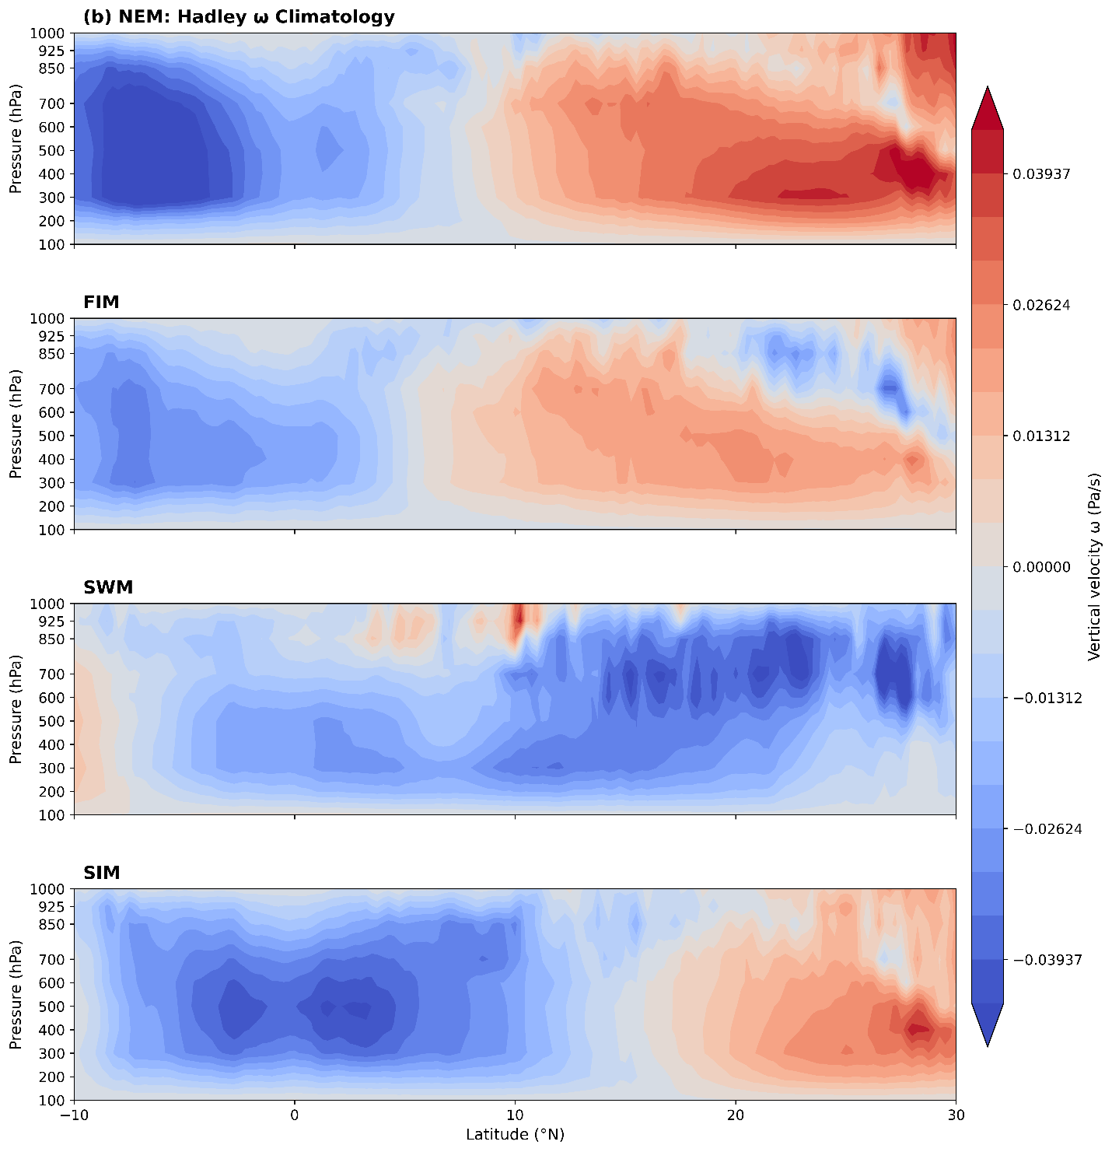
Fig. S3 (a) Seasonal Climatology of the Walker circulation across the tropical Indian Ocean (40°E–120°E) represented by vertical velocity (ω, Pa/s) in the longitude–pressure plane. (b) Seasonal climatology of the Hadley circulation over the tropical Indian Ocean (10S–30N) represented by vertical velocity (ω, Pa/s) in the latitude–pressure plane. Panels show the seasonal mean structure for NEM, FIM, SWM, and SIM. Negative values indicate ascending motion, while positive values represent subsidence
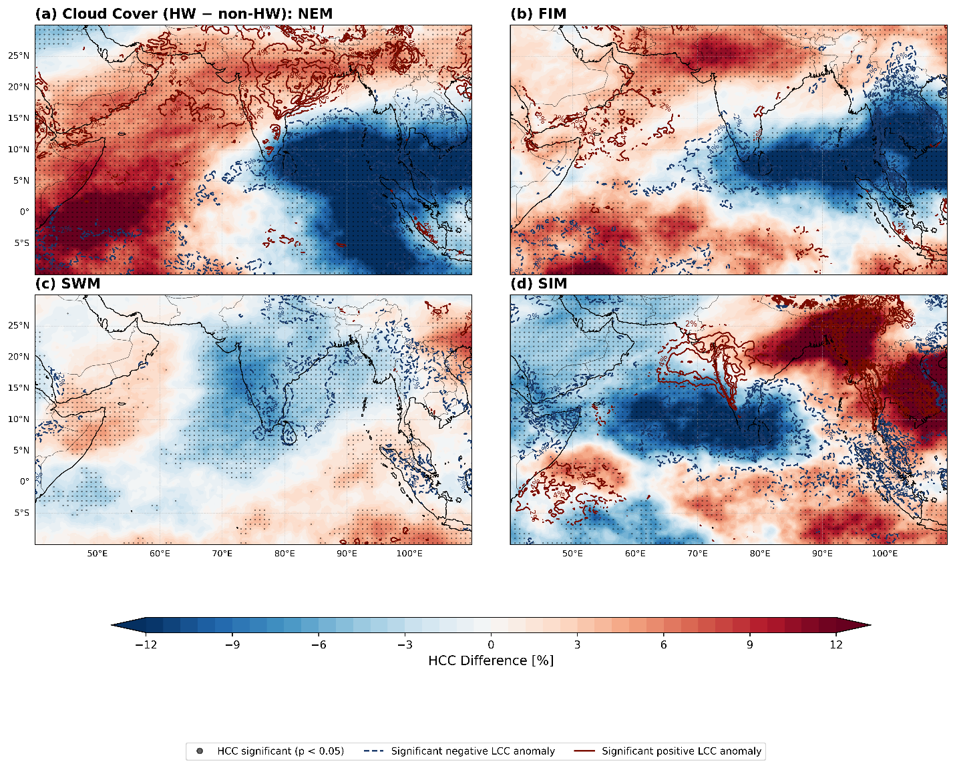
Fig. S4 Composite differences in HCC and LCC between HW and non-HW days. Color shading represent HCC (%) with hatching indicate statistically significant regions at the 5% level (Welch’s t-test ) and Contour lines represent LCC (%) differences, with solid lines indicating Statistically Significant positive anomalies and dashed lines indicating Statistically Significant negative anomalies at the 5% level (Welch’s t-test) (interval: 2%)

