Supplementary Figure S2
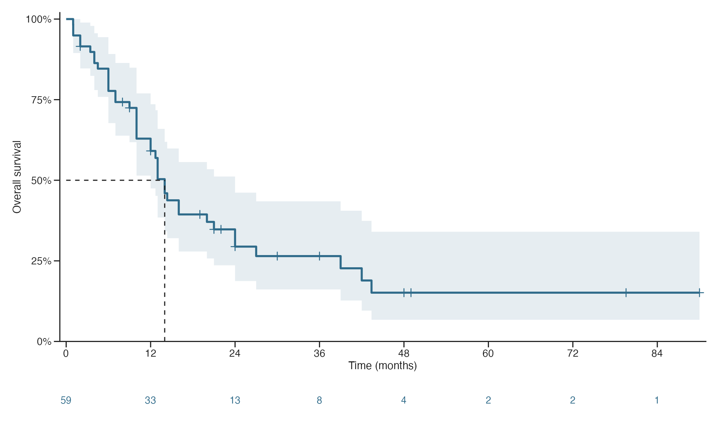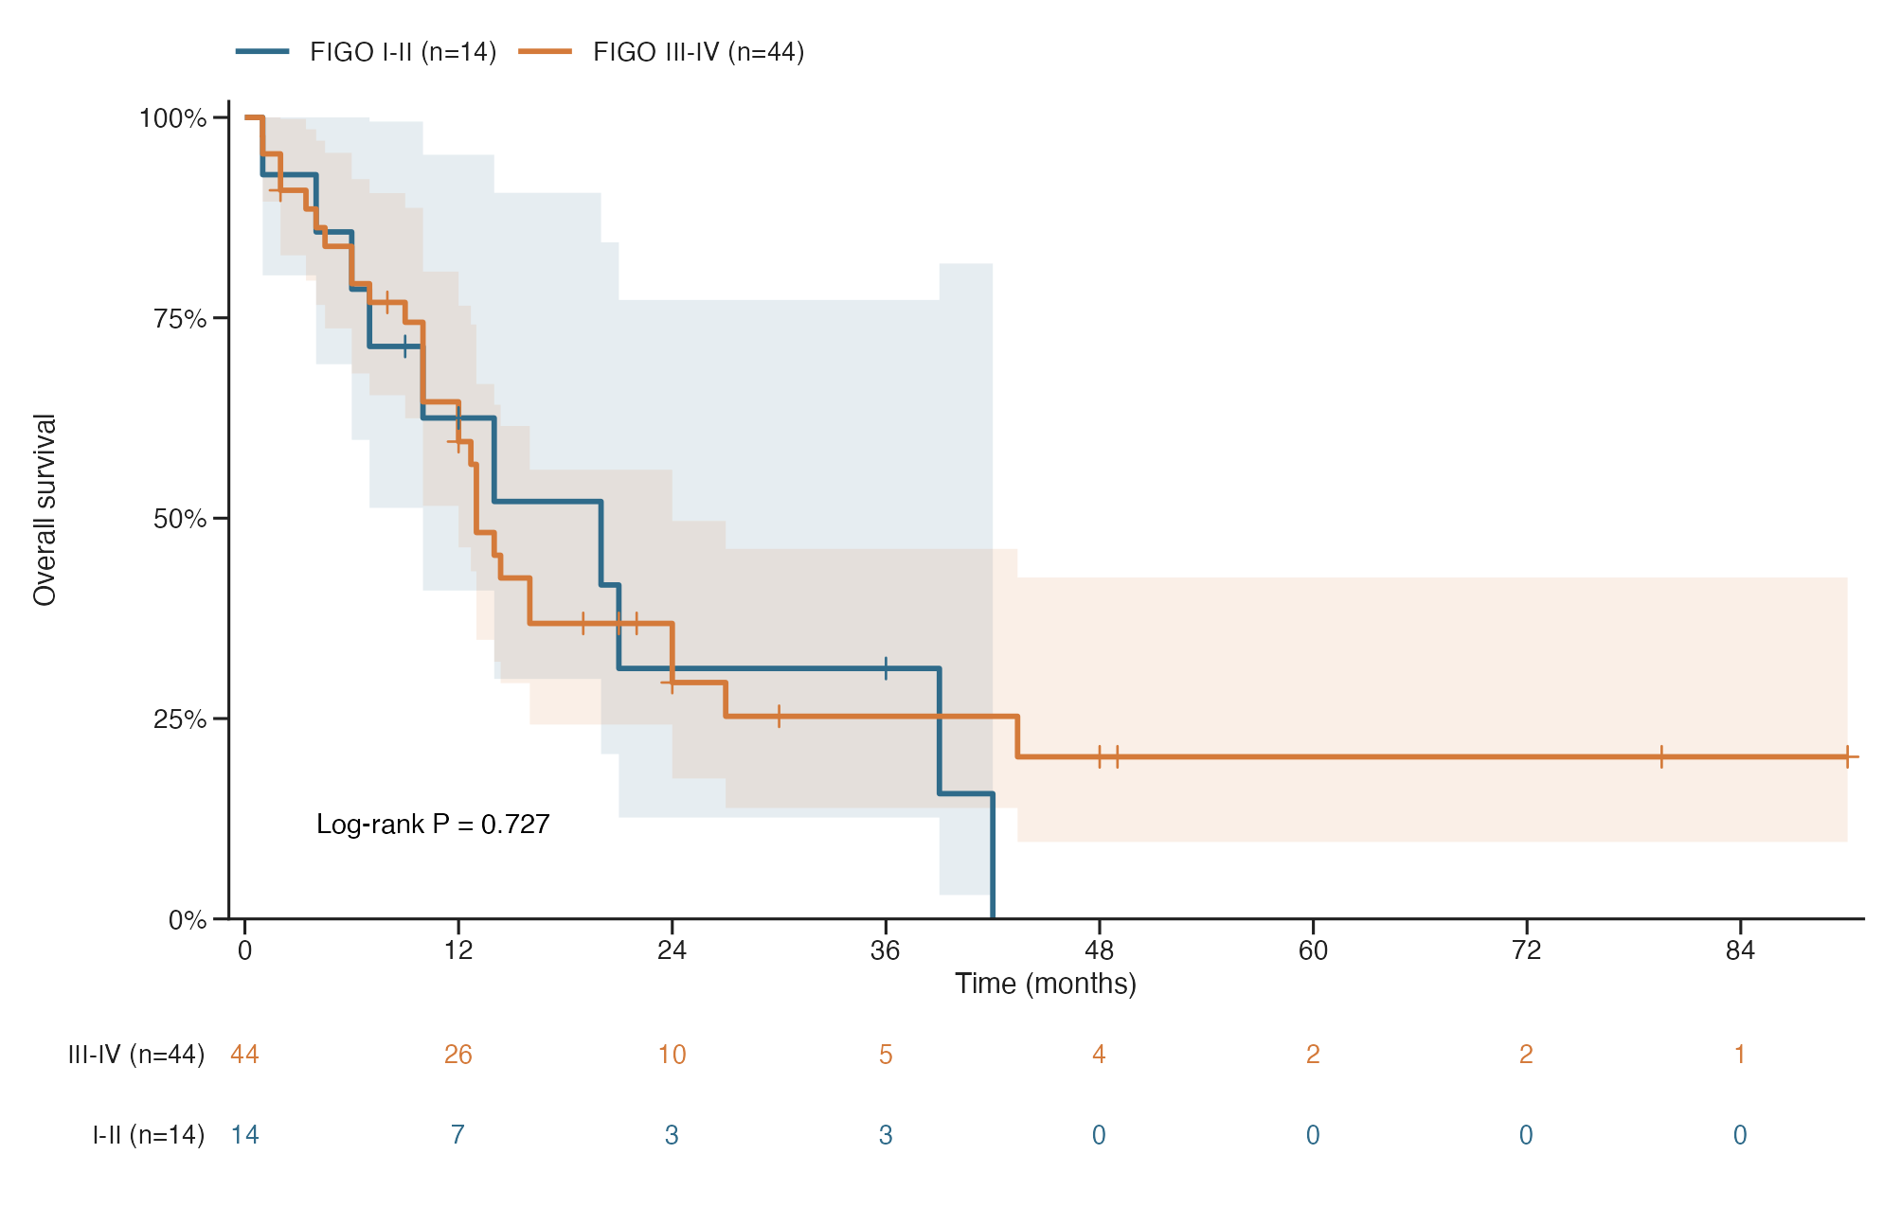
Supplementary Figure S2. Sensitivity analyses of overall survival restricted to published SCCOPT cases.
(A) Kaplan–Meier estimate of overall survival among 59 patients identified from published reports. The median overall survival was 14.0 months.
(B) Overall survival according to FIGO stage among published cases with available stage information. Fourteen patients had early-stage disease (FIGO I–II), and 44 had advanced-stage disease (FIGO III–IV); one patient was excluded from the stage-stratified analysis because stage information was unavailable. No significant difference was observed between the two groups (log-rank P = 0.727). Shaded areas represent 95% confidence intervals, vertical tick marks indicate censored observations, and the numbers below the plots indicate patients at risk.

