Supplementary Figure S1
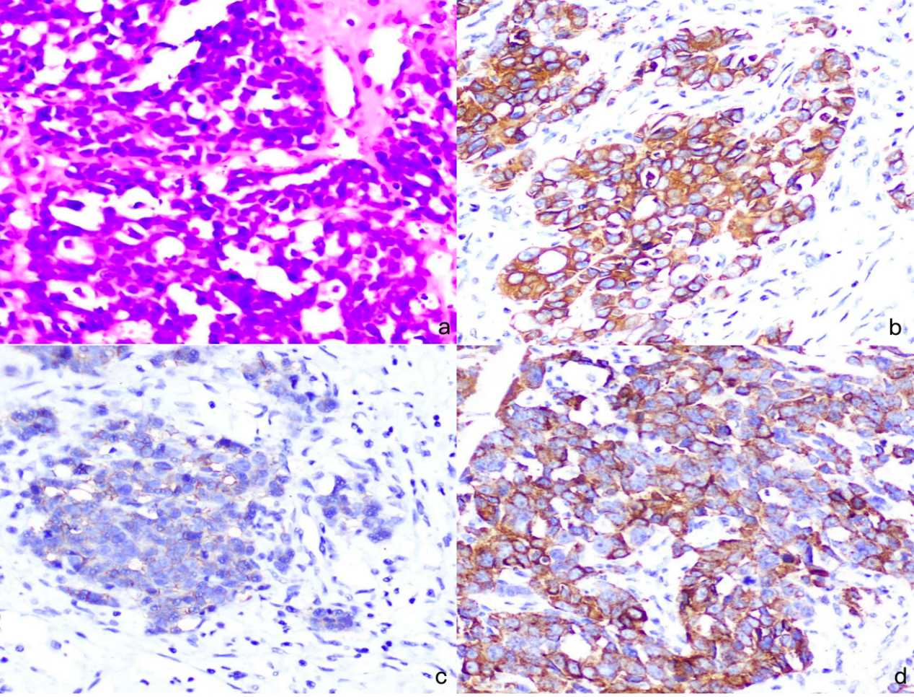
H&E staining as shown in a. CK (200×; H&E staining); b. Positive staining for SYN (200×); c. Positive staining for CD56 (200×); d. Positive staining for CGA (200×).

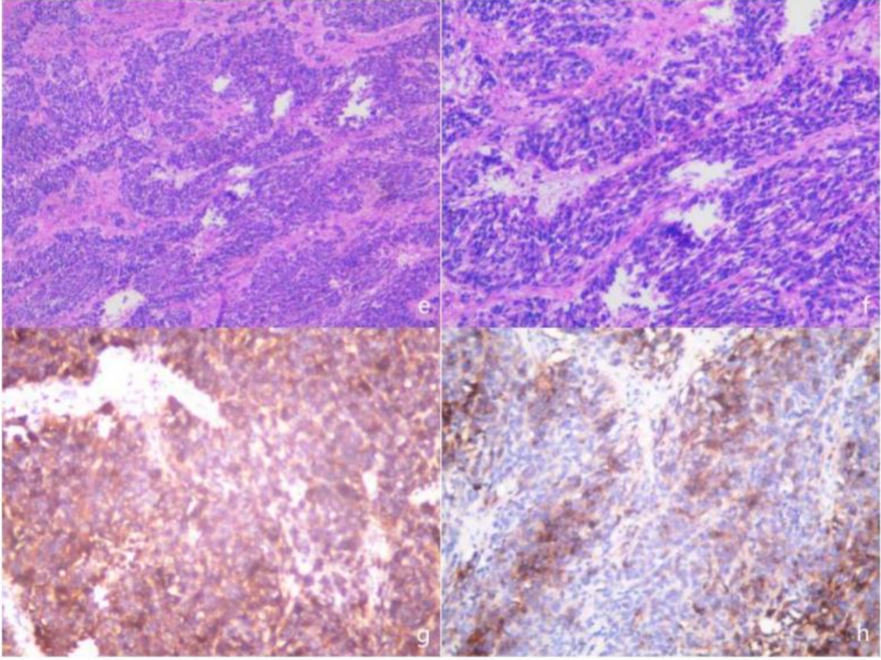
H&E staining as shown in (e) - HE X 5 and (f) - HE X 10 reveals cells of relatively uniform size, with a homogeneous appearance and round or ovoid nuclei. Immunohistochemistry: (g) CD56+, (h) partially SYN+.

