Supporting Information

Reaction Atmosphere-Induced In-Situ Restructuring of FeO_{x} Nanoparticles to Isolated (≡SiO)₃–Fe Sites for High-Temperature NH₃-SCR
Qiang Zhao^{a,b#}, Chao Feng^{c#}, Haitao Zhang^{d}, Zhaoyang Liª, Guodong Zhang^{a*}, Zhicheng Tang^{a*}
(ª National Engineering Research Center for Fine Petrochemical Intermediates, State Key Laboratory of Low Carbon Catalysis and Carbon Dioxide Utilization, Lanzhou Institute of Chemical Physics, Chinese Academy of Sciences, Lanzhou 730000, China.
^{b} University of Chinese Academy of Sciences, Beijing 100039, China.
^{c} College of Chemical and Biological Engineering, Shandong University of Science and Technology, Qingdao, Shandong 266590, China.
^{d} Lanzhou Petrochemical Research Center, Petrochemical Research Institute, PetroChina, Lanzhou 730060, China)
________________________
∗Corresponding author.
#These authors contributed equally: Qiang Zhao, Chao Feng.
E-mail address: guodongzhang@licp.cas.cn (G. Zhang), tangzhicheng@licp.cas.cn (Z. Tang)
Table of Contents
Experimental Section 4
1. Catalyst Preparation 4
2. Catalytic performance test 6
3. Reaction Kinetic Test 7
4. Theoretical calculations 8
5. Catalyst characterizations 10
Result and Discussion 15
Fig. S1. HRTEM images and Electron diffraction rings of the Fe-ZSM-5(20) (a-b), Fe-ZSM-5(20)-H (c-d), Fe-ZSM-5(20)-R (e-f). 15
Fig. S2. N₂ adsorption-desorption isotherms of Fe-ZSM-5(20) and Fe-ZSM-5(100) catalysts before and after NH₃-SCR reaction. 16
Fig. S3. HRTEM images and Electron diffraction rings of the fresh Fe-ZSM-5(100) (a-b) and Fe-ZSM-5(100)-H (c-d). 17
Fig. S4. XRD spectra of Fe-ZSM-5(100) and Fe-ZSM-5(100)-R catalysts. 18
Fig. S5. EDS mappings of Fe-ZSM-5(20). 19
Fig. S6. EDS mappings of Fe-ZSM-5(20)-H. 20
Fig. S7. UV–vis-NIR spectra of Fe-ZSM-5(100) and Fe-ZSM-5(100)-R. 21
Fig. S8. TEM images of Fe-ZSM-5(100) and Fe-ZSM-5(100)-R. 22
Fig. S9. Raman spectra of different catalysts. 23
Fig. S10. Temperature-dependent variations for NO, NO₂, N₂O and NH₃ concentrations in the absence of the catalyst. 24
Fig. S11. Variation of NO_{x} on Fe-ZSM-5(20) catalyst aftter H₂O treatment at 650 ºC. 25
Fig. S12. Variation of NO_{x} and NH₃ Conversion on Fe-ZSM-5(20) catalyst during NO + NH₃ treatment at 650 ºC. 26
Fig. S13. Stability Test of the Fe-ZSM-5(20) Catalyst at 650 ºC 27
Fig. S14. Stability test of Fe-ZSM-5(20)-H for 85h at 650 ºC. 28
Fig. S15. The Effect of Si/Al on the NO_{x} Conversion (a), NH₃ Conversion (b) and N₂ Selectivity (c) of Fe-ZSM-5(x). 29
Fig. S16. Stability Test of the Fe-ZSM-5(x) Catalyst before and after NO+NH₃+H₂O treatment at 650 ºC 30
Fig. S17. Stability test containing 5 vol.% H₂O or 180 ppm SO₂ at 650 ºC. 31
Fig. S18. The Fourier transform R-spaced extended X-ray absorption fine spectra (FT-EXAFS) (left) fitted k³χ(k) oscillation curve (right) and of standard samples and catalysts. 32
Fig. S19. H₂-TPR of different catalysts. 33
Fig. S20. TG curves of Fe-ZSM-5(20) and Fe-ZSM-5(20)-R. 34
Fig. S21 35
Fig. S22. Charge density difference plot for Fe-ZSM-5(20) (a-b) and Fe-ZSM-5(20)-H (c-d). The isosurface value is 0.01 e·Bohr⁻³. Pink is positive and blue is negative (yellow: Si, blue: Fe, cyan: Al). 36
Fig. S23. Density of state (DOS) of Fe-ZSM-5(20) (a) and Fe-ZSM-5(20)-H (b). 37
Fig. S24. Deconvolution fitting process of the NH3 desorption profiles of the Fe-ZSM-5(20) catalyst before and after reaction atmosphere treatment. 38
Fig. S25. Deconvolution fitting process of the NO desorption profiles of the Fe-ZSM-5(20) catalyst before and after reaction atmosphere treatment. 39
Fig. S26. O₂ desorption profiles of Fe-ZSM-5(x) catalysts with different Si/Al ratios before and after reaction atmosphere treatment. 40
Fig. S27. The Crystal Orbital Hamilton Populations (COHP) analysis for NO adsorption (a) and activation (b) on FeO_{x} sites and single-atom Fe sites. 41
Fig. S28. In situ DRIFTs of NH₃ adsorption at 50 ºC (a) and 450 ºC (b), NO+O₂ reacted with pre-adsorbed NH₃ (c-d) on the surface of Fe-ZSM-5(20) at 450 ºC. 42
Fig. S29. In situ DRIFTs of NH₃ adsorption at 50 ºC (a) and 450 ºC (b), NO+O₂ reacted with pre-adsorbed NH₃ (c-d) on the surface of Fe-ZSM-5(20)-H at 450 ºC. 43
Fig. S30. In situ DRIFTs of NO reacted with pre-adsorbed NH₃ on the surface of Fe-ZSM-5(20) at 450 ºC. 44
Fig. S31. In situ DRIFTs of NO reacted with pre-adsorbed NH₃ on the surface of Fe-ZSM-5(20)-H at 450 ºC. 45
Fig. S32. Oxidation capacity of O₂ on the catalyst surface toward NH₃ (a) and NO (b) at 650 °C (GHSV=30,000 h⁻¹). 46
Table S1. EXAFS data fitting results of catalysts. 47
Table S2. BET specific surface area and pore structure properties. 48
Table S3. XPS results of the main atom content (%) on the surface of catalysts. 49
Table S4. ICP results of Fe element in different catalysts. 50
References 51

Experimental Section

1. Catalyst Preparation
Fe(NO₃)₃·9H₂O and tetraethyl orthosilicate (TEOS) were purchased from Chengdu Kelong Chemical Co., Ltd. Colloidal silica, sodium aluminate (NaAlO₂), and Tetrapropylammonium hydroxide solution (25 wt% in H₂O, TPAOH) were obtained from Shandong Keyuan Biochemical Co., Ltd. L-Lysine was purchased from Sinopharm Chemical Reagent Co., Ltd. Sodium hydroxide (NaOH) from Beijing Beihua Fine Chemicals Co., Ltd., and NH₄Cl from Sichuan Xilong Scientific Co., Ltd.
Synthesis of ZSM-5 Zeolite. ZSM-5 were synthesized according to the previously reported procedure.¹⁻² The detailed procedure was as follows. ZSM-5 seeds were first synthesized using a precursor mixture with the following molar composition: 1.0 SiO₂: 0.03 Al₂O₃: 0.0018 NaOH: 0.45 TPAOH: 9 H₂O: 0.4 L-lysine. Specifically, TEOS and TPAOH were thoroughly mixed to obtain solution A. NaAlO₂ and NaOH were dissolved in distilled water to prepare solution B. Solution B was then added dropwise to solution A, followed by the addition of L-lysine. The resulting mixture was continuously stirred at 60 ºC until a gel was formed. The gel was transferred into a Teflon-lined stainless-steel autoclave and hydrothermally treated at 90 ºC for 22 h. The resulting product was collected by repeated centrifugation and washing, dried at 80 ºC for 12 h, and subsequently calcined in a muffle furnace at 550 ºC for 6 h. The obtained white powder was used as the ZSM-5 zeolite seed. Synthesis of ZSM-5 Zeolites with different Si/Al ratios. The precursor mixture had the following molar composition: 1.0 SiO₂: m Al₂O₃: 0.38 NaOH: n TPAOH: 15 H₂O. The Si/Al ratio of the ZSM-5 zeolites was controlled by varying the amount of Al₂O₃, while the TPAOH/ Al₂O₃ molar ratio was fixed at 2.0. Specifically, colloidal silica was first mixed with TPAOH, followed by the addition of ZSM-5 seeds (13 wt%, compared to SiO₂). NaAlO₂ and NaOH were dissolved in distilled water and then added dropwise to the above mixture. The resulting mixture was transferred into a Teflon-lined stainless-steel autoclave and hydrothermally treated at 170 ºC for 72 h. The product was collected by repeated centrifugation and washing, dried at 80 ºC for 12 h, and subsequently calcined in a muffle furnace at 550 ºC for 6 h. The resulting samples were denoted as Na-ZSM-5.
To obtain H-ZSM-5, 3.0 g of Na-ZSM-5 was dispersed in 150 mL of NH₄Cl solution (2 M) and stirred vigorously for 6 h in a water bath at 80 ºC. The solid was then collected by centrifugation and dried at 80 ºC for 12 h. The ion-exchange procedure was repeated once to ensure sufficient removal of Na⁺ ions. Finally, the samples were calcined at 650 ºC for 6 h and denoted as ZSM-5(x), where x = 20, 50, or 100 represents the atomic Si/Al ratio.
Preparation of Fe-ZSM-5(x) Catalysts. Fe species were introduced into ZSM-5 by ion exchange. Specifically, 0.018 g of Fe(NO₃)₃·9H₂O was dissolved in 100 mL of distilled water, after which 0.5 g of ZSM-5 was dispersed in the solution and stirred in a water bath at 80 ºC for 6 h. The resulting suspension was repeatedly centrifuged, and the collected solid was dried at 80 ºC for 12 h and subsequently calcined at 550 ºC for 2 h. The obtained catalysts were denoted as Fe-ZSM-5(x).
Preparation of Fe-ZSM-5(x)-H. Fe-ZSM-5(x) was placed in a fixed-bed NH₃-SCR reactor and heated slowly to 650 ºC under standard SCR conditions. The feed gas consisted of 500 ppm NO, 500 ppm NH₃, and 5 vol% O₂, with N₂ as the balance gas, at a gas space velocity of 30,000 h⁻¹. After the temperature stabilized, the 5 vol% O₂ in the standard feed was replaced with 5 vol% H₂O while maintaining the NO and NH₃ concentrations unchanged. The catalyst was then treated under 500 ppm NO + 500 ppm NH₃ + 5 vol% H₂O for 12 h. Subsequently, the 5 vol% H₂O was replaced with 5 vol% O₂, and the catalyst was further exposed to 500 ppm NO + 500 ppm NH₃ + 5 vol% O₂ for 2 h. The resulting samples were denoted as Fe-ZSM-5(x)-H.
The samples obtained after subjecting Fe-ZSM-5(x)-H to long-term NH₃-SCR reaction at 650 ºC, followed by SO₂ and H₂O tolerance tests, were denoted as Fe-ZSM-5(x)-R.

2. Catalytic performance test
The NH₃-SCR activity tests were performed using a fixed-bed reactor (KLYT5010TCP). The 0.4 g catalyst was loaded into a quartz tube reactor with an inner diameter of 8mm. The simulated flue gas flow rate was controlled at 200 mL/min (GHSV=30,000 h⁻¹), mainly consisting of NO (500 ppm), NH₃ (500 ppm), O₂ (5 vol%) and N₂ (as the balancing gas). The concentrations of NO, NO₂, N₂O, NH₃, and SO₂ in the flue gas were measured by the GASMET DX4000 flue gas analyzer. The conversion of NO_{x}, NH₃ and N₂ selectivity of different catalysts were calculated by Eq. 1-3.
$\text{NO}\text{x}\text{ conversion }\left(\text{\%}\right)=\frac{\left[\text{NO}\right]\text{in - }\left[\text{NO}\text{x}\right]\text{out}}{\left[\text{NO}\right]\text{in}}\text{×100\%}$ (1)
$\text{NH}\text{3}\text{ conversion }\left(\text{\%}\right)\text{ = }\frac{\left[{NH}_{3}\right]\text{in - }\left[{NH}_{3}\right]\text{out}}{\left[{NH}_{3}\right]\text{in}}\text{×100\%}$ (2)
$\text{N}\text{2}\text{ Selectivity (\%) = (1-}\frac{\text{2×}\left[\text{N}\text{2}\text{O}\right]\text{out}}{ \left[\text{NO}\right]\text{in }\text{- }\left[\text{NO}\text{x}\right]\text{out + }\left[\text{NH}\text{3}\right]\text{in - }\left[\text{NH}\text{3}\right]\text{out}}\text{)×100\%}$ (3)

3. Reaction Kinetic Test
The empirical kinetic expression of the reaction rate equation for NO_{x} conversion can be described as:
$R_{{NO}_{x}}=KP_{{NO}_{x}}^{α}×P_{O_{2}}^{β}×P_{{NH}_{3}}^{γ}$ (4)
$F_{total}=F_{N_{2}}+F_{O_{2}}+F_{NO}+F_{{NH}_{3}}$=539 ml/min
At atmospheric pressure, $P_{O_{2}}=\frac{F_{O_{2}}}{539}×P_{total}$
Since both F_{total} and P_{total} are constant, $F_{O_{2}}$ can be directly used instead of $P_{O_{2}}$to fit the reaction order.
Similarly, since $F_{NO}$ and $F_{{NH}_{3}}$ are constant. Therefore,
${LnR}_{{NO}_{x}}=βLnP_{O_{2}}+A$ (5)
To reduce the NO_{x} conversion to below 35% at 360 ºC and 650 ºC, 0.03g of powdered Fe-ZSM-5(20)-H catalyst was loaded into the reactor, and the GHSV was increased to 1,000,000 h⁻¹. This effectively eliminated the mass transfer limitations of the catalyst.

4. Theoretical calculations
All calculations were performed using the density functional theory (DFT) technique using the Vienna ab initio simulation package (VASP).³ Spin-polarized calculations were performed using the generalized gradient approximation (GGA) combined with the Perdew-Burke-Ernzerhof (PBE) method to determine the exchange and correlation energies. The projector-augmented wave (PAW) method was used to represent the core-valence electron interactions. The typical plane-wave cutoff energy was 400 eV for basis-set expansion. For geometry optimization calculations, forces were converged below 0.03 eV/Å. The SCF convergence energy was 1 × 10⁻⁴ eV. A 1 × 1 × 1 k-point mesh was used to perform all the calculations.
The adsorption energy (E_{ads}) of the NO and the other molecule on the surface was calculated as follows (eq 6):
$${\text{E}}_{\text{ads}}\text{=}{\text{E}}_{\text{adsorbate + surface}}\text{-}{\text{E}}_{\text{surface}}\text{-}{\text{E}}_{\text{gas}}\text{ (6) }$$
Where E_{surface} is the clean surface relaxation energy of the surface slab, E_{gas} is the energy of a free gas molecule under conditions of vacuum, and E_{adsorbate + surface} is the energy of the composite system.
According to the definition of ΔG⁴⁻⁷
$\text{∆G=∆E+∆}{\text{E}}_{\text{ZPE}}\text{-T∆S+∆}{\text{G}}_{\text{U}}\text{+∆}{\text{G}}_{\text{pH}}\text{+∆}{\text{G}}_{\text{field}}$ (7)
ΔE is directly calculated by DFT.
ΔE_{ZPE} is obtained by calculating the vibration frequency of the intermediate (the ZPE corrects for the vibration of the adsorbate at 0 K). Due to the conservation of elements before and after each calculation step, in the calculation, ΔE_{ZPE} can be approximated as 0.
Because of the temperature we defined as 0 K, TΔS = 0⁷.
ΔG_{pH} is the contribution of H⁺ concentration change to the Gibbs free energy. Due to the absence of pH changes in the gas-solid reaction, it can be ignored as 0⁸.
ΔG_{U} is the contribution of free energy in the electrode potential. Electrocatalysis is not involved in this experiment, so it is ignored.
The correction term for electric double layer free energy, known as ΔG_{field}, has a negligible effect on overall free energy and can be ignored⁶.
As the calculations are performed at 0 K at a fixed cell volume, the differences in the Gibbs free energy should equal the differences in the total energy. By this definition, a negative value of E_{ads} corresponds to exothermic and spontaneous adsorption processes.
The barrier energy, ΔE, for a difference between the transition state energy difference and standard product formation enthalpy is defined as follows. The energy barrier calculation of *-NO and *-O to *-NO₂ on Fe-ZSM-5(20) as an example (eq 8):
$$\text{Δ}\text{E=}\left({\text{E}}_{\text{NO}\text{2}\text{-Fe-ZSM-5(20)}}\text{-}{\text{E}}_{\text{stab-Fe-ZSM-5(20)}}\right)\text{-(}{\text{E}}_{\text{NO+O-Fe-ZSM-5(20)}}\text{-}{\text{E}}_{\text{stab-Fe-ZSM-5(20)}}\text{) (8) }$$
Where ${\text{E}}_{\text{NO+O-Fe-ZSM-5(20)}}$ and ${\text{E}}_{\text{NO}\text{2}\text{-Fe-ZSM-5(20)}}$ are the energies of the *-NO+O and *-NO₂ on Fe-ZSM-5(20), ${\text{E}}_{\text{stab-Fe-ZSM-5(20)}}$ is the energy of the Fe-ZSM-5(20) surface slab. As the calculations are performed a t=0 K at a fixed cell volume, the differences in the Gibbs free energy should equal the differences in the total energy. By this definition, the lower the ΔE is, the easier it is to react.

5. Catalyst characterizations
The morphology of the catalysts was observed by JEOL JEM-2010 transmission electron microscope (TEM). Rigaku D/MAX-RB X-ray diffractometer (XRD) was used to scan the catalysts in the range of 10-60°. The catalysts were scanned in the range of 100-2000 cm⁻¹ by Lab Ram HR Evolution confocal microscope to obtain Raman results. The BET specific surface area and pore structure of the catalyst were detected and analyzed by N₂ adsorption-desorption experiment using Micromeritics ASAP 2010 instrument. The real content of Fe element (ICP) over the catalyst was obtained by measuring each catalyst with an Agilent ICP-OES 730 instrument. The elemental compositions and valence states on the catalyst surface were qualitatively and quantitatively analyzed by X-ray photoelectron spectrometer (XPS) of VG ESCALAB 210 (Mg Kα radiation was 1253.6 eV). The UV-VIS-NIR results were tested using a Shimadzu 3600 Plus spectrophotometer. The Electron Paramagnetic Resonance (EPR) Technology were employed using a Bruker A300 (Germany), the testing process was carried out at 77K. The NETZSCH STA 449F5 tester was used to increase the temperature from room temperature to 800 ºC for thermogravimetric analysis (TG/DSC) testing of the catalyst. High-angle annular Dark-Field Scanning Transmission Electron Microscopy (AC-HAADF-STEM) images were acquired using a Thermo Fisher Spectra 300 transmission electron microscope equipped with probe and imaging spherical aberration correctors. The ²⁷Al and ²⁹Si solid-state MAS NMR characterizations of the catalysts were performed on a Bruker AVANCE NEO 600 MHz wide-bore spectrometer equipped with a 3.2 mm HXY magic-angle spinning (MAS) probe.
NH₃-TPD, H₂-TPR, O₂-TPD and NO-TPD was measured by Tian-jinXQ TP-5080D auto-adsorption apparatus equipped with a thermal conductivity detector (TCD). The test procedure of H₂-TPR was as follows: Firstly, 50 mg catalyst was pretreated in 30 mL/min N₂ atmosphere at 350 ºC for 1 h, then N₂ as equilibrium gas and 5 vol% H₂ as reduction gas was heated from 50 ºC to 900 ºC for desorption experiment. The test procedure of TPD was as follows: the pretreatment process was consistent with H₂-TPR, then the catalyst was exposed to the atmosphere with N₂ as equilibrium gas and 5 vol% NH₃/NO/O₂ at 100 ºC (or 50 ºC) for adsorption for 30 min. The temperature was raised to 800 ºC in N₂/He atmosphere for desorption experiment after the NH₃/NO/O₂ valve was closed. It is worth noting that O₂-TPD pretreatment process must be conducted in a He atmosphere.
The X-ray absorption find structure spectra (Fe K-edge) analysis was performed with Si (111) crystal monochromators at the BL16U beamlines at the Shanghai Synchrotron Radiation Facility (SSRF) (Shanghai, China). Before the analysis at the beamline, samples were pressed into thin sheets with 1 cm in diameter and sealed using Kapton tape film. The XAFS spectra were recorded at room temperature using a 4-channel Silicon Drift Detector (SDD) Bruker 5040. Fe K-edge extended X-ray absorption fine structure (EXAFS) spectra were recorded in fluorescence excitation mode. Negligible changes in the line-shape and peak position of Fe K-edge XANES spectra were observed between two scans taken for a specific sample. The XAFS spectra of these standard samples (FePC, Fe₂O₃, and Fe₃O₄) were recorded in transmission mode. The XAFS data were processed according to the standard procedures using the Athena module implemented in the IFEFFIT software packages. The EXAFS spectra were obtained by subtracting the post-edge background from the overall absorption and then normalizing with respect to the edge-jump step. Subsequently, the χ(k) data of were Fourier transformed to real (R) space using a hanning windows (dk = 1.0 Å⁻¹) to separate the EXAFS contributions from different coordination shells. To obtain the quantitative structural parameters around central atoms, least-squares curve parameter fitting was performed using the ARTEMIS module of IFEFFIT software packages.
To explore the high-temperature NH₃-SCR reaction mechanism of the catalyst, in situ DRIFTs experiment were performed on a Fourier Transform infrared (FTIR) spectrometer (VERTEX 70) equipped with a Harrick DRIFTs cell and a liquid nitrogen cooled mercury cadmium telluride (MCT) detector. Firstly, the catalyst was pretreated in the N₂ atmosphere (30 mL/min) for 30 min at 350 ºC, then NH₃ (1 vol%) or NO + O₂ (NO: 1 vol%, O₂: 5 vol%) was introduced onto the surface of catalyst to investigate the adsorption capacity of the catalyst at different temperatures. To verify the possible reaction mechanism involved in the high-temperature NH₃-SCR reaction, a series of transient reaction experiments were designed. Firstly, NH₃ was introduced onto the catalyst surface and allowed to reach saturated adsorption at 450 ºC, followed by purging with pure N₂ to remove gas-phase and weakly adsorbed NH₃. Subsequently, NO + O₂ was introduced onto the catalyst surface to examine whether it could react with the adsorbed ammonia species. Furthermore, a fresh catalyst was reloaded into the reactor, and the order of reactant introduction was varied: NO + O₂ was first introduced onto the catalyst surface to achieve saturated adsorption and generate adsorbed NO_{x} species, followed by N₂ purging and subsequent introduction of NH₃, in order to investigate whether gas-phase NH₃ could react with the adsorbed NO_{x} species. In addition, to clarify the role of O₂ in the high-temperature NH₃-SCR reaction, transient SCR experiments in the absence of O₂ were further conducted. Specifically, NH₃ was first introduced onto the catalyst surface to achieve saturated adsorption, followed by purging with pure N₂. Then NO was introduced onto the catalyst surface to react with the adsorbed ammonia species.

Result and Discussion
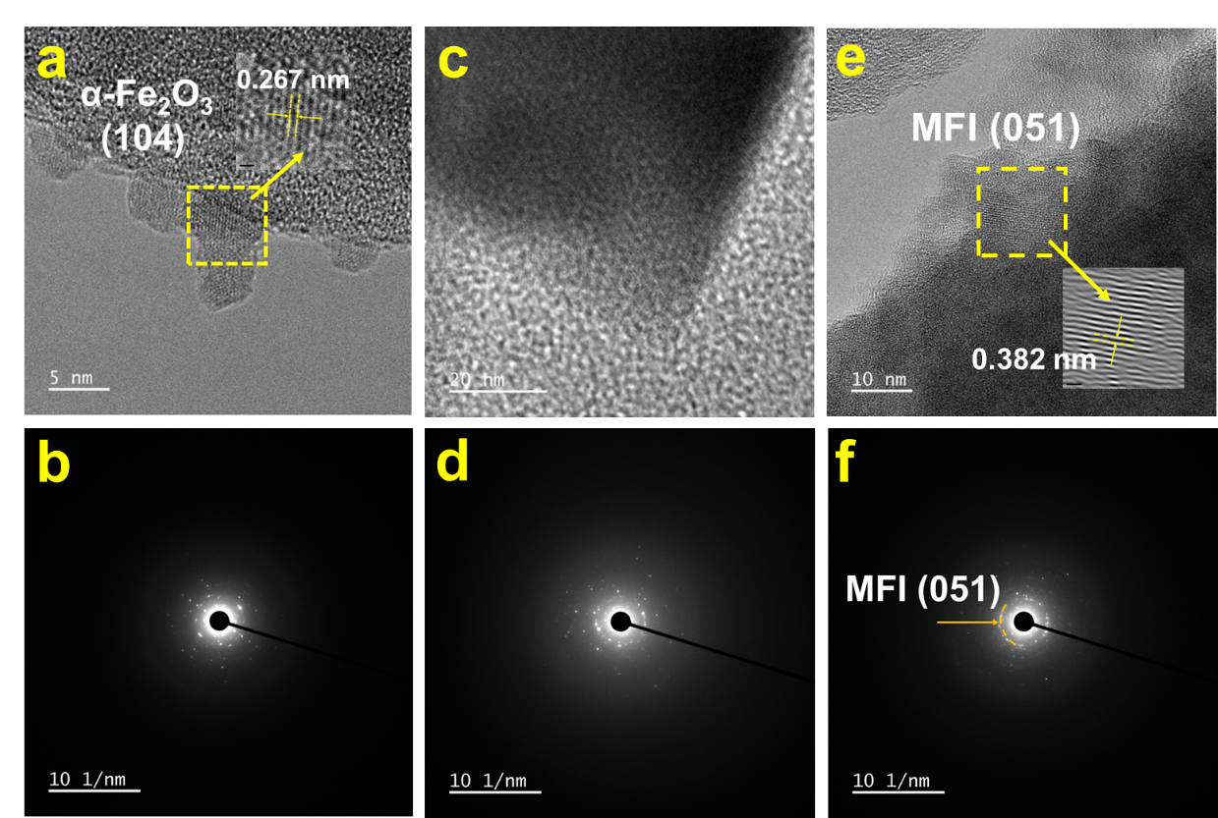

Fig. S1. HRTEM images and Electron diffraction rings of the Fe-ZSM-5(20) (a-b), Fe-ZSM-5(20)-H (c-d), Fe-ZSM-5(20)-R (e-f).

Notes: The electron diffraction patterns show that Fe-ZSM-5(20) still exhibits distinct crystalline diffraction features after treatment in the NO + NH₃ + H₂O atmosphere at 650 ºC and prolonged NH₃-SCR reaction, indicating that its crystal structure has not been damaged.

Fig. S2. N₂ adsorption-desorption isotherms of Fe-ZSM-5(20) and Fe-ZSM-5(100) catalysts before and after NH₃-SCR reaction.

Notes: The adsorption–desorption isotherm types of Fe-ZSM-5(20) and Fe-ZSM-5(100) remain unchanged after treatment under the NO + NH₃ + H₂O atmosphere at 650 ºC and prolonged NH₃-SCR reaction, indicating that the pore structures of the catalysts are largely preserved under high-temperature SCR conditions.
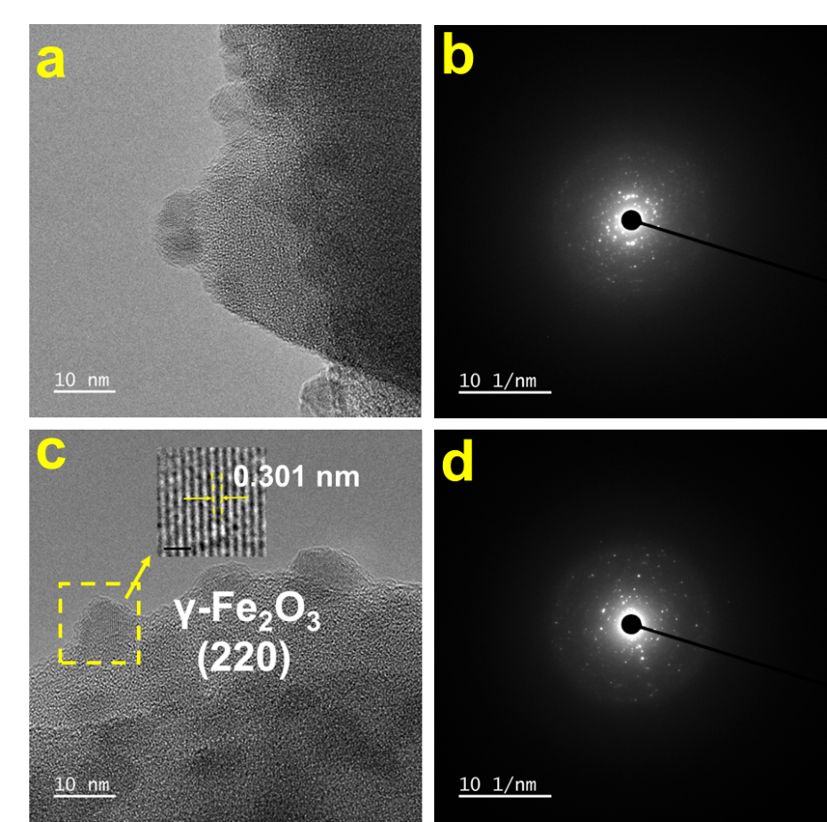

Fig. S3. HRTEM images and Electron diffraction rings of the fresh Fe-ZSM-5(100) (a-b) and Fe-ZSM-5(100)-H (c-d).

Fig. S4. XRD spectra of Fe-ZSM-5(100) and Fe-ZSM-5(100)-R catalysts.

Notes: Fe-ZSM-5(100)-R (obtained after treatment in the NO + NH₃ + H₂O atmosphere at 650 ºC, prolonged NH₃-SCR operation and H₂O and SO₂ tolerance tests) exhibits an XRD pattern identical to that of Fe-ZSM-5(100). This result indicates that neither reaction atmosphere treatment nor NH₃-SCR operation disrupts the MFI topology of the catalyst.

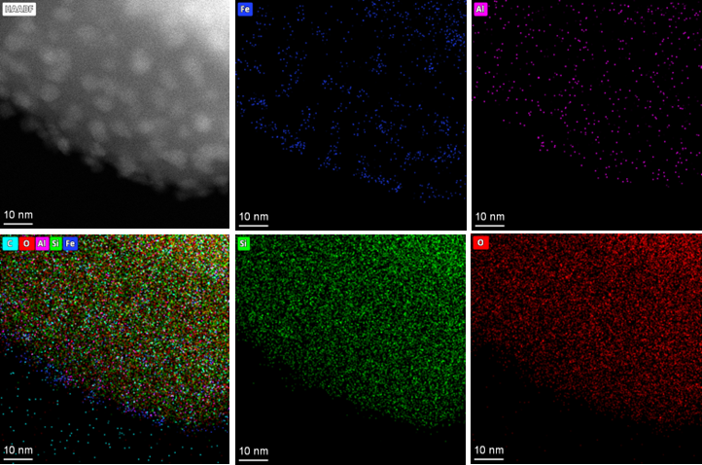

Fig. S5. EDS mappings of Fe-ZSM-5(20).

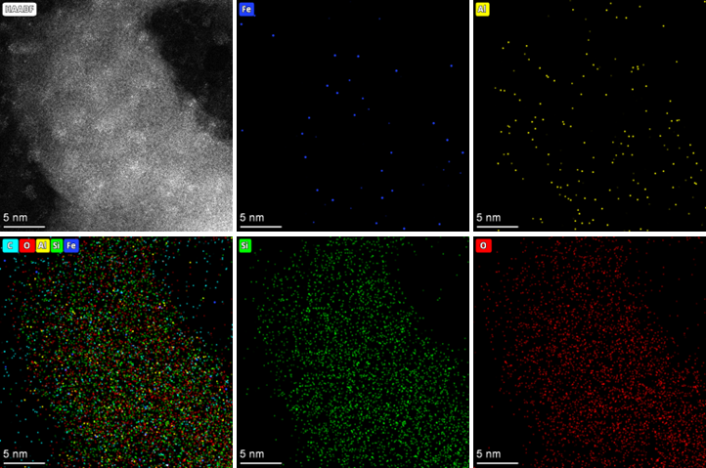

Fig. S6. EDS mappings of Fe-ZSM-5(20)-H.

Fig. S7. UV–vis-NIR spectra of Fe-ZSM-5(100) and Fe-ZSM-5(100)-R.

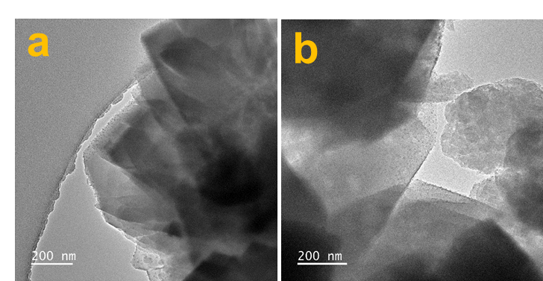

Fig. S8. TEM images of Fe-ZSM-5(100) and Fe-ZSM-5(100)-R.

Fig. S9. Raman spectra of different catalysts.

Notes: All catalysts exhibit a vibrational band at approximately 378 cm⁻¹, which is assigned to a characteristic vibration of the MFI framework.⁹ The low wavenumber bands at 126 and 207 cm⁻¹ are attributed to low frequency lattice vibrations of the MFI framework.^{[10]} Compared with the Fe-ZSM-5(20) catalyst and the samples treated under the reaction atmosphere, only the Fe-ZSM-5(100) and Fe-ZSM-5(100)-R catalysts exhibited peaks at 470 cm⁻¹ associated with Fe–O–Fe vibrations or oligomeric FeO_{x}, further confirming the depolymerization of FeO_{x} nanoparticles/clusters.

Fig. S10. Temperature-dependent variations for NO, NO₂, N₂O and NH₃ concentrations in the absence of the catalyst.

Notes: After introducing NO + NH₃ + O₂ into an empty reactor and performing a programmed temperature ramp, it was found that the concentrations of NO and NH₃ remained essentially unchanged between 250 and 650 ºC, which ruled out any contribution from the NH₃-SNCR reaction to the NO conversion.

Fig. S11. Variation of NO_{x} Conversion on Fe-ZSM-5(20) catalyst aftter H₂O treatment at 650 ºC.

Notes: After treatment with H₂O alone at 650 ºC for 12 h, the NO_{x} conversion increased from 72% to approximately 85%. This result indicate that H₂O can partially activate the catalyst.

Fig. S12. Variation of NO_{x} and NH₃ Conversion on Fe-ZSM-5(20) catalyst during NO + NH₃ treatment at 650 ºC.

Fig. S13. Stability Test of the Fe-ZSM-5(20) Catalyst at 650 ºC

Notes: The NO_{x} conversion over Fe-ZSM-5(20) remained below 75% after 16 h of NH₃-SCR reaction at 650 ºC, indicating that prolonged exposure to the high reaction temperature alone is insufficient to enhance the catalyst activity.

Fig. S14. Stability test of Fe-ZSM-5(20)-H for 85h at 650 ºC.

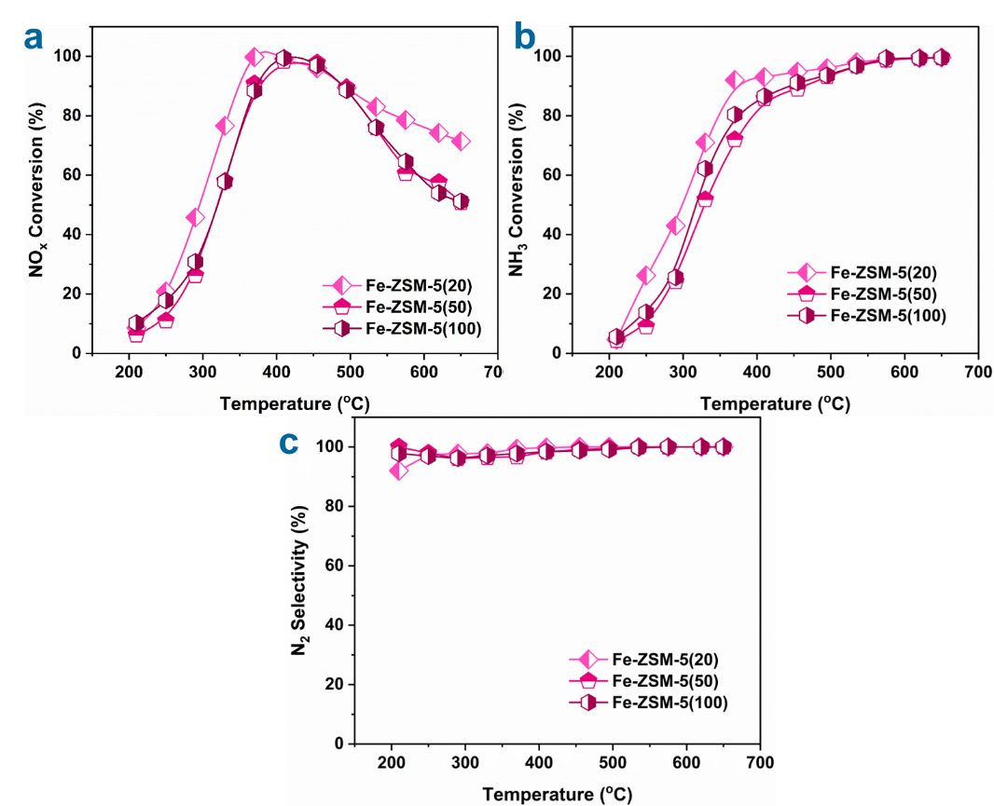

Fig. S15. The Effect of Si/Al on the NO_{x} Conversion (a), NH₃ Conversion (b) and N₂ Selectivity (c) of Fe-ZSM-5(x).

Fig. S16. Stability Test of the Fe-ZSM-5(x) Catalyst before and after the NO + NH₃ + H₂O atmosphere treatment at 650 ºC

Fig. S17. Stability test containing 5 vol.% H₂O or 180 ppm SO₂ at 650 ºC.

Notes: H₂O and SO₂ were introduced into the SCR feed to further evaluate the H₂O and SO₂ tolerance of Fe-ZSM-5(x) before and after reaction atmosphere treatment. The result shows that the introduction of H₂O or SO₂ increases the NO_{x} conversion over Fe-ZSM-5(50)-H and Fe-ZSM-5(100)-H, whereas the conversion decreases to some extent after H₂O and SO₂ is removed from the feed. This behavior may arise from the suppression of nonselective NH₃ oxidation by H₂O and SO₂ at high temperatures, thereby enhancing the NO_{x} conversion.

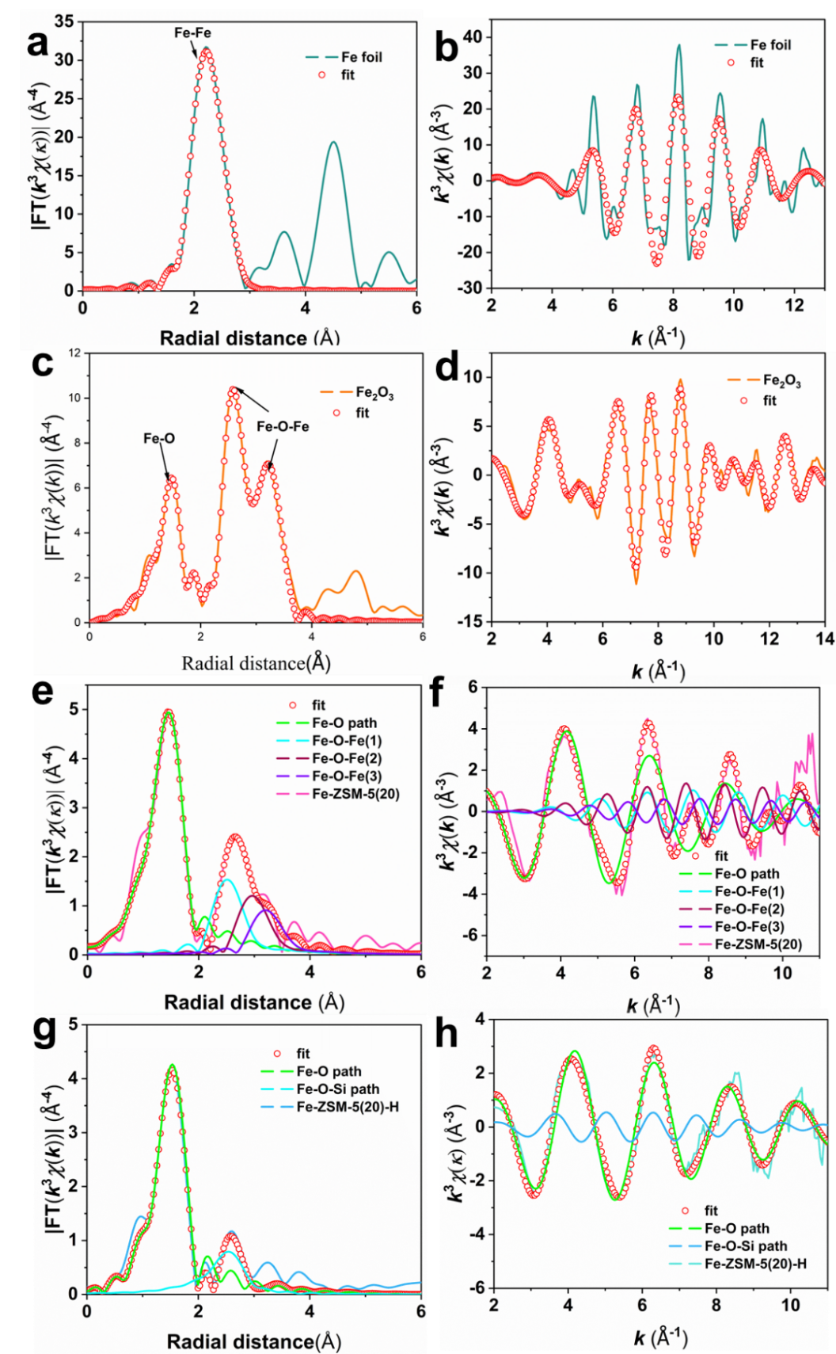

Fig. S18. The Fourier transform R-spaced extended X-ray absorption fine spectra (FT-EXAFS) (left) fitted k³χ(k) oscillation curve (right) and of standard samples and catalysts.
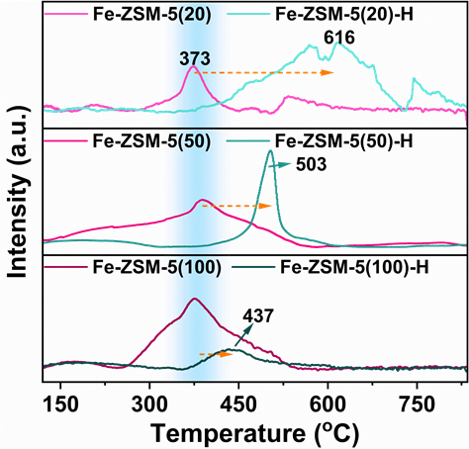

Fig. S19. H₂-TPR of different catalysts.
Notes: The reduction peak at 373 ºC is assigned to the H₂ reduction of FeO_{x} nanoparticles, whereas those at 437 and 503 ºC are attributed to oligomeric FeO_{x} species. The peak at 616 ºC is associated with isolated Fe³⁺ species stabilized through strong interactions with the zeolite framework. As the Si/Al ratio of ZSM-5(x) increases, both the high-temperature shift and the area of the reduction peaks of Fe-ZSM-5(x)-H relative to the corresponding fresh Fe-ZSM-5(x) catalysts progressively decrease. Combined with the UV–vis–NIR and TEM results, this trend suggests that Fe-ZSM-5(50) and Fe-ZSM-5(100) do not generate sufficient silanol nests to stabilize isolated Fe atoms during reaction atmosphere treatment. Consequently, some isolated Fe species were further converted into oligomeric FeO_{x}, decreasing the population of reducible Fe active sites.

Fig. S20. TG curves of Fe-ZSM-5(20) and Fe-ZSM-5(20)-R.

Fig. S21. XPS spectra of S 2p over the Fe-ZSM-5(20)-R catalyst.

Notes: The S 2p XPS spectrum indicates that, during prolonged SO₂ endurance testing at 650 ºC, the active metal Fe in the Fe-ZSM-5(20)-H catalyst does not react with SO₂ to form stable metal sulfates, which effectively ensures the long-term stability of the catalytic system.

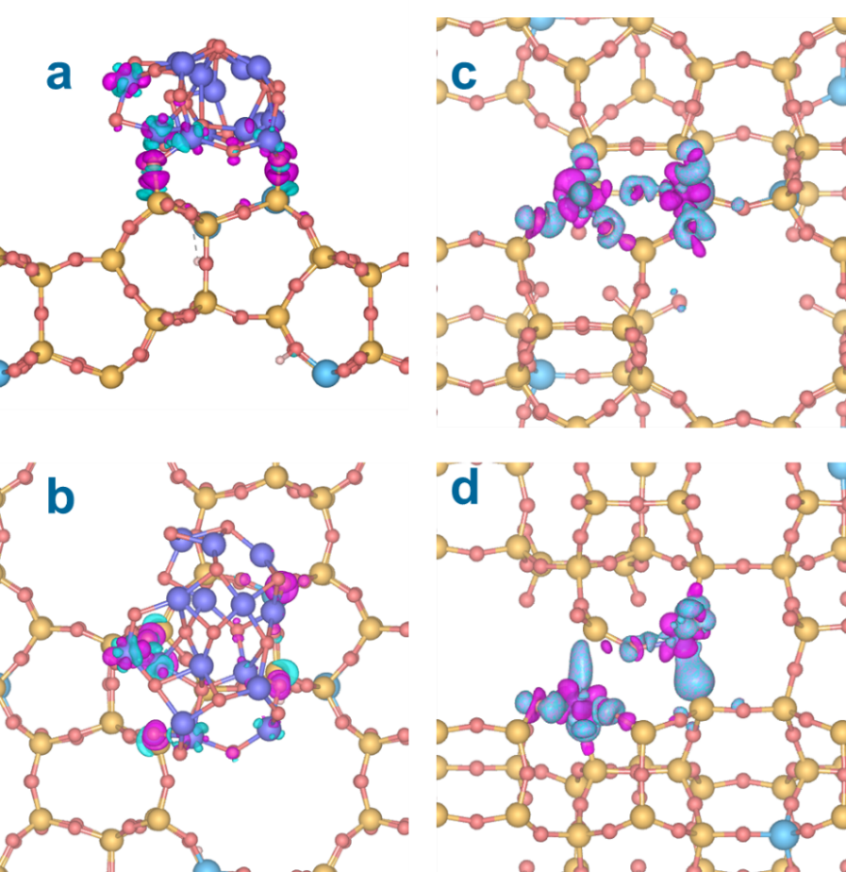

Fig. S22. Charge density difference plot for Fe-ZSM-5(20) (a-b) and Fe-ZSM-5(20)-H (c-d). The isosurface value is 0.01 e·Bohr⁻³. Pink is positive and blue is negative (yellow: Si, blue: Fe, cyan: Al).

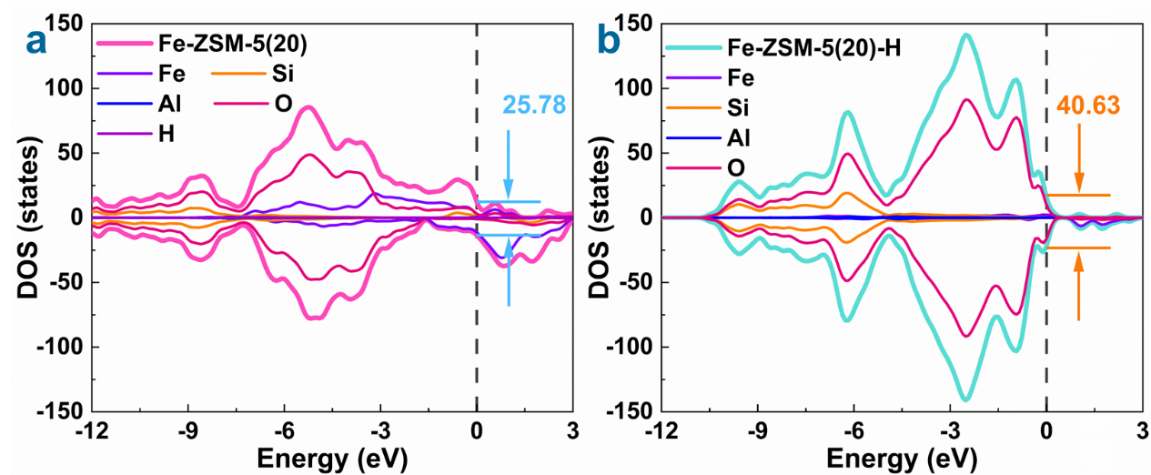

Fig. S23. Density of state (DOS) of Fe-ZSM-5(20) (a) and Fe-ZSM-5(20)-H (b).

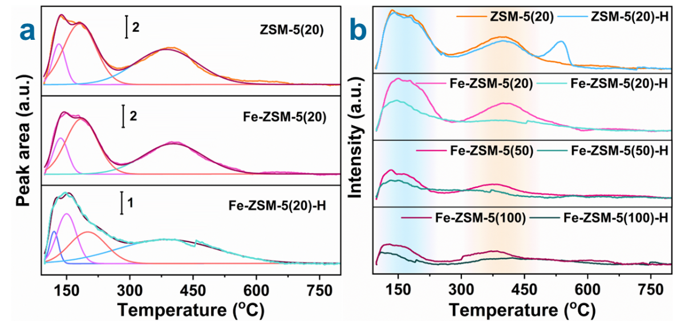
Fig. S24. Deconvolution fitting process of the NH₃ desorption profiles of the Fe-ZSM-5(20) catalyst before and after reaction atmosphere treatment (a). NH₃ desorption profiles of Fe-ZSM-5(x) catalysts with different Si/Al ratios before and after reaction atmosphere treatment (b).
Notes: Compared with ZSM-5(20), ZSM-5(20)-H exhibits a distinct high-temperature NH₃ desorption peak at 538 ºC, indicating that the NO + NH₃ + H₂O atmosphere induced the formation of strong NH₃ adsorption sites on the zeolite. Combined with the ²⁹Si and ²⁷Al MAS NMR results, this feature may be associated with local dealumination induced by the high-temperature reaction atmosphere. The resulting silanol nests and extra-framework Al species may jointly modify the local adsorption environment of NH₃, thereby generating strong acid sites.^{[11]} Notably, the introduction of Fe into the ZSM-5(20) catalyst caused the peak attributed to strong acid sites at 538 ºC to disappear. This observation suggests that the anchoring of isolated Fe species within silanol nests may disrupt the cooperative interaction between extra-framework Al species and Si–OH groups, consequently weakening NH₃ adsorption.

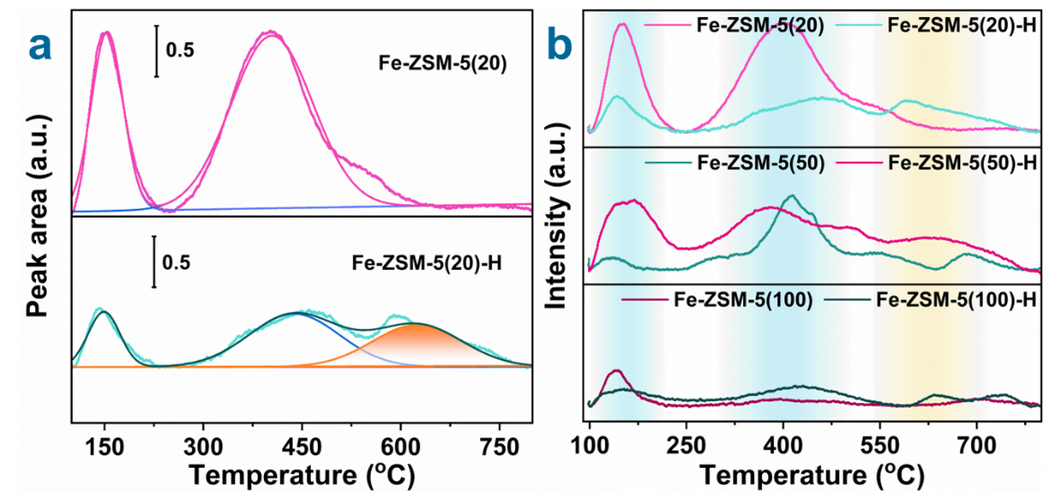
Fig. S25. Deconvolution fitting process of the NO desorption profiles of the Fe-ZSM-5(20) catalyst before and after reaction atmosphere treatment (a). NO desorption profiles of Fe-ZSM-5(x) catalysts with different Si/Al ratios before and after reaction atmosphere treatment (b).

Notes: Desorption peaks in the 100–250 ºC range correspond to NO adsorbed via physical or weak chemical adsorption, while those in the 300–500 ºC range can be attributed to the adsorption of NO by ion-exchange Fe sites and FeO_{x} nanoparticles/clusters.¹²⁻¹³

Fig. S26. O₂ desorption profiles of Fe-ZSM-5(x) catalysts with different Si/Al ratios before and after reaction atmosphere treatment.
Notes: As the Al content decreases, the O₂ adsorption capacity of Fe-ZSM-5(x) at 250-550 ºC also progressively declines. This trend may result from the evolution of highly dispersed Fe species into larger FeO_{x} nanoparticles. The lower fraction of exposed Fe–O–Fe sites and accessible oxygen-activation sites on the larger particles consequently leads to a reduced amount of desorbed O₂.
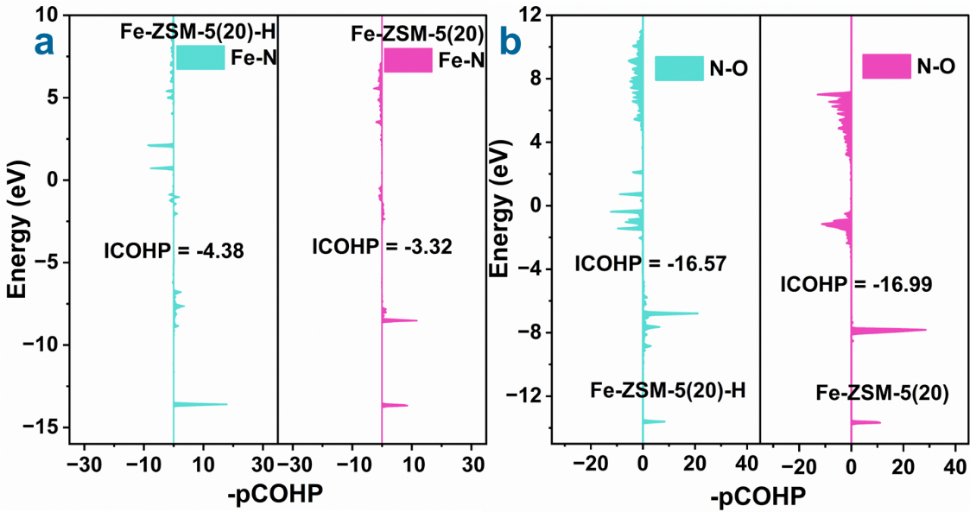

Fig. S27. The Crystal Orbital Hamilton Populations (COHP) analysis for NO adsorption (a) and activation (b) on FeO_{x} sites and single-atom Fe sites.
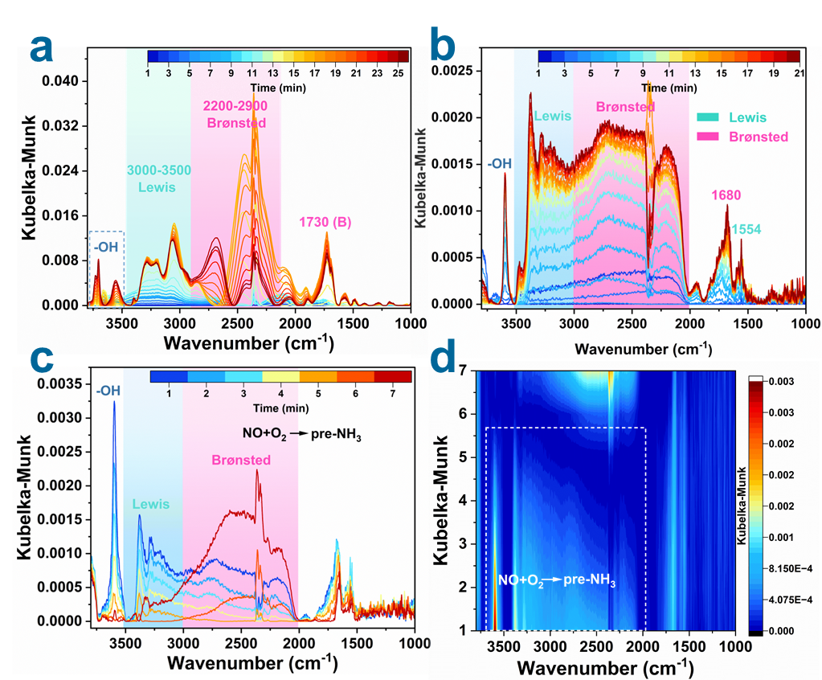

Fig. S28. In situ DRIFTs of NH₃ adsorption at 50 ºC (a) and 450 ºC (b), NO+O₂ reacted with pre-adsorbed NH₃ (c-d) on the surface of Fe-ZSM-5(20) at 450 ºC.

Notes: The bands at 1554 cm⁻¹ and 3000–3500 cm⁻¹ are assigned to NH₃ adsorbed on Lewis acid sites,^{[14]} whereas those at 1680 and 1730 cm⁻¹ and within 2000–3000 cm⁻¹ are attributed to NH₄⁺ species formed on Brønsted acid sites.¹⁵⁻¹⁶

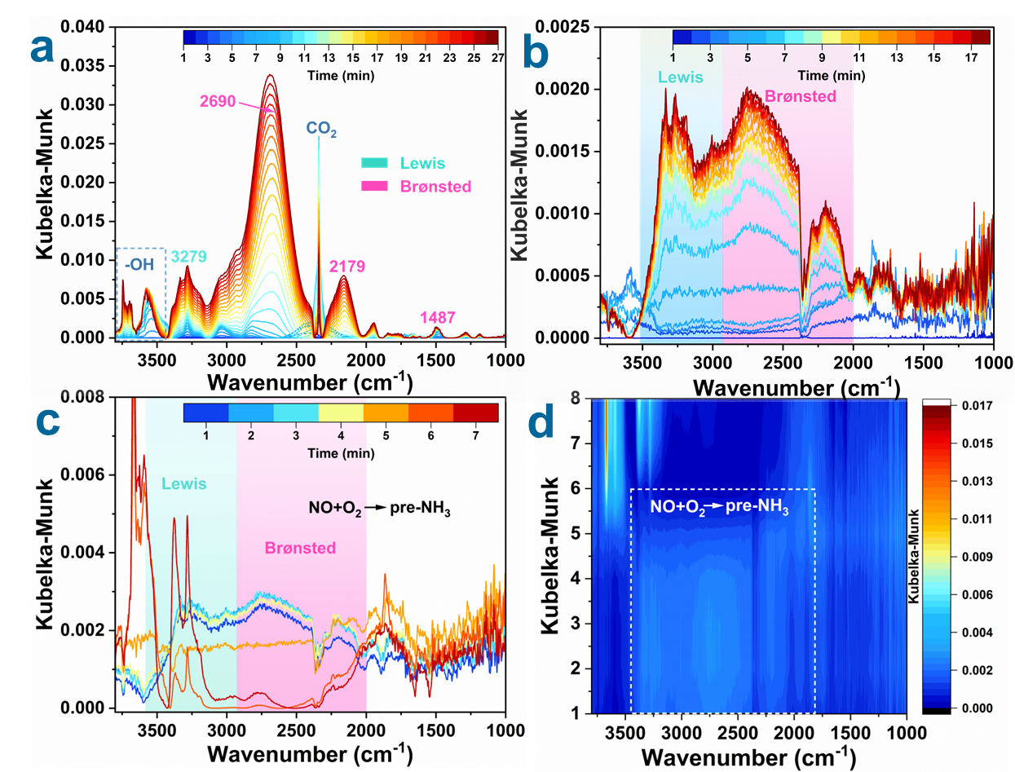

Fig. S29. In situ DRIFTs of NH₃ adsorption at 50 ºC (a) and 450 ºC (b), NO+O₂ reacted with pre-adsorbed NH₃ (c-d) on the surface of Fe-ZSM-5(20)-H at 450 ºC.

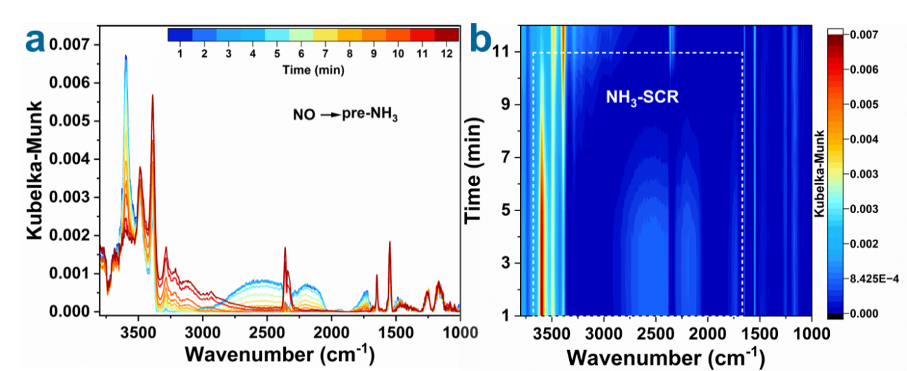

Fig. S30. In situ DRIFTs of NO reacted with pre-adsorbed NH₃ on the surface of Fe-ZSM-5(20) at 450 ºC.

Notes: NH₃ was first introduced onto Fe-ZSM-5(20) for saturation adsorption, followed by N₂ purging and subsequent exposure to NO alone. The rapid consumption of the bands associated with adsorbed NH₃ species indicates that NO and pre-adsorbed NH₃ can undergo the NH₃-SCR reaction on the catalyst surface at 450 ºC.

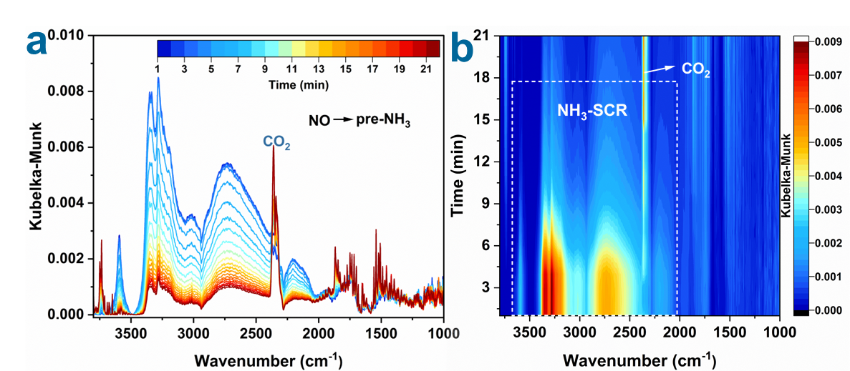

Fig. S31. In situ DRIFTs of NO reacted with pre-adsorbed NH₃ on the surface of Fe-ZSM-5(20)-H at 450 ºC.

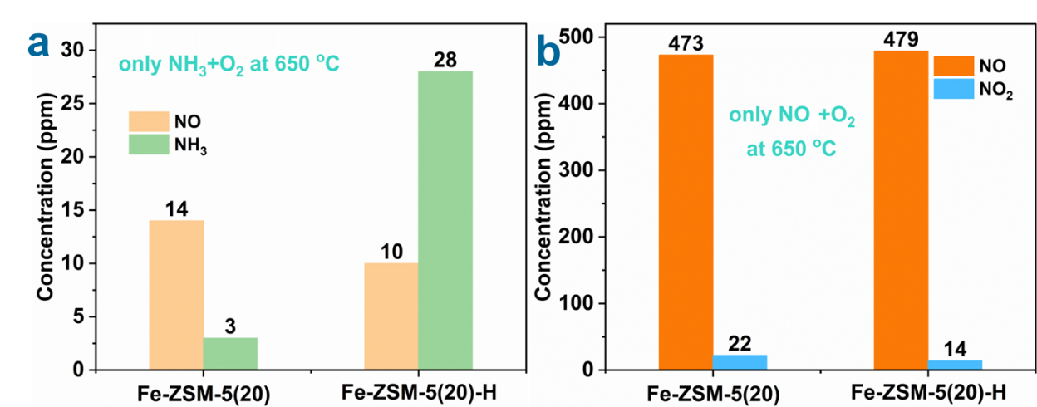

Fig. S32. Oxidation capacity of O₂ on the catalyst surface toward NH₃ (a) and NO (b) at 650 °C (GHSV=30,000 h⁻¹).

Table S1. EXAFS data fitting results of catalysts.
Sample | Path | CNª | R(Å)^{b} | σ² (Å²)^{c} | ΔE₀(eV)^{d} | R factor
Fe foil | Fe-Fe | 8.0* | 2.463±0.004 | 0.0057 | 5.0±0.9 | 0.0041
Fe foil | Fe-Fe | 6.0* | 2.841±0.006 | 0.0057 | 5.0±0.9 | 0.0041
Fe₂O₃ | Fe-O | 3.3±0.2 | 1.936±0.005 | 0.0037 | -0.7±0.7 | 0.0051
Fe₂O₃ | Fe-O | 2.3±0.2 | 2.101±0.009 | 0.0037 | -0.7±0.7 | 0.0051
Fe₂O₃ | Fe-O-Fe1 | 4.6±0.1 | 2.954±0.004 | 0.0065 | -0.7±0.7 | 0.0051
Fe₂O₃ | Fe-O-Fe2 | 3.7±0.3 | 3.379±0.007 | 0.0065 | -0.7±0.7 | 0.0051
Fe₂O₃ | Fe-O-Fe2 | 4.9±0.3 | 3.688±0.005 | 0.0065 | -0.7±0.7 | 0.0051
Fe-ZSM-5(20) | Fe-O | 5.5±0.3 | 1.947±0.012 | 0.0113 | -6.7±1.9 | 0.0076
Fe-ZSM-5(20) | Fe-O-Fe1 | 0.8±0.2 | 2.954±0.019 | 0.0053 | -6.7±1.9 | 0.0076
Fe-ZSM-5(20) | Fe-O-Fe2 | 1.6±0.5 | 3.428±0.025 | 0.0053 | -6.7±1.9 | 0.0076
Fe-ZSM-5(20) | Fe-O-Fe3 | 0.9±0.6 | 3.677±0.041 | 0.0053 | -6.7±1.9 | 0.0076
Fe-ZSM-5(20)-H | Fe-O | 3.2±0.2 | 1.988±0.010 | 0.0073 | -1.2±1.7 | 0.0103
Fe-ZSM-5(20)-H | Fe-O-Si | 2.7±0.7 | 3.168±0.057 | 0.0130 | -12.7±6.3 | 0.0103
Fe K-edge (Ѕ₀²=0.823)
ªCN, coordination number; ^{b}R, the distance between absorber and backscatter atoms; ^{c}σ², the Debye Waller factor value; ^{d}ΔE₀, inner potential correction to account for the difference in the inner potential between the sample and the reference compound; R factor indicates the goodness of the fit. S0² was fixed to 0.823, according to the experimental EXAFS fit of Fe foil by fixing CN as the known crystallographic value. * This value was fixed during EXAFS fitting, based on the known structure of Fe. Fitting conditions: k range：3.0 - 10.5; R range: 1.0-3.0; fitting space: R space; k-weight = 3. A reasonable range of EXAFS fitting parameters: 0.700 < Ѕ₀² < 1.000; CN > 0; σ² > 0 Å²; |ΔE₀| < 15 eV; R factor < 0.02.

Table S2. BET specific surface area and pore structure properties.
Catalysts | S_{BET}ª (m²/g) | S_{micro}^{b} (m²/g) | V_{total}^{c} (cm³/g) | V_{micro}^{d} (cm³/g)
Fe-ZSM-5(20) | 407.85 | 229.55 | 0.24 | 0.09
Fe-ZSM-5(20)-H | 358.29 | 230.58 | 0.25 | 0.09
Fe-ZSM-5(20)-R | 358.42 | 298.63 | 0.24 | 0.13
Fe-ZSM-5(100) | 260.76 | 216.06 | 0.20 | 0.10
Fe-ZSM-5(100)-R | 236.16 | 166.18 | 0.19 | 0.07
ªSpecific surface area calculated by the BET method. ^{b, d}Calculated by the t-plot method. ^{c}Calculated from the adsorption amount at p/p⁰ = 0.99.
Notes: For Fe-ZSM-5(20) catalyst, after induction in the NO + NH₃ + H₂O atmosphere at 650 ºC, its total BET specific surface area decreased from 407.85 m²/g to 358.29 m²/g, whereas the micropore surface area and micropore volume remain nearly unchanged. This result indicates that the decrease in total surface area mainly arises from a reduced contribution of the mesoporous structure. After prolonged NH₃-SCR reaction, the micropore surface area and micropore volume increase from 230.58 m²/g and 0.09 cm³/g to 298.63 m²/g and 0.13 cm³/g, respectively. This increase may be associated with the migration of extra-framework Al species located near micropore entrances and the further stabilization of isolated Fe sites at framework defects during the reaction. In contrast, both the micropore surface area and micropore volume of Fe-ZSM-5(100) decrease markedly after reaction atmosphere treatment and prolonged SCR reaction. Combined with the UV–vis–NIR results, this decrease is attributed to the aggregation of isolated Fe species into oligomeric FeO_{x}, which partially blocks the micropore channels.

Table S3. XPS results of the main atom content (%) on the surface of catalysts.
Catalysts | Fe | O | Si | Al | S
Fe-ZSM-5(20) | 3.05 | 60.61 | 26.60 | 1.27 | —
Fe-ZSM-5(20)-H | 0.46 | 61.41 | 28.49 | 1.78 | —
Fe-ZSM-5(20)-R | 0.38 | 61.38 | 28.40 | 1.64 | 0

Notes: The surface Fe atomic contents of Fe-ZSM-5(20)-H and Fe-ZSM-5(20)-R are 0.46% and 0.38%, respectively, substantially lower than that of Fe-ZSM-5(20) (3.05%). Subsequent ICP results (Table S4) showed that the mass fraction of Fe in both the Fe-ZSM-5(20) and Fe-ZSM-5(20)-H catalysts was 0.46%. These findings further confirm that the FeO_{x} nanoparticles/clusters on the surface of Fe-ZSM-5(20) migrate into the zeolite pore channels after depolymerization in the NO + NH₃ + H₂O atmosphere at 650 ºC, where they are captured and stabilized by silanol nests.

Table S4. ICP results of Fe element in different catalysts.
Samples | W content (wt%)
Fe-ZSM-5(20) | 0.46
Fe-ZSM-5(20)-H | 0.46

References
1 Liu, Y. et al. Protozeolite‐Seeded Synthesis of Single‐Crystalline Hierarchical Zeolites with Facet‐Shaped Mesopores and Their Catalytic Application in Methanol‐to‐Propylene Conversion. Angewandte Chemie International Edition 61, e202205716 (2022).
2 Zhang, Q. et al. Amino Acid-Assisted Construction of Single-Crystalline Hierarchical Nanozeolites via Oriented-Aggregation and Intraparticle Ripening. Journal of the American Chemical Society 141, 3772-3776 (2019).
3 Feng, C. et al. Highly dispersed Pt/Co₃O₄ catalyst constructed by vacancy defect inductive effect for enhanced catalytic propane total oxidation. Chinese Journal of Catalysis 75, 21-33 (2025).
4 Song, W. et al. Computational screening of transition metal atom doped C₃N as electrocatalysts for nitrogen fixation. Molecular Catalysis 535, 112888 (2023).
5 Mao, X., Gu, Z., Yan, C. & Du, A. Unlocking the potential of ruthenium catalysts for nitrogen fixation with subsurface oxygen. Journal of Materials Chemistry A 9, 6575-6582 (2021).
6 Liao, X. et al. Density Functional Theory for Electrocatalysis. Energy & Environmental Materials 5, 157-185 (2021).
7 Kong, W. et al. Construction of dual active sites for efficient alkaline hydrogen evolution: single-metal-atoms supported on BC2N monolayers. Physical Chemistry Chemical Physics 24, 29141-29150 (2022).
8 Wu, Z.-Y. et al. Electrochemical ammonia synthesis via nitrate reduction on Fe single atom catalyst. Nature Communications 12, 2870 (2021).
9 Wu, Y. et al. Insights into the Roles of Different Iron Species on Zeolites for N₂O Selective Catalytic Reduction by CO. Environmental Science & Technology 58, 22583-22593 (2024).
10 Wang, T. et al. Critical Role of Tricyclic Bridges Including Neighboring Rings for Understanding Raman Spectra of Zeolites. Journal of the American Chemical Society 141, 20318-20324 (2019).
11 Balcom, H., Hoffman, A. J., Locht, H. & Hibbitts, D. Brønsted Acid Strength Does Not Change for Bulk and External Sites of MFI Except for Al Substitution Where Silanol Groups Form. ACS Catalysis 13, 4470-4487 (2023).
12 Xia, Y., Zhan, W., Guo, Y., Guo, Y. & Lu, G. Fe-Beta zeolite for selective catalytic reduction of NO_{x} with NH₃: Influence of Fe content. Chinese Journal of Catalysis 37, 2069-2078 (2016).
13 Long, R. Q. & Yang, R. T. Temperature-Programmed Desorption/Surface Reaction (TPD/TPSR) Study of Fe-Exchanged ZSM-5 for Selective Catalytic Reduction of Nitric Oxide by Ammonia. Journal of Catalysis 198, 20-28 (2001).
14 Buttignol, F., Garbujo, A., Biasi, P., Krocher, O. & Ferri, D. N₂O Activation and NO Adsorption Control the Simultaneous Conversion of N₂O and NO Using NH₃ over Fe-ZSM-5. J Am Chem Soc 147, 8978-8990 (2025).
15 Qi, G. Selective catalytic oxidation (SCO) of ammonia to nitrogen over Fe-exchanged zeolites prepared by sublimation of FeCl₃. Journal of Catalysis 226, 120-128 (2004).
16 Zhao, Q. et al. Enhancement effect of Lewis acid-base pair derived from mortise-tenon structure catalyst on high-temperature NH3-SCR: Oxygen vacancy confinement and interfacial electron rearrangement. Applied Catalysis B: Environment and Energy 385, 126329 (2026).

