Supplementary figures
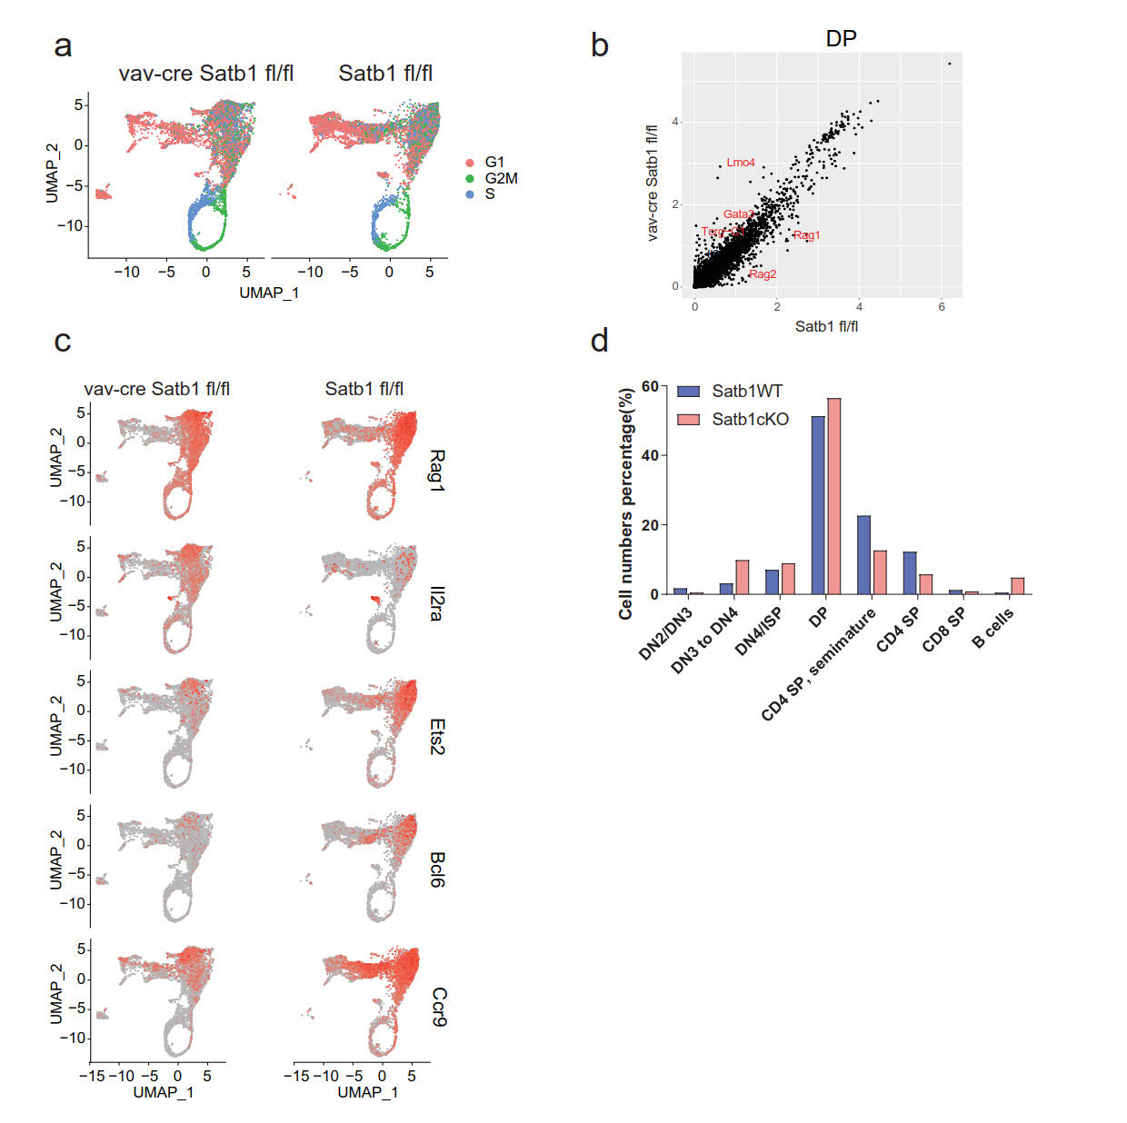
Figure S1 Satb1 controls cell identity of DP thymocytes
a) Same UMAP plot of thymocytes cell by cell cycle phase gene expression.
b) Dot plot of differently expressed (DE) genes in Satb1WT and Satb1cKO DP thymocytes from single-cell datasets.
c) UMAP expression plots of representative DE genes for DP thymocytes (Rag1, Il2ra, Bcl6, Ets2, and Ccr9) between Satb1WT and Satb1cKO group.
d) Cell number percentages of thymocyte subsets from single-cell datasets.

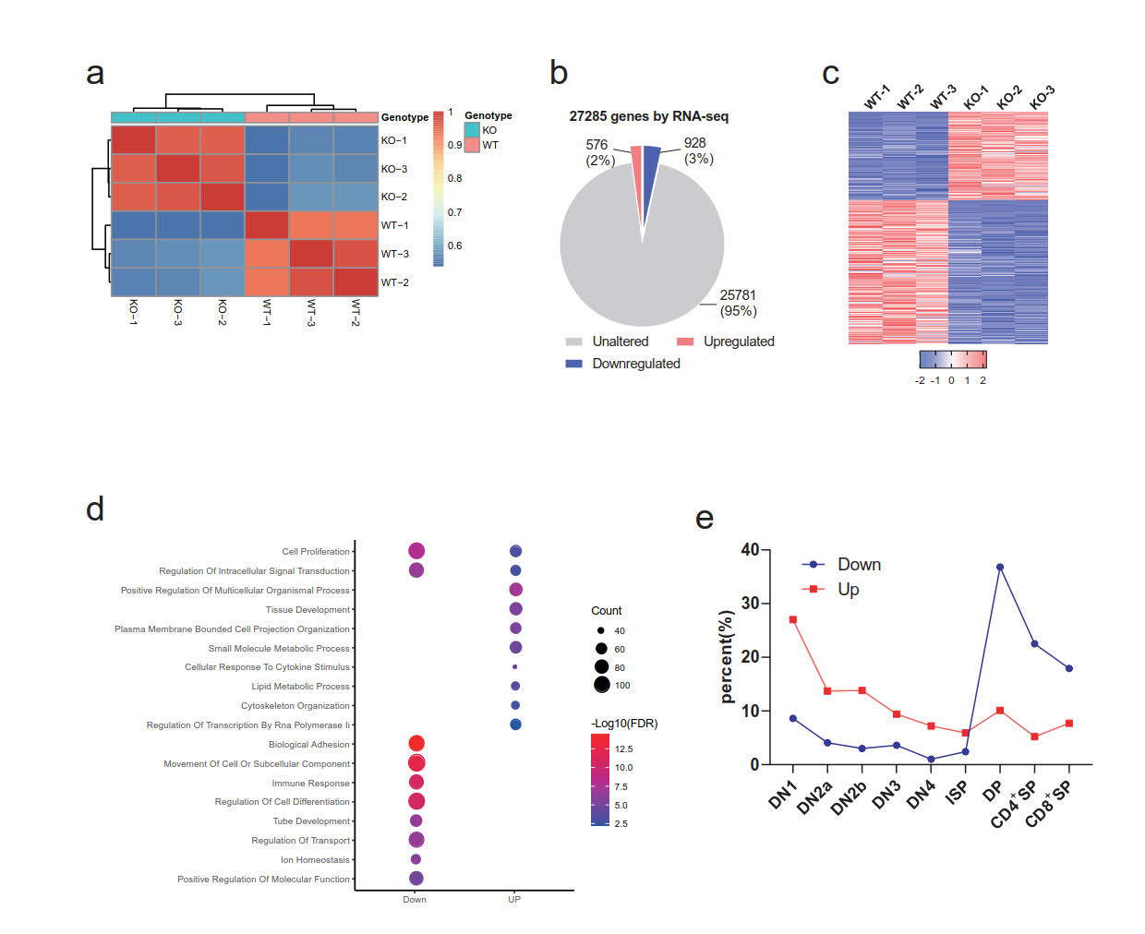

Figure S2 Satb1 regulates gene expression of DP thymocytes
a) RNA-seq replicates were hierarchically clustered according to gene expression sample distances using DESeq2. Three biological replicates of each sample were analyzed.
b) Pie chart indicating the fractions and absolute numbers of differentially expressed genes derived from the analysis of the transcriptome of Satb1 WT and Satb1cKO cells by bulk RNA-Seq. The RNA-Seq analysis indicated that 576 (red) of the total 27,285 genes showed significantly up-regulated (FDR ≥ 0.005) whilst 926 genes were down-regulated (blue) using an fold change (FC) >1 on log 2 scale with an FDR < 0.05 to determine abundance.
c) Heatmap of differentially expressed genes between Satb1WT and Satb1cKO DP thymocytes. Three biological replicates of bulk RNA-seq data were analyzed. Red represents the upregulated genes, while blue represents the downregulated genes.
d) Gene ontology analysis of the biological processes overrepresented in the group of transcripts up-regulated or down-regulate gene. The size of a circle indicates the number of enriched genes, and its color corresponds to the adjusted p value.
e) Percentage of differentially expressed genes with highest mRNA level at each cell subset during the differentiation of DN1 into SP thymocytes.
Figure S3 Related to Figure 2
a) Line diagram and b) heatmap of H3K27ac, H3K4me1, and H3K4me3 ChIP-seq signal intensity at Satb1 binding sites (top 10000 regions) in DP thymocytes.
c) Line diagram and d) heatmap of Rad21, Nipbl, and CTCF ChIP-seq signal intensity at Satb1 binding sites.
e) Distribution of Satb1 binding sites (top 10000 regions) in mouse DP thymocytes.
f) Bar graph showing the percentage of super-enhancers (SE) or traditional enhancers (TE) occupied by Satb1 or not.
g) Bar graph showing the SE or TE numbers of WT and Satb1cKO DP thymocytes
h) Line plot displaying H3K4me1 tag density in Satb1WT vs Satb1cKO at WT DP super-enhancers regions.
i) GSEA of the differentially expressed genes enriched for the gain super-enhancer associated geneset.
Figure S4 Related to Figure 4
a) Subtraction heatmap of Hi-C data from Juicebox corresponding to Satb1cKO–Satb1WT at 500 kb resolution for chromosome 16, with H3K27ac and H3K4me3 ChIP-seq and A/B compartment signals on top.
b) Chromatin contact frequency decay curves of control (blue) and Satb1cKO (red) Hi-C data.
c) Subtraction heatmap (corresponding to Satb1cKO–Satb1WT) of 10kb binned Hi-C data of DP thymocytes from WT or Satb1cKO mice. Data are one of two independent experiments.
Figure S5 Related to Figure 4
a) Pie chart showing the compartment changes between Satb1WT and Satb1cKO DP.
b) Split violin plots correspond to sizes of total or super-enhancer (SE) containing TADs from Hi-C data of WT or Satb1cKO thymocytes. * p < 0.05, ** p < 0.01 by two-side Student’s t test.
c) Aggregate TAD analysis for WT (up) and Satb1cKO (bottom) DP thymocytes. Average coverage-corrected Hi-C contact matrices are shown centered around 2 × 495kb long TADs identified in the WT thymocytes.
d) related to Figure 4c.
e) Split violin plots for loop number changes in promoters of the genes down-regulated (blue) or up-regulated (yellow) in Satb1cKO thymocytes. **** p < 0.0001 by two-side Student’s t test.
f-i) Pearson's correlation correlation analysis of super-enhancer associated f) loop numbers with interactions, g) loop interaction with H3K27ac signals, h) loop interactions with gene expression, and i) H3K27ac signals with gene expression.
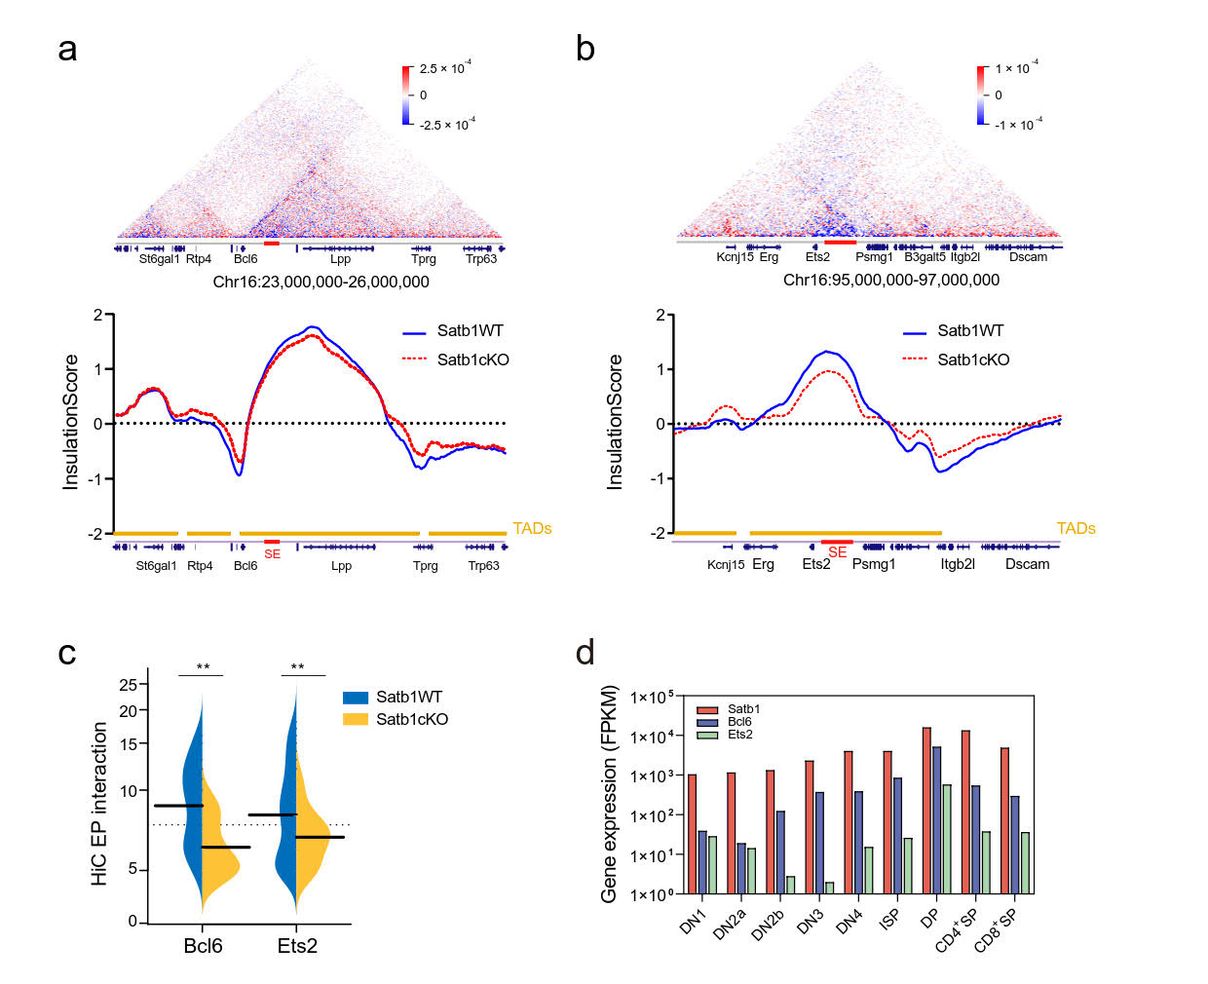
Figure S6 Related to figure 6
a) and b) Subtraction heatmaps (up) and insulation score profiles (bottom) of Hi-C data at a) Bcl6 and b) Ets2 loci in WT (red) and Satb1cKO (blue) DP thymocytes.
c) Split violin plots for enhancer-promoter (EP) interactions of the Bcl6 and Ets2 promoters in WT and Satb1cKO DP thymocytes, **p value < 0.01 by Mann-Whitney test.
d) The expression values (FPKM) of Satb1, Bcl6, and Ets2 during the differentiation of DN1 into DP thymocytes.
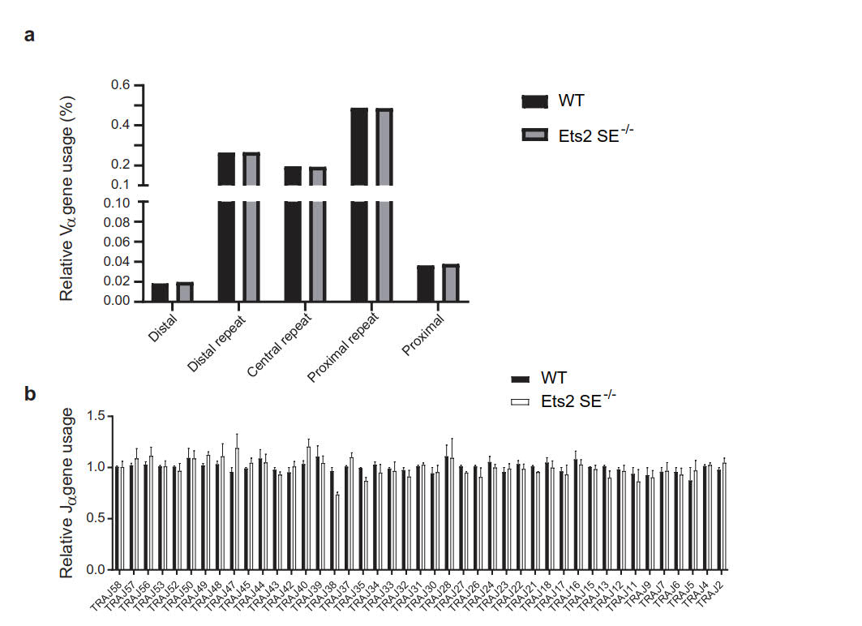
Figure S7 Ets2 SE deletion doesn’t affect Tcra rearrangement
a) and b) Relative Vα and Jα usages determined by deep-sequencing of Tcra transcripts amplified by 5’RACE of WT and Ets2 SE^{-/-} thymocytes, respectively. The relative Vα or Jα usages were calculated by dividing the number of the clonotypes containing the Vα or Jα genes by the total clonotype number.
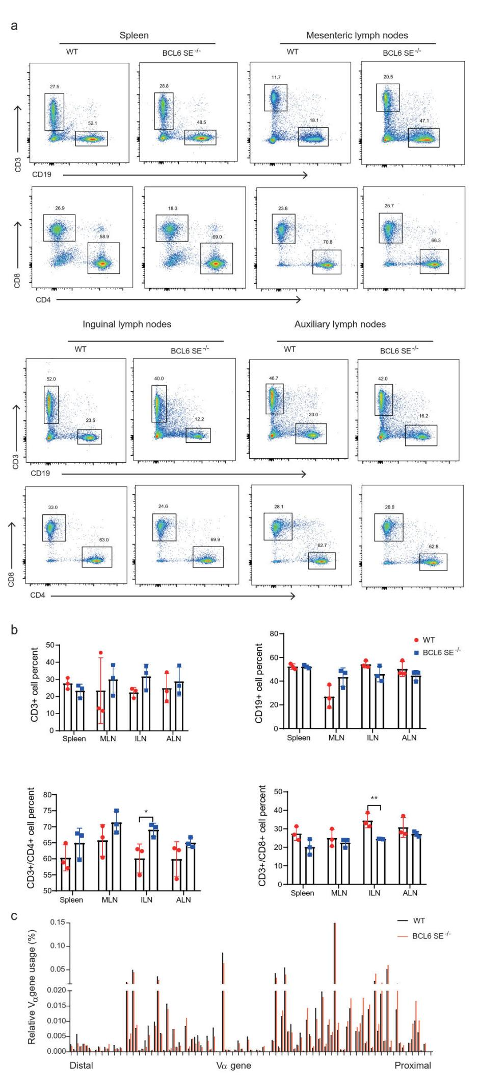
Figure S8 Related to Figure 8
a) Flow cytometry and b) cell proportion of CD3⁺ T cells and CD19⁺ B cells, CD4⁺ and CD8⁺ T cells from spleen, mesenteric lymph nodes, inguinal lymph nodes, and auxiliary lymph nodes of WT and Bcl6 SE-/- mice. Data are representative of three independent experiments (one mouse per experiment). * p < 0.05, ** p < 0.01 by two-side Student’s t test.
c) Relative Vα usage determined by deep-sequencing of Tcra transcripts amplified by 5’RACE of WT and Bcl6 SE^{-/-} thymocytes, respectively.

