Supplemental data
Species | Mescaline concentration | Cultivar name | Citation
T. bridgesii | >0.25% mescaline in raw whole plant | N/A | [22]
T. bridgesii | 0.56% mescaline in dry outer flesh | N/A | [23]
T. bridgesii | 0.18% mescaline in dry outer flesh | N/A | [1]
T. bridgesii | 0.48% mescaline in dry outer flesh | ‘TBM Clone B’ | [1]
T. bridgesii | 2.68% mescaline in dry outer flesh  1.4% mescaline in dry inner flesh | ‘Rita’ | [15]
T. bridgesii | 2.69% mescaline in dry outer flesh  0.66% mescaline in dry inner flesh | ‘CLS’ | [15]
T. bridgesii | 3.25% mescaline in dry outer flesh  1.68% mescaline in dry inner flesh | ‘Experiment’ | [15]
T. pachanoi | >0.25% mescaline in raw whole plant | N/A | [22]
T. pachanoi | 0.12% mescaline in raw whole plant | N/A | [24]
T. pachanoi | 0.04% mescaline in raw whole plant | N/A | [25]
T. pachanoi | 0.67% mescaline in dry outer flesh | N/A | [25]
T. pachanoi | 0.067-0.079% mescaline in raw whole plant | N/A | [26]
T. pachanoi | 0.331% mescaline in dry whole plant | N/A | [27]
T. pachanoi | 2% mescaline in dry whole plant | N/A | [24]
T. pachanoi | 0.109%-2.375% mescaline in dry whole plant | N/A | [28]
T. pachanoi | 0.310% mescaline in raw whole plant | N/A | [29]
T. pachanoi | 2.06% mescaline in dry whole plant | N/A | [29]
T. pachanoi | 5% mescaline in dry outer flesh | N/A | [30]
T. pachanoi | 0.00% mescaline in dry outer flesh | N/A | [18]
T. pachanoi | 0.00% mescaline in dry outer flesh | N/A | [18]
T. pachanoi | 0.45% mescaline in dry outer flesh | N/A | [18]
T. pachanoi | 1.14% mescaline in dry outer flesh | N/A | [18]
T. pachanoi | 0.23% mescaline in dry outer flesh | N/A | [18]
T. pachanoi | 0.28% mescaline in dry outer flesh | N/A | [18]
T. pachanoi | 0.94% mescaline in dry outer flesh | N/A | [18]
T. pachanoi | 0.38% mescaline in dry outer flesh | N/A | [18]
T. pachanoi | 0.55% mescaline in dry outer flesh | N/A | [18]
T. pachanoi | 0.86% mescaline in dry outer flesh | N/A | [18]
T. pachanoi | 1.13% mescaline in dry outer flesh | N/A | [18]
T. pachanoi | 1.4% mescaline in dry outer flesh | N/A | [31]
T. pachanoi | 0.78% mescaline in dry outer flesh | N/A | [31]
T. pachanoi | 4.7% mescaline in dry outer flesh | ‘Ogun’ | [1]
T. pachanoi | 0.54% mescaline in dry outer flesh | N/A | [1]
T. pachanoi | 1.2% mescaline in dry outer flesh | N/A | [1]
T. pachanoi | 0.82% mescaline in dry outer flesh | ‘PCH et al. 6212’ | [1]
T. pachanoi | 1.4% mescaline in dry outer flesh | ‘Tom Juul’s Giant’ | [1]
T. pachanoi | 0.52% mescaline in dry outer flesh  0.12% mescaline in dry inner flesh | ‘Predominant Cultivar’ | [15]
T. peruvianus | 0.817% mescaline in dry whole plant | ‘KK242’ | [32]
T. peruvianus | 0.24% mescaline in dry outer flesh | ‘KK242’ | [1]
T. peruvianus | 0.25% mescaline in dry outer flesh | N/A | [18]
T. peruvianus | 1.61% mescaline in dry outer flesh  0.72% mescaline in dry inner flesh | ‘Control’ | [15]
Table S1. Published mescaline concentrations in commonly studied San Pedro species.

Sample  # | Plant | Garden | Form | Cultivation setting | Segment  position | Tissue | Average mescaline concentration (mg/g DW)
1 | 1 | A | Typical | In-ground | Upper | Parenchyma | 18.05
1 | 1 | A | Typical | In-ground | Upper | Chlorenchyma | 36.19
2 | 1 | A | Typical | In-ground | Lower | Parenchyma | 23.37
2 | 1 | A | Typical | In-ground | Lower | Chlorenchyma | 32.66
3 | 2 | A | Typical | 50 cm pot | Upper | Parenchyma | 5.79
3 | 2 | A | Typical | 50 cm pot | Upper | Chlorenchyma | 18.74
4 | 2 | A | Typical | 50 cm pot | Lower | Parenchyma | 11.74
4 | 2 | A | Typical | 50 cm pot | Lower | Chlorenchyma | 28.84
5 | 3 | A | Typical | 50 cm pot | Upper | Parenchyma | 30.62
5 | 3 | A | Typical | 50 cm pot | Upper | Chlorenchyma | 42.27
6 | 3 | A | Typical | 50 cm pot | Lower | Parenchyma | 3.75
6 | 3 | A | Typical | 50 cm pot | Lower | Chlorenchyma | 5.19
7 | 4 | A | Typical | 20 cm pot | Not recorded | Parenchyma | 2.91
7 | 4 | A | Typical | 20 cm pot | Not recorded | Chlorenchyma | 17.69
8 | 5 | A | Typical | 20 cm pot | Not recorded | Parenchyma | 20.75
8 | 5 | A | Typical | 20 cm pot | Not recorded | Chlorenchyma | 31.67
9 | 6 | A | Typical | 30 cm pot | Not recorded | Parenchyma | 14.07
9 | 6 | A | Typical | 30 cm pot | Not recorded | Chlorenchyma | 35.56
10 | 7 | A | Typical | 30 cm pot | Not recorded | Parenchyma | 12.59
10 | 7 | A | Typical | 30 cm pot | Not recorded | Chlorenchyma | 27.36
11 | 8 | A | Typical | Not recorded | Not recorded | Parenchyma | 10.24
11 | 8 | A | Typical | Not recorded | Not recorded | Chlorenchyma | 21.70
12 | 9 | A | Crested | Not recorded | Not recorded | Parenchyma | 19.00
12 | 9 | A | Crested | Not recorded | Not recorded | Chlorenchyma | 45.16
13 | 10 | A | Crested, variegated | Not recorded | Not recorded | Parenchyma | 34.56
13 | 10 | A | Crested, variegated | Not recorded | Not recorded | Chlorenchyma | 29.04
14 | 11 | A | Crested, reverted to typical | Not recorded | Not recorded | Parenchyma | 16.88
14 | 11 | A | Crested, reverted to typical | Not recorded | Not recorded | Chlorenchyma | 29.67
15 | 12 | B | Typical | Not recorded | Not recorded | Parenchyma | 17.53
15 | 12 | B | Typical | Not recorded | Not recorded | Chlorenchyma | 29.83
16 | 13 | B | Typical | Not recorded | Not recorded | Parenchyma | 3.08
16 | 13 | B | Typical | Not recorded | Not recorded | Chlorenchyma | 20.57
17 | 14 | B | Typical | Not recorded | Not recorded | Parenchyma | 29.49
17 | 14 | B | Typical | Not recorded | Not recorded | Chlorenchyma | 41.60
18 | 15 | C | Typical | 20 cm pot | Not recorded | Parenchyma | 25.39
18 | 15 | C | Typical | 20 cm pot | Not recorded | Chlorenchyma | 23.79
19 | 16 | D | Typical | Not recorded | Not recorded | Parenchyma | 24.39
19 | 16 | D | Typical | Not recorded | Not recorded | Chlorenchyma | 12.74
20 | 17 | E | Typical | Not recorded | Not recorded | Parenchyma | 25.57
20 | 17 | E | Typical | Not recorded | Not recorded | Chlorenchyma | 32.76
21 | 18 | F | Typical | Not recorded | Not recorded | Parenchyma | 28.53
21 | 18 | F | Typical | Not recorded | Not recorded | Chlorenchyma | 30.31
22 | 19 | F | Grafted | Not recorded | Not recorded | Parenchyma | 19.97
22 | 19 | F | Grafted | Not recorded | Not recorded | Chlorenchyma | 36.02
23 | 20 | G | Typical | Not recorded | Not recorded | Parenchyma | 21.82
23 | 20 | G | Typical | Not recorded | Not recorded | Chlorenchyma | 23.96
24 | 21 | G | Typical | Not recorded | Not recorded | Parenchyma | 1.33
24 | 21 | G | Typical | Not recorded | Not recorded | Chlorenchyma | 8.45
25 | 22 | G | Typical | Not recorded | Not recorded | Parenchyma | 18.16
25 | 22 | G | Typical | Not recorded | Not recorded | Chlorenchyma | 21.16
Table S2. Mescaline concentrations in chlorenchyma and parenchyma tissues from 22 cultivated T. bridgesii ‘TBM Clone B’ plants.

Panel | Kai |  | Nimbin
 | Chl. | Par. | Chl. | Par.
1 | 23.29 | 8.97 | 15.18 | 4.76
2 | 22.26 | 11.04 | 16.96 | 5.85
3 | 25.16 | 11.17 | 15.24 | 6.66
4 | 23.92 | 11.64 | 16.29 | 6.16
5 | 20.68 | 11.59 | 19.64 | 5.99
6 | 18.88 | 9.05 | N/A | 5.13
7 | 22.45 | 9.45 | 23.48 | 4.50
8 | 21.45 | 7.85 | 17.22 | 5.37
9 | 25.73 | 7.77 | 16.41 | 6.19
10 | 27.65 | 9.91 | 16.15 | 6.37
Table S3. Mean mescaline concentrations from duplicate preparations of circumferential rib-panel samples from two T. bridgesii cultivars. Both plants had five ribs, with each rib divided into two panels. The junction between panels 1 and 2 was oriented north in both plants. Panels were numbered 1–10 in an anticlockwise direction.

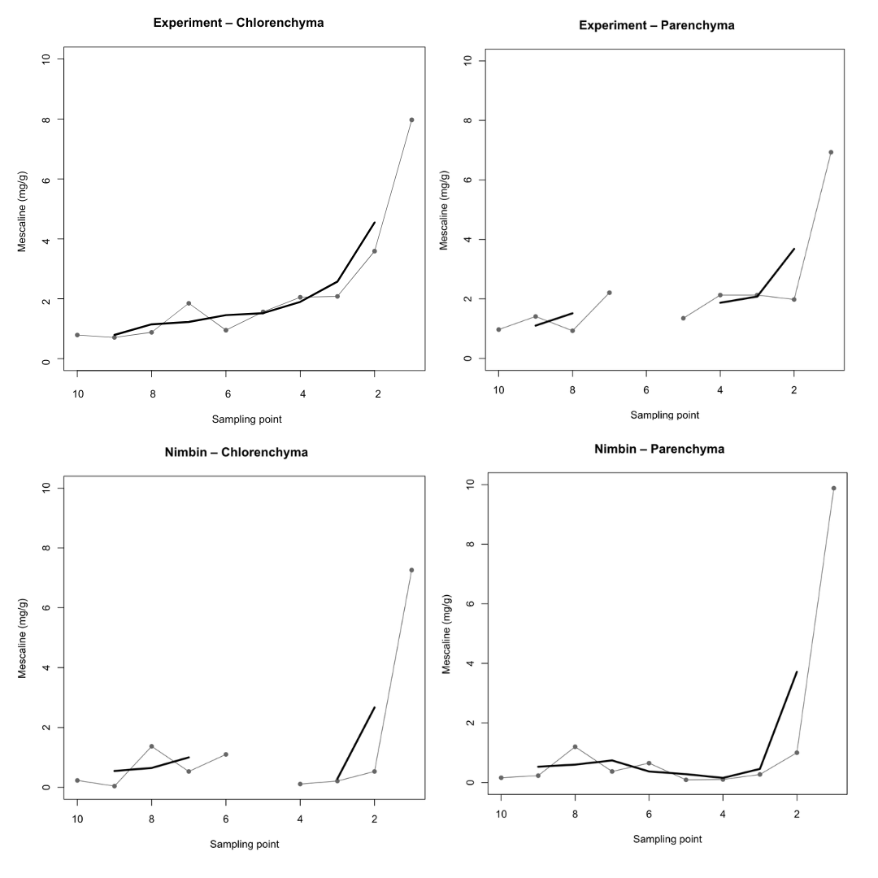
Figure S1. Three-point centred moving averages (boxcar, CAR = 3) of mescaline concentration profiles along mature T. bridgesii stems. Grey lines indicate the original mescaline concentration measurements and black lines the corresponding three-point centred moving averages. Panels show Experiment chlorenchyma (A), ‘Experiment’ parenchyma (B), ‘Nimbin’ chlorenchyma (C), and ‘Nimbin’ parenchyma (D). Sampling points progress from the apical region (Point 10) to the basal region (Point 1). Gaps in the smoothed curves reflect missing measurements that precluded calculation of centred three-point moving averages.

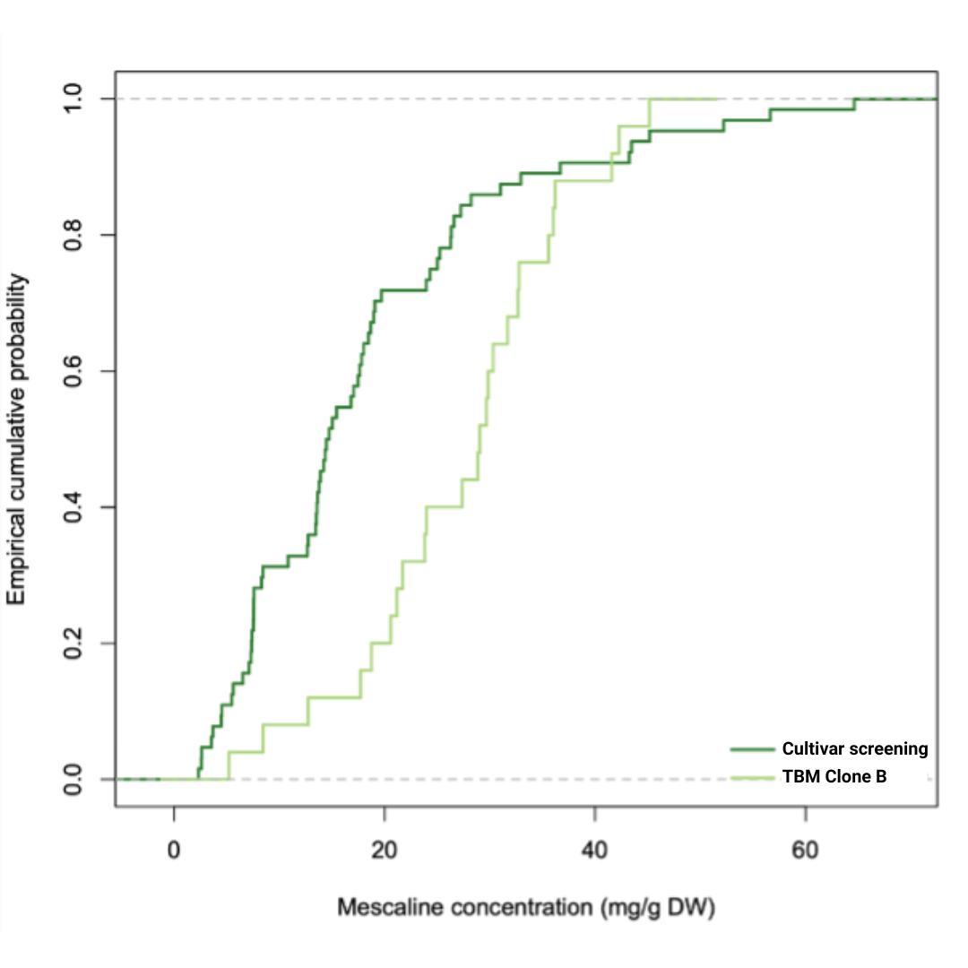
Figure S2. Empirical cumulative distribution functions of chlorenchyma mescaline concentrations in the ‘TBM Clone B’ and cultivar screening datasets.

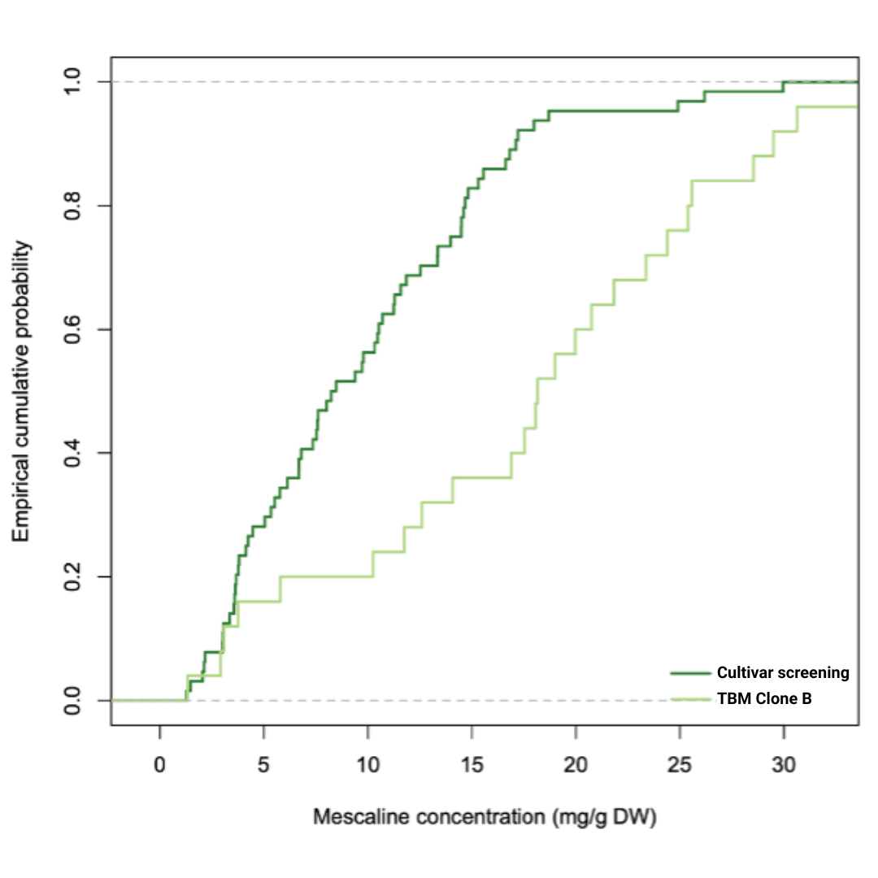
Figure S3. Empirical cumulative distribution functions of parenchyma mescaline concentrations in the ‘TBM Clone B’ and cultivar screening datasets.

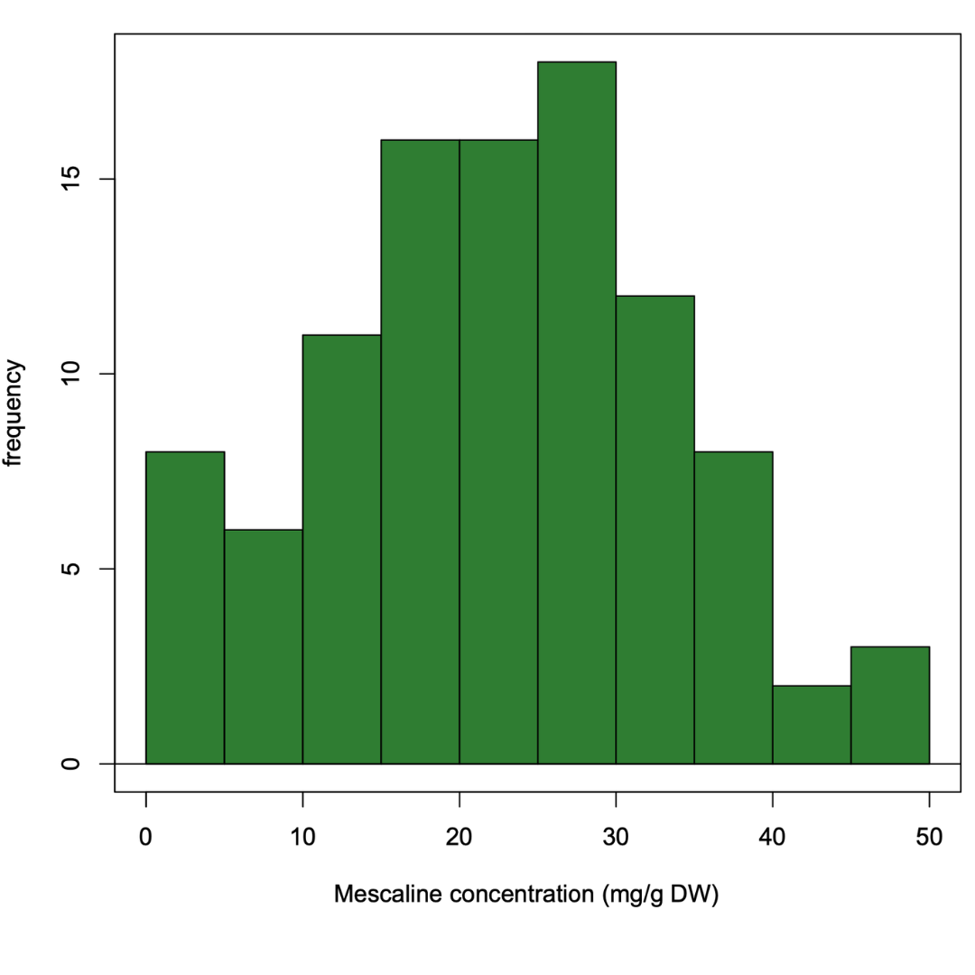

Figure S4. Histogram of chlorenchyma mescaline concentrations in the ‘TBM Clone B’ dataset.
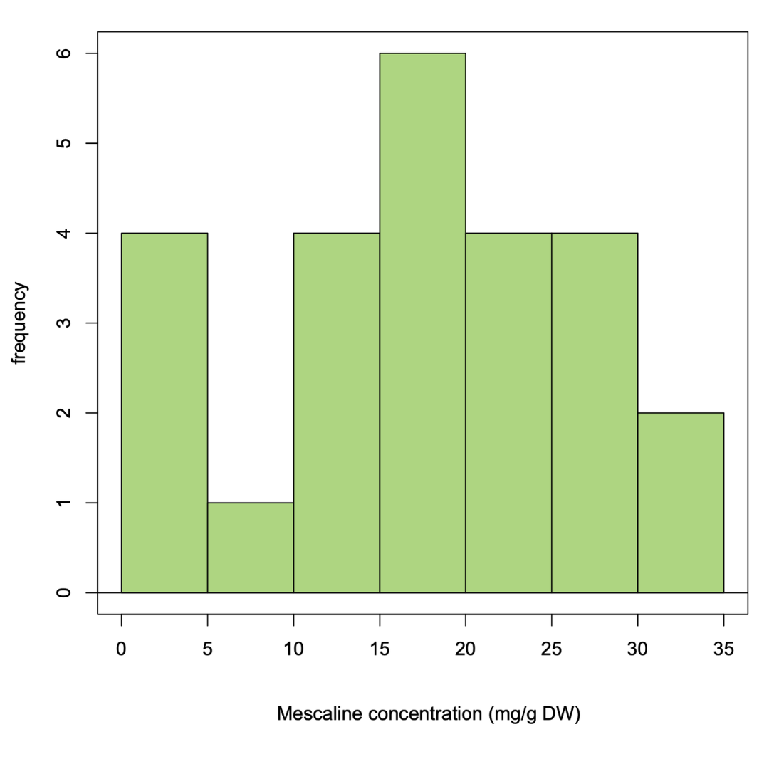

Figure S5. Histogram of parenchyma mescaline concentrations in n the ‘TBM Clone B’ dataset.
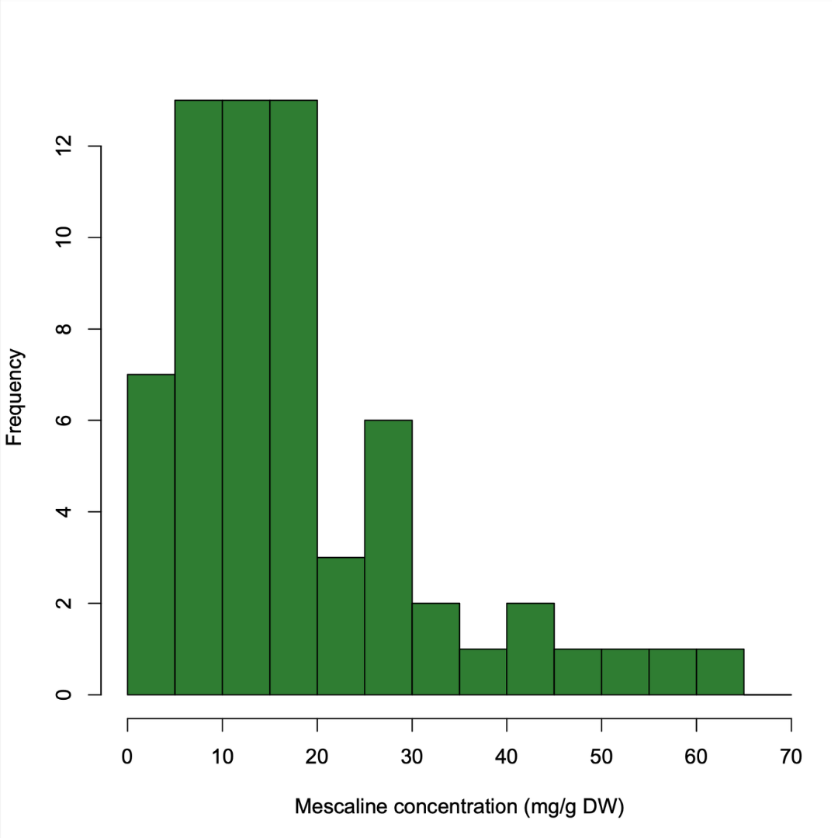

Figure S6. Histogram of chlorenchyma mescaline concentrations in the cultivar-screening dataset.

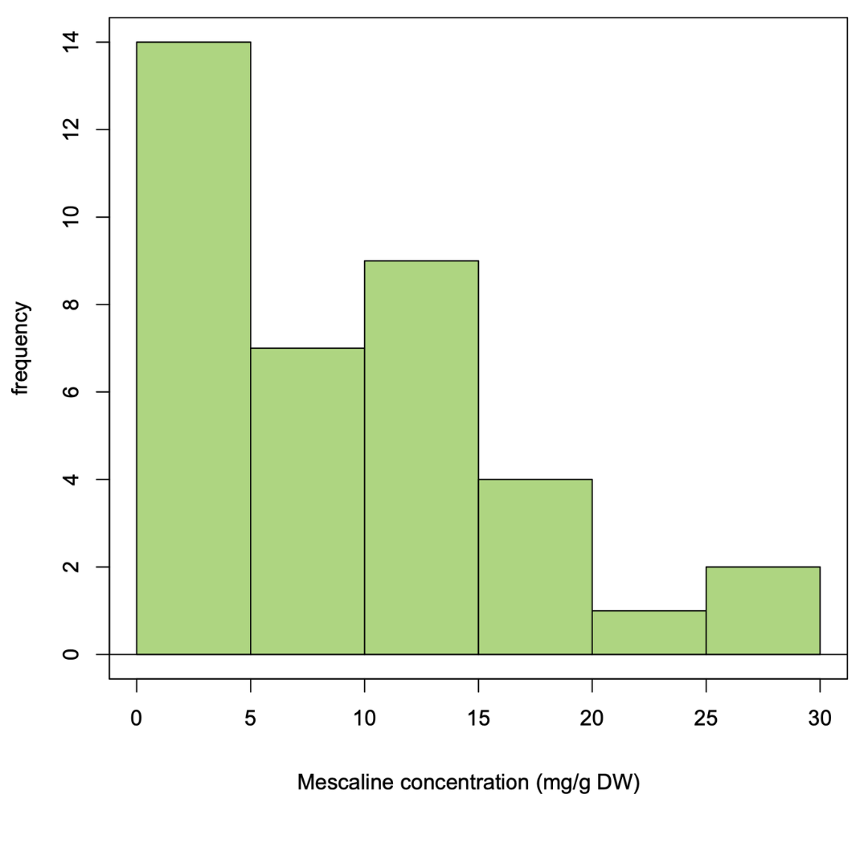

Figure S7. Histogram of parenchyma mescaline concentrations in the cultivar screening dataset.

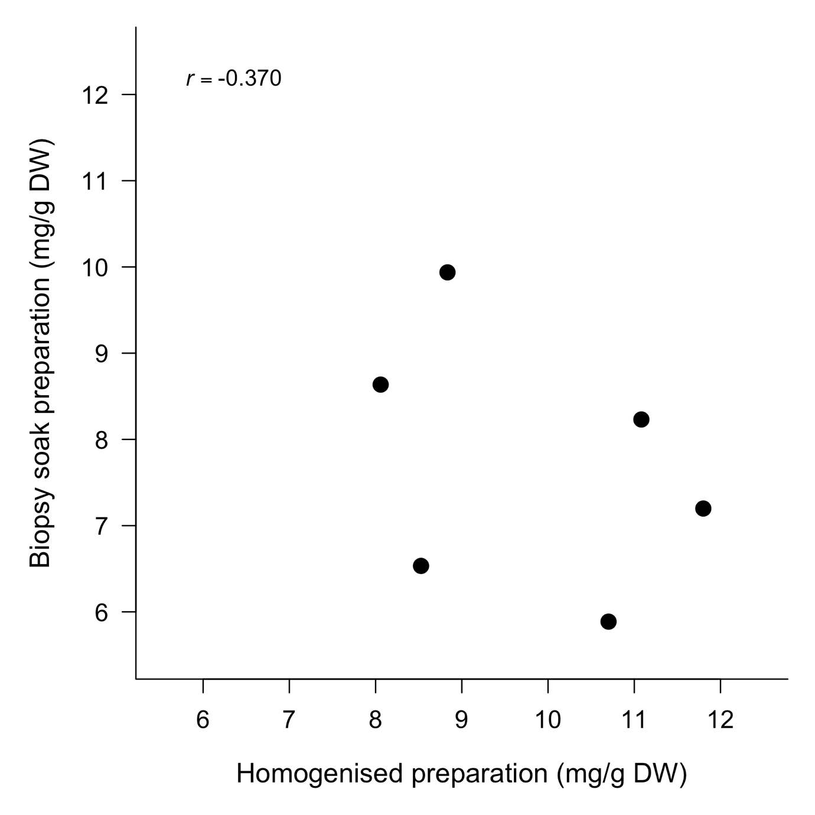
Figure S8. Scatter plot comparing mescaline concentrations determined using the homogenised sample preparation and the biopsy soak preparation in the biopsy validation experiment. Each point represents one paired sample. Pearson's correlation coefficient (r) = −0.370.

