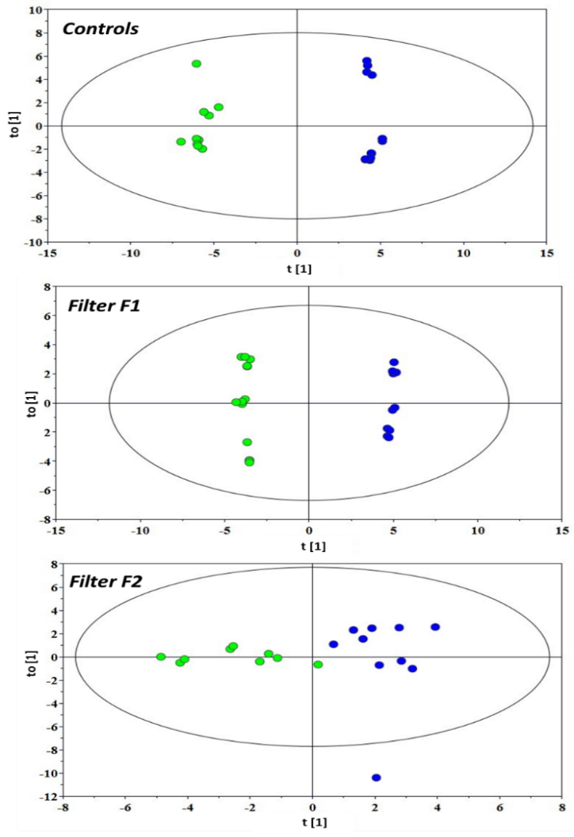
Figure S-1. OPLS-DA scores plots for the models built from the ¹H NMR spectra of embryos relative to the pairwise comparisons between the two sampling time points, i.e. 2d (green) and 4d (blue): (top) Controls; (middle) F1 group; (bottom) F2 group.

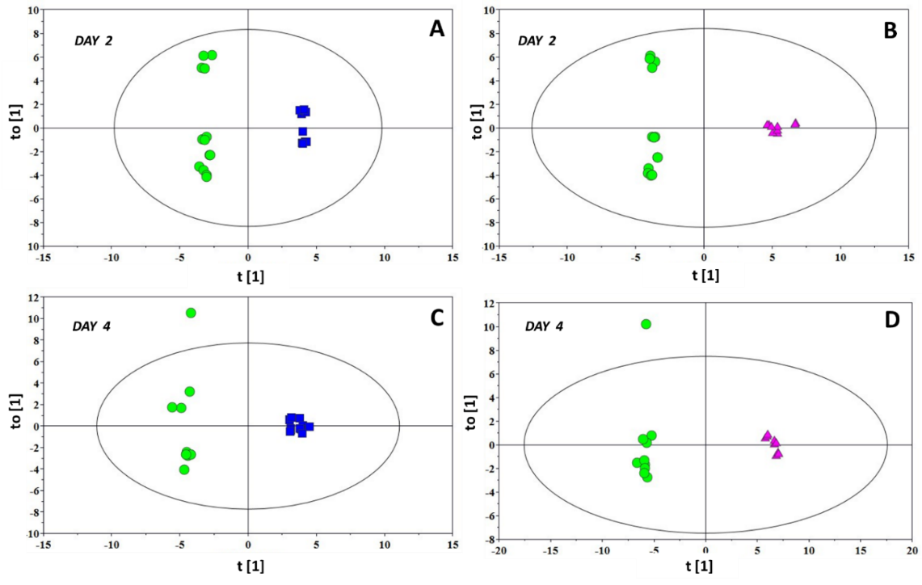

Figure S-2. OPLS-DA scores plots for the models built from the 1H NMR spectra of embryos relative to the pairwise comparisons between controls (circle), F1 (square), and F2 (triangle) samples at 2d (A-B) and 4d (C-D) time points

