Supplementary material 1. Supplementary tables and figures
Table S1. Per-variable characteristics of the analytic dataset.
Variable | n (total/internal/external) | Total (N=99) | Internal (N=73) | External (N=26) | P-value
motor nerve conduction
Median distal motor latency | 91/69/22 | 4.22 ± 2.48 | 4.21 ± 2.65 | 4.22 ± 1.89 | 0.986
Median CMAP amplitude, wrist | 91/69/22 | 8.77 ± 5.17 | 8.60 ± 4.92 | 9.30 ± 5.97 | 0.620
Median CMAP duration, wrist | 90/69/21 | 6.79 ± 3.10 | 6.25 ± 2.59 | 8.54 ± 3.96 | 0.020
Median motor latency, elbow | 91/69/22 | 8.68 ± 3.06 | 8.68 ± 3.21 | 8.66 ± 2.62 | 0.973
Median CMAP amplitude, elbow | 91/69/22 | 7.93 ± 4.98 | 7.75 ± 4.79 | 8.50 ± 5.62 | 0.578
Median CMAP duration, elbow | 89/68/21 | 6.81 ± 2.73 | 6.21 ± 1.82 | 8.73 ± 4.07 | 0.012
Median motor CV, wrist–elbow | 91/69/22 | 52.91 ± 8.17 | 53.05 ± 8.04 | 52.50 ± 8.73 | 0.795
Median motor latency, axilla | 87/69/18 | 10.57 ± 3.13 | 10.63 ± 3.36 | 10.36 ± 2.11 | 0.681
Median CMAP amplitude, axilla | 87/69/18 | 7.51 ± 4.80 | 7.40 ± 4.64 | 7.96 ± 5.49 | 0.693
Median CMAP duration, axilla | 84/67/17 | 6.71 ± 2.65 | 6.18 ± 1.72 | 8.78 ± 4.29 | 0.025
Median motor CV, elbow–axilla | 87/69/18 | 63.69 ± 11.13 | 63.05 ± 11.39 | 66.13 ± 9.99 | 0.267
Ulnar distal motor latency | 94/71/23 | 2.83 ± 1.02 | 2.80 ± 1.05 | 2.90 ± 0.94 | 0.674
Ulnar CMAP amplitude, wrist | 94/71/23 | 8.18 ± 4.67 | 7.86 ± 4.45 | 9.16 ± 5.29 | 0.298
Ulnar CMAP duration, wrist | 93/71/22 | 7.13 ± 2.65 | 6.53 ± 1.20 | 9.10 ± 4.56 | 0.016
Ulnar motor latency, elbow | 94/71/23 | 6.99 ± 1.86 | 7.03 ± 2.02 | 6.89 ± 1.27 | 0.697
Ulnar CMAP amplitude, elbow | 94/71/23 | 7.41 ± 4.52 | 7.10 ± 4.38 | 8.39 ± 4.91 | 0.268
Ulnar CMAP duration, elbow | 93/71/22 | 7.28 ± 2.75 | 6.59 ± 1.27 | 9.49 ± 4.57 | 0.008
Ulnar motor CV, wrist–elbow | 94/71/23 | 55.85 ± 9.58 | 55.85 ± 10.16 | 55.87 ± 7.74 | 0.994
Ulnar motor latency, axilla | 92/69/23 | 9.85 ± 2.30 | 9.94 ± 2.49 | 9.58 ± 1.60 | 0.419
Ulnar CMAP amplitude, axilla | 92/69/23 | 6.72 ± 4.39 | 6.31 ± 4.20 | 7.92 ± 4.81 | 0.162
Ulnar CMAP duration, axilla | 89/67/22 | 7.47 ± 2.79 | 6.76 ± 1.29 | 9.65 ± 4.56 | 0.008
Ulnar motor CV, elbow–axilla | 92/69/23 | 60.39 ± 12.42 | 59.81 ± 12.10 | 62.10 ± 13.50 | 0.474
Peroneal distal motor latency | 85/63/22 | 4.88 ± 2.15 | 4.94 ± 2.33 | 4.72 ± 1.52 | 0.621
Peroneal CMAP amplitude, ankle | 85/63/22 | 4.06 ± 2.93 | 3.91 ± 2.69 | 4.50 ± 3.58 | 0.491
Peroneal CMAP duration, ankle | 84/63/21 | 6.91 ± 2.43 | 6.57 ± 2.12 | 7.90 ± 3.01 | 0.072
Peroneal motor latency, fibular head | 83/61/22 | 12.29 ± 3.40 | 12.29 ± 3.69 | 12.27 ± 2.52 | 0.978
Peroneal CMAP amplitude, fibular head | 83/61/22 | 3.55 ± 2.94 | 3.45 ± 2.69 | 3.83 ± 3.61 | 0.660
Peroneal CMAP duration, fibular head | 80/59/21 | 7.26 ± 2.49 | 6.85 ± 2.28 | 8.42 ± 2.74 | 0.026
Peroneal motor CV, ankle–fibular head | 83/61/22 | 43.53 ± 7.35 | 43.62 ± 7.62 | 43.26 ± 6.68 | 0.836
Tibial distal motor latency | 90/66/24 | 5.13 ± 2.15 | 5.18 ± 2.33 | 4.98 ± 1.56 | 0.647
Tibial CMAP amplitude, ankle | 90/66/24 | 11.71 ± 8.89 | 10.96 ± 8.35 | 13.79 ± 10.11 | 0.228
Tibial CMAP duration, ankle | 89/66/23 | 6.93 ± 2.68 | 6.46 ± 2.10 | 8.29 ± 3.63 | 0.030
Tibial motor latency, popliteal fossa | 89/65/24 | 13.64 ± 3.22 | 13.57 ± 3.42 | 13.82 ± 2.70 | 0.722
Tibial CMAP amplitude, popliteal fossa | 89/65/24 | 9.05 ± 7.11 | 8.47 ± 6.53 | 10.64 ± 8.43 | 0.261
Tibial CMAP duration, popliteal fossa | 88/65/23 | 7.55 ± 3.06 | 6.91 ± 2.18 | 9.36 ± 4.30 | 0.015
Tibial motor CV, ankle–popliteal fossa | 89/65/24 | 43.69 ± 7.10 | 44.19 ± 6.77 | 42.34 ± 7.93 | 0.319
sensory nerve conduction
Median sensory peak latency, finger–wrist | 86/63/23 | 2.99 ± 0.82 | 2.93 ± 0.51 | 3.15 ± 1.35 | 0.437
Median SNAP amplitude, finger–wrist | 86/63/23 | 28.61 ± 20.65 | 28.42 ± 18.68 | 29.12 ± 25.75 | 0.906
Median sensory CV, finger–wrist | 86/63/23 | 44.28 ± 7.16 | 44.63 ± 6.50 | 43.35 ± 8.83 | 0.532
Median sensory peak latency, wrist–elbow | 93/69/24 | 4.07 ± 0.52 | 4.13 ± 0.54 | 3.92 ± 0.43 | 0.059
Median SNAP amplitude, wrist–elbow | 93/69/24 | 31.63 ± 18.17 | 30.40 ± 17.83 | 35.18 ± 19.08 | 0.290
Median sensory CV, wrist–elbow | 93/69/24 | 54.35 ± 5.28 | 53.83 ± 5.24 | 55.82 ± 5.23 | 0.117
Median sensory peak latency, elbow–axilla | 83/70/13 | 2.00 ± 0.41 | 1.98 ± 0.38 | 2.13 ± 0.54 | 0.329
Median SNAP amplitude, elbow–axilla | 83/70/13 | 54.31 ± 38.91 | 55.52 ± 40.81 | 47.78 ± 26.72 | 0.392
Median sensory CV, elbow–axilla | 83/70/13 | 59.48 ± 6.54 | 59.27 ± 6.95 | 60.59 ± 3.56 | 0.314
Ulnar sensory peak latency, finger–wrist | 89/66/23 | 2.60 ± 0.39 | 2.61 ± 0.36 | 2.57 ± 0.48 | 0.702
Ulnar SNAP amplitude, finger–wrist | 90/66/24 | 19.85 ± 12.25 | 20.48 ± 12.93 | 18.11 ± 10.20 | 0.371
Ulnar sensory CV, finger–wrist | 89/66/23 | 44.37 ± 5.41 | 44.01 ± 5.28 | 45.40 ± 5.76 | 0.319
Ulnar sensory peak latency, wrist–elbow | 95/71/24 | 4.25 ± 0.67 | 4.27 ± 0.71 | 4.22 ± 0.56 | 0.719
Ulnar SNAP amplitude, wrist–elbow | 96/71/25 | 28.86 ± 20.98 | 29.73 ± 23.23 | 26.39 ± 12.60 | 0.374
Ulnar sensory CV, wrist–elbow | 95/71/24 | 55.05 ± 6.17 | 54.92 ± 6.19 | 55.42 ± 6.23 | 0.734
Ulnar sensory peak latency, elbow–axilla | 90/72/18 | 2.49 ± 1.46 | 2.40 ± 0.48 | 2.88 ± 3.15 | 0.528
Ulnar SNAP amplitude, elbow–axilla | 90/72/18 | 35.22 ± 28.19 | 33.54 ± 24.79 | 41.96 ± 39.17 | 0.395
Ulnar sensory CV, elbow–axilla | 89/72/17 | 60.21 ± 8.73 | 58.74 ± 7.23 | 66.44 ± 11.67 | 0.018
Superficial peroneal sensory peak latency | 77/61/16 | 3.08 ± 0.54 | 3.07 ± 0.53 | 3.09 ± 0.60 | 0.933
Superficial peroneal SNAP amplitude | 77/61/16 | 13.87 ± 8.61 | 14.66 ± 8.72 | 10.84 ± 7.68 | 0.097
Superficial peroneal sensory CV | 77/61/16 | 39.60 ± 5.70 | 38.92 ± 5.56 | 42.18 ± 5.67 | 0.051
Sural sensory peak latency | 89/65/24 | 3.20 ± 0.62 | 3.14 ± 0.68 | 3.35 ± 0.41 | 0.080
Sural SNAP amplitude | 89/65/24 | 16.20 ± 12.43 | 16.26 ± 13.77 | 16.02 ± 7.94 | 0.917
Sural sensory CV | 89/65/24 | 39.04 ± 5.87 | 38.30 ± 5.83 | 41.06 ± 5.60 | 0.047
f-wave studies
Median F-latency/height ratio | 78/58/20 | 0.17 ± 0.02 | 0.17 ± 0.02 | 0.17 ± 0.03 | 0.992
Ulnar F-latency/height ratio | 78/59/19 | 0.17 ± 0.02 | 0.17 ± 0.02 | 0.16 ± 0.02 | 0.204
Peroneal F-latency/height ratio | 54/40/14 | 0.30 ± 0.04 | 0.29 ± 0.04 | 0.30 ± 0.04 | 0.509
Tibial F-latency/height ratio | 76/58/18 | 0.30 ± 0.04 | 0.31 ± 0.04 | 0.30 ± 0.03 | 0.460
h-reflex
Tibial H-latency ratio | 53/41/12 | 1.16 ± 0.12 | 1.15 ± 0.12 | 1.17 ± 0.13 | 0.708
derived features
CMAP amplitude ratio, median wrist–elbow | 91/69/22 | 0.87 ± 0.17 | 0.86 ± 0.18 | 0.89 ± 0.12 | 0.449
CMAP amplitude ratio, median elbow–axilla | 87/69/18 | 0.94 ± 0.13 | 0.93 ± 0.13 | 0.99 ± 0.11 | 0.031
CMAP amplitude ratio, ulnar wrist–elbow | 94/71/23 | 0.88 ± 0.15 | 0.87 ± 0.16 | 0.91 ± 0.07 | 0.094
CMAP amplitude ratio, ulnar elbow–axilla | 92/69/23 | 0.86 ± 0.19 | 0.84 ± 0.19 | 0.91 ± 0.19 | 0.183
CMAP amplitude ratio, peroneal ankle–fibular head | 83/61/22 | 0.84 ± 0.40 | 0.85 ± 0.45 | 0.82 ± 0.20 | 0.629
CMAP amplitude ratio, tibial ankle–popliteal fossa | 89/65/24 | 0.76 ± 0.16 | 0.75 ± 0.14 | 0.78 ± 0.21 | 0.598
CMAP duration ratio, median wrist–elbow | 89/68/21 | 1.02 ± 0.10 | 1.02 ± 0.11 | 1.02 ± 0.05 | 0.945
CMAP duration ratio, median elbow–axilla | 84/67/17 | 1.01 ± 0.10 | 1.01 ± 0.11 | 1.00 ± 0.06 | 0.528
CMAP duration ratio, ulnar wrist–elbow | 93/71/22 | 1.02 ± 0.11 | 1.01 ± 0.11 | 1.05 ± 0.11 | 0.177
CMAP duration ratio, ulnar elbow–axilla | 89/67/22 | 1.03 ± 0.10 | 1.03 ± 0.10 | 1.02 ± 0.10 | 0.729
CMAP duration ratio, peroneal ankle–fibular head | 80/59/21 | 1.08 ± 0.19 | 1.08 ± 0.21 | 1.08 ± 0.12 | 0.949
CMAP duration ratio, tibial ankle–popliteal fossa | 88/65/23 | 1.10 ± 0.19 | 1.09 ± 0.18 | 1.14 ± 0.21 | 0.299
Sural/median SNAP amplitude ratio | 79/57/22 | 0.85 ± 1.12 | 0.79 ± 1.15 | 1.00 ± 1.02 | 0.434
Sural/ulnar SNAP amplitude ratio | 82/59/23 | 1.03 ± 0.74 | 0.95 ± 0.71 | 1.22 ± 0.80 | 0.170
All nerve conduction parameters were taken from the clinically more affected side, as described in Methods. Values are mean ± standard deviation for the total cohort (N = 99) and for the internal (N = 73) and external (N = 26) partitions, with between-partition comparison by Welch’s t-test (P-value). Units are ms for latency and CMAP duration, mV for CMAP amplitude, µV for SNAP amplitude, and m/s for conduction velocity; F-latency/height ratios are in ms·cm⁻¹ and all other ratios are dimensionless. Non-responsive recordings, which were imputed for modeling (amplitudes, durations and conduction velocities set to 0; latencies set to 999), were excluded from these descriptive statistics, so the number of patients contributing to each row is given as n (total/internal/external). F-wave and H-reflex latencies are shown as height-corrected ratios, consistent with the primary analysis (Methods). Derived features are ratios computed from the parameters listed above: CMAP amplitude and duration ratios are proximal to distal, and sural-sparing ratios are sural to median or to ulnar SNAP amplitude recorded over the finger–wrist segment. They are undefined when either component was non-recordable. Demographic features (sex, age, height) and the serogroup feature are reported in Table 1.
Table S2. Model-specific classification performance stratified by serological feature condition, with internal vs. external dataset comparison
Data | Model | Metric | Internal Mean (95% CI) | External Mean (95% CI) | p-value
Without serology | LGBM | AUC_macro | 0.8573 (0.8431–0.8714) | 0.7857 (0.7775–0.7939) | <0.001
Without serology | LGBM | AUC_micro | 0.8505 (0.8370–0.8641) | 0.8229 (0.8172–0.8286) | <0.001
Without serology | LGBM | AUC_weighted | 0.8529 (0.8386–0.8672) | 0.8319 (0.8258–0.8380) | 0.005
Without serology | LGBM | PRC_macro | 0.8040 (0.7848–0.8232) | 0.6786 (0.6690–0.6882) | <0.001
Without serology | LGBM | PRC_micro | 0.7619 (0.7415–0.7823) | 0.7147 (0.7032–0.7262) | <0.001
Without serology | LGBM | PRC_weighted | 0.8027 (0.7838–0.8216) | 0.7553 (0.7462–0.7643) | <0.001
Without serology | CatBoost | AUC_macro | 0.8864 (0.8724–0.9005) | 0.8251 (0.8195–0.8308) | <0.001
Without serology | CatBoost | AUC_micro | 0.8814 (0.8682–0.8947) | 0.8554 (0.8508–0.8599) | <0.001
Without serology | CatBoost | AUC_weighted | 0.8845 (0.8705–0.8986) | 0.8617 (0.8575–0.8660) | 0.001
Without serology | CatBoost | PRC_macro | 0.8446 (0.8260–0.8632) | 0.7128 (0.7054–0.7202) | <0.001
Without serology | CatBoost | PRC_micro | 0.8160 (0.7964–0.8355) | 0.7757 (0.7682–0.7832) | 0.001
Without serology | CatBoost | PRC_weighted | 0.8446 (0.8263–0.8629) | 0.7876 (0.7815–0.7938) | <0.001
Without serology | XGB | AUC_macro | 0.8694 (0.8556–0.8833) | 0.7769 (0.7687–0.7851) | <0.001
Without serology | XGB | AUC_micro | 0.8646 (0.8518–0.8773) | 0.8219 (0.8161–0.8276) | <0.001
Without serology | XGB | AUC_weighted | 0.8668 (0.8528–0.8808) | 0.8227 (0.8167–0.8288) | <0.001
Without serology | XGB | PRC_macro | 0.8222 (0.8035–0.8409) | 0.6644 (0.6548–0.6741) | <0.001
Without serology | XGB | PRC_micro | 0.7842 (0.7639–0.8045) | 0.7164 (0.7059–0.7270) | <0.001
Without serology | XGB | PRC_weighted | 0.8221 (0.8036–0.8407) | 0.7354 (0.7264–0.7444) | <0.001
With serology | LGBM | AUC_macro | 0.8825 (0.8686–0.8965) | 0.8515 (0.8436–0.8594) | <0.001
With serology | LGBM | AUC_micro | 0.8752 (0.8620–0.8884) | 0.8711 (0.8650–0.8772) | 0.3039
With serology | LGBM | AUC_weighted | 0.8765 (0.8620–0.8910) | 0.8788 (0.8727–0.8849) | 0.7622
With serology | LGBM | PRC_macro | 0.8414 (0.8223–0.8604) | 0.7541 (0.7427–0.7654) | <0.001
With serology | LGBM | PRC_micro | 0.7975 (0.7767–0.8182) | 0.8053 (0.7945–0.8160) | 0.877
With serology | LGBM | PRC_weighted | 0.8370 (0.8178–0.8562) | 0.8131 (0.8036–0.8225) | 0.009
With serology | CatBoost | AUC_macro | 0.9416 (0.9310–0.9523) | 0.9020 (0.8970–0.9071) | <0.001
With serology | CatBoost | AUC_micro | 0.9387 (0.9284–0.9490) | 0.9233 (0.9192–0.9274) | <0.001
With serology | CatBoost | AUC_weighted | 0.9415 (0.9309–0.9522) | 0.9230 (0.9189–0.9271) | <0.001
With serology | CatBoost | PRC_macro | 0.9154 (0.9006–0.9302) | 0.8201 (0.8120–0.8282) | <0.001
With serology | CatBoost | PRC_micro | 0.9054 (0.8907–0.9200) | 0.8807 (0.8743–0.8871) | <0.001
With serology | CatBoost | PRC_weighted | 0.9172 (0.9029–0.9316) | 0.8697 (0.8639–0.8756) | <0.001
With serology | XGB | AUC_macro | 0.9502 (0.9421–0.9584) | 0.9407 (0.9361–0.9453) | 0.0164
With serology | XGB | AUC_micro | 0.9450 (0.9370–0.9531) | 0.9504 (0.9467–0.9540) | 0.6205
With serology | XGB | AUC_weighted | 0.9499 (0.9418–0.9580) | 0.9528 (0.9491–0.9565) | 0.9918
With serology | XGB | PRC_macro | 0.9219 (0.9089–0.9349) | 0.8746 (0.8673–0.8819) | <0.001
With serology | XGB | PRC_micro | 0.9116 (0.8991–0.9241) | 0.9204 (0.9149–0.9260) | 0.5705
With serology | XGB | PRC_weighted | 0.9247 (0.9125–0.9369) | 0.9110 (0.9055–0.9166) | 0.0128
Values represent the mean performance metric with 95% confidence intervals for each individual model (LGBM, CatBoost, XGB) under the with-serology and without-serology conditions. P-values reflect the statistical significance of between-dataset (internal vs. external) differences for each metric within each model and feature condition. Abbreviations: AUC, area under the receiver operating characteristic curve; PRC, area under the precision-recall curve; CI, confidence interval; LGBM, Light Gradient Boosting Machine; XGB, eXtreme Gradient Boosting; NCS, nerve conduction study.
Table S3. Within-internal-dataset comparison of classification performance between the with-serology and without-serology conditions, stratified by model
Model | Metric | with-serology Mean (95% CI) | without-serology Mean (95% CI) | p-value
LGBM | AUC_macro | 0.8825 (0.8686–0.8965) | 0.8573 (0.8431–0.8714) | <0.001
LGBM | AUC_micro | 0.8752 (0.8620–0.8884) | 0.8505 (0.8370–0.8641) | <0.001
LGBM | AUC_weighted | 0.8765 (0.8620–0.8910) | 0.8529 (0.8386–0.8672) | <0.001
LGBM | PRC_macro | 0.8414 (0.8223–0.8604) | 0.8040 (0.7848–0.8232) | <0.001
LGBM | PRC_micro | 0.7975 (0.7767–0.8182) | 0.7619 (0.7415–0.7823) | <0.001
LGBM | PRC_weighted | 0.8370 (0.8178–0.8562) | 0.8027 (0.7838–0.8216) | <0.001
CatBoost | AUC_macro | 0.9416 (0.9310–0.9523) | 0.8864 (0.8724–0.9005) | <0.001
CatBoost | AUC_micro | 0.9387 (0.9284–0.9490) | 0.8814 (0.8682–0.8947) | <0.001
CatBoost | AUC_weighted | 0.9415 (0.9309–0.9522) | 0.8845 (0.8705–0.8986) | <0.001
CatBoost | PRC_macro | 0.9154 (0.9006–0.9302) | 0.8446 (0.8260–0.8632) | <0.001
CatBoost | PRC_micro | 0.9054 (0.8907–0.9200) | 0.8160 (0.7964–0.8355) | <0.001
CatBoost | PRC_weighted | 0.9172 (0.9029–0.9316) | 0.8446 (0.8263–0.8629) | <0.001
XGB | AUC_macro | 0.9502 (0.9421–0.9584) | 0.8694 (0.8556–0.8833) | <0.001
XGB | AUC_micro | 0.9450 (0.9370–0.9531) | 0.8646 (0.8518–0.8773) | <0.001
XGB | AUC_weighted | 0.9499 (0.9418–0.9580) | 0.8668 (0.8528–0.8808) | <0.001
XGB | PRC_macro | 0.9219 (0.9089–0.9349) | 0.8222 (0.8035–0.8409) | <0.001
XGB | PRC_micro | 0.9116 (0.8991–0.9241) | 0.7842 (0.7639–0.8045) | <0.001
XGB | PRC_weighted | 0.9247 (0.9125–0.9369) | 0.8221 (0.8036–0.8407) | <0.001
Values represent the mean performance metric with 95% confidence intervals. P-values reflect the statistical significance of the performance difference between the with-serology and without-serology conditions within the internal dataset (n = 73). All comparisons reached p < 0.001, indicating that including the serological feature improved classification performance within the internal dataset. Abbreviations: AUC, area under the receiver operating characteristic curve; PRC, area under the precision-recall curve; CI, confidence interval; LGBM, Light Gradient Boosting Machine; XGB, eXtreme Gradient Boosting.
Table S4. Within-external-dataset comparison of classification performance between the with-serology and without-serology conditions, stratified by model
Model | Metric | with-serology Mean (95% CI) | without-serology Mean (95% CI) | p-value
LGBM | AUC_macro | 0.8515 (0.8436–0.8594) | 0.7857 (0.7775–0.7939) | <0.001
LGBM | AUC_micro | 0.8711 (0.8650–0.8772) | 0.8229 (0.8172–0.8286) | <0.001
LGBM | AUC_weighted | 0.8788 (0.8727–0.8849) | 0.8319 (0.8258–0.8380) | <0.001
LGBM | PRC_macro | 0.7541 (0.7427–0.7654) | 0.6786 (0.6690–0.6882) | <0.001
LGBM | PRC_micro | 0.8053 (0.7945–0.8160) | 0.7147 (0.7032–0.7262) | <0.001
LGBM | PRC_weighted | 0.8131 (0.8036–0.8225) | 0.7553 (0.7462–0.7643) | <0.001
CatBoost | AUC_macro | 0.9020 (0.8970–0.9071) | 0.8251 (0.8195–0.8308) | <0.001
CatBoost | AUC_micro | 0.9233 (0.9192–0.9274) | 0.8554 (0.8508–0.8599) | <0.001
CatBoost | AUC_weighted | 0.9230 (0.9189–0.9271) | 0.8617 (0.8575–0.8660) | <0.001
CatBoost | PRC_macro | 0.8201 (0.8120–0.8282) | 0.7128 (0.7054–0.7202) | <0.001
CatBoost | PRC_micro | 0.8807 (0.8743–0.8871) | 0.7757 (0.7682–0.7832) | <0.001
CatBoost | PRC_weighted | 0.8697 (0.8639–0.8756) | 0.7876 (0.7815–0.7938) | <0.001
XGB | AUC_macro | 0.9407 (0.9361–0.9453) | 0.7769 (0.7687–0.7851) | <0.001
XGB | AUC_micro | 0.9504 (0.9467–0.9540) | 0.8219 (0.8161–0.8276) | <0.001
XGB | AUC_weighted | 0.9528 (0.9491–0.9565) | 0.8227 (0.8167–0.8288) | <0.001
XGB | PRC_macro | 0.8746 (0.8673–0.8819) | 0.6644 (0.6548–0.6741) | <0.001
XGB | PRC_micro | 0.9204 (0.9149–0.9260) | 0.7164 (0.7059–0.7270) | <0.001
XGB | PRC_weighted | 0.9110 (0.9055–0.9166) | 0.7354 (0.7264–0.7444) | <0.001
Values represent the mean performance metric with 95% confidence intervals. P-values reflect the statistical significance of the performance difference between the with-serology and without-serology conditions within the external validation dataset (n = 26). All comparisons reached p < 0.001, indicating that the discriminative utility of serological information was preserved upon external validation across independent institutions. Abbreviations: AUC, area under the receiver operating characteristic curve; PRC, area under the precision-recall curve; CI, confidence interval; LGBM, Light Gradient Boosting Machine; XGB, eXtreme Gradient Boosting.
Table S5. Peroneal (ankle–fibular head) motor conduction velocity by mechanism-based class.
Class | Recordable n | Velocity, median [IQR] (m/s) | No derivable velocity, n
Axonal-predominant | 31 | 43.0 [41.1–46.0] | 9
Demyelinating | 16 | 35.8 [30.1–41.2] | 6
MFS-spectrum | 36 | 49.5 [43.3–52.0] | 1
Values are median [interquartile range] among patients with a derivable ankle–fibular head conduction velocity (a recordable compound muscle action potential at both stimulation sites). In the remaining patients velocity could not be derived: in almost all this was because the response was absent (non-recordable) at one or both stimulation sites, reflecting severe involvement and most frequent in the axonal-predominant and demyelinating classes. In a single MFS-spectrum case the peroneal study was not performed. Kruskal–Wallis p < 0.001; pairwise Mann–Whitney U: demyelinating vs axonal-predominant p = 0.0006, demyelinating vs MFS-spectrum p < 0.001, axonal-predominant vs MFS-spectrum p = 0.002.

Figure S1. SHAP-based feature importance and value–SHAP correlations for each GBS subtype under the without-serology condition (CatBoost model). SHAP values were aggregated across 100 repeated random splits of the internal dataset (n = 73); CatBoost was the best-performing model under the without-serology condition. The between-seed SD denotes the standard deviation across these 100 repeated splits. The 10 highest-ranked features by importance are shown for each subtype: (a) Axonal-predominant, (b) Demyelinating, and (c) MFS-spectrum. For each subtype, the left panel shows feature importance (Mean |SHAP| ± between-seed SD), and the right panel shows the Pearson correlation between each feature’s value and its SHAP value (corr(feature value, SHAP) ± between-seed SD). A positive correlation (red) indicates that higher feature values contribute toward the respective subtype classification, whereas a negative correlation (blue) indicates that higher feature values contribute toward the opposite. Features for which the value–SHAP correlation was undefined are marked “NA” in the direction panel. GBS, Guillain-Barré syndrome; MFS, Miller Fisher syndrome; SHAP, SHapley Additive exPlanations; SD, standard deviation.
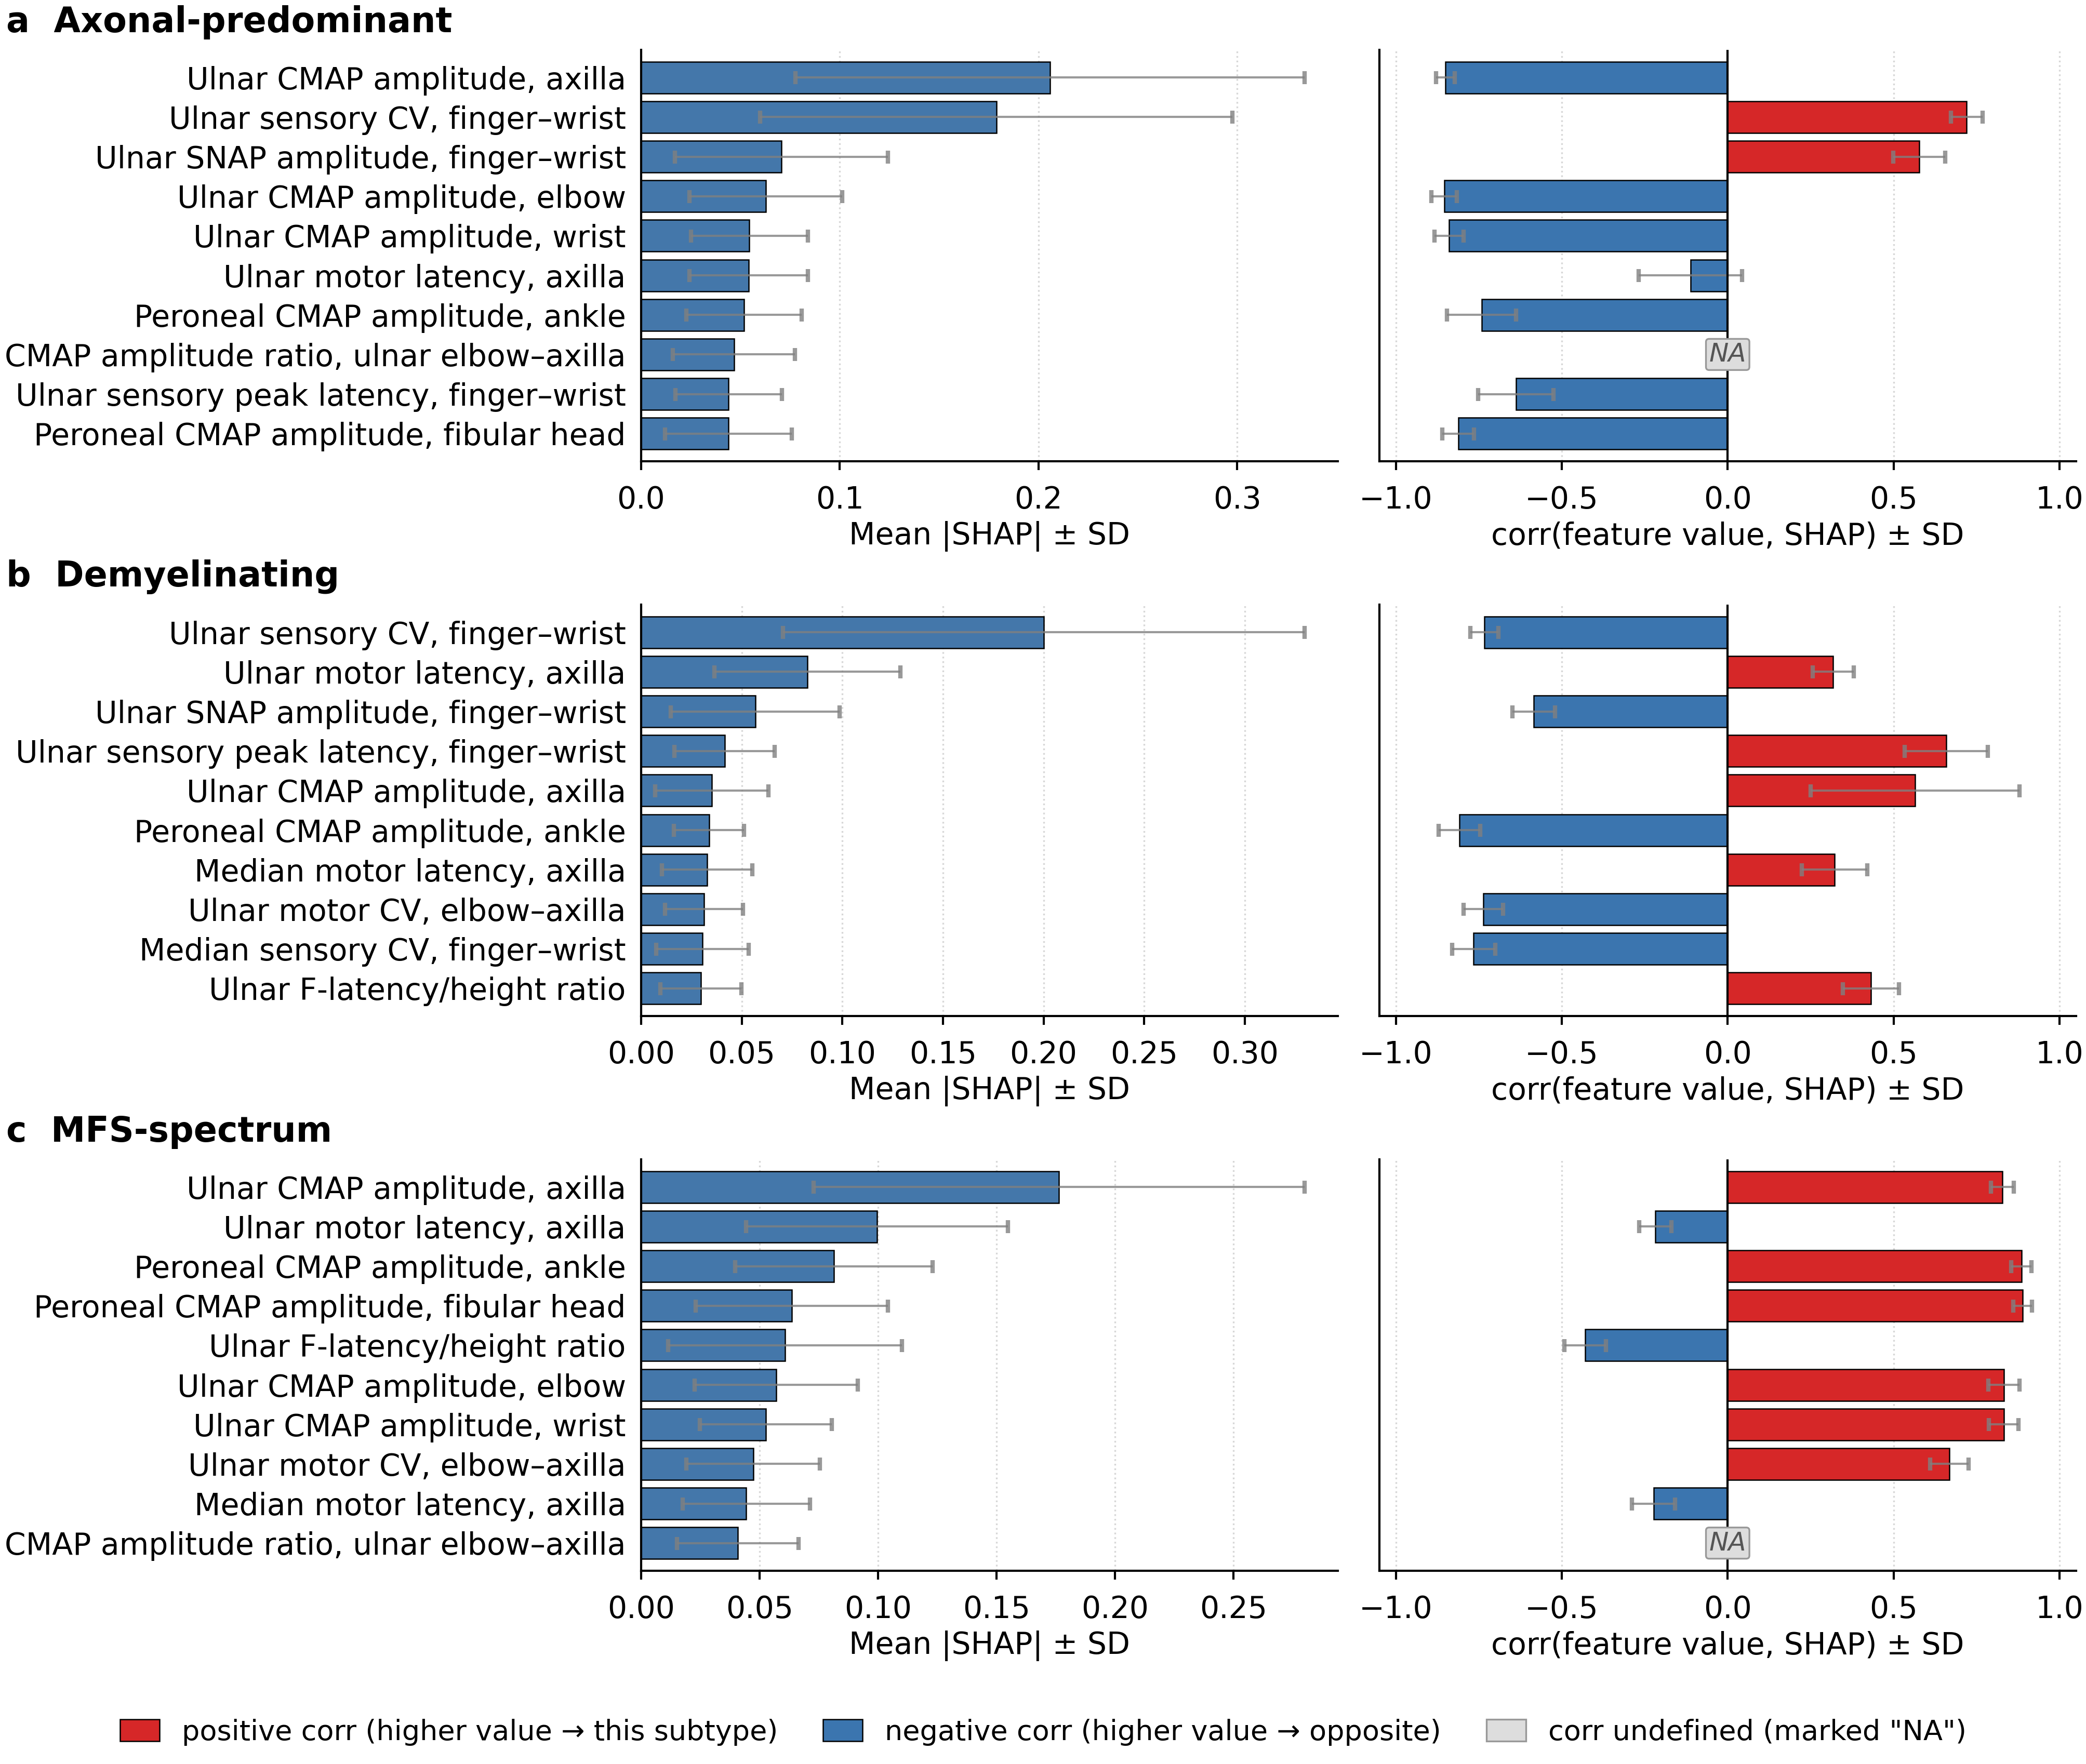
Figure S2. SHAP beeswarm plot for the Axonal-predominant subtype under the with-serology condition. SHAP beeswarm plot derived from a representative run of the XGB model (seed = 11, internal AUC_weighted = 0.958, corresponding to the median internal AUC_weighted performance) under the with-serology condition, displayed for the Axonal-predominant subtype classification. The x-axis represents the SHAP value (impact on model output), with positive values indicating contribution toward Axonal-predominant classification and negative values indicating contribution away from this subtype. Features are ranked in descending order of mean absolute SHAP value. Each dot represents an individual training sample, coloured according to the RobustScaler-normalised feature value (red: high; blue: low). XGB was the best-performing model under the with-serology condition. SHAP, SHapley Additive exPlanations; AUC, area under the receiver operating characteristic curve; AUC_weighted, AUC averaged across the three subtypes weighted by class support.
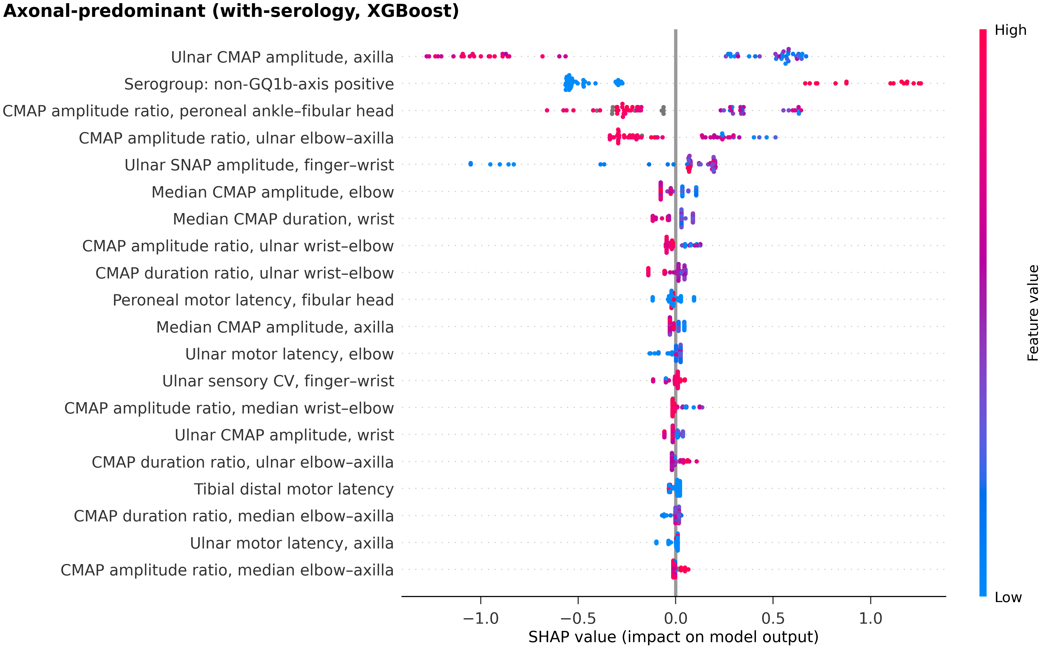
Figure S3. SHAP beeswarm plot for the Demyelinating subtype under the with-serology condition. SHAP beeswarm plot derived from a representative run of the XGB model (seed = 11, internal AUC_weighted = 0.958, corresponding to the median internal AUC_weighted performance) under the with-serology condition, displayed for the Demyelinating subtype classification. The x-axis represents the SHAP value (impact on model output), with positive values indicating contribution toward Demyelinating classification and negative values indicating contribution away from this subtype. Features are ranked in descending order of mean absolute SHAP value. Each dot represents an individual training sample, coloured according to the RobustScaler-normalised feature value (red: high; blue: low). XGB was the best-performing model under the with-serology condition. SHAP, SHapley Additive exPlanations; AUC, area under the receiver operating characteristic curve; AUC_weighted, AUC averaged across the three subtypes weighted by class support.
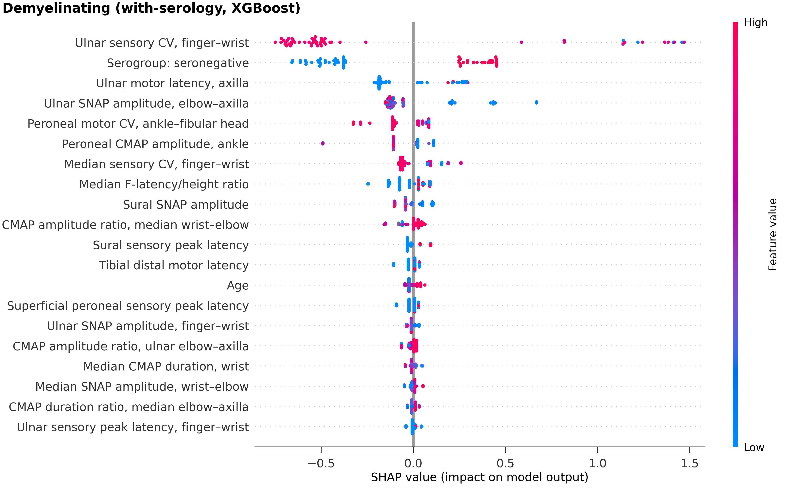
Figure S4. SHAP beeswarm plot for the MFS-spectrum subtype under the with-serology condition. SHAP beeswarm plot derived from a representative run of the XGB model (seed = 11, internal AUC_weighted = 0.958, corresponding to the median internal AUC_weighted performance) under the with-serology condition, displayed for the MFS-spectrum subtype classification. The x-axis represents the SHAP value (impact on model output), with positive values indicating contribution toward MFS-spectrum classification and negative values indicating contribution away from this subtype. Features are ranked in descending order of mean absolute SHAP value. Each dot represents an individual training sample, coloured according to the RobustScaler-normalised feature value (red: high; blue: low). XGB was the best-performing model under the with-serology condition. SHAP, SHapley Additive exPlanations; MFS, Miller Fisher Syndrome; AUC, area under the receiver operating characteristic curve; AUC_weighted, AUC averaged across the three subtypes weighted by class support.
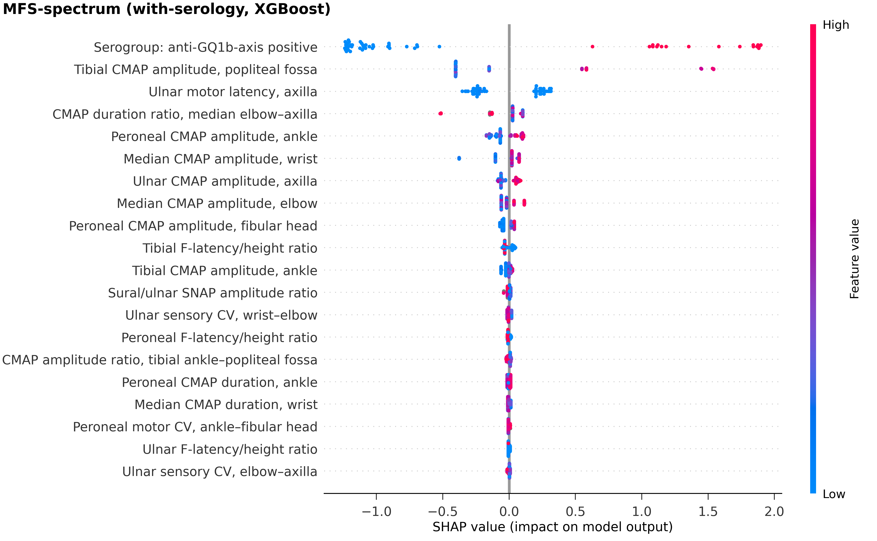
Figure S5. SHAP beeswarm plot for the Axonal-predominant subtype under the without-serology condition. SHAP beeswarm plot derived from a representative run of the CatBoost model (seed = 53, internal AUC_weighted = 0.893, corresponding to the median internal AUC_weighted performance) under the without-serology condition, displayed for the Axonal-predominant subtype classification. The x-axis represents the SHAP value (impact on model output), with positive values indicating contribution toward Axonal-predominant classification and negative values indicating contribution away from this subtype. Features are ranked in descending order of mean absolute SHAP value. Each dot represents an individual training sample, coloured according to the RobustScaler-normalised feature value (red: high; blue: low). CatBoost was the best-performing model under the without-serology condition. SHAP, SHapley Additive exPlanations; AUC, area under the receiver operating characteristic curve; AUC_weighted, AUC averaged across the three subtypes weighted by class support.
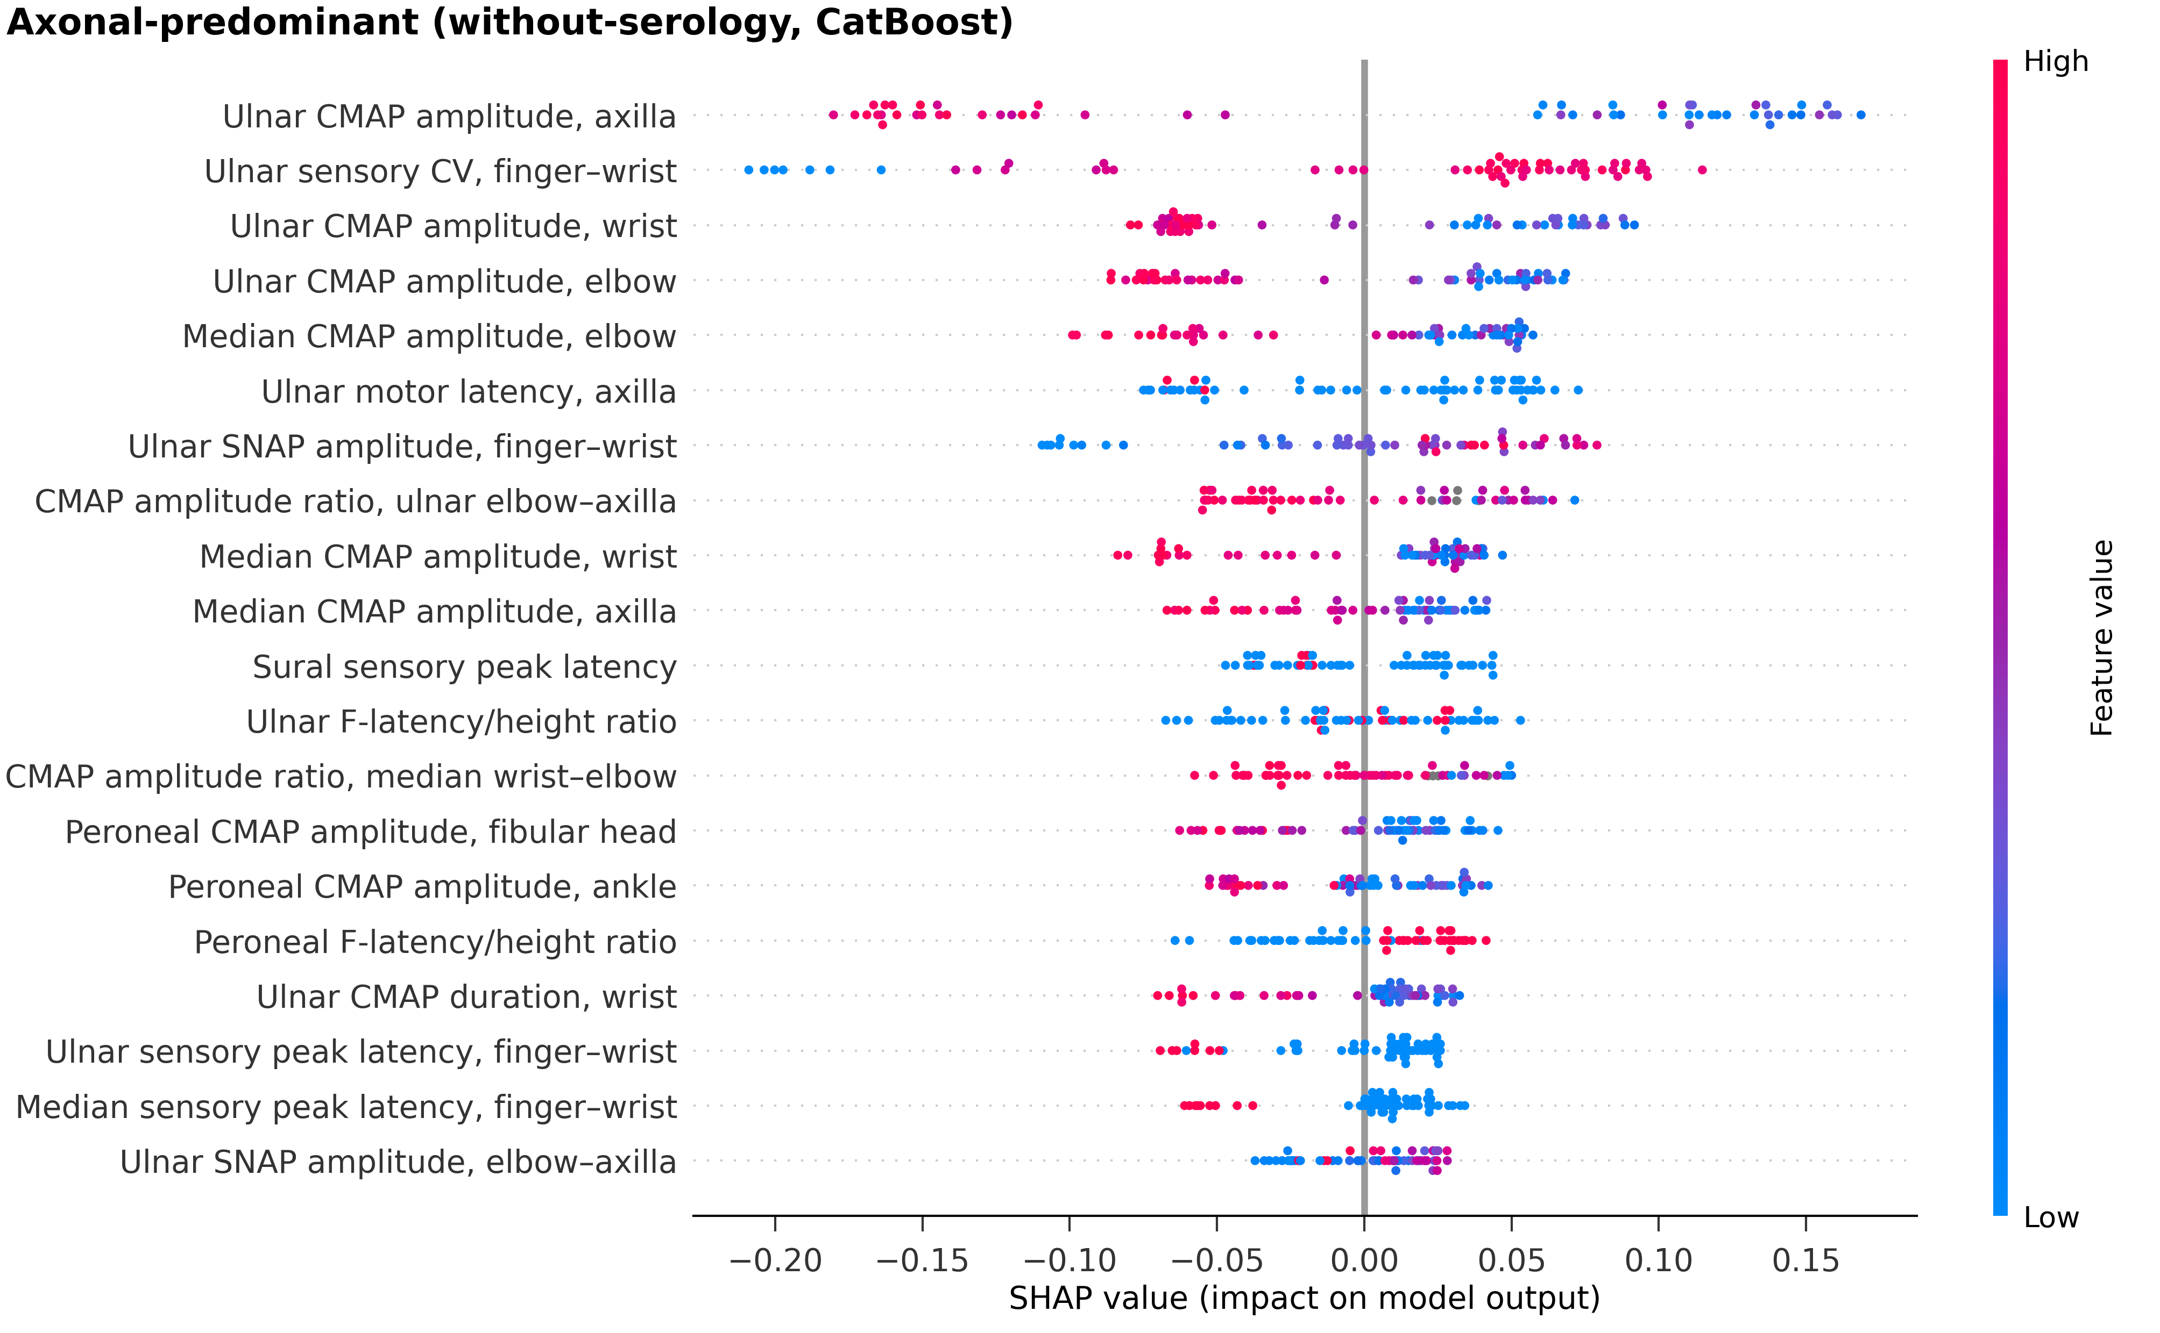
Figure S6. SHAP beeswarm plot for the Demyelinating subtype under the without-serology condition. SHAP beeswarm plot derived from a representative run of the CatBoost model (seed = 53, internal AUC_weighted = 0.893, corresponding to the median internal AUC_weighted performance) under the without-serology condition, displayed for the Demyelinating subtype classification. The x-axis represents the SHAP value (impact on model output), with positive values indicating contribution toward Demyelinating classification and negative values indicating contribution away from this subtype. Features are ranked in descending order of mean absolute SHAP value. Each dot represents an individual training sample, coloured according to the RobustScaler-normalised feature value (red: high; blue: low). CatBoost was the best-performing model under the without-serology condition. SHAP, SHapley Additive exPlanations; AUC, area under the receiver operating characteristic curve; AUC_weighted, AUC averaged across the three subtypes weighted by class support.
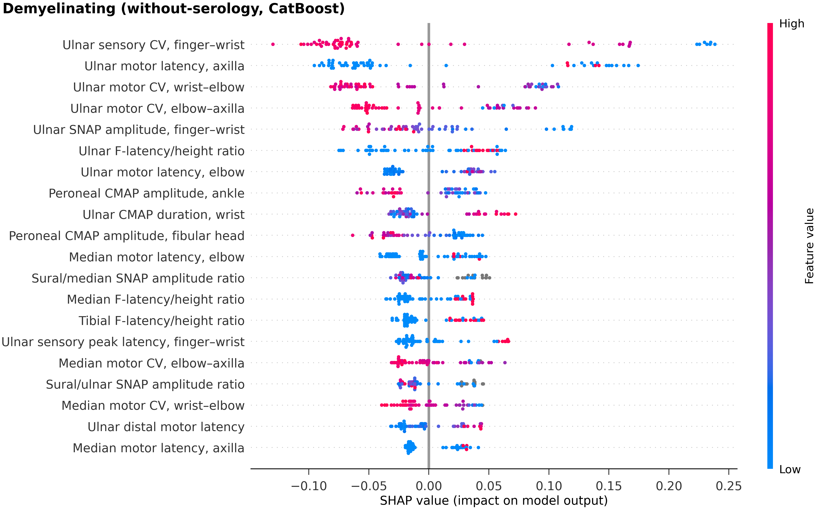
Figure S7. SHAP beeswarm plot for the MFS-spectrum subtype under the without-serology condition. SHAP beeswarm plot derived from a representative run of the CatBoost model (seed = 53, internal AUC_weighted = 0.893, corresponding to the median internal AUC_weighted performance) under the without-serology condition, displayed for the MFS-spectrum subtype classification. The x-axis represents the SHAP value (impact on model output), with positive values indicating contribution toward MFS-spectrum classification and negative values indicating contribution away from this subtype. Features are ranked in descending order of mean absolute SHAP value. Each dot represents an individual training sample, coloured according to the RobustScaler-normalised feature value (red: high; blue: low). CatBoost was the best-performing model under the without-serology condition. SHAP, SHapley Additive exPlanations; MFS, Miller Fisher Syndrome; AUC, area under the receiver operating characteristic curve; AUC_weighted, AUC averaged across the three subtypes weighted by class support.
