Supplementary Materials

Metabolic Markers
Supplementary Figure 1. Weight loss trend over the study period in the full sample, in participants without GLP-1RA use, and in those with GLP-1RA use.
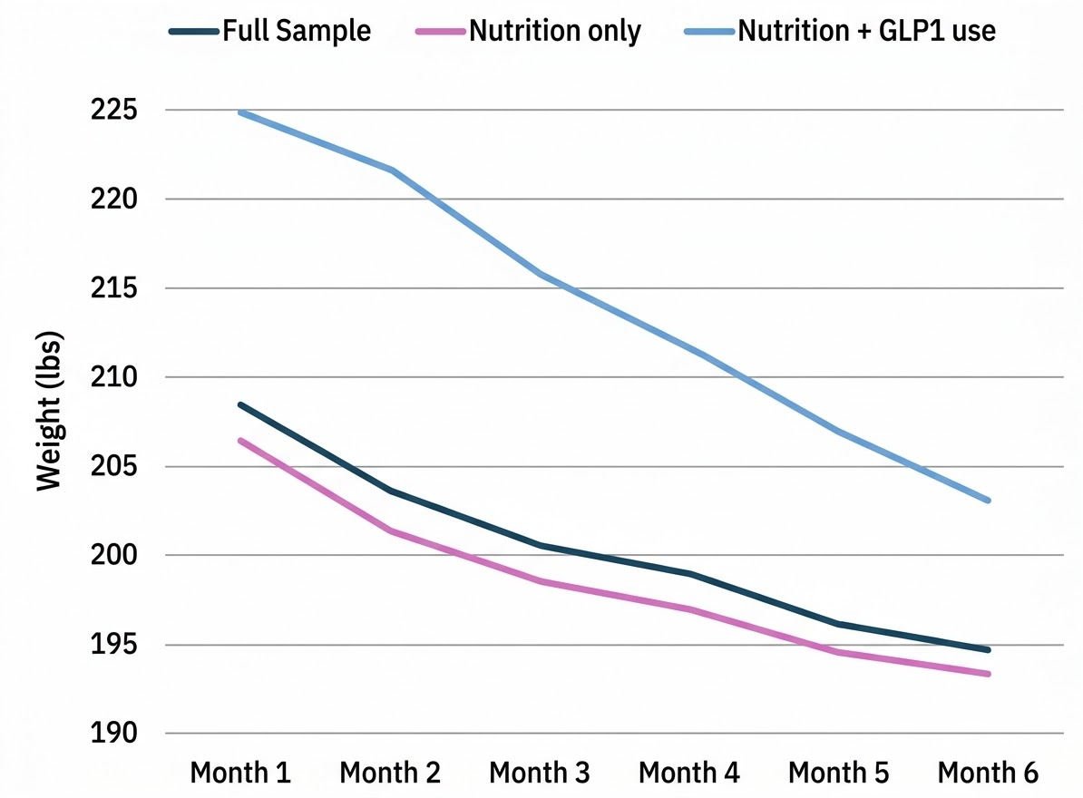
Note. Data points for each time point are means across the 30-days prior. Additionally, for the participants who were already on a GLP-1RA prior to starting Virta, the mean weight loss achieved on the medication (and before enrollment in the Virta program) was 13%.

Mean BHB levels across the 6 months in the full sample were 0.5 mmol/L, with values ranging from 0 to 2.2 mmol/L.

Association Analyses
Supplementary Table 1. Multivariable regression analyses examining associations between food noise, control of eating domains, and 6-month depression and anxiety outcomes.
Outcome | Predictor | B | p-value
Depression | Food noise | 0.15 (0.06, 0.24) | <0.001
 | Craving control | -0.02 (-0.04, 0.00) | 0.01
 | Sweet craving | 0.03 (0.01, 0.04) | 0.003
 | Savory craving | 0.02 (-0.01, 0.04) | 0.18
 | Hunger | 0.03 (0.01, 0.04) | <0.001
 | Satiety | 0.01 (-0.01, 0.02) | 0.24
 | Mood | -0.08 (-0.11, -0.06) | <0.001
 | % Weight change | 7.44 (-0.57, 15.5) | 0.07
 | Ketones | -0.63 (-2.09, 0.84) | 0.40
Anxiety | Food noise | 0.11 (0.01, 0.20) | 0.03
 | Craving control | -0.01 (-0.03, 0.00) | 0.14
 | Sweet craving | 0.02 (-0.00, 0.03) | 0.07
 | Savory craving | 0.01 (-0.02, 0.03) | 0.62
 | Hunger | 0.02 (0.00, 0.04) | 0.02
 | Satiety | -0.002 (-0.02, 0.01) | 0.79
 | Mood | -0.09 (-0.12, -0.07) | <0.001
 | % Weight change | 2.82 (-4.70, 10.34) | 0.46
 | Ketones | -0.06 (-1.39, 1.27) | 0.93
Craving Control | Food noise | -2.66 (-3.26, -2.05) | <0.001
Sweet Cravings | Food noise | 1.81 (1.24, 2.39) | <0.001
Savory Cravings | Food noise | 1.18 (0.71, 1.64) | <0.001
Hunger | Food noise | 1.46 (0.83, 2.09) | <0.001
Satiety | Food noise | -0.54 (-1.30, 0.22) | 0.16
Mood | Food noise | -0.39 (-0.86, 0.08) | 0.10
Note. Unstandardized regression coefficients (B) and p-values were pooled across 100 multiply imputed datasets using Rubin's rules. Depression, anxiety, and control of eating models were adjusted for baseline outcome scores, age, sex, race, ethnicity, baseline BMI, and GLP-1RA exposure.

GLP-1RA use was not independently associated with depression outcomes but was a significant predictor in almost all anxiety outcome models. Additionally, greater weight loss was independently associated with lower 6-month food noise scores but not depression or anxiety scores, while ketone levels were not independently associated with any outcome.

