Supporting information
Electrical Control of Quantum Emitters in a Van der Waals Heterostructure

Simon J U White^{1#}, Tieshan Yang^{1,2#}, Nikolai Dontschuk³, Chi Li¹, Zai-Quan Xu¹, Mehran Kianinia^{1,2}, Alastair Stacey⁴, Milos Toth^{1,2} and Igor Aharonovich^{1,2}
1. School of Mathematical and Physical Sciences, University of Technology Sydney, Ultimo, New South Wales 2007, Australia
2. ARC Centre of Excellence for Transformative Meta-Optical Systems, University of Technology Sydney, Ultimo, New South Wales 2007, Australia
3. School of Physics, University of Melbourne, Parkville, Victoria 3010, Australia
4. School of Science, RMIT University, Melbourne, Victoria 3001, Australia
# These authors contributed equally

The supporting information includes:

- hBN/MLG Heterostructure Device Fabrication

- Confocal Photoluminescence Schematic

- Device Dimensions and AFM

- Device Electrical Characteristics

- Room Temperature Spectral Characterisation

- Cryogenic Spectral Characterisation

hBN/MLG Heterostructure Device Fabrication
After the plasma treatment of hBN flake to activate single photon emitters, the desired hBN flake on SiO₂/Si substrate is identified using optical microscopy. To pick up and transfer the hBN/MLG flakes a dry transfer method with a home-built transfer platform is used. We use a stamp consisting of a thin film of polyvinyl alcohol (PVA) mounted on a block of polydimethylsiloxane (PDMS) for mechanical support. The stamp is placed on a glass slide attached to a micromanipulator under a microscope. The SiO₂/Si substrate with MLG or hBN capping fakes to be transferred, are fixed onto a transfer stage and positioned with a micromanipulator.
Firstly, the PVA stamp is placed into contact with a selected MLG flake. Next, we lift the PVA stamp with MLG flakes from the SiO₂/Si substrate at room temperature.
Then, we remove the SiO₂/Si substrate and place the SiO₂/Si substrate with hBN capping layer onto the transfer stage. We position the MLG flakes on a PVA stamp over a selected region of the target SiO₂/Si substrate with hBN capping layer and bring the PVA stamp and target SiO₂/Si substrate with hBN fully into contact. Next, we lift the PVA stamp with MLG/hBN flakes from the SiO₂/Si substrate at room temperature.
Next, we remove the SiO₂/Si substrate and place the SiO₂/Si substrate with hBN emitter layer onto the stage. We position the hBN/MLG flakes on a PVA stamp over a selected region of the target SiO₂/Si substrate with hBN emitter layer and bring the PVA stamp and target substrate with hBN emitter layer fully into contact. Then, the stage was heated up and reached about ~60 ℃. After this, we lift the glass slide with a PDMS block. The PVA stamp remains on the target substrate due to the preferential adhesion. Finally, we use water to dissolve the PVA stamp and clean the hBN/MLG heterostructure device surface.
Then, the electrode pattern is fabricated by a photolithography method on top of the MLG layer followed by a thermal deposited 5 nm/100 nm thick Cr/Au electrode pad (a gold pad with dimension ~ 600 × 600 µm²). Finally, we use acetone to lift-off the non patterned Cr/Au area and use acetone and isopropyl alcohol (IPA) to clean the hBN/MLG heterostructure device surface.

Confocal Photoluminescence Schematic
A continuous wave (CW) 532 nm laser (Gem 532™, Laser Quantum Ltd.) is used for excitation and photoluminescence (PL) scanning. The beam is directed via a 532 nm dichroic mirror (LP03-532RE-25) into the attoDRY800 cryostat, and focussed to a diffraction limited spot on the sample using a vacuum compatible high numerical aperture objective lens (0.82 NA). A 4f lens system and X-Y piezo scanning mirror (FSM-300™) is used to scan the spot over sample. The collected light is filtered using the dichroic mirror and an additional long pass filter (568 LP filter, Semrock™). The signal is then collected into a multimode fiber and directed to a spectrometer (Acton SpectraPro™, Princeton Instrument Inc.) for spectral characterisation, or avalanche photodiodes (Excelitas SPCM-AQRH) for single photon counting and PL mapping. Correlation measurements are made using a fibre based Habury-Brown and Twiss setup and time-correlated single photon counting module (Swabian, TimeTagger20). A bias is applied to the device (within the cryostat via vacuum feedthrough) using either a Keithley Tektronix sourcemeter (2612B) SMU or a Agilent function generator (33522A).

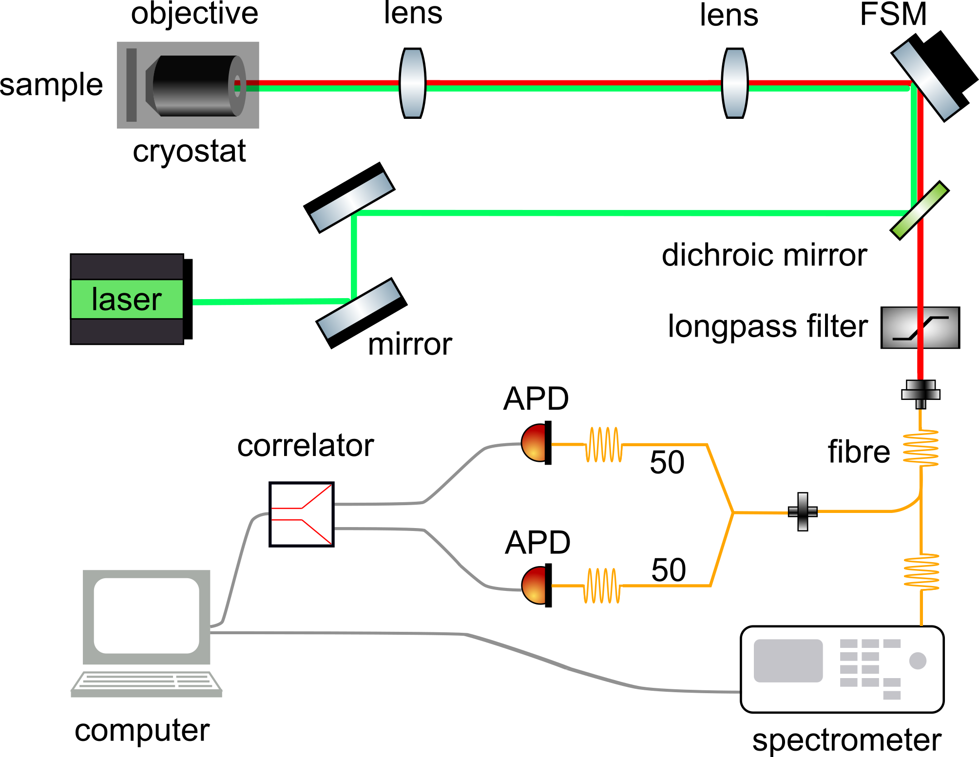
Supplementary Figure 1. Schematic of the confocal photoluminescence setup (FSM, fast steering mirror; APD, avalanche photodiodes).

Device Dimensions and AFM
Optical microscope image and AFM of the hBN/MLG heterostructure device on the 90 nm SiO2/Si substrate is shown in Supplementary Figure 2. A hBN capping layer is introduced to prevent emitters in the hBN layer from quenching during the device fabrication. Non-contact mode AFM was used to create the image shown in Supplementary Figure 2 (b), it displays the target flake area. The pink line at the top of the image marks the location used to measure the thickness of the hBN SPE layer, which shows the thickness of ~35 nm (Supplementary Figure 2c). The red line at the top of the image marks the location used to measure the thickness of the multilayer graphene (MLG), which shows the thickness of ~13 nm (Supplementary Figure 2d). The blue line at the bottom of the image marks the location used to measure the thickness of the hBN capping layer, which shows the thickness of ~22 nm (Supplementary Figure 2e).
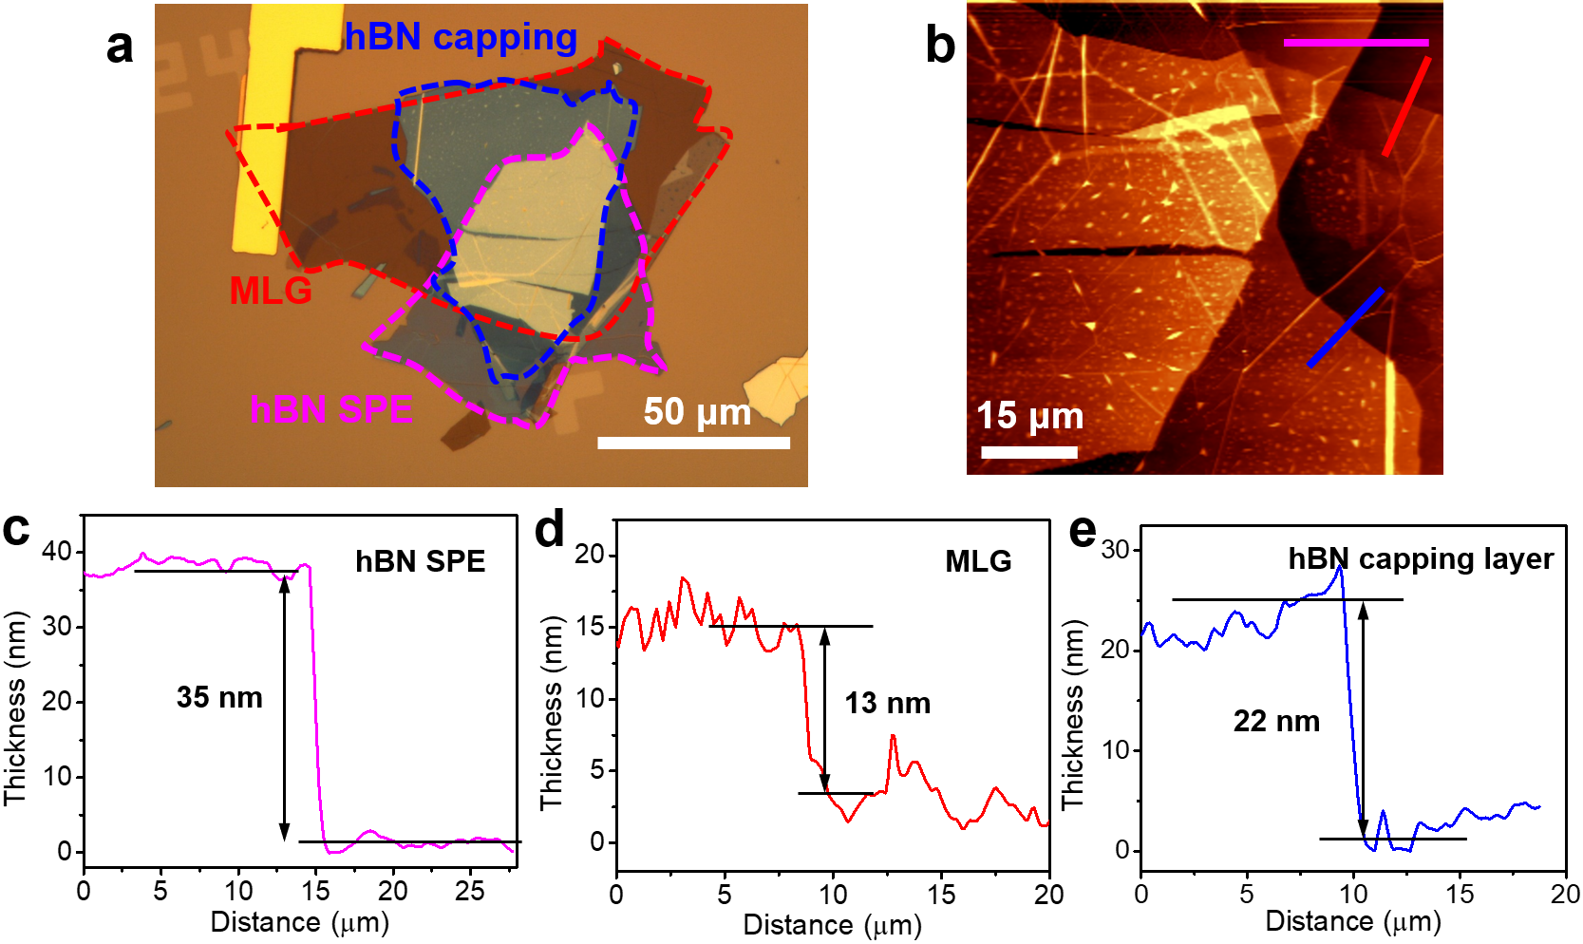

Supplementary Figure 2. MLG/hBN heterostructure device. a, b. Optical microscope image (a) and AFM image (b) of the devices on a p-type silicon with a 90 nm thick thermal oxide layer. Optical image of a device based on MLG/hBN(capping)/hBN(emitters) placed on p-type silicon with a 90 nm thick thermal oxide layer. Each layer is outlined in dash lines. c-e. The height outline of the hBN emitter layer (c), graphene layer (d), and hBN capping layer (c). The thickness of the hBN emitter, MLG, and hBN capping layers are 35, 13, and 22 nm respectively.

Device Electrical Characteristics
To study the current vs. voltage characteristics of the hBN/MLG heterostructure device with 285 nm thermal silicon oxide layer, we apply a bias between the gold electrode on the graphene and the p-type Si, and measure the instantaneous current. We perform voltage sweeps from -20 V to + 20 V and back to -20 V with differing step times (Δt) and 0.4 V steps. As seen in Supplementary Figure 3a and 3b, there is no significant photocurrent in the MLG/hBN heterostructure. The leakage current is also negligible under short time scales (voltage step time Δt = 0.001s, leakage current < 5 nA), and reduces further over time. Interestingly, the device also shows a capacitive behaviour when the bias is applied (and current is measured) on time scales less than 0.1s. We note here, the charging behaviour cannot be isolated to only the hBN/MLG interface and is likely also contributed to by the Si/electrode, MLG electrode interfaces, and also the SiO₂/electrode interface, as the electrode is not confined only to the graphene as seen in Figure 1b of the main.

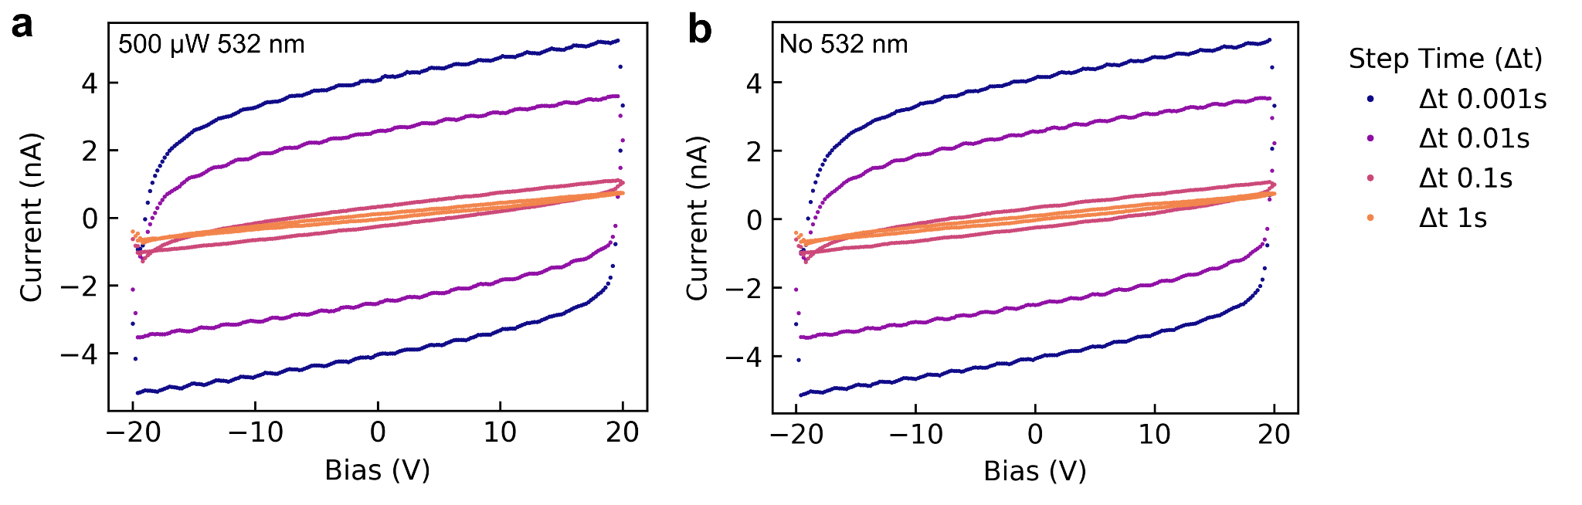

Supplementary Figure 3. I-V characteristics of hBN/MLG heterostructure with 285 nm thermal silicon oxide layer. a. Current vs. voltage curves for voltage step time of 0.001 to 1s with 532 nm laser excitation on the heterostructure. b. Current vs. voltage curves for voltage step time of 0.001 to 1s without 532 nm laser excitation (dark) on the heterostructure.

The I-V characteristics of a hBN/MLG heterostructure device with a 90 nm thermal silicon oxide layer is also shown in Supplementary Figure 5. Here the step time (Δt) is kept at 1s and the leakage current is maintained below 100 nA for a bias range between -2 and +1 V.
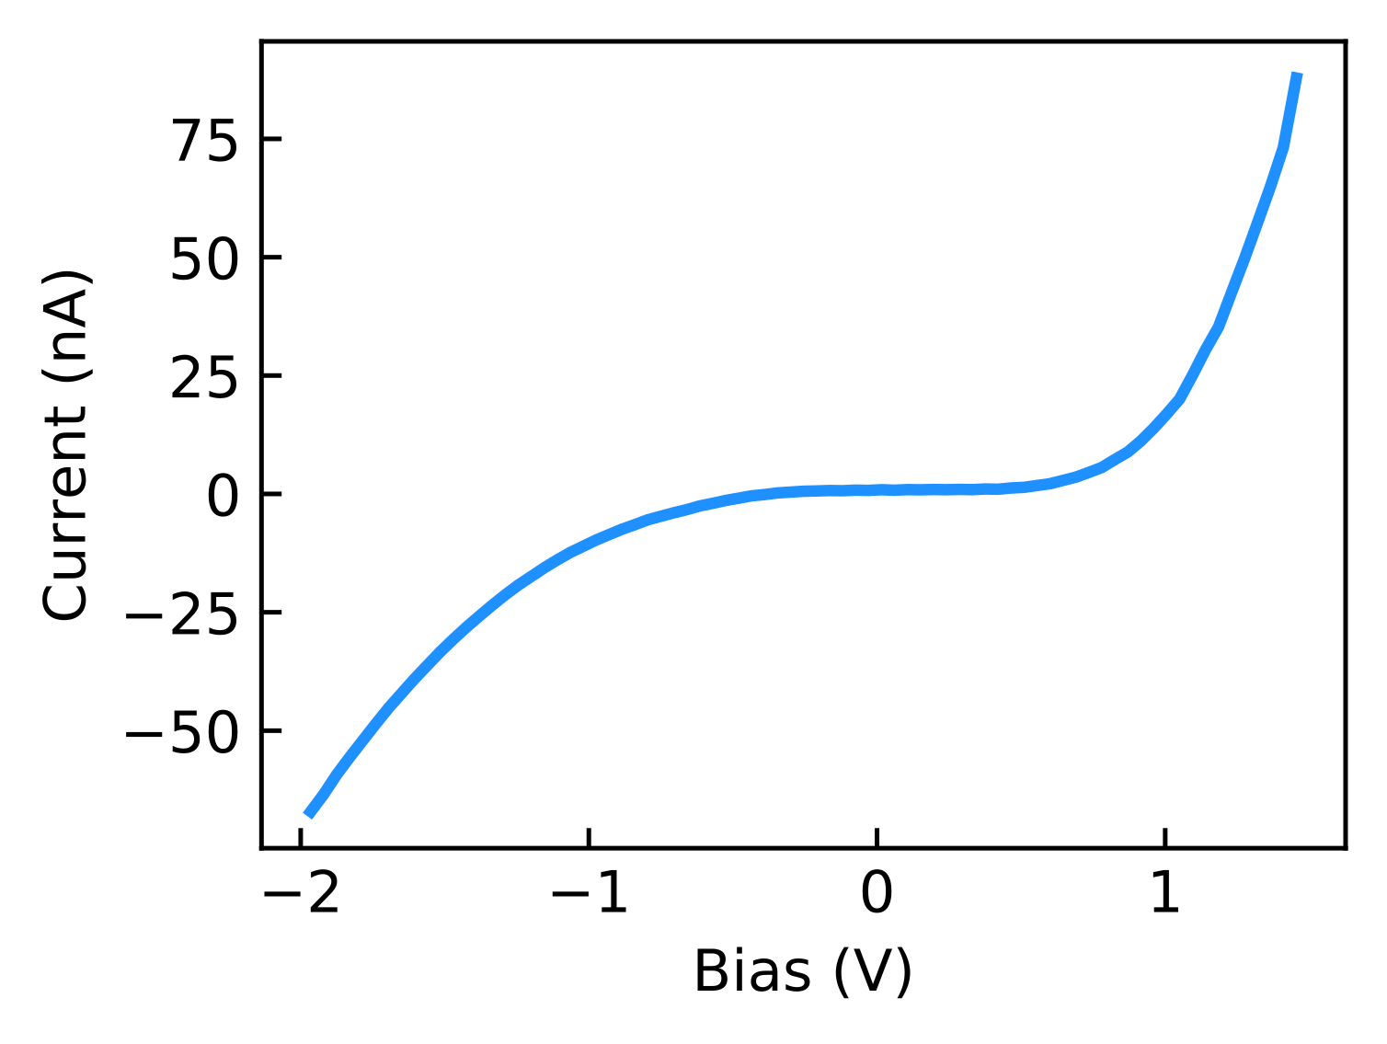
Supplementary Figure 4. I-V characteristics of hBN/MLG heterostructure with 90 nm thermal silicon oxide layer.

Room Temperature Spectral Characterization
We also study the optical properties of the quantum emitters in the hBN/MLG heterostructure device at room temperature. To provide a broader picture of the photophysical properties of quantum emitters under applied bias, we record the behaviour of a large ensemble of quantum emitters. The series of spectra recorded at different biases from -10 V to 10 V is shown in Supplementary Figure 5, where each line corresponds to a single quantum emitter. Note that the emitter is completely dark in the absence of bias. The emission from the hBN emitter at a wavelength of about ~ 665 nm appears at around 2.5 V, reaching its maximum at 6 V. While the hBN emitter is very dim at a positive bias from 0 V to -10 V.

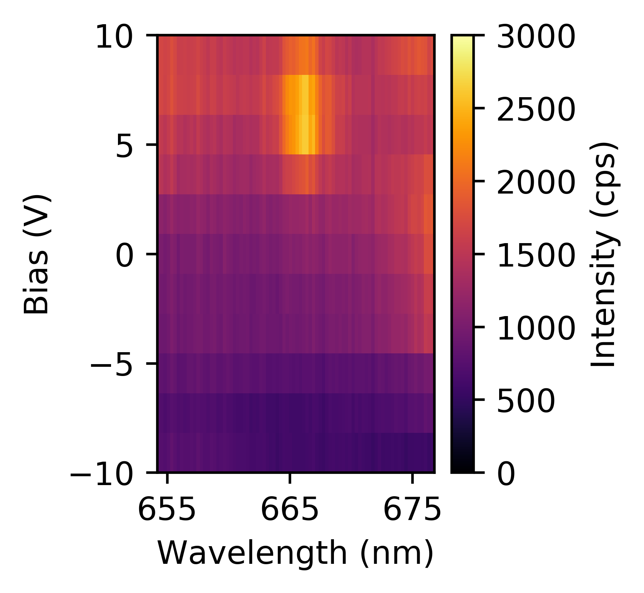
Supplementary Figure 5. Series of PL spectra recorded at a bias range of -10 V to 10 V at room temperature.

Cryogenic Spectral Characterisation
Electrical control of the hBN quantum emitters in the hBN/MLG heterostructure device on 285 nm SiO2/Si substrate is shown in Supplementary Figure 6. The PL spectra under different bias from two emitters are plotted in Supplementary Figure 6a and 6b. In order to clarify, we normalized the spectra intensity. As shown in Supplementary Figure 6a, the emitter is activated at ~8 V and its intensity continues to increase and then the emitter is switched off at ~22 V. While Supplementary Figure 6b demonstrates a different phenomenon. The emitter's intensity increases monotonically as the bias drops from 0 to -30 V.

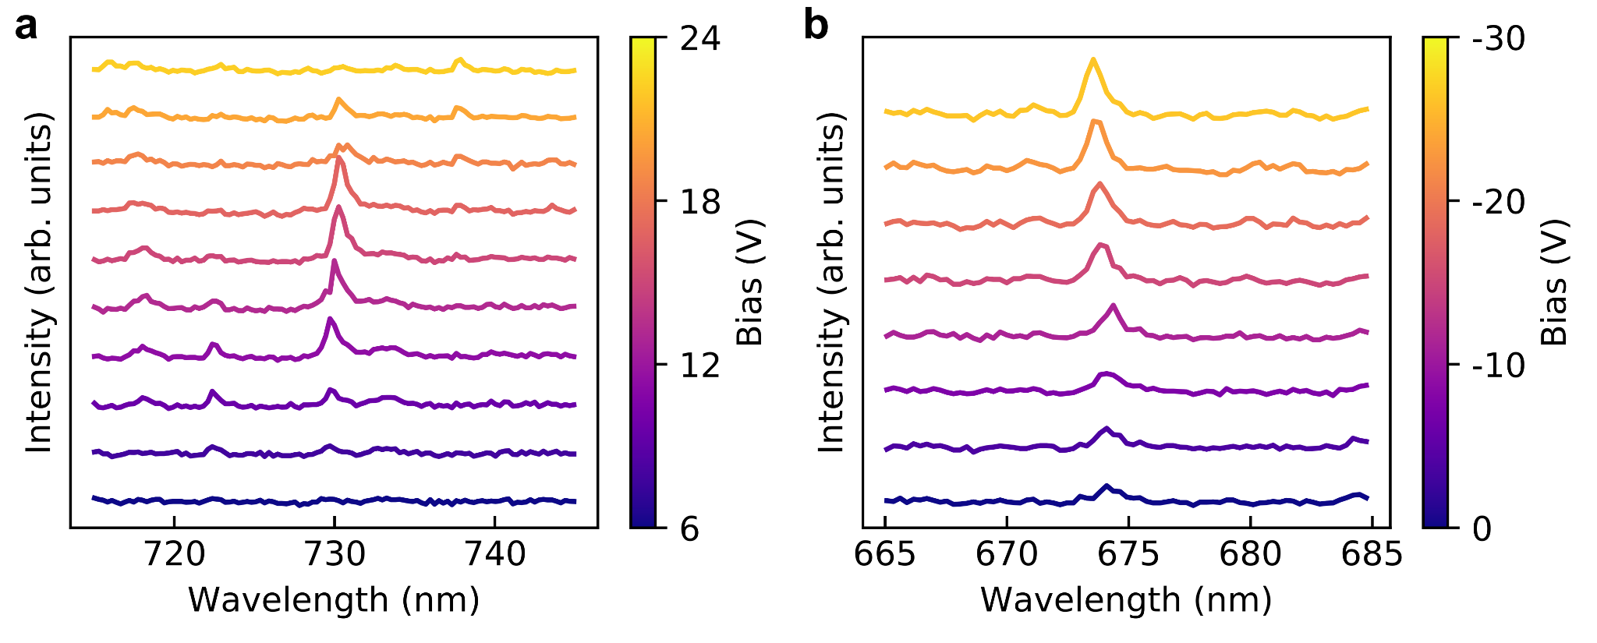
Supplementary Figure 6. a, b. Normalized PL spectra of two different emitters at a positive bias of 6 V to 24 V (a) and negative bias of 0V to -30 V (b), respectively.

To further corroborate our findings we provide PL spectra vs. bias scans for various emitter regions on the MLG/hBN heterostructure device. Supplementary Figure 7 displays hBN emitter activation across the complete visible spectrum from 580 to 800 nm. A bright emission band under +20 V bias is confirmed at various positions across the hBN flake, as illustrated in Supplementary Figures 7a and 7b. The distribution of hBN charge state depths is clearly observed in 7a as individual emitters observe differing optimal +ve and -ve biases. The majority of emitter PL peaks show minimal shift in energy under an applied bias, as the Stark shift depends principally on the orientation of the bias and emitter dipole. The majority of hBN single photon emitter dipoles are thought to lie in-plane and no Stark shift is observed. For a few emitters, as highlighted in Supplementary Figure 7c, the dipole moment lies out of plane, possibly due to wrinkles and/or grain boundaries of the hBN flake. Here, the applied field vector would be parallel to the dipole moment thus a shifting of PL energy can be observed.

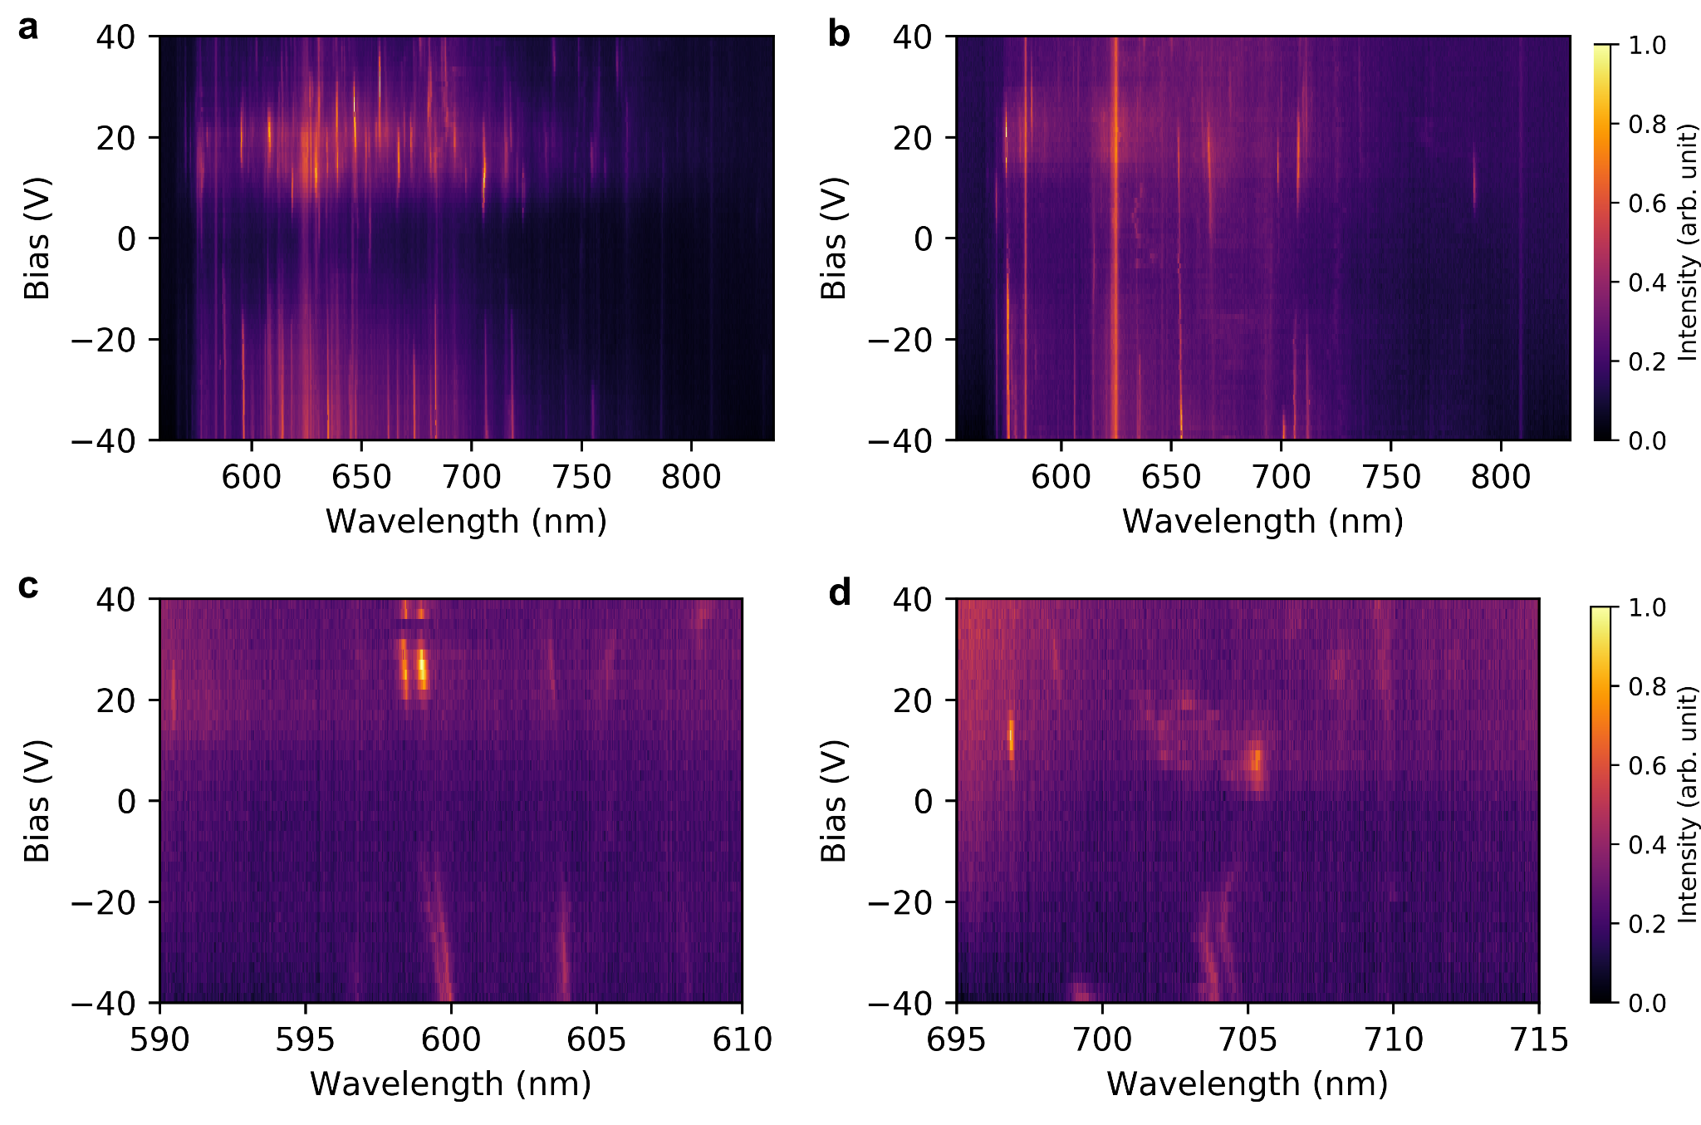
Supplementary Figure 7. Further modulation of hBN quantum emitters in the heterostructure device. a, b. PL spectra recorded as a function of bias, over the range of -40 to +40V for various regions of hBN emitters. c. hBN emitter PL spectra with DC Stark shifts and variable activation bias. d. Individual hBN activated specifically under +ve or -ve bias.

Electrical control of the hBN quantum emitters in a MLG/hBN heterostructure device on a 90 nm thermal oxide layer is also shown in Supplementary Figure 8. We observe similar behavior to the device with 285 nm oxide layer with smaller magnitudes of bias, as expected for an increased effective field proportional to the device thickness. As seen in the main, a band of increased PL is observed for a range of emitters, this time at a bias of +4 V, with subtle changes in optimal bias from emitter to emitter. Also similarly a dark band is observed for the majority of emitters when both electrodes are grounded, with fewer emitters activated in the region. Finally we also observe the monotonic increase in PL under a negative bias.
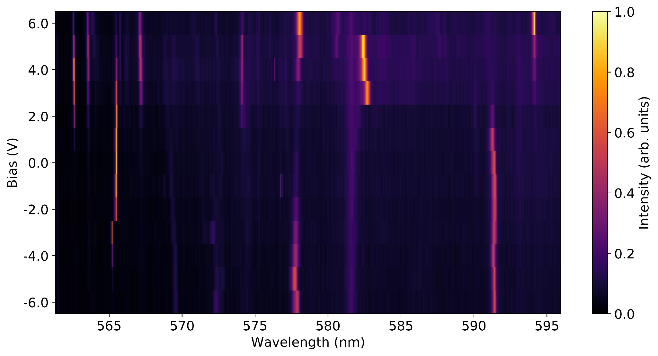
Supplementary Figure 8. Series of PL spectra from hBN emitters at biases ranging from -6 V to 6 V for the heterostructure device with 90 nm silicon oxide.

Finally, the bias-dependent PL spectra from two emitters are plotted in Supplementary Figure 9. The spectra are normalised for clarity. Two different behaviours, under positive and negative bias are observed. The enhanced PL of an emitter under positive bias is seen in Supplementary Figure 9a, with an activation bias around -0.5 V. As the bias is increased to 3V the PL increases substantially. Individual spectra for the same emitter are plotted for -2, 0 and 3V bias to demonstrate the significant PL increase, as seen in Supplementary Figure 9c. A similar case is also shown for a different emitter under negative bias in Supplementary Figure 9b. In this case the emitter is active but relatively dim at 0 V bias. As the bias is dropped to -2 V the PL intensity increases, with individual spectra plotted in Supplementary Figure 9d.

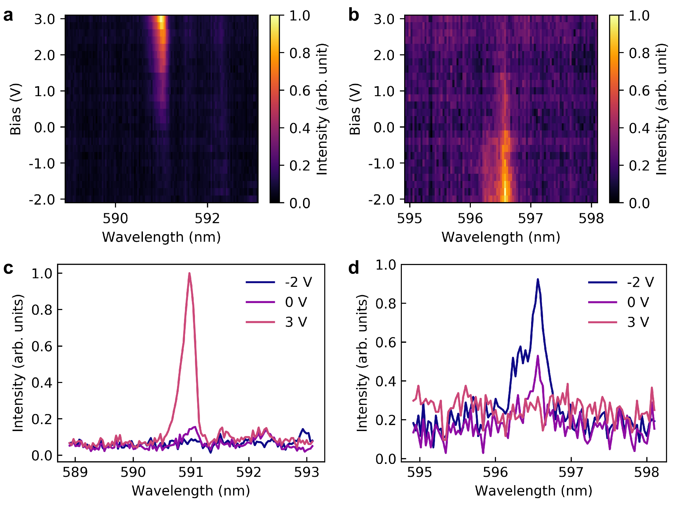

Supplementary Figure 9. Controlled switching of hBN emitters in the quantum heterostructure device. a, b. Series of normalized PL spectra recorded two different emitters at a bias range of -2 V to 3 V. c, d. Normalized PL spectra of two different emitters at a bias of -2 V, 0, and 3 V, respectively. Excitation laser power: 200 μW.

Supplementary Figure 10 shows a typical intensity trace to emphasize the optical stability of the studied quantum emitters at 4 K with no blinking over the course of one minute.
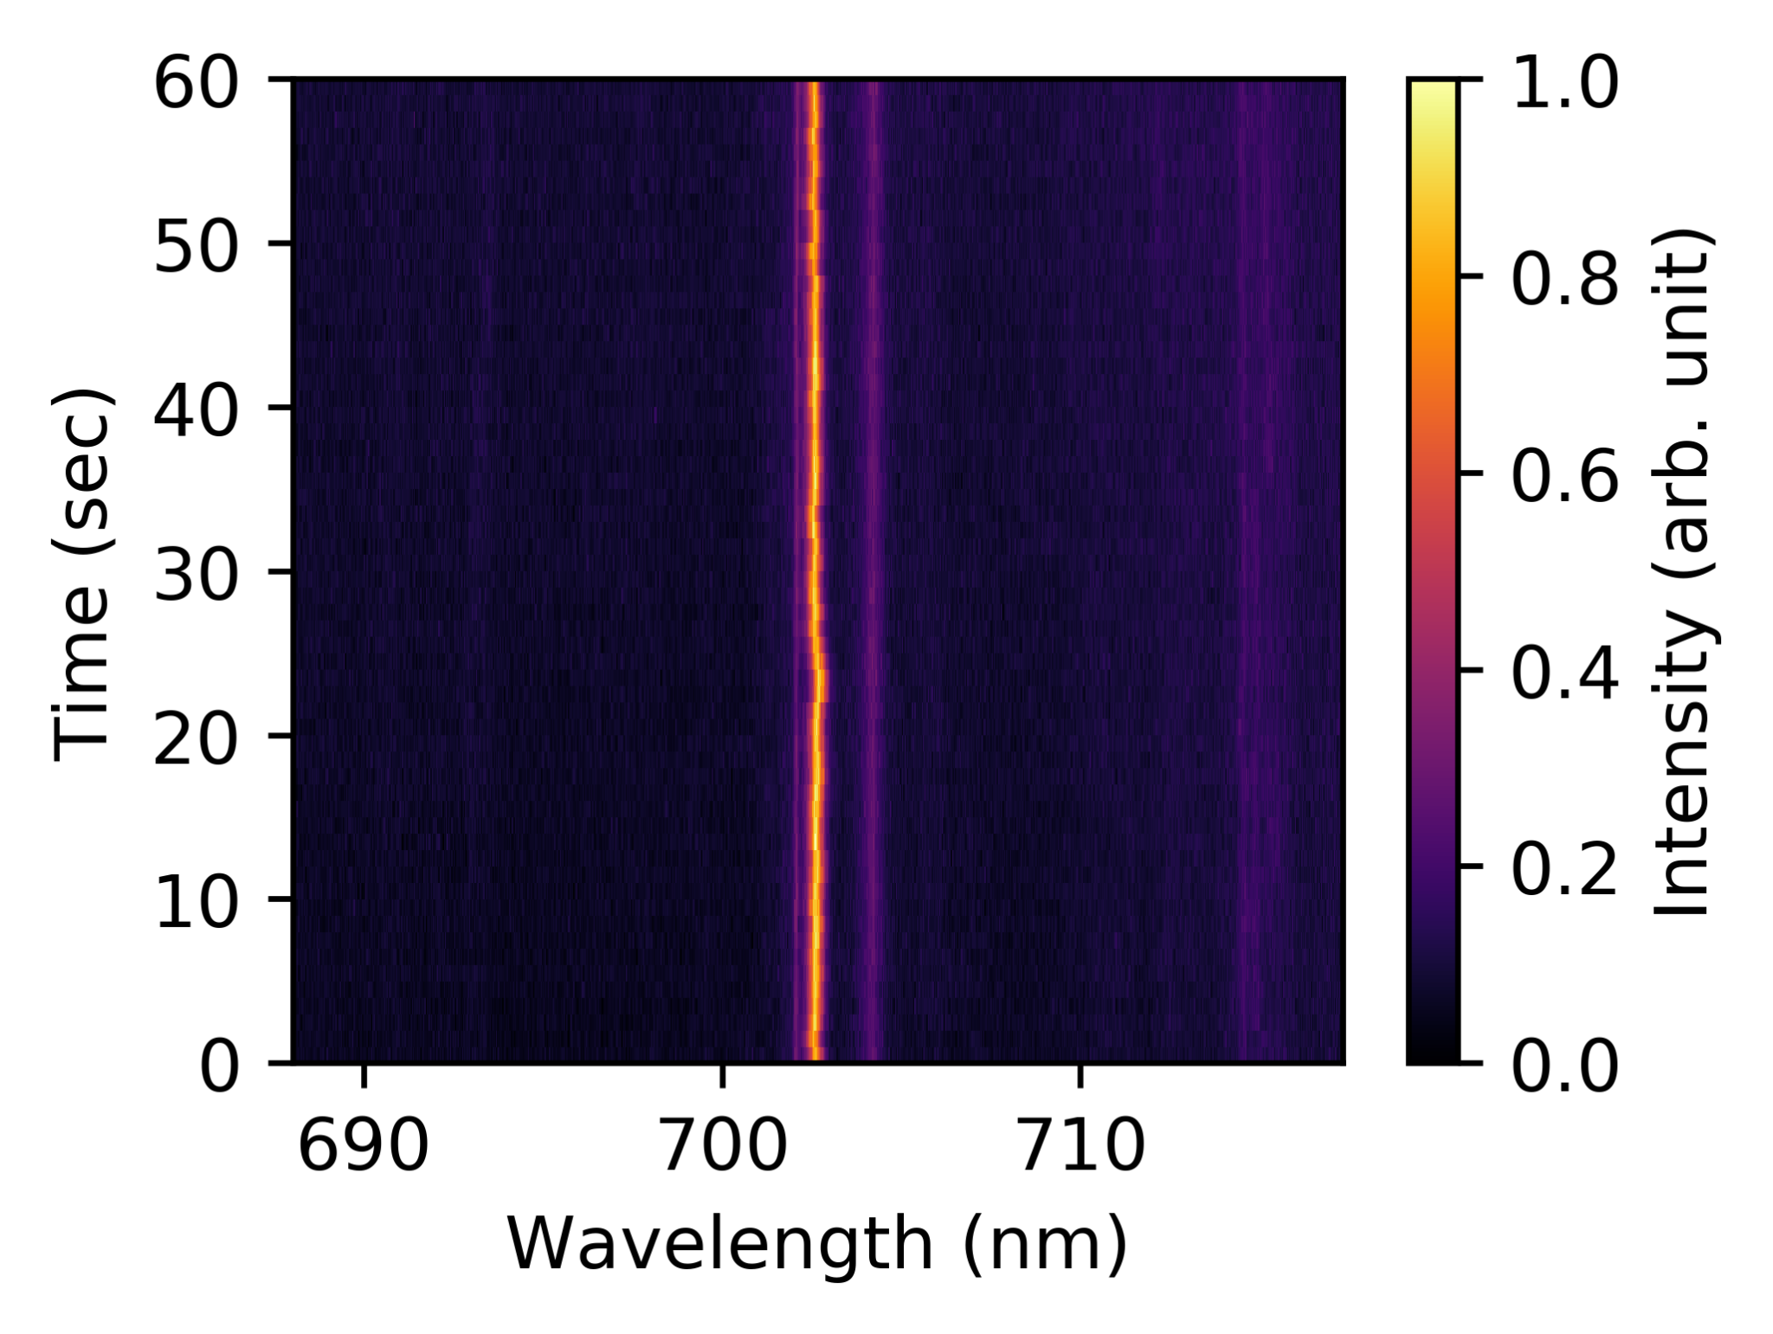

Supplementary Figure 10. PL time series from the same emitter at a 1 s time interval for a 60 s period with 0 bias at 4 K. The intensity and the peak position remain identical throughout the whole process, suggesting this emitter has no blinking on this time scale.

