Supplemental Figure S1. Words cloud “What Matters” Documentation
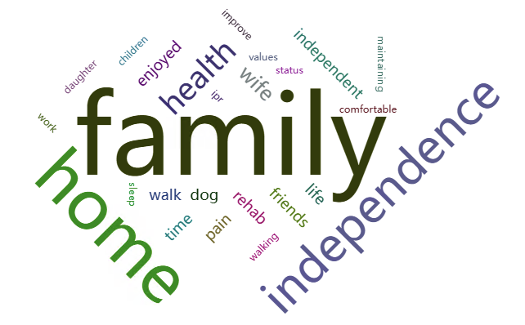
Supplemental Figure S2. Venn Diagram with Overlaps among the themes 