Supporting Information
Morphology-Adaptive Curvature Analysis of Fluid–Fluid Interfaces in Porous Media
Faisal Aljaberiª, Martin J. Blunt^{b}, Mohammed Al Kobaisi^{a,*}
ª Chemical and Petroleum Engineering Department, Khalifa University of Science and Technology, Abu Dhabi P.O. Box 127788, United Arab Emirates
^{b} Department of Earth Science and Engineering, Imperial College London, SW7 2AZ London, United Kingdom
* Corresponding author (mohammed.alkobaisi@ku.ac.ae)

S1: CT-style degradation of analytical mesh surfaces
Micro-CT surface extraction introduces voxel, segmentation, and iso-surfacing artifacts that can dominate curvature error. To retain analytical ground truth while reproducing CT-like mesh quality, axial terracing and normal jitter were applied to clean sphere, torus, and catenoid meshes without changing connectivity. Perturbations were scaled by the mean edge length h (Magid et al. 2007; Váša et al. 2016)
Axial terracing mimics the staircase artifacts of slice-based reconstruction: for each vertex $v_{i}$, the signed coordinate along the scan axis $a$, $s_{i}=v_{i}⋅a$, was partially snapped to slice planes of pitch $Δz$,
 | $$s_{i}^{'}=\left(1-t\right) s_{i}+t Δz\text{round}​\left(\frac{s_{i}}{Δz}\right), v_{i}^{'}=v_{i}+\left(s_{i}^{'}-s_{i}\right) a ,$$ | (S1)
with snap strength $t=0.5$ throughout ($t=0$ leaves the mesh unchanged; $t=1$ fully quantizes vertices to slice planes). This perturbation is deterministic and anisotropic, producing the characteristic staircase structure of voxelized imaging. Normal jitter then represents high-frequency segmentation and iso-surfacing noise: each vertex was displaced along its area-weighted unit normal $n_{i}$ by a Gaussian random variable,
 | $$v_{i}^{″}=v_{i}^{'}+ϵ_{i} n_{i}, ϵ_{i}∼N\left(0,σ_{n}^{2}\right), σ_{n}=0.05 h,$$ | (S2)

The jitter is zero-mean and avoids artificial tangential displacement. Applying it after terracing combines scan-direction bias with high-frequency roughness while preserving connectivity.

S2. Curvature estimation and invariant averaging
Base estimation. Curvature is estimated with the RUS per-face tensor construction described in Sec. 3.2 of the main manuscript. In this approach, per-vertex normals are used to define a finite-difference approximation of the second fundamental form on each triangle. The resulting tensor estimates are then angle-weighted onto the vertices, and their eigenvalues provide the principal curvatures, $κ_{1}$ and $κ_{2}$ and hence the invariants $κ_{m}$ and $κ_{g}$. RUS was selected as the base estimator for the CT-image analysis because it showed the best overall performance across the tested morphologies, as demonstrated in Sec. 4.1 of the main manuscript.
Invariant averaging. The per-vertex invariants are then aggregated by n passes of a self-inclusive, area-weighted average over the closed one-ring ${\overset{‾}{N}}_{1}(v_{i})=\{v_{i}\}∪N_{1}(v_{i})$,
 | κi(k+1)=vj∈N1(vi)​Aj κj(k)vj∈N1(vi)​Aj , | (S3)
Equation (S3) is applied separately to $κ_{m}$ and $κ_{g}$, and $A_{j}$ is the barycentric-cell area of vertex $v_{j}$ (Botsch et al. 2010). Three design choices matter here. Self-inclusion makes each pass a convex combination, so constant fields are fixed points and the iteration is unconditionally stable. Averaging the invariants rather than the principal curvatures preserves the ordering $κ_{1}≥κ_{2}$ when the pair is recovered by inverting Eqs. (2)–(3) of the main manuscript, and avoids the sign ambiguities of averaging eigenvalue fields; $κ_{T}$ and the shape index is then derived from the smoothed pair through Eq. (4) of the main manuscript. Because Eq. (3) is a discrete diffusion step, $n$ passes approximate convolution with a heat kernel of radius $r_{n}∼h\sqrt{n}$: the noise variance decays roughly as the inverse of the accumulated kernel area while the morphology-dependent bias of Sec. 2 grows as $r_{n}^{2} Δ_{S}κ$, so the mean-square error behaves as
 | $$MSE\left(n\right) ∼ \frac{σ_{κ}^{2}}{1+c n} + {\left(\frac{nh^{2}}{8} Δ_{S}κ\right)}^{​2} ,$$ | (S4)
where $σ_{κ}$ is the raw estimator noise and c is a mesh-dependent constant. For a sphere, $Δ_{S}κ=0$ and averaging is pure variance reduction—the optimal $n$ is unbounded; for the gently varying torus field, the bias term remains negligible through n=10; for a catenoid, $|κ_{g}|$ is sharply peaked at the neck, $Δ_{S}κ$ is large, and the optimum collapses to $n≈0$–$1$. Section 4.2 of the main manuscript confirms this prediction quantitatively; averaging reduces the sphere and torus errors approximately threefold but degrades the catenoid by up to threefold. Table 3 of the main manuscript shows the same signature across all nine methods (RUSavg best on caps and arcs; base RUS and SDQF best on saddles).

S3. Benchmark comparison on clean analytical surfaces
The benchmark included eight curvature-estimation methods: Meyer-style discrete differential operators (DDG), local principal curvatures from a neighborhood (FIT), Cohen-Steiner and Morvan normal-cycle measures (CSM), Rusinkiewicz per-face tensors averaged to vertices (RUS), Taubin approximation (TAU), quadric fitting (QF), scale-dependent quadric fitting (SDQF), and normal cycles (NC).
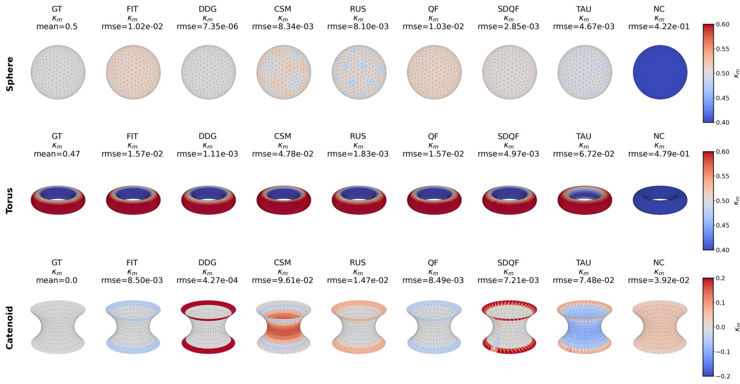
Fig. S1 Per-method mean-curvature maps on the clean benchmark surfaces (GT, analytical ground truth), with the RMSE reported for each map. The catenoid row reveals boundary-concentrated error for DDG, neck flattening for TAU, and rim artifacts for the SDQF variants.

S4. Effect of degradation, smoothing, and invariant averaging
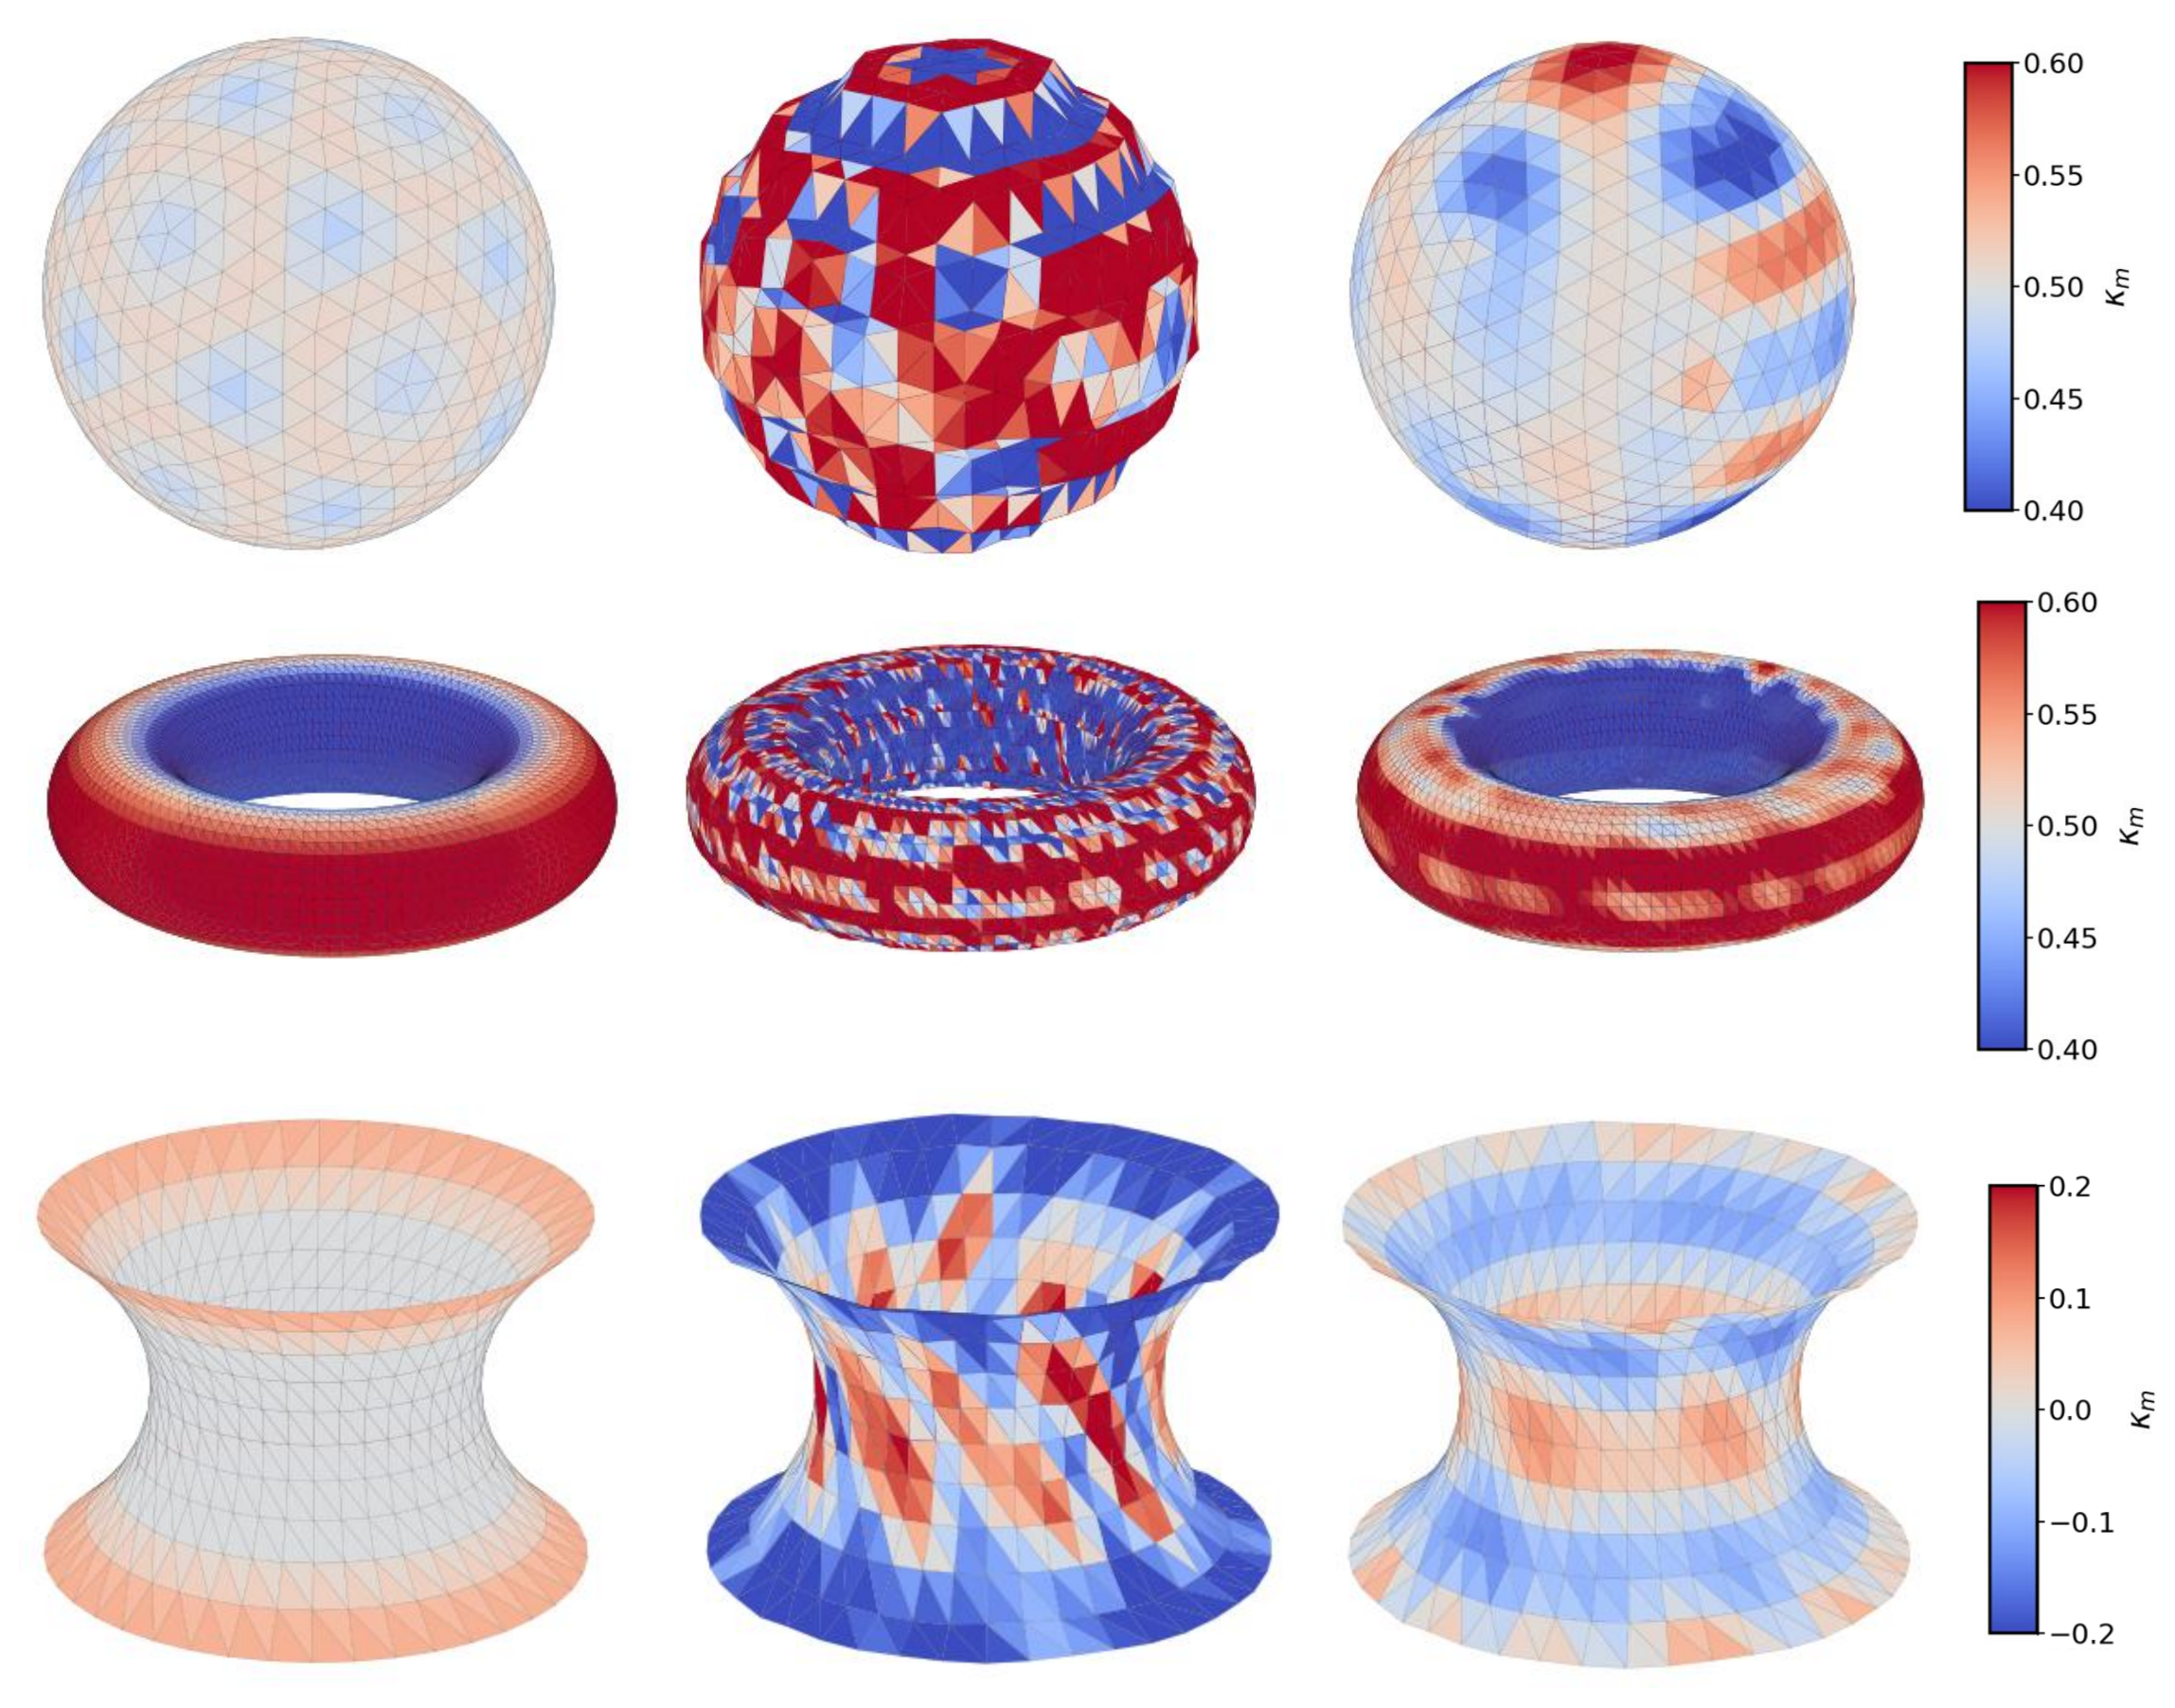
Fig. S2 Effect of CT-style degradation and smoothing on the mean-curvature field (left: clean; middle: after terracing and jitter; right: after Taubin smoothing) for the three benchmark surfaces.

S5. Curvature distributions in water-wet and mixed-wet sandstone
Representative interfacial-curvature distributions for water-wet (WW) and mixed-wet (MW) Bentheimer sandstone are shown in Figure S3. The WW distributions correspond to a water fractional flow f_{w} = 0.85, and the MW distributions correspond to f_{w} = 0.50. Histograms show relative frequency, fitted probability-density curves compare candidate distribution models, and vertical dotted lines indicate the fitted peaks used to select representative curvature values for the capillary pressure-saturation plot (Sec 4.4 of the main manuscript).
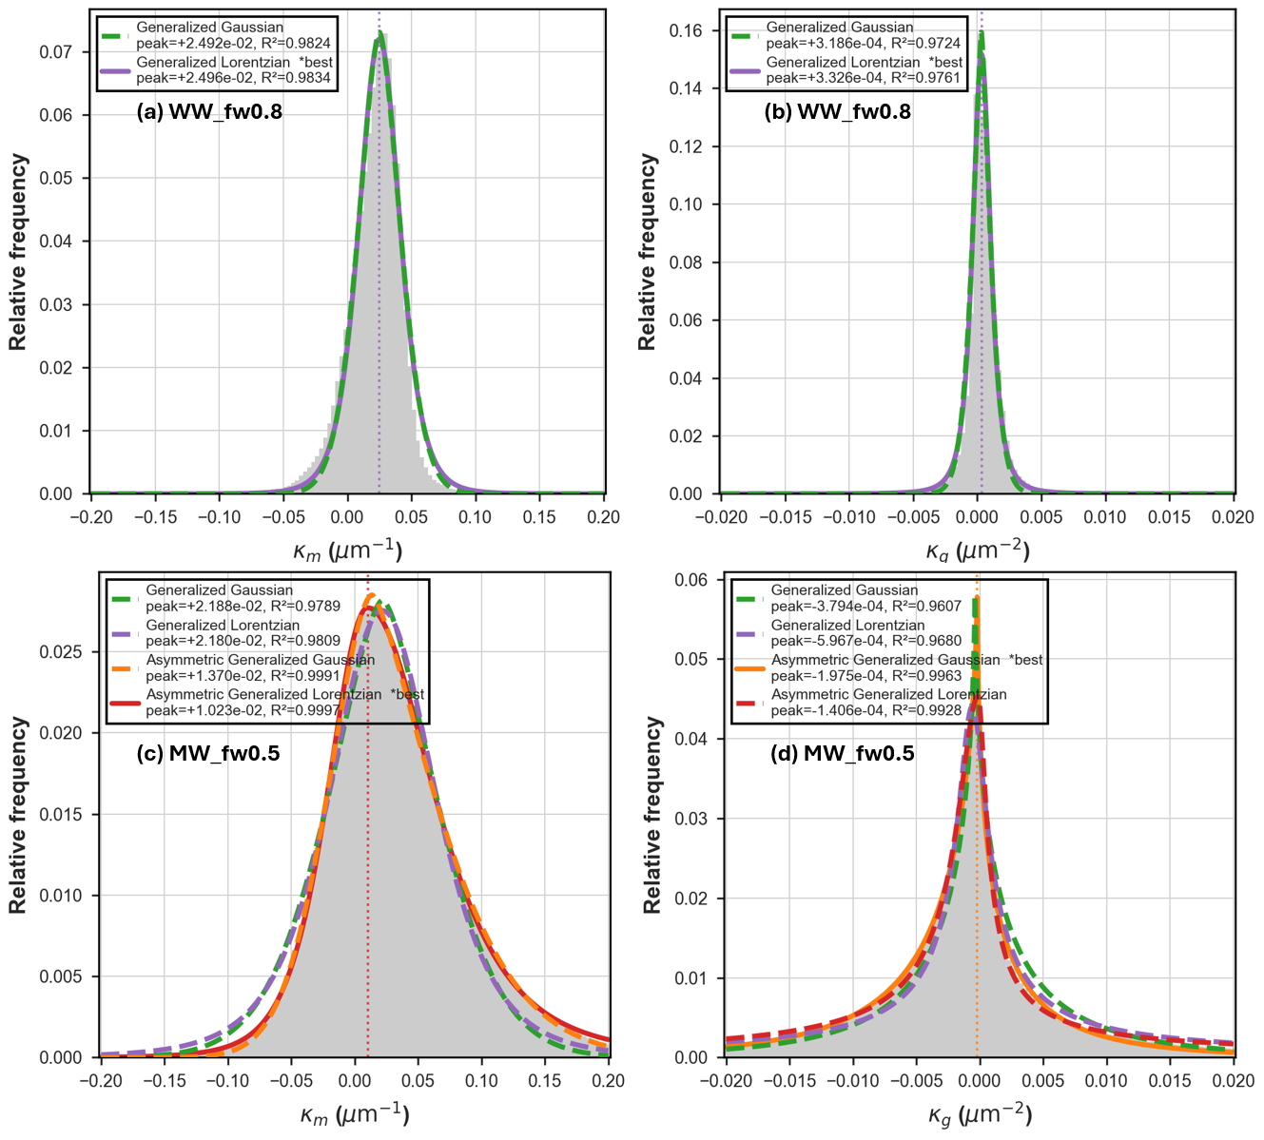
Fig. S3. Representative distributions of $κ_{m}$ and $κ_{g}$.(a, b) WW case at f_{w} = 0.85 and (c,d) MW case at f_{w} = 0.5. Gray histograms show relative frequency, colored curves show fitted distributions, and vertical dotted lines mark the fitted peaks.
The WW $κ_{m}$ distribution is narrow and nearly symmetric. Generalized Gaussian and generalized Lorentzian fits therefore yield almost identical peak locations near 0.025 µm⁻¹, making the representative curvature insensitive to the selected model.

The MW distribution is broader and asymmetric. Symmetric fits place its peak near 0.022 µm⁻¹, whereas asymmetric models yield lower representative values of approximately 0.010–0.014 µm⁻¹. The choice of fitting model consequently has a larger effect on the capillary pressure reconstructed for the mixed-wet state and should be included in the reported uncertainty.

References
Botsch M, Kobbelt L, Pauly M, et al (2010) Polygon Mesh Processing, 0 edn. A K Peters/CRC Press
Magid E, Soldea O, Rivlin E (2007) A comparison of Gaussian and mean curvature estimation methods on triangular meshes of range image data. Computer Vision and Image Understanding 107:139–159. https://doi.org/10.1016/j.cviu.2006.09.007
Váša L, Vaněček P, Prantl M, et al (2016) Mesh Statistics for Robust Curvature Estimation. Computer Graphics Forum 35:271–280. https://doi.org/10.1111/cgf.12982

