Electronic Supporting Information
A one-dimensional Cd(II) coordination polymer based on 2,5-dibromobenzene-1,4-dicarboxylate: Crystal structure and dielectric properties
Bakhtiyor Chori ugli Tursunov ª, Yakubov Yuldash Yusupbaevich ª, Khayit Khudaynazarovich Turaev ^{b}, A. Aditya Prasad ^{c*}, Abrorbek Khamidjanovich Ruzmetov ª, Adkhamjon Sadullayevich Normamatov ^{d,e}, Avazbek Bakhtiyarovich Ibragimov ^{d}, Lutfullo Bozorov ^{f}, Sadridin Eshkaraev ^{g}, Aziz Bakhtiyarovich Ibragimov ^{a,g*}, Chellakarungu Balakrishnan ª
ª Institute of General and Inorganic Chemistry of Uzbekistan Academy of Sciences, 100170, Mirzo Ulug’bek str., 77a Tashkent, Uzbekistan.
^{b} Department of Chemistry, Termez State University, 43 Barkamol Avlod Street, Termez-190111, Uzbekistan.
^{c} Department of Chemistry, CMR Technical Campus, Kandlakoya, Medchal, Secunderabad - 501401, Telangana, India.
^{d} Institute of Bioorganic Chemistry, Uzbekistan Academy of Sciences, Kh. Abdullaev Str., 83, Tashkent, 100143, Uzbekistan.
^{e} Department of Chemistry, National University of Uzbekistan named after Mirzo Ulugbek, Tashkent 100174, Uzbekistan.
^{f} Termiz State Pedagogical Institute, At-Termiziy Str., 191204, Termez, Uzbekistan.
^{g} Department of Medicine, Termez University of Economics and Service, Surkhandarya, Termez, Farovon street 4-b,190111, Uzbekistan.
∗Corresponding authors: E-mail addresses: adityaaraveti@gmail.com (A. Aditya Prasad); aziz_ibragimov@mail.ru (Aziz Bakhtiyarovich Ibragimov).

*Address for correspondence
Dr. A. Aditya Prasad
Associate Professor
Department of Chemistry
CMR Technical Campus
Kompally, Medchal, Hyderabad - 500100, India.
Mobile No.: +91 94900 37019
E-mail address: adityaaraveti@gmail.com
Supplementary Figure Captions
Fig. S1. | Crystal packing diagrams of the coordination polymer [Cd(Br₂-BDC)(2-MeIm)₂(DMF)]_{n} viewed along the (a) bc, (b) ac, and (c) ab crystallographic planes. The structure exhibits a one-dimensional coordination chain constructed from Cd(II) centers interconnected by Br₂BDC ligands, while 2-methylimidazole and DMF molecules complete the coordination environment. The CdO₅N₂ coordination polyhedra are shown in purple. hydrogen atoms are omitted for clarity.
Fig. S2. | Hirshfeld surface maps of (1) and (2) (a) d_{norm} (b) d_{i} (c) d_{e} and (d) curvedness
Fig. S3. | Percentages of molecular interactions represented as a 3D bar chart.
Fig. S4. | FT-IR spectra of complex [Cd(Br₂-BDC)(2-MeIm)₂(DMF)]_{n}.
Fig. S5. | Raman spectra of complex [Cd(Br₂-BDC)(2-MeIm)₂(DMF)]_{n}.
Fig. S6. | SEM images (top) and EDS spectrum (bottom) of compound [Cd(Br₂-BDC)(2-MeIm)₂(DMF)]_{n}.
Fig. S7. | TG-DTA curves of complex [Cd(Br₂-BDC)(2-MeIm)₂(DMF)]_{n}.
Table S1. | The selected bond lengths (Å), angles (°) and dihedral angles (°) of [Cd(Br₂-BDC)₂(2-MeIm)₂(DMF)]_{n}.

c
a
b
Fig. S1. Crystal packing diagrams of [Cd(Br₂-BDC)(2-MeIm)₂(DMF)]_{n} viewed along the (a) bc, (b) ac, and (c) ab crystallographic planes. Hydrogen atoms are omitted for clarity.
c

b

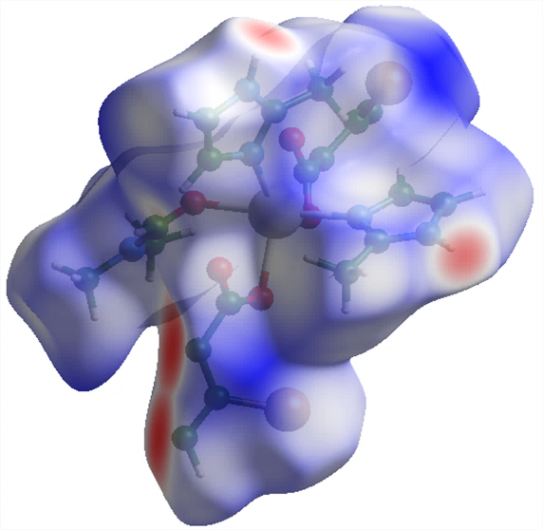
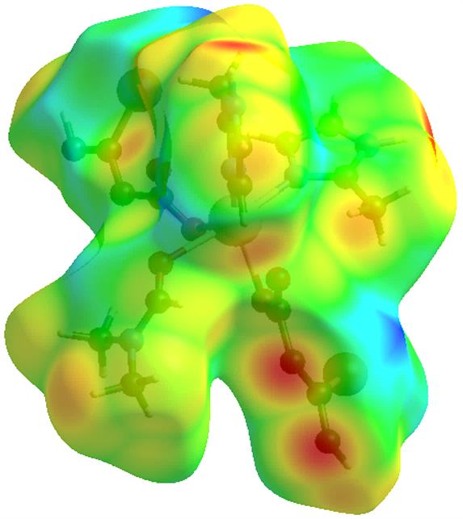
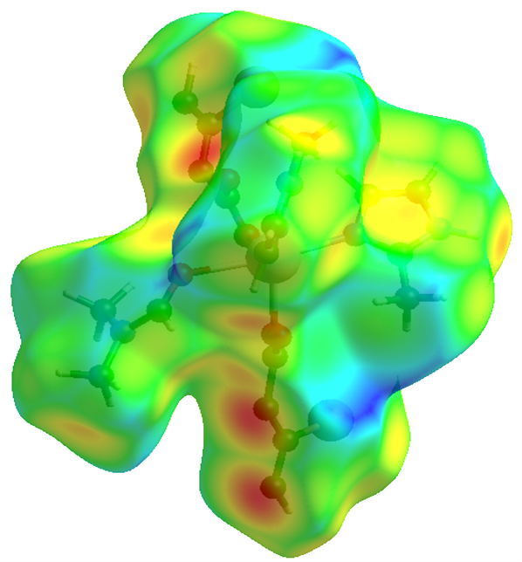
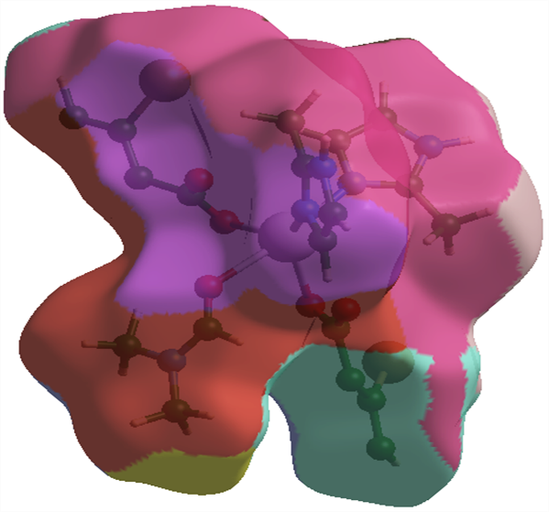
Fig. S2 Hirshfeld surface maps of [Cd(Br₂-BDC)(2-MeIm)₂(DMF)]_{n}: (a) d_{e} (b) d_{i} (c) d_{norm} and (d) fragment patch.
a
b
c
d

Fig. S3 Percentages of molecular interactions represented as a 3D bar chart.

Fig. S4 FT-IR spectrum of [Cd(Br₂-BDC)(2-MeIm)₂(DMF)]_{n}.

Fig. S5 Raman spectrum of [[Cd(Br₂-BDC)(2-MeIm)₂(DMF)]_{n}].

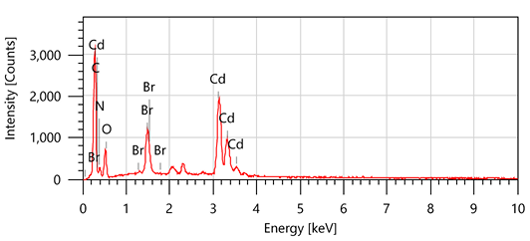
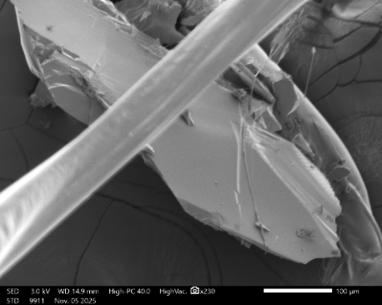
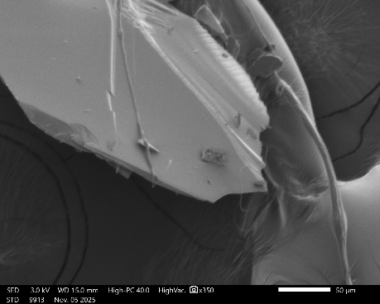
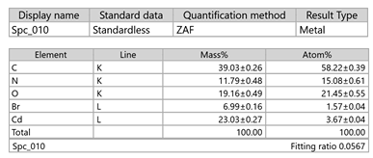
Fig. S6 SEM images (top) and EDS spectrum (bottom) of [Cd(Br₂-BDC)(2-MeIm)₂(DMF)]_{n}

Fig. S7 TG-DTA curves of [Cd(Br₂-BDC)₂(2-MeIm)₂(DMF)]_{n}.

Table S1. Bond lengths [Å], angles and dihedral angles [°] for [Cd(Br₂-BDC)₂(2-MeIm)₂(DMF)]_{n}
Bond | Length (Å) | Bond | Length (Å)
Cd1-O2 | 2.385(3) | C1-C3 | 1.393(5)
Cd1-O1 | 2.531(3) | C7-C5 | 1.398(6)
Cd1-O4 | 2.312(3) | C7-C6 | 1.385(6)
Cd1-O3 | 2.621(3) | N2-C11 | 1.341(6)
Cd1-N1 | 2.252(3) | N2-C10 | 1.361(7)
Cd1-N3 | 2.315(4) | N4-C15 | 1.340(6)
Cd1-O5 | 2.474(4) | N4-C14 | 1.352(6)
Br1-C2 | 1.898(4) | C5-C6 | 1.386(5)
Br2-C6 | 1.901(4) | C5-C8 | 1.502(5)
O2-C4 | 1.263(5) | C2-C3 | 1.377(5)
O1-C4 | 1.242(5) | O5-C19 | 1.191(7)
O4-C8 | 1.247(5) | N5-C19 | 1.327(7)
O3-C8 | 1.247(5) | N5-C18 | 1.454(8)
N1-C11 | 1.336(5) | N5-C17 | 1.446(7)
N1-C9 | 1.372(6) | C15-C16 | 1.479(6)
N3-C15 | 1.322(5) | C11-C12 | 1.480(7)
N3-C13 | 1.379(5) | C13-C14 | 1.330(7)
C1-C2 | 1.400(5) | C9-C10 | 1.350(7)
C1-C4 | 1.504(5)
Bond | Angle(°) | Bond | Angle(°)
O1-Cd1-O2 | 52.88(9) | C6-C7-C5 | 120.6(4)
O4-Cd1-O2 | 82.47(11) | C10-N2-C11 | 108.6(4)
O4-Cd1-O1 | 133.54(10) | C14-N4-C15 | 108.3(4)
O3-Cd1-O2 | 131.70(10) | C6-C5-C7 | 117.4(4)
O3-Cd1-O1 | 154.04(12) | C8-C5-C7 | 118.0(4)
O3-Cd1-O4 | 52.40(10) | C8-C5-C6 | 124.5(4)
N1-Cd1-O2 | 138.17(11) | C1-C2-Br1 | 121.6(3)
N1-Cd1-O1 | 85.30(11) | C3-C2-Br1 | 117.1(3)
N1-Cd1-O4 | 137.68(11) | C3-C2-C1 | 121.3(3)
N1-Cd1-O3 | 85.38(11) | C19-O5-Cd1 | 129.5(4)
N3-Cd1-O2 | 98.86(12) | O1-C4-O2 | 122.2(4)
N3-Cd1-O1 | 108.24(12) | C1-C4-O2 | 119.1(4)
N3-Cd1-O4 | 88.69(12) | C1-C4-O1 | 118.6(4)
N3-Cd1-O3 | 96.56(12) | C7-C6-Br2 | 116.8(3)
N3-Cd1-N1 | 94.10(13) | C5-C6-Br2 | 121.2(3)
O5-Cd1-O2 | 83.49(13) | C5-C6-C7 | 122.0(4)
O5-Cd1-O1 | 80.76(13) | C2-C3-C1 | 122.0(4)
O5-Cd1-O4 | 82.23(14) | C18-N5-C19 | 119.8(6)
O5-Cd1-O3 | 75.11(13) | C17-N5-C19 | 121.6(6)
O5-Cd1-N1 | 90.29(14) | C17-N5-C18 | 118.6(5)
O5-Cd1-N3 | 170.26(14) | O3-C8-O4 | 123.3(4)
C4-O2-Cd1 | 95.5(2) | C5-C8-O4 | 116.5(4)
C4-O1-Cd1 | 89.2(2) | C5-C8-O3 | 120.1(4)
C8-O4-Cd1 | 99.3(3) | N4-C15-N3 | 109.9(4)
C8-O3-Cd1 | 84.8(2) | C16-C15-N3 | 126.0(4)
C11-N1-Cd1 | 130.9(3) | C16-C15-N4 | 124.1(4)
C9-N1-Cd1 | 122.9(3) | N2-C11-N1 | 109.7(4)
C9-N1-C11 | 106.0(4) | C12-C11-N1 | 126.9(4)
C15-N3-Cd1 | 129.4(3) | C12-C11-N2 | 123.4(4)
C13-N3-Cd1 | 125.0(3) | C14-C13-N3 | 109.6(4)
C13-N3-C15 | 105.6(4) | C10-C9-N1 | 109.6(4)
C4-C1-C2 | 126.2(4) | C13-C14-N4 | 106.6(4)
C3-C1-C2 | 116.6(3) | C9-C10-N2 | 106.0(4)
C3-C1-C4 | 117.2(3) | N5-C19-O5 | 127.5(7)
Dihedral bond | Angle (°) | Dihedral bond | Angle (°)
Cd1-O2-C4-O1 | -6.0(3) | N1-C9-C10-N2 | -0.3(5)
Cd1-O2-C4-C1 | 169.3(2) | N3-C15-N4-C14 | -0.0(4)
Cd1-O1-C4-O2 | 5.6(3) | N3-C13-C14-N4 | 0.1(4)
Cd1-O1-C4-C1 | -169.68(19) | C1-C2-C3-C1 | -1.6(4)
Cd1-O4-C8-O3 | 3.0(3) | C7-C5-C6-C7 | 0.1(4)
Cd1-O4-C8-C5 | -176.2(2) | C7-C6-C5-C8 | 179.0(4)
Cd1-O3-C8-O4 | -2.6(3) | N2-C11-N1-C9 | -0.3(5)
Cd1-O3-C8-C5 | 176.58(18) | N4-C15-N3-C13 | 0.1(4)
Cd1-N1-C11-N2 | -175.7(4) | C5-C7-C6-C5 | -0.1(4)
Cd1-N1-C11-C12 | 5.2(5) | C2-C1-C3-C2 | -1.5(3)
Cd1-N1-C9-C10 | 176.2(4) | C2-C3-C1-C2 | 1.5(4)
Cd1-N3-C15-N4 | -179.8(4) | C2-C3-C1-C4 | -176.8(4)
Cd1-N3-C15-C16 | 2.0(5) | O5-C19-N5-C18 | -1.5(8)
Cd1-N3-C13-C14 | 179.7(4) | O5-C19-N5-C17 | 178.8(6)
Cd1-O5-C19-N5 | -123.8(5) | C4-C1-C2-C3 | -176.6(4)
Br1-C2-C1-C4 | 3.9(4) | C4-C1-C3-C2 | 176.8(4)
Br1-C2-C1-C3 | -178.0(3) | C6-C7-C5-C6 | 0.1(4)
Br1-C2-C3-C1 | 177.9(3) | C6-C7-C5-C8 | 179.1(4)
Br2-C6-C7-C5 | 178.3(3) | C6-C5-C7-C6 | -0.1(3)
Br2-C6-C5-C7 | -178.3(3) | C3-C1-C2-C3 | 1.5(3)
Br2-C6-C5-C8 | 0.6(4) | C8-C5-C7-C6 | -179.1(4)
O2-C4-C1-C2 | 40.0(5) | C15-N3-C13-C14 | -0.2(4)
O2-C4-C1-C3 | -138.1(4) | C15-N4-C14-C13 | -0.1(4)
O1-C4-C1-C2 | -144.6(4) | C11-N1-C9-C10 | 0.4(4)
O1-C4-C1-C3 | 37.3(5) | C11-N2-C10-C9 | 0.1(4)
O4-C8-C5-C7 | 48.2(4) | C13-N3-C15-C16 | -178.1(4)
O4-C8-C5-C6 | -130.7(4) | C9-N1-C11-C12 | -179.5(4)
O3-C8-C5-C7 | -131.0(4) | C12-C11-N2-C10 | 179.3(5)
O3-C8-C5-C6 | 50.1(5) | C14-N4-C15-C16 | 178.2(4)

