Table S1. Predictive Mean Matching Imputation Detail
Recipient | Target | Donor | Donor Value | Imputed Value
P04 | Task 1 (Affected) | P53 | 36,51 | 36,51
P17 | Task 1 (Affected) | P54 | 57,99 | 57,99
P21 | Task 1 (Affected) | P05 | 41,73 | 41,73
P37 | Task 1 (Affected) | P55 | 67,7 | 67,7
P41 | Task 1 (Affected) | P05 | 41,73 | 41,73
P59 | Task 1 (Affected) | P25 | 20,88 | 20,88
P13 | Task 7 (Affected) | P53 | 47,99 | 47,99
P04 | Task 1 (Non-Affected) | P08 | 20,27 | 20,27
P17 | Task 1 (Non-Affected) | P18 | 81,19 | 81,19
P21 | Task 1 (Non-Affected) | P34 | 48,77 | 48,77
P37 | Task 1 (Non-Affected) | P56 | 10,14 | 10,14
P41 | Task 1 (Non-Affected) | P34 | 48,77 | 48,77
P59 | Task 1 (Non-Affected) | P57 | 16,32 | 16,32
Note. Imputation performed via Predictive Mean Matching, with donors matched by closeness of regression-predicted values (K = 1); each recipient received the single nearest donor's observed value.

Table S2. Shapiro-Wilk test of Normality
JTHFT | Affected Hand  W (p) | Non-Affected Hand  W (p)
Task 1 | 0.881 (p<0.001) | 0.936 (p.004)
Task 2 | 0.462 (p<0.001) | 0.690 (p<0.001)
Task 3 | 0.768 (p<0.001) | 0.821 (p<0.001)
Task 4 | 0.735 (p<0.001) | 0.970 (p.147)
Task 5 | 0.651 (p<0.001) | 0.851 (p<0.001)
Task 6 | 0.521 (p<0.001) | 0.608 (p<0.001)
Task 7 | 0.505 (p<0.001) | 0.673 (p<0.001)
Total Score | 0.783 (p<0.001) | 0.937 (p.004)
Note. JTHFT - Jebsen Taylor Hand Function Test; Shapiro-Wilk test of normality, based on the final imputed dataset. W = Shapiro-Wilk statistic.

Table S3. Sensitivity Analysis comparing the imputed dataset vs. complete-case dataset.
 | Imputed | Complete-Case | Δ
Affected Hand - Task 1 | (n=60) | (n=54) | -
Loading | 0.632 | 0.597 | 0.035
Communality | 0.400 | 0.357 | 0.043
Cronbach's α (item removed) | 0.915 | 0.899 | 0.016
Affected Hand - Task 7 | (n=60) | (n=59) | -
Loading | 0.896 | 0.891 | 0.005
Communality | 0.803 | 0.794 | 0.009
Cronbach's α (item removed) | 0.821 | 0.809 | 0.012
Non-Affected Hand - Task 1 | (n=60) | (n=54) | -
Loading | 0.519 | 0.583 | −0.064
Communality | 0.270 | 0.340 | −0.070
Cronbach's α (item removed) | 0.839 | 0.863 | 0.024
Note. Complete-case analysis excluded participants with task-abandonment cases for the respective task. Δ = imputed − complete-case.

Table S4. Sensitivity Analysis: Testing Order (Affected Hand Tested First vs. Second)
 | Affected hand tested first (non-dominant, n=24) | Affected hand tested second (dominant, n=36) | p
Affected hand total (Mdn) | 108.24 | 64.74 | < .001
Non-affected hand total (Mdn) | 61.52 | 95.76 | < .001
Note. Mann-Whitney U test. In both groups, the hand tested second showed shorter completion times, regardless of affected/non-affected status.

Table S5. Measure of Sampling Adequacy (MSA).
JTHFT | Affected Hand | Non-Affected Hand
Task 1 | 0.938 | 0.834
Task 2 | 0.942 | 0.945
Task 3 | 0.905 | 0.923
Task 4 | 0.945 | 0.860
Task 5 | 0.911 | 0.832
Task 6 | 0.902 | 0.765
Task 7 | 0.896 | 0.783
Determinant | 0.00200 | 0.00370
Note. JTHFT - Jebsen Taylor Hand Function Test.

Figure S1. Inter-Item Correlation Matrix for Affected Hand

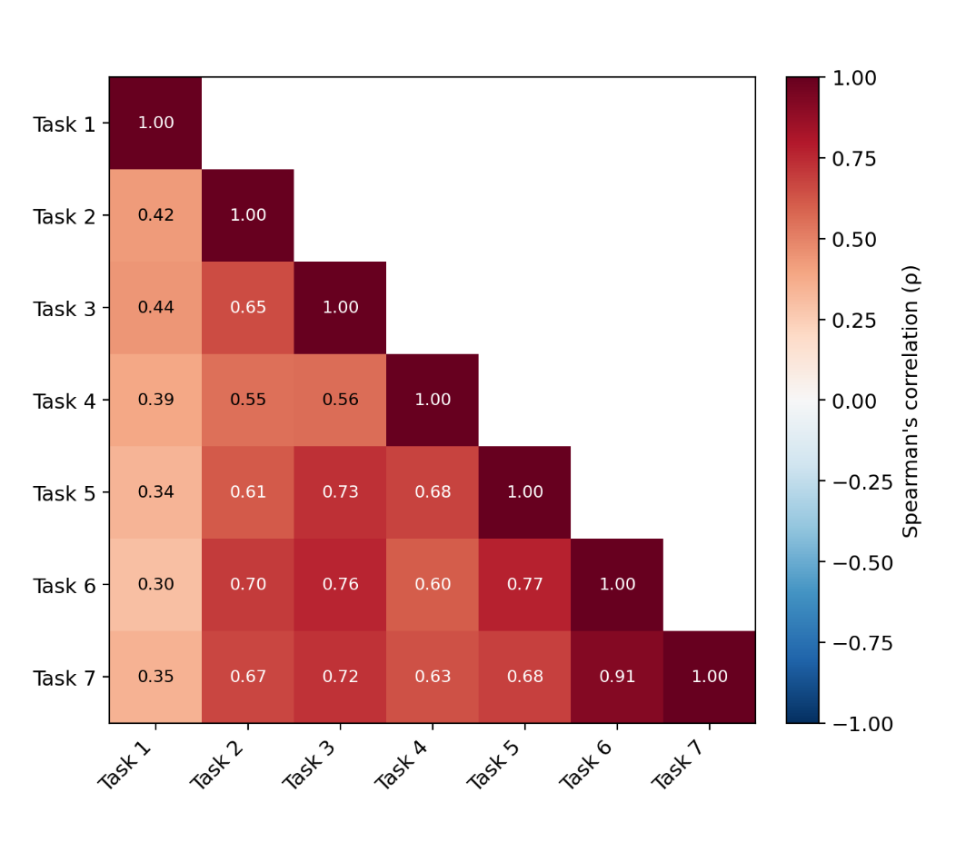

Figure S2. Inter-Item Correlation Matrix for Non-Affected Hand
