Supplementary Information for
How can crop production adapt to growing groundwater restrictions in
the U.S. West?

Pandara Valappil Femeena*, Kathryn Daenzer, Steve Frolking, Danielle Grogan, Jeffrey J Nucciarone, Katherine Calvin, Richard B. Lammers, Karen Fisher-Vanden
Corresponding Author: Pandara Valappil Femeena, Email*: fpp5057@psu.edu

This PDF file includes:
Figures S1 to S6
Table S1

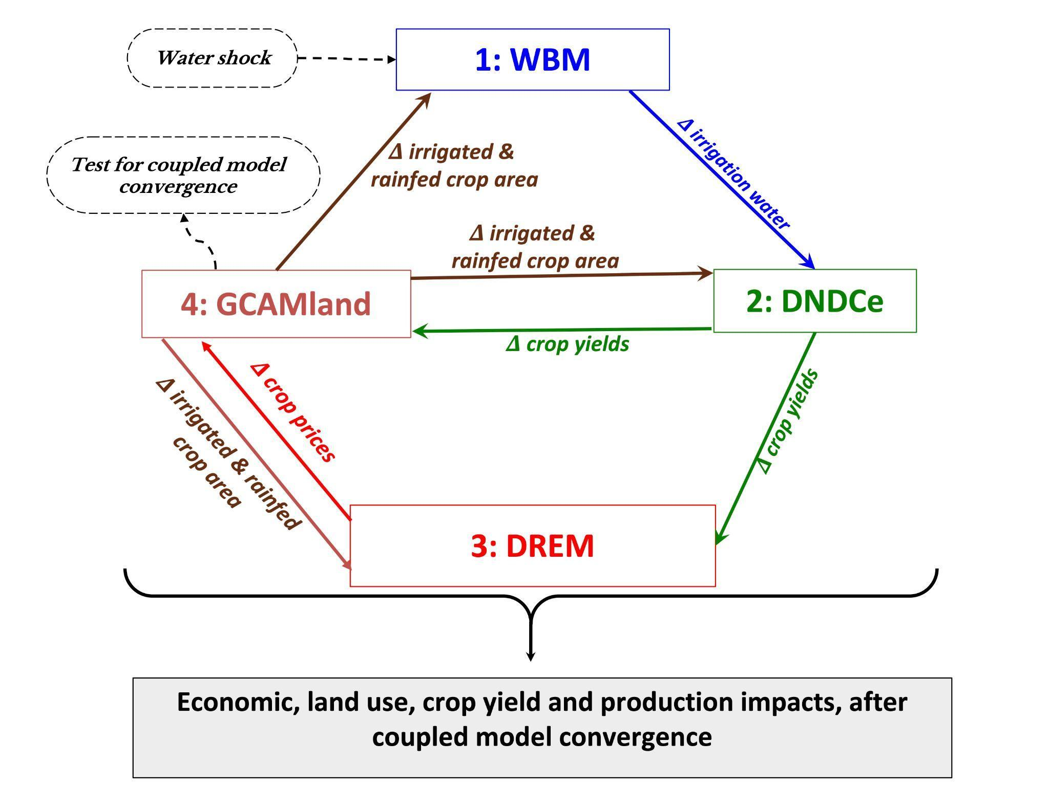

Fig. S1. Coupled hydrology-agroecosystem-land use-economic model diagram

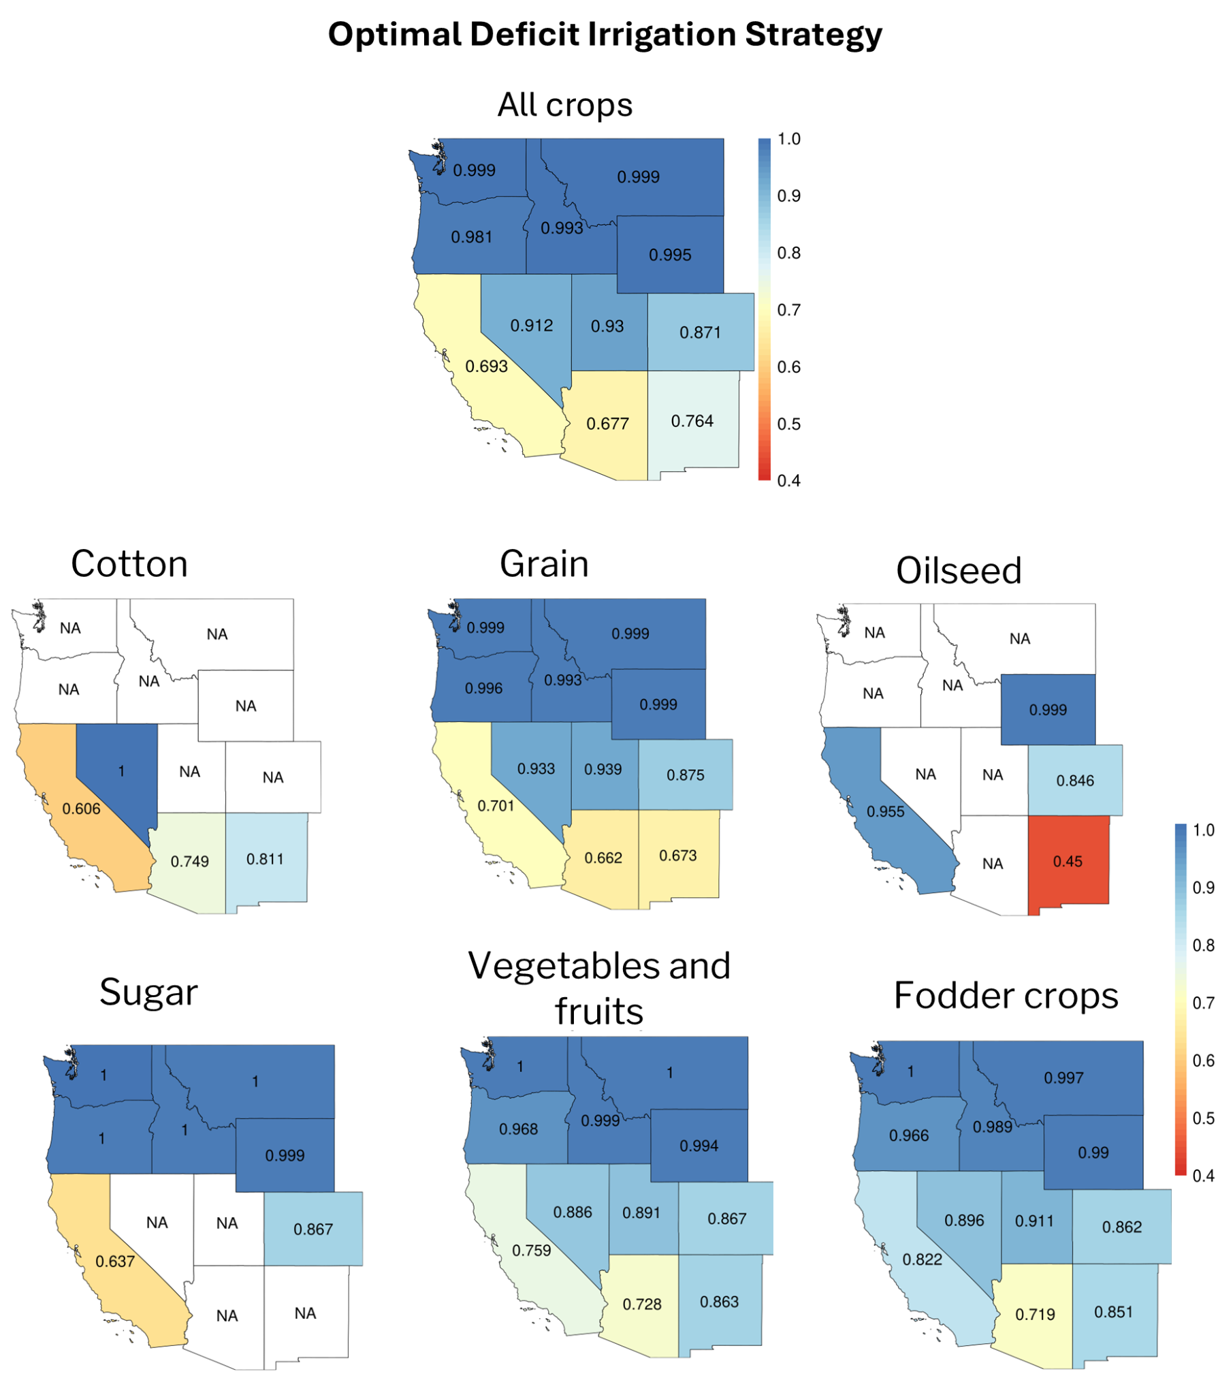Fig. S2. Optimal deficit irrigation strategy to be adopted in different states to maximize profits for all crops. A Value of 1 denotes that full irrigated water demand is met. Left figure is for all crops combined and the right figure is separated for the six crop types. ‘NA’ indicates states where the irrigation is zero or negligible (adapted from Femeena et al., 2025).

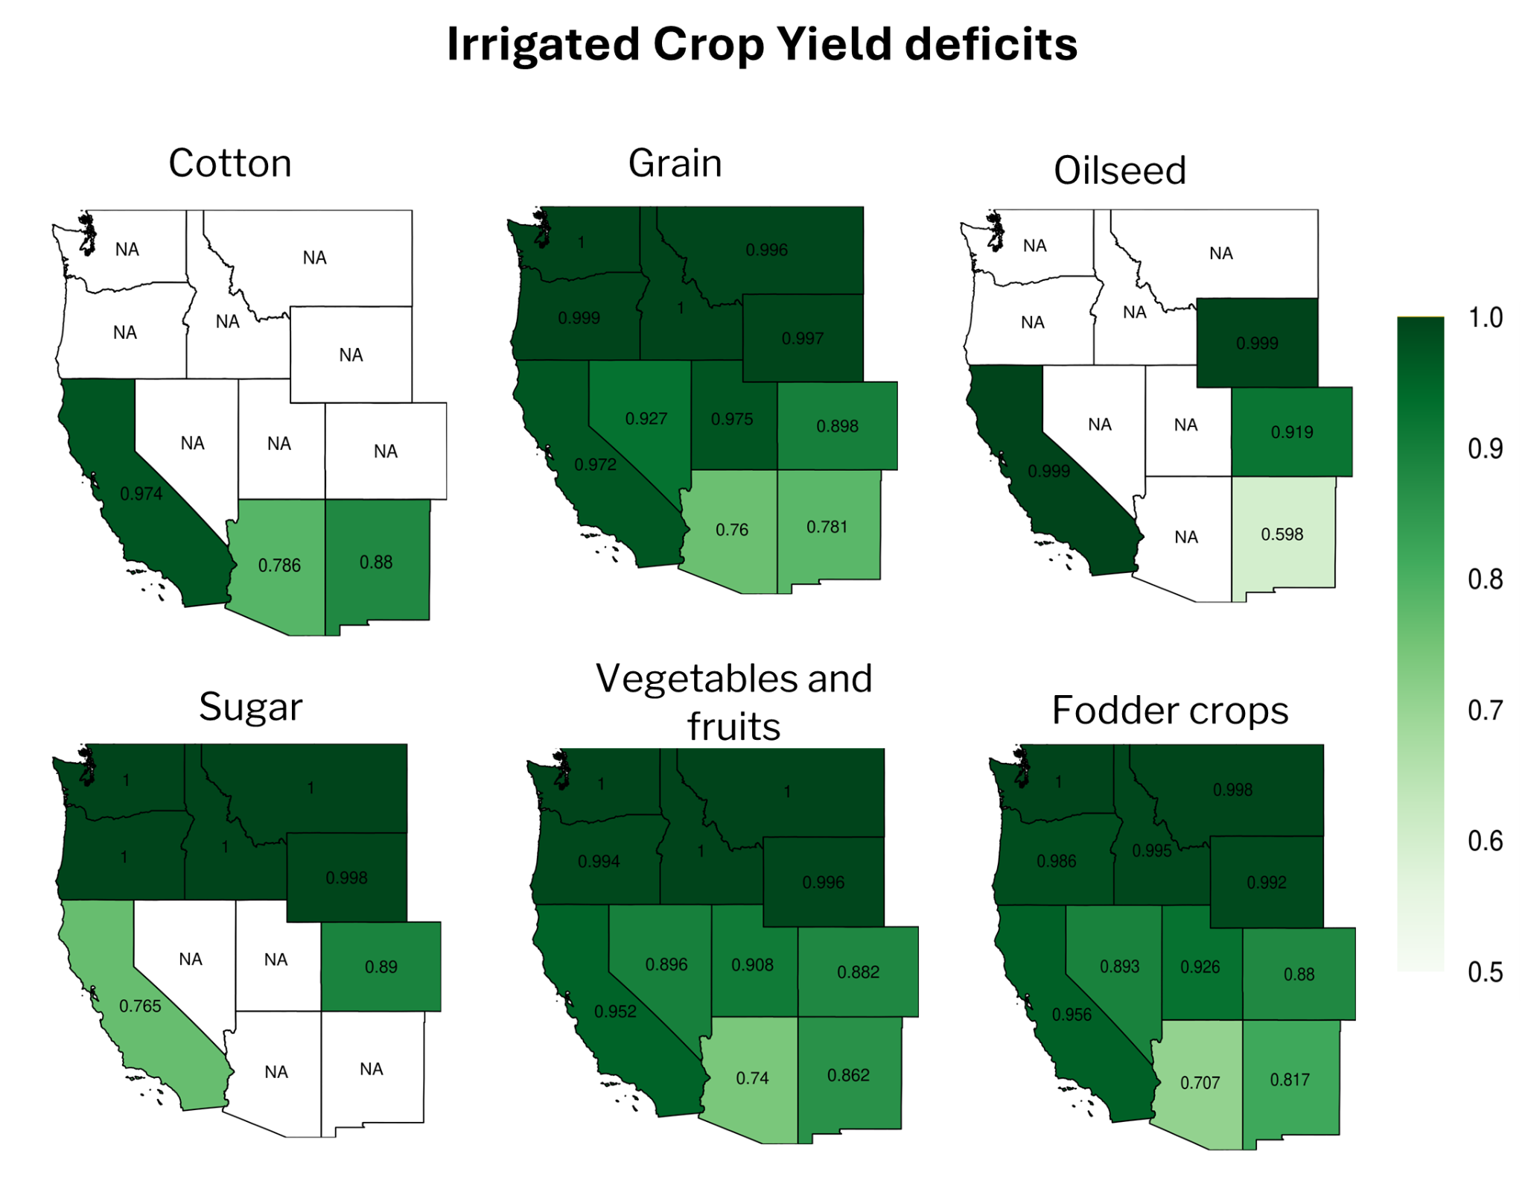

Fig. S3. Yield deficits corresponding to the optimal deficit irrigation fractions adopted in different states for various crop types. A value of 1 denotes that the crop’s maximum yield is obtained.
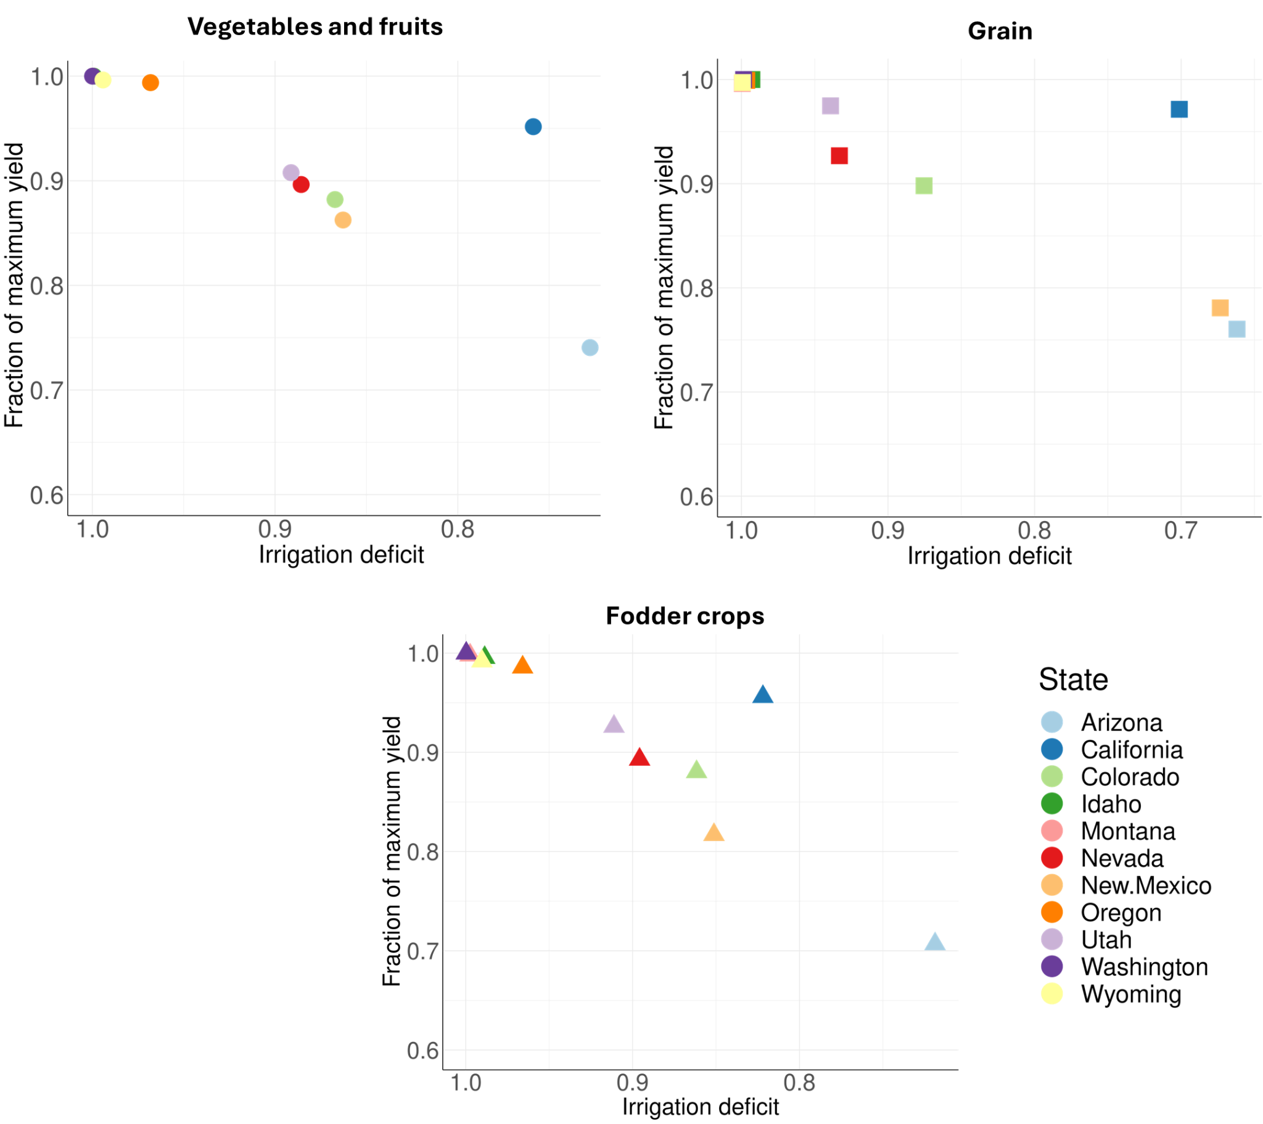
Fig. S4. Yield deficits of three major crop types for the range of optimal deficit irrigation fractions adopted in 11 different US states. A value of 1 on y-axis indicates maximum possible yield and on x-axis indicates full irrigation demand is supplied.

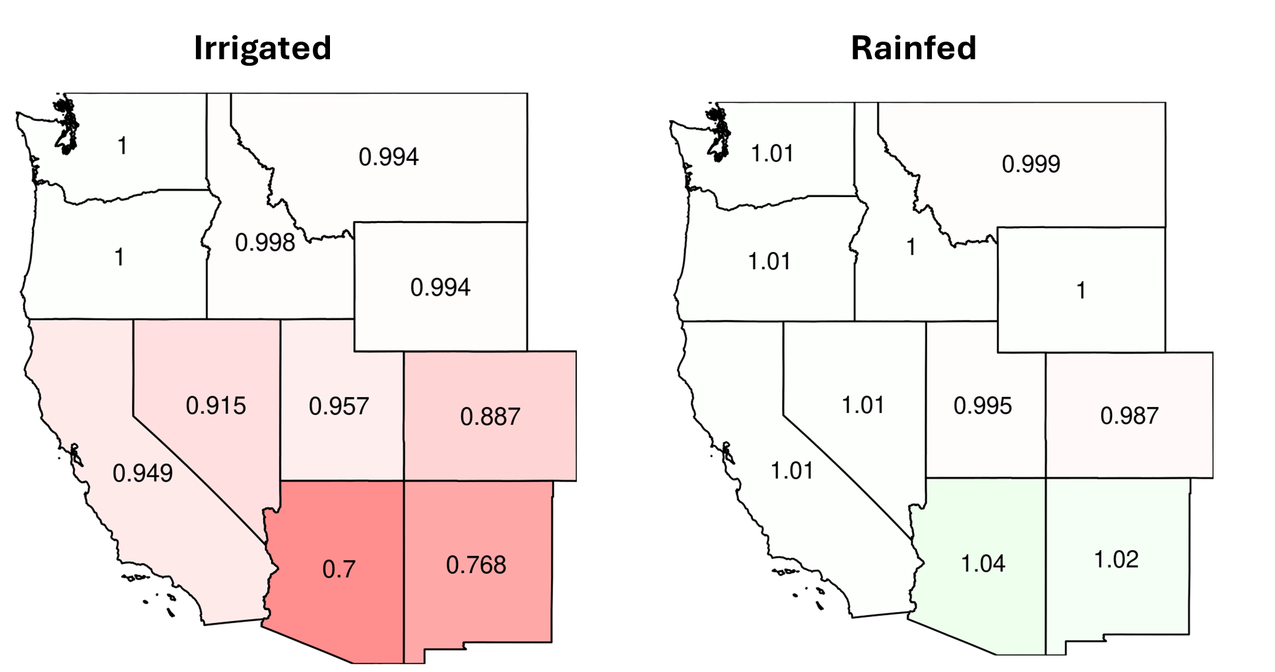
Fig. S5. Change in irrigated or rainfed lands for all crops combined. A value of 1 indicates 2015 reference land values ; >1 means increase and <1 means decrease in 2015 land values under optimal strategy.

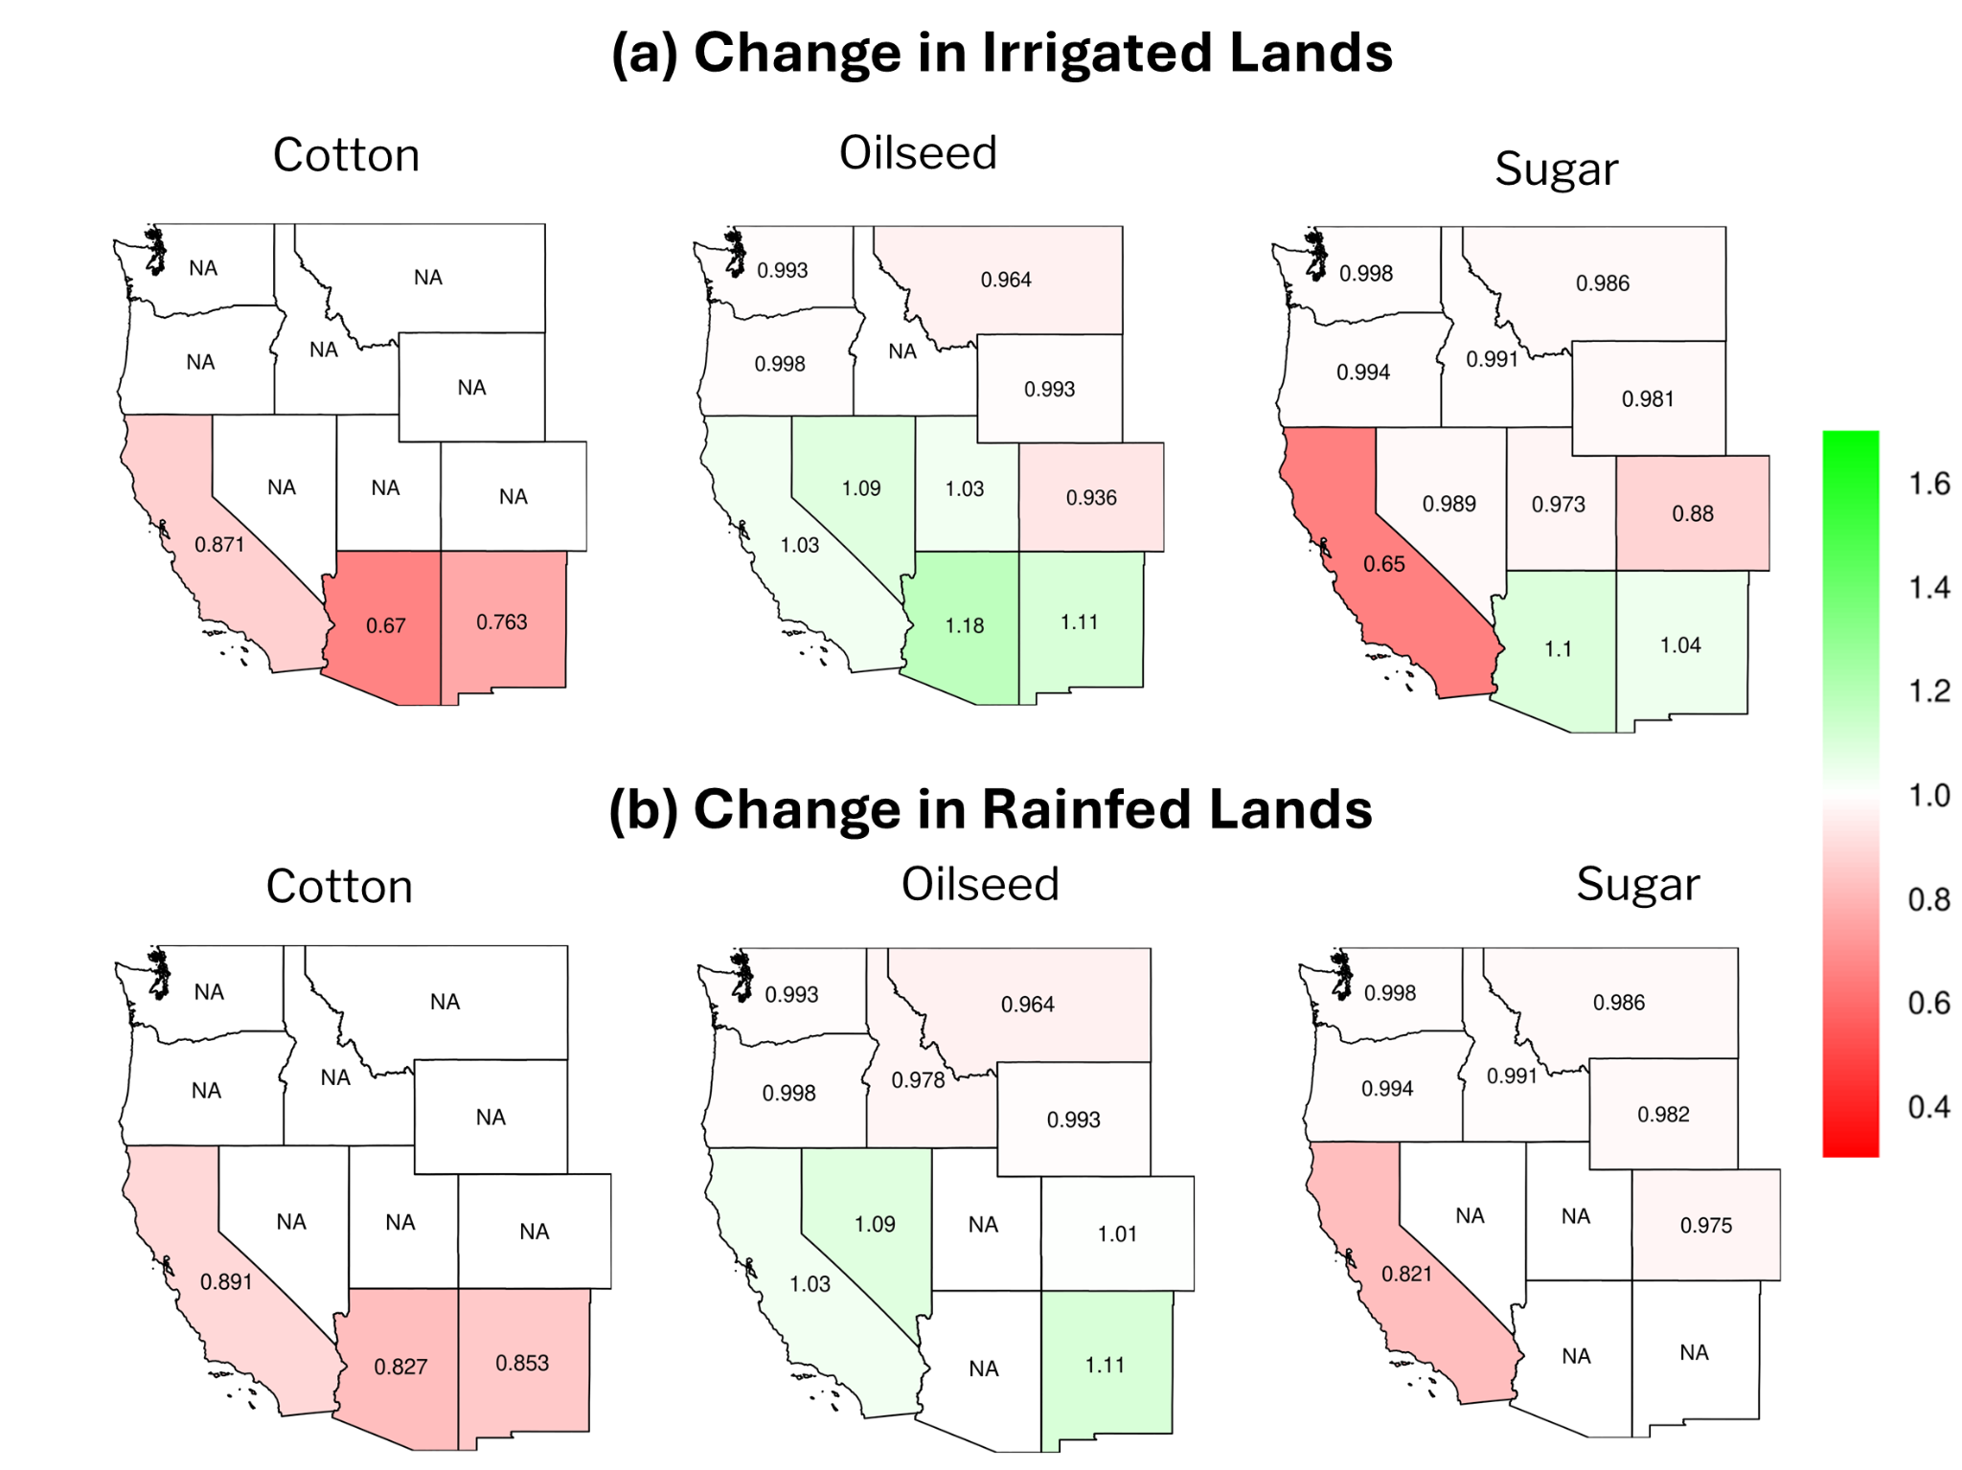
Fig. S6. Change in irrigated and rainfed land areas after imposing the water shock and allowing farmers to adapt for the minor crop varieties: cotton, oilseed, and sugar (1 indicates 2015 reference land values ; >1 means increase and <1 means decrease in 2015 land values under optimal strategy after 10 iteration runs).

 | AZ | CA | CO | ID | MT | NV | NM | OR | UT | WA | WY | Total
Grain | -94% | -5% | -82% | 10% | -2% | -79% | -94% | 2% | -57% | 4% | 0% | -15%
Oilseed | -13% | -1% | -13% | 12% | 4% | -4% | -24% | 1% | -4% | 4% | 9% | 3%
Vegetables and fruits | -51% | -9% | -12% | 30% | -1% | -9% | -40% | 1% | -9% | 18% | -2% | -7%
Cotton | -96% | -43% | NA | NA | NA | NA | -82% | NA | NA | NA | NA | -60%
Sugar | NA | -15% | -18% | 12% | 4% | NA | NA | 2% | NA | 14% | 3% | 6%
Fodder crops | -48% | -4% | -17% | 13% | 18% | -8% | -34% | 4% | -15% | 5% | 10% | -4%

Table S1. Percentage change in value of crop production between the reference and water shock scenarios for each crop and state different crops and states. Shades of green indicate an increase in value of crop production from the reference scenario and shades of yellow/red indicate a decrease from the reference scenario.

