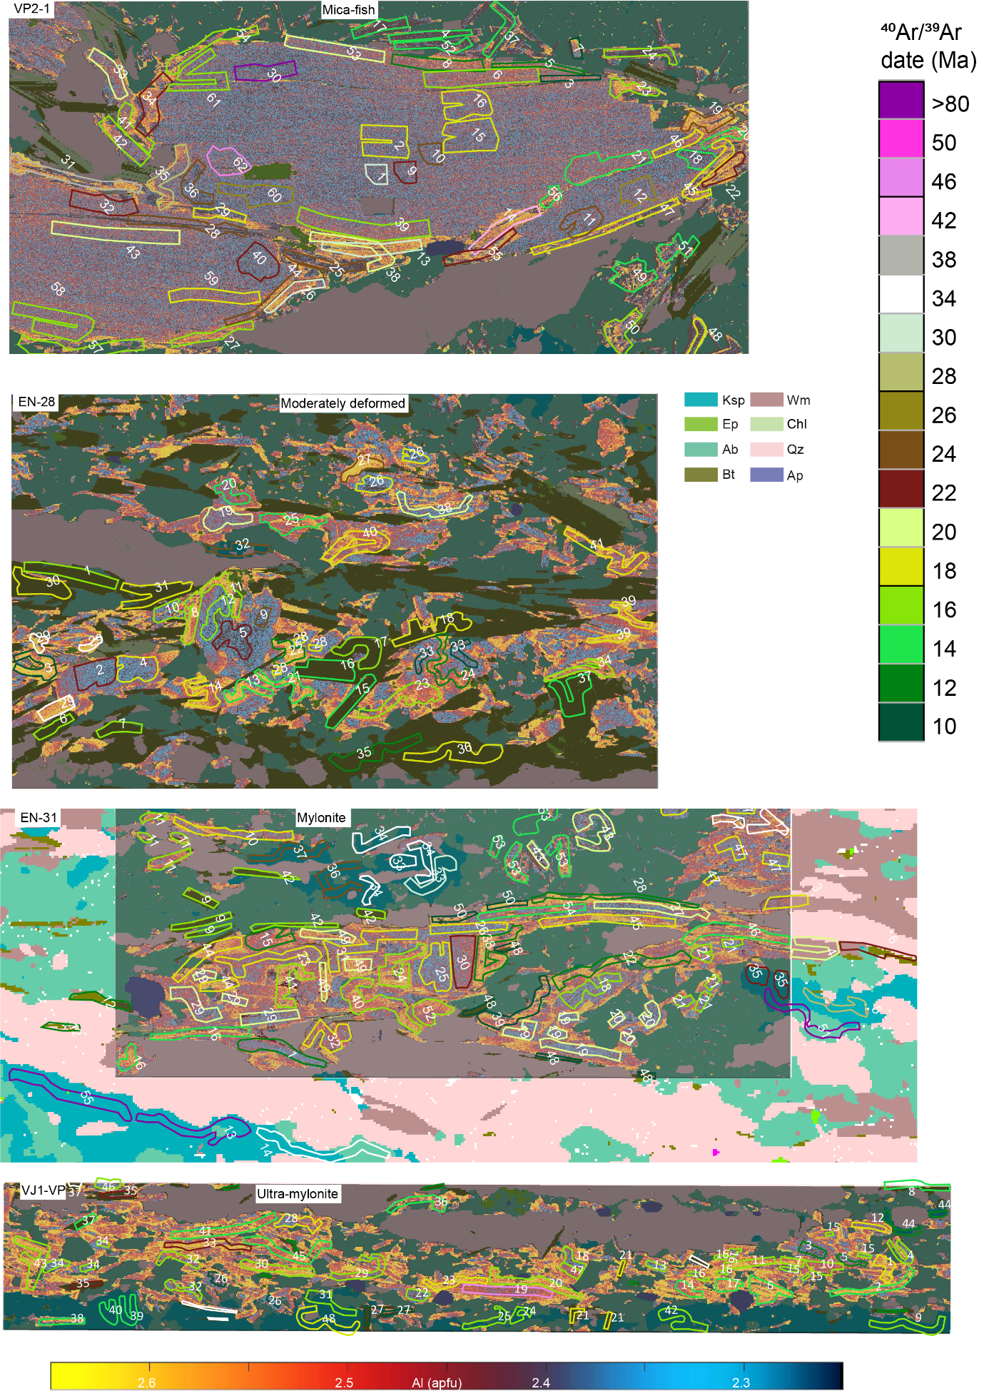
Fig. A1. Al compositional maps of white mica overlaying a mineralogical map. ⁴⁰Ar/³⁹Ar raster ablation are plotted on top with the colour indicating the date and the number referring to the analysis in Table S3.

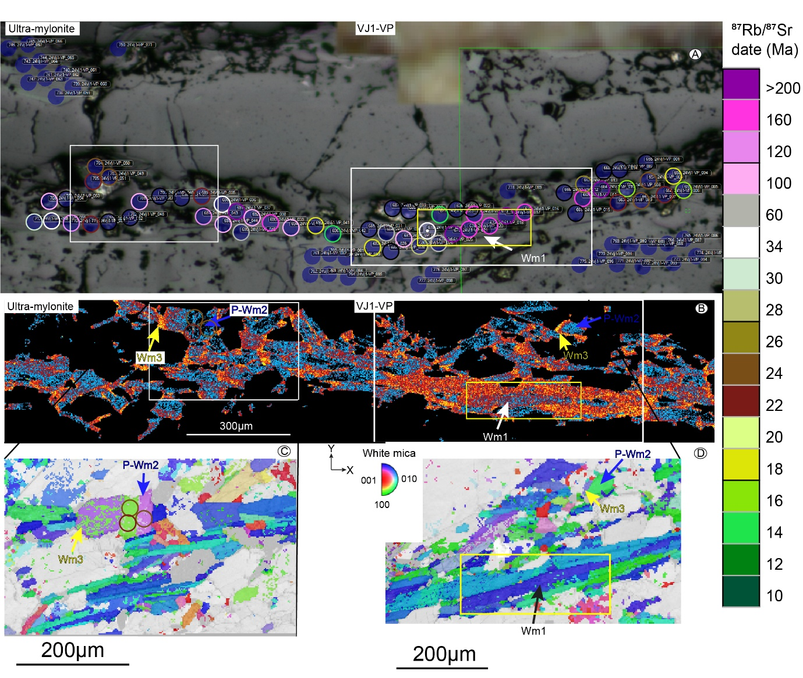
Fig. A2. Single spot ⁸⁷Rb/⁸⁷Sr date locations of the ultra-mylonite (VJ1-VP), and compositional Al (EPMA) and microstructural (EBSD) maps of the same region acquired after the ablation pits was polished down.
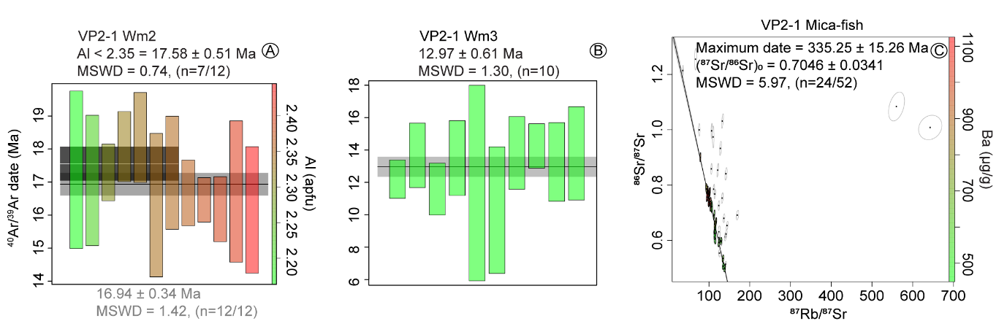
Fig. A3. Geochronology for lightly deformed mica-fish sample VP2-1. A-B) ⁴⁰Ar/³⁹Ar date populations for white mica generation 2 and 3 . C) An inverse isochron diagram displaying the maximum ⁸⁷Rb-⁸⁷Sr date estimated for the mica-fish.
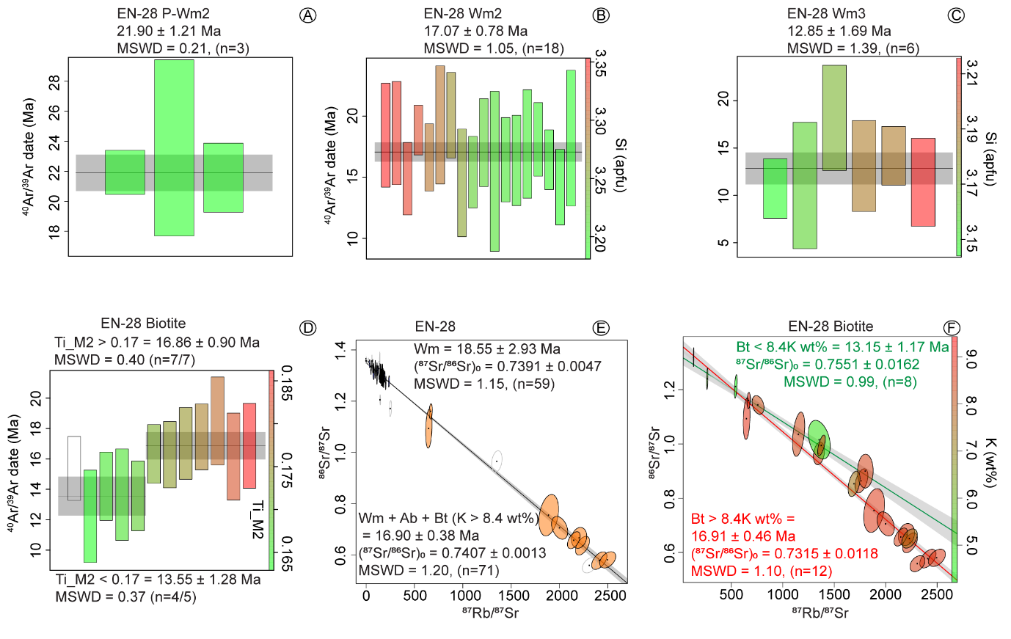
Fig. A4. Geochronology for the moderately deformed meta-granite (EN-28). A-C) ⁴⁰Ar/³⁹Ar date populations for white mica generation P-Wm2, S-Wm2 and Wm3, and for Ti-rich Bt1 and Ti-poor Bt2 in D. E) An inverse isochron diagram with ⁸⁷Rb-⁸⁷Sr dates calculated on the basis of Wm alone and Wm + Ab + Bt. F) Inverse isochron ⁸⁷Rb-⁸⁷Sr dates for Bt1 (K-rich) and Bt2 (K-depleted).
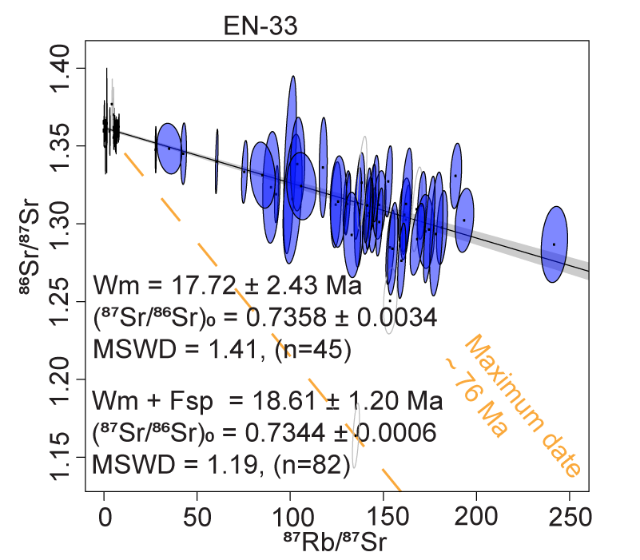
Fig. A5. Geochronology for the highly deformed meta-granite (EN-33). An inverse isochron diagram with ⁸⁷Rb-⁸⁷Sr dates calculated on the basis of Wm alone and Wm + Ksp.
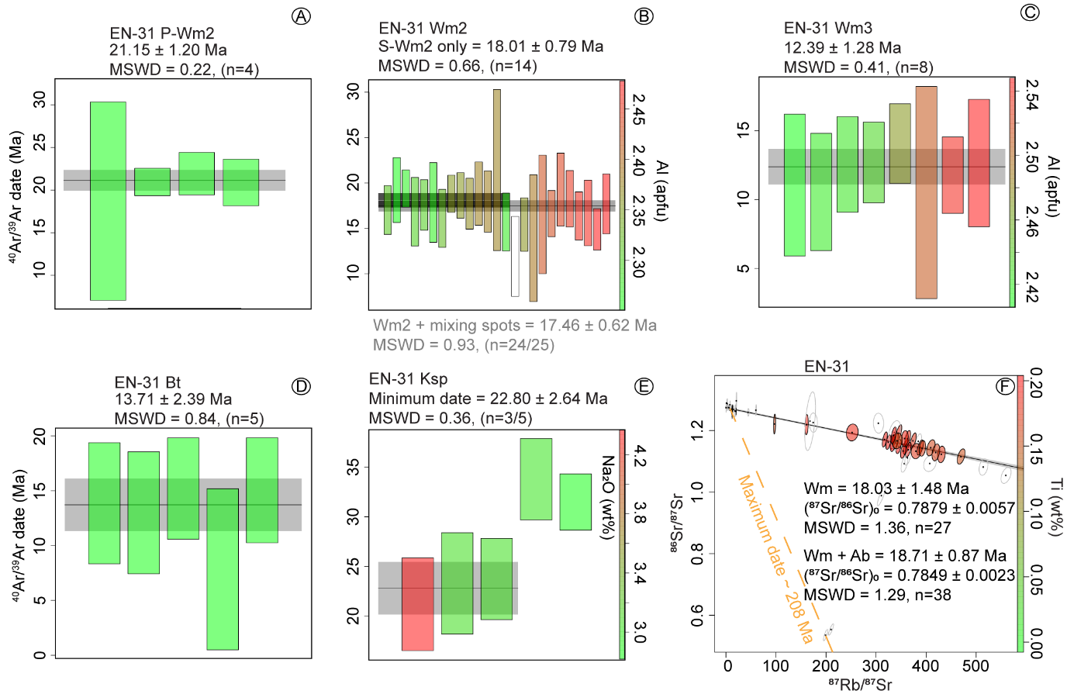
Fig. A6. Geochronology for the mylonitic meta-granite (EN-31). A-C) ⁴⁰Ar/³⁹Ar date populations for white mica generation P-Wm2, S-Wm2 and Wm3. D) A ⁴⁰Ar/³⁹Ar date population for biotite (Bt2) and E) for Na-rich Ksp. F) An inverse isochron diagram with ⁸⁷Rb-⁸⁷Sr dates calculated on the basis of Wm alone and Wm + Ab, with the maximum date given by Wm + Fsp written in orange.
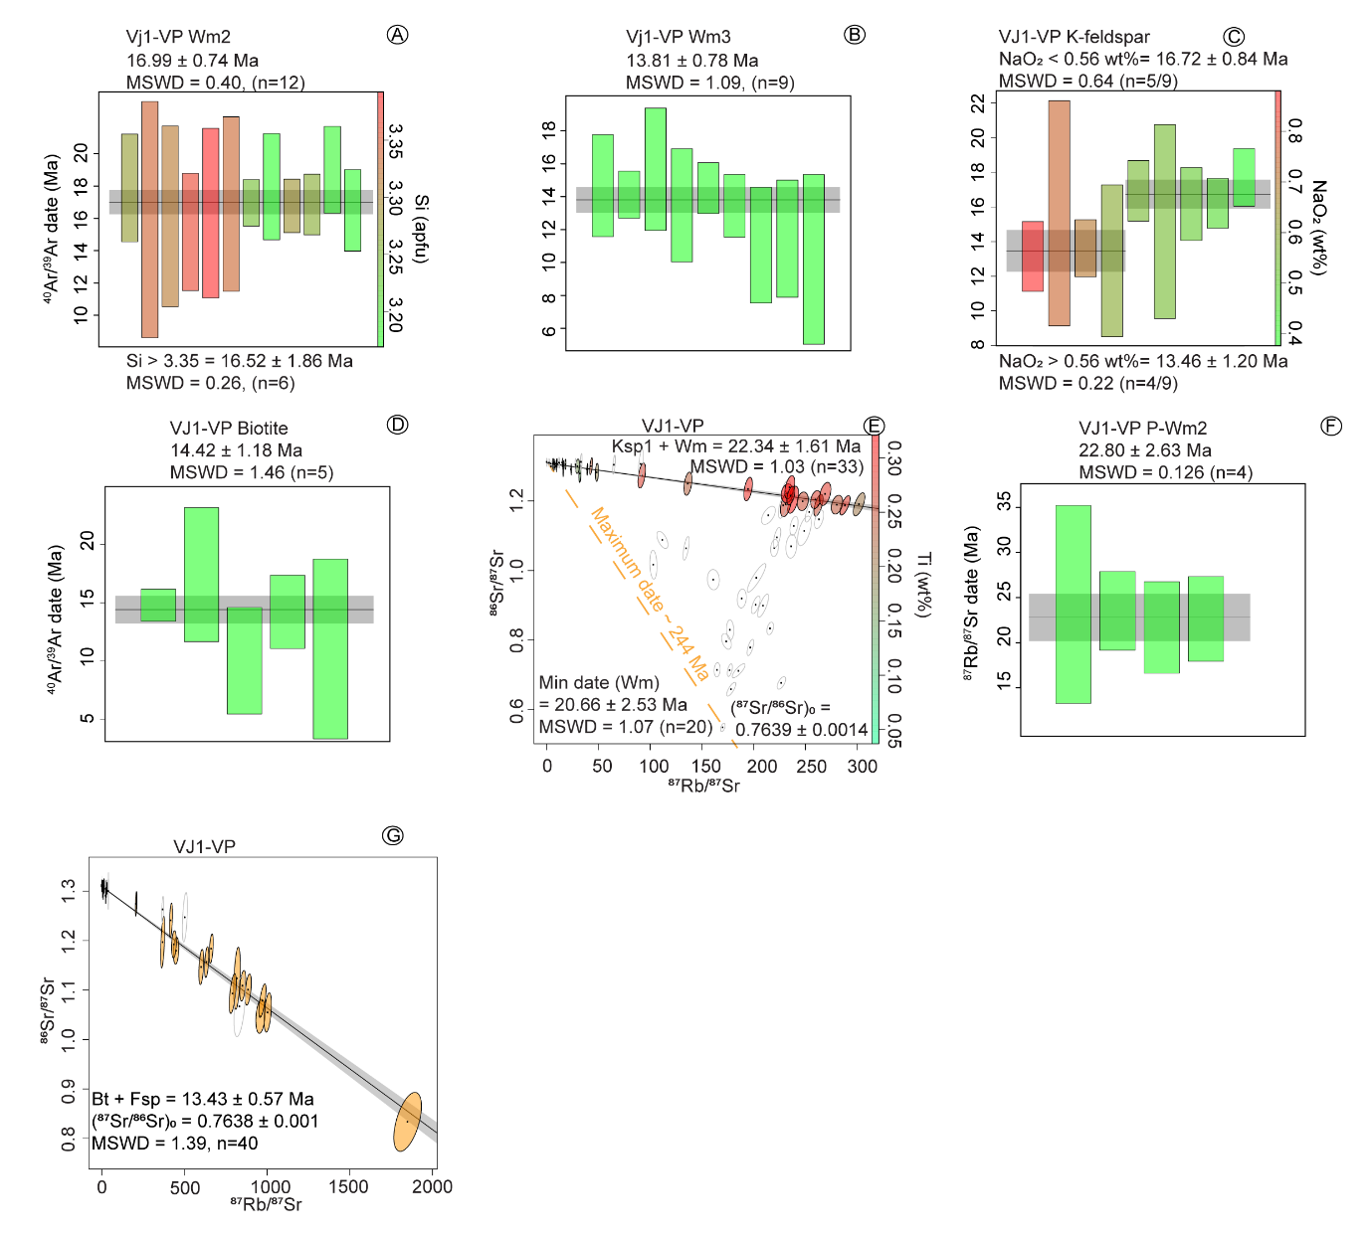

Fig. A7. Geochronology for the ultra-mylonitic meta-granite (Vj1-VP). A-B) ⁴⁰Ar/³⁹Ar date populations for white mica generation S-Wm2 and Wm3, C) for Ksp1 (Na-depleted) and Ksp2 (Na-rich) and D) for biotite (Bt2). E) An inverse isochron diagram with ⁸⁷Rb-⁸⁷Sr dates calculated on the Wm + Ksp, with the maximum date given by Wm + Fsp written in orange, and F) a ⁸⁷Rb-⁸⁷Sr date population for P-Wm2 and G) an inverse isochron ⁸⁷Rb-⁸⁷Sr date for Bt2 + Fsp.
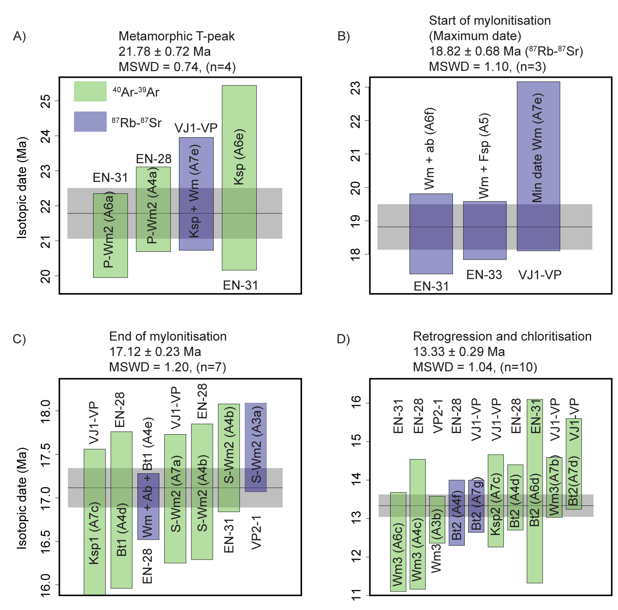
Fig. A8. Geochronological pooled ages for the: A) metamorphic temperature (T) peak, B) maximum start of mylonitisation, C) end of mylonitisation, and D) retrogression. Sample names, weighted mean dates or inverse isochron dates that are included in each pooled age is indicated within each graph with A3 to A7 referring to the figures in the appendix.

