Supplementary information for
AI-driven closed-loop control of lithium plating in batteries
Hong-Yuan He^{1,2,#}, Si-Yuan Ma^{1,2,#}, Zhen Li^{1,2,#}, Wei-Wei Wang², Hong-Yang Yuan^{1,2}, Wan-Jie Zhang², Quan-Fang Wang^{1,2}, Yu-Fei Chen¹, Yu-Ming Su², Hai-Long Wang^{1,2}, Meng-Yao Wang³, Yi-Hui Wu⁴, Jing-Hua Tian^{1,2,*}, Chong Yan^{4,*}, Qiang Zhang^{5,*}, Zhong-Qun Tian^{1,2,*}

¹ State Key Laboratory of Physical Chemistry of Solid Surfaces, College of Chemistry and Chemical Engineering, Xiamen University, Xiamen 361005, China
² Laboratory of AI for Electrochemistry, Innovation Laboratory for Sciences and Technologies of Energy Materials of Fujian Province (IKKEM), Xiamen 361005, China
³ Shanxi Research Institute for Clean Energy, Tsinghua University, Taiyuan 030032, China.
⁴ School of Interdisciplinary Science, Beijing Institute of Technology, Beijing 100081, China
⁵ Beijing Key Laboratory of Complex Solid State Batteries, Department of Chemical Engineering, Tsinghua University, Beijing 100084, China

Supplementary Figures
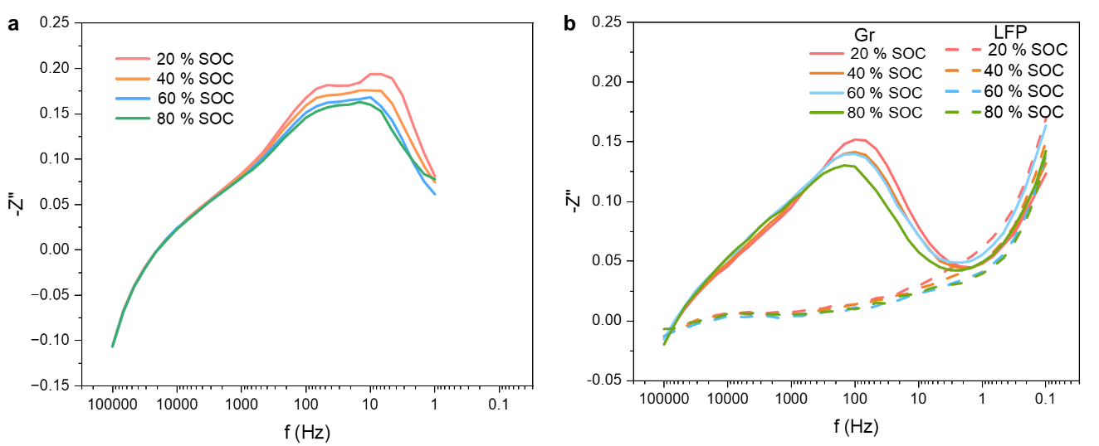
Supplementary Fig. 1 | Identification of the characteristic frequency for the graphite-anode charge-transfer process. a, -Z″ extracted from DEIS spectra of commercial LCO||Gr coin cells with a nominal capacity of 70 mAh. The cell was charged at 1C, and DEIS spectra were collected at different SOCs from 20% to 80%. The frequency range was 1 Hz to 100 kHz, and the AC current amplitude was equivalent to 0.1C. b, -Z″ extracted from static EIS spectra of a three-electrode LFP||Gr pouch cell with a capacity of 43.8 mAh. The cell was charged at 0.5C, followed by a 3 h relaxation period at every 20% SOC increment before static EIS measurement. Static EIS spectra were collected from 0.1 Hz to 100 kHz with a voltage amplitude of 10 mV. The three-electrode configuration enabled separation of the impedance contributions from the graphite anode and the LFP cathode.

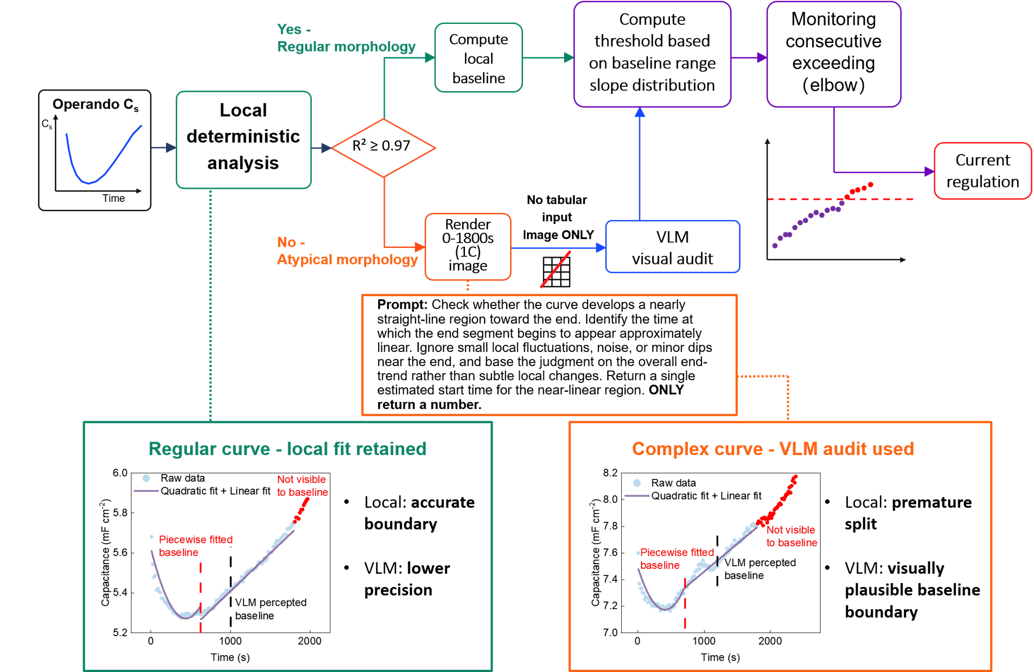Supplementary Fig. 2 | Confidence- and availability-gated VLM assistance for baseline localization in operando C_{s} analysis. High-confidence trajectories retain the deterministic local baseline, whereas atypical low-confidence trajectories undergo a one-time image-based VLM audit. The accepted baseline from either route enters the same deterministic thresholding and consecutive-exceedance procedure. The lower panels compare a regular trajectory retained by local fitting with an atypical trajectory requiring VLM-assisted localization. Routing parameters, timeout fallback and long-cycle implementation are described in Methods.

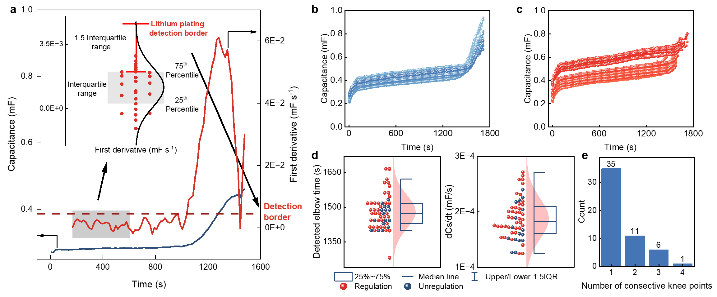
Supplementary Fig. 3 | Algorithmic logic and statistical evaluation of C_{s} knee point detection within the AI driven closed-loop system. a, Decision logic of the analysis layer engineered to detect lithium plating-relevant C_{s} knee points (fixed baseline 200-600 s for single cycle repetition). b, C_{s} trajectories of 16 LFP||Gr coin cells charged at 2C to 95% SOC under open-loop operation, showing offline identification of candidate knee points. c, C_{s} trajectories for 40 LFP||Gr coin cells charged at 2C under closed-loop regulation, in which the fast-charge segment was switched to the low-current mitigation step at the online-detected C_{s} knee point. d, Statistical distributions of the detected C_{s} knee point position and the corresponding first-derivative threshold for the open-loop and closed-loop groups. e, Histogram of the maximum number of consecutive suprathreshold points outside the true knee-point region, used to evaluate the false-triggering tendency of the consecutive-point confirmation rule.

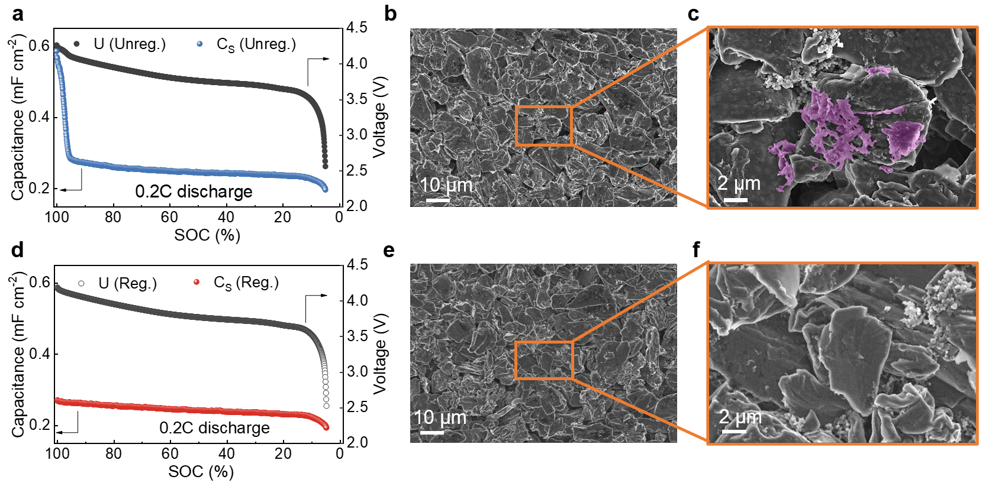
Supplementary Fig. 4 | Discharge-stage morphology of commercial LCO||Gr coin cells after open-loop and closed-loop regulations. a, C_{s} and voltage profiles during discharge at 0.2C to 2.5 V after open-loop operation (Unreg.). b, SEM image of the graphite anode after discharge. c, Magnified SEM image of the orange-boxed region in (b). d, C_{s} and voltage profiles during discharge at 0.2C to 2.5 V after active closed-loop regulation. e, SEM image of the graphite anode after discharge. f, Magnified SEM image of the orange-boxed region in (e).
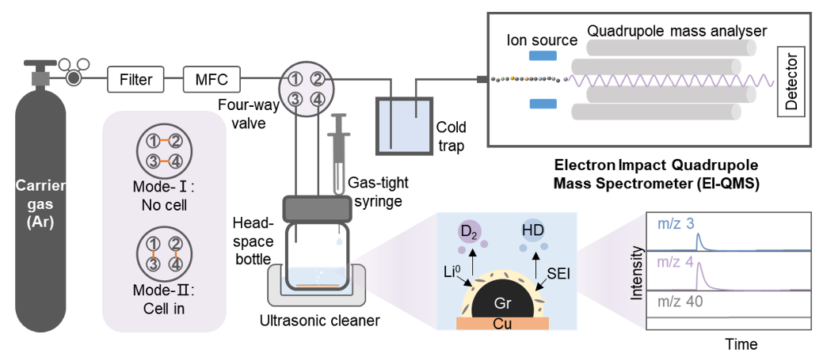
Supplementary Fig. 5 | Schematic illustration of the isotope-labeled titration mass spectrometry apparatus and analytical protocol.

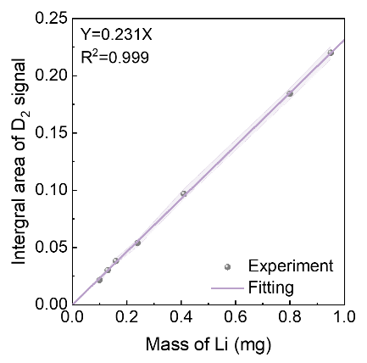
Supplementary Fig. 6 | Standard calibration curve correlating the mass of metallic lithium with the integrated peak area of the evolved D₂ gas (m/z = 4). Each calibration point was measured in triplicate (n = 3).

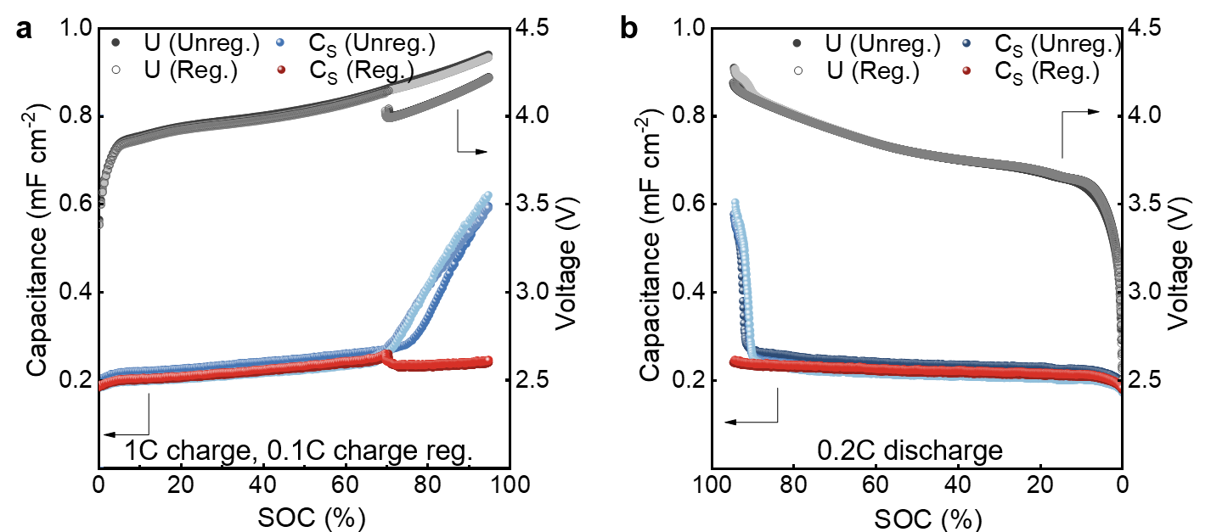
Supplementary Fig. 7 | Electrochemical profiles of commercial LCO||Gr coin cells prepared for TMS quantification. a, b, C_{s} and voltage profiles of the unregulated open-loop group (blue) and AI-LOMAC-regulated closed-loop group (red) during (a) charging and (b) discharging. Each group contained three parallel cells (n = 3).

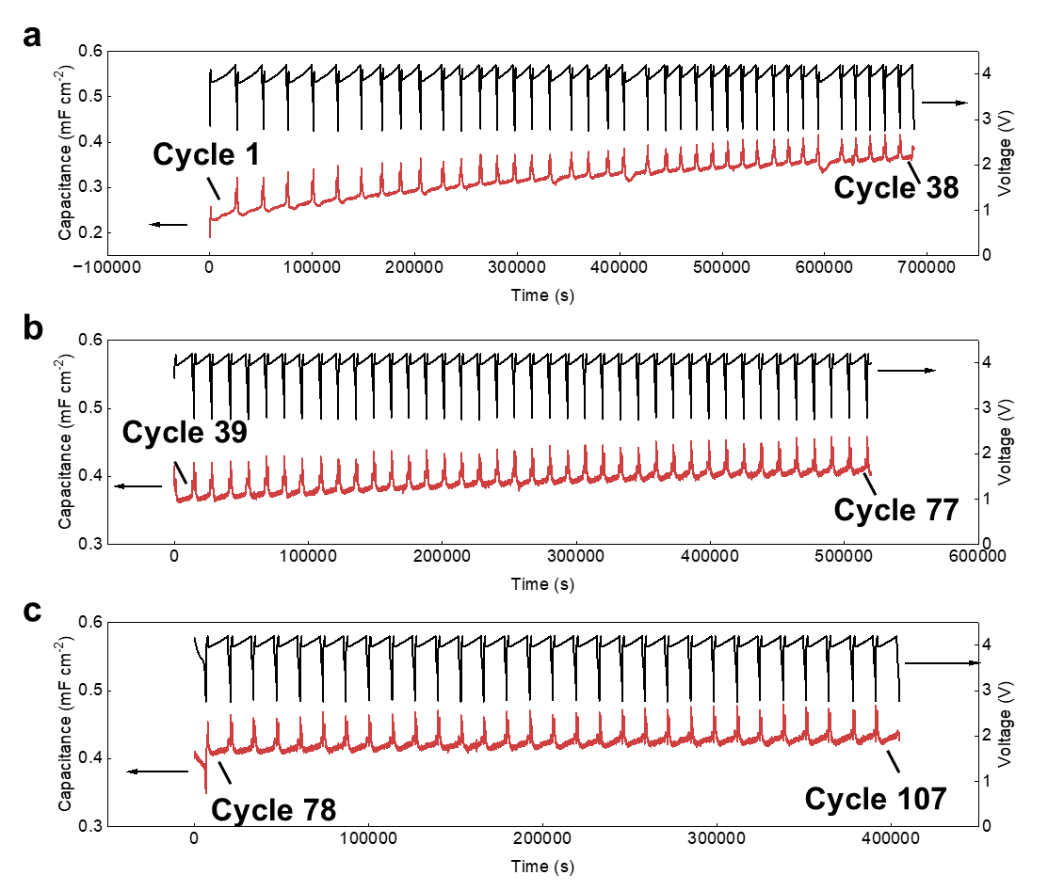
Supplementary Fig. 8 | Long-term closed-loop cycling of LCO||Gr cell under real time active control with AI-LOMAC. a,b,c, The cell was charged at 2C, with the current reduced to 0.1C upon triggering of the regulation protocol, and discharged at 2C. Before the first cycle, the cell was discharged to the lower cut-off voltage.

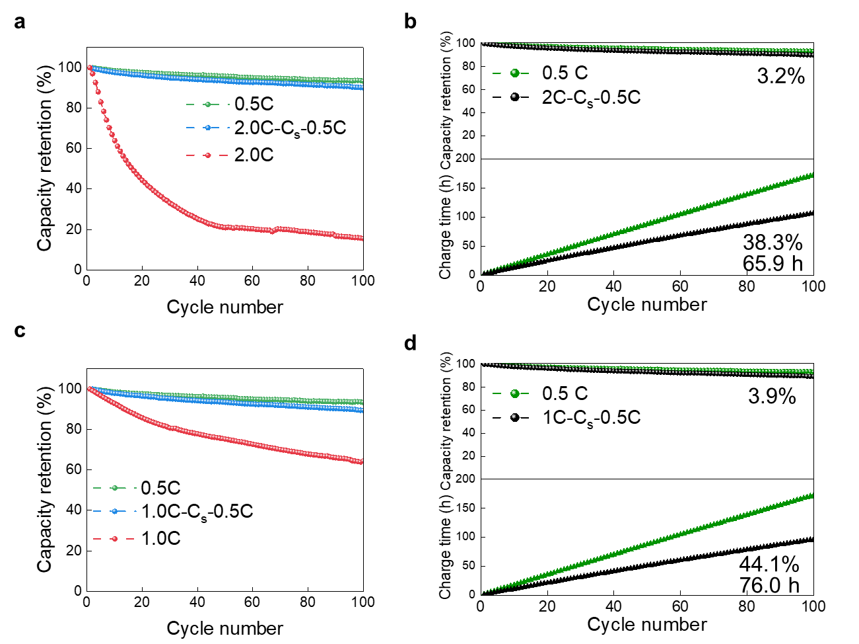
Supplementary Fig. 9 | Cycling stability and charging-time benefits of closed-loop fast-charging regulation. a,c, Capacity retention over 100 cycles under constant fast charging (2C in a and 1C in c), AI-LOMAC-regulated charging (2.0C-C_{s}-0.5C or 1.0C-C_{s}-0.5C), 0.5C, 1.0C or 2.0C charging, the discharging rates are 0.5C for all the tested batteries. b,d, Capacity retention (top) and cumulative charging time (bottom) for the regulated and 0.5C protocols corresponding to a and c. The regulated protocols reduced cumulative charging time by 65.9 h (38.3%) and 76.0 h (44.1%), with capacity retention after 100 cycles lower by 3.2 and 3.9 percentage points, respectively.

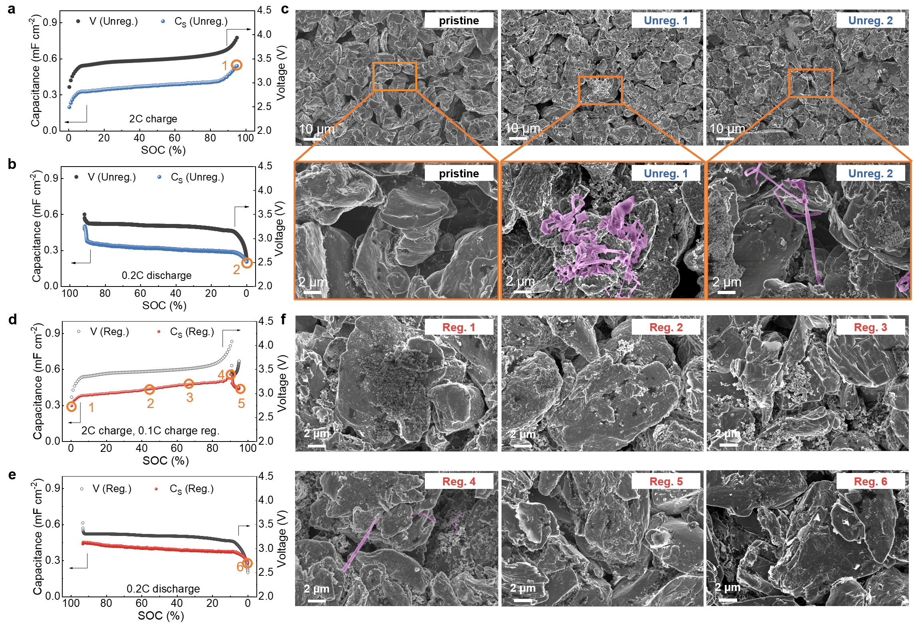
Supplementary Fig. 10 | Morphological characterization of LFP||Gr coin cells under open-loop and closed-loop regulations. a, b, C_{s} and voltage profiles of LFP||Gr coin cells under open-loop without regulation during (a) charging and (b) discharging. c, SEM morphologies of the graphite anode surface at distinct stages: pristine state (pristine), after charging to 95% SOC at 2C (point 1, Unreg. 1), and after discharging to 2.5 V at 0.2C (point 2, Unreg. 2). d, e, C_{s} and voltage profiles of LFP||Gr coin cells under close-loop regulation during (d) charging and (e) discharging. f, SEM morphologies of the graphite anode surface at specific electrochemical states: post-cell formation state before cycling (point 1, Reg. 1), after charging at 2C for 800 s (point 2, Reg. 2), after charging at 2C for 1200 s (point 3, Reg. 3), at the C_{s} knee point (point 4, Reg. 4), after subsequent 0.1C charging to 95% SOC (point 5, Reg. 5), and after discharging to 2.5 V at 0.2C (point 6, Reg. 6).
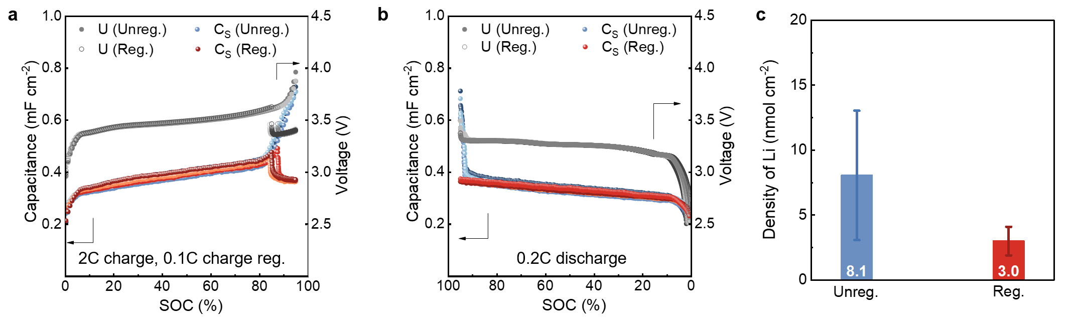
Supplementary Fig. 11 | Electrochemical profiles of LFP||Gr coin cells prepared for TMS quantification. a, b, C_{s} and voltage profiles of the unregulated open-loop group (blue) and AI-LOMAC-regulated closed-loop group (red) during (a) charging and (b) discharging. c, Areal density of residual inactive metallic Li in the unregulated and regulated groups measured by TMS. Each group contained three parallel cells (n=3), and the values in c were obtained from these three measurements.

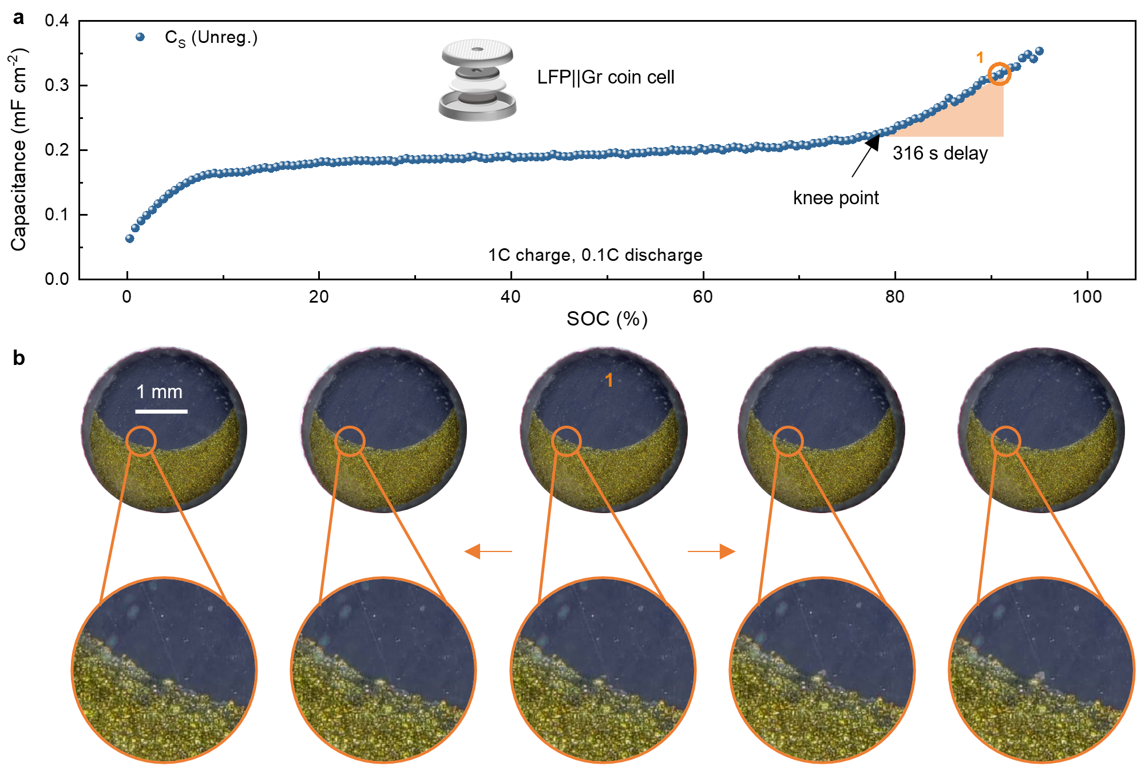
Supplementary Fig. 12 | In situ optical observation of LFP||Gr coin cells under open-loop regulation. a, C_{s} profiles under close-loop regulation during charging. b, The optical images correspond to point 1 and the two adjacent C_{s} points in the C_{s} profile in (a), the central image corresponds to point 1, whereas the left and right images correspond to the neighboring SOC states.
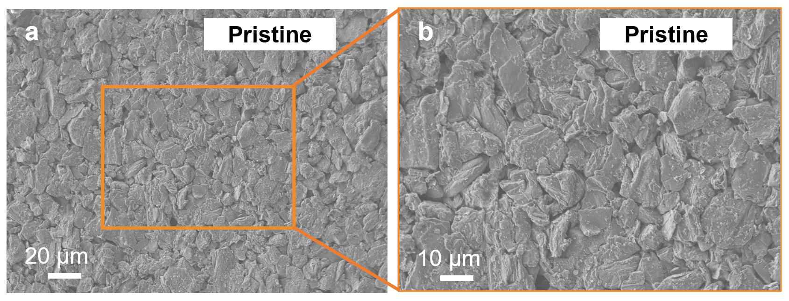
Supplementary Fig. 13 | SEM morphology of the pristine graphite anode from a 314 Ah prismatic cells. a, SEM image of the pristine graphite anode surface. b, Magnified view of the orange-boxed region in (a).

