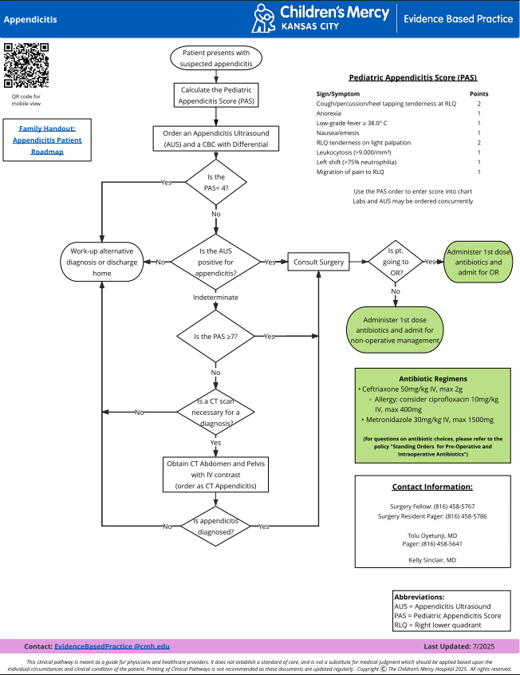
Supplemental Figure 1. Diagnostic Algorithm for Pediatric Acute Appendicitis. This figure demonstrates the management algorithm utilized at Children’s Mercy Kansas City.

Appendix A. A sonographic categorizing framework for diagnosing acute appendicitis

Category I study. The appendix is normal in size and sonographic appearance and demonstrates normal compressibility. There is no peritoneal fluid, abnormal echogenic mesenteric fat or mass. No abnormal lymph nodes are identified.

Category II study. There is an incompletely visualized tubular structure within the right lower
quadrant which measures 4 mm. This may represent the appendix. The tip is not
definitively visualized. There is no peritoneal fluid, abnormal echogenic
mesenteric fat or mass. No abnormal lymph nodes are identified.

Category III study. The appendix is not visualized. Multiple loops of thickened small bowel are noted in the right lower quadrant. A large calcification is visualized and may represent an appendicolith. The mesenteric fat is mildly echogenic. There is no free fluid. No abnormal lymph nodes are identified.

Category IV study: The appendix is enlarged, thick-walled, and noncompressible. The adjacent
mesenteric fat is echogenic. There is moderate free fluid in the right lower quadrant and trace perihepatic free fluid. No abnormal lymph nodes are
Identified.

