SUPPLEMENTAL MATERIAL
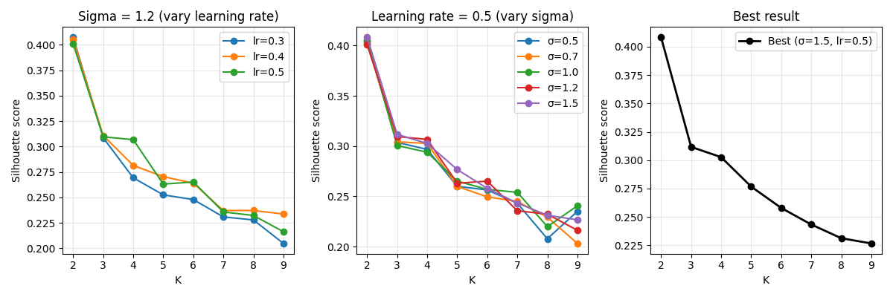
Figure 1. Parameter optimization; (Left) Varying learning rate with constant sigma; (Middle) Varying sigma values with constant learning rate; (Right) Silhouette score per K value with the optimized hyperparameters

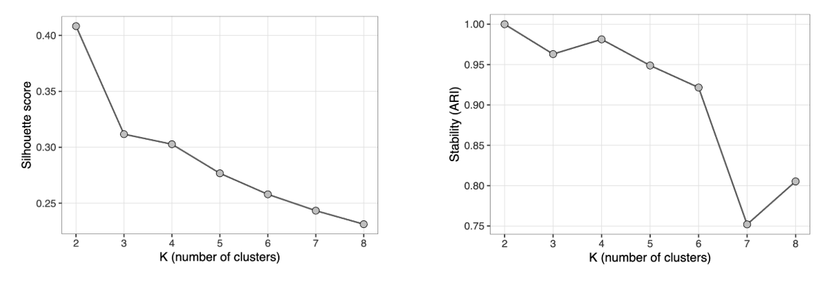Figure 2. (Left) Silhouette score per K value; (Right) Stability (ARI) per K value

Table 1. Uncorrected Linear Model Results for EEG Features Across Behavioral Clusters
 |  | 1 vs 4 |  |  |  | 2 vs 4 |  |  |  | 3 vs 4
 |  | ß | SE | t | p | ß | SE | t | p | ß | SE | t | p
Hurst |  | -0.021 | 0.009 | -2.314 | 0.022 | -0.022 | 0.008 | -2.755 | 0.006 | -0.017 | 0.009 | -1.912 | 0.057
Delta |  | -9.65e-13 | 4.85e-13 | -1.991 | 0.048 | -1.13e-12 | 4.35e-13 | -2.610 | 0.010 | -3.78e-13 | 4.79e-13 | -0.789 | 0.431
Theta |  | 5.69e-13 | 2.57e-13 | 2.215 | 0.028 | 1.62e-13 | 2.31e-13 | 0.704 | 0.482 | 2.56e-13 | 2.54e-13 | 1.010 | 0.314
Alpha |  | -5.89e-14 | 1.96e-13 | -0.301 | 0.764 | 8.41e-14 | 1.75e-13 | 0.479 | 0.632 | 3.73e-14 | 1.93e-13 | 0.193 | 0.847
Beta |  | 3.19e-14 | 3.15e-14 | 1.014 | 0.312 | 4.60e-14 | 2.83e-14 | 1.627 | 0.106 | 1.38e-14 | 3.11e-14 | 0.445 | 0.657
Low Gamma |  | -8.39e-15 | 5.19e-15 | -1.618 | 0.108 | -1.15e-14 | 4.65e-15 | -2.465 | 0.015 | -1.06e-14 | 5.12e-15 | -2.074 | 0.040
High Gamma |  | -1.18e-14 | 5.56e-15 | -2.117 | 0.036 | -1.58e-14 | 4.98e-15 | -3.178 | 0.002 | -1.27e-14 | 5.49e-15 | -2.308 | 0.022
Exponent |  | 0.025 | 0.042 | 0.602 | 0.548 | 0.060 | 0.037 | 1.600 | 0.111 | 0.047 | 0.041 | 1.156 | 0.249
Offset |  | 0.030 | 0.053 | 0.565 | 0.573 | -0.008 | 0.048 | -0.159 | 0.874 | -0.045 | 0.053 | -0.846 | 0.399
CI highscale |  | 0.625 | 0.502 | 1.245 | 0.215 | 0.939 | 0.466 | 2.016 | 0.045 | 0.536 | 0.502 | 1.067 | 0.288
CI lowscale |  | 0.399 | 0.559 | 0.714 | 0.4765 | 0.174 | 0.519 | 0.335 | 0.738 | 0.001 | 0.560 | 0.002 | 0.998
Higuchi |  | -0.007 | 0.005 | -1.376. | 0.171 | -0.015 | 0.  005 | -3.087 | 0.002 | -0.009 | 0.005 | -1.766 | 0.079

Table 2. Resting-State EEG Features Correlation Matrix
 | Hurst | Delta | Low Gamma | High Gamma | Higuchi
Hurst | 1 | - | - | - | -
Delta | 0.352*** | 1 | - | - | -
Low Gamma | 0.403*** | 0.058 | 1 | - | -
High Gamma | 0.451*** | 0.066 | 0.754*** | 1 | -
Higuchi | 0.557*** | 0.02 | 0.452*** | 0.573*** | 1
*** p < 0.001
Table 3. Significant EEG feature from pairwise comparisons per cluster (before FDR correction)
 | 1 vs 4 |  |  |  | 2 vs 4
 | Average 1, 4 | t | df | p | Average 1, 4 | t | df | p
Hurst | 0.67, 0.69 | -2.18 | 63.07 | 0.03 | 0.67, 0.69 | -2.39 | 55.12 | 0.02
Delta |  |  |  |  | 0.00, 0.00 | -2.21 | 37.01 | 0.03
Low-gamma |  |  |  |  | 0.00, 0.00 | -2.00 | 53.41 | 0.05
High-gamma |  |  |  |  | 0.00, 0.00 | -2.57 | 49.42 | 0.01
Higuchi |  |  |  |  | 1.12, 1.13 | -2.34 | 70.05 | 0.02

Table 4. List of affected genes from SNV and CNV

AATF
ABCA4
ABCB8
ABCD3
ABCF2
ABR
AC002472.13
AC006547.14
AC008132.13
AC018470.1
AC073569.1
ACACA
ACADM
ACAP2
ACOT11
ACP6
ACSS3
ACTL8
ACTR3C
ADC
ADORA3
ADPRHL2
AGAP10
AGAP3
AGBL4
AGL
AGO1
AGO3
AGO4
AHCYL1
AHDC1
AIFM3
AIM1L
AK2
AK4
AK5
AKIRIN1
AKR1A1
AKT3
AL603965.1
ALDH4A1
ALDOA
ALG14
ALG6
ALPL
ALX1
ALX3
AMIGO1
AMPD1
AMPD2
ANKLE2
ANKRD13C
ANKRD34A
ANKRD35
ANTXRL
ANXA8L1
ANXA8L2
AOC1
AP4B1
ARHGAP11B
ARHGAP29
ARHGEF10L
ARHGEF19
ARID1A
ARTN
ARVCF
ASAH2C
ASAP3
ASB10
ASB17
ASIC3
ASPHD1
ATG9B
ATP13A2
ATP13A3
ATP13A4
ATP13A5
ATP1A1
ATP5F1
ATP6V0B
ATP6V0E2
ATPAF1
ATXN7L2
B4GALT2
BAI2
BARHL2
BAZ1A
BCAR3
BCL10
BCL2L15
BCL9
BEND5
BEST4
BHLHA9
BRDT
BRMS1L
BSDC1
BTBD19
BTBD8
BTF3L4
C10orf2
C16orf54
C16orf92
C17orf78
C1QA
C1QB
C1QC
C1orf100
C1orf141
C1orf172
C1orf173
C1orf228
C1orf50
C1orf52
C1orf94
C22orf29
C22orf39
C8A
CACHD1
CAP1
CAPZA1
CAPZB
CASP9
CATSPER4
CBL
CC2D1B
CCDC163P
CCDC18
CCDC30
CCDC59
CD101
CD2
CD53
CD58
CDC14A
CDC20
CDC42
CDC45
CDC7
CDCA7
CDCA8
CDIPT
CDK5
CDKN2C
CELA2B
CELSR1
CELSR2
CEP170
CEP85
CEPT1
CFL2
CHD1L
CHD8
CHFR
CHML
CHPF2
CHRFAM7A
CIR1
CLCA1
CLCA4
CLCC1
CLCNKA
CLDN19
CLDN5
CLEC14A
CLIC4
CLSPN
CLTCL1
CMPK1
CNN3
COA7
COL11A1
COL16A1
COL24A1
COL8A2
COL9A2
COMT
CORO1A
CPN2
CPT2
CRK
CRKL
CRYGN
CRYZ
CSDE1
CSF1
CSF3R
CTAGE5
CTBS
CTH
CTPS1
CTTNBP2NL
CYB5RL
CYP4B1
CYP4X1
CYR61
DAB1
DBT
DCDC2B
DCLRE1B
DDAH1
DDI2
DDOST
DDX20
DDX51
DDX52
DENND2C
DENND2D
DEPDC1
DGCR14
DGCR2
DGCR6
DGCR6L
DGCR8
DHCR24
DHDDS
DHRS11
DIO1
DIRAS3
DLGAP3
DLX1
DLX2
DMAP1
DMBX1
DMRTA2
DMRTB1
DNAJB4
DNAJC16
DNAJC6
DNAJC8
DNTTIP2
DOC2A
DOCK7
DPH2
DPYD
DR1
DRAM2
DUSP14
E2F2
EAPP
EBNA1BP2
ECE1
EDN2
EFCAB14
EFCAB7
EGLN3
EIF2B3
EIF3I
EIF4G3
ELAVL4
ELOVL1
ELTD1
EMC1
EP400
EP400NL
EPB41
EPHA2
EPHA8
EPHB2
EPHX4
EPS15
EPS8L3
ERI3
ERMAP
EVA1B
EVI5
EXO1
EXTL1
EXTL2
EYA3
F3
FAAH
FABP3
FAF1
FAM102B
FAM110D
FAM131C
FAM169B
FAM177A1
FAM178A
FAM183A
FAM189A1
FAM212B
FAM21B
FAM43A
FAM46B
FAM46C
FAM57A
FAM57B
FAM69A
FAM73A
FAM76A
FAN1
FASTK
FBRSL1
FBXO11
FBXO33
FBXO42
FCN3
FGGY
FGR
FH
FHL3
FMO5
FNBP1L
FNDC5
FNDC7
FOXA1
FOXD3
FOXJ3
FOXO6
FOXP2
FPGT
FPGT-TNNI3K
FRRS1
FUBP1
FUCA1
GABRB3
GADD45A
GALNT9
GALNTL5
GBP2
GBP5
GBP7
GBX1
GCLM
GDAP2
GDF10
GDF2
GDPD3
GEMIN2
GEMIN4
GFI1
GGNBP2
GIMAP1
GIMAP2
GIMAP4
GIMAP5
GIMAP6
GIMAP7
GIMAP8
GJA4
GJA5
GJA8
GLIS1
GLMN
GLOD4
GMEB1
GNAI3
GNAT2
GNAZ
GNB1L
GNG12
GNL2
GOLGA3
GOLGA8H
GOLGA8J
GOLGA8Q
GOLGA8R
GOLGA8T
GP1BB
GP5
GPBP1L1
GPC4
GPN2
GPR155
GPR61
GPR88
GPR89B
GPRIN2
GPSM2
GRHL3
GRIK3
GSC2
GSTM1
GSTM3
GTF2B
GUCA2A
GUCA2B
HAT1
HCRTR1
HDAC1
HECTD3
HES1
HFE2
HFM1
HHLA3
HIAT1
HIF1AN
HIPK1
HIRA
HIRIP3
HIVEP3
HMGB1
HMGCL
HMGCS2
HMGN2
HNF1B
HNRNPR
HOOK1
HP1BP3
HPCA
HRASLS
HS2ST1
HSPG2
ID3
IFFO2
IFNLR1
IGLL5
IGSF21
IGSF3
IL12RB2
IL22RA1
IL23R
INADL
INO80E
INPP5B
INPP5K
INSM2
IPO13
IPP
ITGA10
ITGA6
JAK1
JUN
KANK4
KAZALD1
KCNA2
KCNA3
KCNC3
KCNC4
KCND3
KCNH2
KCNQ4
KCTD13
KDM1A
KDM4A
KDM5C
KHDRBS1
KIAA0319L
KIAA0391
KIAA0754
KIAA1107
KIAA1324
KIAA1522
KIF17
KIF22
KIF2C
KLF13
KLHL22
KMO
KPNA6
KRBA1
LACTBL1
LAPTM5
LCK
LDLRAP1
LEPR
LEPROT
LHX1
LHX8
LIN28A
LIN7A
LIX1L
LMO4
LPAR3
LPHN2
LPPR4
LPPR5
LRIF1
LRIG2
LRP8
LRRC15
LRRC39
LRRC40
LRRC41
LRRC42
LRRC53
LRRC61
LRRC7
LRRC8B
LRRC8C
LRRC8D
LRRIQ1
LRRIQ3
LSG1
LURAP1
LUZP1
LYPLA2
LZTR1
LZTS2
MA
MAB21L3
MACF1
MAGI3
MAGOH
MAN1A2
MAN1C1
MANEAL
MAP1LC3C
MAP3K6
MAP7D1
MAPK3
MAST2
MATN1
MAZ
MB21D2
MBIP
MCOLN2
MCOLN3
MDS2
MEAF6
MECR
MED15
MED8
METAP1D
METTL25
MFSD2A
MIA2
MIER1
MINOS1
MIPOL1
MKNK1
MLTK
MMP17
MOB3C
MOV10
MPL
MRM1
MROH7
MRPL37
MRPL40
MRPL43
MRTO4
MSH4
MTF1
MTF2
MTFR1L
MTMR10
MUL1
MUTYH
MVP
MYBPHL
MYCBP
MYCL
MYF5
MYF6
MYO19
MYO1C
MYOM3
MYSM1
NASP
NAV3
NBL1
NBPF1
NBPF24
NBPF3
NCDN
NDC1
NDNL2
NDUFB8
NEGR1
NEXN
NFIA
NFKBIA
NFYC
NGF
NHLH2
NIPAL3
NKAIN1
NKX2-1
NKX2-8
NOC4L
NOS3
NOTCH2
NOTCH2NL
NPY4R
NRAS
NRD1
NSD1
NSUN4
NT5C1A
NTNG1
NTS
NUB1
NUDC
NUDT17
NXN
ODF2L
OLA1
OLFM3
OMA1
OPA1
OPN3
OPRD1
ORC1
OSBPL9
OSCP1
OTOGL
OTUD3
OTUD7A
OVGP1
P2RX2
P2RX6
PABPC4
PADI1
PADI2
PADI3
PADI4
PAFAH2
PAGR1
PALMD
PAQR7
PARS2
PAWR
PAX2
PAX7
PAX9
PDE4B
PDE4D
PDGFRB
PDIK1L
PDK1
PDZD7
PEF1
PEX11B
PGAM5
PHACTR4
PHC2
PHGDH
PHTF1
PI4KA
PIAS3
PIGK
PIGW
PIK3R3
PINK1
PITHD1
PITPNA
PKN2
PLA2G2C
PLD5
PLEKHM2
PLK3
PNN
PODN
POLE
POLR1C
POLR2A
POLR3C
POLR3GL
POMGNT1
POU3F1
PPAP2B
PPCS
PPFIA2
PPIAL4G
PPIE
PPIH
PPM1J
PPP1R12A
PPP1R8
PPP2R3C
PPP4C
PPT1
PQLC2
PRKAA2
PRKAB2
PRKACB
PRKAG2
PRMT6
PRODH
PRPF38A
PRPF38B
PRPF8
PRRT2
PSMA5
PSMA6
PSMB2
PTAFR
PTBP2
PTCH2
PTGER3
PTGFR
PTGFRN
PTP4A2
PTPN22
PTPRF
PTPRQ
PTPRU
PUM1
PUS1
PXMP2
QPRT
RAB36
RAB3B
RABGGTB
RAD54L
RALGAPA1
RANBP1
RAP1A
RAP1GAP
RAPGEF4
RARRES2
RASSF9
RAVER2
RBBP4
RBM15
RBM8A
RBMXL1
RBP3
RCC1
RCC2
REPIN1
RHCE
RHD
RHEB
RHOC
RILP
RIMKLA
RIMS3
RLF
RNF11
RNF115
RNF19B
RNF220
RNMTL1
RNPC3
ROR1
RP11-347C12.3
RP11-407N17.3
RP11-426L16.10
RP13-672B3.2
RP5-1052I5.2
RPA1
RPA2
RPAP2
RPE65
RPF1
RPL11
RPL5
RPS6KA1
RPS8
RRAGC
RSBN1
RTCA
RTDR1
RTN4R
RUNX3
RWDD3
S100PBP
S1PR1
SARS
SASS6
SCARF1
SCARF2
SCMH1
SCP2
SCRN3
SDC3
SDCCAG8
SDHB
SEC23A
SEC31B
SEMA4G
SEP15
SEPN1
SEPT5
SERBP1
SERPIND1
SERPINF1
SERPINF2
SESN2
SEZ6L2
SF3A3
SFN
SFPQ
SFSWAP
SFTA3
SFXN3
SGIP1
SH2D5
SH3BGRL3
SH3D21
SH3GLB1
SIKE1
SLC16A1
SLC16A4
SLC22A15
SLC25A1
SLC25A12
SLC25A21
SLC25A21-AS1
SLC25A24
SLC2A1
SLC30A2
SLC30A7
SLC35A3
SLC35D1
SLC43A2
SLC44A5
SLC4A2
SLC6A15
SLC6A17
SLC6A9
SLC7A4
SLC9A1
SLFNL1
SLX1A
SMAD4
SMAP2
SMARCD3
SMIM12
SMYD4
SNAP29
SNIP1
SNRNP40
SNX6
SNX7
SON
SORT1
SP3
SP9
SPAG17
SPEN
SPN
SPOCD1
SPTSSA
SRP54
SRRM1
SRSF11
SRSF4
SSBP3
SSTR1
SSX2IP
ST3GAL3
ST6GALNAC3
ST6GALNAC5
ST7L
STIL
STK40
STMN1
STRIP1
STX12
STXBP3
SULT1A3
SYCP1
SYDE2
SYF2
SYNC
SYNRG
SYPL2
SYT1
SYT6
SYTL1
SZRD1
SZT2
TADA2A
TAF12
TAF13
TAL1
TANC2
TANGO2
TAOK2
TBX1
TBX15
TBX6
TCEA3
TCEB3
TESK2
TFAP2E
TGFBR3
THAP7
THEMIS2
THRAP3
TIE1
TIMM22
TINAGL1
TJP1
TLCD2
TLX1
TLX1NB
TM2D1
TMEM167B
TMEM176A
TMEM176B
TMEM219
TMEM39B
TMEM44
TMEM50A
TMEM51
TMEM53
TMEM54
TMEM56
TMEM56-RWDD3
TMEM57
TMTC2
TMUB1
TNNI3K
TRABD2B
TRAPPC3
TRAPPC6B
TRIM33
TRIM45
TRIM62
TRIT1
TRMT13
TRMT2A
TRNAU1AP
TRPM1
TSPAN19
TSPAN2
TSSK2
TSSK3
TTC22
TTC39A
TTC4
TTC6
TTF2
TTLL7
TUSC5
TXLNA
TXNIP
TXNRD2
TYW3
UBR4
UBXN10
UBXN11
UFD1L
ULK1
UROD
USP1
USP24
USP33
USP41
USP48
USP7
UTP11L
VANGL1
VAV3
VCAM1
WARS2
WASF2
WDR3
WDR47
WDR63
WDR64
WDR65
WDR77
WDR78
WDR81
WDR86
WDTC1
WIPF1
WLS
WNT2B
WNT4
WNT8B
XXYLT1
YARS
YBX1
YIPF1
YPEL3
YTHDF2
YWHAE
ZBED6CL
ZBTB17
ZBTB18
ZBTB40
ZBTB8A
ZBTB8B
ZBTB8OS
ZC3H12A
ZCCHC11
ZCCHC17
ZDHHC18
ZDHHC8
ZFP69
ZFYVE9
ZG16
ZMYM1
ZMYM4
ZMYM6
ZMYND12
ZNF10
ZNF140
ZNF292
ZNF326
ZNF362
ZNF436
ZNF467
ZNF488
ZNF605
ZNF644
ZNF691
ZNF697
ZNF74
ZNF775
ZNF862
ZNF891
ZNHIT3
ZNHIT6
ZRANB2
ZSCAN20
ZSWIM5
ZYG11A
ZYG11B
ZZZ3

